Supplementary Data

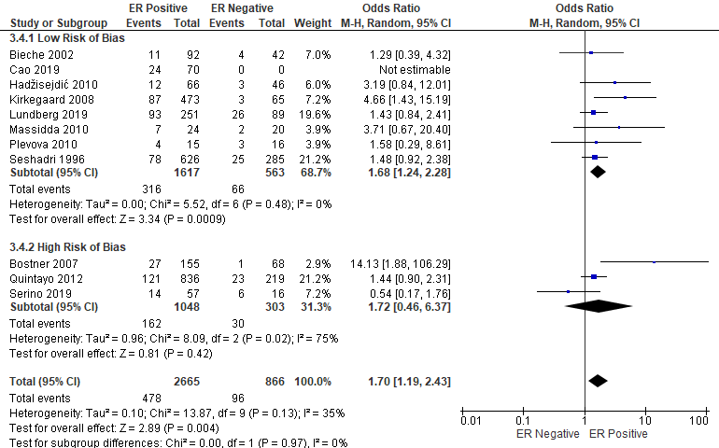
Supplementary Figure 1: Forrest plot of odds ratios for CCND1 amplification and Estrogen Receptor
Analysis includes data from all eligible studies regardless of risk of bias (RoB), with segregation into groups based on RoB assessment. Z values indicate the magnitude of association, with p-values <0.05 indicating statistically significant association. Blue squares indicate ratio, with values >1 indicative of association of the outcome measure (RFS and OS) with CCND1 amplification, with strongest association towards the right of the plot. Black lines either side of squares indicate 95% confidence interval (CI). Size of blue boxes is relative to specific study weight with greatest weight given to studies with minimal variance (calculated based on inverse of the variance). Large black diamond represents pooled ratio estimate of the above studies. A random effects approach was taken. SE – Standard Error. Plots were generated in Review Manager.

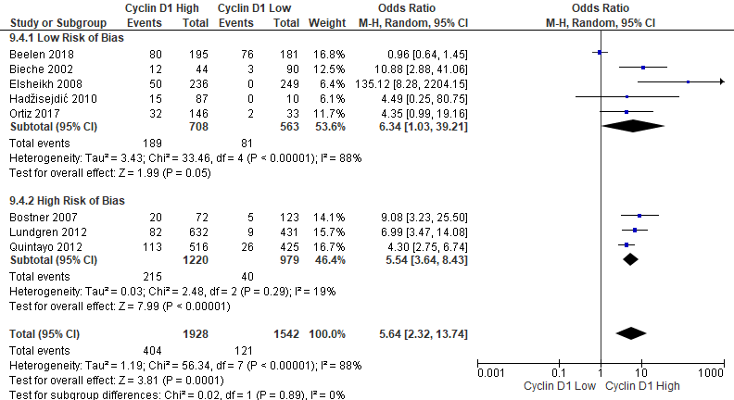
Supplementary Figure 2: Forrest plot of odds ratios for CCND1 amplification and Cyclin D1 Expression
Analysis includes data from all eligible studies regardless of risk of bias (RoB), with segregation into groups based on RoB assessment. Z values indicate the magnitude of association, with p-values <0.05 indicating statistically significant association. Blue squares indicate ratio, with values >1 indicative of association of the outcome measure (RFS and OS) with CCND1 amplification, with strongest association towards the right of the plot. Black lines either side of squares indicate 95% confidence interval (CI). Size of blue boxes is relative to specific study weight with greatest weight given to studies with minimal variance (calculated based on inverse of the variance). Large black diamond represents pooled odds ratio estimate of the above studies. A random effects approach was taken. SE – Standard Error. Plots were generated in Review Manager.

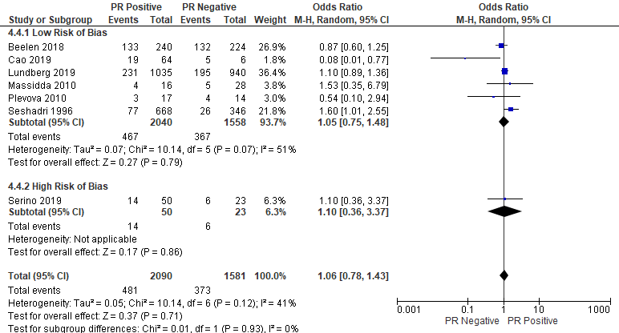
Supplementary Figure 3: Forrest plot of odds ratios for CCND1 amplification and Progesterone Receptor
Analysis includes data from all eligible studies regardless of risk of bias (RoB), with segregation into groups based on RoB assessment. Z values indicate the magnitude of association, with p-values <0.05 indicating statistically significant association. Blue squares indicate odds ratio, with values >1 indicative of association of the outcome measure (RFS and OS) with CCND1 amplification, with strongest association towards the right of the plot. Black lines either side of squares indicate 95% confidence interval (CI). Size of blue boxes is relative to specific study weight with greatest weight given to studies with minimal variance (calculated based on inverse of the variance). Large black diamond represents pooled odds ratio estimate of the above studies. A random effects approach was taken. SE – Standard Error. Plots were generated in Review Manager.

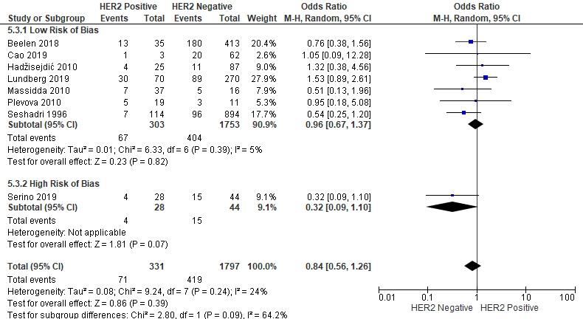
Supplementary Figure 4: Forrest plot of odds ratios for CCND1 amplification and HER2
Analysis includes data from all eligible studies regardless of risk of bias (RoB), with segregation into groups based on RoB assessment. Z values indicate the magnitude of association, with p-values <0.05 indicating statistically significant association. Blue squares indicate odds ratio, with values >1 indicative of association of the outcome measure (RFS and OS) with CCND1 amplification, with strongest association towards the right of the plot. Black lines either side of squares indicate 95% confidence interval (CI). Size of blue boxes is relative to specific study weight with greatest weight given to studies with minimal variance (calculated based on inverse of the variance). Large black diamond represents pooled odds ratio estimate of the above studies. A random effects approach was taken. SE – Standard Error. Plots were generated in Review Manager.

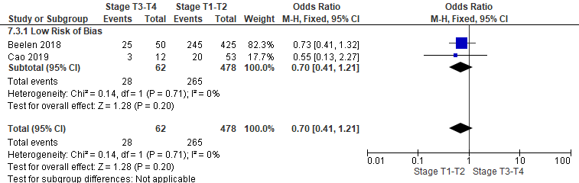
Supplementary Figure 5: Forrest plot of odds ratios for CCND1 amplification and Stage
Analysis includes data from all eligible studies regardless of risk of bias (RoB), with segregation into groups based on RoB assessment. Z values indicate the magnitude of association, with p-values <0.05 indicating statistically significant association. Blue squares indicate odds ratio, with values >1 indicative of association of the outcome measure (RFS and OS) with CCND1 amplification, with strongest association towards the right of the plot. Black lines either side of squares indicate 95% confidence interval (CI). Size of blue boxes is relative to specific study weight with greatest weight given to studies with minimal variance (calculated based on inverse of the variance). Large black diamond represents pooled odds ratio estimate of the above studies. A fixed effects approach was taken. SE – Standard Error. Plots were generated in Review Manager.

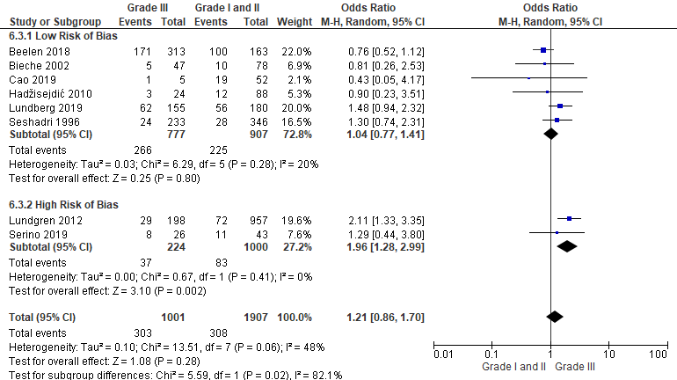
Supplementary Figure 6: Forrest plot of odds ratios for CCND1 amplification and Grade
Analysis includes data from all eligible studies regardless of risk of bias (RoB), with segregation into groups based on RoB assessment. Z values indicate the magnitude of association, with p-values <0.05 indicating statistically significant association. Blue squares indicate odds ratio, with values >1 indicative of association of the outcome measure (RFS and OS) with CCND1 amplification, with strongest association towards the right of the plot. Black lines either side of squares indicate 95% confidence interval (CI). Size of blue boxes is relative to specific study weight with greatest weight given to studies with minimal variance (calculated based on inverse of the variance). Large black diamond represents pooled odds ratio estimate of the above studies. A random effects approach was taken. SE – Standard Error. Plots were generated in Review Manager.

