A systematic review of eHealth physical activity interventions for adults affected by cancer: current evidence and directions for future research

Multimedia Appendix 1

Table S1: Medline search strategy
1. exp Accelerometry/
2. exp Smartphone/
3. exp Text Messaging/
4. exp Social Media/
5. exp Fitness Trackers/
6. exp Telemedicine/
7. exp Internet/
8. exp Mobile Applications/
9. exp Cell Phone/
10. (smartphone* or smart-phone* or mobile phone* or cell phone*).tw,kf.
11. ((phone* or mobile* or cell-phone* or smartphone* or smart-phone*) adj2 app*).tw,kf.
12. ((fitness or activit*) adj2 (track* or monitor*)).tw,kf.
13. (accelerometer* or accelerometry or pedometer*).tw,kf.
14. (digital health or electronic health or mobile health or ehealth or e-health or mhealth or m-health or telemedicine or telehealthcare).tw,kf.
15. (text messag* or SMS or computer tailoring or online or online intervention* or internet or web-based).tw,kf.
16. (fitbit or garmin* or vivofit or vivoactive or vivosmart or vivomove or vivoki or apple watch).tw,kf.
17. exp Neoplasms/
18. exp Cancer Survivors/
19. (neoplasm* or cancer* or melanoma or leukemia or lymphoma or sarcoma or carcinoma).tw,kf.
20. (cancer adj2 survivor*).tw,kf.
21. exp Exercise/
22. exp Exercise Therapy/
23. exp Physical Fitness/
24. (exercis* or group fitness or fitness class*).tw,kf.
25. physiotherap*.tw,kf.
26. ((physical or resistance or weight or aerobic or personal) adj2 train*).tw,kf.
27. exercise oncology.tw,kf.
28. (physical adj2 (activit* or therap* or fitness)).tw,kf.
29. 1 or 2 or 3 or 4 or 5 or 6 or 7 or 8 or 9 or 10 or 11 or 12 or 13 or 14 or 15 or 16
30. 17 or 18 or 19 or 20
31. 21 or 22 or 23 or 24 or 25 or 26 or 27 or 28
32. 29 and 30 and 31

Figure S1: Overview of publications by year
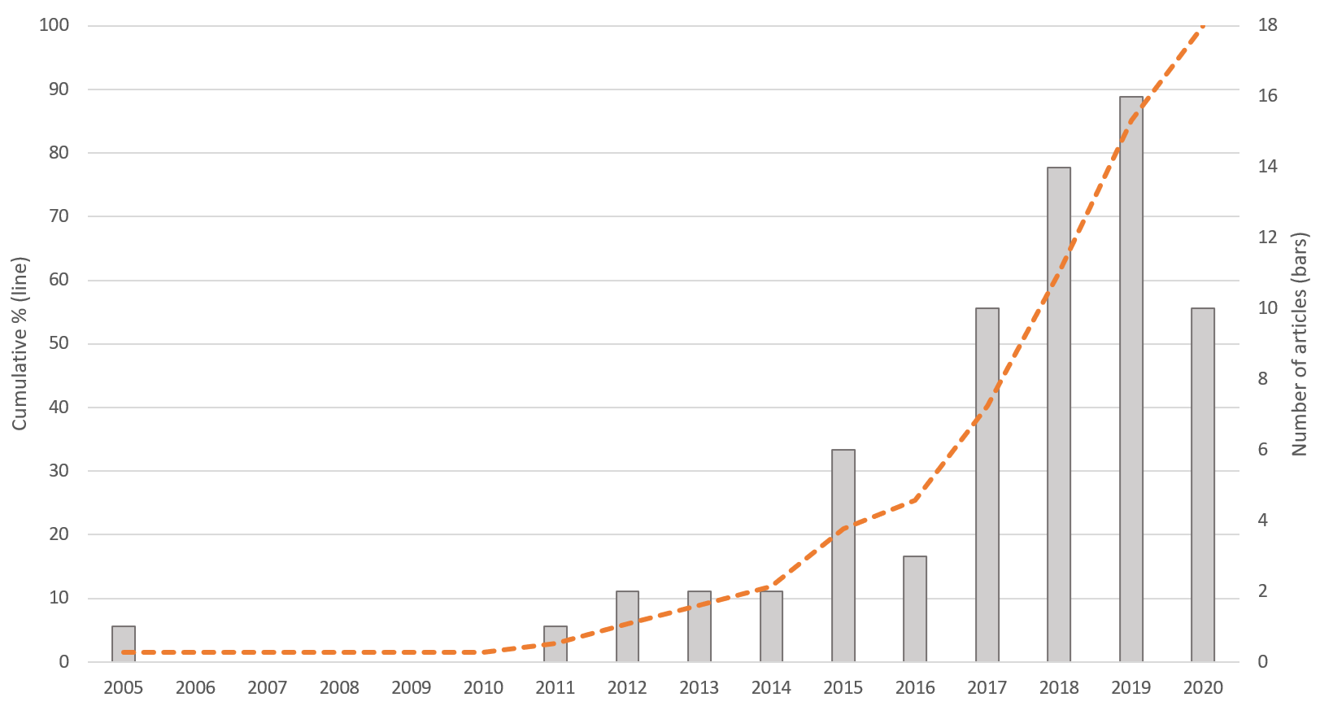

Figure S2: Trends in eHealth use by year
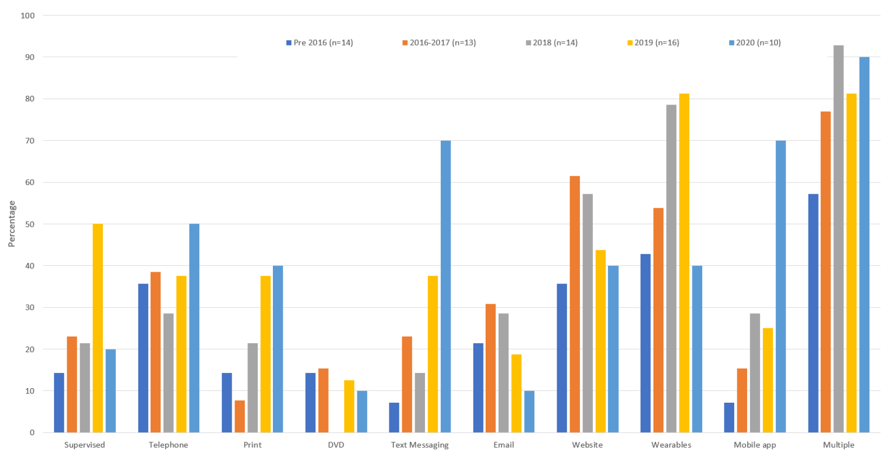

Figure S3: Frequency of use for most common behavior change techniques and categories
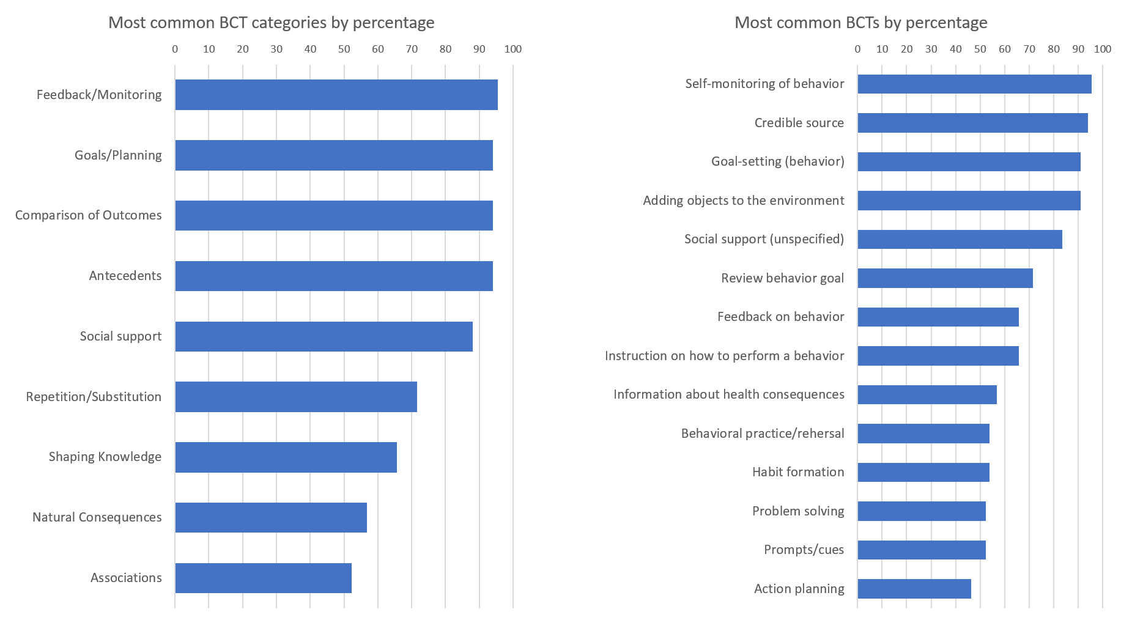

Figure S4: Risk of bias for individual studies
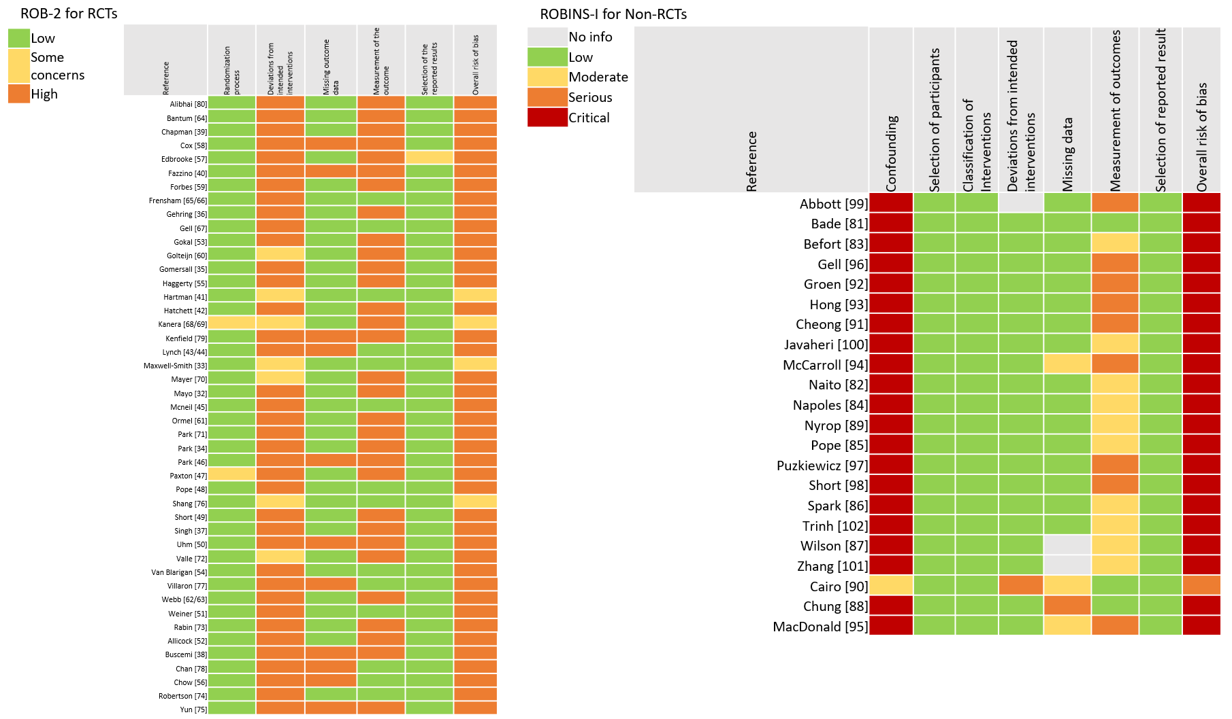
For full references, please refer to the corresponding reference number listed in the main article.

