Supplementary Material
Supplementary Figure 1a.
The STRC mutations prevalence in GJB2-negative HI patients analyzed by subgroup focused on world region
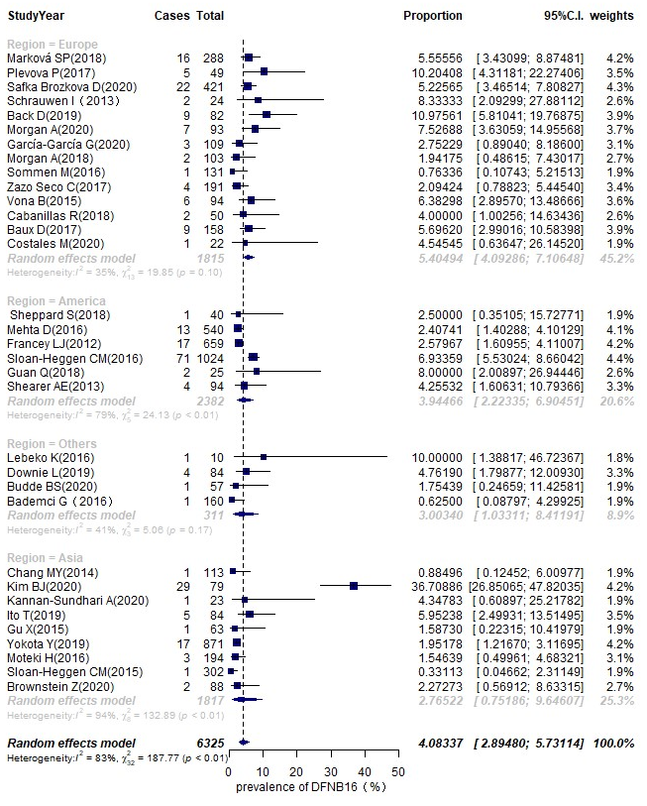
Supplementary Figure 1b.
The STRC mutations prevalence in GJB2-negative HI patients analyzed by subgroup focused on the grade of HI

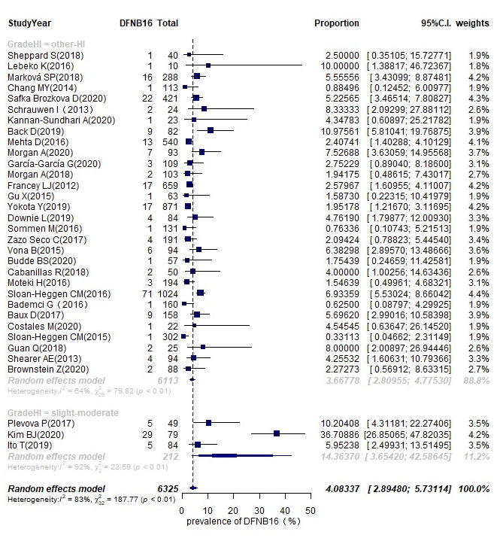

Supplementary Figure 2a.
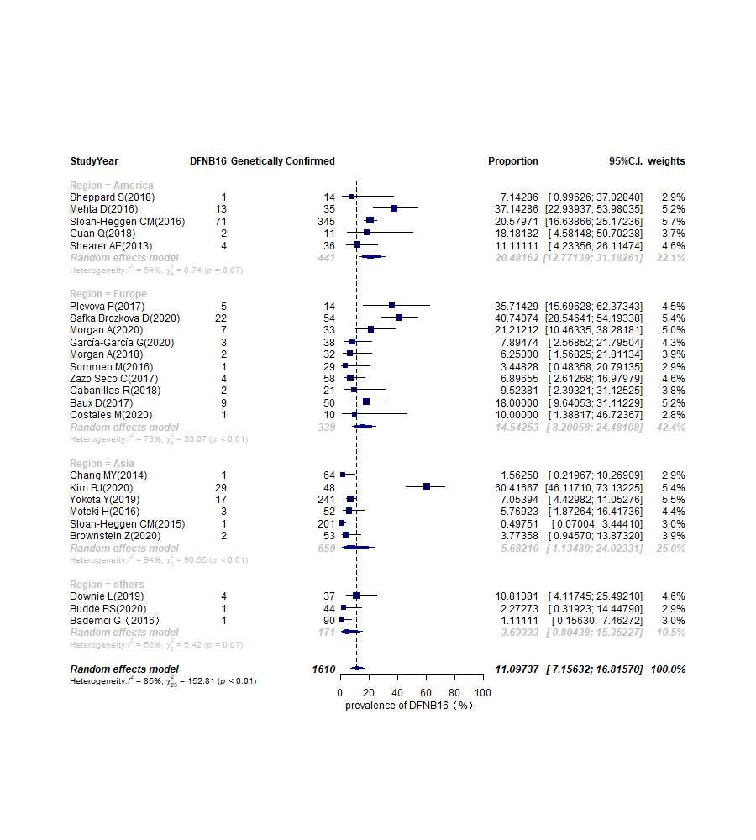
The DFNB16 prevalence in genetically confirmed cases (non-GJB2) analyzed by subgroup focused on world region

Supplementary Figure 2b
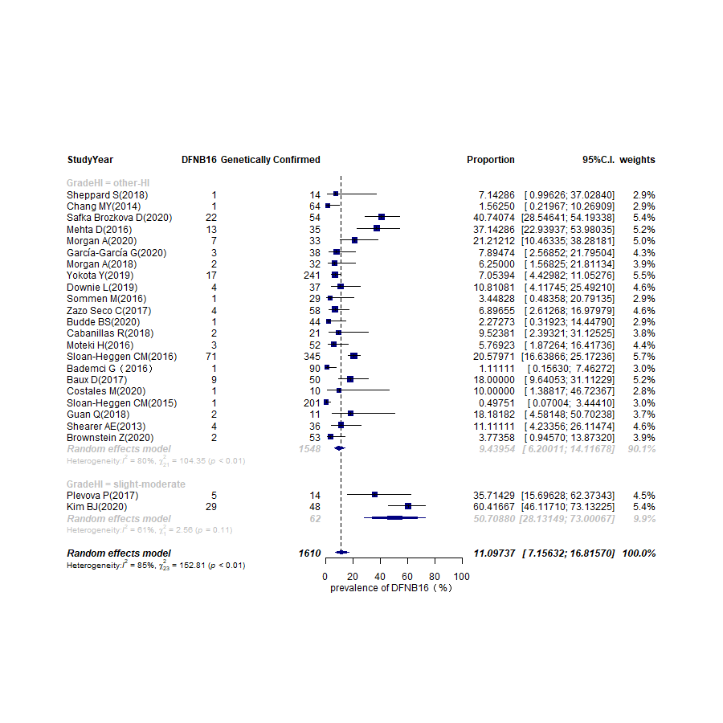
The DFNB16 prevalence in genetically confirmed cases (non-GJB2) analyzed by subgroup focused on the grade of HI

