Supplementary Material

Supplementary Table 1. PRISMA 2020 Checklist
Section and Topic | Item # | Checklist item | Location where item is reported
TITLE
Title | 1 | Identify the report as a systematic review. | Page 1
ABSTRACT
Abstract | 2 | See the PRISMA 2020 for Abstracts checklist. | Page 1-2
INTRODUCTION
Rationale | 3 | Describe the rationale for the review in the context of existing knowledge. | Page 2
Objectives | 4 | Provide an explicit statement of the objective(s) or question(s) the review addresses. | Page 2-3
METHODS
Eligibility criteria | 5 | Specify the inclusion and exclusion criteria for the review and how studies were grouped for the syntheses. | Page 3
Information sources | 6 | Specify all databases, registers, websites, organisations, reference lists and other sources searched or consulted to identify studies. Specify the date when each source was last searched or consulted. | Page 3
Search strategy | 7 | Present the full search strategies for all databases, registers and websites, including any filters and limits used. | Page 3 and Supplementary Material
Selection process | 8 | Specify the methods used to decide whether a study met the inclusion criteria of the review, including how many reviewers screened each record and each report retrieved, whether they worked independently, and if applicable, details of automation tools used in the process. | Page 3
Data collection process | 9 | Specify the methods used to collect data from reports, including how many reviewers collected data from each report, whether they worked independently, any processes for obtaining or confirming data from study investigators, and if applicable, details of automation tools used in the process. | Page 3-4
Data items | 10a | List and define all outcomes for which data were sought. Specify whether all results that were compatible with each outcome domain in each study were sought (e.g. for all measures, time points, analyses), and if not, the methods used to decide which results to collect. | Page 4
Data items | 10b | List and define all other variables for which data were sought (e.g. participant and intervention characteristics, funding sources). Describe any assumptions made about any missing or unclear information. | Page 4
Study risk of bias assessment | 11 | Specify the methods used to assess risk of bias in the included studies, including details of the tool(s) used, how many reviewers assessed each study and whether they worked independently, and if applicable, details of automation tools used in the process. | Page 4
Effect measures | 12 | Specify for each outcome the effect measure(s) (e.g. risk ratio, mean difference) used in the synthesis or presentation of results. | Page 4
Synthesis methods | 13a | Describe the processes used to decide which studies were eligible for each synthesis (e.g. tabulating the study intervention characteristics and comparing against the planned groups for each synthesis (item #5)). | Page 4
Synthesis methods | 13b | Describe any methods required to prepare the data for presentation or synthesis, such as handling of missing summary statistics, or data conversions. | Page 4
Synthesis methods | 13c | Describe any methods used to tabulate or visually display results of individual studies and syntheses.
Synthesis methods | 13d | Describe any methods used to synthesize results and provide a rationale for the choice(s). If meta-analysis was performed, describe the model(s), method(s) to identify the presence and extent of statistical heterogeneity, and software package(s) used. | Page 4
Synthesis methods | 13e | Describe any methods used to explore possible causes of heterogeneity among study results (e.g. subgroup analysis, meta-regression). | Page 4
Synthesis methods | 13f | Describe any sensitivity analyses conducted to assess robustness of the synthesized results. | None
Reporting bias assessment | 14 | Describe any methods used to assess risk of bias due to missing results in a synthesis (arising from reporting biases). | Page 4
Certainty assessment | 15 | Describe any methods used to assess certainty (or confidence) in the body of evidence for an outcome. | None
RESULTS
Study selection | 16a | Describe the results of the search and selection process, from the number of records identified in the search to the number of studies included in the review, ideally using a flow diagram. | Page 4 and Figure 1
Study selection | 16b | Cite studies that might appear to meet the inclusion criteria, but which were excluded, and explain why they were excluded. | Page 4 and Figure 1 and Supplementary Material
Study characteristics | 17 | Cite each included study and present its characteristics. | Page 5
Risk of bias in studies | 18 | Present assessments of risk of bias for each included study. | Page 5 and Supplementary Material
Results of individual studies | 19 | For all outcomes, present, for each study: (a) summary statistics for each group (where appropriate) and (b) an effect estimate and its precision (e.g. confidence/credible interval), ideally using structured tables or plots. | Page 5
Results of syntheses | 20a | For each synthesis, briefly summarise the characteristics and risk of bias among contributing studies. | Page 5
Results of syntheses | 20b | Present results of all statistical syntheses conducted. If meta-analysis was done, present for each the summary estimate and its precision (e.g. confidence/credible interval) and measures of statistical heterogeneity. If comparing groups, describe the direction of the effect. | Page 5
Results of syntheses | 20c | Present results of all investigations of possible causes of heterogeneity among study results. | None
Results of syntheses | 20d | Present results of all sensitivity analyses conducted to assess the robustness of the synthesized results. | None
Reporting biases | 21 | Present assessments of risk of bias due to missing results (arising from reporting biases) for each synthesis assessed. | Page 6
Certainty of evidence | 22 | Present assessments of certainty (or confidence) in the body of evidence for each outcome assessed. | None
DISCUSSION
Discussion | 23a | Provide a general interpretation of the results in the context of other evidence. | Page 6
Discussion | 23b | Discuss any limitations of the evidence included in the review. | Page 7
Discussion | 23c | Discuss any limitations of the review processes used. | Page 7
Discussion | 23d | Discuss implications of the results for practice, policy, and future research. | Page 7
OTHER INFORMATION
Registration and protocol | 24a | Provide registration information for the review, including register name and registration number, or state that the review was not registered. | Page 3
Registration and protocol | 24b | Indicate where the review protocol can be accessed, or state that a protocol was not prepared. | Page 3
Registration and protocol | 24c | Describe and explain any amendments to information provided at registration or in the protocol. | None
Support | 25 | Describe sources of financial or non-financial support for the review, and the role of the funders or sponsors in the review. | Page 8
Competing interests | 26 | Declare any competing interests of review authors. | Page 13
Availability of data, code and other materials | 27 | Report which of the following are publicly available and where they can be found: template data collection forms; data extracted from included studies; data used for all analyses; analytic code; any other materials used in the review. | Page 8

Supplementary Table 2. Search Strategy
PubMed:
#1: Hydroxymethylglutaryl-CoA Reductase Inhibitors[MeSH Terms] OR HMG-CoA[Title/Abstract] OR Hydroxymethylglutaryl-CoA Reductase[All Fields] OR lipid-lowering drugs[All Fields] OR statin[All Fields] OR statins[All Fields] OR simvastatin[All Fields] OR atorvastatin[All Fields] OR pravastatin[All Fields] OR fluvastatin[All Fields] OR cerivastatin[All Fields] OR rosuvastatin[All Fields] OR lovastatin[All Fields] OR mevastatin[All Fields] OR pitavastatin[All Fields] OR dalvastatin[All Fields]
AND
#2: Stroke[MeSH Terms] OR stroke[All Fields] OR AIS[Title/Abstract] OR cerebral infarction[All Fields] OR cerebral ischemia[All Fields] OR brain infarction[All Fields]
AND
#3: Tissue Plasminogen Activator[MeSH Terms] OR tissue plasminogen activator[All Fields] OR tPA[Title/Abstract] OR t-PA[Title/Abstract] OR rtPA[Title/Abstract] OR rt-PA[Title/Abstract] OR thrombolytic[All Fields] OR alteplase[All Fields] OR tenecteplase[All Fields] OR thrombolysis[All Fields] OR IVT[Title/Abstract]
EMBASE:
#1: hydroxymethylglutaryl coenzyme A reductase inhibitor/exp OR hydroxymethylglutaryl-CoA reductase inhibitors:ti,ab OR HMG-CoA reductase inhibitors:ti,ab OR statin:ti,ab OR statins:ti,ab OR simvastatin:ti,ab OR cerivastatin:ti,ab OR rosuvastatin:ti,ab OR pravastatin:ti,ab OR fluvastatin:ti,ab OR atorvastatin:ti,ab OR lovastatin:ti,ab OR lipids:ti,ab OR hypercholesterolemia:ti,ab OR dyslipidemia:ti,ab
AND
#2: brain ischemia/exp OR brain infarction/exp OR cerebrovascular accident/exp OR occlusive cerebrovascular disease/exp OR stroke:ti,ab OR AIS:ti,ab OR cerebral infarction:ti,ab OR cerebral ischemia:ti,ab OR brain infarction:ti,ab
AND
#3: tissue plasminogen activator/exp OR fibrinolytic agent:ti,ab OR tissue plasminogen activator:ti,ab OR tPA:ti,ab OR t-PA:ti,ab OR rtPA:ti,ab OR rt-PA:ti,ab OR alteplase:ti,ab OR tenecteplase:ti,ab OR thrombolysis:ti,ab OR IVT:ti,ab OR IV-tPA:ti,ab OR IV rt-PA:ti,ab
CENTRAL:
(statin:ti,ab,kw OR statins:ti,ab,kw) AND (thrombolysis:ti,ab,kw OR tPA:ti,ab,kw OR tissue plasminogen activator:ti,ab,kw OR IVT:ti,ab,kw) AND stroke:ti,ab,kw

Supplementary Table 3. Excluded studies with reasons for exclusion
Study, year (reference) | Reason(s) for exclusion
Arboix 2010 (1) | Not limited to acute ischemic stroke patients after intravenous thrombolysis
Bang 2007 (2) | Not limited to acute ischemic stroke patients after intravenous thrombolysis
Cougo-Pinto 2012 (3) | No non-statin group
Erdur 2018 (4) | No non-statin group
Makihara 2010 (5) | Providing only overlapping data with previous publication
Meseguer 2012 (6) | Not limited to acute ischemic stroke patients after intravenous thrombolysis
Minhas 2018 (7) | Association statin and outcome not investigated
Nardi 2012 (8) | Association statin and outcome not investigated
Phipps 2013 (9) | Not limited to acute ischemic stroke patients after intravenous thrombolysis
Yang 2021 (10) | No non-statin group
Zhao 2017 (11) | Highly select cohort

Supplementary Figure 1. Pre-stroke statin effect on (A) symptomatic intracranial hemorrhage, (B) any intracranial hemorrhage, (C) 3-month mortality, (D) 3-month favorable functional outcome, and (E) 3-month functional independence.
Figure 1 (A)
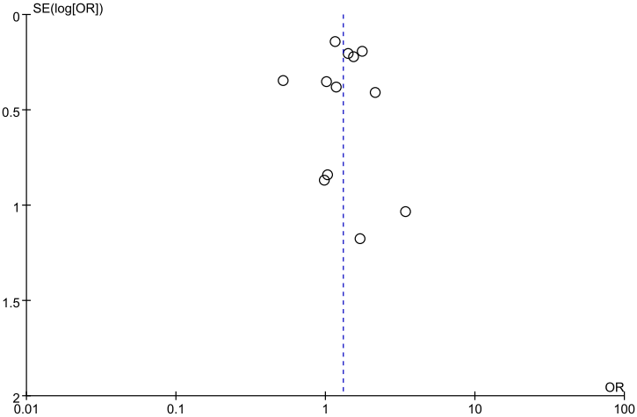
Egger’s test for publication bias: p = 0.957.
Figure 1 (B)
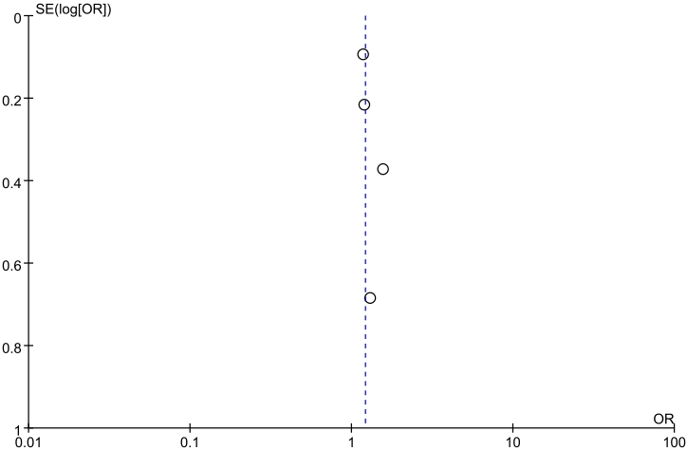
Egger’s test for publication bias: p = 0.294.
Figure 1 (C)
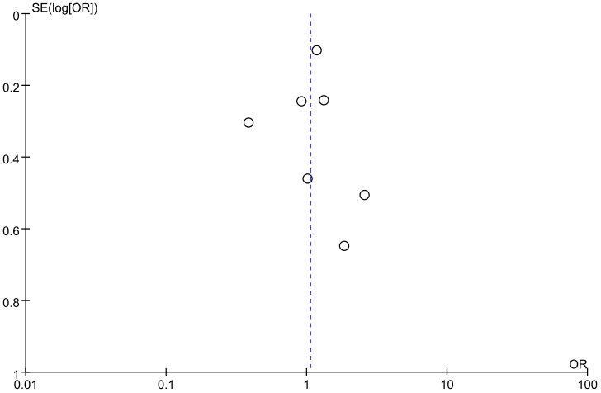
Egger’s test for publication bias: p = 0.887.
Figure 1 (D)
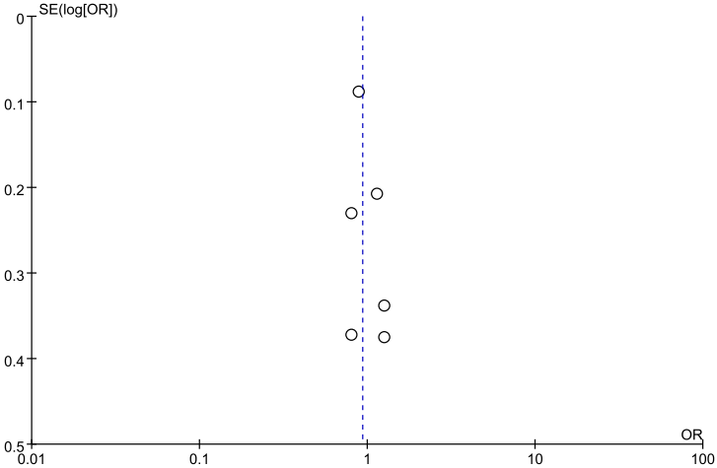
Egger’s test for publication bias: p = 0.304.

Figure 1 (E)
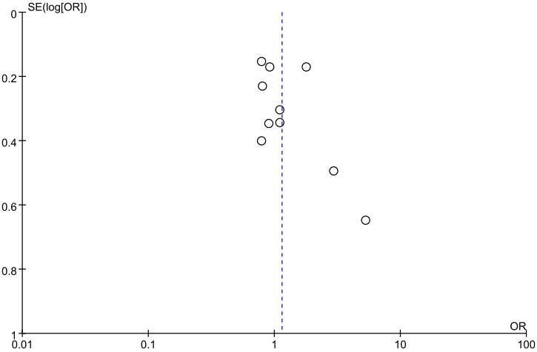
Egger’s test for publication bias: p = 0.299.

Supplementary Figure 2. In-hospital statin effect on (A) symptomatic intracranial hemorrhage, (B) any intracranial hemorrhage, (C) 3-month mortality, (D) 3-month favorable functional outcome, and (E) 3-month functional independence.
Figure 2 (A)
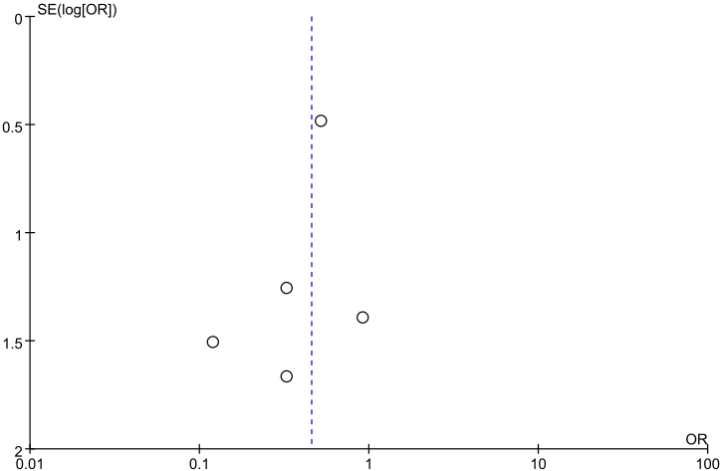
Egger’s test for publication bias: p = 0.454.
Figure 2 (B) 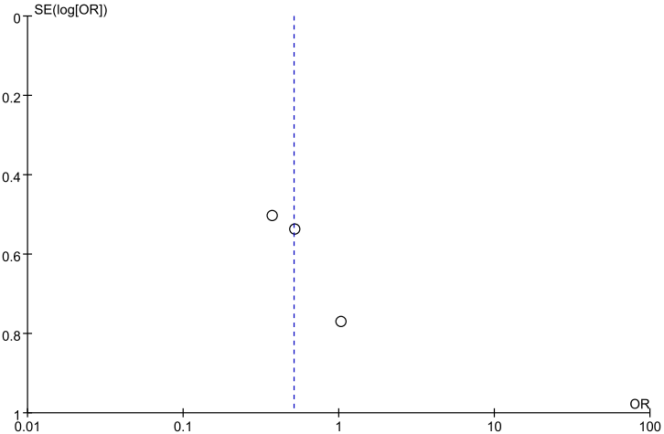
Egger’s test for publication bias: p = 0.238.
Figure 2 (C)
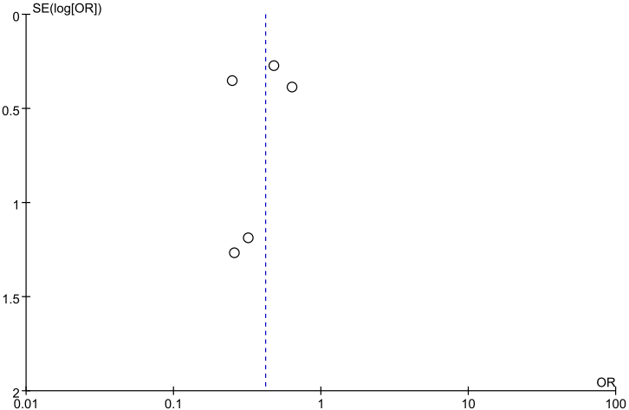
Egger’s test for publication bias: p = 0.674.
Figure 2 (D)
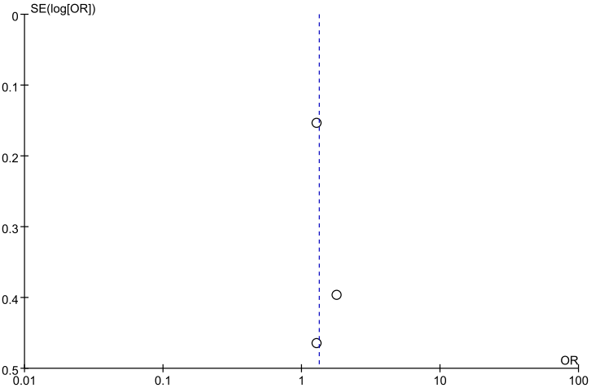
Egger’s test for publication bias: p = 0.575.

Figure 2 (E)
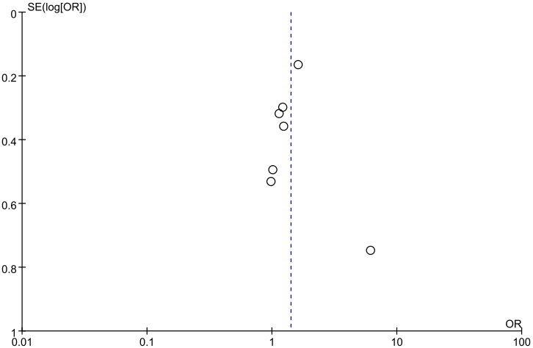
Egger’s test for publication bias: p = 0.903.

Supplementary References

- Arboix A, García-Eroles L, Oliveres M, Targa C, Balcells M, Massons J. Pretreatment with statins improves early outcome in patients with first-ever ischaemic stroke: a pleiotropic effect of statins or a beneficial effect of hypercholesterolemia? BMC Neurol. (2010) 10:47. doi: 10.1186/1471-2377-10-47.
- Bang OY, Saver JL, Liebeskind DS, Starkman S, Villablanca P, Salamon N, et al. Cholesterol level and symptomatic hemorrhagic transformation after ischemic stroke thrombolysis. Neurology. (2007) 68:737-742. doi: 10.1212/01.wnl.0000252799.64165.d5.
- Cougo-Pinto PT, dos Santos BL, Dias FA, Fabio SRC, Werneck IV, Camilo MR, et al. Frequency and predictors of symptomatic intracranial hemorrhage after intravenous thrombolysis for acute ischemic stroke in a Brazilian public hospital. Clinics (Sao Paulo). (2012) 67:739-743. doi: 10.6061/clinics/2012(07)06.
- Erdur H, Polymeris A, Grittner U, Scheitz JF, Tütüncü S, Seiffge DJ, et al. A Score for Risk of Thrombolysis-Associated Hemorrhage Including Pretreatment with Statins. Front Neurol. 2018;9:74. doi: 10.3389/fneur.2018.00074.
- Makihara N, Okada Y, Koga M, Shiokawa Y, Nakagawara J, Furui E, et al. Effects of statin use on intracranial hemorrhage and clinical outcome after intravenous rt-PA for acute ischemic stroke: SAMURAI rt-PA Registry. Rinsho Shinkeigaku. (2010) 50:225-231. doi: 10.5692/clinicalneurol.50.225
- Meseguer E, Mazighi M, Lapergue B, Labreuche J, Sirimarco G, Gonzalez-Valcarcel J, et al. Outcomes after thrombolysis in AIS according to prior statin use: a registry and review. Neurology. (2012) 79:1817-1823. doi: 10.1212/WNL.0b013e318270400b.
- Minhas JS, Wang X, Arima H, Bath PM, Billot L, Broderick JP, et al. Lipid-Lowering Pretreatment and Outcome Following Intravenous Thrombolysis for Acute Ischaemic Stroke: A Post Hoc Analysis of the Enhanced Control of Hypertension and Thrombolysis Stroke Study Trial. Cerebrovasc Dis. (2018) 45:213-220. doi: 10.1159/000488911.
- Nardi K, Engelter S, Strbian D, Sarikaya H, Arnold M, Casoni F, et al. Lipid profiles and outcome in patients treated by intravenous thrombolysis for cerebral ischemia. Neurology. (2012) 79:1101-1108. doi: 10.1212/WNL.0b013e3182608c82.
- Phipps MS, Zeevi N, Staff I, Fortunato G, Kuchel GA, McCullough LD. Stroke severity and outcomes for octogenarians receiving statins. Arch Gerontol Geriatr. (2013) 57:377-382. doi: 10.1016/j.archger.2013.05.007.
- Yang WY, Li YF, Wang ZR, Yu TX, Xu DJ, Yang N, et al. Combined therapy of intensive statin plus intravenous rt-PA in acute ischemic stroke: the INSPIRE randomized clinical trial. J Neurol. (2021) 268:2560-2569. doi: 10.1007/s00415-020-10388-3.
- Zhao Q, Shan W, Liu L, Fu X, Liu P, Hu Y. Predictors of functional outcome and hemorrhagic complications in acute ischemic stroke patients treated with intravenous thrombolysis - A retrospective analysis. Int J Clin Pharmacol Ther. (2017) 55:893-900. doi: 10.5414/CP203117.

