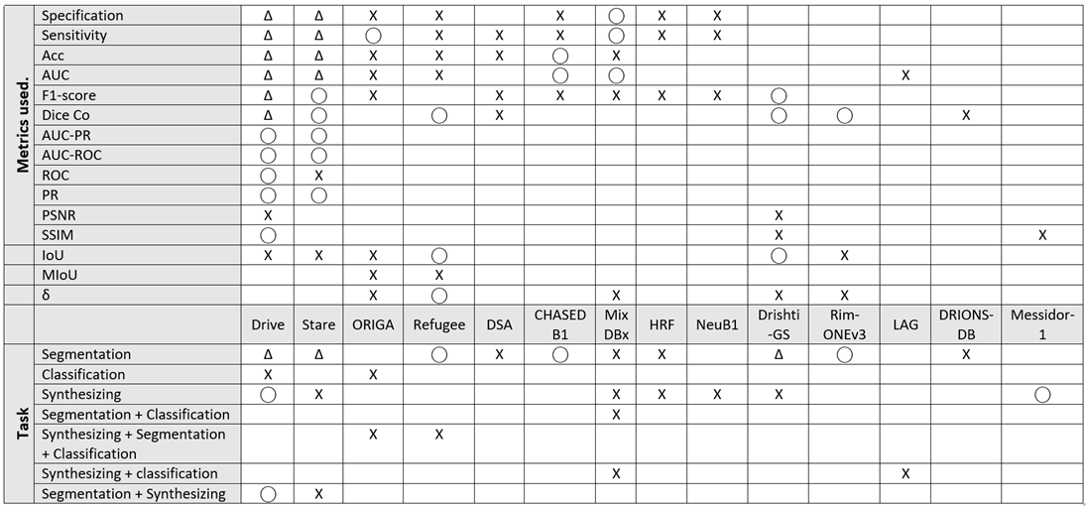
T-shaped matrix diagram shows the total use of each metric according to the dataset used. Similarly, the total use of each dataset according to a specific task. Symbol (Δ) denotes highly used (>4 time), symbol (⃝) denotes moderate use (2-4), symbol (X) denotes rarely used (= 1) and blank means unused (< 1). Note that we have ignored any metric used once by only one single dataset.

