Supplementary Material
Table of contents Page
Supplementary Table 1: Strategies searching using PICO framework. 1
Supplementary Table 2: Results of treatment ranking from network meta-analysis 6
of incidence BPAR and major adverse drug reactions

Figures Page
Supplementary Figure 1: Cochrane Risk of Bias 2.0 Tool of included randomized controlled trials 7
Supplementary Figure 2: Forest plot the efficacy of ganciclovir on incidence BPAR 8
in direct meta-analysis
Supplementary Figure 3: Forest plot the efficacy of acyclovir on incidence BPAR in 8
direct meta-analysis
Supplementary Figure 4: Funnel plot the efficacy of acyclovir on incidence BPAR 9
Supplementary Figure 5: Funnel plot the efficacy of ganciclovir on incidence BPAR 10
Supplementary Figure 6: Network diagram of major adverse reactions 11
Supplementary Figure 7: Comparison-adjusted funnel plot of incidence BPAR reduction 12

Supplementary Table 1. Strategies searching using PICO framework.1.1 Search strategies and results in MEDLINE
Domain | Search number | Query
Patients (P)
P1  (Kidney transplant) | #1 | Search kidney transplantation[MeSH Terms]
P1  (Kidney transplant) | #2 | Search "kidney transplantation"[Text Word]
P1  (Kidney transplant) | #3 | Search kidney transplant*[Text Word]
P2  (Renal transplant) | #4 | Search renal transplantation[MeSH Terms]
P2  (Renal transplant) | #5 | Search "renal transplantation"[Text Word]
P2  (Renal transplant) | #6 | Search renal transplant*[Text Word]
P3  (prophylaxis) | #7 | Search prophylaxis[Text Word]  Search prophyla*[Text Word]  Search (prophyla*[Text Word]) OR prophylaxis[Text Word]
P1 or P2 or P3 | #8 | #1 OR #2 OR #3 OR #4 OR #5 OR #6 OR #7
Interventions (I) and Comparators (C)
I 1  (Valganciclovir) | #14 | Search valganciclovir[MeSH Terms]
I 1  (Valganciclovir) | #15 | Search "valganciclovir"[Text Word]
I 2  (Valaciclovir) | #16 | Search Valaciclovir[MeSH Terms]
I 2  (Valaciclovir) | #17 | Search “valaciclovir”[Text Word]
I 3  (ganciclovir) | #18 | Search ganciclovir[MeSH Terms]
I 3  (ganciclovir) | #19 | Search “ganciclovir”[Text Word]
I 4  (acyclovir or aciclovir) | #20 | Search acyclovir[MeSH Terms]
I 4  (acyclovir or aciclovir) | #21 | Search "acyclovir"[Text Word]
I 4  (acyclovir or aciclovir) | #22 | Search "aciclovir"[Text Word]
I 1 or I2 or I 3 or I4 | #23 | #14 OR #15 OR #16 OR #17 OR #18 OR #19 OR #20 OR #21 OR #22
Outcomes (O)
O 1  (CMV infection)  O2  (Biopsy Proven Acute Rejection) | #24 | Search cytomegalovirus infection[MeSH Terms] AND "CMV"[Text Word]
O 1  (CMV infection)  O2  (Biopsy Proven Acute Rejection) | #25 | Search "cytomegalovirus infection"[Text Word] AND "CMV infection"[Text Word] AND Search CMV disease [Text Word
O 1  (CMV infection)  O2  (Biopsy Proven Acute Rejection) | #26 | Search cytomegalovirus*[Text Word] AND CMV*[Text Word] AND arch cytomegalovirus disease[Text Word]
O 1  (CMV infection)  O2  (Biopsy Proven Acute Rejection) | #27 | Search Acute graft rejection[Text Word]
O 1  (CMV infection)  O2  (Biopsy Proven Acute Rejection) | #28 | Search Biopsy proven acute rejection [Text Word]
O 1  (CMV infection)  O2  (Biopsy Proven Acute Rejection) | #29 | Search “BPRA” [Text Word]
O 1  (CMV infection)  O2  (Biopsy Proven Acute Rejection) | #30 | Search “rejection*” [Text Word]
O 1  (CMV infection)  O2  (Biopsy Proven Acute Rejection) | #31 | Search “graft rejection*” [Text Word]
O1 or O2 | #32 | #24 OR #25 OR #26 OR #27 OR #28 OR #29 OR #30 OR #31
P & I & O | #33 | #13 AND #23 AND#32

  - Search strategies and results in SCOPUS
Domain | Search number | Query
P (Patients)
P1  (Kidney transplant) | #1 | TITLE-ABS-KEY ( "kidney transplantation" )
P1  (Kidney transplant) | #2 | TITLE-ABS-KEY ( kidney AND transplant* )
P2  (Renal transplant) | #3 | TITLE-ABS-KEY ( "renal transplantation" )
P2  (Renal transplant) | #4 | TITLE-ABS-KEY ( renal AND transplant* )
P3  (prophylaxis) | #5 | TITLE-ABS-KEY (prophylaxis)
P1 or P2 or P3 | #6 | #1 OR #2 OR #3 OR #4 OR #5
Interventions and Comparators (I & C)
I1: valganciclovir | #11 | TITLE-ABS-KEY ( valganciclovir )
I2: valaciclovir | #12 | TITLE-ABS-KEY ( valaciclovir )
I3: ganciclovir | #13 | TITLE-ABS-KEY ( ganciclovir )
I4: acyclovir or aciclovir | #14 | TITLE-ABS-KEY ( acyclovir )
I4: acyclovir or aciclovir | #15 | TITLE-ABS-KEY ( aciclovir )
I1 or I2 or I3 or I4 | #16 | #11 OR #12 OR #13 OR #14 OR #15 OR #16
Outcomes (O)
O1  (CMV infection) | #17 | TITLE-ABS-KEY ( "cytomegalovirus infection" )
O1  (CMV infection) | #18 | TITLE-ABS-KEY ( cytomegalovirus* )
O1  (CMV infection) | #19 | TITLE-ABS-KEY ( "CMV" )
O1  (CMV infection) | #20 | TITLE-ABS-KEY ( "CMV infection" )
O1  (CMV infection) | #21 | TITLE-ABS-KEY ( cmv* )
O2  Biopsy Proven Acute Rejection | #22 | TITLE-ABS-KEY ( biopsy proven acute rejection" ) AND TITLE-ABS-KEY (“BPAR”) AND “Graft rejection” AND TITLE-ABS-KEY (“rejection”)
O1 or O2 | #23 | #17 OR #18 OR #19 #20 OR #21 OR #22
P & I & C & O | #24 | #10 AND #16 AND #23

  - Search strategies and results in Embase
Domain | Search number | Query
Patients (P)
P1  (Kidney transplant) | #1 | Search kidney transplantation[Emtree term]
P1  (Kidney transplant) | #2 | Search 'kidney transplantation':ti,ab,kw
P1  (Kidney transplant) | #3 | Search 'kidney transplant*':ti,ab,kw
P2  (Renal transplant) | #4 | Search renal transplantation [Emtree term]
P2  (Renal transplant) | #5 | Search 'renal transplantation':ti,ab,kw
P2  (Renal transplant) | #6 | Search 'renal transplant*':ti,ab,kw
P3  (prophylaxis) | #7 | Search prophylaxis *:ti,ab,kw
P1 or P2 or P3 | #8 | #1 OR #2 OR #3 OR #4 OR #5 OR #6 OR #7
Interventions and Comparators (I & C)
I 1  (Valganciclovir) | #14 | Search 'valganciclovir'/exp[Emtree term]
I 1  (Valganciclovir) | #15 | Search "valganciclovir:ti,ab,kw
I 2  (Valaciclovir) | #16 | Search 'valaciclovir'/de[Emtree term]
I 2  (Valaciclovir) | #17 | Search valaciclovir:ti,ab,kw
I 3  (ganciclovir) | #18 | Search 'ganciclovir'/exp [Emtree term]
I 3  (ganciclovir) | #19 | Search ganciclovir:ti,ab,kw
I 4  (acyclovir or aciclovir) | #20 | Search 'acyclovir'/exp[Emtree term]
I 4  (acyclovir or aciclovir) | #21 | Search 'acyclovir':ti,ab,kw
I 4  (acyclovir or aciclovir) | #22 | Search 'aciclovir':ti,ab,kw
I 1 or I2 or I 3 or I4 | #23 | #14 OR #15 OR #16 OR #17 OR #18 OR #19 OR #20 OR #21 OR #22
Outcomes (O)
O 1  (CMV infection) | #24 | Search 'cytomegalovirus infection'/exp[Emtree term]
O 1  (CMV infection) | #25 | Search 'cytomegalovirus infection':ti,ab,kw
O 1  (CMV infection) | #26 | Search cytomegalovirus*:ti,ab,kw
O 1  (CMV infection) | #27 | Search 'cmv':ti,ab,kw
O 1  (CMV infection) | #28 | Search 'cmv infection':ti,ab,kw
O 1  (CMV infection) | #29 | Search 'cytomegalovirus disease':ti,ab,kw
O 2  Biopsy Proven Acute Rejection | #30 | Search ' biopsy proven acute rejection" AND “BPAR” AND “Graft rejection” AND “rejection” ':ti,ab,kw
 | #31 | Search “rejection” ':ti,ab,kw
O1 or O2 | #32 | #24 OR #25 OR #26 OR #27 OR #28 OR #29 OR #30 OR #31
P & I & C & O | #33 | #13 AND #23 #32

Table 1.4 Gray literature searching
Resources | Key words
- Google scholar  - OpenGrey sera  - Mahidol university Library biomedical librarians  - Gray Source Index  - OpenDOAR directory of academicrepositories | - “Cytomegalovirus prophylaxis and biopsy proven acute rejection”  - “Cytomegalovirus prophylaxis and BPRA”  - “Cytomegalovirus prophylaxis and acute rejection”  - “Cytomegalovirus prophylaxis and graft rejection”  - “anti-CMV prophylaxis and reduce graft rejection”  - “anti-CMV prophylaxis and biopsy proven acute rejection”  - “anti-CMV prophylaxis and graft rejection”  - “anti-CMV prophylaxis and renal graft rejection”  - “anti-CMV prophylaxis and kidney graft rejection”

Supplementary Table 2. Results of treatment ranking from network meta-analysis of incidence BPAR and major adverse drug reactions
Intervention | BPAR |  | Major ADR
Intervention | SUCRA | Pr | SUCRA | Pr
PC | 12.2 | 0.0 | 29.0 | 0.0
AC | 32.50 | 2.0 | 68.2 | 20.0
GC | 46.3 | 16.0 | 36.0 | 1.0
VAC | 74.8 | 31.0 | 28.2 | 2.0
VGC | 84.2 | 58.0 | 88.5 | 77.0
BPAR= Biopsy-proven acute graft rejection, ADR = adverse drug reaction, PC=Placebo/Control, AC=Acyclovir, GC= Ganciclovir, VAC= Valacyclovir, VGC= Valacyclovir, Pr= probability of being the best treatment, SUCRA= surface under the cumulative ranking curve

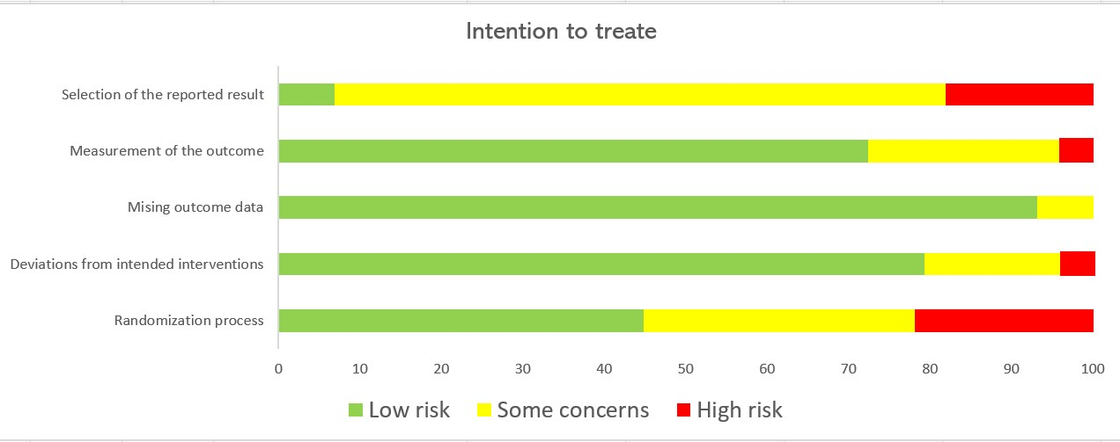
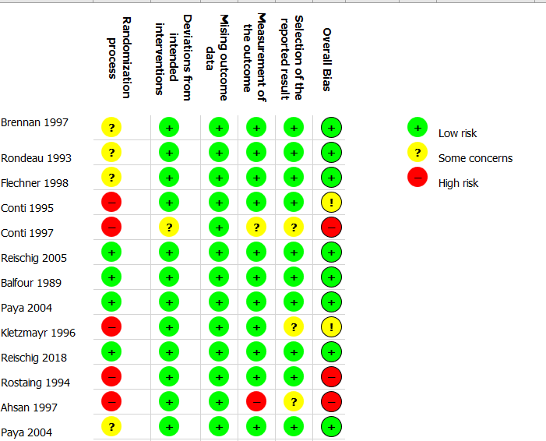
Supplementary Figure 1: Cochrane Risk of Bias 2.0 Tool of included randomized controlled trials

GC= Ganciclovir, PC= Placebo/Control
Supplementary Figure 2. Forest plot the efficacy of ganciclovir on incidence BPAR in direct meta-analysis
AC= Acyclovir, PC= Placebo/Control.
Supplementary Figure 3. Forest plot the efficacy of acyclovir on incidence BPAR in direct meta-analysis

Supplementary Figure 4. Funnel plot the efficacy of acyclovir on incidence BPAR
(egger’s test; p = 0.778)

Supplementary Figure 5. Funnel plot the efficacy of ganciclovir on incidence
(egger’s test; p = 0.896)

Supplementary Figure 6: Network meta-analysis of eligible comparisons for major adverse reactions
The figure plots the network of direct comparisons (black bold lines) and indirect comparisons (dashed line). The width of the lines is proportional to the number of trials comparing every pair of treatments. The size of each circle is proportional to the number of randomly assigned participants (sample size).
BPAR = Biopsy-proven acute rejection

Supplementary Figure 7. Comparison-adjusted funnel plot of incidence BPAR
A = Control, B = Acyclovir, C = Ganciclovir, D = Valacyclovir, E = Valganciclovir

