Supplementary Table 1. Quality assessment of individual studies using the Newcastle-Ottawa Quality Assessment Scale score for cohort studies
Study | Total stars | Selection（4） |  |  |  | Comparability（2） |  | Outcome（3）
Bernard et al, 2018 | 7 | ★ | ★ | ★ | ★ | ★ |  |  | ★ | ★
Fujita et al, 2018 | 8 | ★ | ★ | ★ | ★ | ★ |  | ★ | ★ | ★
Niki et al, 2018 | 8 | ★ | ★ | ★ | ★ | ★ |  | ★ | ★ | ★
Santini et al, 2018 | 8 | ★ | ★ | ★ | ★ | ★ |  | ★ | ★ | ★
Fujita et al, 2019 | 8 | ★ | ★ | ★ | ★ | ★ |  | ★ | ★ | ★
Watanabe et al, 2019 | 8 | ★ | ★ | ★ | ★ | ★ |  | ★ | ★ | ★
Mouri et al, 2019 | 8 | ★ | ★ | ★ | ★ | ★ |  | ★ | ★ | ★
Fujita et al, 2020 | 8 | ★ | ★ | ★ | ★ | ★ |  | ★ | ★ | ★
Gobbini et al, 2020 | 7 | ★ | ★ | ★ | ★ | ★ |  |  | ★ | ★
Herbst RS er al, 2020 | 8 | ★ | ★ | ★ | ★ | ★ |  | ★ | ★ | ★
Katayama et al, 2020 | 7 | ★ | ★ | ★ | ★ | ★ |  |  | ★ | ★
Kitagawa et al, 2020 | 8 | ★ | ★ | ★ | ★ | ★ |  | ★ | ★ | ★
Furuya et al. 2021 | 7 | ★ | ★ | ★ | ★ | ★ |  |  | ★ | ★
Takahara et al. 2022 | 7 | ★ | ★ | ★ | ★ | ★ |  |  | ★ | ★
Xu et al. 2022 | 7 | ★ | ★ | ★ | ★ | ★ |  |  | ★ | ★
★: Eligibility in NOS.
Selection (4): Representativeness of the exposed cohort; Selection of the non-exposed cohort; Ascertainment of exposure; Demonstration that outcome of interest was not present at start of study.
Comparability (2): Comparability of cohorts on the basis of the design or analysis.
Outcomes (3): Assessment of outcome; Was follow-up long enough for outcomes to occur? Adequacy of follow-up of cohorts.

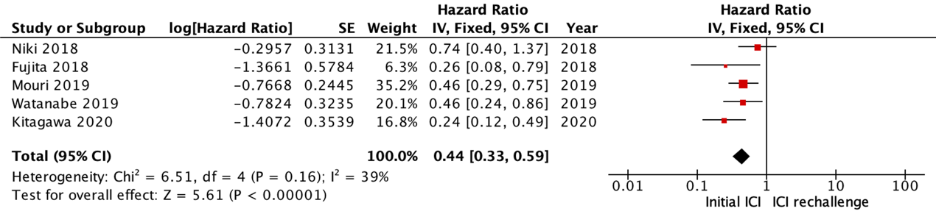
Supplementary Figure 1. Pooled hazard ratio of median progression-free survival compared with the initial treatment of the re-challenge cohort. Lower hazard ratio represents lower progression-free survival. SE: standard error, IV: Inverse Variance.

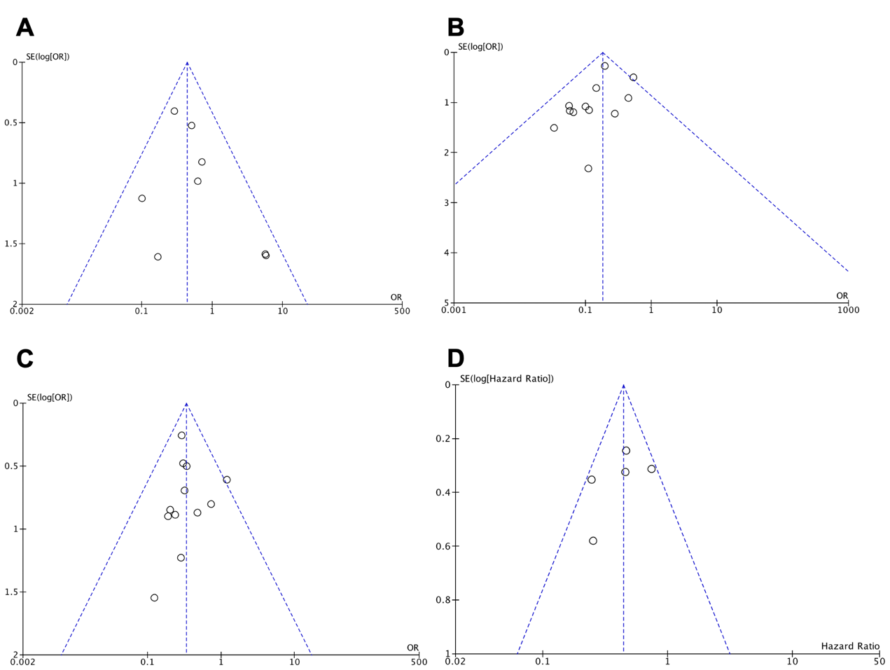
Supplementary Figure 2. Funnel plot for the visual detection of systematic publication bias in (A) grade 3-4 immune-related adverse event, (B) overall response rate, (C) disease control rate and (D) progression-free survival. SE: Standard error, OR: odds ratio.

