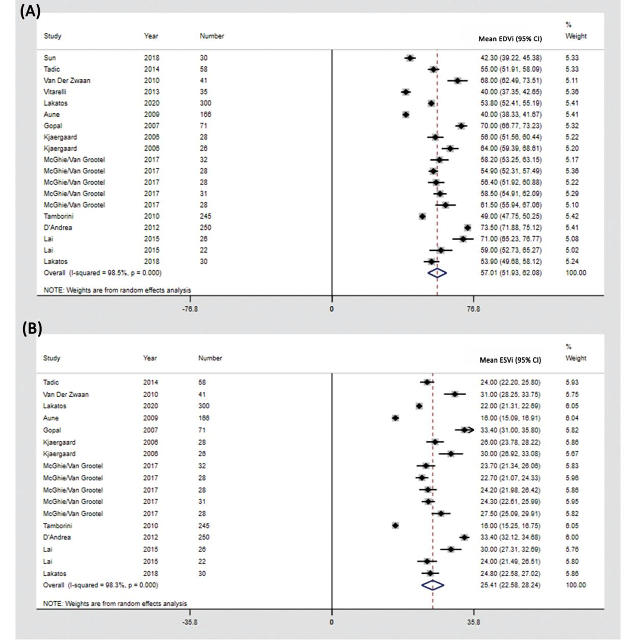
Supplementary Figure 2. The reference values for EDVi and ESVi by 3DE. (A) EDVi, (B) ESVi.
The square represents the mean of the point effect estimate of each study. The square size indicates the weight of the study. The horizontal line extending from either side of the square represents the 95% CI. The diamond reflects the pooled overall consequence. 3DE, three-dimensional echocardiography; CI, confidence interval; EDVi, end-diastolic volume indexed by body surface area; ESVi, end-systolic volume indexed by body surface area.

