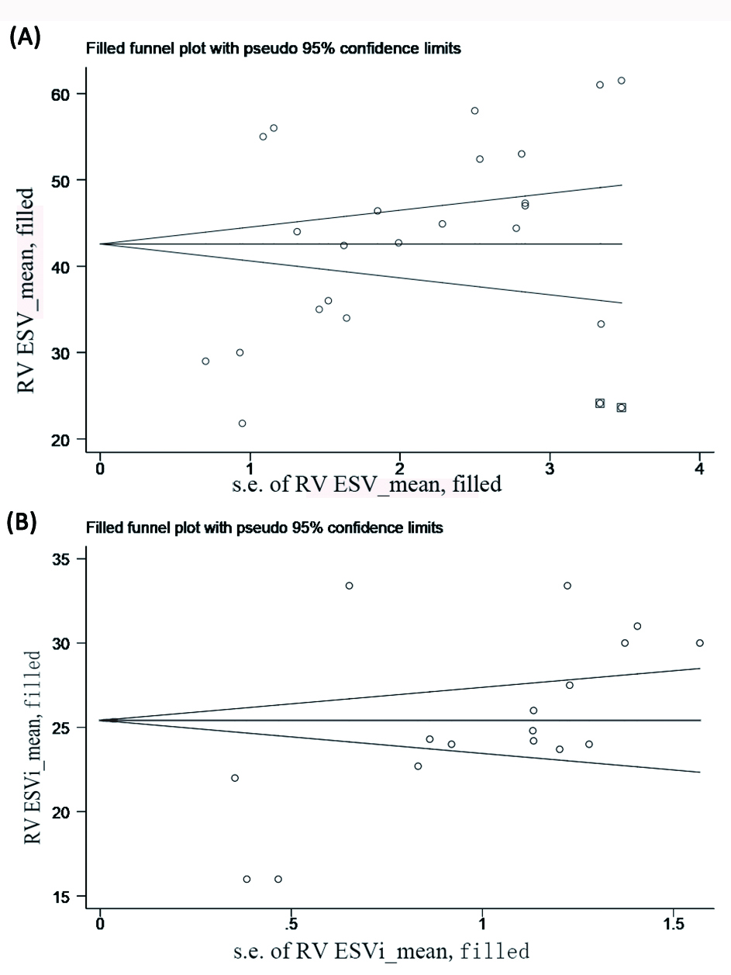

Supplementary Figure 3. Funnel plots with ESV and ESVi estimates using the “trim and fill” method. (A) RV ESV, (B) RV ESVi.
The standard error of the effect estimate is plotted on the horizontal axis. The mean is plotted on the vertical axis. The circle presents each included study. The square presents the filled studies. The black lines indicate the pooled mean and 95% CI.
3DE, three-dimensional echocardiography; RV, right ventricular; ESV, end-systolic volume; ESVi, end-systolic volume indexed by body surface area.

