Figure S1. Effect of statistical analysis on SBP reduction in all studies.

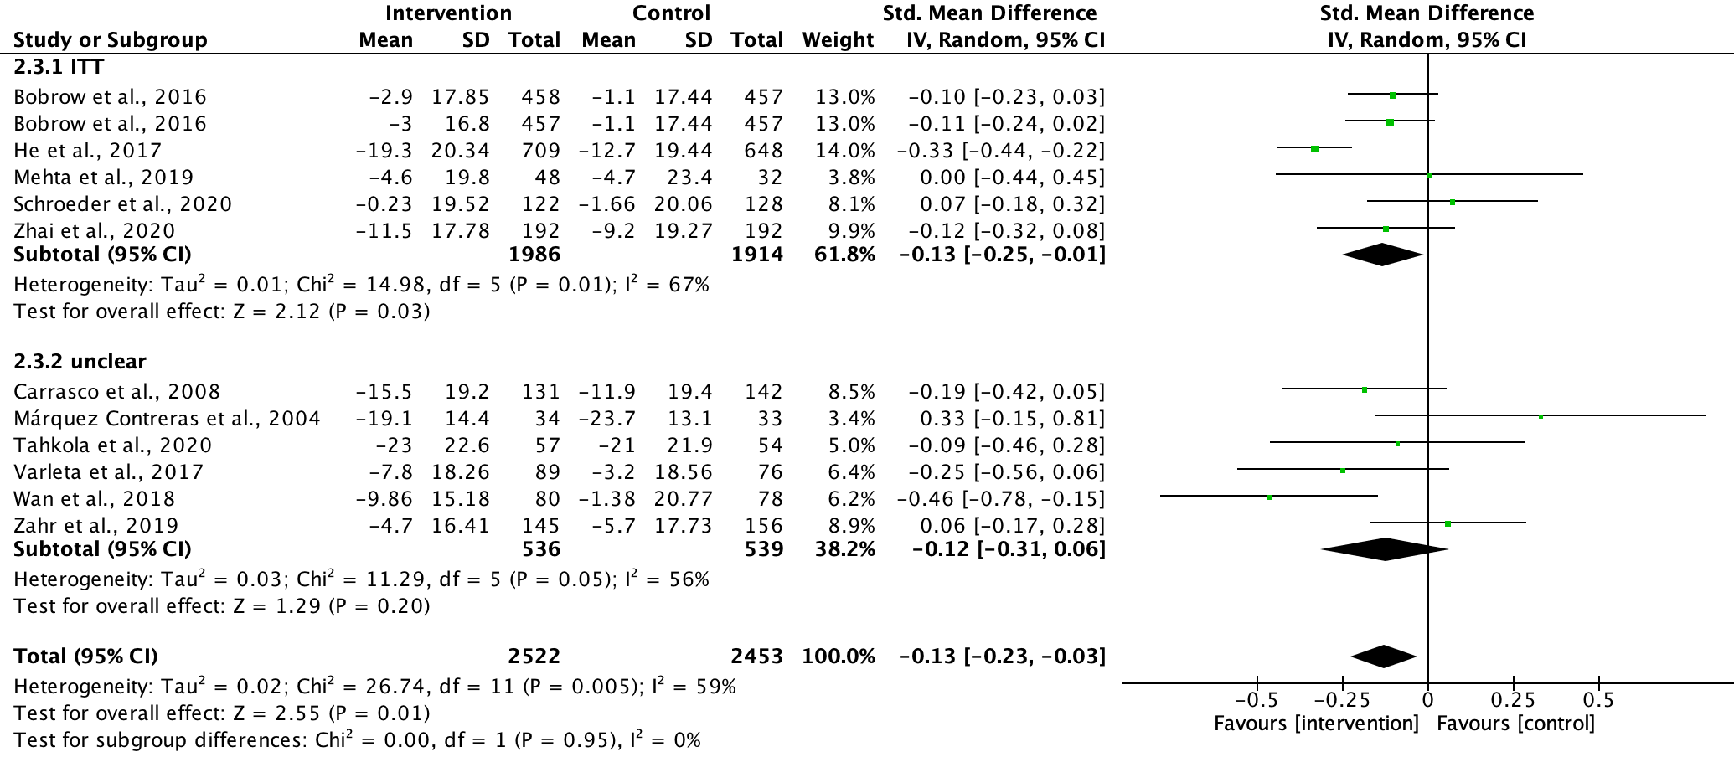

Figure S2. Effect of statistical analysis on DBP reduction in all studies.

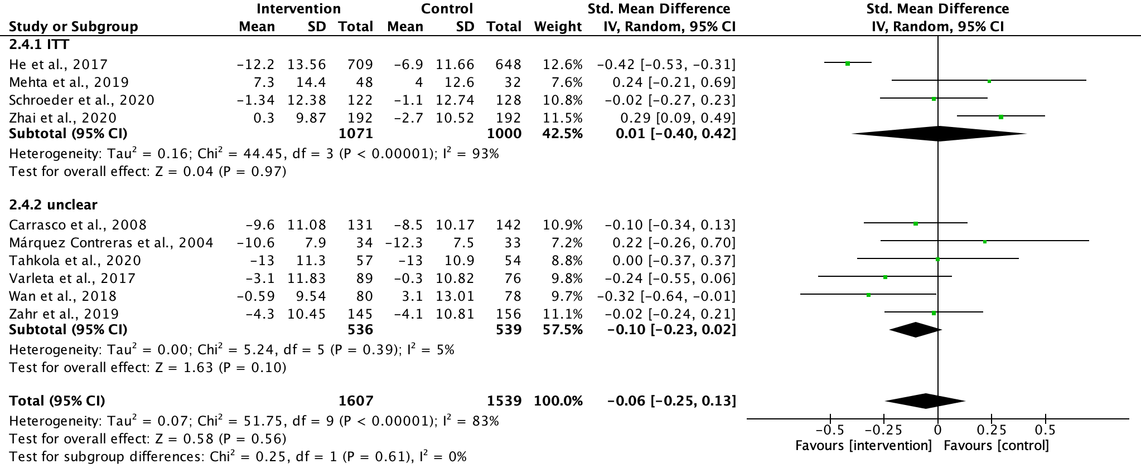

Figure S3. Effect of statistical analysis on SBP reduction in studies that lasted less than 6 months.

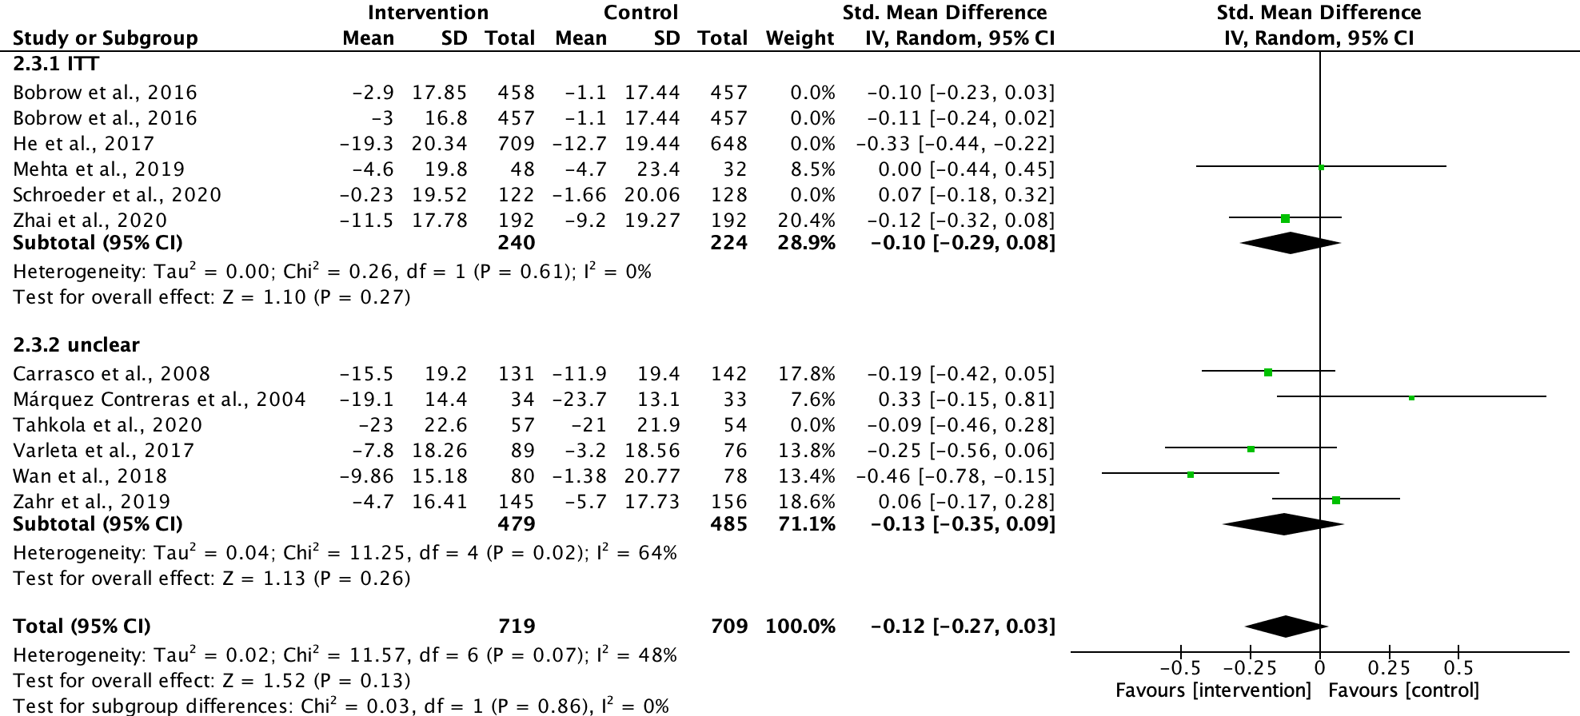

Figure S4. Effect of statistical analysis on DBP reduction in studies that lasted less than 6 months.



