Supplementary Figures and Table Legend

Supplementary Table 1. Newcastle-Ottawa scale for quality assessment and bias assessment of observational studies

Supplementary Figure 1. Leave-one-out analysis for heart failure

Supplementary Figure 2. Funnel plots for publication bias for heart failure

Supplementary Table 1. Newcastle-Ottawa scale for quality assessment and bias assessment of observational studies.

Studies | Selection |  |  |  | Comparability | Outcomes |  |  | Total
 | Representatives of exposed group | Selection of control group | Exposure ascertainment | Outcomes of interest |  | Outcome assessment | Adequacy of follow up duration | Adequacy of follow up of cohort
Yafasova et al 2020 | 1 | 1 | 1 | 1 | 2 | 1 | 1 | 1 | 9
Rosenthal et al 2021 | 1 | 1 | 1 | 1 | 2 | 1 | 0 | 0 | 7
Louise et al 2017 | 1 | 1 | 1 | 1 | 2 | 1 | 1 | 1 | 9
Nery et al 2014 | 1 | 1 | 1 | 1 | 2 | 1 | 1 | 1 | 9
Rossides et al 2021 | 1 | 1 | 1 | 1 | 2 | 1 | 1 | 1 | 9
Ungprasert et al 2017 | 1 | 1 | 1 | 1 | 1 | 1 | 1 | 1 | 8
*Score >6 was considered as an adequate quality study.

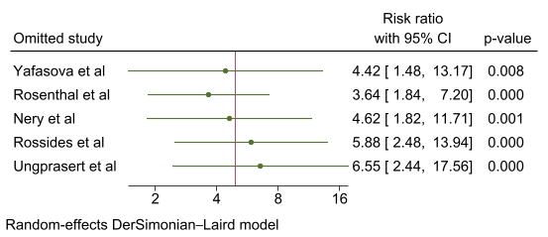

Supplementary Figure 1: Leave-one-out analysis for heart failure.

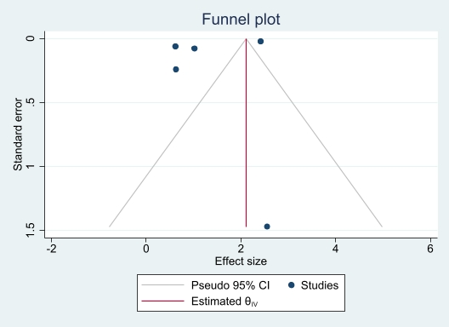
Supplementary Figure 2: Funnel plots for publication bias for heart failure

