Supplementary Materials

List of abbreviated names of brain regions – page 2

Search terms by database – page 3

Depression scales references – page 6

Supplementary Figure 1 – page 7

Coordinates for the Primary Pain contrast – page 8

Coordinates for the Primary Depression contrast – page 11

List of abbreviated names of brain regions

(B) = bilateral
(L) = left-sided
(R) = right-sided
ACC = anterior cingulate cortex
DLPFC = dorsolateral prefrontal cortex
HPA = hypothalamus-pituitary axis
IFG = inferior frontal gyrus
MFG = middle frontal gyrus
MPFC = medial prefrontal cortex
OFC = orbitofrontal cortex
PAG = periaqueductal grey
PCC = posterior cingulate cortex
PCG = posterior cingulate gyrus
S1 = primary somatosensory cortex
S2 = secondary somatosensory cortex
SFG = superior frontal gyrus
VLPFC = ventrolateral prefrontal cortex

Search terms by database

- PsycInfo:
[exp “Depression (Emotion)*/or exp Major Depression/ or exp Reactive Depression/ or exp Beck Depression Inventory/ or exp Treatment Resistant Depression/ or depression.mp. or exp Recurrent Depression/ or exp Late Life Depression/] AND [(exp Pain Management/ or pain.mp. or exp Myofascial Pain/ or exp Pain Measurement/ or exp Pain Thresholds/ or exp Pain Perception/ or exp Neuropathic Pain/ or exp Chronic Pain/ or exp Back Pain/ or exp Pain/) OR (exp Musculoskeletal Disorders/ or exp Fibromyalgia/ or exp Rheumatoid Arthritis/ or fibromyalgia.mp.) OR (exp Trigeminal Neuralgia/ or exp Neuralgia/ or neuralgia.mp.)] AND [(neuroimaging.mp. or exp Neuroimaging/ or exp Tomography/) OR (exp Magnetoencephalography/ or exp Brain/ or exp Magnetic Resonance Imaging/ or exp Neuropathology/ or magnetic resonance imaging.mp.) OR (mri.mp. or exp Magnetic Resonance Imaging) OR (neuroanatomy.mp. or exp Neuroanatomy/) OR ((neural adj5 (pathway* or correlate* or system* or circuit* or network* or activit* or mechanism* or basis or structure*)).mp. [mp=title, abstract, heading word, table of contents, key concepts, original title, tests & measures, mesh])]

- Embase
[exp major depression/ or exp depression/ or depression.mp. or exp depression assessment/] AND [(exp chronic pain/ or pain/) OR (exp fibromyalgia/ or fibromyalgia.mp.) OR (neuralgia.mp. or exp neuralgia/)] AND [(exp neuroimaging/ or exp functional neuroimaging/ or neuroimaging.mp.) OR (mri.mp. or exp nuclear magnetic resonance imaging/) OR (neuroanatomy.mp. or exp neuroanatomy/) OR (neural adj3 (correlate* or pathway* or circuit* or structure* or network*). mp. [mp=title, abstract, heading word, drug trade name, original title, device manufacturer, drug manufacturer, device trade name, keyword, floating subheading word, candidate term word])]

- Medline
[(exp neuroimaging/ or exp functional neuroimaging/ limited to (full text and human and English language)) OR (exp nuclear magnetic resonance imaging/ limited to (full text and human and English language)) OR (neural adj3 (pathway* or system* or network* or circuit* or strucutr*) mp. [mp=title, abstract, original title, name of substance word, subject heading word, floating sub-heading word, keyword heading word, organism supplementary concept word, protocol supplementary concept word, rare disease supplementary concept word, unique identifier, synonyms] limited to (full text and human and English language)) OR (exp neuroanatomy/ limited to (full text and human and English language))] AND [((exp pain severity/ or exp pain intensity/ or exp pain threshold/ or exp chronic pain/ or pain.mp. or exp pain/) limited to (full text and human and English language)) OR ((exp fibromyalgia/ or fibromyalgia.mp) limited to full text and human and English language) OR ((neuralgia.mp. or exp neuralgia/ or exp trigeminus neuralgia) limited to full text and human and English language)] AND [((exp major depression/ or exp chronic depression/ or exp depression/) limited to full text and human and English language) OR ((depression.mp. or exp depression/ or exp major depression/) limited to full text and human and English language)]

[((exp pain severity/ or exp pain intensity/ or exp pain threshold/ or exp chronic pain/ or pain.mp. or exp pain/) limited to full text and human and English language) OR ((exp fibromyalgia/ or fibromyalgia.mp) limited to full text and human and English language) OR ((neuralgia.mp. or exp neuralgia/ or exp trigeminus neuralgia/) limited to full text and human and English language)] AND [((exp major depression/ or exp chronic depression/ or exp depression/) limited to full text and human and English language) OR ((depressive.mp. or exp depression/ or exp major depression) limited to full text and human and English language)] AND [(((exp neuroimaging/ or exp functional neuroimaging/) limited to full text and human and English language) or ((neural adj3 (pathway* or system* or network* or circuit* or strucutr*).mp. [mp=title, abstract, original title, name of substance word, subject heading word, floating sub-heading, organism supplementary concept word, protocol supplementary concept word, rare disease supplementary concept word, unique identifier, synonyms] limited to full text and human and English language) or ((exp neuroanatomy/) limited to full text and human and English language) or ((exp magnetic resonance imaging/ or mri.mp) limited to English language and full text and humans))]

[((exp Neuroimaging/ or exp Functional Neuroimaging/ or neuroimaging.mp.) limited to English language and full text and humans) OR ((brain imaging.mp. or exp Neuroimaging/) limited to English language and full text and humans) OR ((“magnetic resonance imaging” or “MRI” or “positron emission tomography” or “single photon emission computed tomography” or “SPECT”).mp. [mp=title, abstract, original title, name of substance word, subject heading word, floating sub-heading word, keyword heading word, organism supplementary concept word, protocol supplementary concept word, rare disease supplementary concept word, unique identifier, synonyms]) OR ((neural adj3 (path* or circuit* or system* or network*).mp. [mp=title, abstract, original title, name of substance word, subject heading word, floating sub-heading word, keyword heading word, organism supplementary concept word, protocol supplementary concept word, rare disease supplementary concept word, unique identifier, synonyms] limited to English language and full text and humans) OR ((neuroanatomy.mp. or exp Neuroanatomy/ or exp Neural Pathways/) limited to English language and full text and humans)] AND [((exp Chronic Pain/ or pain.mp. or exp Nociceptive Pain/ or exp Pain/ or exp Pain Perception/) limited to English language and full text and humans) OR ((exp Neuralgia/ or neuralgia.mp) limited to english language and full text and humans) OR ((fibromyalgia.mp. or exp fibromyalgia/) limited to english language and full text and humans)] AND [((depression.mp. or exp Depression/) limited to english language and full text and humans) OR ((Depressive Disorder, Major/ or depression.mp) limited to english language and full text and humans) OR ((Depressive Disorder, Major/ or MDD.mp) limited to english language and full text and humans)]

- Web of Science
[((TS=(neural NEAR/3 (path* OR circuit* OR network* OR system*))) AND LANGUAGE: (English) AND DOCUMENT TYPES: (article)) OR ((TS=((structural OR functional) AND neuroimaging)) AND LANGUAGE: (English) AND DOCUMENT TYPES: (Article)) OR ((TS=(“positron emission tomography” OR SPECT OR “single photon emission computed tomography”)) AND LANGUAGE: (English) AND DOCUMENT TYPES: (Article)) OR ((TS=(“magnetic resonance imaging” OR mri OR neuroimaging OR neuroanatomy)) AND LANGUAGE: (English) AND DOCUMENT TYPES: (Article))] AND [(TS=(pain OR fibromyalgi* OR neuralgi*)) AND LANGUAGE: (English) AND DOCUMENT TYPES: (article)] AND [(TS=depress*) AND LANGUAGE: (English) AND DOCUMENT TYPES: (Article)]

- PubMed
"depression"[MeSH Major Topic] AND ("pain"[MeSH Major Topic] OR "neuralgia"[MeSH Major Topic] OR "fibromyalgia"[MeSH Major Topic]) AND ("neuroimaging"[MeSH Major Topic] OR "brain"[MeSH Major Topic] OR "magnetic resonance imaging"[MeSH Major Topic] OR "positron emission tomography"[MeSH Major Topic] OR "single photon emission computed tomography computed tomography"[MeSH Major Topic] OR "neural pathways"[MeSH Major Topic]) AND "English"[Language] AND 1800/01/01:2020/08/15[Date - Publication]

Depression scales references

Beck, A. T., Steer, R. A., & Brown, G. (1996). Beck depression inventory–II. Psychological Assessment.
Hamilton M. A rating scale for depression. J Neurol Neurosurg Psychiatry 1960; 23:56–62
Jensen, M. P., Chen, C., & Brugger, A. M. (2003). Interpretation of visual analog scale ratings and change scores: a reanalysis of two clinical trials of postoperative pain. The Journal of Pain, 4(7), 407-414.
Kroenke, K., Spitzer, R. L., & Williams, J. B. (2001). The PHQ-9: validity of a brief depression severity measure. Journal of general internal medicine, 16(9), 606–613. https://doi.org/10.1046/j.1525-1497.2001.016009606.x
McCaffery, M., & Beebe, A. (1989). The numeric pain rating scale instructions. In Pain: Clinic Manual for Nursing Practice. Mosby, St. Louis.
Snaith, R. P. (2003). The hospital anxiety and depression scale. Health and quality of life outcomes, 1(1), 1-4.
Yang, M., Rendas-Baum, R., Varon, S. F., & Kosinski, M. (2011). Validation of the Headache Impact Test (HIT-6™) across episodic and chronic migraine. Cephalalgia : an international journal of headache, 31(3), 357–367. https://doi.org/10.1177/0333102410379890
Zung, WW (1965) A self-rating depression scale. Arch Gen Psychiatry 12, 63-70.

Supplementary Figure 1. PRISMA Flowchart (August 2020-September 2021 search)

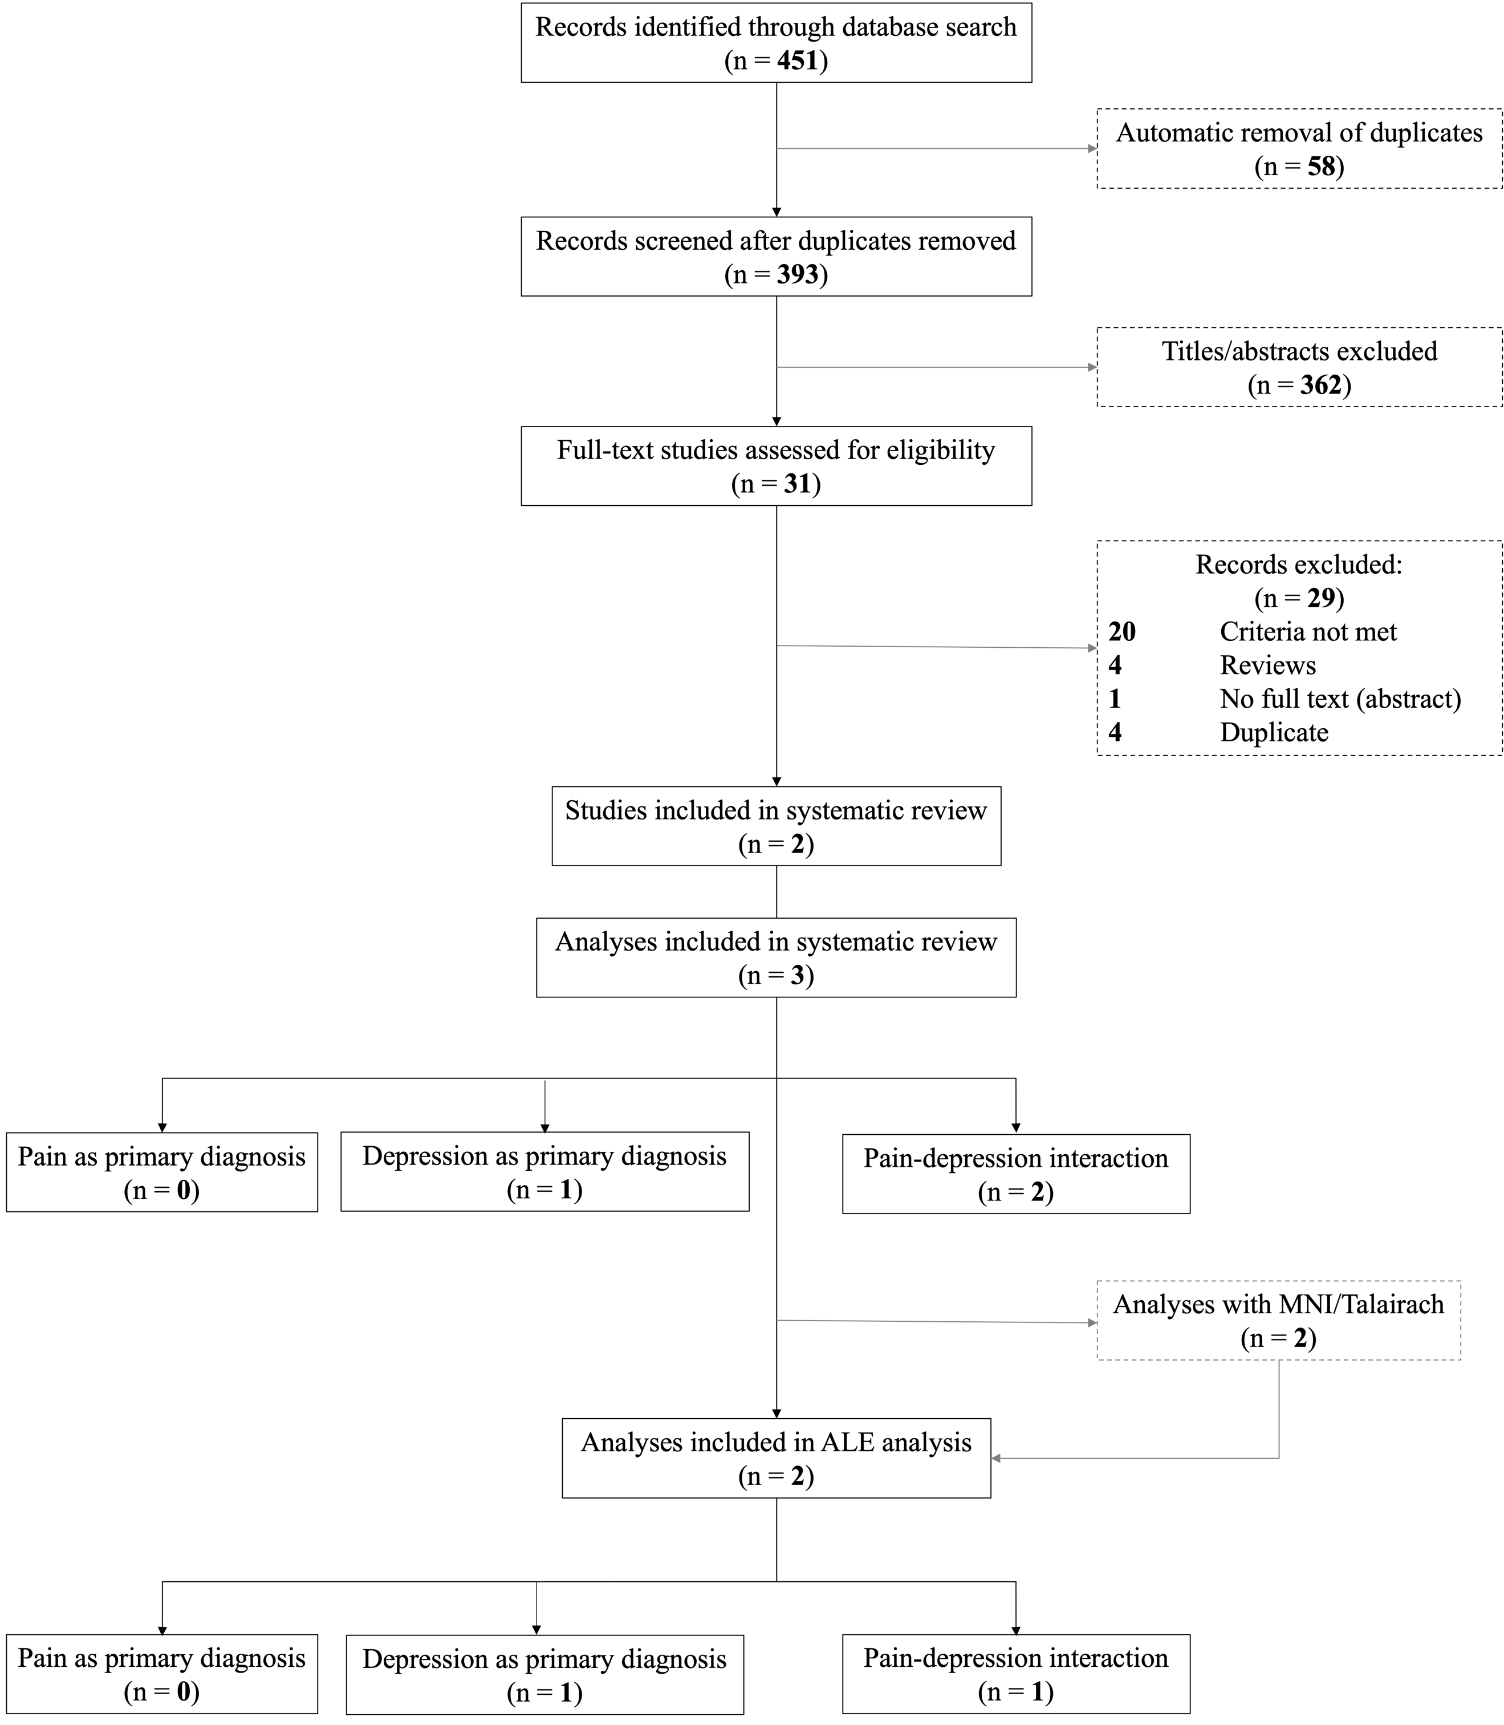

Coordinates for the Primary Pain contrast

// Reference=MNI
// Albrecht 2019
// Subjects=25
2 40 -2
-10 36 22
24 22 50

// As-Sanie 2016
// Subjects=14
34 19 0
0 46 22

// Cifre 2012
// Subjects=20
20 -18 12
6 -32 -10
-2 8 30
-6 -32 -10

// Feliu-Soler 2020
// Subjects=47
11 -2 -12
-8 0 -11

// Giesecke 2005
// Subjects=30
-20.39 0.01 -17.22
20.23 0.43 -15.49
35.38 4.69 10.75

// Gustin 2013
// Subjects=42
-14 -18 -4
6 -6 0
6 38 2
-42 22 22
10 -36 30
-26 -42 0
26 -40 -6
-12 -4 8
6 -4 0
-48 24 38
0 -42 28
-28 28 12
-38 -36 -10
36 -42 -2

// Ikeda 2018
// Subjects=23
32 10 -18
-12 12 -12

// Jensen 2013
// Subjects=26
18 -72 5
38 -62 -18
34 -46 -14
24 -86 17
17 -26 39
-39 -70 44
-25 -2 45
-18 -77 30
-37 -29 -25
-54 -51 27
21 15 0

// Khan 2014
// Subjects=18
-9 57 3
35 3 -24
20 -2 -21

// Klega 2010
// Subjects=10
-52 -22 2

// Li J 2020
// Subjects=49
-33 42 22.15
-30 28.5 -9
30 51 -7.5
-25.5 57 -6
37.5 60 4.5
-33 6 15

// Li J 2020
// Subjects=64
-28.5 28.5 -12

// Ma 2018
// Subjects=32
12 -12 6
27 -3 -42

// Rosenberger 2013
// Subjects=15
20 -40 -28
14 -34 -14
8 -62 -16
26 -56 -34
38 -48 -40
-2 -82 -44
46 -52 -56
36 -60 -62

// Schweinhardt 2008
// Subjects=20
-4 66 8

// Seifert 2011
// Subjects=13
-35.25 16.35 2.77

// Vachon-Presseau 2016
// Subjects=39
-23 -5 -18
23 -5 -18
-10 12 -7
10 12 -7
-7 66 4
8 66 5

// Wagner 2009
// Subjects=32
24.66 -16.58 -1.85
-24.52 -20.48 -6.53

// Wang 2017
// Subjects=38
39 -1 15
-6 50 9

// Zhang 2018
// Subjects=29
18 4.5 -22
36 54 0

Coordinates for the Primary Depression contrast

// Reference=MNI
// Bar 2007
// Subjects=26
-15.87 -9.45 11.4

// Berna 2010
// Subjects=40
-30 -58 48
-6 -46 44
36 -40 38
-62 -44 30
-56 14 6
-20 -64 64
-24 22 44
-2 6 -6
-45 40 -14
-56 -56 -10
-56 -62 -26
-36 -26 8
-20 -36 -2
-16 -12 8
-12 10 6
-32 -76 28
-38 -32 34
-68 -36 -4
-66 -42 -6
52 -12 36
2 -48 44
-56 -18 32

// Malejko 2020
// Subjects=22
40 -24 54

// Strigo 2008
// Subjects=30
30.77 -2.11 -35.47
-41.76 -11.03 -20.51
-53.39 -53.74 -21.25
5.22 41.55 -5.38
12.79 45.79 7.56
36.69 17.04 46.5
-45.6 12.14 45.62
-49.24 38.3 -1.14
-17.83 31.86 50.34
-22.12 24 45.47
-56.47 -43.67 -.87
-34.65 -69.73 45.67
-48.66 -50.06 39.72
11.8 -35.75 -14.59
13.85 -40.99 -27.55

Additional search studies:

//Hou 2021: activation during pain stimulation DEP vs. HC
// Subjects=44
-64 -6 12
39 0 -45
52 -8 -4

//Hou 2021: activation during pain stimulation DEP+P vs. DEP
// Subjects=36
-56 -22 42
-39 -63 -15
-52 -12 -10

