Meta-Analyses: Appendix
Formulas
- Obtain standard deviation from standard error:
$$Standard deviation=Standard error* \sqrt{N}$$
$$N=sample size$$
- Relationship between variance and standard deviation:
$$Variance={\left(Standard deviation\right)}^{2}$$
- Pooled mean from multiple means (1 to k):
$$Pooled mean=\frac{\sum_{i=1}^{k}{(n_{i}*mean_{i})}}{\sum_{i=1}^{k}{(n_{i})}}$$

$$n_{i}=sample size of the sample from which mean_{i} is calculated \\ k=amount of mean values$$

- Pooled variance from multiple variances (1 to k):

$$Pooled variance= \frac{\sum_{i=1}^{k}{\left(n_{i}-1\right)*variance_{i}}}{\sum_{i=1}^{k}{\left(n_{i}-1\right)}}$$
$$n_{i}=sample size of the sample from which mean_{i} is calculated \\ k=amount of variances$$

Formula 4 is taken from:
Hedges, L. V. (1981). Distribution theory for Glass's estimator of effect size and related estimators. journal of Educational Statistics, 6(2), 107-128.
Articles for the frontal alpha asymmetry meta-analysis
- Peterson (2011): Asymmetric frontal cortical activity and negative affective responses to ostracism.
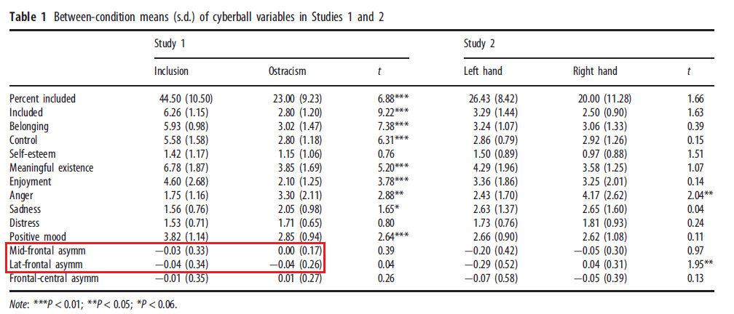
Mid-frontal asymm = F3/F4 electrode pair
Lat-frontal asymm = F7/F8 electrode pair
- Kawamoto (2013): Cognitive, affective, and motivational changes during ostracism: an ERP, EMG, and EEG study using a computerized cyberball task
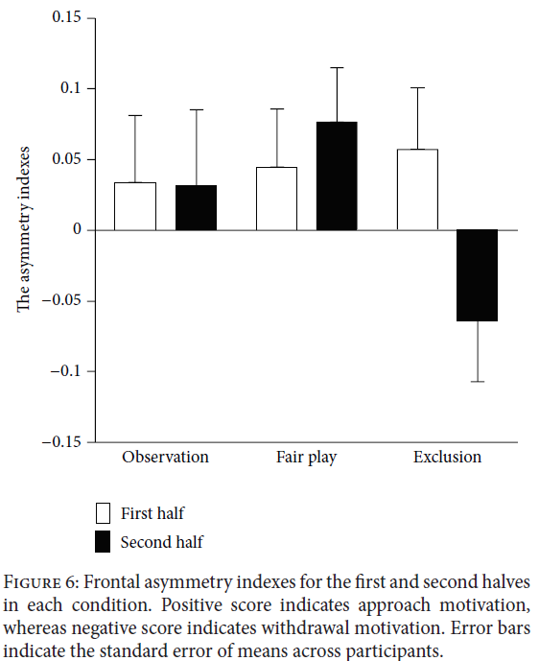
Fair play:
First half = 0.0452 ± 0.1652
Second half = 0.0774 ± 0.1783
Pooled: 0.0613 ± 0.1719 (formula 3 & 4)

Exclusion:
First half = 0.0577 ± 0.19
Second half = -0.0645 ± 0.1844
Pooled: -0.0034 ± 0.1872 (formula 3 & 4)

- Brouwer (2011): EEG alpha asymmetry, heart rate variability and cortisol in response to virtual reality induced stress
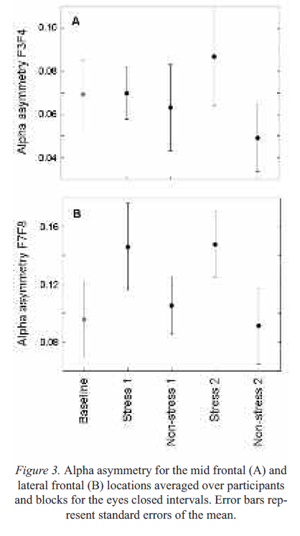
Control 1:
F3/F4: 0.063 ± 0.0597
F7/F8: 0.1053 ± 0.0567
Stress 1:
F3/F4: 0.0699 ± 0.0363
F7/F8: 0.1453 ± 0.0918

- Wang (2015): Reappraisal writing relieves social anxiety and may be accompanied by changes in frontal alpha asymmetry
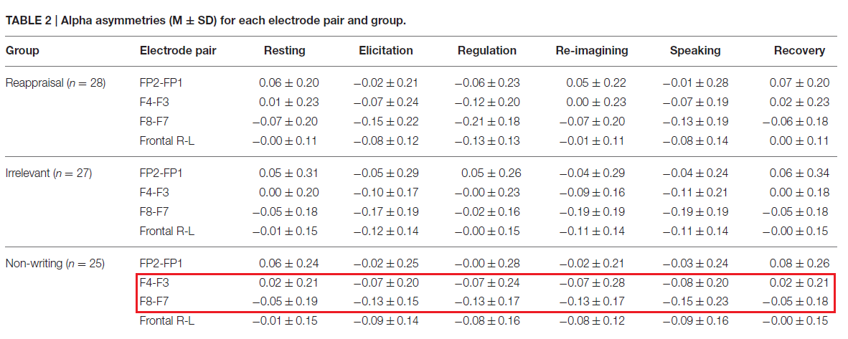
- Pérez-Edgar (2013): The relation between electroencephalogram asymmetry and attention biases to threat at baseline and under stress
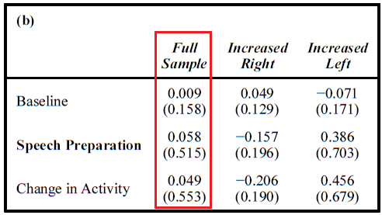
Extracted from Table 1, standard deviations given
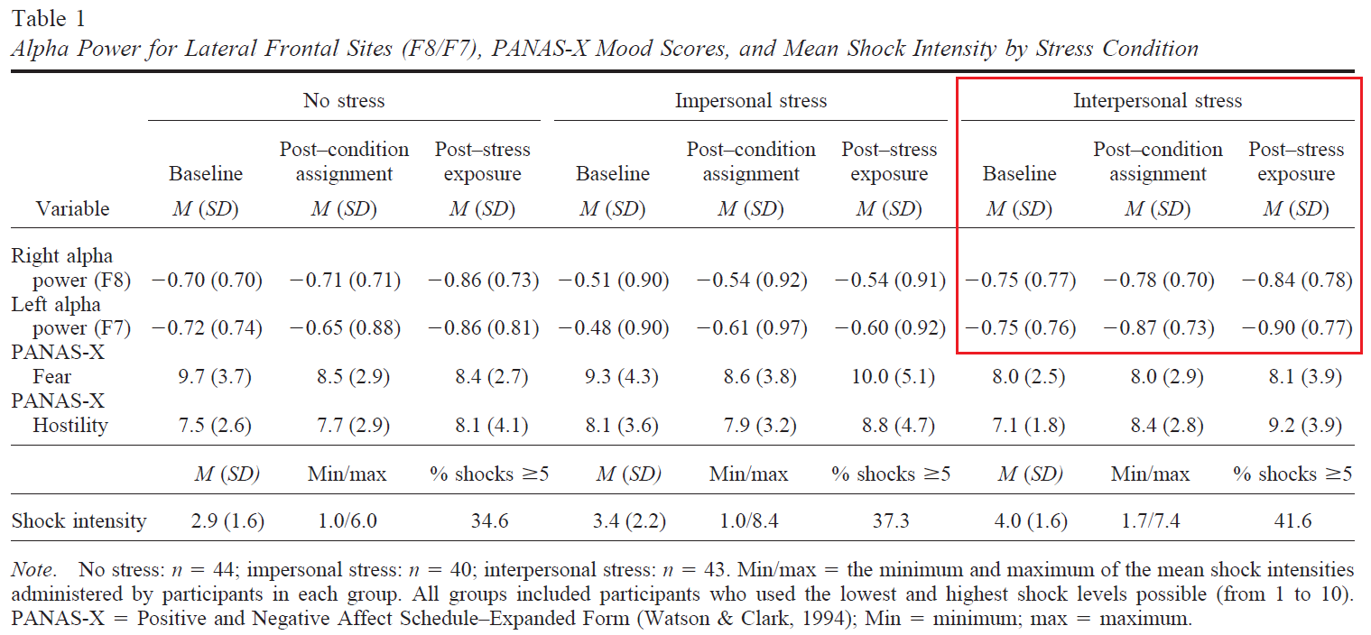
- Verona (2009): Stress-induced asymmetric frontal brain activity and aggression risk

Calculate frontal alpha asymmetry from power values of F7 & F8
Baseline: FAA = 0 ± 0.77
Post-Stress exposure: 0.06 ± 0.78
- Quaedflied (2015): The functional role of individual-alpha based frontal asymmetry in stress responding
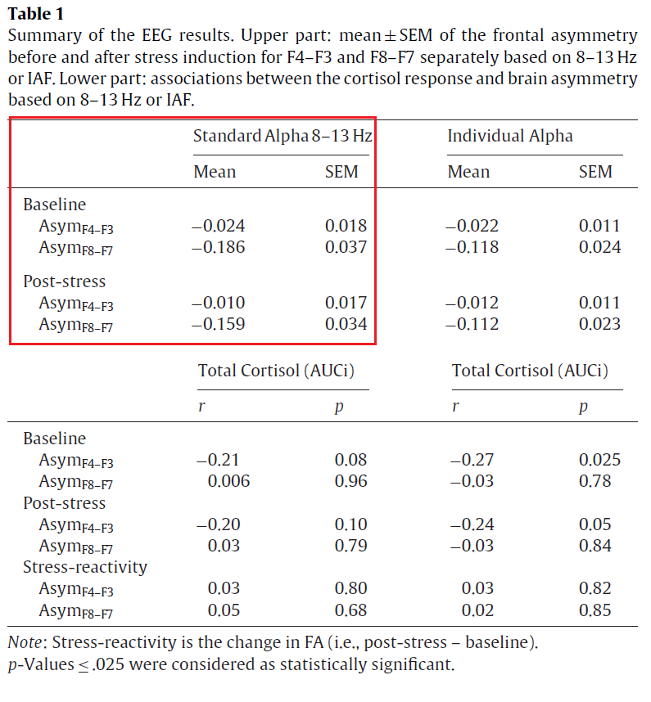
Standard error converted to standard deviation using formula 1 (N = 70)

- Hoffman(2005): The worried mind: autonomic and prefrontal activation during worrying
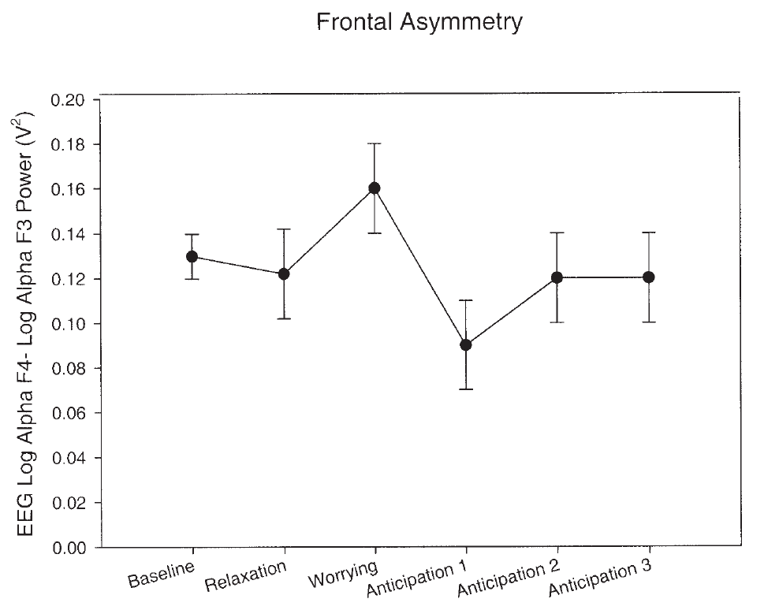
Baseline: 0.1298 ± 0.051
Anticipation 1: 0.0902 ± 0.1018
Anticipation 2: 0.1201 ± 0.1055
Anticipation 3: 0.12 ± 0.1055
Pooled anticipation: 0.1101 ± 0.1043 (formula 3 & 4)
- Al-Shargie (2017): Towards multilevel mental stress assessment using SVM with ECOC: an EEG approach
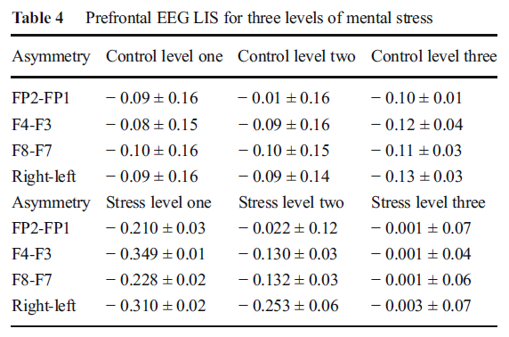
It is assumed that standard deviations are given. should also be mentioned that this article uses LIS (= Lateral Index at Stress (normalized version of FAA))
Step 1: pool over the three levels (N = 18, stds already calculated using formula 1)
Control F3/F4:
Level 1: -0.08 ± 0.15
Level 2: -0.09 ± 0.16
Level 3: -0.12 ± 0.04
Pooled: -0.0967 ± 0.1287
Control F7/F8:
Level 1: -0.1 ± 0.16
Level 2: -0.1 ± 0.15
Level 3: -0.11 ± 0.03
Pooled: -0.1033 ± 0.1278
Stress F3/F4:
Level 1: -0.349 ± 0.01
Level 2: -0.13 ± 0.03
Level 3:-0.001 ± 0.04
Pooled: -0.16 ± 0.0294
Stress F7/F8:
Level 1: -0.228 ± 0.02
Level 2: -0.132 ± 0.03
Level 3: -0.001 ± 0.06
Pooled: -0.1203 ± 0.0404
- Düsing (2016): Relative frontal brain asymmetry and cortisol release after social stress: the role of action orientation
The results were sent to us by the authors.
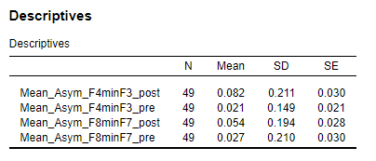

Articles for the alpha power meta-analysis

- Al-Shargie (2017): Assessment of mental stress effects on prefrontal cortical activities using canonical correlation analysis: an fNIRS-EEG study
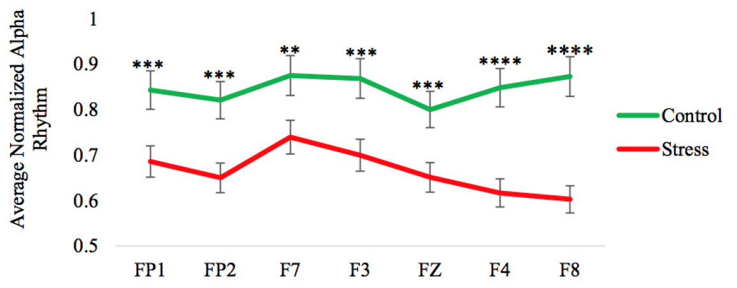
It is assumed that the bars on the figure represent standard errors. These are converted to standard deviation using formula 1 (N = 25). An overall frontal alpha power is calculated.
 | Control | Stress
FP1 | 0.8446 ± 0.2040 | 0.6869 ± 0.1755
FP2 | 0.8236 ± 0.1865 | 0.6519 ± 0.1635
F7 | 0.8750 ± 0.2160 | 0.7395 ± 0.1870
F3 | 0.8680 ± 0.2160 | 0.6998 ± 0.1810
FZ | 0.8026 ± 0.1925 | 0.6542 ± 0.1520
F4 | 0.8493 ± 0.2045 | 0.6192 ± 0.1575
F8 | 0.8727 ± 0.2105 | 0.6051 ± 0.1460
Pooled (formula 3 & 4) | 0.8480 ± 0.2046 | 0.6652 ± 0.1667

- Betti (2016): Evaluation of an integrated system of wearable physiological sensors for stress monitoring in working environments by using biological markers
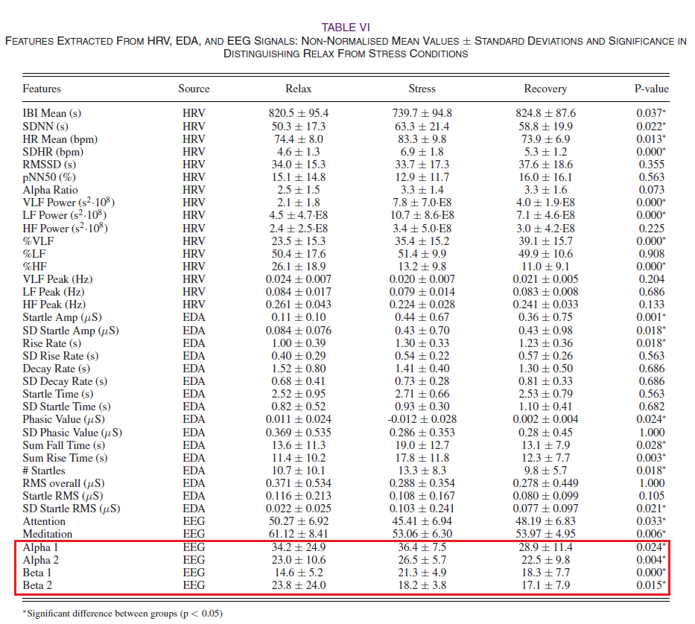
Data is pooled to obtain an average value for the alpha frequency band. Since alpha 1 is defined as 8-9Hz and alpha 2 is defined as 10-12Hz; formula 3 & 4 are used with n_{alpha1} = 2 & n_{alpha2} = 3.
 | Relax | Stress | Recovery
Alpha 1 | 34.2 ± 24.9 | 36.4 ± 7.5 | 28.9 ± 11.4
Alpha 2 | 23.0 ± 10.6 | 26.5 ± 5.7 | 22.5 ± 9.8
Pooled | 27.48 ± 16.78 | 30.46 ± 6.36 | 25.06 ± 10.361

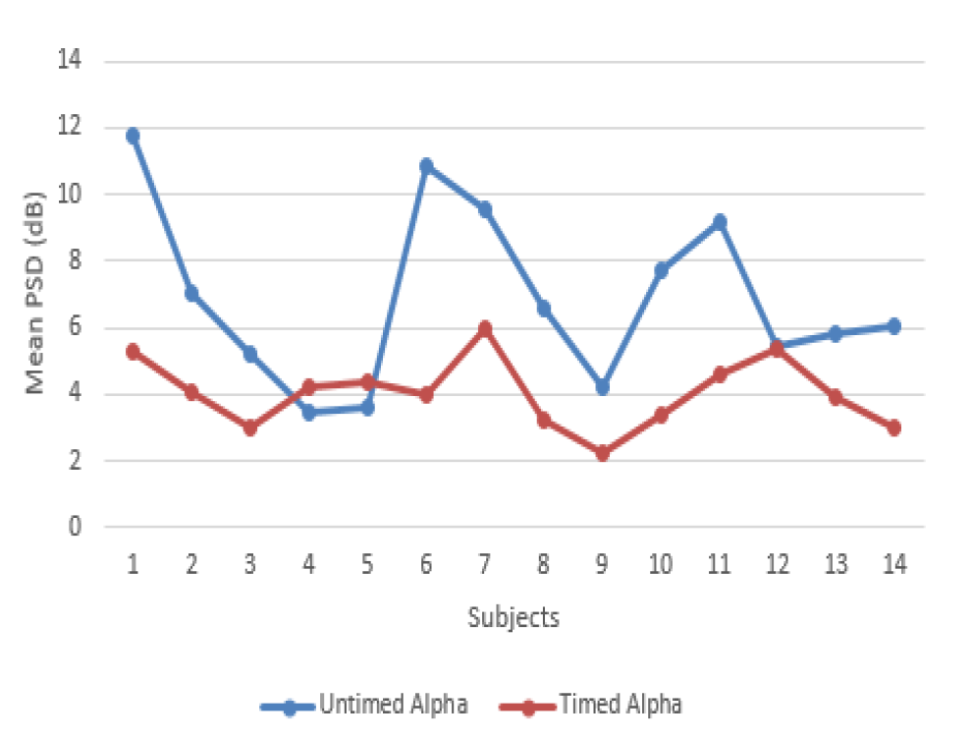
- Hafeez (2018): Stress effects on exam performance using EEG

 | Untimed Alpha | Timed Alpha
Subject 1 | 11.77 | 5.3084
Subject 2 | 7.014 | 4.0707
Subject 3 | 5.266 | 2.998
Subject 4 | 3.438 | 4.2083
Subject 5 | 3.603 | 4.3733
Subject 6 | 10.892 | 4.0157
Subject 7 | 9.572 | 5.9961
Subject 8 | 6.574 | 3.2456
Subject 9 | 4.208 | 2.2279
Subject 10 | 7.729 | 3.3831
Subject 11 | 9.187 | 4.5933
Subject 12 | 5.446 | 5.3910
Subject 13 | 5.804 | 3.9332
Subject 14 | 6.051 | 2.9980
Pooled | 6.8939 ± 2.628 | 4.053 ± 1.0464

- Guo (2020): Stress recovery of campus street trees as visual stimuli on graduate students in autumn
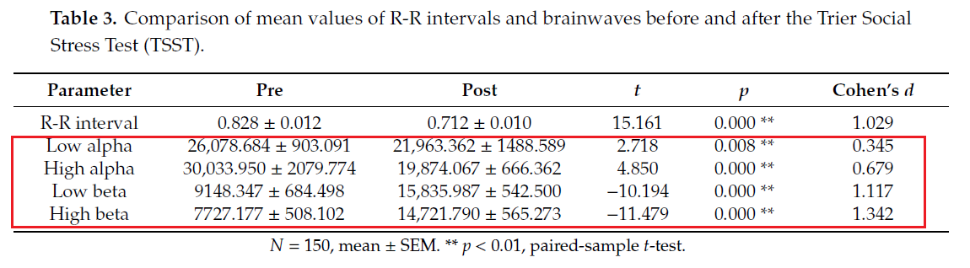
Standard errors are converted to standard deviation using formula 1 (N = 150). Data is pooled to obtain an average value for the alpha frequency band. Since low alpha is defined as 8-10Hz and high alpha is defined as 10-12Hz, formula 3 & 4 are used with n_{LowAlpha} = n_{HighAlpha} = 2.
 | Pre | Post
Low alpha | 26078.684 ± 11060 | 21963.362 ± 18231
High alpha | 30033.95 ± 25471 | 19874.067 ± 8161
Pooled | 28056 ± 19636 | 20919 ± 14124

- Hoffman (2006): The emotional consequences of social pragmatism: the psychophysiological correlated with self-monitoring
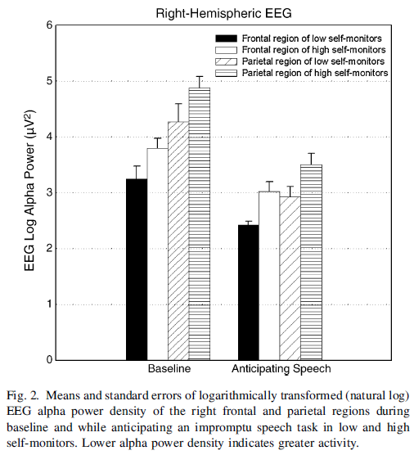
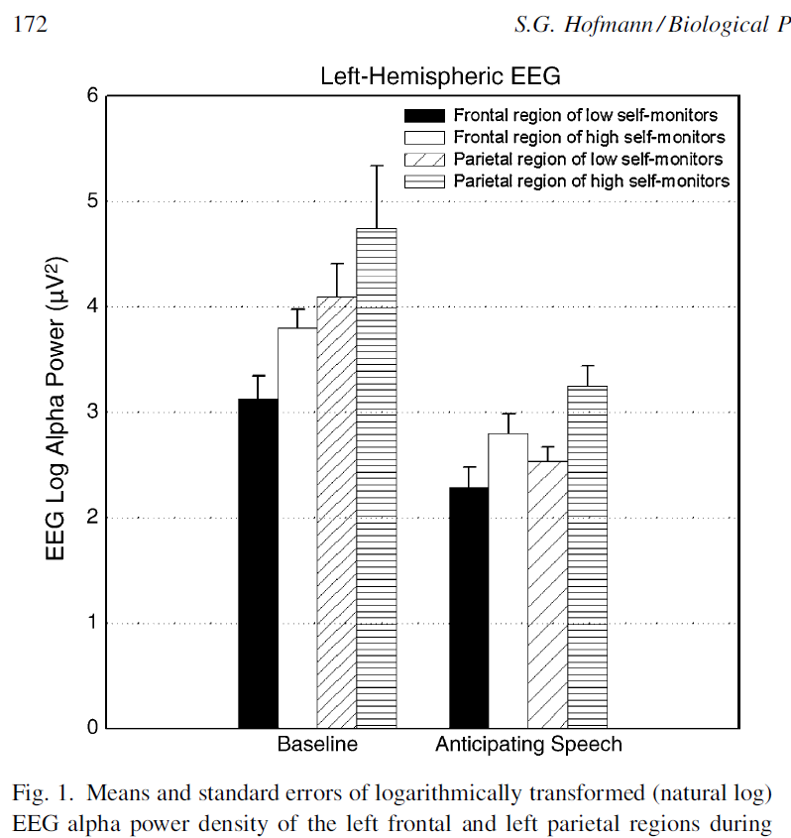

The first step that is conducted is merging the data from the low- and high self-monitors (n = 10 for both groups, using formula 3 & 4). Standard errors are converted to standard deviations using formula 1.
Left-hemispheric EEG | Baseline | Anticipation
Frontal region of low self-monitors | 3.1263 ± 0.6761 | 2.303 ± 0.5805
Frontal regions of high self-monitors | 3.7984 ± 0.5805 | 2.8135 ± 0.5805
Pooled | 3.4624 ± 0.6301 | 2.5583 ± 0.5805

Right-hemispheric EEG | Baseline | Anticipation
Frontal region of low self-monitors | 3.2583 ± 0.7596 | 2.4339 ± 0.197
Frontal regions of high self-monitors | 3.8016 ± 0.5344 | 3.0217 ± 0.5626
Pooled | 3.5299 ± 0.6567 | 2.7278 ± 0.4215

The second step that is conducted is merging the pooled data from the left- and rtight-hemispheric EEG data (n = 20 for both groups, using formula 3 & 4).
 | Baseline | Anticipation
Left-hemispheric EEG | 3.4624 ± 0.6301 | 2.5583 ± 0.5805
Right-hemispheric EEG | 3.5299 ± 0.6567 | 2.7278 ± 0.4215
Pooled | 3.4962 ± 0.6435 | 2.6430 ± 0.5073

- Ehrhardt (2021): Separating EEG correlates of stress: cognitive effort, time pressure, and social-evaluative threat
Data was provided by the author of the paper (N. A. Ehrhardt). The condition “PASAT + Time” is chosen as the Control condition, “PASAT + Time + Social” is chosen as the Reactive condition.
Condition | Log alpha power (mean + SD)
Resting | 1.71 ± 0.89
PASAT | 0.82 ± 0.65
PASAT + Time | 0.85 ± 0.65
PASAT + Time + Social | 0.74 ± 0.68

- Hoffman (2005): The worried mind: autonomic and prefrontal activation during worrying
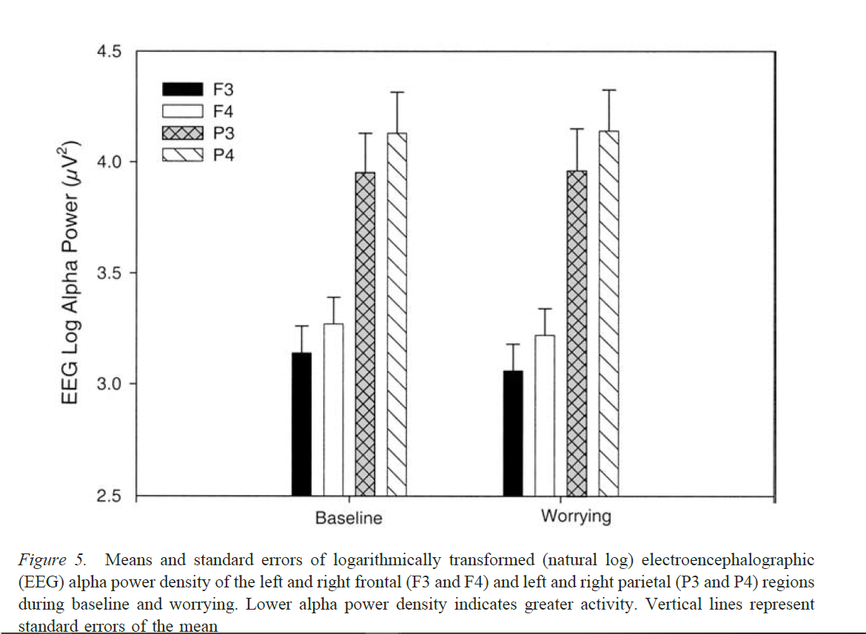
The data is pooled (formula 3 & 4, n = 27) by combining electrode F3 & F4.
 | Baseline | Worrying
F3 | 3.1462 ± 0.6221 | 3.0640 ± 0.6220
F4 | 3.2733 ± 0.6221 | 3.2228 ± 0.6221
Pooled | 3.2097 ± 0.6221 | 3.1434 ± 0.6221

Articles for the beta power meta-analysis
- Izhar (2019): Classification of neuroticism using psychophysiological signals during speaking task based on two dfferent baseline measurements
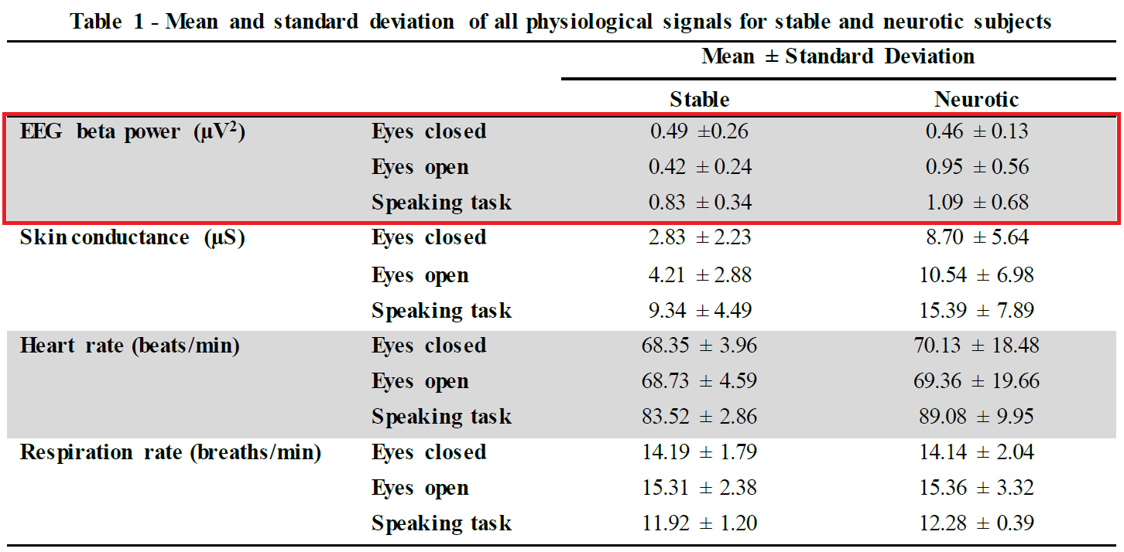
In order to obtain the best estimate of difference between baseline and the reactive phase, Eyes open is selected.
Stable & Neurotic data are pooled using formula 3 & 4 (n_{stable} = n _{neurotic} = 4)
 | Eyes open | Speaking task
Stable | 0.42 ± 0.24 | 0.83 ± 0.34
Neurotic | 0.95 ± 0.56 | 1.09 ± 0.68
Pooled | 0.6850 ± 0.4308 | 0.96 ± 0.5376

- Betti(2017): Evaluation of an integrated system of wearable physiological sensors for stress monitoring in working environments by using biological markers
Beta 1 and Beta 2 are pooled together using formula 3 & 4. Since Beta 1 is defined as 13 – 17 Hz and Beta 2 is defined as 18 – 30 Hz, n_{Beta1} = 5 and n_{Beta2} = 13 are chosen for pooling the data.
 | Relax | Stress | Recovery
Beta 1 | 14.6 ± 5.2 | 21.3 ± 4.9 | 18.3 ± 7.7
Beta 2 | 23.8 ± 24.0 | 18.2 ± 3.8 | 17.1 ± 7.9
Pooled | 21.24 ± 20.947 | 19.061 ± 4.1027 | 17.433 ± 7.8505

- Hafeez (2018): 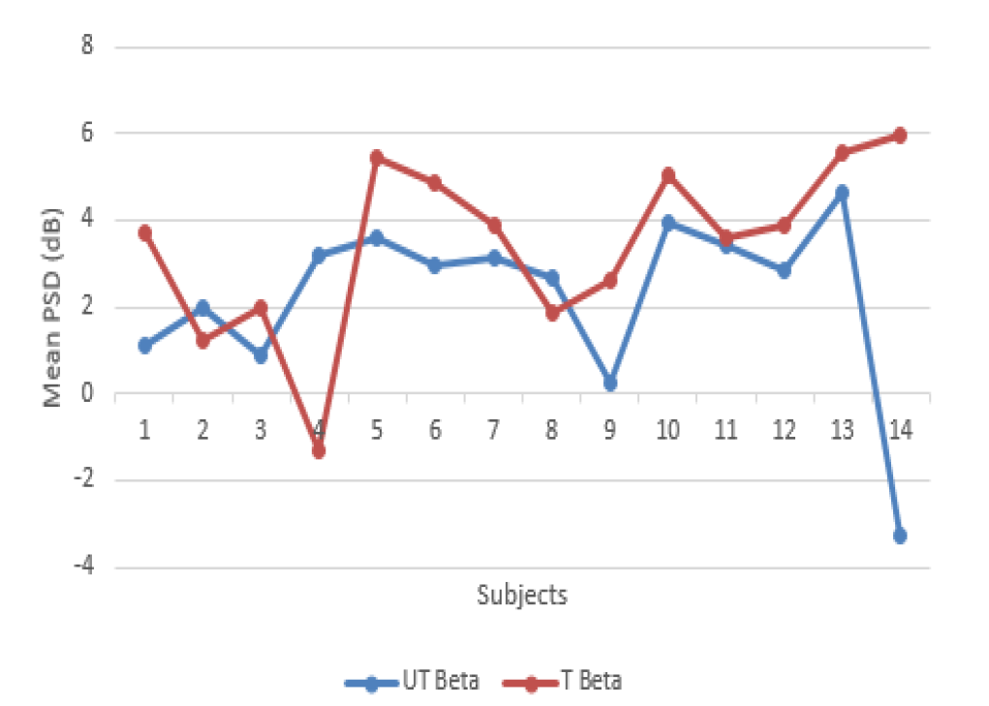
 | Untimed Beta | Timed Beta
Subject 1 | 1.1458 | 3.75
Subject 2 | 2.0208 | 1.25
Subject 3 | 0.9375 | 2.0208
Subject 4 | 3.2292 | -1.25
Subject 5 | 3.6250 | 5.4792
Subject 6 | 2.9792 | 4.875
Subject 7 | 3.1667 | 3.9167
Subject 8 | 2.6667 | 1.8958
Subject 9 | 0.2708 | 2.6250
Subject 10 | 3.9583 | 5.0833
Subject 11 | 3.4375 | 3.6458
Subject 12 | 2.8750 | 3.9167
Subject 13 | 4.6667 | 5.5833
Subject 14 | -3.2292 | 6
Pooled | 2.2679 ± 1.9978 | 3.4851 ± 2.0093

- Guo (2020): Stress recovery of campus street trees as visual stimuli on graduate students in autumn
Standard errors are converted to standard deviation using formula 1 (N = 150). Data is pooled to obtain an average value for the beta frequency band. Since low beta is defined as 12-20Hz and high beta is defined as 20-30Hz, formula 3 & 4 are used with n_{LowBeta} = 9 and n_{HighBeta} = 11.
 | Pre | Post
Low Beta | 9148.347 ± 8383.35 | 15835.987 ± 6644.24
High Beta | 7727.177 ± 6222.95 | 14721.79 ± 6923.15
Pooled | 8437.762 ± 7303.15 | 15278.889 ± 6783.695

- Perrin (2019): Waking qEEG to assess psychophysiological stress and alertness during simulated on-call conditions
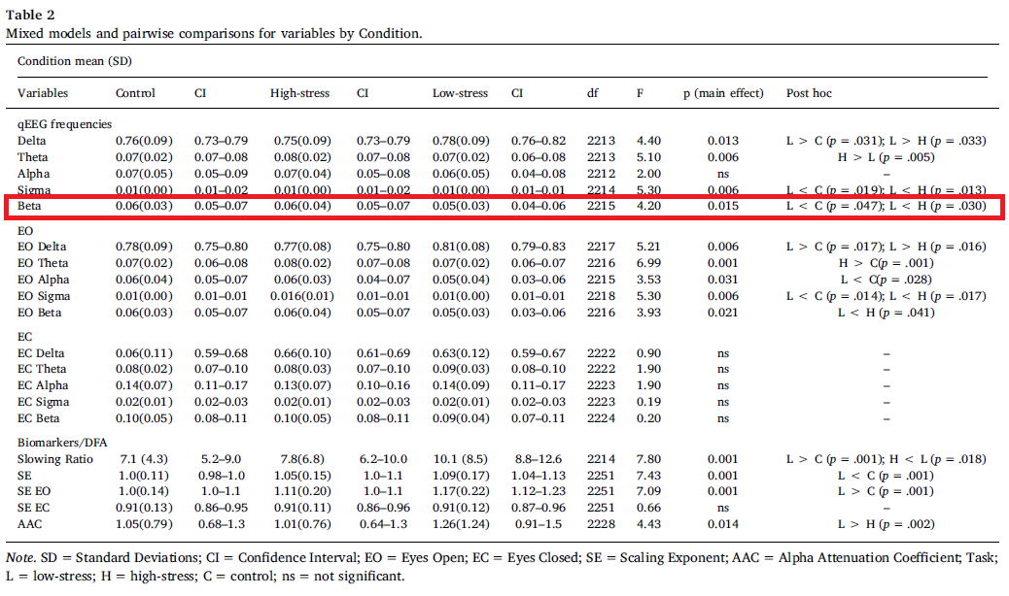

- Ehrhardt (2021): Separating EEG correlates of stress: cognitive, effort, time pressure, and social evaluative threat
Data was provided by the author of the paper (N. A. Ehrhardt). The condition “PASAT + Time” is chosen as the Control condition, “PASAT + Time + Social” is chosen as the Reactive condition.
Condition | Log beta power (mean + SD)
Resting | -0.23 ± 0.57
PASAT | 0.24 ± 0.62
PASAT + Time | 0.43 ± 0.75
PASAT + Time + Social | 0.28 ± 0.70

