Figure (Extra). Forest plot illustrating the standardized mean differences (SMD), individual effect sizes, overall effect size and heterogeneity statistics for the meta-analysis examining changes in alpha power from a control (non-stressed) condition to a stress condition, without the articles that employ the Montreal Imaging Stress Task (MIST). Hofmann 2005 and Hofmann 2006 report a baseline - anticipatory phase comparison; Al-Shargie 2017, Hafeez 2018 and Ehrhardt 2021 report a control condition - reactive phase comparison; Betti 2017 and Guo 2019 report a baseline - recovery phase comparison.
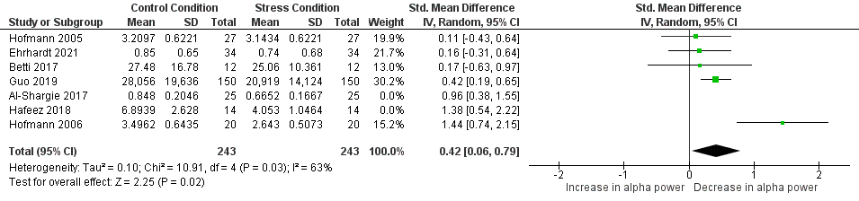
Figure (Extra).

