Meta-Analysis – Publication Bias analysis
Document detailing the results and analysis steps taken for the publication bias analysis. Funnel plots and Egger’s test results (Egger et al., 1997) have been obtained using the R software language. The following R packages have been used to obtain the results: meta, dmetar.
The code for each publication bias analysis can be found on the following GitHub page: https://github.com/dx2r/Systematic-Review-and-Meta-Analysis-Psychosocial-stress-EEG-.git
It should be noted that the Egger’s test might not have sufficient power to detect publication bias due to the relative small amount of studies in each meta-analysis (Sterne et al., 2011).

Reference for the Egger’s test:
Egger, M., Smith, G. D., Schneider, M., & Minder, C. (1997). Bias in meta-analysis detected by a simple, graphical test. Bmj, 315(7109), 629-634.
Reference for the Egger’s test power:
Sterne, J. A., Sutton, A. J., Ioannidis, J. P., Terrin, N., Jones, D. R., Lau, J., ... & Higgins, J. P. (2011). Recommendations for examining and interpreting funnel plot asymmetry in meta-analyses of randomised controlled trials. Bmj, 343.

Alpha power meta-analysis
Funnel plot:
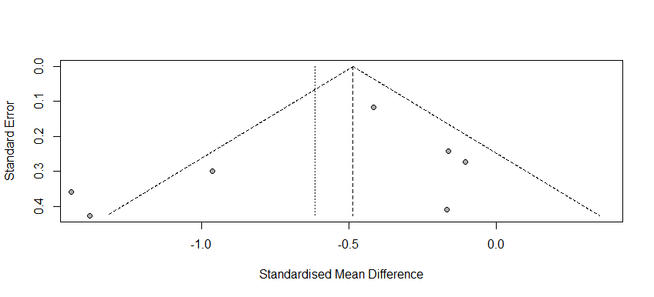
Corresponding Egger’s test results:
Intercept: -1.53841
Lower bound (95% confidence): -4.373
Upper bound (95% cconfidence): 1.296
t-value: -1.0639
p-value: 0.336
Conclusion:
The results of the Egger’s test show no indication of a publication bias. In addition, no apparent funnel plot asymmetry is present.

Beta power meta-analysis
Funnel plot:
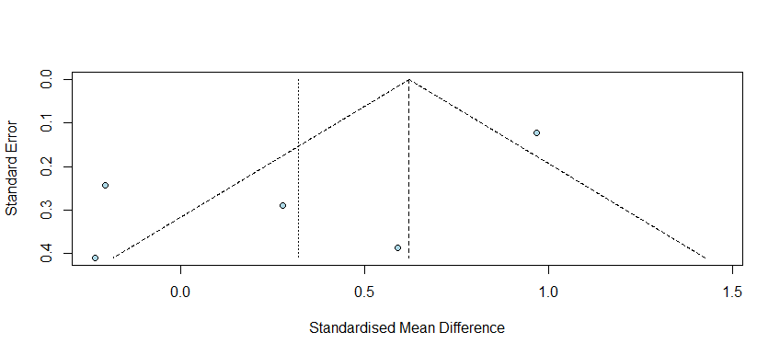
Corresponding Egger’s test results:
Intercept: -3.801
Lower bound (95% confidence): -7.44
Upper bound (95% cconfidence): -0.17
t-value: -2.049
p-value: 0.13
Conclusion:
The results of the Egger’s test indicate that no significant publication bias is present. However, the funnel plot shows that four articles lie on the left side of the plot, indicating funnel plot asymmetry. Therefore, it can be concluded that some publication bias is present for the beta power analysis.

Frontal alpha asymmetry (F3-F4) meta-analysis
Funnel plot:
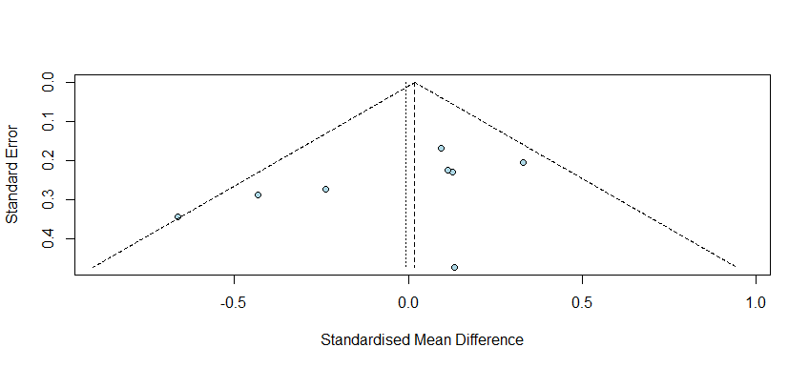
Corresponding Egger’s test results:
Intercept: -2.345
Lower bound (95% confidence): -5.14
Upper bound (95% cconfidence): -0.45
t-value: -1.642
p-value: 0.15
Conclusion:
The results of the Egger’s test show no indication of a publication bias. In addition, no apparent funnel plot asymmetry is present.

Frontal alpha asymmetry (F7-F8) meta-analysis
Funnel plot:
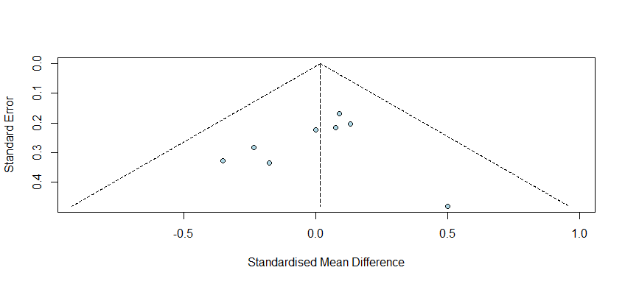
Corresponding Egger’s test results:
Intercept: -0.637
Lower bound (95% confidence): -2.56
Upper bound (95% cconfidence): -1.29
t-value: -0.649
p-value: 0.54
Conclusion:
The results of the Egger’s test show no indication of a publication bias. In addition, no apparent funnel plot asymmetry is present.

