SUPPLEMENTARY DATA
Table S1. Search strategy (at January 09, 2021).
PubMed (1152 hits)
(clopidogrel[tiab] OR prasugrel[tiab] OR ticagrelor[tiab] OR P2Y12[tiab]) AND (“unstable angina”[tiab] OR “non-ST-segment elevation”[tiab] OR “non-ST elevation”[tiab] OR “acute coronary syndrome”[tiab] OR “acute coronary syndromes”[tiab]) AND (random*[tiab] OR placebo[tiab] OR “clinical trial”[tiab])
EMBASE (1743 hits)
('clopidogrel':ti,ab OR 'prasugrel':ti,ab OR 'ticagrelor':ti,ab OR 'p2y12':ti,ab) AND ('unstable angina':ti,ab OR 'non-st-segment elevation':ti,ab OR 'non-st elevation':ti,ab OR 'acute coronary syndrome':ti,ab OR 'acute coronary syndromes':ti,ab) AND ('random*':ti,ab OR 'placebo':ti,ab OR 'clinical trial':ti,ab)
Scopus (1364 hits)
TITLE-ABS ((“clopidogrel” OR “prasugrel” OR “ticagrelor” OR “P2Y12”) AND (“unstable angina” OR “non-ST-segment elevation” OR “non-ST elevation” OR “acute coronary syndrome” OR “acute coronary syndromes”) AND (“random*” OR “placebo” OR “clinical trial”))
Web of Science (957 hits)
TI=((“clopidogrel” OR “prasugrel” OR “ticagrelor” OR “P2Y12”) AND (“unstable angina” OR “non-ST-segment elevation” OR “non-ST elevation” OR “acute coronary syndrome” OR “acute coronary syndromes”) AND (“random*” OR “placebo” OR “clinical trial”)) OR AB=((“clopidogrel” OR “prasugrel” OR “ticagrelor” OR “P2Y12”) AND (“unstable angina” OR “non-ST-segment elevation” OR “non-ST elevation” OR “acute coronary syndrome” OR “acute coronary syndromes”) AND (“random*” OR “placebo” OR “clinical trial”))
CENTRAL (1459 hits)
(clopidogrel OR prasugrel OR ticagrelor OR P2Y12) AND (“unstable angina” OR “non-ST-segment elevation” OR “non-ST elevation” OR “acute coronary syndrome” OR “acute coronary syndromes”) in Title and Abstract
Table S2. Definitions of MACE and bleeding
Study | Efficacy endpoint | Key safety endpoint
Study | MACE | Bleeding
Bonello, 2015 | Cardiovascular death, myocardial infarction, urgent revascularization, or stroke | BARC >2
De Servi, 2014 | Death from cardiovascular causes, nonfatal myocardial infarction, or nonfatal stroke | Non-CABG TIMI major bleeding
Montalescot, 2013 | Death from cardiovascular causes, myocardial infarction, stroke, urgent revascularization, or glycoprotein IIb/IIIa bailout | All CABG-related or non–CABG-related TIMI major bleeding
Gimbel, 2020 | Cardiovascular death, myocardial infarction, stroke, PLATO major or minor bleeding | PLATO major or minor bleeding
Lindholm, 2014 | Cardiovascular death, myocardial infarction (excluding silent infarctions), or stroke | PLATO major bleeding
Valina, 2020 | Death, myocardial infarction, or stroke | BARC 3, 4, or 5
Tarantini, 2020 | Death from vascular causes (cardiovascular or cerebrovascular death, any death without another known cause), non-fatal myocardial infarction, non-fatal stroke, major or fatal bleeding (BARC 3, 4, or 5) | BARC 3, 4, or 5
Savonitto, 2018 | All-cause mortality, myocardial infarction, disabling stroke, and rehospitalization for cardiovascular causes or bleeding within 1 year | -
Roe, 2012 | Cardiovascular death, myocardial infarction or stroke | TIMI major bleeding not related to CABG
MACE, major adverse cardiovascular events; BARC, bleeding academic research consortium; CABG, coronary artery bypass grafting; TIMI, thrombolysis in myocardial infarction; PLATO, platelet inhibition and patient outcomes; GUSTO, global use of strategies to open occluded arteries.

Table S3. Demographic and clinical characteristics of included patients.
Study | Arms | Timing | Dosage | Age, years | Male | HTN | DM | Previous MI | Previous PCI | Previous CABG | Type of  NSTE-ACS
Bonello,  2015 | Ticagrelor | Early | 180 mg LD, then 90 mg BID | 61.5±10.4 | 70% | 53% | 29% | 11% | 12% | 3% | Unstable angina (46%), NSTEMI (54%)
Bonello,  2015 | Prasugrel | Delayed | 60 mg LD, then 10mg QD | 60 ± 9.6 | 80% | 58% | 41% | 12% | 12% | 3% | Unstable angina (54%), NSTEMI (46%)
De Servi,  2014 | Prasugrel | Delayed | 60 mg LD, then 10mg QD | 61.5±11.2 | 74% | 69% | 25% | 21% | 16% | 10% | Unstable angina (25%), NSTEMI (75%)
De Servi,  2014 | Clopidogrel | Delayed | 300 mg LD, then 75 mg QD | 61.3±11.3 | 72% | 69% | 24% | 20% | 16% | 9% | Unstable angina (25%), NSTEMI (75%)
Montalescot, 2013 | Prasugrel | Early | 30 mg LD, then 10 mg QD (5 mg in ≥75 years or body weight <60 kg) | 63.8 | 73% | 63% | 20% | 14% | 16% | 5% | NSTEMI (100%)
Montalescot, 2013 | Prasugrel | Delayed | 60 mg LD, then 10 mg QD (5 mg in ≥75 years or body weight <60 kg) | 63.6 | 72% | 61% | 20% | 15% | 17% | 5% | NSTEMI (100%)
Gimbel,  2020 | Ticagrelor | Early | 180 mg LD, then 90 mg BID | 77 (73-82) | 65% | 73% | 30% | 27% | 24% | 17% | Unstable angina (11%), NSTEMI (86%), other (4%)
Gimbel,  2020 | Clopidogrel | Early | 300-600 mg LD, then 75 mg QD | 77 (73-81) | 63% | 73% | 29% | 24% | 20% | 17% | Unstable angina (11%), NSTEMI (100%), other (3%)
Lindholm,  2014 | Ticagrelor | Early | 180 mg LD, then 90 mg BID | 64 (56-72) | 69% | 70% | 29% | 25% | 17% | 8% | Unstable angina (27%), NSTEMI (65%), STEMI (8%)
Lindholm,  2014 | Clopidogrel | Early | 300-600 mg LD, then 75 mg QD | 64 (56-72) | 68% | 70% | 28% | 26% | 17% | 9% | Unstable angina (28%), NSTEMI (64%), STEMI (8%)
Valina,  2020 | Ticagrelor | Early | 180 mg LD, then 90 mg BID | 66.0 ±11.7 | 74% | 78% | 25% | 18% | 28% | 7% | Unstable angina (21%), NSTEMI (79%)
Valina,  2020 | Prasugrel | Delayed | 60 mg LD, then 10 mg QD (5 mg in elderly) | 65.6±1 2.0 | 74% | 75% | 24% | 19% | 29% | 9% | Unstable angina (22%), NSTEMI (78%)
Tarantini,  2020 | Ticagrelor | Early | 180 mg LD, then 90 mg BID | 64 (57-72) | 75% | 68% | 24% | 19% | 20% | 5% | Unstable angina (21%), NSTEMI (79%)
Tarantini,  2020 | Prasugrel | Delayed | Prasugrel 60mg LD, then 5 or 10mg QD | 65 ± 8 | 84% | 66% | 25% | 15% | 16% | 4% | Unstable angina (18%), NSTEMI (79%)
Tarantini,  2020 | Ticagrelor | Delayed | Ticagrelor 180 mg LD, then 90mg BID | 65 ± 8 | 82% | 74% | 25% | 17% | 17% | 3% | Unstable angina (19%), NSTEMI (77%)
Savonitto,  2018 | Prasugrel | Delayed | 60 mg LD, then 5 mg QD | 80 (77-83) | 63% | 82% | 32% | 26% | 24% | 12% | Unstable angina (17%), NSTEMI (83%)
Savonitto,  2018 | Clopidogrel | Delayed | 300-600 mg LD, then 75 mg QD |  |  |  |  |  |  |  | Unstable angina (19%), NSTEMI (81%)
Roe,  2012 | Prasugrel | Delayed | 30 mg LD, then 5 or 10 mg QD | 66 (58 - 74) | 61% | 82% | 38% | 43% | 26% | 15% | Unstable angina (29.6%), NSTEMI (70.4%)
Roe,  2012 | Clopidogrel | Delayed | 300 mg, then 75 mg QD | 66 (59 - 73) | 61% | 82% | 38% | 43% | 27% | 16% | Unstable angina (30.6%), NSTEMI (69.4%)
DM, diabetes mellitus; HTN, hypertension; MI, myocardial infarction; PCI, percutaneous coronary intervention; CABG, coronary artery bypass grafting; NSTE-ACS, non-ST-segment elevation acute coronary syndrome; LD, load dose; QD, once a day; BID, twice a day; NSTEMI, non-ST-segment elevation myocardial infarction.
Table S4. Raking of P2Y12 inhibitors per outcome. A higher p-score means such a treatment ranks better than others with lower p-scores for a given outcome.
 | Outcomes
Treatment arms | MACE (HR) | MACE | Bleeding (HR) | Bleeding | All-cause mortality | CV mortality | Myocardial infarction | Stent thrombosis | Urgent coronary revascularization | Stroke
Early clopidogrel | 0.04 | 0.06 | 0.32 | 0.61 | 0.17 | 0.12 | 0.22 | 0.05 | 0.80 | 0.59
Delayed clopidogrel | 0.51 | 0.42 | 0.84 | 0.88 | 0.64 | 0.52 | 0.49 | 0.40 | - | 0.45
Early prasugrel | 0.79 | 0.67 | 0.06 | 0.02 | 0.83 | 0.92 | 0.67 | 0.85 | 0.11 | 0.83
Delayed prasugrel | 0.80 | 0.70 | 0.55 | 0.50 | 0.79 | 0.67 | 0.83 | 0.59 | 0.31 | 0.51
Early ticagrelor | 0.29 | 0.28 | 0.47 | 0.35 | 0.43 | 0.41 | 0.43 | 0.41 | 0.93 | 0.56
Delayed ticagrelor | 0.57 | 0.87 | 0.76 | 0.63 | 0.13 | 0.36 | 0.36 | 0.71 | 0.34 | 0.05
MACE, major adverse cardiovascular events; HR, hazard ratio; CV, cardiovascular.
Cells in green and red are the highest and lowest p-score values, respectively.

Table S5. League table of the effects of P2Y12 inhibitors expressed as risk ratio with their 95% CIs on all-cause mortality (white cells) and cardiovascular mortality (gray cells).
Delayed clopidogrel | 0.65 (0.38-1.11) | 1.06 (0.93-1.21) | 1.70 (0.86-3.36) | 0.65 (0.07-6.39) | 0.83 (0.50-1.39)
1.69 (1.06-2.70) | Early clopidogrel | 1.64 (0.97-2.77) | 2.63 (1.12-6.14) | 1.00 (0.10-9.72) | 1.29 (1.08-1.54)
0.94 (0.82-1.07) | 0.56 (0.35-0.87) | Delayed prasugrel | 1.60 (0.82-3.13) | 0.61 (0.06-6.00) | 0.78 (0.48-1.29)
0.74 (0.29-1.88) | 0.43 (0.15-1.22) | 0.78 (0.31-1.98) | Early prasugrel | 0.38 (0.04-4.12) | 0.49 (0.21-1.12)
3.27 (0.54-20.00) | 1.93 (0.32-11.65) | 3.48 (0.57-21.14) | 4.44 (0.58-33.75) | Delayed ticagrelor | 1.28 (0.13-12.33)
1.32 (0.85-2.04) | 0.78 (0.66-0.91) | 1.40 (0.92-2.13) | 1.79 (0.65-4.94) | 0.40 (0.07-2.41) | Early ticagrelor
CIs, confidence intervals; MACE, major adverse cardiovascular events. For hazard ratios of all-cause mortality and cardiovascular mortality the comparison is row versus column (comparator). Effects in bold are statistically significant.

Table S6. League table of the effects of P2Y12 inhibitors expressed as risk ratio with their 95% CIs on myocardial infarction (white cells) and stent thrombosis (gray cells).
Delayed clopidogrel | 0.10 (0.01-2.87) | 1.60 (0.38-6.64) | 4.08 (0.46-35.75) | 2.96 (0.11-76.96) | 1.06 (0.18-6.32)
1.23 (0.75-2.04) | Early clopidogrel | 16.67 (0.76-365.06) | 42.53 (1.29-1400.68) | 30.89 (0.52-1820.96) | 11.04 (0.61-199.20)
0.86 (0.72-1.02) | 0.69 (0.43-1.11) | Delayed prasugrel | 2.55 (0.50-13.14) | 1.85 (0.10-34.70) | 0.66 (0.23-1.95)
0.91 (0.63-1.31) | 0.74 (0.42-1.30) | 1.06 (0.77-1.46) | Early prasugrel | 0.73 (0.03-20.85) | 0.26 (0.04-1.85)
1.29 (0.34-4.92) | 1.04 (0.28-3.91) | 1.51 (0.40-5.68) | 1.42 (0.36-5.54) | Delayed ticagrelor | 0.36 (0.02-6.32)
1.10 (0.70-1.73) | 0.89 (0.72-1.11) | 1.29 (0.85-1.95) | 1.21 (0.72-2.04) | 0.85 (0.23-3.13) | Early ticagrelor
CIs, confidence intervals; MACE, major adverse cardiovascular events. For hazard ratios of MACE and bleeding the comparison is row versus column (comparator). Effects in bold are statistically significant.

Table S7. League table of the effects of P2Y12 inhibitors expressed as risk ratio with their 95% CIs on stroke (white cells) and urgent coronary revascularization (gray cells).
Delayed clopidogrel | - | - | - | - | -
0.88 (0.36-2.12) | Early clopidogrel | 0.12 (0.02-0.70) | 0.09 (0.01-0.58) | 0.14 (0.02-0.83) | 1.34 (0.57-3.15)
0.96 (0.74-1.25) | 1.09 (0.47-2.54) | Delayed prasugrel | 0.74 (0.39-1.41) | 1.16 (0.39-3.38) | 11.31 (2.37-54.05)
0.61 (0.25-1.45) | 0.69 (0.21-2.25) | 0.63 (0.27-1.45) | Early prasugrel | 1.56 (0.45-5.44) | 15.24 (2.81-82.63)
5.51 (0.59-51.06) | 6.26 (0.70-55.73) | 5.72 (0.63-52.17) | 9.08 (0.85-96.47) | Delayed ticagrelor | 9.78 (1.99-48.13)
0.90 (0.39-2.05) | 1.02 (0.74-1.40) | 0.93 (0.43-2.03) | 1.48 (0.47-4.64) | 0.16 (0.02-1.42) | Early ticagrelor
CIs, confidence intervals; MACE, major adverse cardiovascular events. For hazard ratios of MACE and bleeding the comparison is row versus column (comparator). Effects in bold are statistically significant.

Table S8. Sensitivity analysis excluding Roe et al. trial.
 |  |  |  |  |  |  | Outcomes
Treatment arms | MACE (HR) | MACE |  | Bleeding (HR) |  | Bleeding |  | All-cause mortality | CV mortality | Myocardial infarction | Stent thrombosis | Urgent coronary revascularization | Stroke
Early clopidogrel | 0.04 | 0.06 |  | 0.32 |  | 0.61 |  | 0.21 | 0.12 | 0.18 | 0.05 | 0.80 | 0.59
Delayed clopidogrel | 0.51 | 0.35 |  | 0.84 |  | 0.88 |  | - | 0.58 | 0.38 | 0.40 | - | 0.45
Early prasugrel | 0.79 | 0.70 |  | 0.06 |  | 0.02 |  | 0.86 | 0.91 | 0.73 | 0.85 | 0.11 | 0.83
Delayed prasugrel | 0.80 | 0.71 |  | 0.55 |  | 0.50 |  | 0.79 | 0.62 | 0.86 | 0.59 | 0.31 | 0.51
Early ticagrelor | 0.29 | 0.30 |  | 0.47 |  | 0.35 |  | 0.51 | 0.40 | 0.47 | 0.41 | 0.93 | 0.56
Delayed ticagrelor | 0.57 | 0.87 |  | 0.76 |  | 0.63 |  | 0.14 | 0.36 | 0.37 | 0.71 | 0.34 | 0.05
MACE, major adverse cardiovascular events; HR, hazard ratio; CV, cardiovascular.
Cells in green and red are the highest and lowest p-score values, respectively.

Table S9. Sensitivity analysis considering only the delayed treatment with ticagrelor and prasugrel groups of the Tarantini et al. trial.
 | Outcomes
Treatment arms | MACE (HR) | MACE | Bleeding (HR) | Bleeding | All-cause mortality | CV mortality | Myocardial infarction | Stent thrombosis | Urgent coronary revascularization | Stroke
Early clopidogrel | 0.06 | 0.05 | 0.34 | 0.55 | 0.12 | 0.09 | 0.16 | 0.04 | - | 0.57
Delayed clopidogrel | 0.50 | 0.43 | 0.81 | 0.85 | 0.61 | 0.50 | 0.47 | 0.40 | - | 0.43
Early prasugrel | 0.76 | 0.66 | 0.07 | 0.02 | 0.80 | 0.89 | 0.64 | 0.83 | 0.21 | 0.82
Delayed prasugrel | 0.78 | 0.69 | 0.53 | 0.51 | 0.76 | 0.64 | 0.80 | 0.58 | 0.61 | 0.49
Early ticagrelor | 0.29 | 0.25 | 0.49 | 0.30 | 0.37 | 0.36 | 0.34 | 0.37 | - | 0.54
Delayed ticagrelor | 0.61 | 0.91 | 0.76 | 0.75 | 0.34 | 0.52 | 0.58 | 0.78 | 0.68 | 0.14
MACE, major adverse cardiovascular events; HR, hazard ratio; CV, cardiovascular.
Cells in green and red are the highest and lowest p-score values, respectively.

Figure S1. Risk of Bias 2.0 tool for risk assessment of included randomized controlled trials.

Figure S2. Network geometries for primary and secondary outcomes.
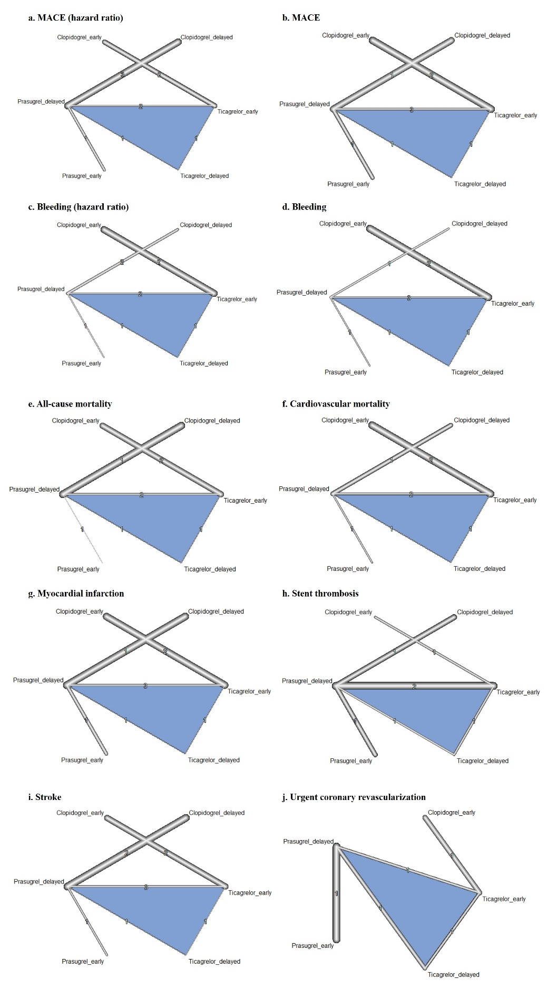
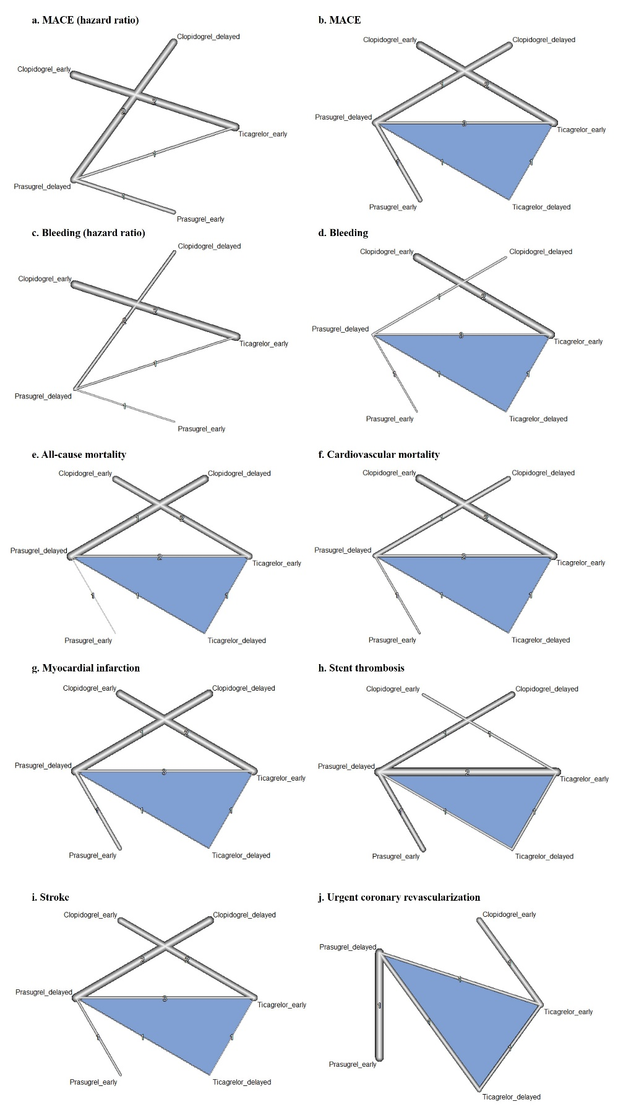

Figure S3. Effect of P2Y12 inhibitors on primary and secondary outcomes in comparison to early-treatment with clopidogrel.
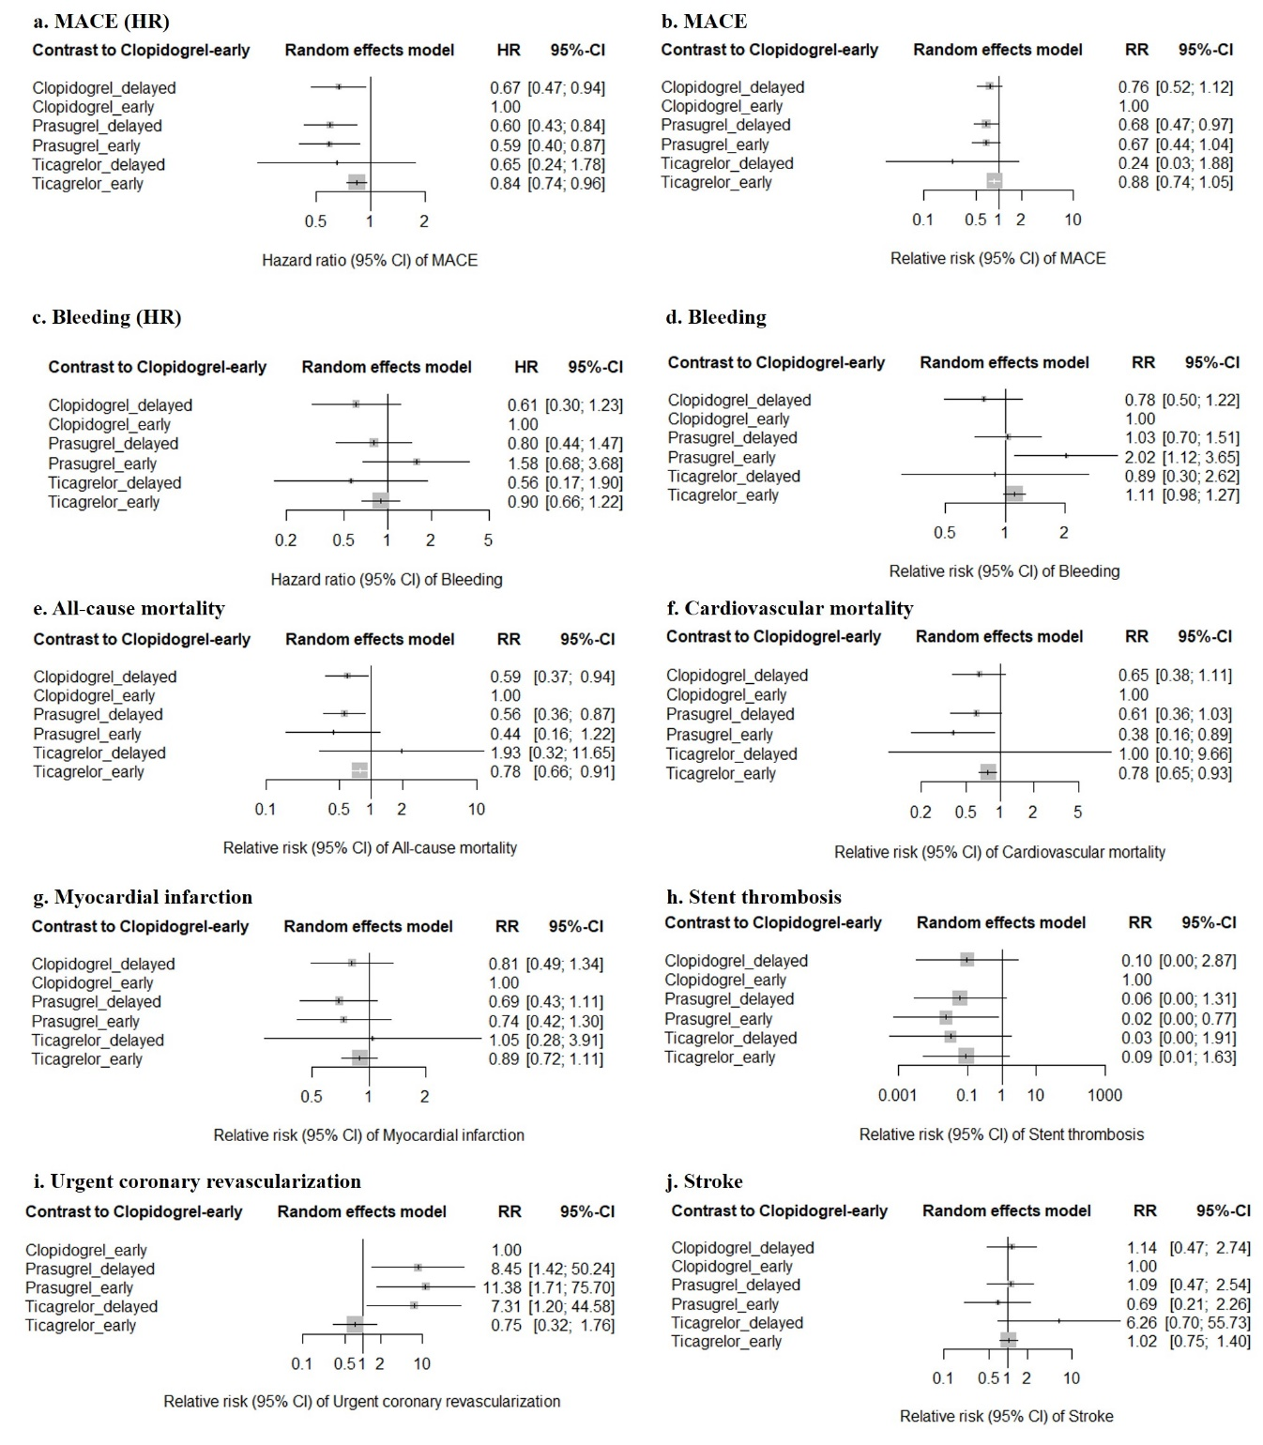
MACE, major adverse cardiovascular events; RR, risk ratio; CI, confidence interval; HR, hazard ratio.

Figure S4. Direct and indirect effects of P2Y12 inhibitors on MACE (HR).
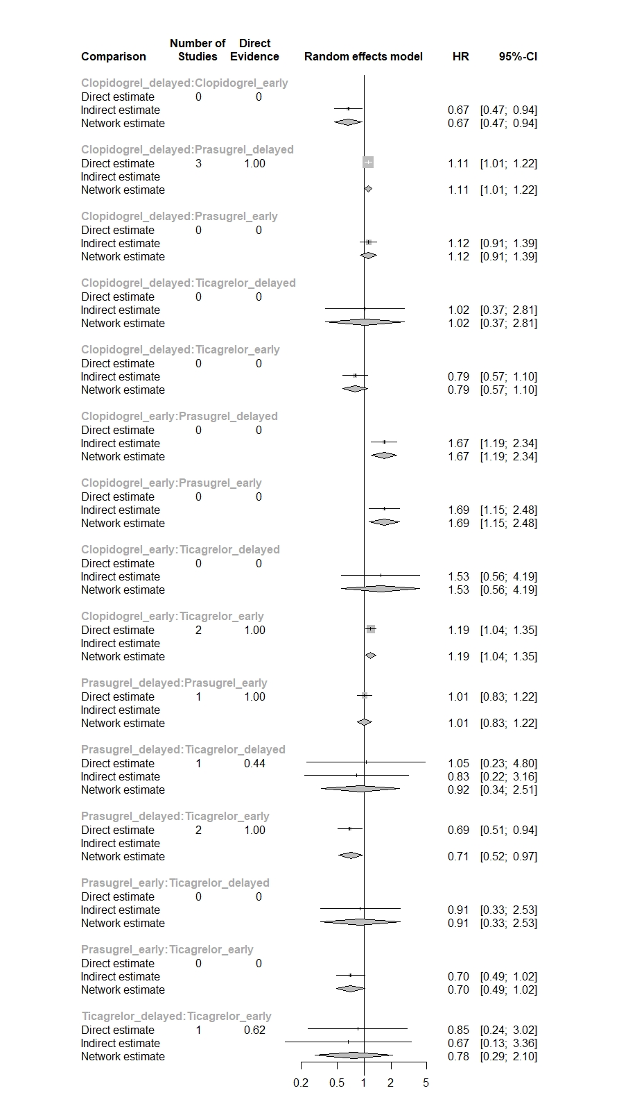
MACE, major adverse cardiovascular events; HR, hazard ratio; CI, confidence interval.
Figure S5. Direct and indirect effects of P2Y12 inhibitors on MACE.
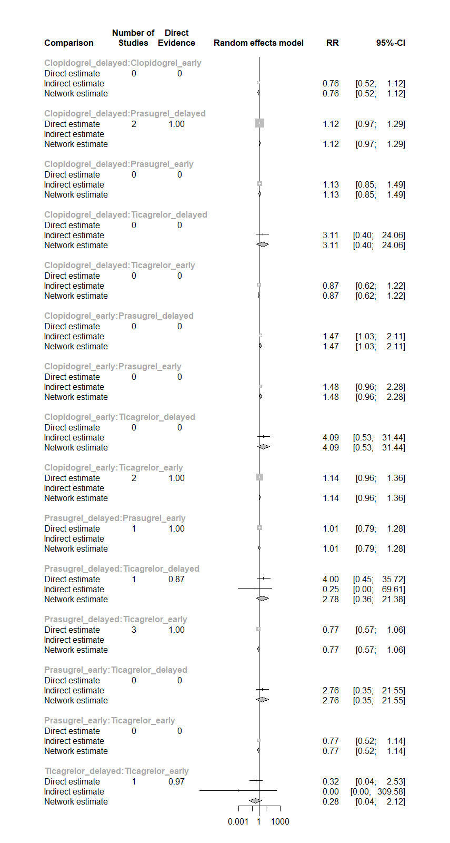
MACE, major adverse cardiovascular events; RR, risk ratio; CI, confidence interval.
Figure S6. Direct and indirect effects of P2Y12 inhibitors on bleeding (HR).
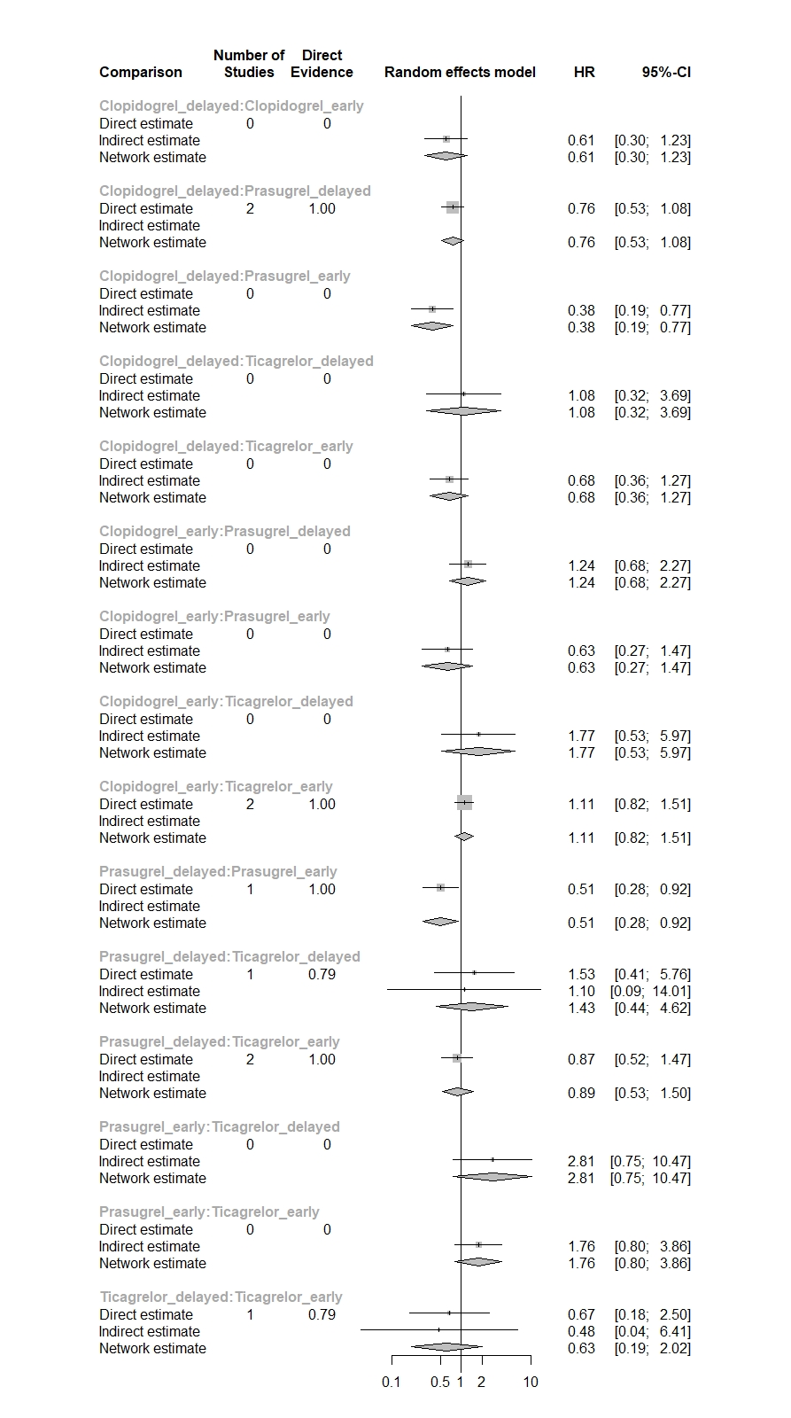
HR, risk ratio; CI, confidence interval.
Figure S7. Direct and indirect effects of P2Y12 inhibitors on bleeding.
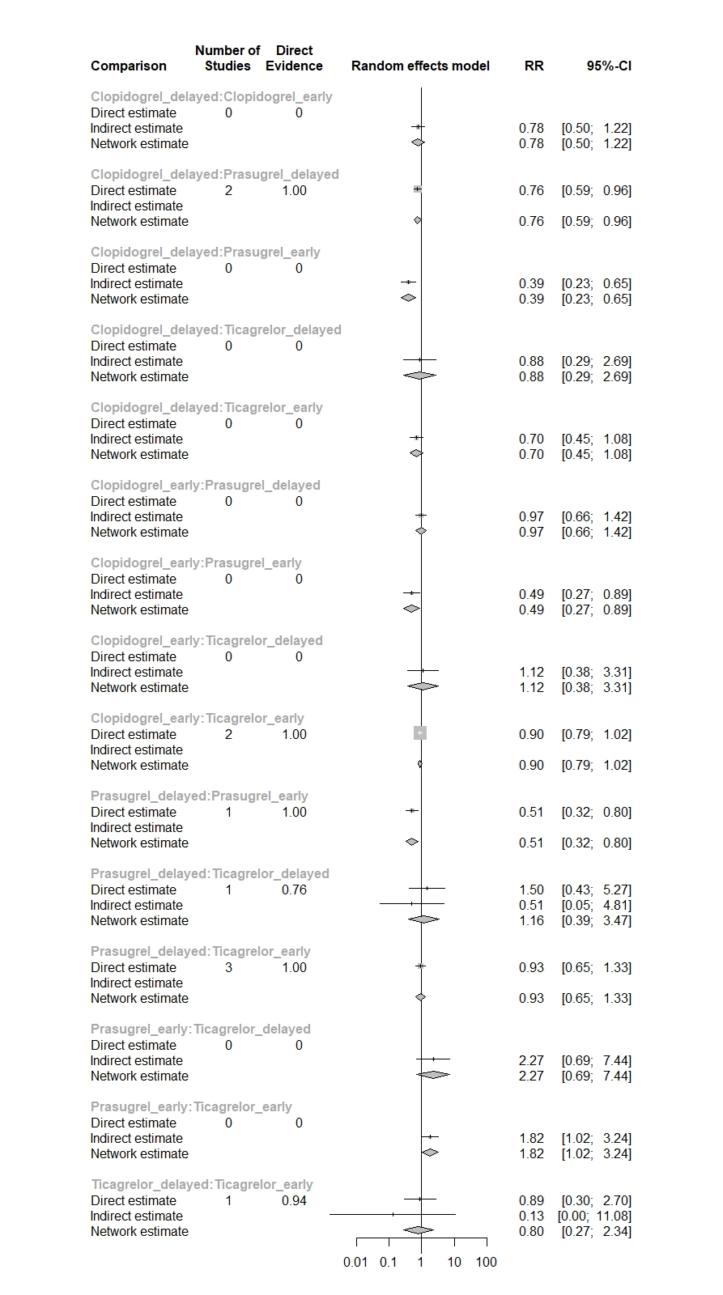
RR, risk ratio; CI, confidence interval.
Figure S8. Direct and indirect effects of P2Y12 inhibitors on all-cause mortality.
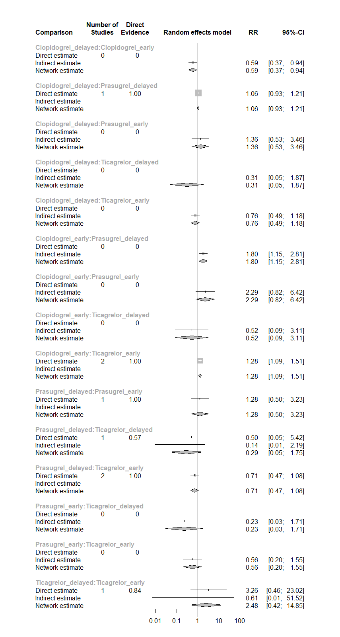
RR, risk ratio; CI, confidence interval.
Figure S9. Direct and indirect effects of P2Y12 inhibitors on cardiovascular mortality.
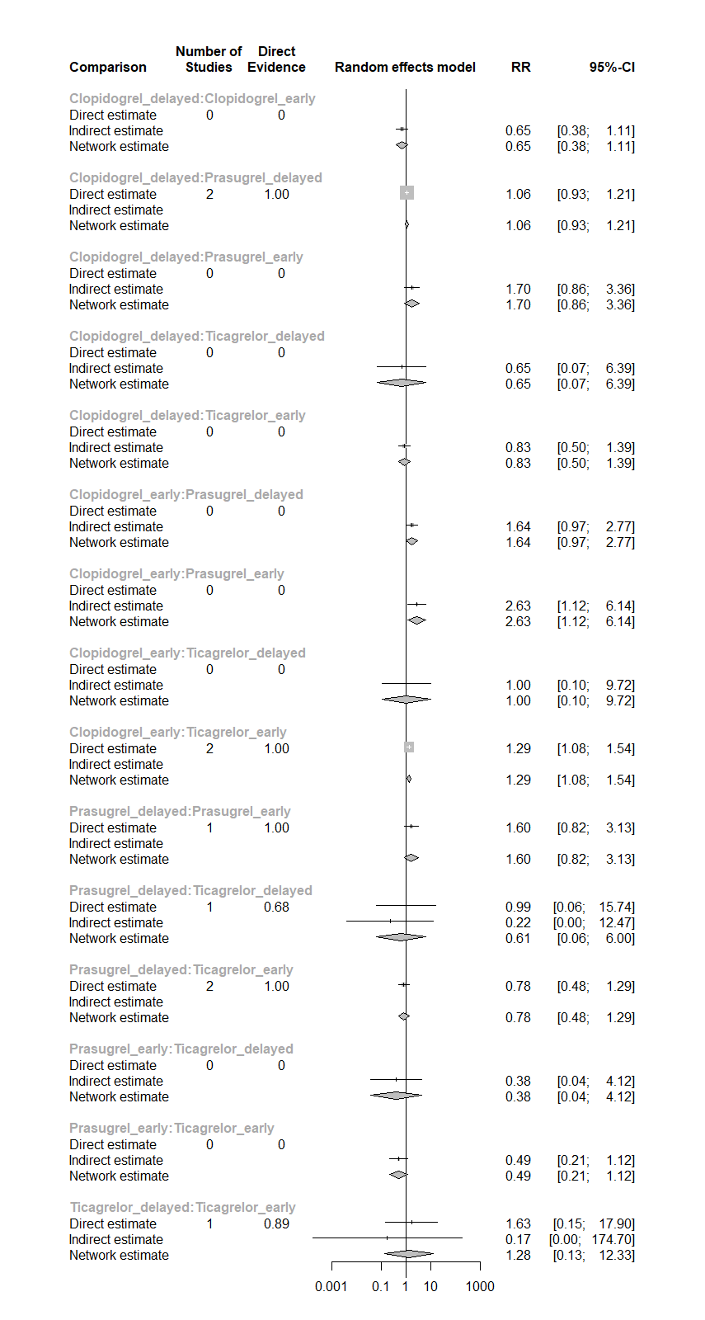
RR, risk ratio; CI, confidence interval.
Figure S10. Direct and indirect effects of P2Y12 inhibitors on myocardial infarction.
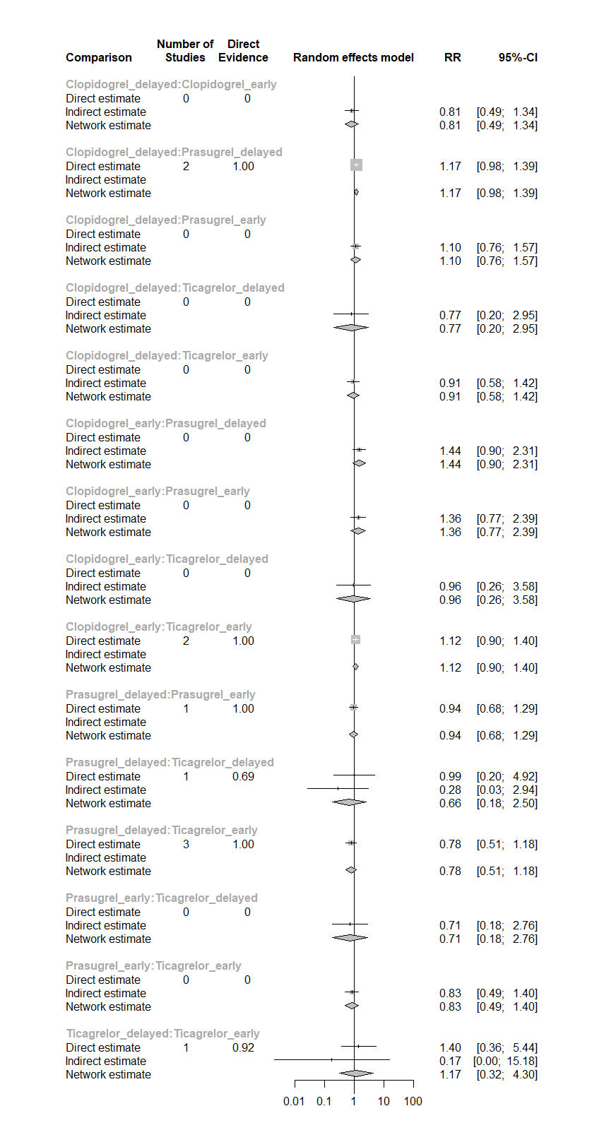
RR, risk ratio; CI, confidence interval.
Figure S11. Direct and indirect effects of P2Y12 inhibitors on stent thrombosis.
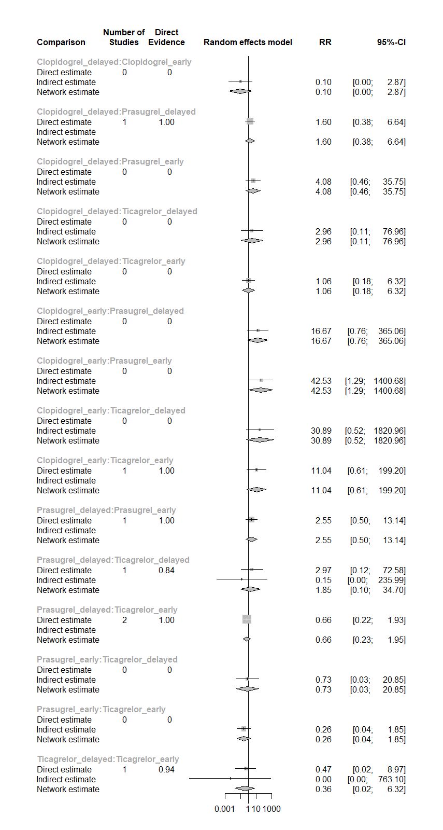
RR, risk ratio; CI, confidence interval.
Figure S12. Direct and indirect effects of P2Y12 inhibitors on stroke.
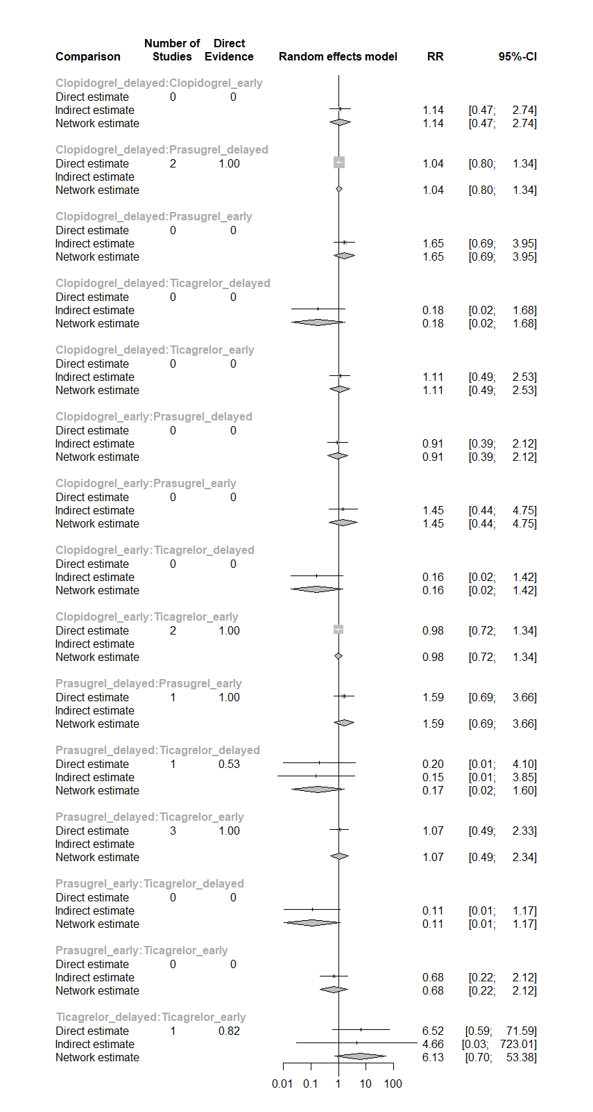
RR, risk ratio; CI, confidence interval.
Figure S13. Direct and indirect effects of P2Y12 inhibitors on urgent coronary revascularization.
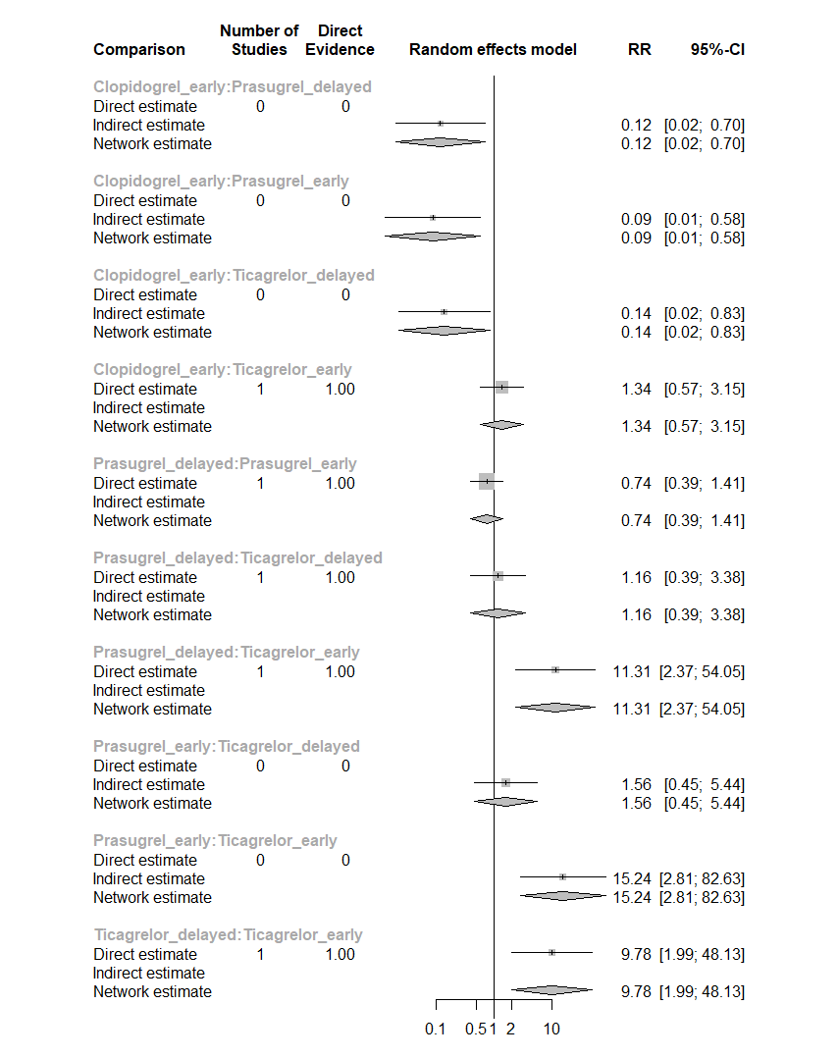
RR, risk ratio; CI, confidence interval.

