Content

- Electronic search strategy------------------------------------------------------------------------------------------------------------------------2
- Table S1. MOOSE checklist----------------------------------------------------------------------------------------------------------------------7
- Table S2. PRISMA checklist--------------------------------------------------------------------------------------------------------------------- 9
- Table S3. Study and participant characteristics of included studies--------------------------------------------------------------------11
- Table S4. Quality assessment of included studies-------------------------------------------------------------------------------------------26
- Table S5. Definitions------------------------------------------------------------------------------------------------------------------------------40
- Table S6. Summary of publication bias-----------------------------------------------------------------------------------------------------43
- List of Supplemental Figures-------------------------------------------------------------------------------------------------------------------45
Figure S1. The forest plots of prevalence of mental health symptoms during epidemics across different populations------45
Figure S2. The forest plots of prevalence of mental health symptoms during different types of pandemics -----------------77
Figure S3. Meta-regression analysis of prevalence of depression, anxiety, and insomnia among different populations during
COVID-19 estimated by time-------------------------------------------------------------------------------------------------------------------83
Figure S4. Prevalence of depression, anxiety, and insomnia among different populations across countries-------------------85
Figure S5. The forest plots of factors in the risk of depression during pandemics--------------------------------------------------90
Figure S6. The forest plots of factors in the risk of anxiety during epidemics-------------------------------------------------------114
Figure S7. The forest plots of factors in the risk of insomnia during epidemics---------------------------------------------------138
Figure S8. The sensitivity analysis -----------------------------------------------------------------------------------------------------------159
Figure S9. The results of funnel plots and p-value of Begg’s test-----------------------------------------------------------------------195
9. References------------------------------------------------------------------------------------------------------------------------------------------231

1. Electronic search strategy in PubMed, Embase, Web of Science, and Cochrane library

Search date: August 14, 2020
PubMed: 3050
#1 Search: ((((((((((“Influenza A Virus, H5N1 Subtype”[MeSH] OR “H5N1” OR "influenza A virus" OR "bird flu virus" OR “H5N1 virus” OR “H5N1 Viruses” OR “Virus, H5N1” OR “Viruses, H5N1” OR “H5N1 avian influenza” OR “H5N1 Virus infection”)) OR (“Human Influenza” OR “Influenza Pandemic” OR “Influenza Epidemic”)) OR “Nipah Virus”[MeSH]) OR (“Middle East Respiratory Syndrome Coronavirus”[MeSH] OR “MERS-CoV” OR “coronavirus infections” OR “MERS Virus” OR “MERS Viruses” OR “Virus, MERS” OR “Viruses, MERS” OR “Middle East respiratory syndrome-related coronavirus” OR “Middle East respiratory syndrome related coronavirus” OR “MERS”)) OR (“SARS Virus”[MeSH] OR “Severe Acute Respiratory Syndrome” OR “SARS” OR “Severe Acute Respiratory Syndrome Virus” OR “SARS-Related Coronavirus” OR “Coronavirus, SARS-Related” OR “SARS Related Coronavirus” OR “SARS-CoV” OR “Urbani SARS-Associated Coronavirus” OR “Coronavirus, Urbani SARS-Associated” OR “SARS-Associated Coronavirus, Urbani” OR “Urbani SARS Associated Coronavirus” OR “SARS Coronavirus” OR “Coronavirus, SARS” OR “Severe acute respiratory syndrome-related coronavirus” OR “Severe acute respiratory syndrome related coronavirus” OR “SARS-Associated Coronavirus” OR “Coronavirus, SARS-Associated” OR “SARS Associated Coronavirus”)) OR (“Poliomyelitis”[MeSH] OR “Poliomyelitis” OR “Polio” OR “Polios” OR “Polio Encephalitis” OR “Infantile Paralysis” OR “Poliomyelitis, Epidemic Acute” OR “Epidemic Acute Poliomyelitis” OR “Poliomyelitis Infection” OR “Preparalytic Poliomyelitis”)) OR ("Hemorrhagic Fever, Ebola"[MeSH] OR "Ebola" OR "Ebola Infection" OR "Infection, Ebola" OR "Ebola Virus Disease" OR "Ebola Virus Infection" OR "Infection, Ebola Virus" OR "Virus Infection, Ebola" OR "Ebolavirus Infection" OR "Ebolavirus Infections" OR "Infection, Ebolavirus" OR "Infections, Ebolavirus" OR "Ebola Hemorrhagic Fever")) OR ("Zika Virus Infection"[MeSH] OR "Zika" OR "Infection, Zika Virus" OR "Virus Infection, Zika" OR "ZikV Infection" OR "Infection, ZikV" OR "Fever, Zika" OR "Zika Virus Disease" OR "Disease, Zika Virus" OR "Virus Disease, Zika" OR "Zika Fever" OR "Congenital Zika Syndrome" OR "Congenital Zika Virus Infection")) OR ("Influenza A Virus, H1N1 Subtype"[MeSH] OR "H1N1" OR "H1N1 Virus" OR "H1N1 Viruses" OR "Virus, H1N1" OR "Viruses, H1N1" OR "Swine-Origin Influenza A H1N1 Virus" OR "Swine Origin Influenza A H1N1 Virus")) OR (“coronavirus" OR "coronaviruses" OR “2019 novel coronavirus disease” OR “COVID 19” OR “COVID-19” OR “SARS-CoV-2” OR “COVID-19 virus” OR “2019 novel coronavirus” or “2019-nCoV” or “coronavirus disease 2019” or “coronavirus disease-19” or “2019-nCoV disease” or “COVID-19 virus infection” or “severe acute respiratory syndrome coronavirus 2”))
#2 Search: "Mental Disorder" [Mesh] or “Mental disorders” or “mental symptom” or “mental illness”
#3 Search: "Anxiety Disorder" [Mesh] or "Anxiety" [Mesh] or "anxiety disorder" or "anxiety" or "anxious"
#4 Search: “Depressive Disorder” [Mesh] or “Depression” [Mesh] or “depressive disorder, major” [Mesh] or “major depression” or “major depressive disorder” or “MDD” or “mood disorder” or “depression” or “depress*” or “depressed”
#5 Search: “Sleep” [Mesh] OR “sleep disturbance” [Mesh] OR "sleep" OR "sleep problems" OR "sleep disturbances" OR "insomnia" OR "Sleep Initiation and Maintenance Disorders"
#6 Search: #2 OR #3 OR #4 OR #5
#7 Search: #1 AND #6

Embase: 4433
#1 “Influenza A Virus, H5N1 Subtype” OR “H5N1” OR "influenza A virus" OR "bird flu virus" OR “H5N1 virus” OR “H5N1 Viruses” OR “Virus, H5N1” OR “Viruses, H5N1” OR “H5N1 avian influenza” OR “H5N1 Virus infection” OR “Human Influenza” OR “Influenza Pandemic” OR “Influenza Epidemic” OR “Nipah Virus” OR “Middle East Respiratory Syndrome Coronavirus” OR “MERS-CoV” OR “coronavirus infections” OR “MERS Virus” OR “MERS Viruses” OR “Virus, MERS” OR “Viruses, MERS” OR “Middle East respiratory syndrome-related coronavirus” OR “Middle East respiratory syndrome related coronavirus” OR “MERS” OR “SARS Virus” OR “Severe Acute Respiratory Syndrome” OR “SARS” OR “Severe Acute Respiratory Syndrome Virus” OR “SARS-Related Coronavirus” OR “Coronavirus, SARS-Related” OR “SARS Related Coronavirus” OR “SARS-CoV” OR “Urbani SARS-Associated Coronavirus” OR “Coronavirus, Urbani SARS-Associated” OR “SARS-Associated Coronavirus, Urbani” OR “Urbani SARS Associated Coronavirus” OR “SARS Coronavirus” OR “Coronavirus, SARS” OR “Severe acute respiratory syndrome-related coronavirus” OR “Severe acute respiratory syndrome related coronavirus” OR “SARS-Associated Coronavirus” OR “Coronavirus, SARS-Associated” OR “SARS Associated Coronavirus” OR “Poliomyelitis” OR “Poliomyelitis” OR “Polio” OR “Polios” OR “Polio Encephalitis” OR “Infantile Paralysis” OR “Poliomyelitis, Epidemic Acute” OR “Epidemic Acute Poliomyelitis” OR “Poliomyelitis Infection” OR “Preparalytic Poliomyelitis” OR "Hemorrhagic Fever, Ebola" OR "Ebola" OR "Ebola Infection" OR "Infection, Ebola" OR "Ebola Virus Disease" OR "Ebola Virus Infection" OR "Infection, Ebola Virus" OR "Virus Infection, Ebola" OR "Ebolavirus Infection" OR "Ebolavirus Infections" OR "Infection, Ebolavirus" OR "Infections, Ebolavirus" OR "Ebola Hemorrhagic Fever" OR "Zika Virus Infection" OR "Zika" OR "Infection, Zika Virus" OR "Virus Infection, Zika" OR "ZikV Infection" OR "Infection, ZikV" OR "Fever, Zika" OR "Zika Virus Disease" OR "Disease, Zika Virus" OR "Virus Disease, Zika" OR "Zika Fever" OR "Congenital Zika Syndrome" OR "Congenital Zika Virus Infection" OR "Influenza A Virus, H1N1 Subtype" OR "H1N1" OR "H1N1 Virus" OR "H1N1 Viruses" OR "Virus, H1N1" OR "Viruses, H1N1" OR "Swine-Origin Influenza A H1N1 Virus" OR "Swine Origin Influenza A H1N1 Virus" OR “coronavirus" OR "coronaviruses" OR “2019 novel coronavirus disease” OR “COVID 19” OR “COVID-19” OR “SARS-CoV-2” OR “COVID-19 virus” OR “2019 novel coronavirus” or “2019-nCoV” or “coronavirus disease 2019” or “coronavirus disease-19” or “2019-nCoV disease” or “COVID-19 virus infection” or “severe acute respiratory syndrome coronavirus 2”
#2 "Mental Disorder" or “Mental disorders” or “mental symptom” or “mental illness” or "Anxiety Disorder" or "Anxiety" or "anxiety disorder" or "anxiety" or "anxious" or “Depressive Disorder” or “Depression” or “depressive disorder, major” or “major depression” or “major depressive disorder” or “MDD” or “mood disorder” or “depression” or “depress*” or “depressed” or “Sleep” OR “sleep disturbance” OR "sleep" OR "sleep problems" OR "sleep disturbances" OR "insomnia" OR "Sleep Initiation and Maintenance Disorders"
#3 #1 AND #2

Web of Science: 2340
#1 TS= (H5N1 OR influenza A virus OR bird flu virus OR H5N1 virus)
#2 TS=(Human Influenza OR Influenza Pandemic OR Influenza Epidemic OR Nipah Virus OR Middle East Respiratory Syndrome Coronavirus OR MERS CoV OR MERS Virus OR MERS)
#3 TS=(SARS Virus OR Severe Acute Respiratory Syndrome OR SARS OR Severe Acute Respiratory Syndrome Virus OR SARS Related Coronavirus)
#4 TS=(Poliomyelitis OR Polio OR Polio Encephalitis OR Poliomyelitis Infection OR Preparalytic Poliomyelitis)
#5 TS=(Ebola OR Ebola Infection OR Ebola Virus Infection OR Ebolavirus Infection OR Ebola Hemorrhagic Fever)
#6 TS=(Zika Virus Infection OR Zika OR Zika Virus Disease)
#7 TS=(H1N1 OR H1N1 Virus OR Swine Origin Influenza A H1N1 Virus)
#8 TS=(coronavirus OR 2019 novel coronavirus disease OR COVID19 virus OR 2019 novel coronavirus or 2019nCoV or COVID 19 virus infection or severe acute respiratory syndrome coronavirus 2)
#9 TS=#8 OR #7 OR #6 OR #5 OR #4 OR #3 OR #2 OR #1
#10 TS=(Mental Disorder or Mental disorders or mental symptom or mental illness)
#11 TS=(Anxiety Disorder or anxiety or anxious)
#12 TS=(Depressive Disorder or Depression or depressive disorder, major or major depression or major depressive disorder or MDD or mood disorder or depression or depress* or depressed)
#13 TS=(Sleep OR sleep disturbance OR sleep problems OR sleep disturbances OR insomnia OR Sleep Initiation and Maintenance Disorders)
#14 TS= #10 OR #11 OR #12 OR #13
#15 TS=#9 AND #14

OVID: 1380
#1 TS= (H5N1 OR influenza A virus OR bird flu virus OR H5N1 virus).ab, at.
#2 TS=(Human Influenza OR Influenza Pandemic OR Influenza Epidemic OR Nipah Virus OR Middle East Respiratory Syndrome Coronavirus OR MERS CoV OR MERS Virus OR MERS) .ab, at.
#3 TS=(SARS Virus OR Severe Acute Respiratory Syndrome OR SARS OR Severe Acute Respiratory Syndrome Virus OR SARS Related Coronavirus) .ab, at.
#4 TS=(Poliomyelitis OR Polio OR Polio Encephalitis OR Poliomyelitis Infection OR Preparalytic Poliomyelitis) .ab, at.
#5 TS=(Ebola OR Ebola Infection OR Ebola Virus Infection OR Ebolavirus Infection OR Ebola Hemorrhagic Fever) .ab, at.
#6 TS=(Zika Virus Infection OR Zika OR Zika Virus Disease) .ab, at.
#7 TS=(H1N1 OR H1N1 Virus OR Swine Origin Influenza A H1N1 Virus) .ab, at.
#8 TS=(coronavirus OR 2019 novel coronavirus disease OR COVID19 virus OR 2019 novel coronavirus or 2019nCoV or COVID 19 virus infection or severe acute respiratory syndrome coronavirus 2) .ab, at.
#9 TS=#8 OR #7 OR #6 OR #5 OR #4 OR #3 OR #2 OR #1
#10 TS=(Mental Disorder or Mental disorders or mental symptom or mental illness) .ab, at.
#11 TS=(Anxiety Disorder or anxiety or anxious) .ab, at.
#12 TS=(Depressive Disorder or Depression or depressive disorder, major or major depression or major depressive disorder or MDD or mood disorder or depression or depress* or depressed) .ab, at.
#13 TS=(Sleep OR sleep disturbance OR sleep problems OR sleep disturbances OR insomnia OR Sleep Initiation and Maintenance Disorders) .ab, at.
#14 TS= #10 OR #11 OR #12 OR #13
#15 TS=#9 AND #14

Medline: 3411
#1 TS= (H5N1 OR influenza A virus OR bird flu virus OR H5N1 virus)
#2 TS=(Human Influenza OR Influenza Pandemic OR Influenza Epidemic OR Nipah Virus OR Middle East Respiratory Syndrome Coronavirus OR MERS CoV OR MERS Virus OR MERS)
#3 TS=(SARS Virus OR Severe Acute Respiratory Syndrome OR SARS OR Severe Acute Respiratory Syndrome Virus OR SARS Related Coronavirus)
#4 TS=(Poliomyelitis OR Polio OR Polio Encephalitis OR Poliomyelitis Infection OR Preparalytic Poliomyelitis)
#5 TS=(Ebola OR Ebola Infection OR Ebola Virus Infection OR Ebolavirus Infection OR Ebola Hemorrhagic Fever)
#6 TS=(Zika Virus Infection OR Zika OR Zika Virus Disease)
#7 TS=(H1N1 OR H1N1 Virus OR Swine Origin Influenza A H1N1 Virus)
#8 TS=(coronavirus OR 2019 novel coronavirus disease OR COVID19 virus OR 2019 novel coronavirus or 2019nCoV or COVID 19 virus infection or severe acute respiratory syndrome coronavirus 2)
#9 TS=#8 OR #7 OR #6 OR #5 OR #4 OR #3 OR #2 OR #1
#10 TS=(Mental Disorder or Mental disorders or mental symptom or mental illness)
#11 TS=(Anxiety Disorder or anxiety or anxious)
#12 TS=(Depressive Disorder or Depression or depressive disorder, major or major depression or major depressive disorder or MDD or mood disorder or depression or depress* or depressed)
#13 TS=(Sleep OR sleep disturbance OR sleep problems OR sleep disturbances OR insomnia OR Sleep Initiation and Maintenance Disorders)
#14 TS= #10 OR #11 OR #12 OR #13
#15 TS=#9 AND #14

Cochrane library: 1270
#1 Influenza A Virus, H5N1 Subtype OR H5N1 OR influenza A virus OR bird flu virus OR H5N1 virus OR H5N1 Viruses OR Virus, H5N1 OR Viruses, H5N1 OR H5N1 avian influenza OR H5N1 Virus infection OR Human Influenza OR Influenza Pandemic OR Influenza Epidemic OR Nipah Virus OR Middle East Respiratory Syndrome Coronavirus OR MERS CoV OR coronavirus infections OR MERS Virus OR MERS Viruses OR Virus, MERS OR Viruses, MERS OR Middle East respiratory syndrome related coronavirus OR MERS OR SARS Virus OR Severe Acute Respiratory Syndrome OR SARS OR Severe Acute Respiratory Syndrome Virus OR SARS Related Coronavirus OR Coronavirus, SARS Related OR SARS CoV OR Urbani SARS Associated Coronavirus OR Coronavirus, Urbani SARS Associated OR SARS Associated Coronavirus, Urbani OR SARS Coronavirus OR Coronavirus, SARS OR Severe acute respiratory syndrome related coronavirus OR SARS Associated Coronavirus OR Coronavirus, SARS Associated OR Poliomyelitis OR Polio OR Polio Encephalitis OR Infantile Paralysis OR Poliomyelitis, Epidemic Acute OR Epidemic Acute Poliomyelitis OR Poliomyelitis Infection OR Preparalytic Poliomyelitis OR Hemorrhagic Fever, Ebola OR Ebola OR Ebola Infection OR Infection, Ebola OR Ebola Virus Disease OR Ebola Virus Infection OR Infection, Ebola Virus OR Virus Infection, Ebola OR Ebolavirus Infection OR Ebolavirus Infections OR Infection, Ebolavirus OR Infections, Ebolavirus OR Ebola Hemorrhagic Fever OR Zika Virus Infection OR Zika OR Infection, Zika Virus OR Virus Infection, Zika OR ZikV Infection OR Infection, ZikV OR Fever, Zika OR Zika Virus Disease OR Disease, Zika Virus OR Virus Disease, Zika OR Zika Fever OR Congenital Zika Syndrome OR Congenital Zika Virus Infection OR Influenza A Virus, H1N1 Subtype OR H1N1 OR H1N1 Virus OR H1N1 Viruses OR Virus, H1N1 OR Viruses, H1N1 OR Swine Origin Influenza A H1N1 Virus OR coronavirus OR coronaviruses OR 2019 novel coronavirus disease OR COVID 19 OR SARS CoV2 OR COVID19 virus OR 2019 novel coronavirus or 2019nCoV or coronavirus disease 2019 or coronavirus disease 19 or 2019nCoV disease or COVID 19 virus infection or severe acute respiratory syndrome coronavirus 2
#2 MeSH descriptor: [Influenza A Virus, H5N1 Subtype] explode all trees
#3 MeSH descriptor: [Influenza, Human] explode all trees
#4 MeSH descriptor: [Influenza Pandemic, 1918-1919] explode all trees
#5 MeSH descriptor: [Nipah Virus] explode all trees
#6 MeSH descriptor: [Coronavirus Infections] explode all trees
#7 MeSH descriptor: [Middle East Respiratory Syndrome Coronavirus] explode all trees
#8 MeSH descriptor: [Severe Acute Respiratory Syndrome] explode all trees
#9 MeSH descriptor: [SARS Virus] explode all trees
#10 MeSH descriptor: [Poliomyelitis] explode all trees
#11 MeSH descriptor: [Hemorrhagic Fever, Ebola] explode all trees
#12 MeSH descriptor: [Ebolavirus] explode all trees
#13 MeSH descriptor: [Zika Virus Infection] explode all trees
#14 MeSH descriptor: [Influenza A Virus, H1N1 Subtype] explode all trees
#15 MeSH descriptor: [Coronavirus] explode all trees
#16 #15 OR #14 OR #13 OR #12 OR #11 OR #10 OR #9 OR #8 OR #7 OR #6 OR #5 OR #4 OR #3 OR #2 OR #1
#17 Mental Disorder or Mental disorders or mental symptom or mental illness or Anxiety Disorder or anxiety or anxious or Depressive Disorder or Depression or depressive disorder, major or major depression or major depressive disorder or MDD or mood disorder or depression or depress* or depressed or Sleep OR sleep disturbance OR sleep problems OR sleep disturbances OR insomnia OR Sleep Initiation and Maintenance Disorders
#18 MeSH descriptor: [Mental disorders] explode all trees
#19 MeSH descriptor: [Anxiety] explode all trees
#20 MeSH descriptor: [Anxiety Disorders] explode all trees
#21 MeSH descriptor: [Depression] explode all trees
#22 MeSH descriptor: [Depression Disorders] explode all trees
#23 MeSH descriptor: [Sleep] explode all trees
#24 MeSH descriptor: [Sleep Initiation and Maintenance Disorders] explode all trees
#25 #17 OR #18 OR #19 OR #20 OR #21 OR #22 OR #23 OR #24
#26 #16 AND #25

bioRxiv and medRxiv: 1637
depression OR depressive disorder OR anxiety OR anxiety disorder OR insomnia

Table S1. MOOSE checklist
Item No | Recommendation | Reported on Page No
Reporting of background should include
1 | Problem definition | 5-6
2 | Hypothesis statement | 6-7
3 | Description of study outcome(s) | 6-7
4 | Type of exposure or intervention used | 6-7
5 | Type of study designs used | 6-7
6 | Study population | 6-7
Reporting of search strategy should include
7 | Qualifications of searchers (eg, librarians and investigators) | 7
8 | Search strategy, including time period included in the synthesis and key words | 7,  Supplement 1
9 | Effort to include all available studies, including contact with authors | 7
10 | Databases and registries searched | 7
11 | Search software used, name and version, including special features used (eg, explosion) | 7,  Supplement 1
12 | Use of hand searching (eg, reference lists of obtained articles) | 7
13 | List of citations located and those excluded, including justification | Supplement Table 3
14 | Method of addressing articles published in languages other than English | 7
15 | Method of handling abstracts and unpublished studies | 7
16 | Description of any contact with authors | NA
Reporting of methods should include
17 | Description of relevance or appropriateness of studies assembled for assessing the hypothesis to be tested | 7
18 | Rationale for the selection and coding of data (eg, sound clinical principles or convenience) | 7-8
19 | Documentation of how data were classified and coded (eg, multiple raters, blinding and interrater reliability) | 7-8
20 | Assessment of confounding (eg, comparability of cases and controls in studies where appropriate) | 7-8
21 | Assessment of study quality, including blinding of quality assessors, stratification or regression on possible predictors of study results | 8,  Supplement Table 4
22 | Assessment of heterogeneity | 8
23 | Description of statistical methods (eg, complete description of fixed or random effects models, justification of whether the chosen models account for predictors of study results, dose-response models, or cumulative meta-analysis) in sufficient detail to be replicated | 8-9
24 | Provision of appropriate tables and graphics | Supplement Table 4-6,  Fig. 1
Reporting of results should include
25 | Graphic summarizing individual study estimates and overall estimate | 10-13,  Fig. 2-5,  Supplement Fig. 1-7
26 | Table giving descriptive information for each study included | Supplement Table 3
27 | Results of sensitivity testing (eg, subgroup analysis) | 11-13,  Fig. 2-5,  Supplemental Fig. S1-8
28 | Indication of statistical uncertainty of findings | 13,  Supplemental Fig. 7-8

Table S2: PRISMA 2009 Checklist
Section/topic | # | Checklist item | Reported on page #
TITLE
Title | 1 | Identify the report as a systematic review, meta-analysis, or both. | 1
ABSTRACT
Structured summary | 2 | Provide a structured summary including, as applicable: background; objectives; data sources; study eligibility criteria, participants, and interventions; study appraisal and synthesis methods; results; limitations; conclusions and implications of key findings; systematic review registration number. | 3-4
INTRODUCTION
Rationale | 3 | Describe the rationale for the review in the context of what is already known. | 5
Objectives | 4 | Provide an explicit statement of questions being addressed with reference to participants, interventions, comparisons, outcomes, and study design (PICOS). | 5-6
METHODS
Protocol and registration | 5 | Indicate if a review protocol exists, if and where it can be accessed (e.g., Web address), and, if available, provide registration information including registration number. | 6
Eligibility criteria | 6 | Specify study characteristics (e.g., PICOS, length of follow-up) and report characteristics (e.g., years considered, language, publication status) used as criteria for eligibility, giving rationale. | 7
Information sources | 7 | Describe all information sources (e.g., databases with dates of coverage, contact with study authors to identify additional studies) in the search and date last searched. | 7
Search | 8 | Present full electronic search strategy for at least one database, including any limits used, such that it could be repeated. | 7,  Supplement 1
Study selection | 9 | State the process for selecting studies (i.e., screening, eligibility, included in systematic review, and, if applicable, included in the meta-analysis). | 7
Data collection process | 10 | Describe method of data extraction from reports (e.g., piloted forms, independently, in duplicate) and any processes for obtaining and confirming data from investigators. | 7-8
Data items | 11 | List and define all variables for which data were sought (e.g., PICOS, funding sources) and any assumptions and simplifications made. | 8
Risk of bias in individual studies | 12 | Describe methods used for assessing risk of bias of individual studies (including specification of whether this was done at the study or outcome level), and how this information is to be used in any data synthesis. | 9
Summary measures | 13 | State the principal summary measures (e.g., risk ratio, difference in means). | 9
Synthesis of results | 14 | Describe the methods of handling data and combining results of studies, if done, including measures of consistency (e.g., I²) for each meta-analysis. | 8-9

Section/topic | # | Checklist item | Reported on page #
Risk of bias across studies | 15 | Specify any assessment of risk of bias that may affect the cumulative evidence (e.g., publication bias, selective reporting within studies). | 9
Additional analyses | 16 | Describe methods of additional analyses (e.g., sensitivity or subgroup analyses, meta-regression), if done, indicating which were pre-specified. | 9
RESULTS
Study selection | 17 | Give numbers of studies screened, assessed for eligibility, and included in the review, with reasons for exclusions at each stage, ideally with a flow diagram. | 10, Fig. 1
Study characteristics | 18 | For each study, present characteristics for which data were extracted (e.g., study size, PICOS, follow-up period) and provide the citations. | 10-11,  Supplement Table S3
Risk of bias within studies | 19 | Present data on risk of bias of each study and, if available, any outcome level assessment (see item 12). | 11, Supplement Table S4
Results of individual studies | 20 | For all outcomes considered (benefits or harms), present, for each study: (a) simple summary data for each intervention group (b) effect estimates and confidence intervals, ideally with a forest plot. | 11-13，Fig.2,  Supplement Fig. S1-2,  Supplement Fig. S5-7
Synthesis of results | 21 | Present results of each meta-analysis done, including confidence intervals and measures of consistency. | 10-13, Fig.2,  Supplement Fig. S1-2,  Supplement Fig. S5-7
Risk of bias across studies | 22 | Present results of any assessment of risk of bias across studies (see Item 15). | 13,  Supplement Fig. S8-9
Additional analysis | 23 | Give results of additional analyses, if done (e.g., sensitivity or subgroup analyses, meta-regression [see Item 16]). | 11-13, Supplement Fig. S1-7
DISCUSSION
Summary of evidence | 24 | Summarize the main findings including the strength of evidence for each main outcome; consider their relevance to key groups (e.g., healthcare providers, users, and policy makers). | 14-18
Limitations | 25 | Discuss limitations at study and outcome level (e.g., risk of bias), and at review-level (e.g., incomplete retrieval of identified research, reporting bias). | 18-19
Conclusions | 26 | Provide a general interpretation of the results in the context of other evidence, and implications for future research. | 19
FUNDING
Funding | 27 | Describe sources of funding for the systematic review and other support (e.g., supply of data); role of funders for the systematic review. | 19-20

From: Moher D, Liberati A, Tetzlaff J, Altman DG, The PRISMA Group (2009). Preferred Reporting Items for Systematic Reviews and Meta-Analyses: The PRISMA Statement. PLoS Med 6(7): e1000097. doi:10.1371/journal.pmed1000097

Table S3: Summary of studies included in meta-analysis.
Study* | Publication year | Research site | Infectious Outbreak | Population | Study type | investing time | Sample size | Measurement of depression (cutoff: mild /moderate) | Prevalence of any depression | Prevalence of moderate depression | Measurement of anxiety (cutoff: mild /moderate) | Prevalence of any anxiety | Prevalence of moderate anxiety | Measurement of insomnia (cutoff: mild /moderate) | Prevalence of any insomnia | Prevalence of moderate insomnia
Ahmad et al.¹ | 2020 | India | COVID-19 | General population | Cross-sectional | 2020.03.29-2020.04.12 | 392 |  |  |  | GAD-7(-/10) |  | 25.30%
Ahmed et al.² | 2020 | China | COVID-19 | General population | Cross-sectional | na | 1074 | BDI(14/20) | 37.10% | 26.90% | BAI(8/16) | 29.00% | 18.90%
Alasdair et al.³ | 2020 | UK, Poland, Singapore | COVID-19 | Health worker | Cross-sectional | 2020.03.27-2020.06.16 | 3537 | HADS(11) | 11% |  | HADS(11) | 19.82%
Alkhamees et al.⁴ | 2020 | Saudi Arabia | COVID-19 | General population | Cross-sectional | 2020.04.02-2020.04.05 | 1160 | DASS-21(10/13) | 40.90% | 28.36% | DASS-21(7/10) | 29.90% | 24.05%
Al-Rabiaah et al.⁵ | 2020 | Saudi Arabia | MERS | Student | Cross-sectional | 2014.07 | 174 |  |  |  | GAD-7(5/10) | 23.00% | 4.60%
Alshekaili et al.⁶ | 2020 | Oman | COVID-19 | Health worker | Cross-sectional | 2020.04.08-2020.04.17 | 1139 | DASS-21(10) | 32.30% |  | DASS-21(8) | 34.06% |  | ISI(14) | 18.53%
Alyami et al.⁷ | 2020 | Saudi Arabia | COVID-19 | General population | Cross-sectional | 2020.03.27-2020.04.27 | 2081 | PHQ-9(5/10) | 70.35% | 29.41% | GAD-7(5/10) | 100% | 26.53%
An Ying et al.⁸ | 2020 | China | COVID-19 | Health worker | Cross-sectional | 2020.03.15-2020.03.20 | 1103 | PHQ-9(5) | 43.61%
Apisarnthanarak et al.⁹ | 2020 | Thailand | COVID-19 | Health worker | Cross-sectional | 2020.03.01-2020.03.31 | 160 |  |  |  | GAD-7(5/10) | 42.50% | 19.40%
Bachilo et al.¹⁰ | 2020 | Russia | COVID-19 | Health worker | Cross-sectional | 2020.04.21-2020.05.18 | 812 | PHQ-9(5/10) | 57.64% | 30.54% | GAD-7(5/10) | 48.77% | 16.38%
Badahdah et al.¹¹ | 2020 | Oman | COVID-19 | Health worker | Cross-sectional | 2020.04 | 509 |  |  |  | GAD-7(6/10) | 100.00% | 25.90%
Banna et al.¹² | 2020 | Bangladesh | COVID-19 | General population | Cross-sectional | 2020.04.29-2020.05.07 | 1427 | DASS-21(9) | 57.90% |  | DASS-21(6) | 33.70%
Başer et al.¹³ | 2020 | Turkey | COVID-19 | General population | Cross-sectional | 2020.03.20-2020.03.25 | 1070 |  |  |  | BAI(8/16) | 100.00% | 21.30%
Bauer et al.¹⁴ | 2020 | Germany | COVID-19 | Quarantine | Cross-sectional | 2020.04.08-2020.04.26 | 3700 | PHQ-D(5/10) | 71.05% | 31.30% | PHQ-D(na) | 7.40% |  | PSQI(6) | 58.30%
Bäuerle et al.¹⁵ | 2020 | German | COVID-19 | General population | Cross-sectional | 2020.03.10-2020.05.05 | 15037 | PHQ-2(3) | 14.30% |  | GAD-7(5/10) | 44.90% | 16.60%
Bowman et al.¹⁶ | 2020 | China; UK | COVID-19 | General population | Cross-sectional | China: 2020.01.24-2020.02.13; UK: 2020.03.17-2020.03.18 | 3431 |  |  |  | HASD-A(8/11) | 55.06% | 30.34%
Bryan et al.¹⁷ | 2020 | USA | COVID-19 | General population | Cross-sectional | 2020.03.18-2020.04.02 | 10,625 | PHQ-9(-/14) |  | 19.50%
Caballero-Dominguez et al.¹⁸ | 2020 | Colombia | COVID-19 | General population | Cross-sectional | 2020.03.30-2020.04.08 | 700 | WHO-5(≤9) | 61.10% |  |  |  |  | AIS(-/10) |  | 42.00%
Cai Qi et al.¹⁹ | 2020 | China | COVID-19 | Health worker | Case-control | 2020.02.11-2020.02.26 | 2346 | PHQ-9(-/10) |  | 12.23% | BAI(-/15) |  | 11.55% | ISI(9) | 38.45%
Cai Xin et al.²⁰ | 2020 | China | COVID-19 | Survivor, quarantine | Cross-sectional | 2020.02.20-2020.03.15 | 126 | SDS(53) | 38.10% |  | SAS(50) | 22.20%
ÇALIŞKAN et al.²¹ | 2020 | Turkey | COVID-19 | Health worker | Cross-sectional | 2020.03.14-2020.03.20 | 290 | HADS(7) | 62% |  | HADS(10) | 35.50%
Cameron et al.²² | 2020 | Canada | COVID-19 | Others (mothers) | Cross-sectional | 2020.04.14-2020.04.28 | 641 | EPDS, CESD(-/13, 26) |  | 41.51% | GAD-7, PASS(-/10, 26) |  | 32.69%
Cao Wenjun et al.²³ | 2020 | China | COVID-19 | Student | Cross-sectional | na | 7143 |  |  |  | GAD-7(5/10) | 24.90% | 3.60%
Capuano et al.²⁴ | 2020 | Italy | COVID-19 | Patients with physical disorder | Cohort | 2020.04.16-2020.04.23 | 67 | BDI(-/18) |  | 11.90% | STAI(na) | 16.40%
Cellini et al.²⁵ | 2020 | Italy | COVID-19 | General population | Cross-sectional | 2020.03.24-2020.03.28 | 1310 | DASS-21(-/14) |  | 24.20% | DASS-21(-/10) |  | 32.60% | PSQI(5) | 52.40%
Ceulemans et al.²⁶ | 2020 | Belgium | COVID-19 | Pregnant and breastfeeding women | Cross-sectional | na | 5866 | EDS(13) | 24.28% |  | GAD-7(5/10) | 53.14% | 13.72%
Chang Jinghui et al.²⁷ | 2020 | China | COVID-19 | Student | Cross-sectional | 2019.01.31-2020.02.03 | 3881 | PHQ-9(5/10) | 21.16% | 4.18% | GAD-7(6/10) | 26.60% | 3.41%
Chen Fangping et al.²⁸ | 2020 | China | COVID-19 | Youth | Cross-sectional | 2020.04.16-2020.04.23 | 1036 | DSRS-C(15) | 11.78% |  | SCARED(25) | 18.92%
Chen Jiyao et al.²⁹ | 2020 | Iran | COVID-19 | General population | Cross-sectional | 2020.04.01-2020.04.10 | 474 | PHQ-2(3) | 21.94% |  | GAD-2(3) | 21.10%
Chen Xi et al.³⁰ | 2020 | Ecuador | COVID-19 | Health worker | Cross-sectional | 2020.04.10-2020.05.02 | 252 |  |  |  | GAD-7(-/10) |  | 28.17%
Chen Yun et al.³¹ | 2020 | China | COVID-19 | Health worker | Cross-sectional | na | 105 | SDS(53/63) | 29.52% | 8.57% | SAS(50/60) | 18.10% | 7.62%
Cheng Fangfang et al.³² | 2020 | China | COVID-19 | Health worker | Cross-sectional | 2020.02.09-2020.02.13 | 534 |  |  |  | SAS(50) | 14.00% |  | PSQI(7) | 30.00%
Cheng SKW et al.³³ | 2004 | China, Hong Kong | SARS | Survivor | Cross-sectional | 2003.05-2003.07 | 180 | BDI(10/19) | 50.60% | 25.80% | BAI(10/19) | 55.30% | 31.90%
Chew et al.³⁴ | 2020 | Singapore and India | COVID-19 | Health worker | Cross-sectional | 2020.02.19-2020.04.17 | 906 | DASS-21(10/14) | 10.60% | 5.30% | DASS-21(8/10) | 15.70% | 8.70%
Choi et al.³⁵ | 2020 | Hong Kong | COVID-19 | General population | Cross-sectional | 2020.04.24-2020.05.03 | 500 | PHQ-9(5/10) | 48.80% | 19.80% | GAD-7(-/10) |  | 14.00%
Cici et al.³⁶ | 2020 | Turkey | COVID-19 | Medical student | Cross-sectional | 2020.03-2020.04 | 322 |  |  |  | BAI(-/16) |  | 50.90%
Civantos et al.³⁷ | 2020 | United States | COVID-19 | Health worker | Cross-sectional | 2020.04.14-2020.04.25 | 349 | PHQ-2(3) | 10.60% |  | GAD-7(5/10) | 47.90% | 18.90%
Colkesen et al.³⁸ | 2020 | Turkey | COVID-19 | Patients with physical disorder | Cross-sectional | 2020.04.20-2020.05.15 | 480 | HADS(7) | 34% |  | HADS(10) | 33.33%
Consolo et al.³⁹ | 2020 | Italy | COVID-19 | Health worker | Cross-sectional | 2020.04.02-2020.04.21 | 356 |  |  |  | GAD-7(5/10) | 57.30% | 23.90%
Corbett et al.⁴⁰ | 2020 | Ireland | COVID-19 | Health worker | Cross-sectional | 2020.04.20-2020.05.05 | 197 | PHQ-9(-/10) |  | 20.30% | GAD-7(-/10) |  | 21.00%
Cortés-Álvarez et al.⁴¹ | 2020 | Mexico | COVID-19 | General population | Cross-sectional | 2020.03.30-2020.04.05 | 1105 | DASS-21(-/13) |  | 15.70% | DASS-21(-/10) |  | 22.60%
Creese et al.⁴² | 2020 | UK | COVID-19 | Old adults | Cohort | 2020.05.13-2020.06.08 | 3281 | PHQ-9(5/10) | 24.96% | 5.64% | GAD-7(5/10) | 15.36% | 2.71%
Dal’BoscoI et al.⁴³ | 2020 | Brazil | COVID-19 | Health worker | Cross-sectional | 2020.03-2020.04 | 88 | HADS(8) | 48.90% |  | HADS(8) | 25.00%
Delshad et al.⁴⁴ | 2020 | Iran | COVID-19 | General population | Cross-sectional | 2020.02.19-2020.03.13 | 500 |  |  |  | GAD-7(-/10) |  | 92.40%
Devkota et al.⁴⁵ | 2020 | Nepal | COVID-19 | Suspected infector | Cross-sectional | 2020.05.13-2020.06.09 | 618 | DASS-21(10/14) | 6.80% | 3.40% | DASS-21(8/10) | 13.75% | 8.41%
Di Tella et al.⁴⁶ | 2020 | Italy | COVID-19 | Health worker | Cross-sectional | 2020.03.19-2020.04.05 | 145 | BDI(13) | 31.00% |  | STAI(41) | 71.00%
Ding Yubin et al.⁴⁷ | 2020 | China | COVID-19 | General population | Cross-sectional | 2020.02.29-2020.03.08 | 1081 | Self-designed(-/27) |  | 25.00%
Duan Li et al.⁴⁸ | 2020 | China | COVID-19 | Youth | Cross-sectional | na | 3613 | CDI(19) | 22.28%
Durankuş et al.⁴⁹ | 2020 | Turkey | COVID-19 | Pregnant | Cross-sectional | na | 260 | EPDS(13) | 35.40%
Elbay et al.⁵⁰ | 2020 | Turkey | COVID-19 | Health worker | Cross-sectional | 2020.03.10-2020.03.15 | 442 | DASS-21(10/14) | 64.70% | 47.10% | DASS-21(8/10) | 51.60% | 35.30%
Elhai et al.⁵¹ | 2020 | China | COVID-19 | General population | Cross-sectional | 2020.02.24-2020.03.15 | 908 | DASS-21(7/13) | 11.67% | 3.74% | DASS-21(7) | 6.83%
Elizarraras-Rivas et al.⁵² | 2010 | Mexico | H1N1 | Others (family members of infectors) | Cross-sectional | 2009.11.01-2009.11.30 | 35 | CES-D(16/na) | 42.86% | 9%
Evanoff et al.⁵³ | 2020 | USA | COVID-19 | Other (university staff) | Cohort | 2020.04.17-2020.05.01 | 5550 | DASS-21(-/14) |  | 15.90% | DASS-21(na) | 13.00%
Fang Xinyu et al.⁵⁴ | 2020 | China | COVID-19 | Other (frontline non-medical worker), student | Cross-sectional | 2020.02.20-2020.03.20 | 191 | PHQ-9(5/10) | 50.26% | 17.26%
Filgueiras et al.⁵⁵ | 2020 | Brazil | COVID-19 | Quarantine | Cohort | 2020.03.20-2020.03.25 | 360 | FDI(88) | 8.00% |  | STAI(men66, women69) | 9.40%
Fitzpatrick et al.⁵⁶ | 2020 | USA | COVID-19 | General population | Cross-sectional | 2020.03.23-2020.03.30 | 10368 | CES-D(16) | 43.99%
Forte et al.⁵⁷ | 2020 | Italy | COVID-19 | General population | Cross-sectional | 2020.03.18-2020.03.31 | 2291 |  |  |  | STAI-S(-/55) |  | 37.19%
Fu Wenning et al.⁵⁸ | 2020 | China | COVID-19 | General population | Cross-sectional | 2020.02.18-2020.02.28 | 1242 | PHQ-9(5) | 29.30% |  | GAD-7(5) | 27.50% |  | AIS(5) | 30.00%
Gallagher et al.⁵⁹ | 2020 | UK | COVID-19 | General population, others (caregivers) | Cohort | 2020.05 | 7527 | GHQ-12(6) | 18.60%
Gao Junling et al.⁶⁰ | 2020 | China | COVID-19 | General population | Cross-sectional | 2020.01.31-2020.02.02 | 4872 | WHO-5(<13) | 48.30% |  | GAD-7(-/10) |  | 22.60%
Garcia de Avila et al.⁶¹ | 2020 | Brazil | COVID-19 | Children | Cross-sectional | 2020.04.25-2020.05.25 | 289 |  |  |  | CAQ, NRS(9, 7) | 19.4%, 21.8%
García-Fernandez et al.⁶² | 2020 | Spain | COVID-19 | General population | Cross-sectional | 2020.03.29-2020.04.05 | 1639 | BDI(4) | 36.20%
Giusti et al.⁶³ | 2020 | Italy | COVID-19 | Health worker | Cross-sectional | 2020.04.16-2020.05.11 | 330 | DASS-21(na) | 26.80% |  | STAI, DASS-21(na) | 71.2%, 31.3%
González-Sanguino et al.⁶⁴ | 2020 | Spain | COVID-19 | General population | Cross-sectional | 2020.03.21-2020.03.28 | 3480 | PHQ-2(3) | 18.70% |  | GAD-2(3) | 21.60%
Gorrochategi et al.⁶⁵ | 2020 | Spain | COVID-19 | Old adults | Cross-sectional | na | 290 | DASS-21(10/14) | 18.62% | 10.34% | DASS-21(8/10) | 13.45% | 8.97%
Gualano et al.⁶⁶ | 2020 | Italy | COVID-19 | General population | Cross-sectional | 2020.04.19-2020.05.03 | 1515 | PHQ-2(3) | 24.70% |  | GAD-2(3) | 23.20% |  | ISI(8/10) | 33.80% | 7.34%
Guiroy et al.⁶⁷ | 2020 | Latin America(Argentina, Brazil, Chile, Mexico) | COVID-19 | Health worker | Cross-sectional | 2020.04.04-2020.04.06 | 204 | PHQ-9(5/10) | 48.53% | 22.10%
Guo Jing et al.⁶⁸ | 2020 | China | COVID-19 | General population | Cross-sectional | 2020.02.01-2020.02.10 | 2441 | CESD(21) | 72.60% |  |  |  |  | PSQI(7) | 20.60%
Guo Yan et al.⁶⁹ | 2020 | China | COVID-19 | Quarantine | Cross-sectional | 2020.02.26-2020.02.29 | 2331 | HADS(8) | 21.30% |  | HADS(8) | 25.40%
Gupta et al.⁷⁰ | 2020 | Nepal | COVID-19 | Health worker | Cross-sectional | 2020.05.11-2020.06.10 | 150 | PHQ-9(5/10) | 34.00% | 8.00% | GAD-7(5/10) | 37.33% | 10%
Han Lin et al.⁷¹ | 2020 | China | COVID-19 | Health worker | Cross-sectional | 2020.02.07-2020.02.10 | 21199 | SDS(53/63) | 28.60% | 8.20% | SAS(50/60) | 20.60% | 4.70%
Hao Fengyi et al.⁷² | 2020 | China | COVID-19 | General population, patients with mental disorders | Case-control | 2020.02.19-2020.02.22 | 185 | DASS-21(10/14) | 15.14% | 9.73% | DASS-21(8/10) | 14.59% | 11.35% | ISI(8/15) | 36.76% | 12.43%
Hawari et al.⁷³ | 2020 | Jordan | COVID-19 | Health worker | Cross-sectional | 2020.04.21-2020.05.17 | 1006 | PROMIS (-/11) |  | 19% | PROMIS (-/11) |  | 34%
Hawryluck et al.⁷⁴ | 2004 | Canada | SARS | Quarantine | Cross-sectional |  | 129 | CES-D(16) | 31.20%
Hu Deying et al.⁷⁵ | 2020 | China | COVID-19 | Health worker | Cross-sectional | 2020.01.013-2020.02.13 | 2014 | SDS(53/63) | 43.60% | 10.70% | SAS(50/60) | 41.40% | 14.30%
Hu Wei et al.⁷⁶ | 2020 | China | COVID-19 | Quarantine | Cross-sectional | 2020.02.19-2020.02.26 | 992 |  |  |  | SAS(50/60) | 9.58% | 2.83%
Hu Yanyu et al.⁷⁷ | 2020 | China | COVID-19 | Infectors | Cross-sectional | 2020.03.07-2020.03.24 | 85 | PHQ-9(5/10) | 45.90% | 24.70% | GAD-7(5/10) | 38.80% | 16.50% | ISI(8/15) | 54.10% | 21.10%
Huang Lei et al.⁷⁸ | 2020 | China | COVID-19 | Health worker | Cross-sectional | 2020.02.07-2020.02.09 | 364 |  |  |  | SAS(50/60) | 23.40% | 6.00%
Huang Yeen et al.^{79, 80} | 2020 | China | COVID-19 | General population | Cross-sectional | 2020.02.03-2020.02.17 | 7236 | CES-D(28) | 20.10% |  | GAD-7(9) | 35.10% |  | PSQI(7) | 18.20%
Hyland et al.⁸¹ | 2020 | Ireland | COVID-19 | General population | Cross-sectional | 2020.03.31-2020.04.05 | 1041 | PHQ-9(-/10) |  | 22.80% | GAD-7(-/10) |  | 20.00%
Jacob et al.⁸² | 2020 | UK | COVID-19 | General population | Cross-sectional | 2020.03.17 | 902 | BDI(-/20) |  | 18.80% | BAI(-/16) |  | 30.70%
Jahrami et al.⁸³ | 2020 | Bahrain | COVID-19 | Healthcare worker | Cross-sectional | 2020.04 | 257 |  |  |  |  |  |  | PSQI(5) | 75.20%
Jeong et al.⁸⁴ | 2016 | Korea | MERS | Quarantine | Cross-sectional | 2015.09-2015.11 | 1692 |  |  |  | GAD-7(-/10) |  | 8.45%
Jia Ru et al.⁸⁵ | 2020 | UK | COVID-19 | General population | Cohort | 2020.04.03-2020.04.30 | 3097 | PHQ-9(5/10) | 63.67% | 31.58% | GAD-7(5/10) | 56.60% | 26.03%
Joseph et al.⁸⁶ | 2020 | Saudi Arabia | COVID-19 | General population | Cross-sectional | 2020.04.12-2020.05.10 | 584 | PHQ-2(3) | 21.90% |  | GAD-2(3) | 17.80%
Kantor et al.⁸⁷ | 2020 | US | COVID-19 | General population | Cross-sectional | 2020.03.29-2020.03.31 | 1005 | PHQ-9(5/10) | 46.27% | 23.08% | GAD-7(5/10) | 51.04% | 26.27%
Kaveh et al.⁸⁸ | 2020 | Iran | COVID-19 | Health worker | Cross-sectional | 2020.03.25-2020.03.31 | 1038 |  |  |  | BAI(-/16) |  | 39.60%
Keita et al.⁸⁹ | 2017 | Guinea | Ebola | Survivor | Cross-sectional | 2015.03.23-2016.07.11 | 256 | CESD(men 17, women 23) | 14.84%
Khanna et al.⁹⁰ | 2020 | India | COVID-19 | Health worker | Cross-sectional | 2020.04.15-2020.04.19 | 2355 | PHQ-9(5/10) | 32.60% | 11.20%
Killgore et al.⁹¹ | 2020 | US | COVID-19 | General population | Cross-sectional | na | 1013 |  |  |  |  |  |  | ISI(8/15) | 56% | 25%
Kim et al.⁹² | 2020 | South Africa | COVID-19 | General population | Cohort | 2020.03-2020.05 | 221 | CES-D(10) | 14.50%
Kim Hyun-Chung et al.⁹³ | 2018 | Korea | MERS | Patients with suspected and confirmed MERS | Cross-sectional | 2015.05-2015.07 | 27 | PHQ-9(5) | 40.74%
Kim Young-Jae et al.⁹⁴ | 2020 | Korea | COVID-19 | General population | Cross-sectional | 2020.05.08-2020.05.13 | 550 | PHQ-9(5/10) | 51.64% | 20.20%
Kneale et al.⁹⁵ | 2020 | UK | COVID-19 | Others (LGBTQ) | Cross-sectional | 2020.04.27-2020.07.13 | 310 | CES-D(10) | 71.94%
Ko Chih-Hung et al.⁹⁶ | 2006 | China, Taiwan | SARS | General population | Cross-sectional |  | 1499 | TDQ(19) | 3.70%
Kokou-Kpolou et al.⁹⁷ | 2020 | France | COVID-19 | General population | Cross-sectional | 2020.05.03-2020.05.06 | 556 |  |  |  |  |  |  | ISI(-/15) |  | 19.10%
Kong Xiangyu et al.⁹⁸ | 2020 | China | COVID-19 | Infectors | Cross-sectional | 2020.02.23-2020.03.13 | 144 | HADS(8/11) | 28.47% | 14.59% | HADS(8/11) | 34.72% | 17.36%
Košir et al.⁹⁹ | 2020 | UK | COVID-19 | Patients with physical disorder | Cross-sectional | 2020.04.06-2020.05.12 | 177 | PHQ-4(3) | 19.21% |  | PHQ-4(3) | 31.64%
Kuman et al.¹⁰⁰ | 2020 | Turkey | COVID-19 | Patients with physical disorder | Cross-sectional | 2020.04.06-2020.04.13 | 307 |  |  |  | BAI(-/16) |  | 25.70%
Kumar et al.¹⁰¹ | 2020 | India | COVID-19 | Others (migrant worker) | Cross-sectional | na | 98 | PHQ-2(1) | 73.50% |  | GAD-2(3) | 50.90%
Kuper et al.¹⁰² | 2019 | Brazil | Zika | Other(caregiver) | Cross-sectional | 2017.05-2018.01 | 430 | DASS-21(10) | 45.41% |  | DASS-21(8) | 47.41%
Kwek et al.¹⁰³ | 2006 | Singapore | SARS | Infectors | Cross-sectional | na | 63 | HADS(8/11) | 27.00% | 11.10% | HADS(8/11) | 33.00% | 17.50%
Kwong et al.¹⁰⁴ | 2020 | UK | COVID-19 | General population | Cohort | 2020.04-2020.05 | 2872 | PHQ-9(-/10) |  | 18.14% | GAD-7(-/10) |  | 24.00%
Lai Jianbo et al.¹⁰⁵ | 2020 | China | COVID-19 | Health worker | Cross-sectional | 2020.01.29-2020.02.03 | 1257 | PHQ-9(5/10) | 50.40% | 14.80% | GAD-7(5/10) | 44.60% | 12.30% | ISI(8/15) | 34.00% | 7.80%
Lan Fan-yun et al.¹⁰⁶ | 2020 | USA | COVID-19 | Others (retail workers) | Cohort | 2020.05 | 99 | PHQ-9(5) | 8.08% |  | GAD-7(5) | 24.24%
Lebel et al.¹⁰⁷ | 2020 | Canada | COVID-19 | Pregnant | Cross-sectional | 2020.04.05-2020.04.20 | 1987 | EPDS(13) | 37.00% |  | PROMIS (-/60) |  | 56.60%
Lee Dominic T.S. et al.¹⁰⁸ | 2006 | China Hongkong | SARS | Pregnant | Case-control | 2003.04-2003.06 | 235 | BDI(14.5) | 12.30%
Lee Sang Min et al.¹⁰⁹ | 2018 | South Korea | MERS | Quarantine, patients with physical disorder | Cross-sectional | na | 73 | HADS(8) | 15.10% |  | HADS(8) | 11.00%
Lee T. M. C. et al.¹¹⁰ | 2006 | China Hongkong | SARS | Old adults and middle aged | Cross-sectional | 2003.08.04-2003.09.07 | 146 | CESD(16) | 25.34%
Lei Lei et al.¹¹¹ | 2020 | China | COVID-19 | General population | Cross-sectional | 2020.02.04-2020.02.10 | 1593 | SDS(50/60) | 14.60% | 6.30% | SAS(50/60) | 8.30% | 2.50%
Li Jianfeng et al.¹¹² | 2005 | China | SARS | Others(soldier) | Cross-sectional | 2003.05.06 | 141 | SCL-90 depression(3) | 5.00% |  | SCL-90 anxiety(3) | 2.10%
Li Ruilin et al.¹¹³ | 2020 | China | COVID-19 | Health worker | Cross-sectional | 2020.01-2020.02 | 176 |  |  |  | HAMA(14/21) | 77.30% | 50.00%
Li Xin et al.¹¹⁴ | 2020 | China | COVID-19 | Others (workers with income loss) | Cross-sectional | 2020.04.25-2020.05.09 | 398 | PHQ-9(5/15) | 45.40% | 19.10% | GAD-7(5) | 49.50% |  | ISI-7(8) | 30.90%
Li Xingxing et al.¹¹⁵ | 2020 | China | COVID-19 | Health worker | Cross-sectional | 2020.02.15-2020.02.22 | 948 |  |  |  |  |  |  | AIS(6) | 32.81%
Lin Liyu et al.¹¹⁶ | 2020 | China | COVID-19 | General population | Cross-sectional | 2020.02.05-2020.02.23 | 5641 | PHQ-9(5/10) | 50.13% | 24.46% | GAD-7(5/10) | 41.32% | 18.47% | ISI(8/15) | 29.60% | 9.02%
Lin Yulan et al.¹¹⁷ | 2020 | China | COVID-19 | Student | Cross-sectional | 2020.04.06-2020.04.22 | 2086 |  |  |  | STAI(-/44) |  | 38.10%
Lin Yulan et al.¹¹⁸ | 2020 | China | COVID-19 | General population | Cross-sectional | 2020.01.24-2020.02.24 | 2,446 |  |  |  | STAI-S(40) | 78.30%
Liu Chenyun et al.¹¹⁹ | 2020 | China | COVID-19 | Health worker | Cross-sectional | 2020.02.10-2020.02.20 | 512 |  |  |  | SAS(50/60) | 12.50% | 2.15%
Liu Cindy et al.¹²⁰ | 2020 | USA | COVID-19 | Youth | Cross-sectional | 2020.04.13-2020.05.19 | 898 | PHQ-8(10) | 43.30% |  | GAD-7(-/10) |  | 45.40%
Liu Jia et al.¹²¹ | 2020 | China | COVID-19 | Student | Cross-sectional | 2020.02.23-2020.04.02 | 217 | PHQ-9(5/10) | 35.48% | 11.06% | GAD-7(5/10) | 22.12% | 7.37%
Liu Nianqi et al.¹²² | 2020 | China | COVID-19 | General population | Cross-sectional | 2020.01.30-2020.02.08 | 285 |  |  |  |  |  |  | PSQI(na) | 20.70%
Liu Xi et al.¹²³ | 2020 | China | COVID-19 | General population | Cross-sectional | 2020.01.30-2020.02.03 | 608 | SDS(na) | 27.14% |  | STAI(na) | 15.82%
Liu Xiyao et al.¹²⁴ | 2020 | China | COVID-19 | Pregnant | Cross-sectional | 2020.02.03-2020.02.09 | 1947 |  |  |  | SAS(50/60) | 17.15% | 3.29%
Liu Xuehua et al.¹²⁵ | 2003 | China | SARS | Health worker | Cross-sectional | 2003.05.05-2003.05.12 | 101 | BDI(na/na) | 52.48% | 16.83%
Liu Yin et al.¹²⁶ | 2020 | China | COVID-19 | Health worker | Cross-sectional | 2020.02.17-2020.02.23 | 2031 | DASS-21(10/14) | 14.81% | 7.09% | DASS-21(8/10) | 18.30% | 12.21%
Lu Haiyang et al.¹²⁷ | 2020 | China | COVID-19 | General population | Cross-sectional | 2020.03.06-2020.03.12 | 1849 | CES-D(na) | 14.93%
Lu Wen et al.¹²⁸ | 2020 | China | COVID-19 | Health worker | Cross-sectional | 2020.02.25-2020.02.26 | 2299 | HAMD(7) | 11.66% |  | HAMA(7) | 24.75%
Luceño-Moreno et al.¹²⁹ | 2020 | Spain | COVID-19 | Health worker | Cross-sectional | na | 1442 | HADS(7/14) | 51.30% | 5.30% | HADS(7/14) | 79.30% | 20.70%
Ma Yarong et al.¹³⁰ | 2020 | China | COVID-19 | Health worker | Cross-sectional | 2020.02.22-2020.02.29 | 34 | PHQ-9(5) | 23.50% |  | GAD-7(5) | 35.30%
Ma Yufen et al.¹³¹ | 2020 | China | COVID-19 | Infectors | Cross-sectional | 2020.02.24-2020.03.08 | 770 | PHQ-9(5/10) | 43.12% | 18.57%
Magnavita et al.¹³² | 2020 | Italy | COVID-19 | Health worker | Cross-sectional | 2020.03.27-2020.04.30 | 595 | GADS(2) | 20.34% |  | GADS(5) | 16.64%
Mahendran et al.¹³³ | 2020 | China, Hong Kong | COVID-19 | Health worker | Cross-sectional | 2020.01.24-2020.02.13 | 120 |  |  |  | GAD-7(5/10) | 53.30% | 32.50%
Majumdar et al.¹³⁴ | 2020 | India | COVID-19 | Others (office worker) | Cross-sectional | 2020.04.14-2020.05.02 | 528 | CES-D(16) | 24.62%
Malhotra et al.¹³⁵ | 2020 | Singapore | COVID-19 | General population | Cross-sectional | 2020.03.31-2020.04.14 | 1017 |  |  |  | GAD-7(5/10) | 51.60% | 23.20%
Mappa et al.¹³⁶ | 2020 | Italy | COVID-19 | Pregnant | Cross-sectional | 2020.01-2020.02 | 178 |  |  |  | STAI(40) | 76.97%
Marelli et al.¹³⁷ | 2020 | Italy | COVID-19 | Student; and university administration staff workers | Cross-sectional | 2020.03.24-2020.05.03 | 400 | BDI(-/20) |  | 27.80% | BAI(-/16) |  | 34.30% | PSQI(5) | 70.25% | ≥15
Matsungo et al.¹³⁸ | 2020 | Zimbabwe | COVID-19 | General population | Cross-sectional | 2020.05.11-2020.05.25 | 339 |  |  |  | GAD-7(-/10) |  | 40.41%
Mazza et al.¹³⁹ | 2020 | Italy | COVID-19 | General population | Cross-sectional | 2020.03.18-2020.03.22 | 2766 | DASS-21(10/14) | 32.80% | 15.80% | DASS-21(8/10) | 18.70% | 11.50%
Mazza et al.¹⁴⁰ | 2020 | Italy | COVID-19 | Survivor | Cross-sectional | 2020.04.06-2020.06.09 | 402 | BDI(9) | 11.29% |  | STAI-S(40) | 42.23% |  | WHIIRS(9) | 40.05%
Mechili et al.¹⁴¹ | 2020 | Albania | COVID-19 | Student | Cross-sectional | 2020.03.30-2020.04.09 | 863 | PHQ-9(5/10) | 49.94% | 25.14%
Mishra et al.¹⁴² | 2016 | India | H1N1 | Health worker | Cross-sectional | 2015.02-2015.03 | 271 |  |  |  | BAI(-/16) |  | 1.48%
Moghanibashi-Mansourieh et al.¹⁴³ | 2020 | Iran | COVID-19 | General population | Cross-sectional | 2020.03.01-2020.03.09 | 10754 |  |  |  | DASS-21(8/10) | 50.88% | 40.39%
Monterrosa-Castro et al.¹⁴⁴ | 2020 | Colombia | COVID-19 | Health worker | Cross-sectional | 2020.03.24-2020.03.30 | 531 |  |  |  | GAD-7(-/10) |  | 39.30%
Moreira et al.¹⁴⁵ | 2020 | Portuguesa | COVID-19 | General population | Cross-sectional | 2020.03.23-2020.03.31 | 1280 | DASS-21(10/14) | 31.09% | 18.75% | DASS-21(8/10) | 28.44% | 17.42%
Muñoz-Navarro et al.¹⁴⁶ | 2020 | Spain | COVID-19 | General population | Cross-sectional | 2020.03.26-2020.04.25 | 1753 | PHQ-9(5/10) | 58.93% | 22.76% | GAD-7(5/10) | 60.87% | 20.82%
Nalleballe et al.¹⁴⁷ | 2020 | worldwide | COVID-19 | Infectors | Cross-sectional | 2020.01.20-2020.06.10 | 40469 |  |  |  | clinical diagnosis(na)
Naser et al.¹⁴⁸ | 2020 | Jordan | COVID-19 | General population, health worker, student | Cross-sectional | 2020.03.22-2020.03.28 | 4126
Naser et al.¹⁴⁹ | 2020 | Iran | COVID-19 | Patients with physical disorders | Cross-sectional | 2020.02.25 | 33 |  |  |  | BAI(8/16) | 100.00% | 100.00%
Newby et al.¹⁵⁰ | 2020 | Australia | COVID-19 | General population | Cross-sectional | 2020.03.27-2020.04.07 | 5071 | DASS-21(10/14) | 61.81% | 46.72% | DASS-21(8/10) | 49.77% | 41.21%
Ng DWL et al.¹⁵¹ | 2020 | China, Hong Kong | COVID-19 | Patients with physical disorder, general population | Cross-sectional | 2003.04.28-2003.05.03 | 117 | HADS(11) | 5.98% |  | HADS(11) | 5.13%
Nguyen et al.¹⁵² | 2020 | Vietnam | COVID-19 | Outpatient department visitor. Suspected infector | Cross-sectional | 2020.02.14-2020.03.02 | 3947 | PHQ-9(-/10) |  | 7.45%
Ni Michael et al.¹⁵³ | 2020 | China | COVID-19 | General population, health worker | Cross-sectional | 2020.02.18-2020.02.24 | 1791 | PHQ-2(3) | 19.21% |  | GAD-2(3) | 23.62%
Nie Xuedan et al.¹⁵⁴ | 2020 | China | COVID-19 | Infectors | Cross-sectional | 2020.02.14-2020.03.18 | 78 | SDS(50/60) | 35.90% | 15.38% | SAS(50/60) | 38.50% | 10.26%
Odriozola-González et al.¹⁵⁵ | 2020 | Spain | COVID-19 | General population | Cross-sectional | 2020.03.28-2020.04.04 | 2530 | DASS-21(10/14) | 48.10% | 34.19% | DASS-21(8/10) | 35.18% | 21.34%
Ojewale et al.¹⁵⁶ | 2020 | Ibadan | COVID-19 | Student | Cross-sectional | na | 386 | HADS(8/11) | 31.87% | 10.88% | HADS(8/11) | 41.45% | 20.73%
Ozamiz-Etxebarria et al.¹⁵⁷ | 2020 | Spain | COVID-19 | General population | Cross-sectional | 2020.03.11-2020.03.15 | 976 | DASS-21(10/14) | 18.85% | 8.91% | DASS-21(8/10) | 26.02% | 18.55%
Ozamiz-Etxebarria et al.¹⁵⁸ | 2020 | Spain | COVID-19 | General population | Cross-sectional | 2020.03.11-2020.03.18, 2020.04.02-2020.04.12 | 1,933 | DASS-21(na) | 27.50% |  | DASS-21(na) | 26.90%
Özdin et al.¹⁵⁹ | 2020 | Turkey | COVID-19 | General population | Cross-sectional | 2020.04.14-2020.04.16 | 343 | HADS(10) | 23.60% |  | HADS(7) | 45.10%
Papandreou et al.¹⁶⁰ | 2020 | Spain, Greece | COVID-19 | General population | Cross-sectional | Spain 2020.04.23, Greece 2020.05.03 | 1841 | PHQ-9(-/10) |  | 16.00% | GAD-7(-/10) |  | 12.70%
Patabendige et al.¹⁶¹ | 2020 | Sri Lanka | COVID-19 | Pregnant women | Cross-sectional | 2020.04.27-2020.05.20 | 257 | HADS(8) | 19.50% |  | HADS(8) | 17.50%
Patsali et al.¹⁶² | 2020 | Greece | COVID-19 | Student | Cross-sectional | 2020.04.05-2020.05.02 | 1535 | CES-D(na) | 12.43%
Peng Min et al.¹⁶³ | 2020 | China | COVID-19 | Quarantine | Cross-sectional | 2020.02.14-2020.03.04 | 2237 | SDS(50) | 6.21%
Perz et al.¹⁶⁴ | 2020 | USA | COVID-19 | Student | Cross-sectional | na | 237 |  |  |  | GAD-7(5/10) | 58.00% | 33%
Petzold et al.¹⁶⁵ | 2020 | German | COVID-19 | General population | Cross-sectional | 2020.03.27-2020.04.06 | 6509 | PHQ-2(3/5) | 25.00% | 10% | GAD-2(3/5) | 25.00% | 10.00%
Pieh et al.¹⁶⁶ | 2020 | Austria | COVID-19 | General population | Cross-sectional | 2020.04.30 | 1005 | PHQ-9(-/10) |  | 21.00% | GAD-7(-/10) |  | 19.00% | ISI(-/15) |  | 15.70%
Priego-Parra et al.¹⁶⁷ | 2020 | Mexico | COVID-19 | General population | Cross-sectional | 2020.03.23-2020.04.21 | 561 | HADS(8) | 27.63% |  | HADS(8) | 49.91%
Qi Han et al.¹⁶⁸ | 2020 | China | COVID-19 | Youth | Cross-sectional | 2020.02.20-2020.02.27 | 9554 |  |  |  | GAD(5/10) | 19.00% | 4.60%
Qi Jing et al.¹⁶⁹ | 2020 | China | COVID-19 | Health worker | Cross-sectional | 2020.02 | 1306 |  |  |  |  |  |  | PSQI(6) | 71.70%
Qi Meng et al.¹⁷⁰ | 2020 | China | COVID-19 | Youth | Cross-sectional | 2020.03.08-2020.03.15 | 7202 | PHQ-9(5) | 44.50% |  | GAD-7(5) | 38.00%
Qi Rongfeng et al.¹⁷¹ | 2020 | China | COVID-19 | Infectors | Cross-sectional | 2020.02 | 41 | SDS(53) | 24.39% |  | SAS(50) | 14.63%
Qian Mengcen et al.¹⁷² | 2020 | China | COVID-19 | General population | Cross-sectional | 2020.02.01-2020.02.10 | 1011 |  |  |  | GAD-7(-/10) |  | 26.61%
Quah et al.¹⁷³ | 2004 | Singapore | SARS | General population | Cross-sectional | 2003.05.05-2003.05.10 | 1201 |  |  |  | BA Thyer anxiety scale(-/≤3.25) |  | 45.30%
Que Jianyu et al.¹⁷⁴ | 2020 | China | COVID-19 | Health worker | Cross- sectional | 2020.02.16-2020.02.23 | 2285 | PHQ-9(5/10) | 44.38% | 12.82% | GAD-7(5/10) | 46.04% | 11.60% | ISI(8/15) | 28.75% | 6.78%
Ran Liuyi et al.¹⁷⁵ | 2020 | China | COVID-19 | General population | Cross-sectional | 2020.02.23-2020.03.02 | 1770 | PHQ-9(5/10) | 47.10% | 18.14% | GAD(5/10) | 31.90% | 8.81%
Ranzo et al.¹⁷⁶ | 2020 | Italy | COVID-19 | General population | Cross-sectional | 2020.04.24-2020.05.18 | 602 | HMDS(na) | 61.30% |  | HMAS(na) | 70.40%
Ren Yali et al.¹⁷⁷ | 2020 | China | COVID-19 | General population | Cross-sectional | 2020.02.14-2020.03.29 | 1172 | PHQ-9(na) | 18.80% |  | GAD-7(na) | 13.30% |  | ISI(na) | 7.20%
Rettie et al.¹⁷⁸ | 2020 | UK | COVID-19 | General population | Cross-sectional | 2020.04.17-2020.04.26 | 842 | PHQ-8(-/10) |  | 25.80% | GAD-7(-/10) |  | 24.30%
Rodríguez-Rey et al.¹⁷⁹ | 2020 | Spain | COVID-19 | General population | Cross-sectional | 2020.03.17-2020.03.24 | 3055 | DASS-21 (-/13) | 41.00% | 29.60% | DASS-21(7/10) | 30.70% | 25.40%
Romito et al.¹⁸⁰ | 2020 | Italy | COVID-19 | Cancer patients | Cross-sectional | 2020.04.02-2020.04.29 | 77 | HADS-D(8) | 31.00% |  | HADS-A(8) | 36.00%
Rong Yuan et al.¹⁸¹ | 2020 | China | COVID-19 | Others (parents of hospitalized children) | Cross-sectional | na | 50 | HADS(8) | 48.00% |  | HADS(8) | 42.00%
Rosenberg et al.¹⁸² | 2020 | US | COVID-19 | General population | Cross-sectional | 2020.04.10-2020.04.20 | 1010 | CES-D(10) | 30%
Rossell et al.¹⁸³ | 2020 | Australia | COVID-19 | General population | Cross-sectional | 2020.04.01-2020.04.04 | 5158 | DASS-21(10/13) | 51.12% | 35.42% | DASS-21(7/10) | 40.73% | 32.22%
Rossi et al.¹⁸⁴ | 2020 | Italy | COVID-19 | Health worker | Cross- sectional | 2020.03.27-2020.03.31 | 1379 | PHQ-9(-/15) |  | 24.73% | GAD-7(-/15) |  | 19.80% | ISI(-/22) |  | 8.27%
Rossi et al.¹⁸⁵ | 2020 | Italy | COVID-19 | General population | Cross-sectional | 2020.03.27-2020.04.06 | 18147 | PHQ-9(-/15) |  | 17.30% | GAD-7(-/15) |  | 20.80% | ISI(-/22) |  | 7.30%
Rubin et al.¹⁸⁶ | 2009 | UK | H1N1 | General population | Cross-sectional | 2009.05.08-2009.05.12 | 997 |  |  |  | STAI(12/18) | 23.80% | 2.10%
Saddik et al. (a)¹⁸⁷ | 2020 | United Arab Emirates | COVID-19 | General population | Cross-sectional | 2020.03.24-2020.05.15 | 1469 |  |  |  | GAD-7(5/10) | 71% | 38%
Saddik et al. (b)¹⁸⁸ | 2020 | United Arab Emirates | COVID-19 | Student | Cross-sectional | 2020.03.11-2020.03.21 | 1385 |  |  |  | GAD-7(5/10) | 47.70% | 22.60%
Saikarthik et al.¹⁸⁹ | 2020 | India | COVID-19 | General population | Cross-sectional | 2020.05.05-2020.05.14 | 873 | DASS-21(10/14) | 18.56% | 3.50% | DASS-21(8/10) | 25.66% | 18.30%
Salam et al.¹⁹⁰ | 2020 | Pakistan | COVID-19 | Student | Cross-sectional | 2020.04-2020.05 | 1134 | PHQ-9(5/10) | 69.50% | 45% | GAD-7(-/10) |  | 34.00%
Salman et al.¹⁹¹ | 2020 | Pakistan | COVID-19 | Health worker | Cross-sectional | 2020.04.15-2020.05.20 | 398 | PHQ-9(5/10) | 64.10% | 21.90% | GAD-7(-/10) |  | 21.40%
Sandesh et al.¹⁹² | 2020 | Pakistan | COVID-19 | Health worker | Cross-sectional | 2020.05 | 112 | DASS-21(na/na) | 90.18% | 72.30% | DASS-21(na/na) | 95.54% | 85.71%
Saricam et al.¹⁹³ | 2020 | Turkey | COVID-19 | Health worker | Cross-sectional | 2020.04.10-2020.04.20 | 123 |  |  |  | STAI(-/57) |  | 46.30%
Sartorão Filho et al.¹⁹⁴ | 2020 | Brazil | COVID-19 | Medical student | Cross-sectional | 2020.05.18-2020.05.19 | 340 | PHQ-9(5/10) | 89.71% | 64.41% | GAD-7(5/10) | 84.41% | 38.23%
Savitsky et al.¹⁹⁵ | 2020 | Israel | COVID-19 | Medical student | Cross-sectional | na | 216 |  |  |  | GAD-7(-/10) |  | 42.80%
Seyahi et al.¹⁹⁶ | 2020 | Turkey | COVID-19 | Patients with physical disorders, health workers, teachers | Cross-sectional | na | 2223 | HADS(8) |  |  | HADS(11)
Shapiro et al.¹⁹⁷ | 2020 | Israel | COVID-19 | General population | Cross-sectional | 2020.04 | 503 | PHQ-2(3) | 12.52%
Shechter et al.¹⁹⁸ | 2020 | USA | COVID-19 | Health worker | Cross-sectional | 2020.04.09-2020.04.24 | 657 | PHQ-2(3) | 48.00% |  | GAD-2(3) | 33.00% |  | modified PSQI and ISI(na) | 71.00%
Sheng Xiaoyan et al.¹⁹⁹ | 2020 | China | COVID-19 | Health worker | Cross-sectional | na | 92 | SDS(50) | 29.35% |  | SAS(50) | 5.43% |  | PSQI(7) | 17.39%
Shevlin et al.²⁰⁰ | 2020 | UK | COVID-19 | General population | Cross-sectional | 2020.03.23-2020.03.28 | 2025 |  |  |  | GAD-7(-/10) |  | 21.60%
Shi Le et al.²⁰¹ | 2020 | China | COVID-19 | General population | Cross-sectional | 2020.02.28-2020.03.11 | 56679 | PHQ-9(5/10) | 27.90% | 10.80% | GAD-7(5/10) | 31.60% | 10.40% | ISI(8/15) | 29.20% | 5.70%
Sigdel et al.²⁰² | 2020 | Nepal | COVID-19 | General population | Cross-sectional | 2020.04.09-2020.04.16 | 349 | PHQ-9(-/10) |  | 34% | GAD-7(-/10) |  | 31.23%
Sipos et al.²⁰³ | 2018 | USA | Ebola | Others(soldier) | Cross-sectional | 2015.02 | 173 | PHQ-8(na) | 2.30% |  | GAD-7(na) | 2.30% |  | ISI(na) | 12.40%
Skoda et al.²⁰⁴ | 2020 | German | COVID-19 | General population | Cross-sectional | 2020.03.10-2020.03.31 | 10940 |  |  |  | GAD-7(-/10) |  | 14.95%
Smith et al.²⁰⁵ | 2020 | UK | COVID-19 | General population | Cross-sectional | 2020.05.06-2020.05.07 | dep 2104, anx 2090 | PHQ-2(3) | 23.50% |  | GAD-2(3) | 21.90%
Sögüt et al.²⁰⁶ | 2020 | Turkey | COVID-19 | Student | Cross-sectional | 2020.03.15-2020.03.30 | 972 |  |  |  | BAI(-/22) |  | 5.50%
Solomou et al.²⁰⁷ | 2020 | Cyprus | COVID-19 | General population | Cross-sectional | 2020.04.03-2020.04.09 | 1642 | PHQ-9(5/15) | 57.30% | 9.20% | GAD-7(5/10) | 64.10% | 23.10%
Song Lili et al.²⁰⁸ | 2020 | China | COVID-19 | Others (resuming work) | Cross-sectional | 2020.04.09-2020.04.22 | 709 | CES-D(14) | 13.50% |  | GAD-7(9) | 14.10% |  | ISI(8) | 20.70%
Song Xingyue et al.²⁰⁹ | 2020 | China | COVID-19 | Health worker | Cross-sectional | 2020.02.28-2020.03.18 | 14825 | CES-D(16) | 25.20%
Speth et al.²¹⁰ | 2020 | Switzerland | COVID-19 | Infectors | Cross-sectional | 2020.03.03-2020.04.17 | 114 | PHQ-2(3) | 21.10% |  | GAD-2(3) | 10.50%
Stanton et al.²¹¹ | 2020 | Australia | COVID-19 | General population | Cross-sectional | 2020.04.09-2020.04.19 | 1491 | DASS-21(5/7) | 38.30% | 26.56% | DASS-21(4/6) | 21.19% | 13.48%
Stickley et al. (a), Ueda et al. (b)^{212, 213} | 2020 | Japan | COVID-19 | General population | Cross-sectional | 2020.04.16-2020.04.18, 2020.05.15-2020.05.17 | 2000 | PHQ-9(5/10) | 43.20% | 17.30% | GAD-7(5/10) | 31.60% | 10.90%
Stojanov et al.²¹⁴ | 2020 | China | COVID-19 | Health workers | Cross-sectional | na | 201 | SDS(-/60) |  | 15.78% | GAD-7(-/10) |  | 25.44%
Su Jinghua et al.²¹⁵ | 2020 | China | COVID-19 | General population | Cross-sectional | 2020.02.07-2020.02.08 | 403 |  |  |  | GAD-7(5) | 37.70%
Su Tungping et al.²¹⁶ | 2007 | China, Taiwan | SARS | Health worker | Cross-sectional | 2020.05.13-2020.06.30 | 102 | BDI(10) | 27.45% |  |  |  |  | DSM-IV(na)
Sun Shufang et al.²¹⁷ | 2020 | China | COVID-19 | Student, quarantine | Cross-sectional | 2020.03.20-2020.04.10 | 1912 | PHQ-9(5/10) | 46.55% | 15.59% | GAD-7(5/10) | 34.73% | 9.63%
Suryadevara et al.²¹⁸ | 2020 | India | COVID-19 | Quarantine, student | Cross-sectional | 2020.04.23-2020.04.30 | 500 | DASS-21(10/14) | 43% | 34% | DASS-21(8/10) | 47.00% | 44.00%
Taghizadeh et al.²¹⁹ | 2020 | Iran | COVID-19 | General population | Cross-sectional | 2020.04.06-2020.04.15 | 2045 | HADS(8) | 42.30% |  | HADS(8) | 55.55%
Tan Wanqiu et al.²²⁰ | 2020 | China | COVID-19 | General population | Cross-sectional | 2020.02.24-2020.02.25 | 673 | DASS-21(10/14) | 5.94% | 3.71% | DASS-21(8/10) | 6.09% | 3.86% | ISI(8/15) | 14.56% | 2.38%
Tang Fang et al.²²¹ | 2020 | China | COVID-19 | General population | Cross-sectional | 2020.02.05-2020.02.07 | 1160 | CES-D(15) | 26.47% |  | GAD-7(5) | 70.78%
Tang Quansheng et al.²²² | 2005 | China | SARS | Student | Cross-sectional | 2003.04.28 | 121 | SDS(50) | 33.90% |  | SAS(50) | 22.30%
Tang Wanjie et al.²²³ | 2020 | China | COVID-19 | Student, quarantine | Cross-sectional | 2020.02.20-2020.02.27 | 2485 | PHQ-9(-/10) |  | 9.00%
Tang Yamei et al.²²⁴ | 2005 | China | SARS | Infectors | Cross-sectional | 2003.01.30-2003.05.10 | 173 | clinical diagnosis |  |  | clinical diagnosis(na)
Temsah et al.²²⁵ | 2020 | Saudi Arabia | COVID-19 | Health worker | Cross-sectional | 2020.02.05-2020.02.16 | 582 |  |  |  | GAD-7(5/10) | 31.80% | 11.00%
Teng Ziwei et al.²²⁶ | 2020 | China | COVID-19 | Frontline | Cross-sectional | na | 2614 | PHQ-9(5/10) | 49.99% | 21.63% | SAS(50/60) | 23.40% | 7.51%
Teo et al.²²⁷ | 2020 | Singapore | COVID-19 | Health worker | Cross-sectional | 2020.05.25-2020.06.08 | 122 | SDS(50/60) | 62.10% | 37.80% | GAD-7(5/10) | 53.40% | 24.30%
Termorshuizen et al.²²⁸ | 2020 | USA, Netherlands | COVID-19 | Patients with eating disorders | Cross-sectional | 2020.04.08-2020.05.06 (USA); 2020.04.17-2020.05.15 (Netherlands) | 952 |  |  |  | GAD-7(-/10) |  | 65.55%
Thapa et al.²²⁹ | 2020 | Nepal | COVID-19 | Health worker | Cross-sectional | na | 100 |  |  |  | SAS(45/60) | 34.00% | 6%
Thomaier et al.²³⁰ | 2020 | USA | COVID-19 | Health worker | Cross-sectional | 2020.03.27-2020.04.10 | 374 | PHQ-2(3) | 23.50% |  | GAD-2(3) | 62.00%
Torrente et al.²³¹ | 2020 | Argentina | COVID-19 | Quarantine | Cross-sectional | 2020.03.24-2020.03.20 | 10053 | PHQ-9(6/9) | 47.00% | 28.60% | GAD-7(5/10) | 54.90% | 23.20%
Twenge et al.²³² | 2020 | USA | COVID-19 | General population | Cross-sectional | 2020.04.23-2020.05.04 | 336,525 | PHQ-2(3) | 23.50% |  | GAD-2(3) | 30.80%
Ustun et al.²³³ | 2020 | Turkey | COVID-19 | General population | Cross-sectional | 2020.03.23-2020.04.03 | 1115 | BDI(10/17) | 53.00% | 27.30%
Verma et al.²³⁴ | 2020 | India | COVID-19 | General population | Cross-sectional | 2020.04.04-2020.04.14 | 354 | DASS-21(10) | 25.10% |  | DASS-21(8) | 28.00%
Voitsidis et al.²³⁵ | 2020 | Greece | COVID-19 | General population | Cross-sectional | 2020.04.10-2020.04.13 | 2363 |  |  |  |  |  |  | AIS(na) | 37.60%
Wan Innes et al.²³⁶ | 2004 | China, Hong Kong | SARS | Patient with physical disorders | Cross-sectional | 2003.04 | 57 | HADS(8) | 26.32% |  | HADS(5) | 42.10%
Wang Chongying et al.²³⁷ | 2020 | China | COVID-19 | Student | Cross-sectional | 2020.02.15-2020.02.17 | 3611 |  |  |  | SAS(50/60) | 15.43% | 5.51%
Wang Cuiyan et al.²³⁸ | 2020 | China | COVID-19 | General population | Cross-sectional | 2020.01.31-2020.02.02 | 1210 | DASS-21(10/13) | 30.30% | 16.50% | DASS-21(7/10) | 36.36% | 28.84%
Wang Huajun et al.²³⁹ | 2020 | China | COVID-19 | Health worker | Cross-sectional | 2020.02.02-2020.02.03 | 1045 | HADS-D(-/10) |  | 13.60% | HADS-A(-/10) |  | 20.00% | ISI(-/14) |  | 10.40%
Wang Liqiong et al.²⁴⁰ | 2020 | China | COVID-19 | Health worker | Cross-sectional | 2020.02.26-2020.03.03 | 274 | PHQ-9(-/10) |  | 16.10% | GAD-7(-/10) |  | 13.90% | PSQI(5) | 19.70%
Wang S et al.²⁴¹ | 2020 | China | COVID-19 | Health worker | Cross-sectional | 2020.01.30-2020.02.07 | 123 | SDS(50) | 25.20% |  | SAS(50) | 7.32% |  | PSQI(7) | 38.21%
Wang Wei et al.²⁴² | 2020 | China | COVID-19 | Health worker | Cross-sectional | 2020.03.04-2020.03.09 | 2001 | HADS-D(7) | 35.00% |  | HADS-A(7) | 22.60% |  | PSQI(5/10) | 61.60% | 18.30%
Wang Yenan et al.²⁴³ | 2020 | China | COVID-19 | General population | Cross-sectional | 2020.02.06-2020.02.09 | 600 | SDS(53/63) | 17.17% | 2.83% | SAS(50/60) | 6.33% | 0.67%
Wang Yuanyuan et al.²⁴⁴ | 2020 | China | COVID-19 | Patients with chronic disease | Cross-sectional | 2020.04.09-2020.04.19 | 6213 | PHQ-9(7) | 23.40% |  | GAD-7(7) | 17.70%
Wang Zhenghe et al.²⁴⁵ | 2020 | China | COVID-19 | Student | Cross-sectional | 2020.01.31-2020.02.05 | 44447 | CES-D(-/28) |  | 12.20% | SAS(50) | 7.70%
Wong Liping et al.²⁴⁶ | 2020 | Iran | COVID-19 | General population | Cross-sectional | 2003.03.16-2003.04.01 | 1789 |  |  |  | STAI(-/44) |  | 68.00%
Wong Liping et al. (2)²⁴⁷ | 2020 | China, Taiwan | COVID-19 | General population | Cross-sectional | 2020.02.14-2020.02.16 | 3555 |  |  |  | STAI(-/44) |  | 48.80%
Wong Liping et al. (3)²⁴⁸ | 2020 | Malaysia | COVID-19 | General population | Cross-sectional | 2020.01.25-2020.04.03 | 962 |  |  |  | STAI(-/44) |  | 72.10%
Wu Chaomin et al.²⁴⁹ | 2020 | China | COVID-19 | Survivor | Cross-sectional | na | 370 | PHQ-9(5) | 10.80% |  | GAD-7(5) | 13.50%
Wu Kitty et al.²⁵⁰ | 2005 | China, Hong Kong | SARS | Survivor | Cross-sectional | 2003.03-2003.08 | 195 | HADS(-/11) |  | 17.95% | HADS(-/11) |  | 14.36%
Wu Koulong et al.²⁵¹ | 2020 | China | COVID-19 | Health worker | Cross-sectional | na | 60 |  |  |  |  |  |  | PSQI(5/10) | 100.00% | 88.33%
Wu Ping et al.²⁵² | 2008 | China | SARS | Health worker | Cross-sectional | na | 549 | CES-D(16) | 22.80%
Wu Yanting et al.²⁵³ | 2020 | China | COVID-19 | Pregnant | Cross-sectional | 2020.01.01-2020.02.09 | 4124 | EPDS(10) | 27.16%
Xiao Huidi et al.²⁵⁴ | 2020 | China | COVID-19 | Medical student | Cross-sectional | 2020.02.04-2020.02.12 | 933 | PHQ-9(5) | 25.30% |  | GAD-7(5) | 17.10%
Xiao Xiao et al.²⁵⁵ | 2020 | China | COVID-19 | Health worker | Cross-sectional | 2020.01.28 | 958 | HADS(8) | 57.30% |  | HADS(8) | 54.10%
Xing Jun et al.²⁵⁶ | 2020 | China | COVID-19 | Health workers | Cross-sectional | 2020.01.25-2020.02.16 | 548 | SCL-90 depression(na) | 29.74% |  | SCL-90 anxiety(na) | 34.12%
Xu Jian et al.²⁵⁷ | 2020 | China | COVID-19 | Health worker | Cross-sectional | 2020.01.28-2020.02.29; 2020.03.02-2020.03.21 | 120 | depression index(8) | 25.83% |  | anxiety index(8) | 28.33%
Yan Fang et al.²⁵⁸ | 2020 | China | SARS | Survivor | Cross-sectional | 2020.07.01-2020.07.20 | 286 | SDS(50) | 16.40% |  | SAS(50) | 10.10%
Yang Seoyon et al.²⁵⁹ | 2020 | South Korea | COVID-19 | Health worker | Cross-sectional | 2020.04.10 | 65 | PHQ-9(-/10) |  | 18.50% | GAD-7(5) | 32.30%
Yang Xiuping et al.²⁶⁰ | 2020 | China | COVID-19 | Health worker | Cross-sectional | 2020.02.24-2020.02.28 | 449 |  |  |  | SAS(50) | 29.18%
Ying Yuchen et al.²⁶¹ | 2020 | China | COVID-19 | Other (family member of health worker) | Cross-sectional | 2020.02.10-2020.02.20 | 845 | PHQ-9(5) | 29.35% |  | GAD-7(5) | 33.73%
Yu HYR et al.²⁶² | 2005 | China, Hong Kong | SARS | Old adults | Cross-sectional | 2003.05.06-2003.05.22 | 126 | CES-D(16) | 28.60%
Yuan Bo et al.²⁶³ | 2020 | China | COVID-19 | Infectors | Cross-sectional | 2020.02.21-2020.03.14 | 96 | SDS(50) | 43.75%
Yuan Xun et al.²⁶⁴ | 2004 | China | SARS | Student | Cross-sectional | 2003.05.18 | 352 |  |  |  | SAS(50/60) | 9.38% | 0.28%
Yue Chongyu et al.²⁶⁵ | 2020 | China | COVID-19 | Pregnant | Cross-sectional | 2020.02.16-2020.02.21 | 308 |  |  |  | SAS(50/60) | 14.30% | 1.90%
Zanardo et al.²⁶⁶ | 2020 | Italy | COVID-19 | Mothers who gave birth during COVID-19; general mother | Case-control | 2020.03.08-2020.05.03 | 192 | EPDS(13) | 19.79%
Zarghami et al.²⁶⁷ | 2020 | Iran | COVID-19 | Infectors | Cross-sectional | 2003.03.18-2003.04.17 | 82 | PHQ-9(5) | 37.80% |  | GAD-7(5) | 29.27%
Zhang Chenxi et al.²⁶⁸ | 2020 | China | COVID-19 | Health worker | Cross-sectional | 2020.01.29-2020.02.03 | 1563 | PHQ-9(5/10) | 50.70% | 17.21% | GAD-7(5/10) | 44.70% | 12.92% | ISI(8) | 36.08%
Zhang Jie et al.²⁶⁹ | 2020 | China | COVID-19 | General population, infector, quarantine | Cross-sectional | 2020.02.15-2020.02.29 | 205 | PHQ-9(5/10) | 48.78% | 27.80% | GAD-7(5/10) | 38.05% | 19.51%
Zhang Jie et al. (2)²⁷³ | 2020 | China | COVID-19 | Infectors | Cross-sectional | 2020.03.03-2020.03.05 | 296 | HADS(8) | 18.60% |  | HADS(8) | 20.90%
Zhang Stephen et al.²⁷⁰ | 2020 | Iran | COVID-19 | Health worker | Cross-sectional | 2020.04.06-2020.04.15 | 304 | PHQ-2(3) | 30.60% |  | GAD-2(3) | 28.00%
Zhang Wenrui et al.²⁷¹ | 2020 | China | COVID-19 | Health worker | Cross-sectional | 2020.02.19-2020.03.06 | 2182 | PHQ-2(3) | 10.60% |  | GAD-2(3) | 10.40% |  | ISI(8) | 33.90%
Zhang Yao et al.²⁷² | 2020 | China | COVID-19 | Student | Cross-sectional | 2020.02.19 | 66 | DASS-21(9) | 22.73% |  | DASS-21(8) | 45.45% |  | PSQI(5) | 42.42%
Zhao Hongyu et al.²⁷⁴ | 2020 | China | COVID-19 | General population | Cross-sectional | 2020.02.04-2020.02.06 | 2003 |  |  |  | BAI(10/19) | 22.07% | 9.39%
Zhao Qian et al.²⁷⁵ | 2020 | China | COVID-19 | Infectors | Cross-sectional | 2020.02.02-2020.02.16 | 106 | PHQ-9(5/10) | 49.06% | 32.08% | GAD-7(5/10) | 56.60% | 32.08%
Zhao Xiaolin et al.²⁷⁶ | 2020 | China | COVID-19 | General population | Cross-sectional | 2020.02.18-2020.02.25 | 1630 |  |  |  |  |  |  | PSQI(5) | 36.38%
Zhao Yuqing et al.²⁷⁷ | 2020 | China | COVID-19 | Quarantine | Cross-sectional | 2020.01.26-2020.02.02 | 515 | SDS(53/63) | 29.70% | 9.30% | SAS(50/60) | 14.40% | 2.90%
Zheng Yanghao et al.²⁷⁸ | 2020 | China | COVID-19 | Children | Cross-sectional | 2020.01-2020.02 | 1620 | DSRS-C(15) | 6.30% |  | SASC(8) | 17.22%
Zhou Jiaojiao et al.²⁷⁹ | 2020 | China | COVID-19 | Youth | Cross-sectional | 2020.02.20-2020.02.27 | 4805 | CES-D(15) | 39.50%
Zhou Shuangjiang et al.²⁸⁰ | 2020 | China | COVID-19 | Youth | Cross-sectional | 2020.03.08-2020.03.15 | 8079 | PHQ-9(5/10) | 43.73% | 17.35% | GAD-7(5/10) | 37.38% | 10.35%
Zhu Juhong et al.²⁸¹ | 2020 | China | COVID-19 | Health worker | Cross-sectional | 2020.02.01-2020.02.29 | 165 | SDS(50) | 44.24% |  | SAS(50) | 20.00%
Zhu Shen et al.²⁸² | 2020 | China | COVID-19 | General population | Cross-sectional | 2020.02.12-2020.03.17 | 1443 | PHQ-9(5) | 22.10% |  | GAD-7(5) | 22.20%
Zhu Zhou et al.²⁸³ | 2020 | China | COVID-19 | Health worker | Cross-sectional | 2020.02.08-2020.02.10 | 5062 | PHQ-9(-/10) |  | 13.45% | GAD-7(8) | 24.06%
*Full names were used to differentiate authors with same last name.
Abbreviations of depression scales:
BDI: Beck Depression Inventory
CDI: Children's Depression Inventory
CES-D: Center for Epidemiological Survey, Depression Scale
DASS-21: The Depression Anxiety Stress Scale
DSRS-C: Depression Self-rating Scale for Children
EDS: Edinburgh Depression Scale
EPDS: Edinburgh Postnatal Depression Scale
FDI: Filgueiras Depression Scale
GADS: Goldberg Anxiety and Depression Scale
GHQ-12: General Health Questionnaire
HADS: The Hospital Anxiety and Depression Scale
HAMD: Hamilton Depression Rating Scale
PHQ: Patient Health Questionnaire
PROMIS: Patient-Reported Outcomes Measurement Information System
SCL-90: The Symptom Checklist 90
SDS: Self-rating depression scale
TDQ: Taiwanese Depression Questionnaire
WHO-5: World Health Organization Well-Being Index
Abbreviations of anxiety scales:
BAI: Beck Anxiety Inventory
CAQ: The Children’s Anxiety Questionnaire
NRS: The Numerical Rating Scale
GAD: Generalized Anxiety Disorder Scale
PASS: The Perinatal Anxiety Screening Scale
HAMA: The Hamilton Anxiety Scale
SAS: The Zung Self-Rating Anxiety Scale
SCARED: The Screen for Child Anxiety Related Disorders
STAI: The State-Trait Anxiety Inventory
Abbreviations of insomnia scales:
AIS: Athens Insomnia Scale
ISI: The Insomnia Severity Index
PSQI: The Pittsburgh Sleep Quality Index
WHIIRS: Women’s Health Initiative Insomnia Rating Scale
Abbreviations of other scales:
DSM-IV: The Diagnostic and Statistical Manual of Mental Disorders, Fourth Edition
Table S4: Quality assessment of the included studies (JBI-QARI).
Study* | Q1 | Q2 | Q3 | Q4 | Q5 | Q6 | Q7 | Q8 | Q9 | Total score
Ahmad et al., 2020 | no | yes | no | yes | no | yes | yes | yes | unclear | 5
Ahmed et al., 2020 | no | unclear | yes | yes | yes | no | yes | yes | yes | 6
Alasdair et al., 2020 | yes | yes | yes | yes | yes | yes | yes | yes | yes | 9
Alkhamees et al., 2020 | yes | unclear | no | yes | yes | yes | yes | yes | unclear | 6
AlNajjar et al., 2017 | yes | no | no | no | yes | yes | yes | yes | no | 5
Al-Rabiaah et al., 2020 | yes | yes | yes | yes | yes | yes | yes | yes | unclear | 8
Alshekaili et al., 2020 | no | yes | no | yes | yes | yes | yes | yes | unclear | 6
Alwani et al., 2020 | yes | yes | no | yes | no | yes | yes | yes | yes | 7
Alyami et al., 2020 | yes | yes | yes | yes | yes | yes | yes | yes | unclear | 8
An Ying et al., 2020 | no | yes | yes | yes | yes | yes | yes | yes | yes | 8
Apisarnthanarak et al., 2020 | yes | yes | yes | yes | yes | yes | yes | yes | yes | 9
Bachilo et al., 2020 | no | yes | yes | yes | yes | yes | yes | yes | yes | 8
Badahdah et al., 2020 | no | yes | yes | yes | yes | yes | yes | yes | yes | 8
Banna et al., 2020 | yes | unclear | no | yes | yes | yes | yes | yes | yes | 7
Başer et al., 2020 | no | yes | yes | unclear | no | yes | yes | yes | yes | 6
Bauer et al., 2020 | no | yes | no | yes | yes | yes | yes | yes | yes | 7
Bäuerle et al., 2020 | yes | unclear | yes | yes | yes | yes | yes | yes | unclear | 7
Bowman et al., 2020 | yes | yes | no | yes | yes | yes | yes | yes | yes | 8
Bryan et al., 2020 | no | yes | yes | yes | yes | yes | yes | yes | yes | 8
Caballero-Dominguez et al., 2020 | no | yes | no | yes | no | yes | yes | yes | unclear | 5
Cai Qi et al., 2020 | yes | yes | yes | yes | yes | yes | yes | yes | yes | 9
Cai Xin et al., 2020 | yes | yes | yes | yes | yes | yes | yes | yes | yes | 9
Çalişkan et al., 2020 | no | yes | yes | yes | yes | yes | yes | yes | yes | 8
Cameron et al., 2020 | yes | yes | yes | yes | yes | yes | yes | yes | yes | 9
Cao Wenjun et al., 2020 | yes | yes | yes | yes | yes | yes | yes | yes | yes | 9
Capuano et al., 2020 | yes | yes | yes | yes | yes | yes | yes | yes | yes | 9
Castro et al., 2020 | no | yes | yes | yes | yes | yes | yes | yes | yes | 8
Cellini et al., 2020 | yes | yes | yes | yes | yes | yes | yes | yes | yes | 9
Ceulemans et al., 2020 | no | unclear | no | no | yes | yes | yes | unclear | yes | 4
Chang Jinghui et al., 2020 | yes | yes | yes | yes | yes | yes | yes | yes | yes | 9
Chen Fangping et al., 2020 | no | yes | no | yes | yes | yes | yes | yes | unclear | 6
Chen Jiyao et al., 2020 | no | yes | no | yes | yes | yes | yes | yes | yes | 7
Chen Xi et al., 2020 | no | yes | no | yes | yes | yes | yes | yes | yes | 7
Chen Yun et al., 2020 | yes | yes | yes | yes | yes | yes | yes | yes | yes | 9
Cheng Fangfang et al., 2020 | yes | yes | yes | yes | yes | yes | yes | yes | yes | 9
Cheng SKW et al., 2004 | yes | yes | no | yes | yes | yes | yes | yes | unclear | 7
Chew et al., 2020 | no | yes | yes | yes | no | yes | yes | yes | yes | 7
Choi et al., 2020 | yes | yes | yes | yes | yes | yes | yes | yes | yes | 9
Cici et al., 2020 | yes | yes | yes | no | yes | yes | yes | no | unclear | 6
Civantos et al., 2020 | yes | yes | yes | yes | yes | yes | yes | yes | yes | 9
Colkesen et al., 2020 | no | yes | no | yes | yes | yes | yes | yes | yes | 7
Consolo et al., 2020 | yes | yes | yes | yes | yes | yes | yes | yes | yes | 9
Corbett et al., 2020 | yes | yes | yes | yes | yes | yes | yes | yes | yes | 9
Cortés-Álvarez et al., 2020 | no | unclear | no | yes | yes | yes | yes | yes | no | 5
Cortés-Álvarez et al., 2020 | no | yes | no | yes | yes | yes | yes | yes | yes | 7
Creese et al., 2020 | no | yes | no | yes | yes | yes | yes | yes | yes | 7
Dal’BoscoI et al., 2020 | yes | yes | yes | yes | yes | yes | yes | yes | unclear | 8
Delshad et al., 2020 | no | yes | yes | yes | yes | yes | yes | yes | yes | 8
Devkota et al., 2020 | yes | unclear | no | yes | yes | yes | yes | yes | yes | 7
Di Tella et al., 2020 | no | yes | no | yes | yes | yes | yes | yes | yes | 7
Ding Yubin et al., 2020 | no | yes | no | yes | no | yes | yes | yes | unclear | 5
Duan Li et al., 2020 | yes | yes | yes | yes | yes | yes | yes | yes | yes | 9
Durankuş et al., 2020 | no | yes | yes | yes | yes | yes | yes | yes | unclear | 7
Elbay et al., 2020 | no | yes | no | yes | yes | yes | yes | yes | yes | 7
Elhai et al., 2020 | no | yes | no | yes | yes | yes | yes | yes | yes | 7
Elizarraras-Rivas et al., 2010 | yes | yes | no | yes | yes | yes | yes | yes | yes | 8
Evanoff et al., 2020 | no | yes | no | yes | yes | yes | yes | yes | yes | 7
Fang Xinyu et al., 2020 | yes | yes | yes | yes | yes | yes | yes | yes | yes | 9
Filgueiras et al., 2020 | no | yes | no | yes | yes | yes | yes | yes | no | 6
Fitzpatrick et al., 2020 | yes | yes | yes | yes | yes | yes | yes | yes | unclear | 8
Forte et al., 2020 | no | yes | yes | yes | yes | yes | yes | yes | yes | 8
Fu Wenning et al., 2020 | yes | yes | yes | yes | yes | yes | yes | yes | yes | 9
Gallagher et al., 2020 | yes | yes | yes | yes | yes | yes | yes | yes | yes | 9
Gao Junling et al., 2020 | yes | yes | yes | yes | yes | yes | yes | yes | yes | 9
Garcia de Avila et al., 2020 | yes | yes | no | yes | no | yes | yes | yes | yes | 7
García-Fernandez et al., 2020 | yes | yes | yes | yes | yes | yes | yes | yes | yes | 9
Giusti et al., 2020 | yes | yes | yes | yes | yes | yes | yes | yes | yes | 9
González-Sanguino et al., 2020 | no | yes | yes | yes | yes | yes | yes | yes | unclear | 7
Gorrochategi et al., 2020 | yes | yes | yes | yes | yes | yes | yes | yes | yes | 9
Gualano et al., 2020 | yes | yes | no | yes | yes | yes | yes | yes | yes | 8
Guiroy et al., 2020 | yes | yes | no | yes | no | yes | yes | yes | unclear | 6
Guo Jing et al., 2020 | yes | yes | unclear | no | yes | yes | yes | yes | yes | 7
Guo Yan et al., 2020 | yes | yes | no | yes | yes | yes | yes | yes | yes | 8
Gupta et al., 2020 | no | no | no | yes | yes | yes | yes | yes | yes | 6
Han Lin et al., 2020 | no | yes | no | yes | yes | yes | yes | yes | unclear | 6
Hao Fengyi et al., 2020 | no | yes | no | yes | yes | yes | yes | yes | yes | 7
Hawari et al., 2020 | yes | yes | no | yes | yes | yes | yes | yes | yes | 8
Hawryluck et al., 2004 | no | yes | yes | yes | yes | yes | yes | yes | yes | 8
Hu Deying et al., 2020 | no | yes | no | yes | yes | yes | yes | yes | unclear | 6
Hu Wei et al., 2020 | no | yes | yes | no | no | yes | yes | yes | unclear | 5
Hu Yanyu et al., 2020 | yes | yes | no | yes | yes | yes | yes | yes | yes | 8
Huang et al., 2020 | yes | yes | yes | yes | yes | yes | yes | yes | no | 8
Huang Lei et al., 2020 | no | yes | no | yes | yes | yes | yes | yes | yes | 7
Huang Yeen et al., 2020 | yes | yes | yes | yes | yes | yes | yes | yes | unclear | 8
Hyland et al., 2020 | no | yes | yes | yes | yes | yes | yes | yes | no | 7
Jacob et al., 2020 | yes | yes | yes | yes | yes | yes | yes | yes | unclear | 8
Jahrami et al., 2020 | yes | yes | yes | yes | yes | yes | yes | yes | unclear | 8
Jeong et al., 2016 | yes | yes | yes | yes | yes | yes | yes | yes | yes | 9
Ji Dong et al., 2020 | no | yes | yes | no | no | yes | yes | yes | unclear | 5
Jia Ru et al., 2020 | no | yes | yes | yes | yes | yes | yes | yes | yes | 8
Joseph et al., 2020 | no | yes | yes | yes | yes | yes | yes | yes | yes | 8
Kampfen et al., 2020 | no | yes | no | yes | no | yes | yes | yes | unclear | 5
Kantor et al., 2020 | yes | yes | yes | yes | yes | yes | yes | yes | yes | 9
Kaveh et al., 2020 | yes | yes | yes | yes | yes | yes | yes | yes | unclear | 8
Keita et al., 2017 | no | yes | yes | yes | no | yes | yes | yes | yes | 7
Khanna et al., 2020 | yes | yes | yes | yes | yes | yes | yes | yes | unclear | 8
Killgore et al., 2020 | yes | yes | yes | yes | yes | yes | yes | yes | unclear | 8
Kim et al., 2020 | no | yes | yes | yes | yes | yes | yes | yes | unclear | 7
Kim Hyun-Chung et al., 2018 | no | yes | no | yes | no | yes | yes | yes | yes | 6
Kim Young-Jae et al., 2020 | yes | yes | yes | yes | yes | yes | yes | yes | unclear | 8
Kneale et al., 2020 | yes | unclear | no | yes | yes | yes | yes | yes | unclear | 6
Ko Chih-Hung et al., 2006 | yes | yes | yes | yes | yes | yes | yes | yes | yes | 9
Kokou-Kpolou et al., 2020 | no | yes | no | yes | yes | yes | yes | yes | yes | 7
Kong Xiangyu et al., 2020 | no | yes | yes | yes | yes | yes | yes | yes | yes | 8
Košir et al., 2020 | no | yes | no | yes | yes | yes | yes | yes | yes | 7
Kuman et al., 2020 | yes | yes | yes | yes | yes | yes | yes | yes | yes | 9
Kumar et al., 2020 | yes | yes | yes | yes | yes | yes | yes | yes | yes | 9
Kuper et al., 2019 | no | yes | no | yes | yes | yes | yes | yes | yes | 7
Kwek et al., 2006 | yes | yes | yes | yes | yes | yes | yes | yes | yes | 9
Kwong et al., 2020 | yes | yes | yes | yes | yes | yes | yes | yes | yes | 9
Lai Jianbo et al., 2020 | yes | yes | yes | yes | yes | yes | yes | yes | yes | 9
Lan Fan-yun et al., 2020 | no | yes | yes | yes | yes | yes | yes | yes | yes | 8
Lebel et al., 2020 | yes | yes | no | yes | no | yes | yes | yes | yes | 7
Lee Dominic T.S. et al., 2006 | no | yes | no | yes | yes | yes | yes | yes | yes | 7
Lee Sang Min et al., 2018 | unclear | yes | no | yes | yes | yes | yes | yes | yes | 7
Lee T. M. C. et al., 2006 | yes | yes | yes | no | yes | yes | yes | yes | yes | 8
Lee T. M. C. et al., 2006 | no | yes | yes | yes | yes | yes | yes | yes | unclear | 7
Lei Lei et al., 2020 | yes | unclear | yes | yes | yes | yes | yes | yes | yes | 8
Li Jianfeng et al., 2005 | yes | yes | yes | yes | yes | yes | yes | yes | yes | 9
Li Ruilin et al., 2020 | yes | unclear | no | yes | yes | yes | yes | yes | yes | 7
Li Xin et al., 2020 | yes | yes | yes | yes | yes | yes | yes | yes | unclear | 8
Li Xingxing et al., 2020 | yes | yes | yes | yes | yes | yes | yes | yes | no | 8
Lin Liyu et al., 2020 | no | yes | no | yes | yes | yes | yes | yes | yes | 7
Lin Yulan et al., 2020 | yes | yes | yes | yes | yes | yes | yes | yes | yes | 9
Lin Yulan et al., 2020 | yes | yes | yes | yes | yes | yes | yes | yes | yes | 9
Liu Chenyun et al., 2020 | yes | yes | yes | yes | yes | yes | yes | yes | yes | 9
Liu Cindy et al., 2020 | no | yes | yes | yes | yes | yes | yes | yes | no | 7
Liu Jia et al., 2020 | yes | yes | unclear | yes | no | yes | yes | yes | unclear | 6
Liu Nianqi et al., 2020 | yes | yes | yes | yes | yes | yes | yes | yes | yes | 9
Liu Xi et al., 2020 | yes | no | yes | yes | no | yes | yes | yes | unclear | 6
Liu Xiyao et al., 2020 | yes | yes | yes | yes | yes | yes | yes | yes | yes | 9
Liu Xuehua et al., 2003 | yes | yes | yes | yes | yes | yes | yes | yes | yes | 9
Liu Yin et al., 2020 | yes | yes | yes | yes | yes | yes | yes | yes | no | 8
Lu Haiyang et al., 2020 | no | yes | yes | yes | yes | yes | yes | yes | unclear | 7
Lu Wen et al., 2020 | no | yes | no | yes | yes | yes | yes | yes | unclear | 6
Luceño-Moreno et al., 2020 | no | yes | yes | yes | yes | yes | yes | yes | unclear | 7
Ma Yarong et al., 2020 | no | yes | yes | yes | yes | yes | yes | yes | unclear | 7
Ma Yufen et al., 2020 | no | yes | no | yes | no | yes | yes | yes | yes | 6
Magnavita et al., 2020 | yes | yes | yes | yes | yes | yes | yes | yes | unclear | 8
Mahendran et al., 2020 | yes | unclear | yes | yes | yes | no | yes | yes | yes | 7
Majumdar et al., 2020 | yes | yes | yes | yes | yes | yes | yes | yes | yes | 9
Malhotra et al., 2020 | no | yes | yes | yes | yes | yes | yes | yes | unclear | 7
Mappa et al., 2020 | yes | yes | yes | yes | yes | yes | yes | yes | unclear | 8
Marelli et al., 2020 | no | yes | no | yes | yes | yes | yes | yes | no | 6
Matsungo et al., 2020 | no | yes | no | yes | yes | yes | yes | yes | yes | 7
Mazza et al., 2020 | yes | yes | yes | yes | yes | yes | yes | yes | unclear | 8
Mazza et al., 2020 | yes | yes | no | yes | yes | yes | yes | yes | no | 7
Mechili et al., 2020 | yes | yes | no | yes | yes | yes | yes | yes | yes | 8
Mishra et al., 2016 | no | yes | no | yes | yes | yes | yes | yes | yes | 7
Moghanibashi-Mansourieh et al., 2020 | no | yes | yes | yes | yes | yes | yes | yes | yes | 8
Monterrosa-Castro et al., 2020 | yes | yes | yes | yes | yes | yes | yes | yes | yes | 9
Moreira et al., 2020 | no | yes | yes | yes | yes | yes | yes | yes | yes | 8
Muñoz-Navarro et al., 2020 | no | yes | yes | yes | yes | yes | yes | yes | yes | 8
Nalleballe et al., 2020 | no | yes | no | yes | yes | yes | yes | yes | yes | 7
Naser et al., 2020 | no | yes | yes | yes | yes | yes | yes | yes | yes | 8
Naser et al., 2020 | no | yes | yes | yes | yes | yes | yes | yes | yes | 8
Newby et al., 2020 | no | yes | no | yes | yes | yes | yes | yes | yes | 7
Ng DWL et al., 2020 | yes | yes | yes | yes | yes | yes | yes | yes | unclear | 8
Nguyen et al., 2020 | yes | yes | no | yes | yes | yes | yes | yes | yes | 8
Ni Michael et al., 2020 | no | unclear | yes | yes | yes | yes | yes | yes | unclear | 6
Nie Xuedan et al., 2020 | yes | yes | yes | yes | yes | yes | yes | yes | yes | 9
Odriozola-González et al., 2020 | yes | yes | yes | no | no | yes | yes | yes | yes | 7
Ojewale et al., 2020 | no | yes | no | yes | yes | yes | yes | yes | unclear | 6
Ozamiz-Etxebarria et al., 2020 | yes | yes | yes | yes | yes | yes | yes | yes | yes | 9
Ozamiz-Etxebarria et al., 2020 | yes | yes | yes | yes | yes | yes | yes | yes | yes | 9
Özdin et al., 2020 | no | yes | no | yes | yes | yes | yes | yes | yes | 7
Papandreou et al., 2020 | yes | yes | yes | yes | yes | yes | yes | yes | yes | 9
Patabendige et al., 2020 | no | yes | no | no | yes | yes | yes | unclear | yes | 5
Patsali et al., 2020 | no | yes | yes | yes | yes | yes | yes | yes | yes | 8
Peng Min et al., 2020 | no | yes | no | yes | yes | yes | yes | yes | yes | 7
Perz et al., 2020 | yes | yes | yes | yes | yes | yes | yes | yes | unclear | 8
Petzold et al., 2020 | no | yes | yes | yes | no | yes | yes | yes | yes | 7
Pieh et al., 2020 | no | yes | yes | yes | yes | yes | yes | yes | unclear | 7
Pinato et al., 2018 | yes | yes | yes | yes | yes | yes | yes | yes | yes | 9
Priego-Parra et al., 2020 | yes | yes | yes | yes | yes | yes | yes | yes | yes | 9
Qi Han et al., 2020 | no | yes | yes | yes | yes | yes | yes | yes | yes | 8
Qi Jing et al., 2020 | no | yes | yes | yes | yes | yes | yes | yes | yes | 8
Qi Meng et al., 2020 | no | yes | no | yes | yes | yes | yes | yes | no | 6
Qi Rongfeng et al., 2020 | yes | no | no | yes | yes | yes | yes | yes | yes | 7
Qian Mengcen et al., 2020 | no | yes | no | yes | yes | yes | yes | yes | unclear | 6
Quah et al., 2004 | no | yes | no | yes | yes | yes | yes | yes | unclear | 6
Que et al., 2020 | yes | yes | yes | yes | yes | yes | yes | yes | yes | 9
Ran Liuyi et al., 2020 | no | yes | yes | yes | yes | yes | yes | yes | unclear | 7
Ran Liuyi et al., 2020 | no | yes | yes | yes | yes | yes | yes | yes | yes | 8
Ranzo et al., 2020 | yes | yes | yes | yes | yes | yes | yes | yes | yes | 9
Ren Yali et al., 2020 | no | yes | no | yes | yes | yes | yes | no | unclear | 5
Rettie et al., 2020 | no | yes | no | yes | yes | yes | yes | yes | yes | 7
Rodríguez-Rey et al., 2020 | yes | yes | yes | yes | no | yes | yes | yes | yes | 8
Romito et al., 2020 | yes | yes | yes | yes | yes | yes | yes | yes | yes | 9
Rong Yuan et al., 2020 | yes | yes | yes | yes | yes | yes | yes | yes | yes | 9
Rosenberg et al., 2020 | yes | yes | yes | yes | yes | yes | yes | yes | yes | 9
Rossell et al., 2020 | yes | yes | yes | yes | yes | yes | yes | yes | yes | 9
Rossi et al., 2020 | yes | no | yes | yes | unclear | yes | yes | yes | unclear | 6
Rossi et al., 2020 | no | yes | no | yes | yes | yes | yes | yes | unclear | 6
Rubin et al., 2009 | unclear | yes | yes | yes | yes | yes | yes | yes | yes | 8
Saddik et al. (a), 2020 | no | yes | yes | yes | yes | yes | yes | yes | yes | 8
Saddik et al. (b), 2020 | no | unclear | yes | yes | yes | yes | yes | yes | yes | 7
Saikarthik et al., 2020 | yes | yes | yes | yes | yes | yes | yes | yes | yes | 9
Salam et al., 2020 | no | yes | yes | yes | yes | yes | yes | yes | yes | 8
Salman et al., 2020 | yes | yes | yes | yes | yes | yes | yes | yes | yes | 9
Sandesh et al., 2020 | yes | yes | yes | yes | yes | yes | yes | yes | unclear | 8
Saricam et al., 2020 | yes | yes | no | yes | yes | yes | yes | yes | yes | 8
Sartorão Filho et al., 2020 | yes | yes | yes | yes | yes | yes | yes | yes | yes | 9
Savitsky et al., 2020 | yes | yes | yes | yes | yes | yes | yes | yes | yes | 9
Seyahi et al., 2020 | no | yes | yes | yes | yes | yes | yes | yes | yes | 8
Shapiro et al., 2020 | no | yes | no | yes | yes | yes | yes | yes | unclear | 6
Sharif et al., 2020 | no | yes | yes | yes | yes | yes | yes | yes | yes | 8
Shechter et al., 2020 | yes | yes | no | yes | yes | yes | yes | yes | no | 7
Sheng Xiaoyan et al., 2020 | no | yes | no | yes | yes | yes | yes | yes | yes | 7
Shevlin et al., 2020 | no | yes | no | yes | yes | yes | yes | yes | no | 6
Shi Le et al., 2020 | no | yes | no | yes | yes | yes | yes | yes | yes | 7
Sigdel et al., 2020 | no | yes | yes | yes | yes | yes | yes | yes | unclear | 7
Sipos et al., 2018 | yes | yes | no | yes | yes | yes | yes | yes | yes | 8
Skoda et al., 2020 | no | yes | yes | yes | yes | yes | yes | yes | yes | 8
Smith et al., 2020 | yes | yes | yes | yes | yes | yes | yes | yes | unclear | 8
Sögüt et al., 2020 | no | yes | yes | yes | yes | yes | yes | yes | unclear | 7
Solomou et al., 2020 | yes | yes | yes | yes | yes | yes | yes | yes | yes | 9
Song Lili et al., 2020 | no | yes | yes | yes | yes | yes | yes | yes | yes | 8
Song Xingyue et al., 2020 | no | yes | no | yes | yes | yes | yes | yes | no | 6
Speth et al., 2020 | no | yes | yes | yes | yes | yes | yes | yes | yes | 8
Stanton et al., 2020 | yes | yes | yes | yes | yes | yes | yes | yes | unclear | 8
Stewart-Ibarra et al., 2017 | no | yes | no | yes | yes | yes | yes | yes | unclear | 6
Stickley et al. (a), Ueda et al. (b), 2020 | no | yes | no | yes | no | yes | yes | no | unclear | 4
Stojanov et al., 2020 | no | yes | no | yes | yes | yes | yes | yes | unclear | 6
Su Jinghua et al., 2020 | yes | unclear | no | yes | yes | yes | yes | yes | yes | 7
Su Tungping et al., 2007 | no | yes | no | yes | yes | yes | yes | yes | unclear | 6
Sun Shufang et al., 2020 | yes | yes | yes | yes | yes | yes | yes | yes | yes | 9
Suryadevara et al., 2020 | yes | yes | no | yes | yes | yes | yes | yes | no | 7
Taghizadeh et al., 2020 | no | yes | yes | yes | yes | yes | yes | yes | yes | 8
Tan Wanqiu et al., 2020 | yes | yes | yes | yes | yes | yes | yes | yes | no | 8
Tang Fang et al., 2020 | no | yes | no | yes | yes | yes | yes | yes | no | 6
Tang Quansheng et al., 2005 | no | yes | yes | yes | yes | yes | yes | yes | unclear | 7
Tang Wanjie et al., 2020 | no | yes | unclear | yes | yes | yes | yes | yes | no | 6
Tang Yamei et al., 2005 | no | yes | no | yes | no | yes | yes | yes | unclear | 5
Temsah et al., 2020 | no | yes | unclear | yes | yes | yes | yes | yes | no | 6
Teng Ziwei et al., 2020 | no | yes | yes | yes | yes | yes | yes | yes | yes | 8
Teo et al., 2020 | yes | yes | yes | yes | yes | yes | yes | yes | yes | 9
Termorshuizen et al., 2020 | no | unclear | yes | yes | yes | yes | yes | yes | yes | 7
Thapa et al., 2020 | yes | yes | yes | yes | yes | yes | yes | yes | unclear | 8
Thomaier et al., 2020 | no | yes | no | yes | yes | yes | yes | yes | unclear | 6
Torrente et al., 2020 | no | yes | no | yes | yes | yes | yes | yes | yes | 7
Twenge et al., 2020 | no | yes | yes | yes | yes | yes | yes | yes | no | 7
Ustun et al., 2020 | yes | yes | yes | yes | yes | yes | yes | yes | yes | 9
Verma et al., 2020 | no | no | yes | yes | no | yes | yes | yes | yes | 6
Voitsidis et al., 2020 | yes | yes | yes | yes | yes | yes | yes | yes | unclear | 8
Wan Innes et al., 2004 | yes | yes | yes | yes | yes | yes | yes | yes | yes | 9
Wang Chongying et al., 2020 | no | yes | yes | yes | yes | yes | yes | yes | yes | 8
Wang Cuiyan et al., 2020 | yes | unclear | yes | yes | yes | yes | yes | yes | yes | 8
Wang Huajun et al., 2020 | no | yes | no | yes | yes | yes | yes | yes | yes | 7
Wang Liqiong et al., 2020 | yes | yes | yes | yes | yes | yes | yes | yes | unclear | 8
Wang S et al., 2020 | no | yes | no | yes | yes | yes | yes | yes | unclear | 6
Wang Wei et al., 2020 | yes | yes | yes | yes | yes | yes | yes | yes | unclear | 8
Wang Yenan et al., 2020 | no | yes | no | yes | yes | yes | yes | yes | unclear | 6
Wang Yuanyuan et al., 2020 | yes | yes | yes | yes | yes | yes | yes | yes | unclear | 8
Wang Zhenghe et al., 2020 | no | yes | no | yes | yes | yes | yes | yes | unclear | 6
Williams et al., 2019 | no | yes | yes | yes | yes | yes | yes | yes | unclear | 7
Wong Liping et al. (2), 2020 | no | yes | no | yes | no | yes | yes | yes | unclear | 5
Wong Liping et al. (3), 2020 | unclear | unclear | no | yes | yes | yes | yes | yes | unclear | 5
Wong Liping et al., 2020 | no | yes | yes | yes | yes | yes | yes | yes | yes | 8
Wong William et al., 2007 | yes | unclear | no | yes | yes | yes | yes | yes | unclear | 6
Wu Chaomin et al., 2020 | no | yes | yes | yes | yes | yes | yes | yes | yes | 8
Wu Kitty et al., 2005 | yes | yes | yes | yes | yes | yes | yes | yes | unclear | 8
Wu Koulong et al., 2020 | no | yes | no | yes | yes | yes | yes | yes | unclear | 6
Wu Ping et al., 2008 | no | yes | no | yes | yes | yes | yes | yes | yes | 7
Wu Yanting et al., 2020 | yes | yes | no | yes | yes | yes | yes | yes | yes | 8
Xiao Huidi et al., 2020 | yes | yes | yes | yes | yes | yes | yes | yes | yes | 9
Xiao Xiao et al., 2020 | yes | yes | yes | yes | yes | yes | yes | yes | yes | 9
Xing Jun et al., 2020 | no | yes | no | yes | yes | yes | yes | yes | yes | 7
Xu Jian et al., 2020 | yes | yes | yes | yes | yes | yes | yes | yes | no | 8
Yan Fang et al., 2020 | no | yes | no | yes | yes | yes | yes | yes | yes | 7
Yang Seoyon et al., 2020 | no | yes | no | yes | yes | yes | yes | yes | unclear | 6
Yang Xiuping et al., 2020 | no | yes | yes | yes | yes | yes | yes | yes | unclear | 7
Ying Yuchen et al., 2020 | no | yes | yes | yes | no | yes | yes | yes | yes | 7
Yu HYR et al., 2005 | no | yes | no | yes | yes | yes | yes | yes | yes | 7
Yuan Bo et al., 2020 | no | yes | no | yes | yes | yes | yes | yes | unclear | 6
Yuan Xun et al., 2004 | yes | yes | yes | yes | yes | yes | yes | yes | unclear | 8
Yue Chongyu et al., 2020 | yes | yes | yes | yes | yes | yes | yes | yes | yes | 9
Zanardo et al., 2020 | no | yes | yes | yes | yes | yes | yes | yes | yes | 8
Zarghami et al., 2020 | yes | yes | yes | yes | yes | yes | yes | yes | yes | 9
Zhang Chenxi et al., 2020 | yes | yes | yes | yes | yes | yes | yes | yes | unclear | 8
Zhang Jie et al. (2), 2020 | no | yes | yes | no | yes | yes | yes | yes | unclear | 6
Zhang Jie et al., 2020 | no | yes | yes | yes | yes | yes | yes | yes | unclear | 7
Zhang Stephen et al., 2020 | yes | yes | unclear | yes | yes | yes | yes | yes | unclear | 7
Zhang Wenrui et al., 2020 | no | yes | yes | yes | no | no | no | no | yes | 4
Zhang Yao et al., 2020 | yes | yes | yes | yes | yes | yes | yes | yes | unclear | 8
Zhao Hongyu et al., 2020 | yes | yes | no | yes | yes | yes | yes | yes | yes | 8
Zhao Qian et al., 2020 | no | yes | no | no | no | yes | yes | yes | unclear | 4
Zhao Xiaolin et al., 2020 | no | yes | no | yes | yes | yes | yes | no | unclear | 5
Zhao Yuqing et al., 2020 | no | no | yes | yes | no | yes | yes | yes | unclear | 5
Zheng Yanghao et al., 2020 | yes | yes | yes | yes | yes | yes | yes | yes | no | 8
Zhou Jiaojiao et al., 2020 | no | yes | no | yes | yes | yes | yes | yes | yes | 7
Zhou Shuangjiang et al., 2020 | no | yes | no | yes | yes | yes | yes | yes | yes | 7
Zhu Juhong et al., 2020 | yes | yes | yes | yes | yes | yes | yes | yes | yes | 9
Zhu Shen et al., 2020 | no | yes | no | yes | yes | yes | yes | yes | yes | 7
Zhu Zhou et al., 2020 | yes | yes | yes | yes | yes | yes | yes | yes | yes | 9
Zhuo Kaiming et al., 2020 | yes | yes | no | yes | yes | yes | yes | yes | yes | 8
*Full names were used to differentiate authors with same last name.
Q1. Was the sample frame appropriate to address the target population?
Q2. Were study participants sampled in an appropriate way?
Q3. Was the sample size adequate?
Q4. Were the study subjects and the setting described in detail?
Q5. Was the data analysis conducted with sufficient coverage of the identified sample?
Q6. Were valid methods used for the identification of the condition?
Q7. Was the condition measured in a standard, reliable way for all participants?
Q8. Was there appropriate statistical analysis?
Q9. Was the response rate adequate, and if not, was the low response rate managed appropriately?

Table S5. Definitions.

Terms | Definitions
Infectious disease epidemics | The infectious diseases that cause a sudden increase in the number of infected cases in a short period of time, such that the outbreak posed serious public health threats against related populations during 21st century. This definition then included SARS, H1N1, poliomyelitis, Ebola, Zika, Nipah, MERS-CoV, H5N1, and COVID-19.
Mental health problems
Depression | Depression was based on scales (e.g., Beck Depression Inventory, child Depression Inventory, Center for Epidemiological Studies Depression Scale, Depression Anxiety Stress Scale-depression, Edinburgh Depression Scale, Goldberg Anxiety and Depression Scale, Hospital Anxiety and Depression Scale-depression, Hamilton Depression Scale, Patient Health Questionnaire, Self-rating Depression Scale) or clinical diagnosis during epidemics. Moderate-to-severe depression was based on criteria of the related scales.
Anxiety | Anxiety was based on scales (e.g., Beck Anxiety Inventory, Depression Anxiety Stress Scale-anxiety, Generalized Anxiety Disorder Scale, Hospital Anxiety and Depression Scale-anxiety, Hamilton Anxiety Scale, Self-rating Anxiety Scale, State-Trait Anxiety Inventory) or clinical diagnosis during epidemics. Moderate-to-severe anxiety was based on criteria of the related scales.
Insomnia | Insomnia was based on scales (e.g., Athens Insomnia Scale, Insomnia Severity Index, Pittsburgh Sleep Quality Index) or clinical diagnosis during epidemics. Moderate-to-severe insomnia was based on criteria of the related scales.
Populations
Older adults | Older adults were defined as participants aged over fifty years.
Health workers | Health workers included doctors, nurses, and health staff that working in the hospital.
Infected patients | Infected patients referred to individuals self-reported, or clinically diagnosed or examined infected with viruses.
Infected survivors | Infected survivors were defined as those recovered and survived from infection.
Risk factors
Age | Age was categorized as > 40 years and < 40 years, based on the criteria of classification of age in most included studies.
Education level | Education level was categorized as high and low level. High education level referred to participants with college or higher degrees, while low education level referred to participants with less than college degrees.
Marital status | Marital status was categorized as married and not married. Not married category including single, separate, divorced, and widowed participants.
Income level | Income level was categorized as dichotomous variables (relatively high- or low- income levels) according to the criteria in the included studies.
Living area | Living areas was categorized as rural and urban areas.
Smoking | Smoking was categorized as yes and no.
Drinking | Drinking was categorized as yes and no.
Living alone | Living alone was categorized as yes and no.
Emergency experience | Emergency experience was categorized as yes and no. Having emergency experience referred to individuals who had experienced of participating in rescuing in disasters or epidemics.
Physical disorder | Physical disorder was categorized as yes and no. Having physical disorders referred to individuals with self-reported or clinical diagnosis of physical disorders.
Mental disorder | Mental disorder was categorized as yes and no. Mental disorder was categorized as yes and no. Having mental disorders referred to individuals with self-reported or clinical diagnosis of mental disorders.
Suspected or confirmed infected | Suspected or confirmed infected patients was categorized as yes and no. Suspected or confirmed infected patients referred to individuals self-reported, or clinically diagnosed or examined infected with viruses.
Colleagues or family members infected | Colleagues or family members infected was categorized as yes and no.
Frontline worker | Frontline worker referred to the individuals who directly participated in the control of epidemics, covering a wide range of occupations (e.g., medicine, research, public health, media, security work, police, community work).
Close contact with infected patients | Close contact with infected patients was categorized as yes and no. Individuals with close contact with infected patients referred to those who reported experience of direct or close contact with infected patients.
Epidemic location | Epidemic location was categorized as high and low level. High epidemic location referred to epidemic location with relatively severe epidemics (e.g., Hong-Kong, and Toronto during SARS, Wuhan during COVID-19), whereas low epidemic location referred to epidemic location with relatively less severe epidemics.
Exposure risk | Exposure risk was categorized as high and low exposure risk. High exposure risk was defined as participants with high risk of getting in touch with infectors during work or in the community, or self-perceived high exposure risk of infection.
Working status | Working status was categorized as working or not during epidemics.
Being concerned about epidemics | Being concerned about epidemics was categorized as highly and not highly concerned about epidemics based on d self-reported concern about the epidemics or time spend on epidemic information. Being highly concerned about epidemics referred to individuals self-reported highly concerned about the epidemics or spend more time on epidemic information.
Quarantine | Quarantine was categorized as yes and no.
Social support | Social support was categorized as good and poor social support based on self-reported social support from society or family.
Exercise frequency | Exercise frequency was categorized as dichotomous variables (relatively high- or low- income levels) according to the time or frequency spend on exercise. High exercise frequency referred to relatively longer time spend on exercise, whereas low exercise frequency referred to shorter time spend on exercise based on the criteria of included studies.
Preventive behaviors frequency | Preventive behaviors included wearing masks, and gloves, and washing hands. Preventive behaviors frequency was categorized as dichotomous variables (relatively high- or low- income levels) according to the criteria of included studies.

Table S6: Summary of publication bias.
(a) Publication bias of studies that investigated prevalence of mental health problems during pandemics.

 | depression | anxiety | insomnia
Populations
General public | 0.706 | 0.346 | 0.502
Health worker | 0.800 | 0.323 | 0.484
University student | 0.373 | 0.760 | 1.000
Old adult | 0.917 | 0.462 | /
Infector | 0.050 | 0.103 | 0.541
Survivor | 0.133 | 0.130 | /
Pregnant | 0.266 | 0.707 | /
Type of infection
SARS | 0.458 | 0.035 | /
COVID-19 | 0.549 | 0.115 | 0.383
Others | 0.348 | 0.027 | /
 | moderate-to-severe depression | moderate-to-severe anxiety | moderate-to-severe insomnia
Populations
General public | 0.172 | 0.057 | 0.016
Health worker | 0.108 | 0.098 | 0.060
University student | 0.295 | 0.150 | 0.163
Old adult | 0.296 | 0.707 | /
Infector | 0.755 | 0.074 | 0.211
Survivor | 1.000 | 1.000 | /
Pregnant | / | 0.308 | /
Type of infection
SARS | 0.308 | 1.000 | /
COVID-19 | 0.029 | 0.019 | 0.012
Others | / | 0.734 | /

(b) Publication bias of studies that investigated risk of factors for mental health problems during pandemics.

 | Depression | Anxiety | Insomnia
Female (ref: male) | 0.991 | 0.690 | 0.081
>40 years (ref: <40 years) | 0.236 | 0.634 | 0.462
High education (ref: low education) | 0.251 | 0.472 | 0.917
Not married (ref: married) | 0.828 | 0.227 | 0.462
High income (ref: low income) | 0.472 | 0.422 | /
Rural area (ref: urban area) | 0.256 | 0.880 | /
Smoking (ref: no smoking) | 1.000 | 0.174 | /
Drinking (ref: no drinking) | 0.548 | 0.221 | /
Living alone (ref: not living alone) | 0.386 | 0.711 | /
Emergency experience (ref: no emergency experience) | 0.734 | 1.000 | /
Physical disorder (ref: no physical disorder) | 0.913 | 0.843 | /
Mental disorder (ref: no mental disorder) | 0.837 | 1.000 | 0.452
Infected (ref: not infected) | 0.536 | 0.283 | 0.806
Colleagues or family members infected (ref: no colleagues or family members infected) | 0.110 | 0.369 | 0.707
Frontline (ref: non-frontline) | 0.101 | 0.621 | 0.276
Closely contact with infector (ref: not closely contact with infector) | 0.726 | 0.651 | 0.707
High epidemic location (ref: low epidemic location) | 0.503 | 0.463 | 0.536
High exposure risk (ref: low exposure risk) | 0.014 | 0.938 | 0.300
Working (ref: not working) | 0.110 | 0.381 | 1.000
Highly concerned about epidemic (ref: not highly concerned about epidemic) | 0.755 | 0.893 | 0.734
Quarantine (ref: not quarantine) | 0.474 | 0.474 | /
Good social support (ref: poor social support) | 0.764 | 0.707 | /
Exercise frequently (ref: exercise less frequently) | 0.020 | 0.108 | /
Frequent preventive behavior (ref: less frequent preventive behavior) | 0.806 | 0.548 | /

Figure S1. The forest plots of prevalence of mental health symptoms during pandemics across different populations.

(a) Prevalence of mild depression among general population.

(b) Prevalence of moderate depression among general population.

(c) Prevalence of mild anxiety among general population.

(d) Prevalence of moderate anxiety among general population.

(e) Prevalence of mild insomnia among general population.
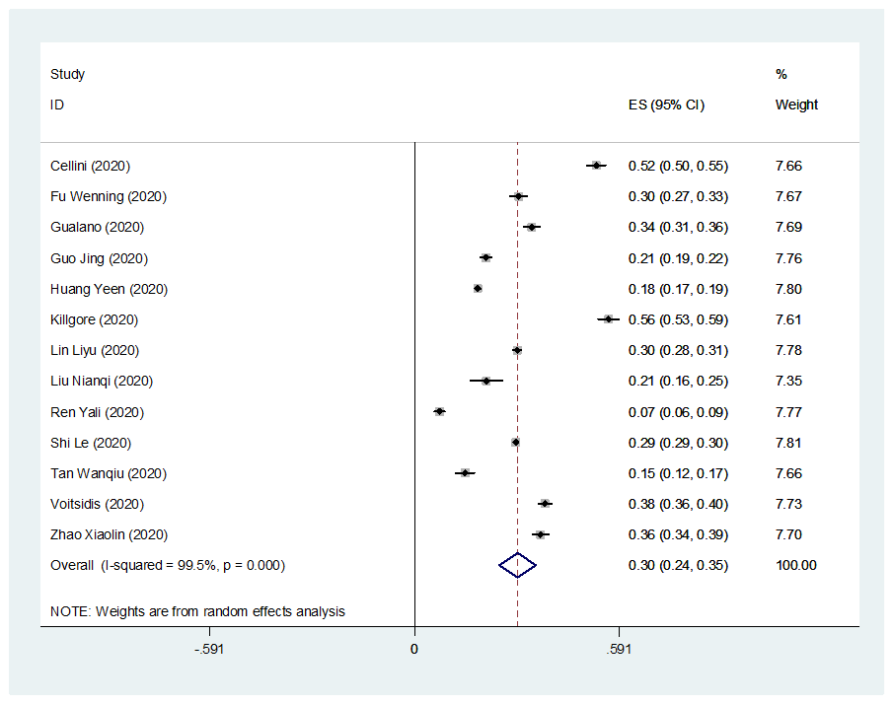

(f) Prevalence of moderate insomnia among general population.
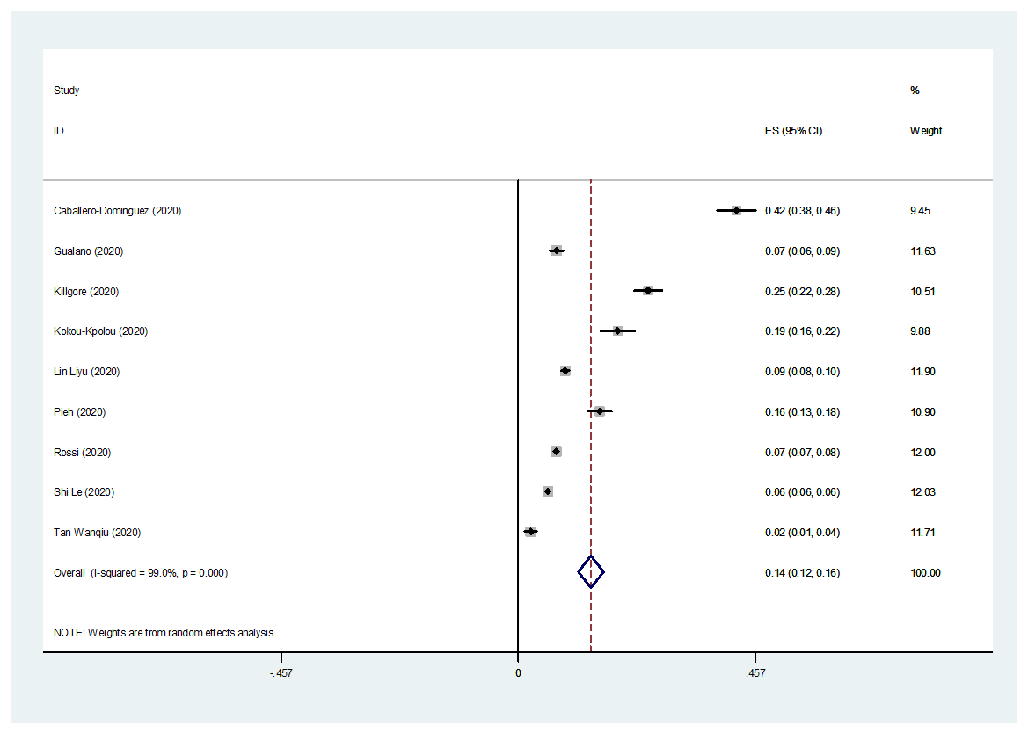

(g) Prevalence of mild depression among health workers.

(h) Prevalence of moderate depression among health workers.

(i) Prevalence of mild anxiety among health workers.

(j) Prevalence of moderate anxiety among health workers.

(k) Prevalence of mild insomnia among health workers.
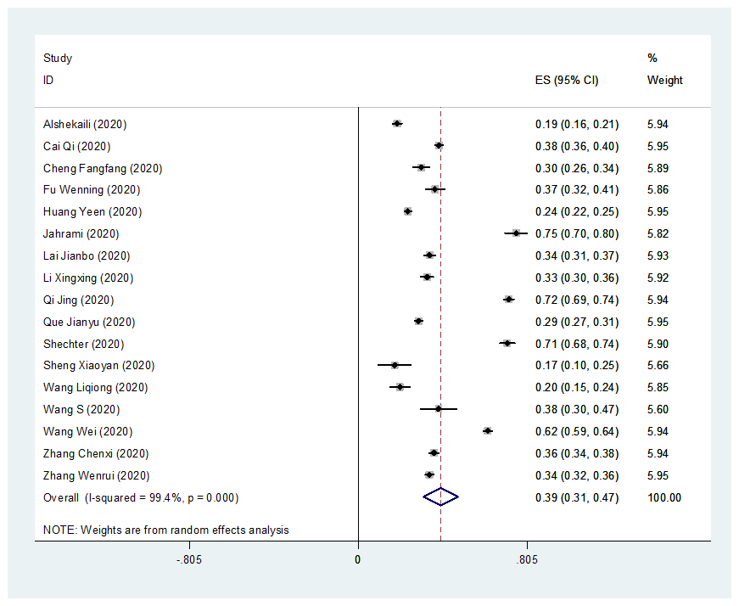

(l) Prevalence of moderate insomnia among health workers.
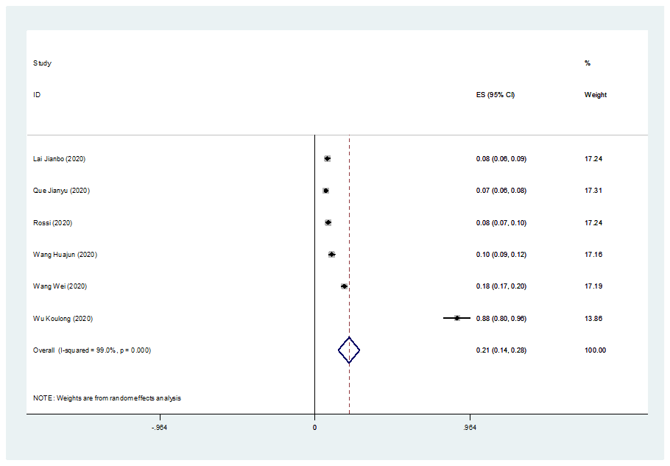

(m) Prevalence of mild depression among university students.

(n) Prevalence of moderate depression among university students.

(o) Prevalence of mild anxiety among university students.

(p) Prevalence of moderate anxiety among university students.

(q) Prevalence of mild insomnia among university students.

(r) Prevalence of mild depression among old adults.

(s) Prevalence of moderate depression among old adults.

(t) Prevalence of mild anxiety among old adults.

(u) Prevalence of moderate anxiety among old adults.

(v) Prevalence of mild depression among infectors.

(w) Prevalence of moderate depression among infectors.

(x) Prevalence of mild anxiety among infectors.

(y) Prevalence of moderate anxiety among infectors.

(z) Prevalence of mild depression among survivors.

(aa) Prevalence of moderate depression among survivors.

(ab) Prevalence of mild anxiety among survivors.

(ac) Prevalence of moderate anxiety among survivors.

(ad) Prevalence of mild depression among the pregnant.

(ae) Prevalence of mild anxiety among the pregnant.
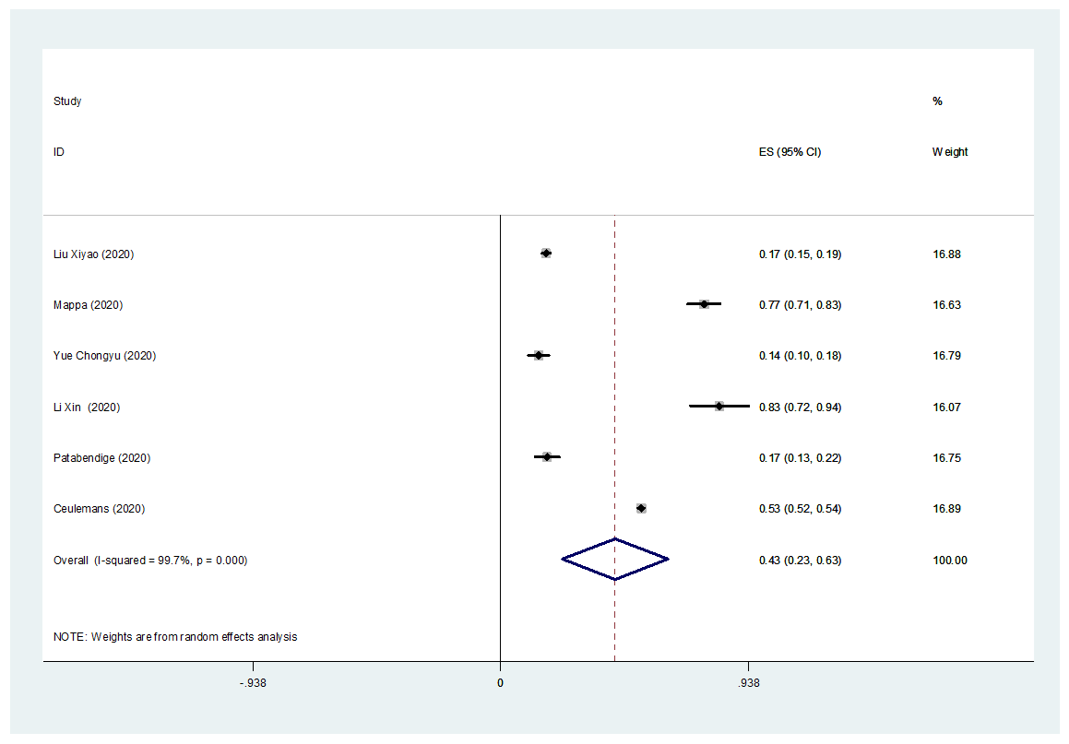

(af) Prevalence of moderate anxiety among the pregnant.
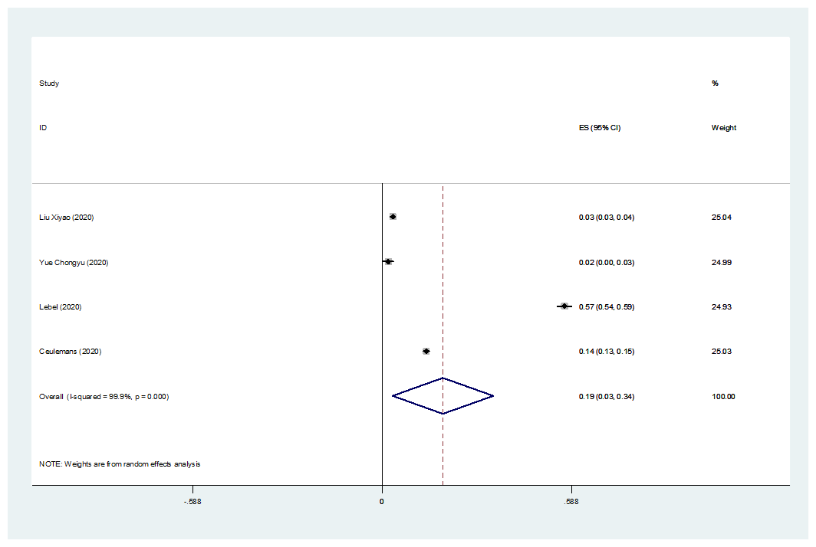

Figure S2. The forest plots of prevalence of mental health symptoms during different types of pandemics.
(a) Prevalence of mild depression symptoms during different types of pandemics.
(b) Prevalence of moderate depression symptoms during different types of pandemics.

(c) Prevalence of mild anxiety symptoms during different types of pandemics.
(d) Prevalence of moderate anxiety symptoms during different types of pandemics.

(e) Prevalence of mild insomnia symptoms during different types of pandemics.
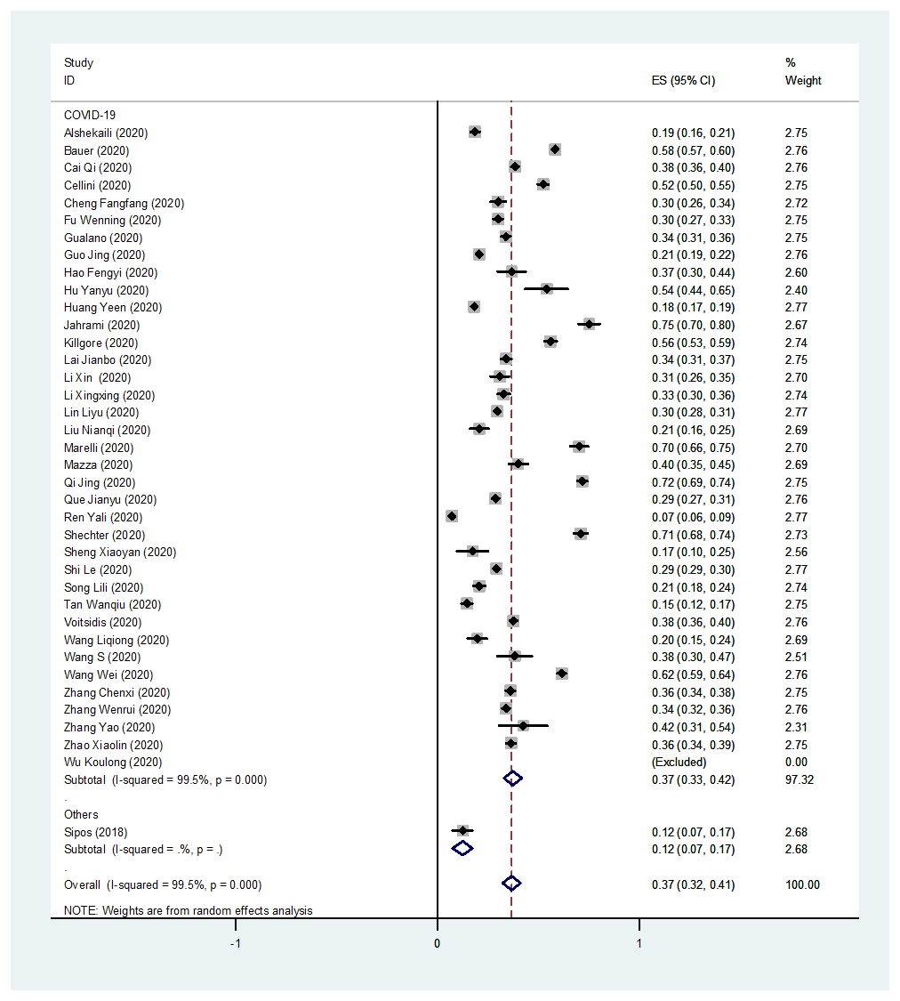

(f) Prevalence of moderate insomnia symptoms during different types of pandemics.
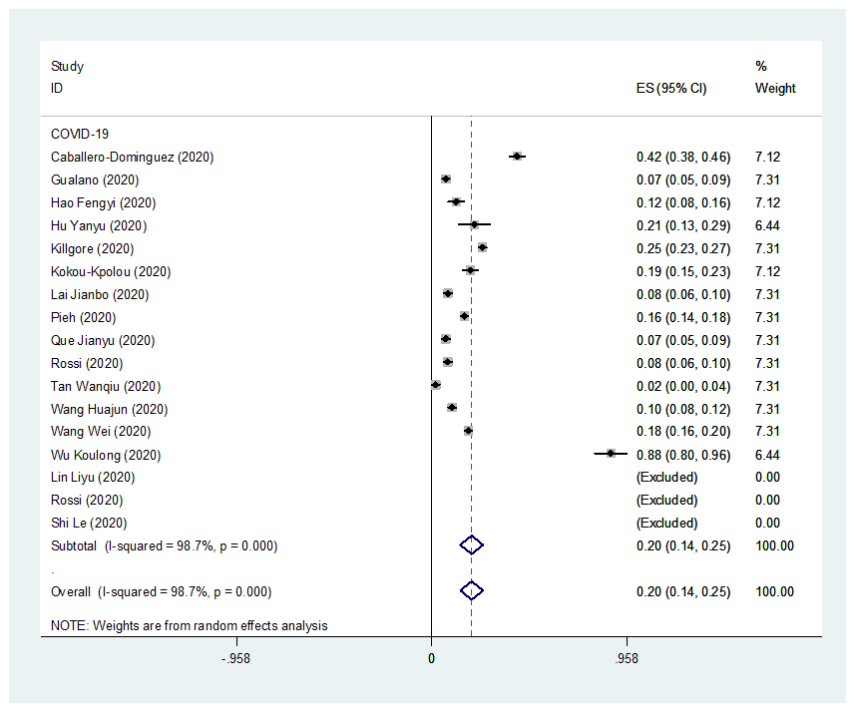

Figure S3. Meta-regression analysis of prevalence of depression, anxiety, and insomnia among different populations during COVID-19 estimated by time.

Prevalence of (a) mild and (b) moderate depression among university students estimated by time.
(a) p = 0.522 (b) p = 0.093
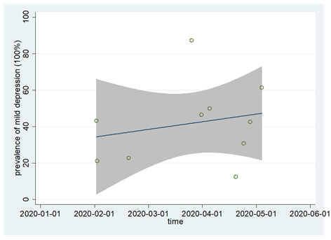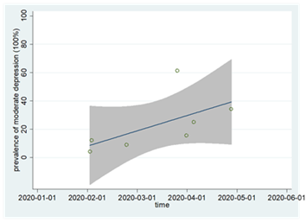

Prevalence of (c) mild and (d) moderate anxiety among university students estimated by time.
(c) p = 0.117 (d) p = 0.002
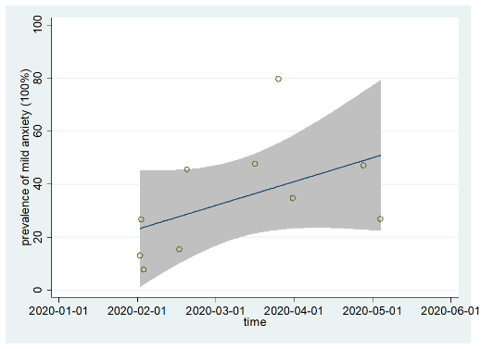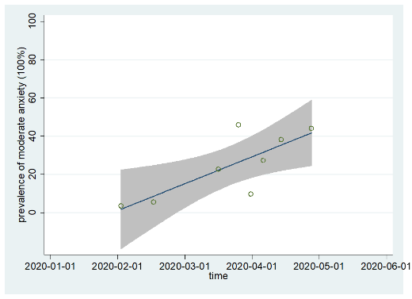

Prevalence of (e) mild and (f) moderate depression among infectors estimated by time.
(e) p = 0.558 (f) p = 0.151
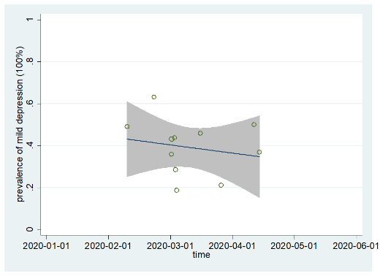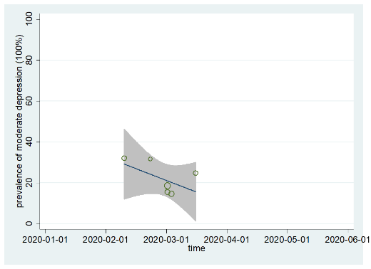

Prevalence of (g) mild and (h) moderate anxiety among infectors estimated by time.
(g) p = 0.642 (h) p = 0.052
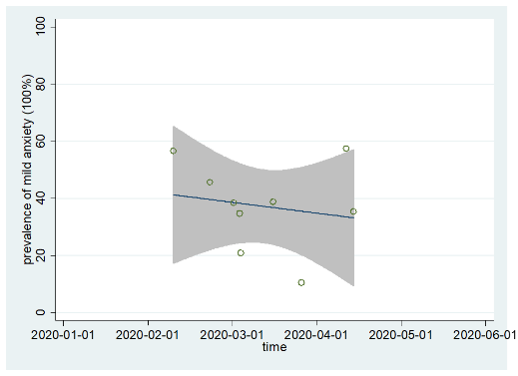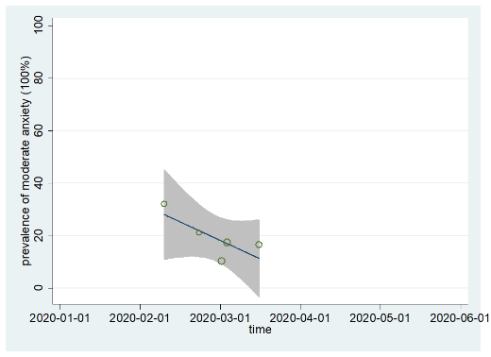
Figure S4. Prevalence of depression, anxiety, and insomnia among different populations across countries.

Maps of prevalence of mild and moderate (a-b) depression, (c-d) anxiety, and (e-f) insomnia among university students across countries.
(a) (b)
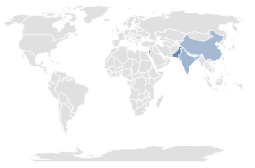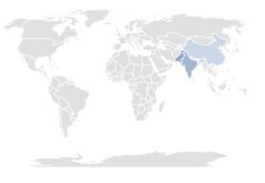
Range: 12.4% (Greece) -87.3% (Jordan) Range: 10.2% (China) -61.4% (Jordan)

(c) (d)
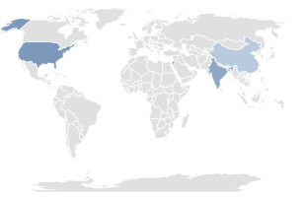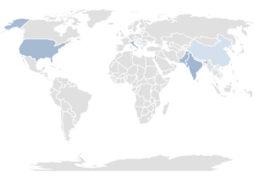
Range: 21.0% (China) -79.7% (Jordan) Range: 4.7% (China) -45.8% (Jordan)

(e) (f)
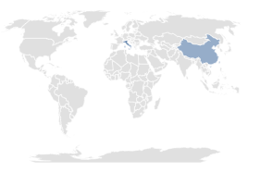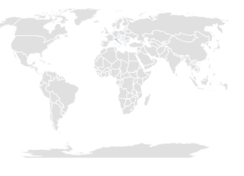
Range: 42.4% (China) -73.3% (Italy) Range: 16.3% (Italy)

Maps of prevalence of mild and moderate (h-i) depression, (j-k) anxiety among old adults across countries.

(h) (i)
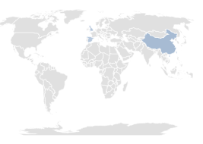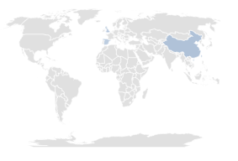
Range: 10.5% (German) -32.4% (Hong Kong, China) Range: 18.6% (Spain)-26.6% (China)

(j) (k)
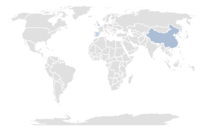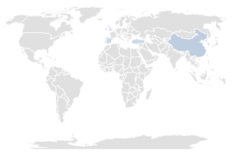
Range: 13.4% (Spain)-37.0% (German) Range: 2.7% (UK)-18.4% (China)

Maps of prevalence of mild and moderate (l-m) depression, (n-o) anxiety, and (p-q) insomnia among infectors across countries.
(l) (m)
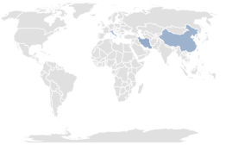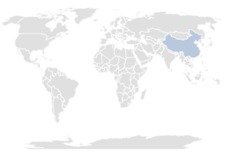
Range: 21.1% (Switzerland)-44.0% (Iran) Range: 21.5% (China)

(n) (o)
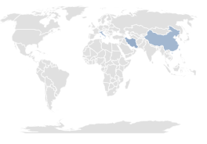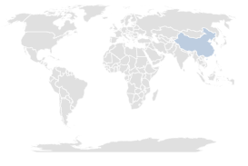
Range: 10.5% (Switzerland)-43.3% (Iran) Range: 19.0% (China)

(p) (q)
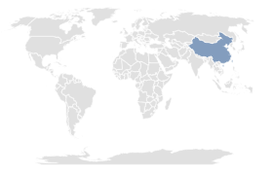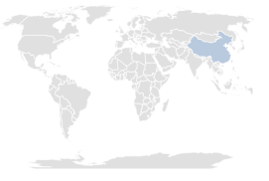
Range: 54.1% (China) Range: 21.1% (China)

Maps of prevalence of mild (r) depression, (s) anxiety, and (t) insomnia among survivors across countries.

(r)
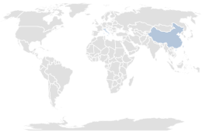
Range: 11.3% (China)-24.2% (Italy)

(s)
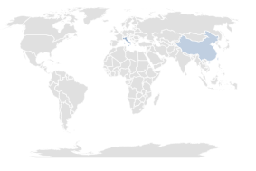
Range: 17.2% (China)-42.2% (Italy)

(t)
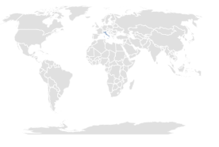
Range: 40.0% (Italy)

Maps of prevalence of (u) mild depression, (v) mild and (w) moderate anxiety, and (x) mild insomnia among the pregnant across countries.

(u)
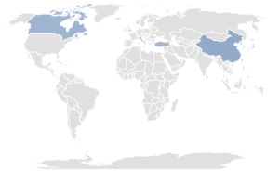
Range: 19.5% (Sri Lanka)-45.1% (China)
(v)
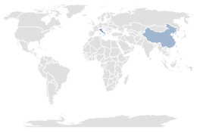
Range: 17.5% (Sri Lanka)-53.1% (Belgium)
(w)
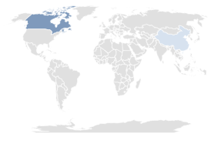
Range: 2.8% (China)-56.6% (Canada)
(x)
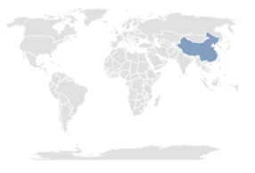
Range: 53.5% (China)

Figure S5. The forest plots of factors in the risk of depression during pandemics

(a) Female (ref: male)

(b) >40 years (ref: <40 years)

(c) High education (ref: low education)

(d) Not married (ref: married)

(e) High income (ref: low income)
(f) Rural area (ref: urban area)

(g) Smoking (ref: no smoking)

(h) Drinking (ref: no drinking)

(i) Living alone (ref: not living alone)
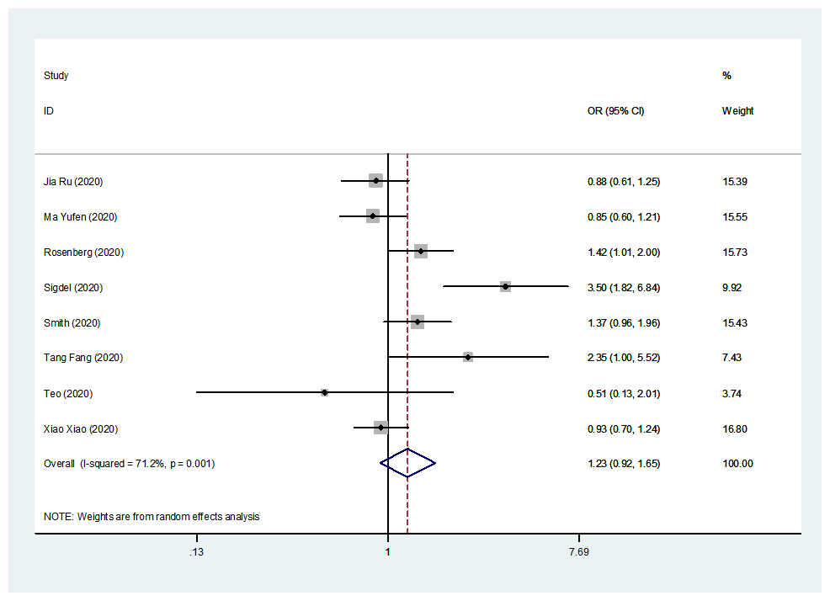

(j) Emergency experience (ref: no emergency experience)
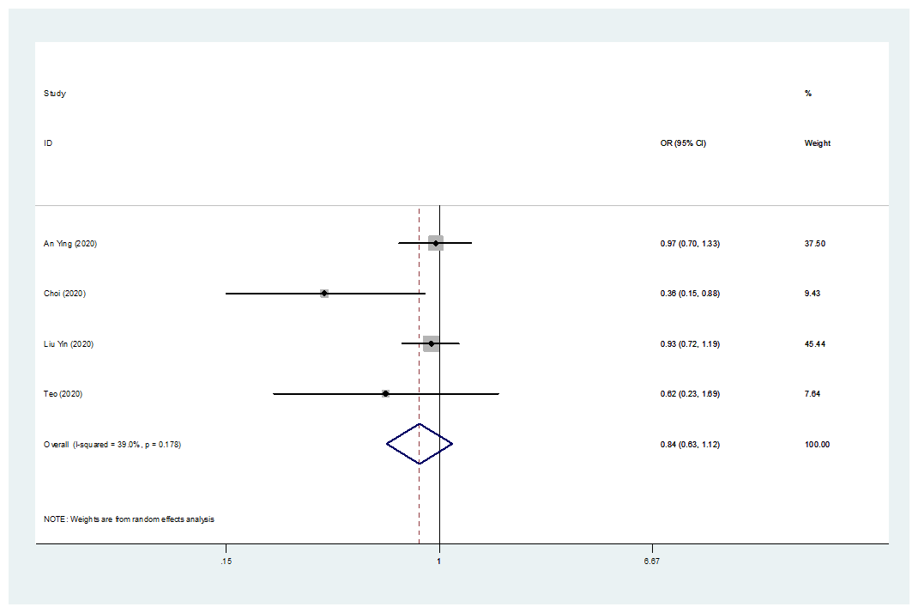

(k) Physical disorder (ref: no physical disorder)

(l) Mental disorder (ref: no mental disorder)

(m) Infected (ref: not infected)
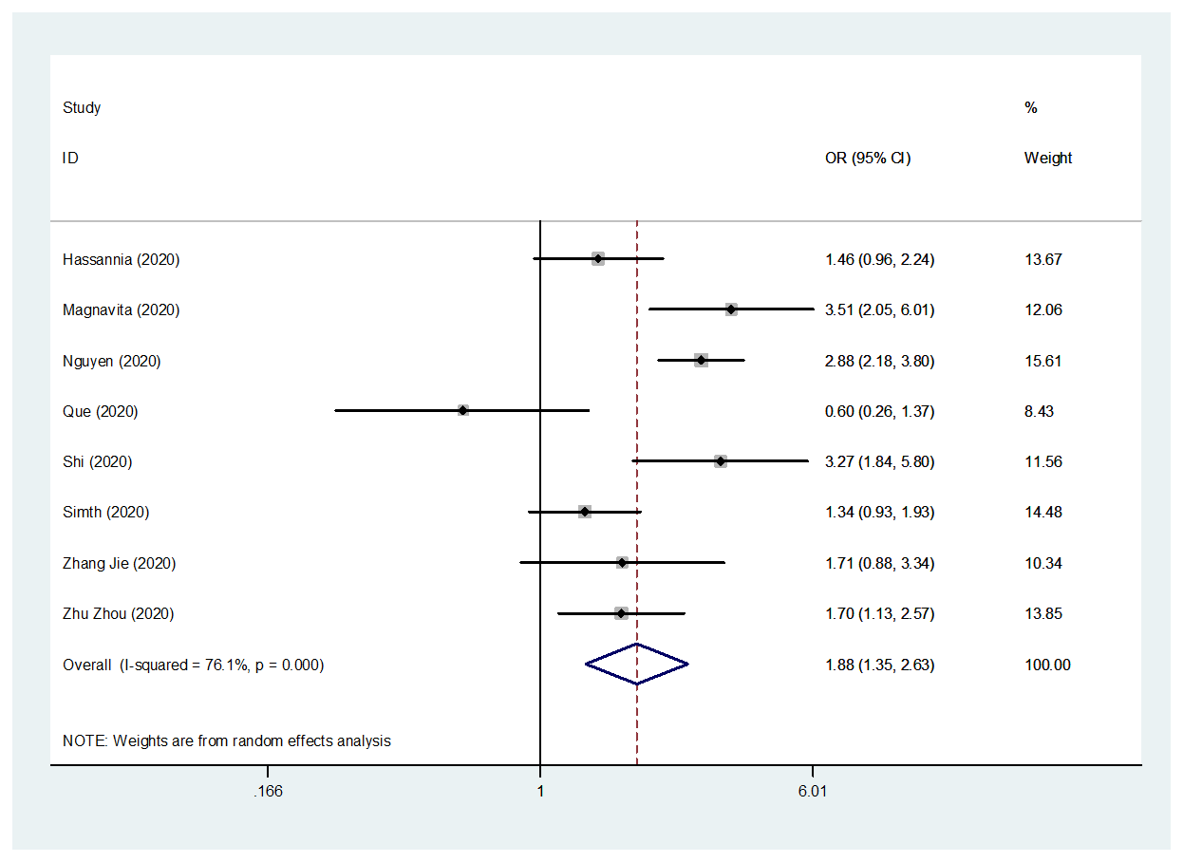

(n) Colleagues or family members infected (ref: no colleagues or family members infected)

(o) Frontline (ref: non-frontline)
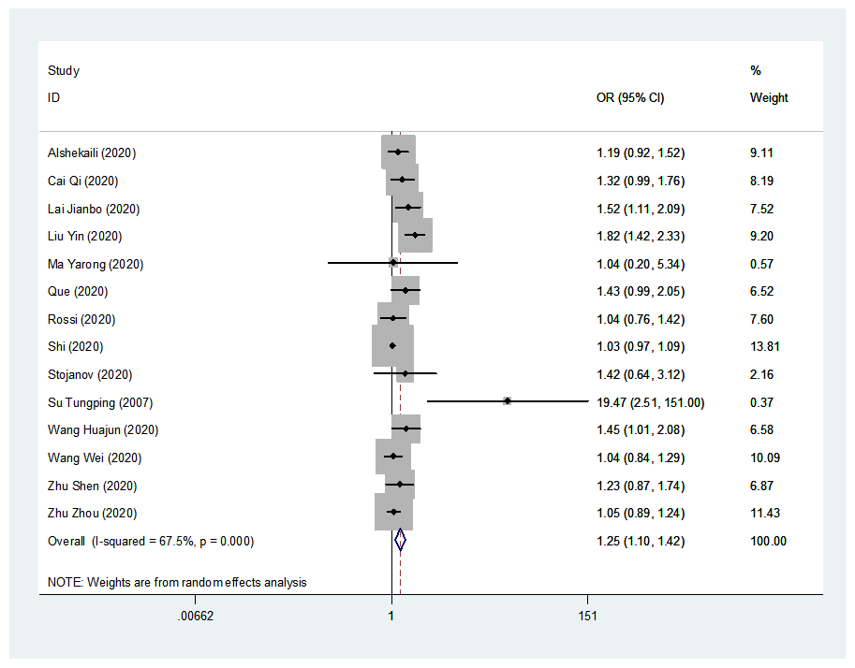

(p) Closely contact with infector (ref: not closely contact with infector)

(q) High epidemic location (ref: low epidemic location)
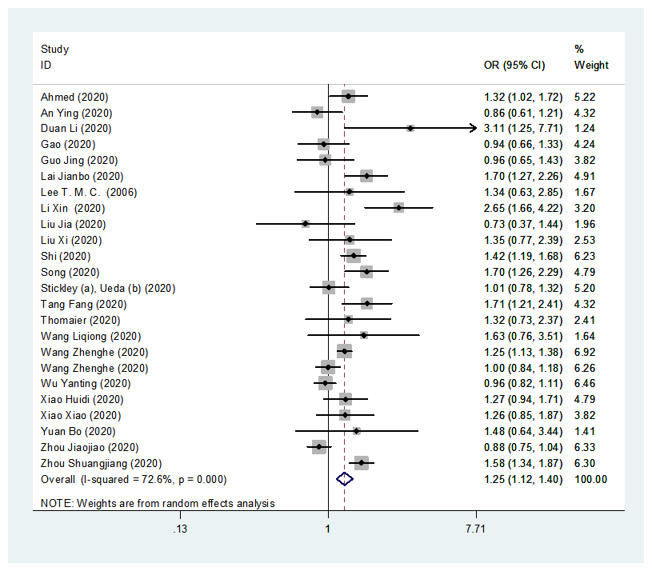

(r) High exposure risk (ref: low exposure risk)
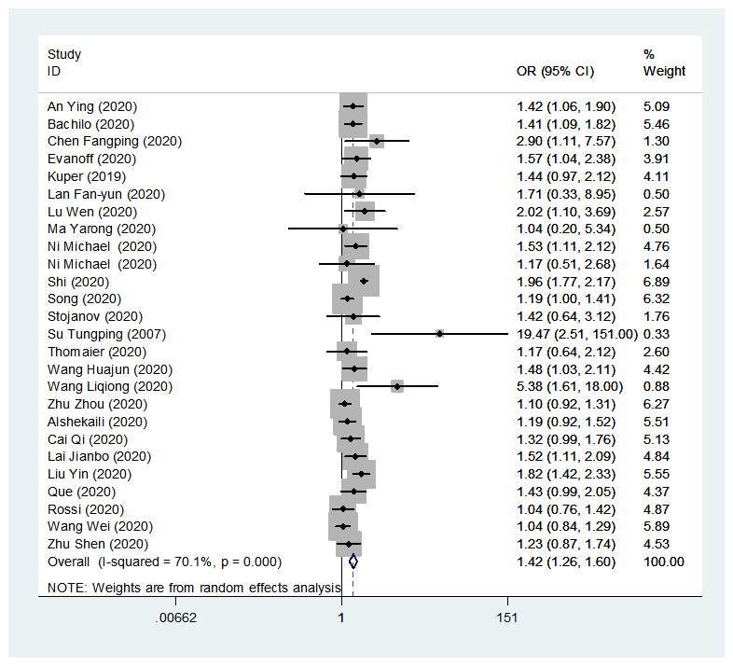

(s) Working (ref: not working)

(t) Highly concerned about epidemic (ref: not highly concerned about epidemic)
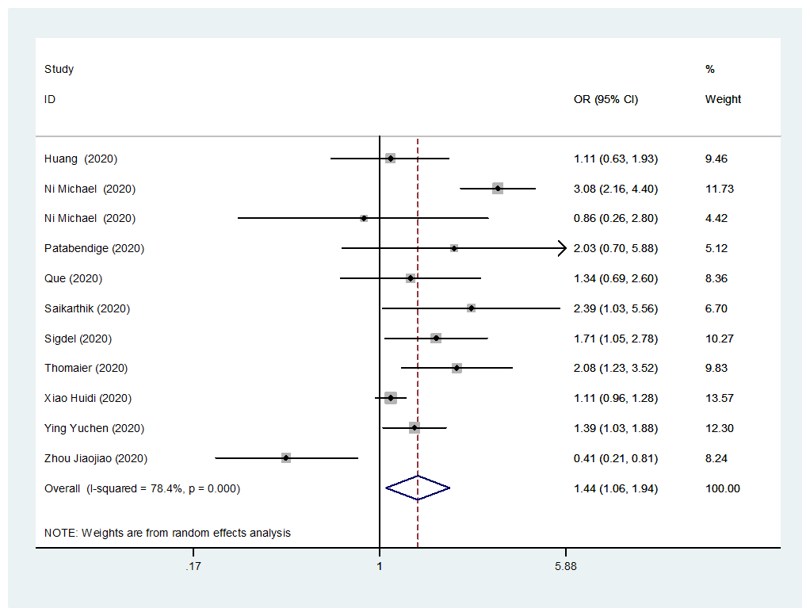

(u) Quarantine (ref: not quarantine)

(v) Good social support (ref: poor social support)
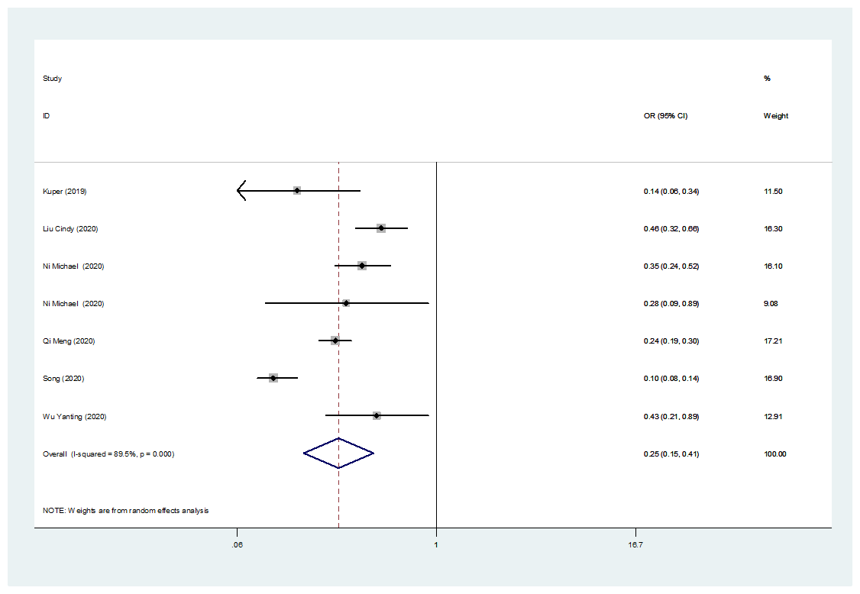

(w) Exercise frequently (ref: exercise less frequently)
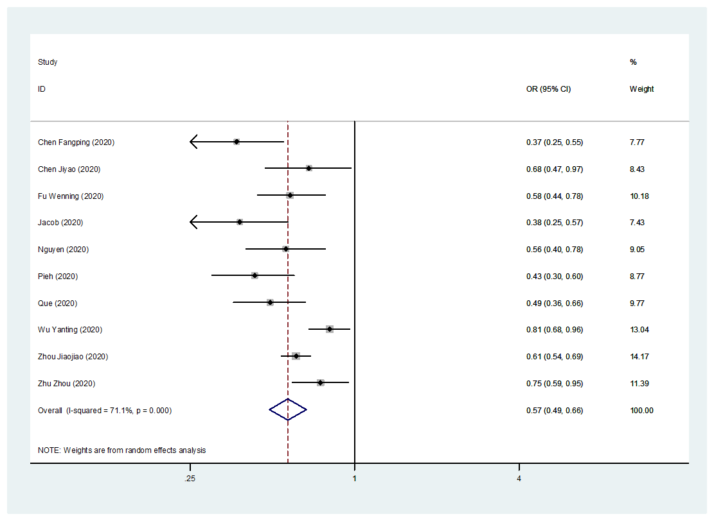

(x) Frequent preventive behavior (ref: less frequent preventive behavior)

Figure S6. The forest plots of factors in the risk of anxiety during pandemics

(a) Female (ref: male)

(b) >40 years (ref: <40 years)

(c) High education (ref: low education)

(d) Not married (ref: married)

(e) High income (ref: low income)

(f) Rural area (ref: urban area)

(g) Smoking (ref: no smoking)

(h) Drinking (ref: no drinking)

(i) Living alone (ref: not living alone)

(j) Emergency experience (ref: no emergency experience)

(k) Physical disorder (ref: no physical disorder)

(l) Mental disorder (ref: no mental disorder)

(m) Infected (ref: not infected)

(n) Colleagues or family members infected (ref: no colleagues or family members infected)

(o) Frontline (ref: non-frontline)

(p) Closely contact with infector (ref: not closely contact with infector)

(q) High epidemic location (ref: low epidemic location)

(r) High exposure risk (ref: low exposure risk)

(s) Working (ref: not working)

(t) Highly concerned about epidemic (ref: not highly concerned about epidemic)

(u) Quarantine (ref: not quarantine)

(v) Good social support (ref: poor social support)

(w) Exercise frequently (ref: exercise less frequently)

(x) Frequent preventive behavior (ref: less frequent preventive behavior)

Figure S7. The forest plots of factors in the risk of insomnia during pandemics

(a) Female (ref: male)

(b) >40 years (ref: <40 years)

(c) High education (ref: low education)

(d) Not married (ref: married)
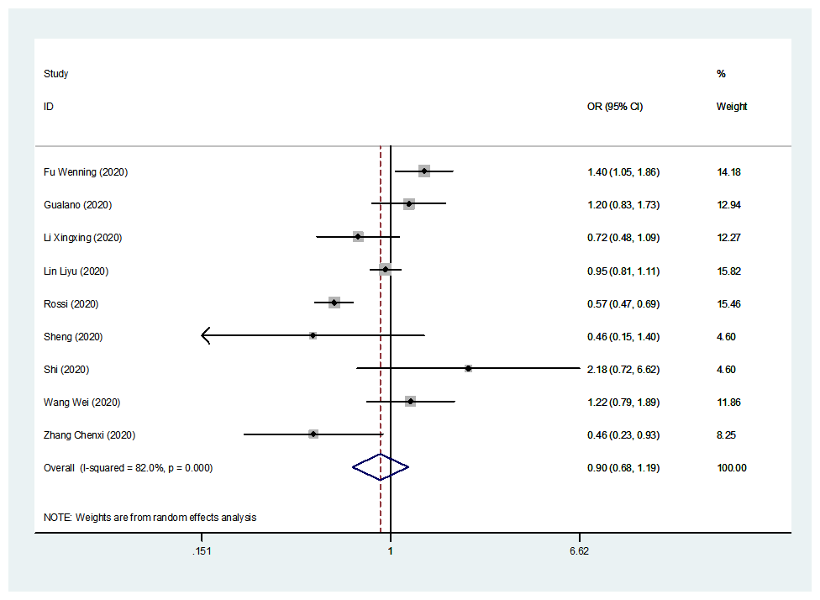

(e) High income (ref: low income)
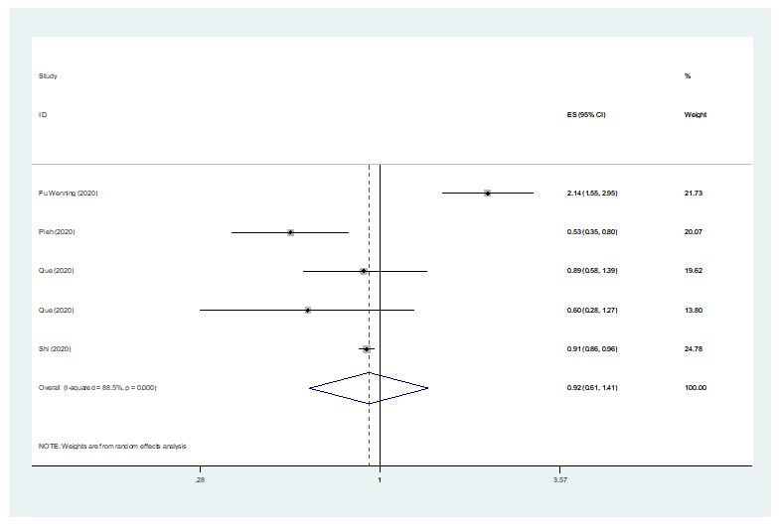

(f) Rural area (ref: urban area)
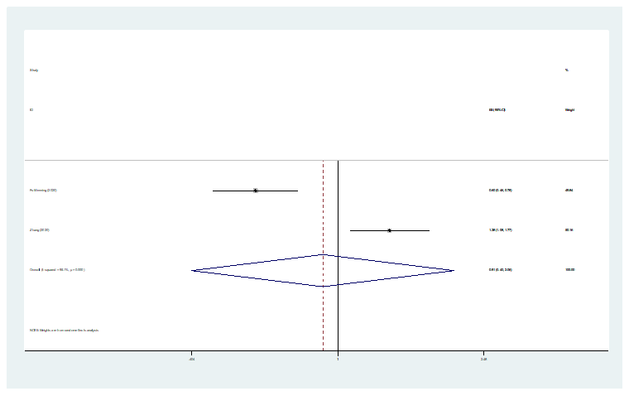

(g) Smoking (ref: no smoking)
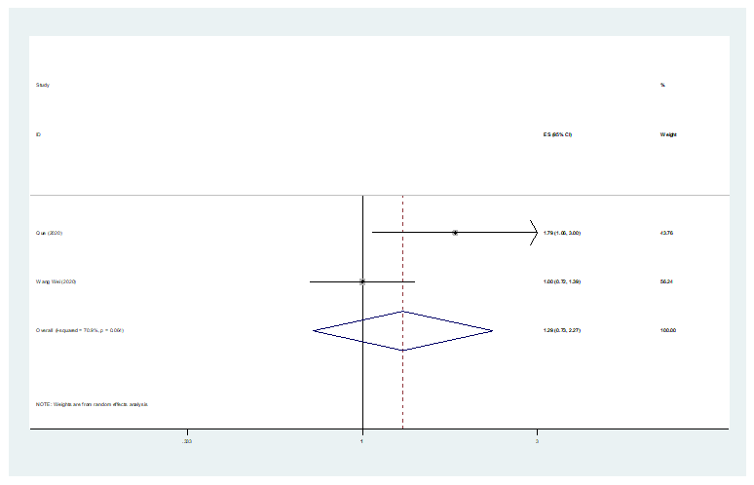

(h) Drinking (ref: no drinking)
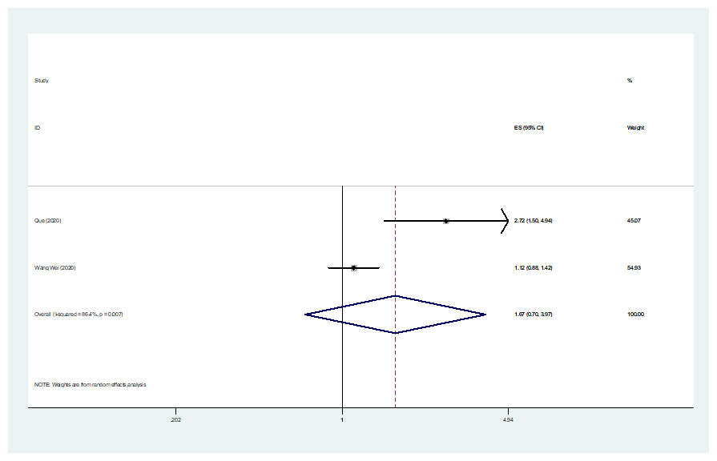

(i) Physical disorder (ref: no physical disorder)

(j) Mental disorder (ref: no mental disorder)

(k) Infected (ref: not infected)

(l) Colleagues or family members infected (ref: no colleagues or family members infected)

(m) Frontline (ref: non-frontline)

(n) Closely contact with infector (ref: not closely contact with infector)

(o) High epidemic location (ref: low epidemic location)

(p) High exposure risk (ref: low exposure risk)

(q) Working (ref: not working)

(r) Highly concerned about epidemic (ref: not highly concerned about epidemic)

(s) Quarantine (ref: not quarantine)

(t) Exercise frequently (ref: exercise less frequently)

(u) Frequent preventive behavior (ref: less frequent preventive behavior)

Figure S8. The sensitivity analysis.
(a1-10) The sensitivity analysis of prevalence of mild depression among different populations during different pandemics.
(a1) general population
(a2) health workers
(a3) university students
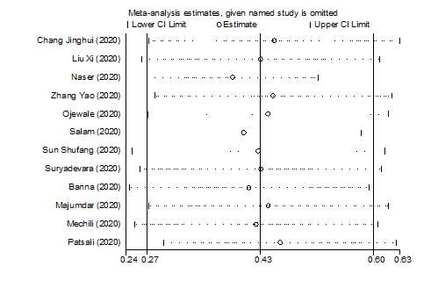
(a4) old adults
(a5) infectors
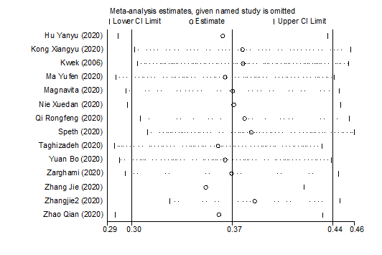
(a6) survivors
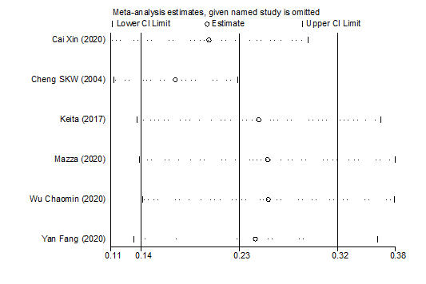
(a7) pregnant
(a8) COVID-19看不清
(a9) SARS
(a10) other pandemics

(b1-10) The sensitivity analysis of prevalence of mild anxiety among different populations during different pandemics.
(b1) general population
(b2) health workers
(b3) university students
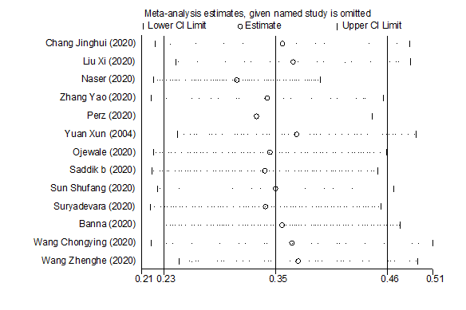
(b4) old adults
(b5) infectors
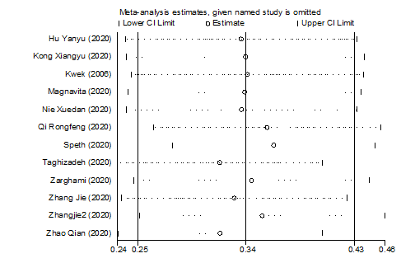
(b6) survivors
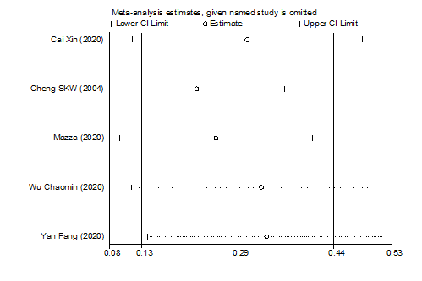
(b7) pregnant
(b8) COVID-19
(b9) SARS
(b10) other pandemics

(c1-3) The sensitivity analysis of prevalence of mild insomnia among different populations during different pandemics.
(c1) general population
(c2) health workers
(c3) COVID-19

(d1-6) The sensitivity analysis of prevalence of moderate depression among different populations during different pandemics.
(d1) general population
(d2) health workers
(d3) university students
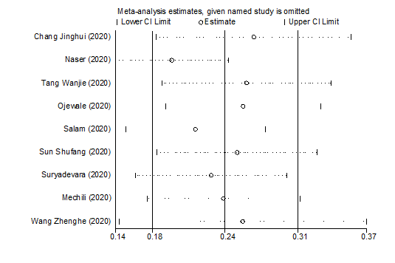
(d4) infectors
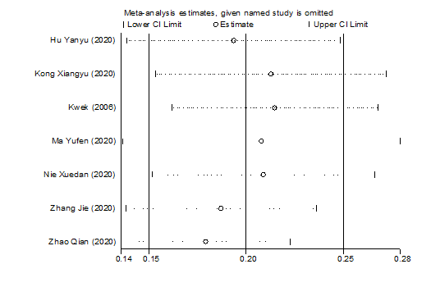
(d5) COVID-19
(d6) SARS

(e1-7) The sensitivity analysis of prevalence of moderate anxiety among different populations during different pandemics.
(e1) general population
(e2) health workers
(e3) university students
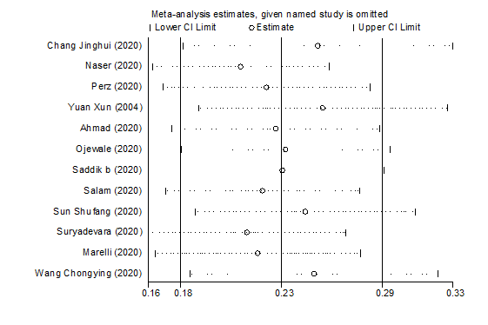
(e4) old adults
(e5) infectors
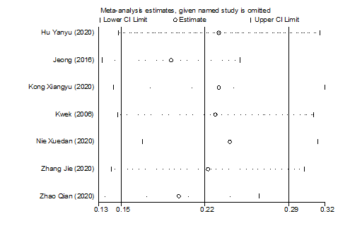
(e6) COVID-19
(e7) SARS

(f1-3) The sensitivity analysis of prevalence of moderate insomnia among different populations during different pandemics.
(f1) general population
(f2) health workers
(f3) COVID-19

(g1-g24) The sensitivity analysis of factors associated with depression during pandemics.
(g1) gender
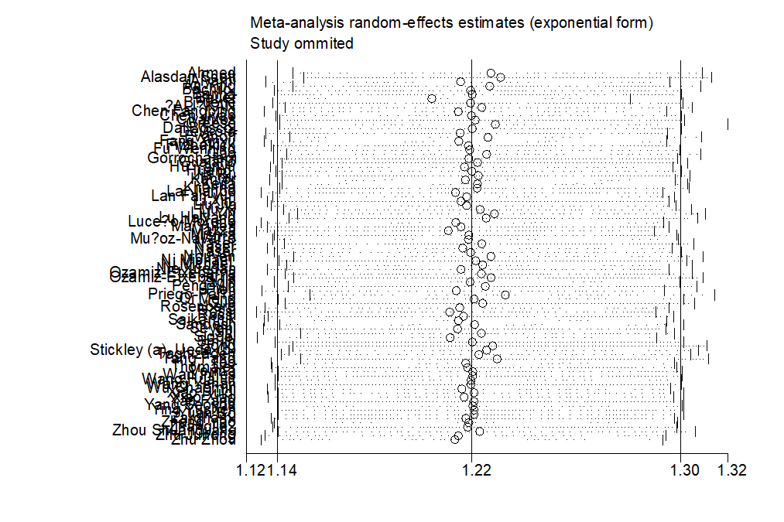
(g2) age
(g3) education level

(g4) marital status
(g5) income level
(g6) living area

(g7) smoking
(g8) drinking
(g9) living alone
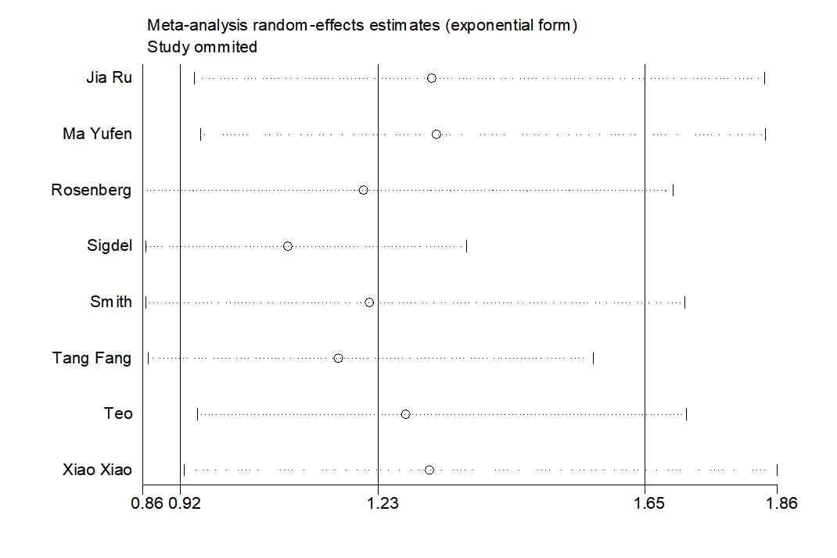

(g10) physical disorders

(g11) mental disorders

(g12) confirmed or suspected infection
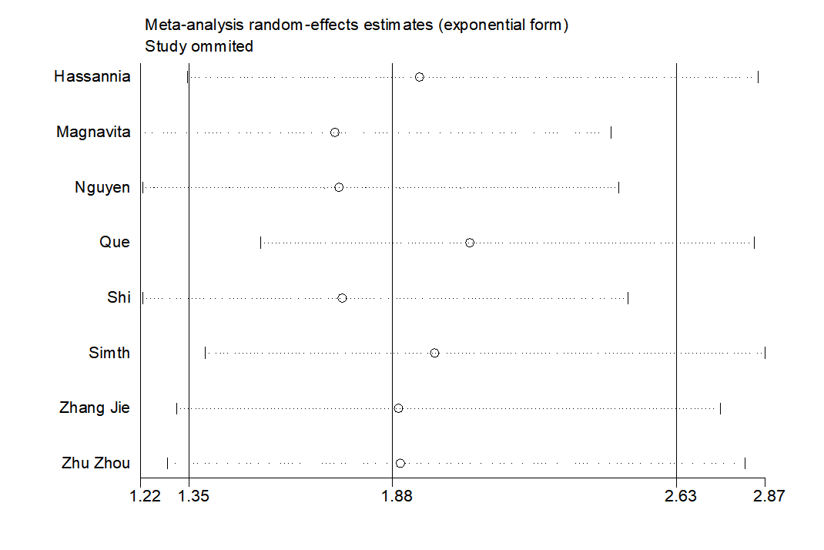

(g13) colleagues or family members infected

(g14) frontline
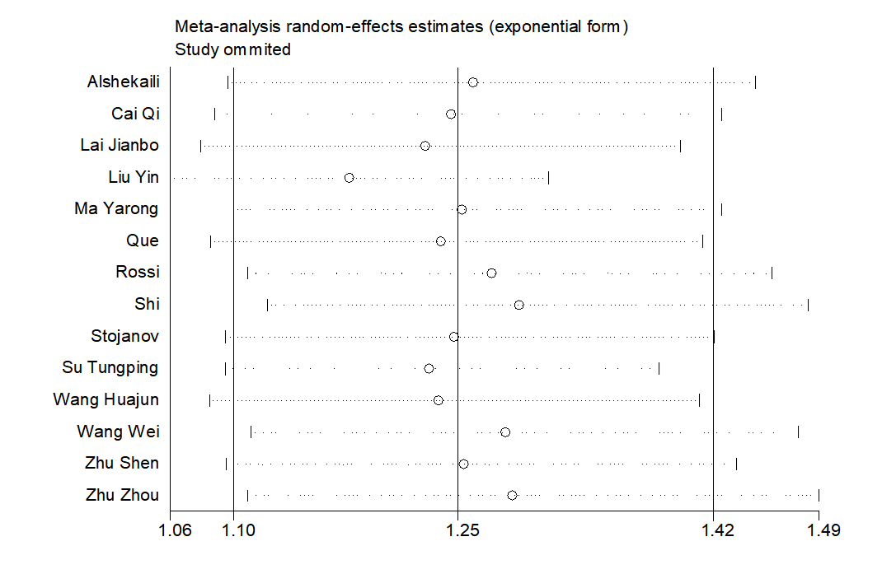

(g15) closely contact with infectors

(g16) high epidemic location
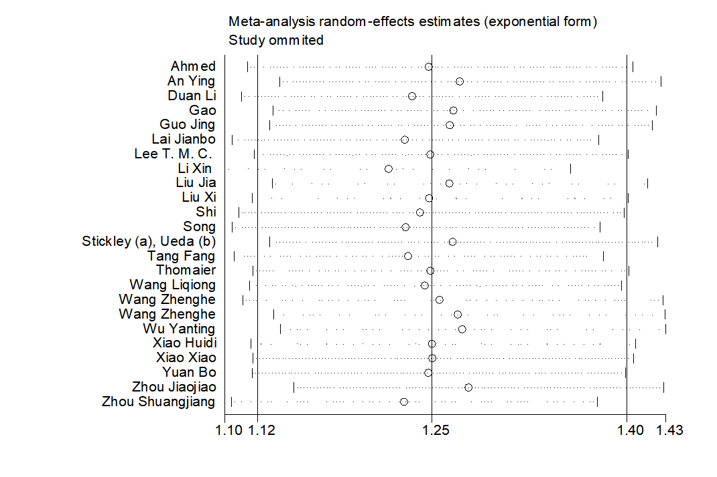

(g17) high exposure risk
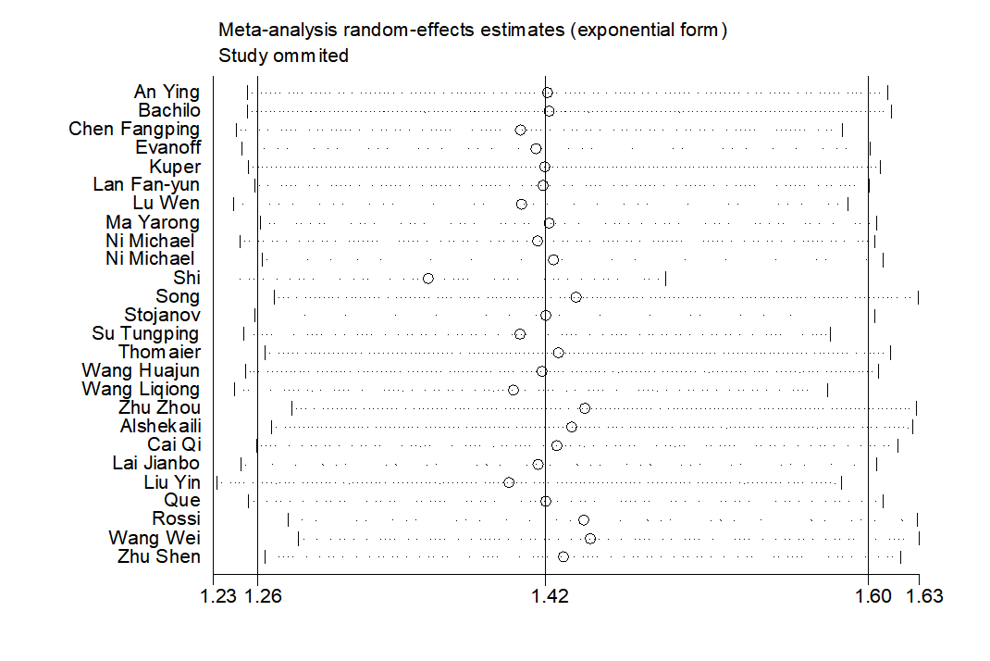

(g18) working

(g19) high concerned about epidemics
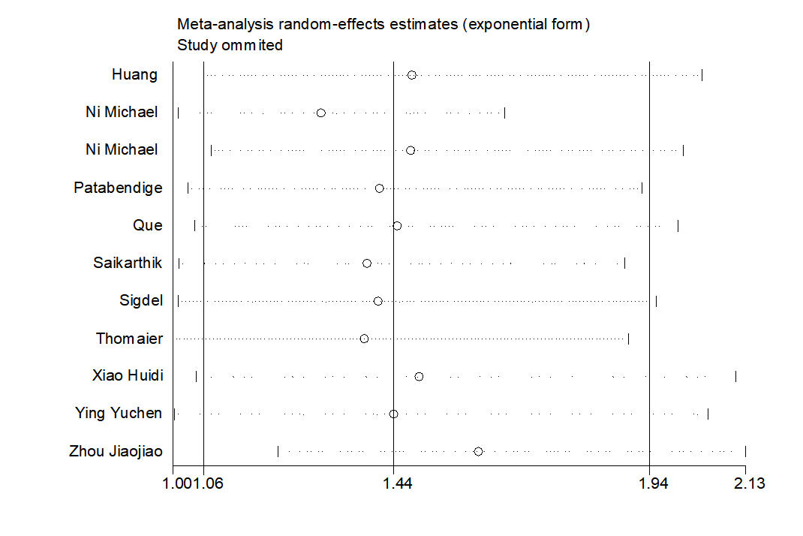

(g20) quarantine
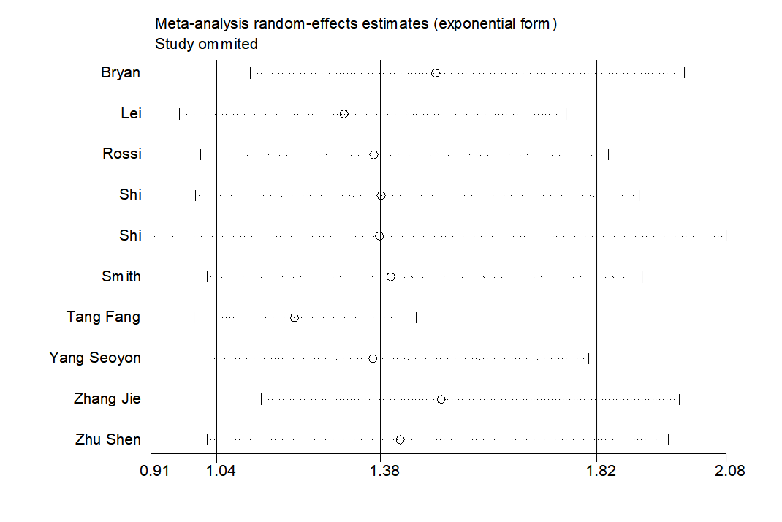

(g21) social support
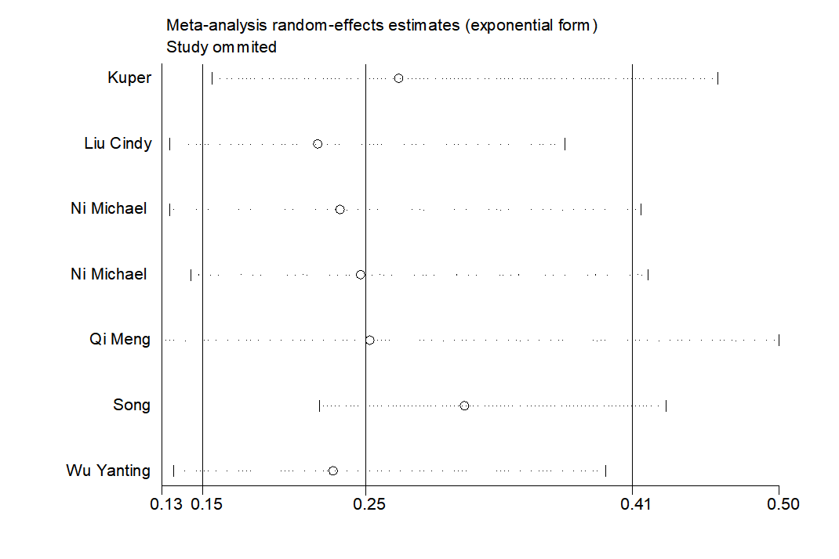

(g22) exercise
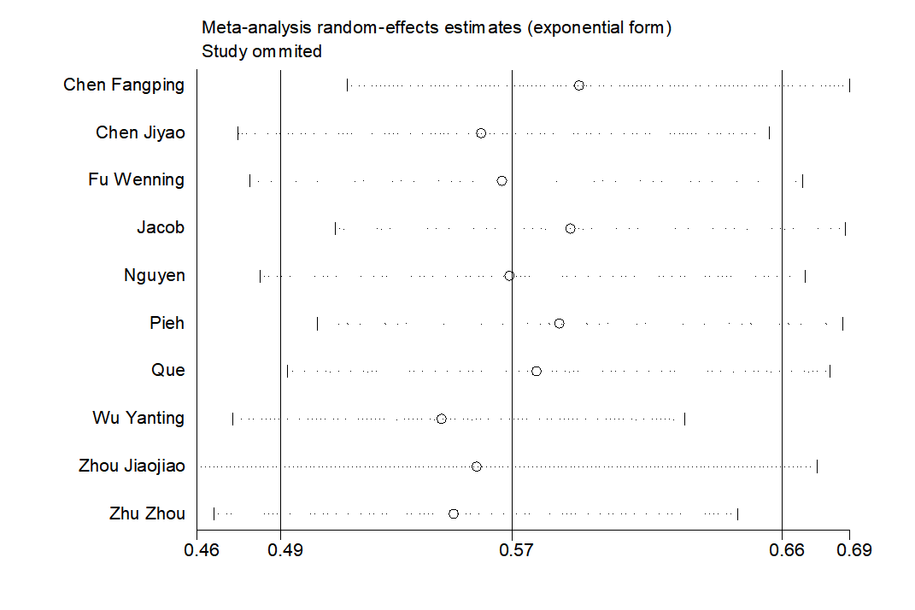

(g23) frequent preventive behavior
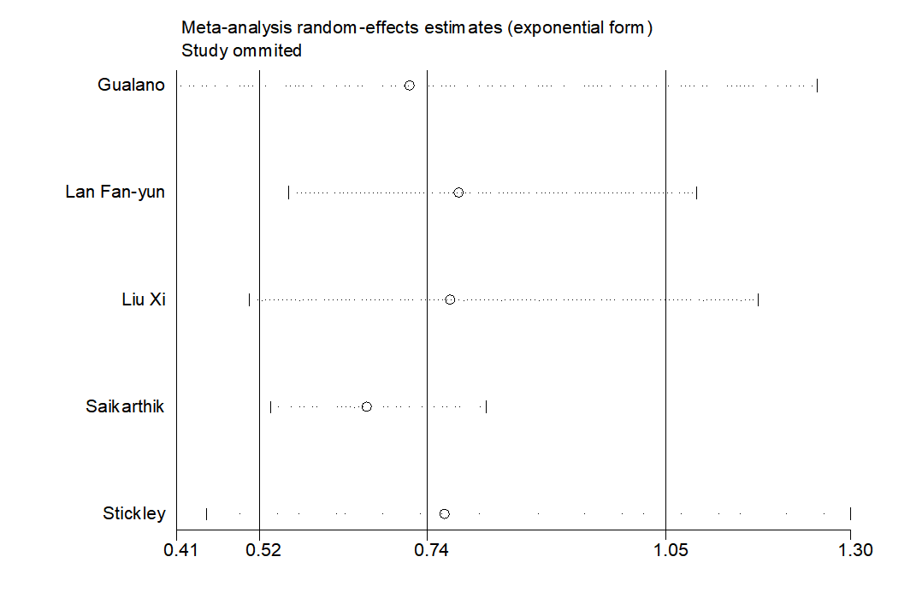

(h1-h23) The sensitivity analysis of factors associated with anxiety during pandemics.

(h1) gender
(h2) age
(h3) education level
(h4) marital status
(h5) income level
(h6) living area

(h7) smoking
(h8) drinking
(h9) living alone
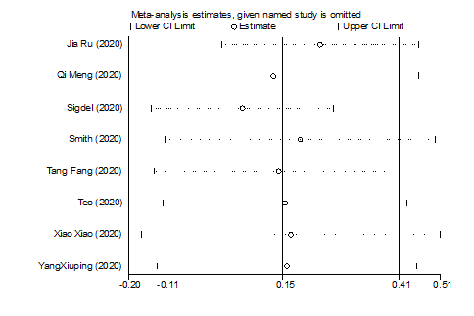

(h10) physical disorder
(h11) mental disorder
(h12) confirmed or suspected infected

(h13) Colleagues or family members infected
(h14) frontline
(h15) closely contact with infector

(h16) High epidemic location
(h17) High exposure risk
(h18) working

(h19) Highly concerned about epidemic
(h20) Quarantine
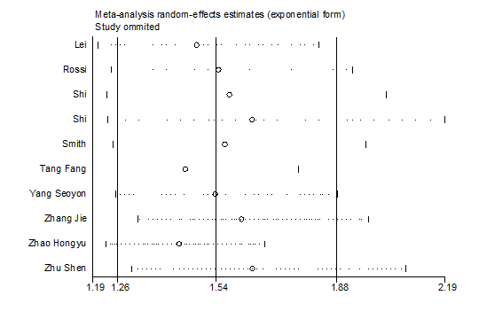
(h21) social support

(h22) exercise
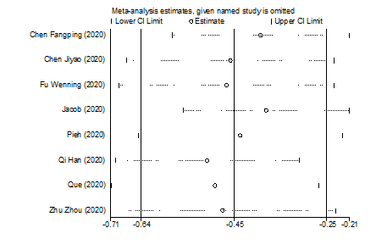
(h23) preventive behavior
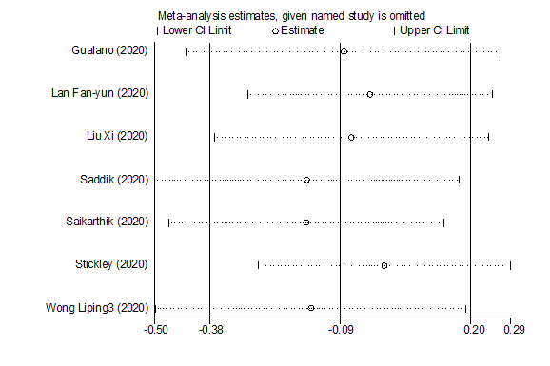

(i1-i3) The sensitivity analysis of factors associated with insomnia during pandemics.

(i1) gender
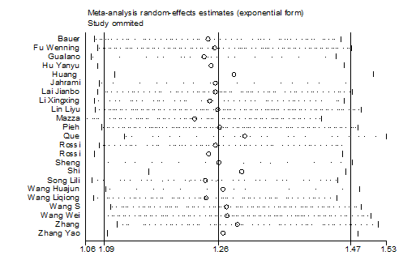
(i2) age
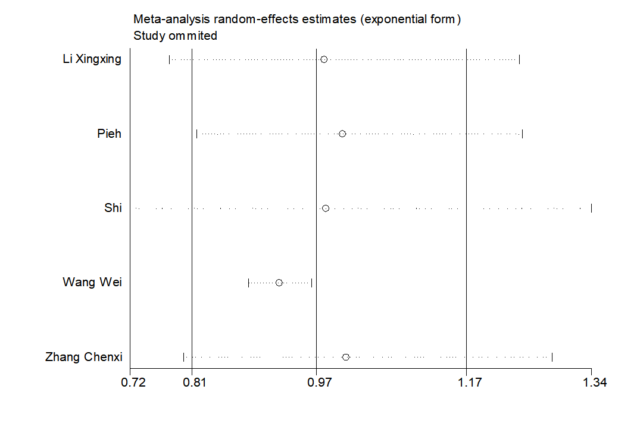
(i3) education level
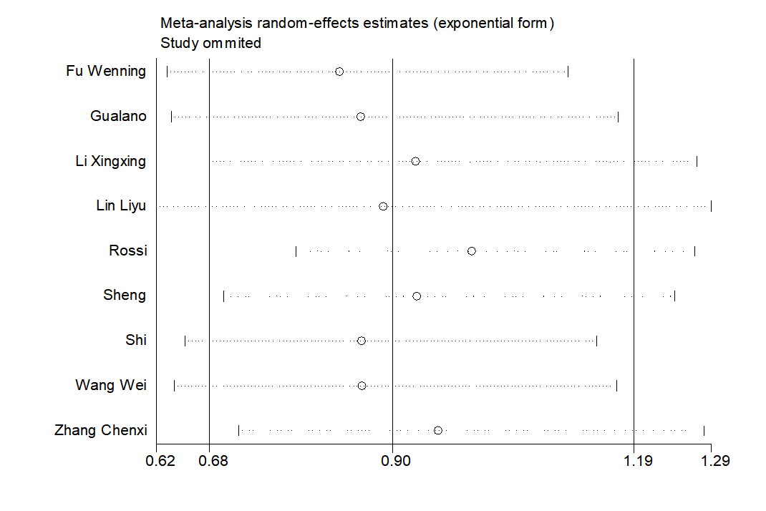

(i4) marital status

(i5) mental disorders
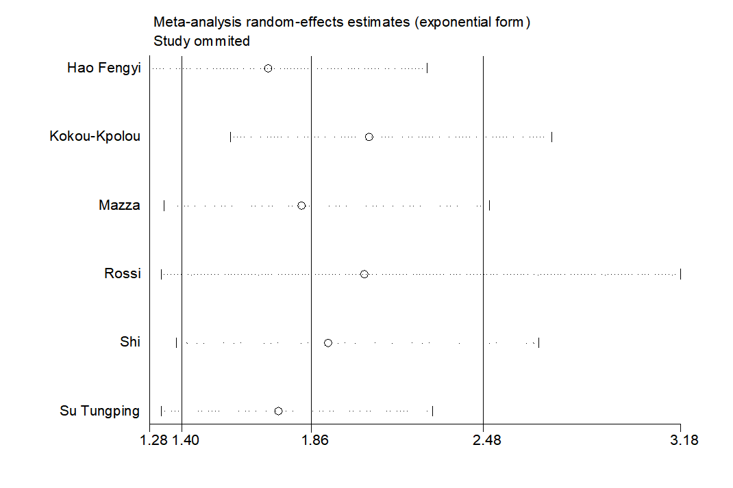

(i6) confirmed or suspected infection
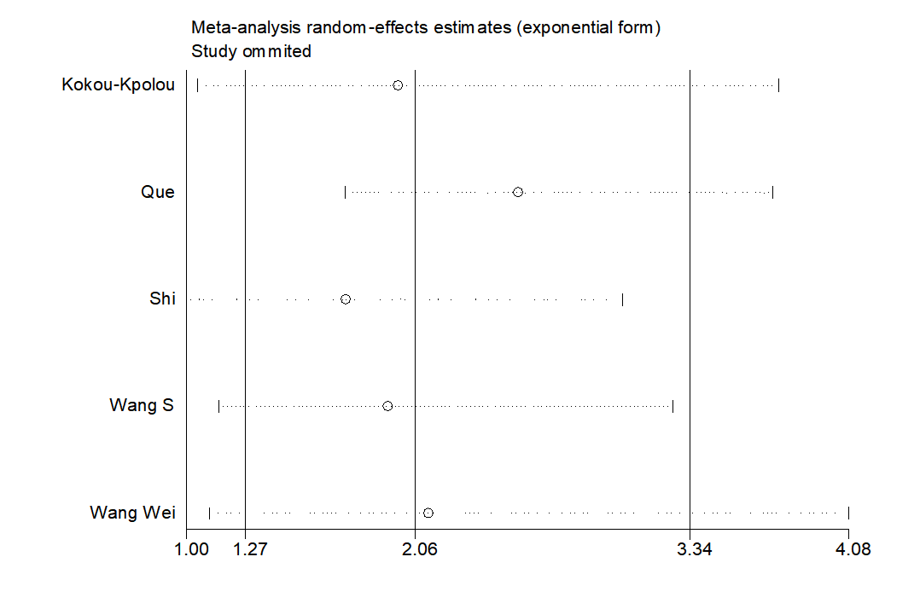

(i7) colleagues or family members infected
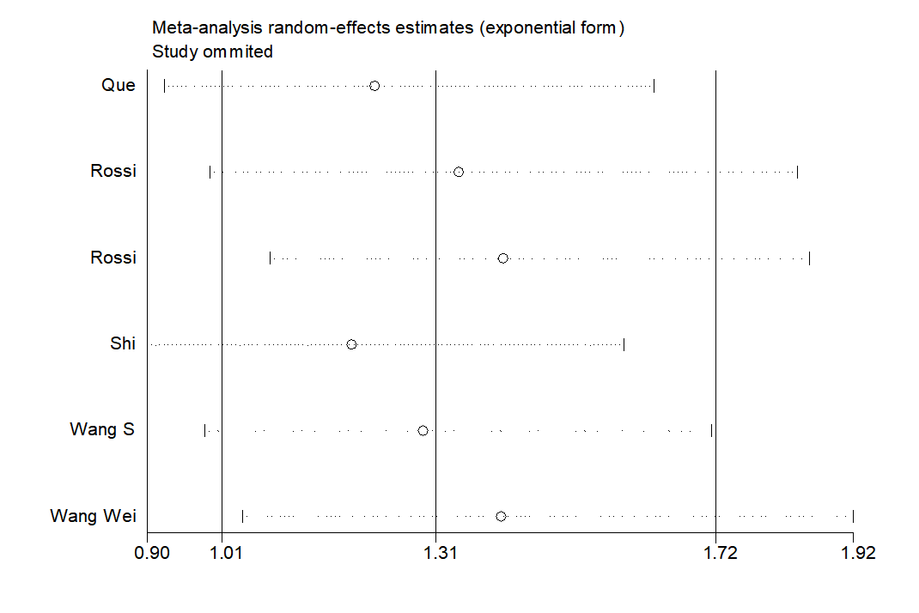

(i8) frontline
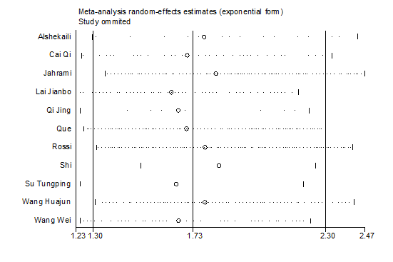

(i9) closely contact with infectors
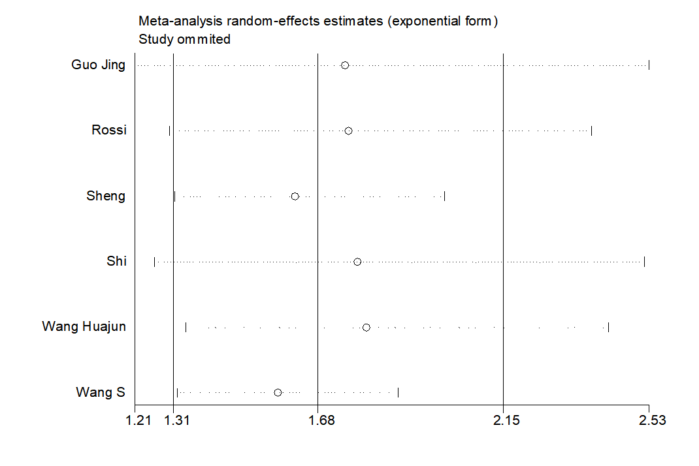

(i10) high epidemic location
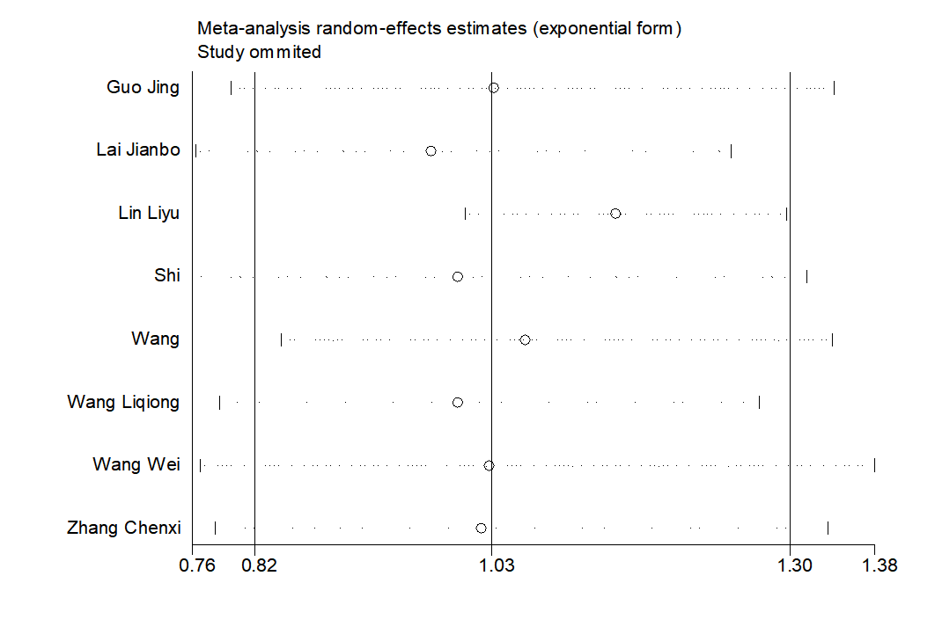
(i11) high exposure risk
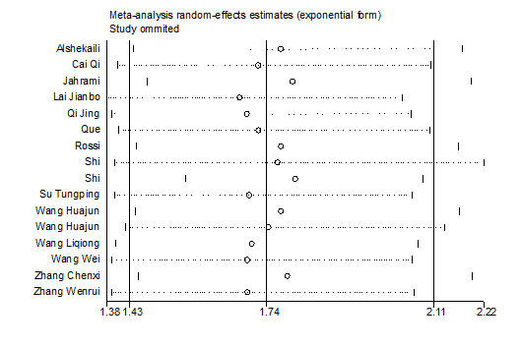
(i12) working
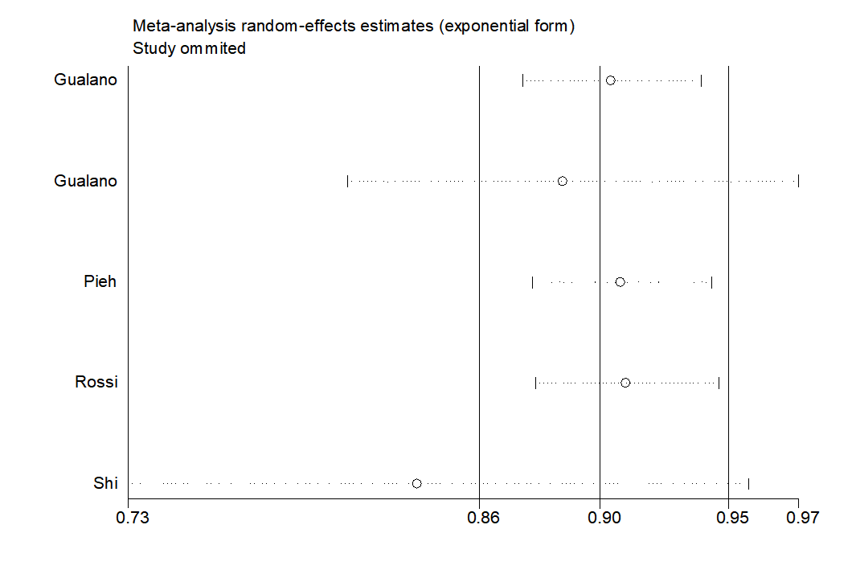
Figure S9. The results of funnel plots and p-value of Begg’s test.
(a1-10) The funnel plots of prevalence of mild depression among different populations during different pandemics.
(a1) General public
p = 0.706
(a2) Health worker
p = 0.8
(a3) University student
p = 0.373
(a4) Old adult
p = 0.917
(a5) Infector
p = 0.05
(a6) Survivor
p = 0.133

(a7) Pregnant
p = 0.266
(a8) COVID-19
p = 0.549
(a9) SARS
p = 0.458
(a10) other pandemics
p = 0.348

(b1-10) The funnel plots of prevalence of mild anxiety among different populations during different pandemics.
(b1) General public
p = 0.346
(b2) Health worker
p = 0.323
(b3) University student
p = 0.76
(b4) Old adult
p = 0.462
(b5) Infector
p = 0.103
(b6) Survivor
p = 0.13

(b7) Pregnant
p = 0.707
(b8) COVID-19
p = 0.115
(b9) SARS
p = 0.035
(b10) other pandemics
p = 0.027

(c1-3) The funnel plots of prevalence of mild insomnia among different populations during different pandemics.
(c1) General public
p = 0.502
(c2) Health worker
p = 0.484
(c3) COVID-19
p = 0.383

(d1-8) The funnel plots of prevalence of moderate depression among different populations during different pandemics.
(d1) General public
p = 0.172
(d2) Health worker
p = 0.108
(d3) University student
p = 0.295
(d4) Old adult
p = 0.296
(d5) Infector
p = 0.755
(d6) Survivor
p = 1.0
(d7) COVID-19
p = 0.029
(d8) SARS
p = 0.308

(e1-9) The funnel plots of prevalence of moderate anxiety among different populations during different pandemics.
(e1) General public
p = 0.057
(e2) Health worker
p = 0.098
(e3) University student
p = 0.15
(e4) Old adult
p = 0.707
(e5) Infector
p = 0.074
(e6) Survivor
p = 1.0
(e7) Pregnant
p = 0.308
(e8) COVID-19
p = 0.019
(e9) SARS
p = 1.0

(f1-3) The funnel plots of prevalence of moderate insomnia among different populations during different pandemics.
(f1) General public
p = 0.016
(f2) Health worker
p = 0.06
(f3) COVID-19
p = 0.012

(g1-g24) The funnel plots of factors associated with depression during pandemics.
(g1) gender
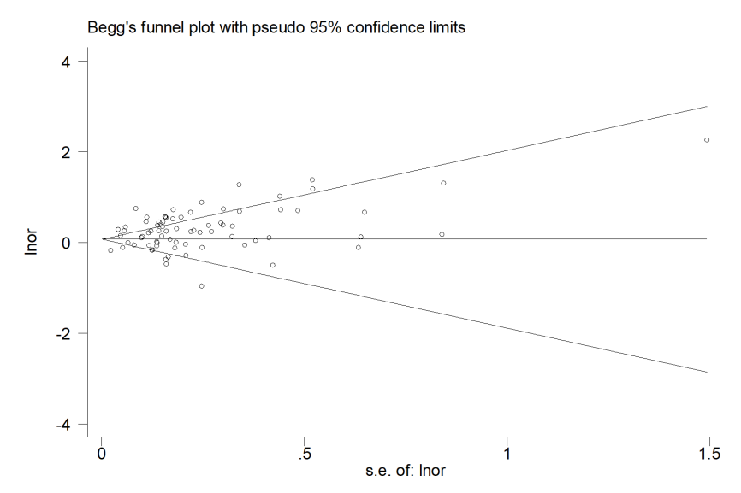
p = 0.991
(g2) age
p = 0.236
(g3) education level
p = 0.251

(g4) marital status
p = 0.828
(g5) income level
p = 0.472
(g6) living area
p = 0.256

(g7) smoking
p = 1.0
(g8) drinking
p = 0.548
(g9) living alone
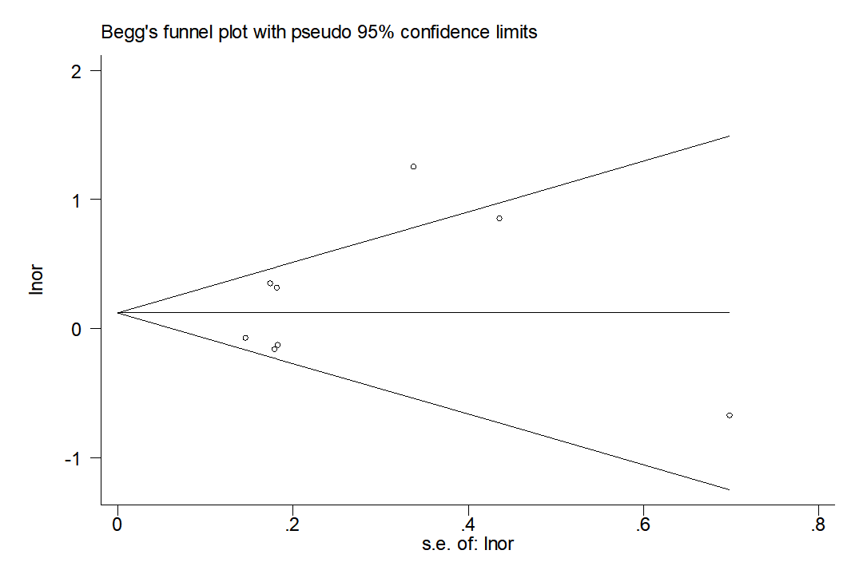
p = 0.386

(g10) emergency experience
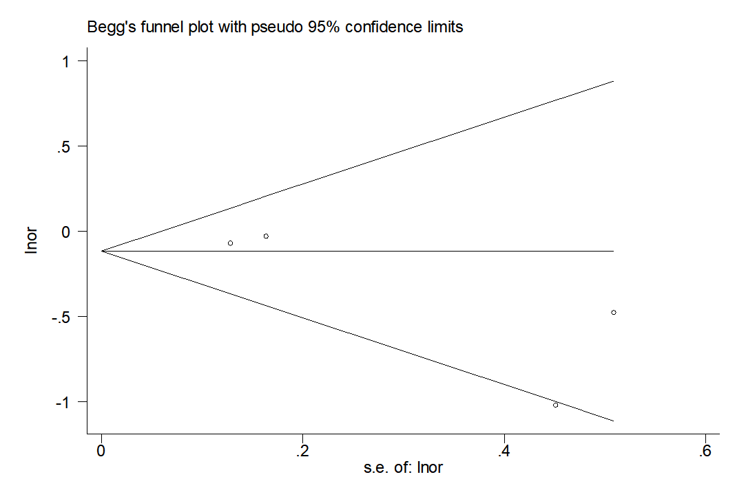
p = 0.734
(g11) physical disorders
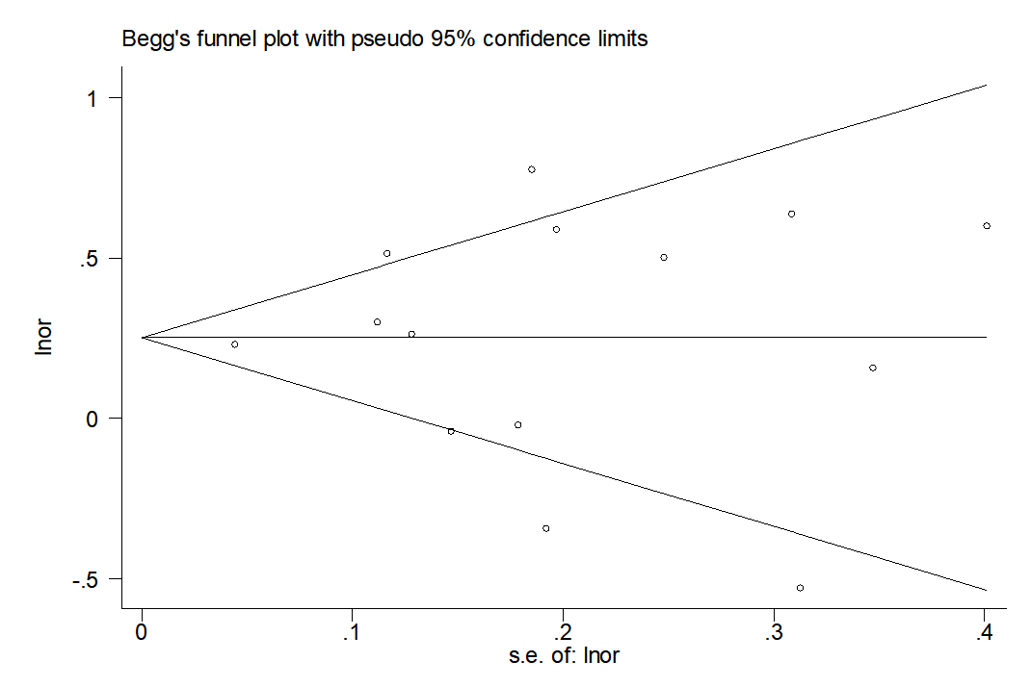
p = 0.913
(g12) mental disorders
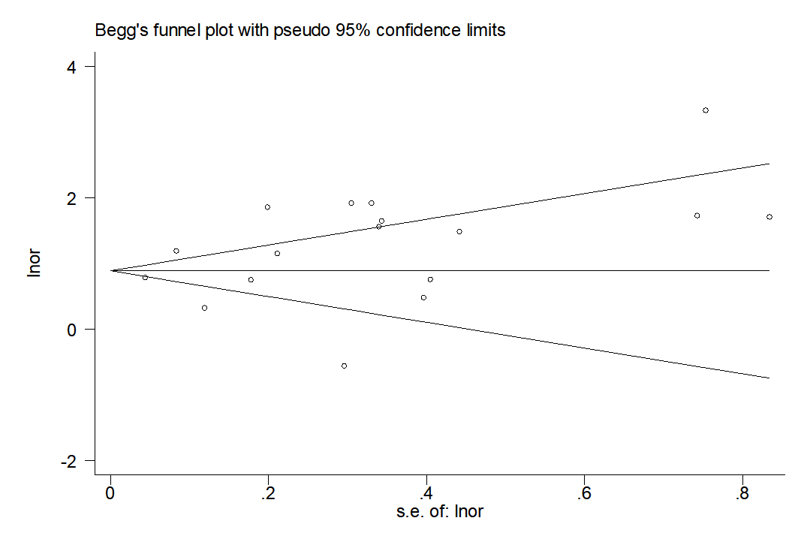
p = 0.837

(g13) confirmed or suspected infected
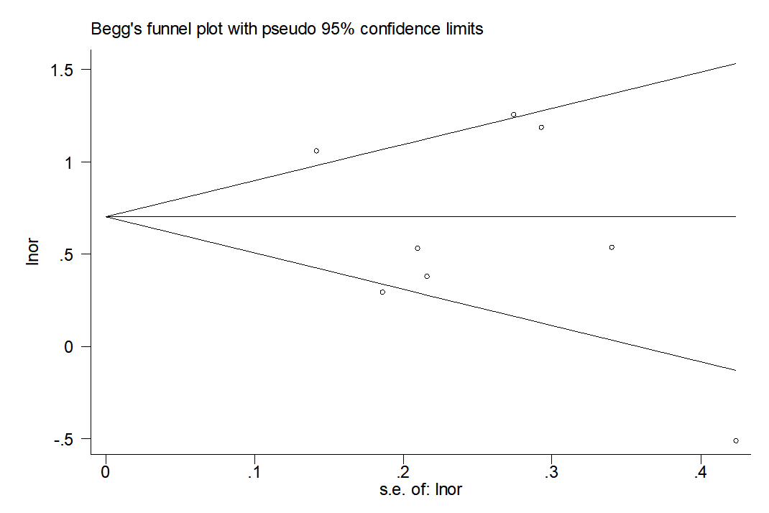
p = 0.536
(g14) colleagues or family members infected
p = 0.11
(g15) frontline
p = 0.101

(g16) closely contact with infectors
p = 0.726
(g17) high epidemic location
p = 0.503
(g18) high exposure risk
p = 0.014

(g19) working status
p = 0.11
(g20) highly concerned about epidemic
p = 0.755
(g21) quarantine
p = 0.474

(g22) Social support
p = 0.764
(g23) exercise
p = 0.02
(g24) preventive behavior
p = 0.806

(h1-h23) The funnel plots of factors associated with anxiety during pandemics.

(h1) gender
p = 0.69
(h2) age
p = 0.634
(h3) education level
p = 0.472

(h4) marital status
p = 0.227
(h5) income level
p = 0.422
(h6) living area
p = 0.88

(h7) smoking
p = 0.174
(h8) Drinking
p = 0.221
(h9) physical disorder
p = 0.843

(h10) mental disorder
p = 1.0
(h11) living alone
p = 0.711
(h12) Infected
p = 0.283

(h13) family infected
p = 0.369
(h14) frontline
p = 0.621
(h15) contact
p = 0.651

(h16) Epidemic location
p = 0.463
(h17) Exposure risk
p = 0.938
(h18) Working status
p = 0.381

(h19) concern about COVID-19
p = 0.893
(h20) Quarantine
p = 0.474
(h21) social support
p = 0.707

(h22) Exercise
p = 0.108
(h23) preventive behavior
p = 0.548

(i1-22) The funnel plots of factors associated with insomnia during pandemics.
(i1) gender
p = 0.081
(i2) age
p = 0.462
(i3) education level
p = 0.917

(i4) marital status
p = 0.462

(i5) mental disorder
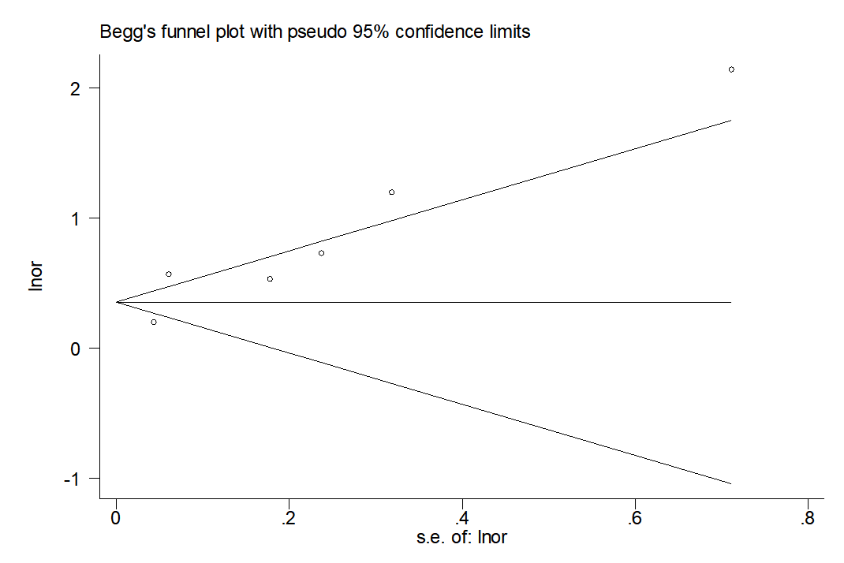
p = 0.452

(i6) confirmed or suspected infected
p = 0.806

(i7) colleagues or family members infected
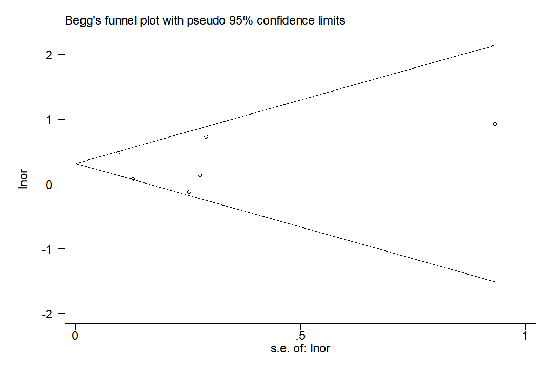
p = 0.707
(i8) frontline
p = 0.276
(i9) closely contact with infector
p = 0.707

(i10) epidemic location
p = 0.536
(i11) exposure risk
p = 0.3
(i12) working status
p = 1.0

References
1. Ahmad A, Rahman I, Agarwal M. Factors Influencing Mental Health During Covid-19 Outbreak: An Exploratory Survey Among Indian Population. medRxiv 2020.
2. Ahmed MZ, Ahmed O, Aibao Z, Hanbin S, Siyu L, Ahmad A. Epidemic of COVID-19 in China and associated Psychological Problems. Asian J Psychiatr 2020; 51: 102092.
3. Denning M, Goh ET, Tan B, Kanneganti A, Almonte M, Scott A et al. Determinants of Burnout and other aspects of Psychological Well-being in Healthcare Workers during the COVID-19 Pandemic: A Multinational Cross-Sectional Study. medRxiv 2020.
4. Alkhamees AA, Alrashed SA, Alzunaydi AA, Almohimeed AS, Aljohani MS. The psychological impact of COVID-19 pandemic on the general population of Saudi Arabia. Compr Psychiatry 2020; 102: 152192.
5. Al-Rabiaah A, Temsah MH, Al-Eyadhy AA, Hasan GM, Al-Zamil F, Al-Subaie S et al. Middle East Respiratory Syndrome-Corona Virus (MERS-CoV) associated stress among medical students at a university teaching hospital in Saudi Arabia. J Infect Public Health 2020; 13(5): 687-691.
6. Alshekaili M, Hassan W, Al Said N, Alsulaimani F, Jayapal SK, Al-Mawali A et al. Factors Associated with Mental Health Outcomes in Oman during COVID19: Frontline vs Non-frontline Healthcare Workers medRxiv 2020.
7. Alyami HS, Naser AY, Dahmash EZ, Alyami MH, Al Meanazel OT, Al-Meanazel AT et al. Depression and anxiety during 2019 coronavirus disease pandemic in Saudi Arabia: a crosssectional study. medRxiv 2020.
8. An Y, Yang Y, Wang A, Li Y, Zhang Q, Cheung T et al. Prevalence of depression and its impact on quality of life among frontline nurses in emergency departments during the COVID-19 outbreak. J Affect Disord 2020; 276: 312-315.
9. Apisarnthanarak A, Apisarnthanarak P, Siripraparat C, Saengaram P, Leeprechanon N, Weber DJ. Impact of anxiety and fear for COVID-19 toward infection control practices among Thai healthcare workers. Infect Control Hosp Epidemiol 2020: 1-2.
10. Bachilo E, Barylnik J, Shuldyakov A, Efremov A, Novikov D. Mental Health of Medical Workers During the COVID-19 Pandemic in Russia: Results of a Cross-Sectional Study. medRxiv 2020.
11. Badahdah A, Khamis F, Al Mahyijari N, Al Balushi M, Al Hatmi H, Al Salmi I et al. The mental health of health care workers in Oman during the COVID-19 pandemic. Int J Soc Psychiatry 2020: 20764020939596.
12. Banna MHA, Sayeed A, Kundu S, Christopher E, Hasan MT, Begum MR et al. The impact of the COVID-19 pandemic on the mental health of the adult population in Bangladesh: a nationwide cross-sectional study. Int J Environ Health Res 2020: 1-12.
13. Ayhan B D, Çevik M, Gümüştakim Ş, Başara E. Assessment of Individuals' Attitude, Knowledge and Anxiety Toward Covid 19 At The First Period of the Outbreak in Turkey: A Web Based Cross-Sectional Survey. Int J Clin Pract 2020: e13622.
14. Bauer LL, Seiffer B, Deinhart C, Atrott B, Sudeck G, Hautzinger M et al. Associations of exercise and social support with mental health during quarantine and socialdistancing measures during the COVID-19 pandemic: A cross-sectional survey in Germany. medRxiv 2020.
15. Bäuerle A, Teufel M, Musche V, Weismüller B, Kohler H, Hetkamp M et al. Increased generalized anxiety, depression and distress during the COVID-19 pandemic: a cross-sectional study in Germany. J Public Health (Oxf) 2020; 42(4): 672-678.
16. Bowman L, Kwok KO, Redd R, Yi Y, Ward H, Wei WI et al. Public perceptions and preventive behaviours during the early phase of the COVID-19 pandemic: a comparative study between Hong Kong and the United Kingdom. medRxiv 2020.
17. Bryan CJ, Bryan AO, Baker JC. Associations among state-level physical distancing measures and suicidal thoughts and behaviors among U.S. adults during the early COVID-19 pandemic. Suicide Life Threat Behav 2020; 50(6): 1223-1229.
18. Caballero-Dominguez CC, Jimenez-Villamizar MP, Campo-Arias A. Suicide risk during the lockdown due to coronavirus disease (COVID-19) in Colombia. Death Stud 2020: 1-6.
19. Cai Q, Feng HL, Huang J, Wang MY, Wang QF, Lu XZ et al. The mental health of frontline and non-frontline medical workers during the coronavirus disease 2019 (COVID-19) outbreak in China: A case-control study. J Affect Disord 2020; 275: 210-215.
20. Cai X, Hu X, Ekumi IO, Wang J, An Y, Li Z et al. Psychological Distress and Its Correlates Among COVID-19 Survivors During Early Convalescence Across Age Groups. Am J Geriatr Psychiatry 2020; 28(10): 1030-1039.
21. Çalişkan F, Dost B. The evaluation of knowledge, attitudes, depression and anxiety levels among emergency physicians during the COVID-19 pandemic. Signa Vitae 2020; 16(1): 163-171.
22. Cameron EE, Joyce KM, Delaquis CP, Reynolds K, Protudjer JLP, Roos LE. Maternal psychological distress & mental health service use during the COVID-19 pandemic. J Affect Disord 2020; 276: 765-774.
23. Cao W, Fang Z, Hou G, Han M, Xu X, Dong J et al. The psychological impact of the COVID-19 epidemic on college students in China. Psychiatry Res 2020; 287: 112934.
24. Capuano R, Altieri M, Bisecco A, d’Ambrosio A, Docimo R, Buonanno D et al. Psychological consequences of COVID-19 pandemic in Italian MS patients: signs of resilience? J Neurol 2020; 268(3): 743-750.
25. Cellini N, Canale N, Mioni G, Costa S. Changes in sleep pattern, sense of time and digital media use during COVID-19 lockdown in Italy. J Sleep Res 2020: e13074.
26. Ceulemans M, Hompes T, Foulon V. Mental health status of pregnant and breastfeeding women during the COVID-19 pandemic: A call for action. Int J Gynaecol Obstet 2020; 151(1): 146-147.
27. Chang J, Yuan Y, Wang D. [Mental health status and its influencing factors among college students during the epidemic of COVID-19]. Nan Fang Yi Ke Da Xue Xue Bao 2020; 40(2): 171-176.
28. Chen F, Zheng D, Liu J, Gong Y, Guan Z, Lou D. Depression and anxiety among adolescents during COVID-19: A cross-sectional study. Brain Behav Immun 2020; 88: 36-38.
29. Chen J, Zhang SX, Wang Y, Afshar Jahanshahi A, Mokhtari Dinani M, Nazarian Madavani A et al. The curvilinear relationship between the age of adults and their mental health in Iran after its peak of COVID-19 cases. medRxiv 2020.
30. Chen X, Zhang SX, Jahanshahi AA, Alvarez-Risco A, Dai H, Li J et al. Belief in Conspiracy Theory about COVID-19 Predicts Mental Health and Well-being – A Study of Healthcare Staff in Ecuador. medRxiv 2020.
31. Chen Y, Zhou H, Zhou Y, Zhou F. Prevalence of self-reported depression and anxiety among pediatric medical staff members during the COVID-19 outbreak in Guiyang, China. Psychiatry Res 2020; 288: 113005.
32. Cheng F-F, Zhan S-H, Xie A-W, Cai S-Z, Hui L, Kong X-X et al. Anxiety in Chinese pediatric medical staff during the outbreak of Coronavirus Disease 2019: a cross-sectional study. Transl Pediatr 2020; 9(3): 231-236.
33. Cheng SK, Wong CW, Tsang J, Wong KC. Psychological distress and negative appraisals in survivors of severe acute respiratory syndrome (SARS). Psychol Med 2004; 34(7): 1187-1195.
34. Chew NWS, Lee GKH, Tan BYQ, Jing M, Goh Y, Ngiam NJH et al. A multinational, multicentre study on the psychological outcomes and associated physical symptoms amongst healthcare workers during COVID-19 outbreak. Brain Behav Immun 2020; 88: 559-565.
35. Choi EPH, Hui BPH, Wan EYF. Depression and Anxiety in Hong Kong during COVID-19. Int J Environ Res Public Health 2020; 17(10): 3740.
36. Cici R, Yilmazel G. Determination of anxiety levels and perspectives on the nursing profession among candidate nurses with relation to the COVID-19 pandemic. Perspect Psychiatr Care 2020; 57(1): 358-362.
37. Civantos AM, Byrnes Y, Chang C, Prasad A, Chorath K, Poonia SK et al. Mental health among otolaryngology resident and attending physicians during the COVID-19 pandemic: National study. Head Neck 2020; 42(7): 1597-1609.
38. Colkesen F, Kilincel O, Sozen M, Yildiz E, Beyaz S, Colkesen F et al. The impact of SARS-CoV-2 transmission fear and COVID-19 pandemic on the mental health of patients with primary immunodeficiency disorders, severe asthma, and other high-risk groups. medRxiv 2020.
39. Consolo U, Bellini P, Bencivenni D, Iani C, Checchi V. Epidemiological Aspects and Psychological Reactions to COVID-19 of Dental Practitioners in the Northern Italy Districts of Modena and Reggio Emilia. Int J Environ Res Public Health 2020; 17(10): 3459.
40. Corbett GA, Milne SJ, Mohan S, Reagu S, Farrell T, Lindow SW et al. Anxiety and Depression Scores in Maternity Healthcare Workers during the Covid-19 Pandemic. Int J Gynaecol Obste 2020; 151(2): 297-298.
41. Cortes-Alvarez NY, Pineiro-Lamas R, Vuelvas-Olmos CR. Psychological effects and associated factors of COVID-19 in a Mexican sample. Disaster Med Public Health Prep 2020: 1-27.
42. Creese B, Khan Z, Henley W, Corbett A, Vasconcelos Da Silva M, Mills K et al. Loneliness, physical activity and mental health during Covid-19: a longitudinal analysis of depression and anxiety between 2015 and 2020. medRxiv 2020.
43. Dal'Bosco EB, Floriano LSM, Skupien SV, Arcaro G, Martins AR, Anselmo ACC. Mental health of nursing in coping with COVID-19 at a regional university hospital. Rev Bras Enferm 2020; 73 Suppl¬†2: e20200434.
44. pourhaji f, delshad mh, Pourhaji F, Ghanbarizadeh SR, Azhdari Zarmehri H, Bazrafshan E et al. Community responses during early phase of the COVID-19 epidemic: a crosssectional study. medRxiv 2020.
45. Devkota HR, Sijali TR, Bogati R, Ahmad M, Shakya KL, Adhikary P. The Impact of COVID‐19 on Mental Health outcomes among hospital fever clinic attendants across Nepal: A community‐based cross‐sectional study. medRxiv 2020.
46. Di Tella M, Romeo A, Benfante A, Castelli L. Mental health of healthcare workers during the COVID-19 pandemic in Italy. J Eval Clin Pract 2020; 26(6): 1583-1587.
47. Ding Y, Xu J, Huang S, Li P, Lu C, Xie S. Risk Perception and Depression in Public Health Crises: Evidence from the COVID-19 Crisis in China. Int J Environ Res Public Health 2020; 17(16): 5728.
48. Duan L, Shao X, Wang Y, Huang Y, Miao J, Yang X et al. An investigation of mental health status of children and adolescents in china during the outbreak of COVID-19. J Affect Disord 2020; 275: 112-118.
49. Durankus F, Aksu E. Effects of the COVID-19 pandemic on anxiety and depressive symptoms in pregnant women: a preliminary study. J Matern Fetal Neonatal Med 2020: 1-7.
50. Elbay RY, Kurtulmus A, Arpacioglu S, Karadere E. Depression, anxiety, stress levels of physicians and associated factors in Covid-19 pandemics. Psychiatry Res 2020; 290: 113130.
51. Elhai JD, Yang H, McKay D, Asmundson GJG. COVID-19 anxiety symptoms associated with problematic smartphone use severity in Chinese adults. J Affect Disord 2020; 274: 576-582.
52. Elizarraras-Rivas J, Vargas-Mendoza JE, Mayoral-Garcia M, Matadamas-Zarate C, Elizarraras-Cruz A, Taylor M et al. Psychological response of family members of patients hospitalised for influenza A/H1N1 in Oaxaca, Mexico. BMC Psychiatry 2010; 10: 104.
53. Evanoff BA, Strickland JR, Dale AM, Hayibor L, Page E, Duncan JG et al. Work-related and Personal Factors Associated with Mental Well-being during COVID-19 Response: A Survey of Health Care and Other Workers medRxiv 2020.
54. Fang X, Zhang J, Teng C, Zhao K, Su KP, Wang Z et al. Depressive symptoms in the front-line non-medical workers during the COVID-19 outbreak in Wuhan. J Affect Disord 2020; 276: 441-445.
55. Filgueiras A, Stults-Kolehmainen M. Factors linked to changes in mental health outcomes among Brazilians in quarantine due to COVID-19. medRxiv 2020.
56. Fitzpatrick KM, Harris C, Drawve G. Living in the midst of fear: Depressive symptomatology among US adults during the COVID-19 pandemic. Depress Anxiety 2020; 37(10): 957-964.
57. Forte G, Favieri F, Tambelli R, Casagrande M. The Enemy Which Sealed the World: Effects of COVID-19 Diffusion on the Psychological State of the Italian Population. J Clin Med 2020; 9(6): 1802.
58. Fu W, Wang C, Zou L, Guo Y, Lu Z, Yan S et al. Psychological health, sleep quality, and coping styles to stress facing the COVID-19 in Wuhan, China. Transl Psychiatry 2020; 10(1): 225.
59. Gallagher S, Wetherell M. Risk of Depression in Family Caregivers: Unintended Consequence of COVID-19. medRxiv 2020.
60. Gao J, Zheng P, Jia Y, Chen H, Mao Y, Chen S et al. Mental health problems and social media exposure during COVID-19 outbreak. PLoS ONE 2020; 15(4): e0231924.
61. Garcia de Avila MA, Hamamoto Filho PT, Jacob F, Alcantara LRS, Berghammer M, Jenholt Nolbris M et al. Children's Anxiety and Factors Related to the COVID-19 Pandemic: An Exploratory Study Using the Children's Anxiety Questionnaire and the Numerical Rating Scale. Int J Environ Res Public Health 2020; 17(16): 5757.
62. García-Fernández L, Romero-Ferreiro V, López-Roldán PD, Padilla S, Rodriguez-Jimenez R. Mental Health in Elderly Spanish People in Times of COVID-19 Outbreak. Am J Geriatr Psychiatry 2020; 28(10): 1040-1045.
63. Giusti EM, Pedroli E, D'Aniello GE, Stramba Badiale C, Pietrabissa G, Manna C et al. The Psychological Impact of the COVID-19 Outbreak on Health Professionals: A Cross-Sectional Study. Front Psychol 2020; 11: 1684.
64. Gonzalez-Sanguino C, Ausin B, Castellanos MA, Saiz J, Lopez-Gomez A, Ugidos C et al. Mental health consequences during the initial stage of the 2020 Coronavirus pandemic (COVID-19) in Spain. Brain Behav Immun 2020; 87: 172-176.
65. Picaza Gorrochategi M, Eiguren Munitis A, Dosil Santamaria M, Ozamiz Etxebarria N. Stress, Anxiety, and Depression in People Aged Over 60 in the COVID-19 Outbreak in a Sample Collected in Northern Spain. Am J Geriatr Psychiatry 2020; 28(9): 993-998.
66. Gualano MR, Lo Moro G, Voglino G, Bert F, Siliquini R. Effects of Covid-19 Lockdown on Mental Health and Sleep Disturbances in Italy. Int J Environ Res Public Health 2020; 17(13): 4779.
67. Guiroy A, Gagliardi M, Coombes N, Landriel F, Zanardi C, Camino Willhuber G et al. COVID-19 Impact Among Spine Surgeons in Latin America. Global Spine J 2020; 11(6): 859-865.
68. Guo J, Feng XL, Wang XH, van Ijzendoorn MH. Coping with COVID-19: Exposure to COVID-19 and Negative Impact on Livelihood Predict Elevated Mental Health Problems in Chinese Adults. Int J Environ Res Public Health 2020; 17(11): 3857.
69. Guo Y, Cheng C, Zeng Y, Li Y, Zhu M, Yang W et al. Mental Health Disorders and Associated Risk Factors in Quarantined Adults During the COVID-19 Outbreak in China: Cross-Sectional Study. J Med Internet Res 2020; 22(8): e20328.
70. Gupta AK, Mehra A, Niraula A, Kafle K, Deo SP, Singh B et al. Prevalence of anxiety and depression among the healthcare workers in Nepal during the COVID-19 pandemic. Asian J Psychiatr 2020; 54: 102260.
71. Han L, Wong FKY, She DLM, Li SY, Yang YF, Jiang MY et al. Anxiety and Depression of Nurses in a North West Province in China During the Period of Novel Coronavirus Pneumonia Outbreak. J Nurs Scholarsh 2020; 52(5): 564-573.
72. Hao F, Tan W, Jiang L, Zhang L, Zhao X, Zou Y et al. Do psychiatric patients experience more psychiatric symptoms during COVID-19 pandemic and lockdown? A case-control study with service and research implications for immunopsychiatry. Brain Behav Immun 2020; 87: 100-106.
73. Hawari FI, Obeidat NA, Dodin YI, Albtoosh AS, Manasrah RM, Alaqeel IO et al. The inevitability of Covid-19 related distress among healthcare workers: findings from a low caseload country under lockdown. medRxiv 2020.
74. Hawryluck L, Gold WL, Robinson S, Pogorski S, Galea S, Styra R. SARS control and psychological effects of quarantine, Toronto, Canada. Emerging Infect Dis 2004; 10(7): 1206-1212.
75. Hu D, Kong Y, Li W, Han Q, Zhang X, Zhu LX et al. Frontline nurses' burnout, anxiety, depression, and fear statuses and their associated factors during the COVID-19 outbreak in Wuhan, China: A large-scale cross-sectional study. EClinicalMedicine 2020; 24: 100424.
76. Hu W, Su L, Qiao J, Zhu J, Zhou Y. Countrywide quarantine only mildly increased anxiety level during COVID-19 outbreak in China. medRxiv 2020.
77. Hu Y, Chen Y, Zheng Y, You C, Tan J, Hu L et al. Factors related to mental health of inpatients with COVID-19 in Wuhan, China. Brain Behav Immun 2020; 89: 587-593.
78. Huang L, Wang Y, Liu J, Ye P, Chen X, Xu H et al. Factors Influencing Anxiety of Health Care Workers in the Radiology Department with High Exposure Risk to COVID-19. Med Sci Monit 2020; 26: e926008.
79. Huang Y, Zhao N. Generalized anxiety disorder, depressive symptoms and sleep quality during COVID-19 outbreak in China: a web-based cross-sectional survey. Psychiatry Res 2020; 288: 112954.
80. Huang Y, Zhao N. Mental health burden for the public affected by the COVID-19 outbreak in China: Who will be the high-risk group? Psychol Health Med 2020: 1-12.
81. Hyland P, Shevlin M, McBride O, Murphy J, Karatzias T, Bentall RP et al. Anxiety and depression in the Republic of Ireland during the COVID-19 pandemic. Acta Psychiatr Scand 2020; 142(3): 249-256.
82. Jacob L, Tully MA, Barnett Y, Lopez-Sanchez GF, Butler L, Schuch F et al. The relationship between physical activity and mental health in a sample of the UK public: A cross-sectional study during the implementation of COVID-19 social distancing measures. Ment Health Phys Act 2020; 19: 100345.
83. Jahrami H, BaHammam AS, AlGahtani H, Ebrahim A, Faris M, AlEid K et al. The examination of sleep quality for frontline healthcare workers during the outbreak of COVID-19. Sleep Breath 2020; 25(1): 503-511.
84. Jeong H, Yim HW, Song YJ, Ki M, Min JA, Cho J et al. Mental health status of people isolated due to Middle East Respiratory Syndrome. Epidemiol Health 2016; 38: e2016048.
85. Jia R, Ayling K, Chalder T, Massey A, Broadbent E, Coupland C et al. Mental health in the UK during the COVID-19 pandemic: early observations Brief title: Mental Health in the UK and COVID-19. medRxiv 2020.
86. Joseph R, Alshayban D, Lucca JM, Alshehry YA. The immediate psychological response of the general population in Saudi Arabia during COVID-19 pandemic: a cross-sectional study. medRxiv 2020.
87. Kantor BN, Kantor J. Mental health outcomes and associations during the coronavirus disease 2019 pandemic: A cross-sectional survey of the US general population. medRxiv 2020.
88. Kaveh M, Davari-tanha F, Varaei S, Shirali E, Shokouhi N, Nazemi P et al. Anxiety levels among Iranian health care workers during the COVID-19 surge: A cross-sectional study. medRxiv 2020.
89. Keita MM, Taverne B, Sy Savan√© S, March L, Doukoure M, Sow MS et al. Depressive symptoms among survivors of Ebola virus disease in Conakry (Guinea): preliminary results of the PostEboGui cohort. BMC Psychiatry 2017; 17(1): 127.
90. Khanna RC, Honavar SG, Metla AL, Bhattacharya A, Maulik PK. Psychological impact of COVID-19 on ophthalmologists-in-training and practising ophthalmologists in India. Indian J Ophthalmol 2020; 68(6): 994-998.
91. Killgore WDS, Cloonan SA, Taylor EC, Fernandez F, Grandner MA, Dailey NS. Suicidal ideation during the COVID-19 pandemic: The role of insomnia. Psychiatry Res 2020; 290: 113134-113134.
92. Kim AW, Nyengerai T, Mendenhall E. Evaluating the Mental Health Impacts of the COVID-19 Pandemic in Urban South Africa: Perceived Risk of COVID-19 Infection and Childhood Trauma Predict Adult Depressive Symptoms. medRxiv 2020.
93. Kim HC, Yoo SY, Lee BH, Lee SH, Shin HS. Psychiatric Findings in Suspected and Confirmed Middle East Respiratory Syndrome Patients Quarantined in Hospital: A Retrospective Chart Analysis. Psychiatry Investig 2018; 15(4): 355-360.
94. Kim Y-J, Cho J-H, Kim ES. Differences in Sense of Belonging, Pride, and Mental Health in the Daegu Metropolitan Region due to COVID-19: Comparison between the Presence and Absence of National Disaster Relief Fund. Int J Environ Res Public Health 2020; 17(13): 4910.
95. Kneale D, Becares L. The mental health and experiences of discrimination of LGBTQ+ people during the COVID-19 pandemic: Initial findings from the Queerantine Study. medRxiv 2020.
96. Ko CH, Yen CF, Yen JY, Yang MJ. Psychosocial impact among the public of the severe acute respiratory syndrome epidemic in Taiwan. Psychiatry Clin Neurosci 2006; 60(4): 397-403.
97. Kokou-Kpolou CK, Megalakaki O, Laimou D, Kousouri M. Insomnia during COVID-19 pandemic and lockdown: Prevalence, severity, and associated risk factors in French population. Psychiatry Res 2020; 290: 113128-113128.
98. Kong X, Zheng K, Tang M, Kong F, Zhou J, Diao L et al. Prevalence and Factors Associated with Depression and Anxiety of Hospitalized Patients with COVID-19. medRxiv 2020.
99. Kosir U, Loades M, Wild J, Wiedemann M, Krajnc A, Roskar S et al. The impact of COVID-19 on the cancer care of adolescents and young adults and their well-being: Results from an online survey conducted in the early stages of the pandemic. Cancer 2020; 126(19): 4414-4422.
100. Kuman Tunçel Ö, Pullukçu H, Erdem HA, Kurtaran B, Taşbakan SE, Taşbakan M. COVID-19 related anxiety in people living with HIV: An online cross-sectional study. Turk J Med Sci 2020; 50(8): 1792-1800.
101. Kumar K, Mehra A, Sahoo S, Nehra R, Grover S. The psychological impact of COVID-19 pandemic and lockdown on the migrant workers: A cross-sectional survey. Asian J Psychiatr 2020; 53: 102252.
102. Kuper H, Lopes Moreira ME, Barreto de Ara√Їjo TV, Valongueiro S, Fernandes S, Pinto M et al. The association of depression, anxiety, and stress with caring for a child with Congenital Zika Syndrome in Brazil; Results of a cross-sectional study. PLoS Negl Trop Dis 2019; 13(9): e0007768.
103. Kwek S-K, Chew W-M, Ong K-C, Ng AW-K, Lee LS-U, Kaw G et al. Quality of life and psychological status in survivors of severe acute respiratory syndrome at 3 months postdischarge. J Psychosom Res 2006; 60(5): 513-519.
104. Kwong ASF, Pearson RM, Adams MJ, Northstone K, Tilling K, Smith D et al. Mental health during the COVID-19 pandemic in two longitudinal UK population cohorts. medRxiv 2020.
105. Lai J, Ma S, Wang Y, Cai Z, Hu J, Wei N et al. Factors Associated With Mental Health Outcomes Among Health Care Workers Exposed to Coronavirus Disease 2019. JAMA Netw Open 2020; 3(3): e203976.
106. Lan F-Y, Suharlim C, Kales SN, Yang J. Mental health during the COVID-19 pandemic in two longitudinal UK population cohorts. medRxiv 2020.
107. Lebel C, MacKinnon A, Bagshawe M, Tomfohr-Madsen L, Giesbrecht G. Elevated depression and anxiety symptoms among pregnant individuals during the COVID-19 pandemic. J Affect Disord 2020; 277: 5-13.
108. Lee DTS, Sahota D, Leung TN, Yip ASK, Lee FFY, Chung TKH. Psychological responses of pregnant women to an infectious outbreak: A case-control study of the 2003 SARS outbreak in Hong Kong. J Psychosom Res 2006; 61(5): 707-713.
109. Lee SM, Kang WS, Cho A-R, Kim T, Park JK. Psychological impact of the 2015 MERS outbreak on hospital workers and quarantined hemodialysis patients. Compr Psychiatry 2018; 87: 123-127.
110. Lee TMC, Chi I, Chung LWM, Chou KL. Ageing and psychological response during the post-SARS period. Aging Ment Health 2006; 10(3): 303-311.
111. Lei L, Huang X, Zhang S, Yang J, Yang L, Xu M. Comparison of Prevalence and Associated Factors of Anxiety and Depression Among People Affected by versus People Unaffected by Quarantine During the COVID-19 Epidemic in Southwestern China. Med Sci Monit 2020; 26: e924609.
112. Li JF, Han HG, Zhao X. Psychological status under stress in soldiers at different posts and of different service age. Chin J Clin Rehabil 2005; 9(32): 112-113.
113. Li R, Chen Y, Lv J, Liu L, Zong S, Li H et al. Anxiety and related factors in frontline clinical nurses fighting COVID-19 in Wuhan. Medicine (Baltimore) 2020; 99(30): e21413.
114. Li X, Lu P, Hu L, Huang T, Lu L. Factors associated with mental health results among workers with income losses exposed to COVID‐19 in China. Int J Environ Res Public Health 2020; 17(15): 1-11.
115. Li X, Yu H, Bian G, Hu Z, Liu X, Zhou Q et al. Prevalence, risk factors, and clinical correlates of insomnia in volunteer and at home medical staff during the COVID-19. Brain Behav Immun 2020; 87: 140-141.
116. Lin LY, Wang J, Ou-Yang XY, Miao Q, Chen R, Liang FX et al. The immediate impact of the 2019 novel coronavirus (COVID-19) outbreak on subjective sleep status. Sleep Med 2020; 77: 348-354.
117. Lin Y, Hu Z, Alias H, Wong LP. Impact of mass and social media on psychobehavioural responses to COVID-19: A survey of medical university students in Fujian, China during the downward trend of COVID-19. J Med Internet Res 2020; 22(7):e19982.
118. Lin YL, Hu ZJ, Alias H, Wong LP. Knowledge, Attitudes, Impact, and Anxiety Regarding COVID-19 Infection Among the Public in China. Front Public Health 2020; 8: 236.
119. Liu CY, Yang YZ, Zhang XM, Xu X, Dou QL, Zhang WW et al. The prevalence and influencing factors in anxiety in medical workers fighting COVID-19 in China: a cross-sectional survey. Epidemiol Infect 2020; 148: e98.
120. Liu CH, Zhang E, Wong GTF, Hyun S, Hahm HC. Factors associated with depression, anxiety, and PTSD symptomatology during the COVID-19 pandemic: Clinical implications for U.S. young adult mental health. Psychiatry Res 2020; 290: 113172-113172.
121. Liu J, Zhu Q, Fan W, Makamure J, Zheng C, Wang J. Online Mental Health Survey in a Medical College in China During the COVID-19 Outbreak. Front Psychiatry 2020; 11: 459.
122. Liu N, Zhang F, Wei C, Jia Y, Shang Z, Sun L et al. Prevalence and predictors of PTSS during COVID-19 outbreak in China hardest-hit areas: Gender differences matter. Psychiatry Res 2020; 287: 112921.
123. Liu X, Luo W-T, Li Y, Li C-N, Hong Z-S, Chen H-L et al. Psychological status and behavior changes of the public during the COVID-19 epidemic in China. Infect Dis Poverty 2020; 9(1): 58-58.
124. Liu X, Chen M, Wang Y, Sun L, Zhang J, Shi Y et al. Prenatal anxiety and obstetric decisions among pregnant women in Wuhan and Chongqing during the COVID-19 outbreak: a cross-sectional study. BJOG 2020; 127(10): 1229-1240.
125. Liu X, Ma L, Meng F. Psychological Stress of Nurses in SARS wards. Chin Ment Health J 2003; 17(8): 526-527.
126. Liu Y, Wang L, Chen L, Zhang X, Bao L, Shi Y. Mental Health Status of Paediatric Medical Workers in China During the COVID-19 Outbreak. Front Psychiatry 2020; 11: 702.
127. Lu H, Nie P, Qian L. Do quarantine experiences and attitudes towards covid-19 affect the distribution of mental health in china? A quantile regression analysis. Appl Res Qual Life 2020; 29: 1-18.
128. Lu W, Wang H, Lin Y, Li L. Psychological status of medical workforce during the COVID-19 pandemic: A cross-sectional study. Psychiatry Res 2020; 288: 112936.
129. Luceño-Moreno L, Talavera-Velasco B, García-Albuerne Y, Martín-García J. Symptoms of posttraumatic stress, anxiety, depression, levels of resilience and burnout in spanish health personnel during the COVID-19 pandemic. Int J Environ Res Public Health 2020; 17(15): 1-29.
130. Ma Y, Rosenheck R, He H. Psychological stress among health care professionals during the 2019 novel coronavirus disease Outbreak: Cases from online consulting customers. Intensive Crit Care Nurs 2020: 102905.
131. Ma YF, Li W, Deng HB, Wang L, Wang Y, Wang PH et al. Prevalence of depression and its association with quality of life in clinically stable patients with COVID-19. J Affect Disord 2020; 275: 145-148.
132. Magnavita N, Tripepi G, Di Prinzio RR. Symptoms in Health Care Workers during the COVID-19 Epidemic. A Cross-Sectional Survey. Int J Environ Res Public Health 2020; 17(14): 5218.
133. Mahendran K, Patel S, Sproat C. Psychosocial effects of the COVID-19 pandemic on staff in a dental teaching hospital. Br Dent J 2020; 229(2): 127-132.
134. Majumdar P, Biswas A, Sahu S. COVID-19 pandemic and lockdown: cause of sleep disruption, depression, somatic pain, and increased screen exposure of office workers and students of India. Chronobiol Int 2020: 1-10.
135. Malhotra C, Chaudhry I, Ozdemir S, Teo I, Finkelstein EA. Anxiety and perceived risk during COVID-19 outbreak. medRxiv 2020.
136. Mappa I, Distefano FA, Rizzo G. Effects of coronavirus 19 pandemic on maternal anxiety during pregnancy: a prospectic observational study. J Perinat Med 2020; 48(6): 545-550.
137. Marelli S, Castelnuovo A, Somma A, Castronovo V, Mombelli S, Bottoni D et al. Impact of COVID-19 lockdown on sleep quality in university students and administration staff. J Neurol 2020: 1-8.
138. Matsungo TM, Chopera P. The effect of the COVID-19 induced lockdown on nutrition, health and lifestyle patterns among adults in Zimbabwe. medRxiv 2020.
139. Mazza C, Ricci E, Biondi S, Colasanti M, Ferracuti S, Napoli C et al. A Nationwide Survey of Psychological Distress among Italian People during the COVID-19 Pandemic: Immediate Psychological Responses and Associated Factors. Int J Environ Res Public Health 2020; 17(9): 3165.
140. Mazza MG, De Lorenzo R, Conte C, Poletti S, Vai B, Bollettini I et al. Anxiety and depression in COVID-19 survivors: Role of inflammatory and clinical predictors. Brain Behav Immun 2020; 89: 594-600.
141. Mechili EA, Saliaj A, Kamberi F, Girvalaki C, Peto E, Patelarou AE et al. Is the mental health of young students and their family members affected during the quarantine period? Evidence from the COVID-19 pandemic in Albania. J Psychiatr Ment Health Nurs 2020; 28(3): 317-325.
142. Mishra P, Bhadauria US, Dasar PL, N S, Kumar S, Lalani A et al. Knowledge,attitude and anxiety towards pandemic flu a potential bio weapon among health professionals in Indore City. Przegl Epidemiol 2016; 70(1): 41-45, 125-127.
143. Moghanibashi-Mansourieh A. Assessing the anxiety level of Iranian general population during COVID-19 outbreak. Asian J Psychiatr 2020; 51: 102076-102076.
144. Monterrosa-Castro A, Redondo-Mendoza V, Mercado-Lara M. Psychosocial factors associated with symptoms of generalized anxiety disorder in general practitioners during the COVID-19 pandemic. J Investig Med 2020; 68(7): 1228.
145. Moreira PS, Ferreira S, Couto B, Machado-Sousa M, Fernandez M, Raposo-Lima C et al. Protective elements of mental health status during the COVID-19 outbreak in the Portuguese population. medRxiv 2020.
146. Munoz-Navarro R, Cano-Vindel A, Schmitz F, Cabello R, Fernandez-Berrocal P. Emotional distress and associated sociodemographic risk factors during the COVID-19 outbreak in Spain. medRxiv 2020.
147. Nalleballe K, Reddy Onteddu S, Sharma R, Dandu V, Brown A, Jasti M et al. Spectrum of neuropsychiatric manifestations in COVID-19. Brain Behav Immun 2020; 88: 71-74.
148. Naser AY, Dahmash EZ, Al-Rousan R, Alwafi H, Alrawashdeh HM, Ghoul I et al. Mental health status of the general population, healthcare professionals, and university students during 2019 coronavirus disease outbreak in Jordan: A cross-sectional study. Brain Behav 2020: e01730-e01730.
149. Naser Moghadasi A. One Aspect of Coronavirus disease (COVID-19) Outbreak in Iran: High Anxiety among MS Patients. Mult Scler Relat Disord 2020; 41: 102138.
150. Newby JM, O'Moore K, Tang S, Christensen H, Faasse K. Acute mental health responses during the COVID-19 pandemic in Australia. PLoS ONE 2020; 15(7): e0236562.
151. Ng DWL, Chan FHF, Barry TJ, Lam C, Chong CY, Kok HCS et al. Psychological distress during the 2019 Coronavirus Disease (COVID-19) pandemic among cancer survivors and healthy controls. Psychooncology 2020; 29(9): 1380-1383.
152. Nguyen HC, Nguyen MH, Do BN, Tran CQ, Nguyen TTP, Pham KM et al. People with Suspected COVID-19 Symptoms Were More Likely Depressed and Had Lower Health-Related Quality of Life: The Potential Benefit of Health Literacy. J Clin Med 2020; 9(4): 965.
153. Ni MY, Yang L, Leung CMC, Li N, Yao XI, Wang Y et al. Mental Health, Risk Factors, and Social Media Use During the COVID-19 Epidemic and Cordon Sanitaire Among the Community and Health Professionals in Wuhan, China: Cross-Sectional Survey. JMIR Ment Health 2020; 7(5): e19009.
154. Nie X-D, Wang Q, Wang M-N, Zhao S, Liu L, Zhu Y-L et al. Anxiety and depression and its correlates in patients with coronavirus disease 2019 in Wuhan. Int J Psychiatry Clin Pract 2020: 1-6.
155. Odriozola-González P, Planchuelo-Gómez Á, Irurtia MJ, de Luis-García R. Psychological effects of the COVID-19 outbreak and lockdown among students and workers of a Spanish university. Psychiatry Res 2020; 290: 113108.
156. Ojewale LY. Psychological state and family functioning of University of Ibadan students during the COVID-19 lockdown. medRxiv 2020.
157. Ozamiz-Etxebarria N, Dosil-Santamaria M, Picaza-Gorrochategui M, Idoiaga-Mondragon N. Stress, anxiety, and depression levels in the initial stage of the COVID-19 outbreak in a population sample in the northern Spain. Cad Saude Publica 2020; 36(4): e00054020.
158. Ozamiz-Etxebarria N, Idoiaga Mondragon N, Dosil Santamar√≠a M, Picaza Gorrotxategi M. Psychological Symptoms During the Two Stages of Lockdown in Response to the COVID-19 Outbreak: An Investigation in a Sample of Citizens in Northern Spain. Front Psychol 2020; 11: 1491.
159. Ozdin S, Bayrak Ozdin S. Levels and predictors of anxiety, depression and health anxiety during COVID-19 pandemic in Turkish society: The importance of gender. Int J Soc Psychiatry 2020; 66(5): 504-511.
160. Papandreou C, Arija V, Aretouli E, Tsilidis KK, Bulló M. Comparing eating behaviours, and symptoms of depression and anxiety between Spain and Greece during the COVID-19 outbreak: Cross-sectional analysis of two different confinement strategies. Eur Eat Disord Rev 2020; 28(6): 836-846.
161. Patabendige M, Gamage MM, Weerasinghe M, Jayawardane A. Psychological impact of the COVID-19 pandemic among pregnant women in Sri Lanka. Int J Gynaecol Obstet 2020; 151(1): 150-153.
162. Patsali ME, Mousa DPV, Papadopoulou EVK, Papadopoulou KKK, Kaparounaki CK, Diakogiannis I et al. University students’ changes in mental health status and determinants of behavior during the COVID-19 lockdown in Greece. Psychiatry Res 2020; 292.
163. Peng M, Mo B, Liu Y, Xu M, Song X, Liu L et al. Prevalence, risk factors and clinical correlates of depression in quarantined population during the COVID-19 outbreak. J Affect Disord 2020; 275: 119-124.
164. Perz CA, Lang BA, Harrington R. Validation of the fear of covid-19 scale in a us college sample. Int J Ment Health Addict 2020; 25: 1-11.
165. Petzold MB, Bendau A, Plag J, Pyrkosch L, Mascarell Maricic L, Betzler F et al. Risk, resilience, psychological distress, and anxiety at the beginning of the COVID-19 pandemic in Germany. Brain Behav 2020: e01745.
166. Pieh C, Budimir S, Probst T. The effect of age, gender, income, work, and physical activity on mental health during coronavirus disease (COVID-19) lockdown in Austria. J Psychosom Res 2020; 136: 110186.
167. Garcia-Priego BA, Triana-Romero A, Pinto-Galvez SM, Duran-Ramos C, Salas-Nolasco O, Manriquez Reyes M et al. Anxiety, depression, attitudes, and internet addiction during the initial phase of the 2019 coronavirus disease (COVID-19) epidemic: A cross-sectional study in México. medRxiv 2020.
168. Qi H, Liu R, Chen X, Yuan XF, Li YQ, Huang HH et al. Prevalence of anxiety and associated factors for Chinese adolescents during the COVID-19 outbreak. Psychiatry Clin Neurosci 2020; 74(10): 555-557.
169. Qi J, Xu J, Li BZ, Huang JS, Yang Y, Zhang ZT et al. The evaluation of sleep disturbances for Chinese frontline medical workers under the outbreak of COVID-19. Sleep Med 2020; 72: 1-4.
170. Qi M, Zhou SJ, Guo ZC, Zhang LG, Min HJ, Li XM et al. The Effect of Social Support on Mental Health in Chinese Adolescents During the Outbreak of COVID-19. J Adolesc Health 2020; 67(4): 514-518.
171. Qi R, Chen W, Liu S, Thompson PM, Zhang LJ, Xia F et al. Psychological morbidities and fatigue in patients with confirmed COVID-19 during disease outbreak: prevalence and associated biopsychosocial risk factors. medRxiv 2020.
172. Qian M, Wu Q, Wu P, Hou Z, Liang Y, Cowling BJ et al. Psychological responses, behavioral changes and public perceptions during the early phase of the COVID-19 outbreak in China: a population based cross-sectional survey. medRxiv 2020.
173. Quah SR, Hin-Peng L. Crisis prevention and management during SARS outbreak, Singapore. Emerging Infect Dis 2004; 10(2): 364-368.
174. Que J, Shi L, Deng J, Liu J, Zhang L, Wu S et al. Psychological impact of the COVID-19 pandemic on healthcare workers: a cross-sectional study in China. Gen Psychiatr 2020; 33(3).
175. Ran L, Wang W, Ai M, Kong Y, Chen J, Kuang L. Psychological resilience, depression, anxiety, and somatization symptoms in response to COVID-19: A study of the general population in China at the peak of its epidemic. Soc Sci Med 2020; 262: 113261.
176. Renzo LD, Gualtieri P, Cinelli G, Bigioni G, Soldati L, Attinà A et al. Psychological aspects and eating habits during covid-19 home confinement: Results of ehlc-covid-19 italian online survey. Nutrients 2020; 12(7): 1-14.
177. Ren Y, Zhou Y, Qian W, Li Z, Liu Z, Wang R et al. Letter to the Editor "A longitudinal study on the mental health of general population during the COVID-19 epidemic in China". Brain Behav Immun 2020; 87: 132-133.
178. Rettie H, Daniels J. Coping and tolerance of uncertainty: Predictors and mediators of mental health during the COVID-19 pandemic. Am Psychol 2020; 76(3): 427-437.
179. Rodr√≠guez-Rey R, Garrido-Hernansaiz H, Collado S. Psychological Impact and Associated Factors During the Initial Stage of the Coronavirus (COVID-19) Pandemic Among the General Population in Spain. Front Psychol 2020; 11: 1540.
180. Romito F, Dellino M, Loseto G, Opinto G, Silvestris E, Cormio C et al. Psychological Distress in Outpatients With Lymphoma During the COVID-19 Pandemic. Front Oncol 2020; 10: 1270.
181. Yuan R, Xu Q-H, Xia C-C, Lou C-Y, Xie Z, Ge Q-M et al. Psychological status of parents of hospitalized children during the COVID-19 epidemic in China. Psychiatry Res 2020; 288: 112953.
182. Rosenberg M, Luetke M, Hensel D, Kianersi S, Herbenick D. Depression and loneliness during COVID-19 restrictions in the United States, and their associations with frequency of social and sexual connections. medRxiv 2020.
183. Rossell S, Neill E, Phillipou A, Tan E, Toh WL, Van Rheenen T et al. An overview of current mental health in the general population of Australia during the COVID-19 pandemic: Results from the COLLATE project. medRxiv 2020.
184. Rossi R, Socci V, Pacitti F, Di Lorenzo G, Di Marco A, Siracusano A et al. Mental Health Outcomes Among Frontline and Second-Line Health Care Workers During the Coronavirus Disease 2019 (COVID-19) Pandemic in Italy. JAMA Netw Open 2020; 3(5): e2010185.
185. Rossi R, Socci V, Talevi D, Mensi S, Niolu C, Pacitti F et al. COVID-19 pandemic and lockdown measures impact on mental health among the general population in Italy. An N=18147 web-based survey. medRxiv 2020.
186. Rubin GJ, Amlot R, Page L, Wessely S. Public perceptions, anxiety, and behaviour change in relation to the swine flu outbreak: cross sectional telephone survey. BMJ 2009; 339: b2651.
187. Saddik B, Hussein A, Albanna A, Elbarazi I, Al-Shujairi A, Sharif-Askari FS et al. Assessing the influence of parental anxiety on childhood anxiety during the COVID-19 pandemic in the United Arab Emirates. medRxiv 2020.
188. Saddik B, Hussein A, Sharif-Askari FS, Kheder W, Temsah M-H, Koutaich RA et al. Increased levels of anxiety among medical and non-medical university students during the COVID-19 pandemic in the United Arab Emirates. medRxiv 2020.
189. Saikarthik J, Saraswathi I, Siva T. Risk factors and protective factors of mental health during COVID-19 outbreak and lockdown in adult Indian population- A cross-sectional study. medRxiv 2020.
190. Salman M, Asif N, Mustafa ZU, Khan TM, Shehzadi N, Hussain K et al. Psychological Impact of COVID-19 on Pakistani University Students and How They Are Coping. medRxiv 2020.
191. Salman M, Raza MH, Mustafa ZU, Khan TM, Asif N, Tahir H et al. The psychological effects of COVID-19 on frontline healthcare workers and how they are coping: a web-based, cross-sectional study from Pakistan. medRxiv 2020.
192. Sandesh R, Shahid W, Dev K, Mandhan N, Shankar P, Shaikh A et al. Impact of COVID-19 on the Mental Health of Healthcare Professionals in Pakistan. Cureus 2020; 12(7): e8974.
193. Saricam M. COVID-19-Related anxiety in nurses working on front lines in Turkey. Nurs Midwifery Stud 2020; 9(3): 178-181.
194. Sartorao Filho CI, Rodrigues WCdLV, Beauchamp de Castro R, Marcal AA, Pavelqueires S, Takano L et al. Impact Of Covid-19 Pandemic On Mental Health Of Medical Students: A CrossSectional Study Using GAD-7 And PHQ-9 Questionnaires. medRxiv 2020.
195. Savitsky B, Findling Y, Ereli A, Hendel T. Anxiety and coping strategies among nursing students during the covid-19 pandemic. Nurse Educ Pract 2020; 46: 102809.
196. Seyahi E, Poyraz BC, Sut N, Akdogan S, Hamuryudan V. The psychological state and changes in the routine of the patients with rheumatic diseases during the coronavirus disease (COVID-19) outbreak in Turkey: a web-based cross-sectional survey. Rheumatol Int 2020; 40(8): 1229-1238.
197. Shapiro E, Levine L, Kay A. Mental health stressors in Israel during the coronavirus pandemic. Psychol Trauma 2020; 12(5): 499-501.
198. Shechter A, Diaz F, Moise N, Anstey DE, Ye S, Agarwal S et al. Psychological distress, coping behaviors, and preferences for support among New York healthcare workers during the COVID-19 pandemic. Gen Hosp Psychiatry 2020; 66: 1-8.
199. Sheng X, Liu F, Zhou J, Liao R. Psychological status and sleep quality of nursing interns during the outbreak of COVID-19. Nan Fang Yi Ke Da Xue Xue Bao 2020; 40(3): 346-350.
200. Shevlin M, Nolan E, Owczarek M, McBride O, Murphy J, Gibson Miller J et al. COVID-19-related anxiety predicts somatic symptoms in the UK population. Br J Health Psychol 2020; 25(4): 875-882.
201. Shi L, Lu ZA, Que JY, Huang XL, Liu L, Ran MS et al. Prevalence of and Risk Factors Associated With Mental Health Symptoms Among the General Population in China During the Coronavirus Disease 2019 Pandemic. JAMA Netw Open 2020; 3(7): e2014053.
202. Sigdel A, Bista A, Bhattarai N, Poon BC, Giri G, Marqusee H et al. Depression, Anxiety and Depression-anxiety comorbidity amid COVID-19 Pandemic: An online survey conducted during lockdown in Nepal. medRxiv 2020.
203. Sipos ML, Kim PY, Thomas SJ, Adler AB. US Service Member Deployment in Response to the Ebola Crisis: The Psychological Perspective. Mil Med 2018; 183(3-4): E171-E178.
204. Skoda EM, Teufel M, Stang A, Jöckel KH, Junne F, Weismüller B et al. Psychological burden of healthcare professionals in Germany during the acute phase of the COVID-19 pandemic: differences and similarities in the international context. J Public Health (Oxf) 2020; 42(4): 688-695.
205. Smith LE, Amlôt R, Lambert H, Oliver I, Robin C, Yardley L et al. Factors associated with self-reported anxiety, depression, and general health during the UK lockdown; a crosssectional survey. medRxiv 2020.
206. Sögüt S, Dolu İ, Cangöl E. The relationship between covid‐19 knowledge levels and anxiety states of midwifery students during the outbreak: A cross‐sectional web‐based survey. Perspect Psychiatr Care 2020; 57(1): 246-252.
207. Solomou I, Constantinidou F. Prevalence and Predictors of Anxiety and Depression Symptoms during the COVID-19 Pandemic and Compliance with Precautionary Measures: Age and Sex Matter. Int J Environ Res Public Health 2020; 17(14): 4924.
208. Song L, Wang Y, Li Z, Yang Y, Li H. Mental Health and Work Attitudes among People Resuming Work during the COVID-19 Pandemic: A Cross-Sectional Study in China. Int J Environ Res Public Health 2020; 17(14): 5059.
209. Song X, Fu W, Liu X, Luo Z, Wang R, Zhou N et al. Mental health status of medical staff in emergency departments during the Coronavirus disease 2019 epidemic in China. Brain Behav Immun 2020; 88: 60-65.
210. Speth MM, Singer-Cornelius T, Oberle M, Gengler I, Brockmeier SJ, Sedaghat AR. Mood, anxiety and olfactory dysfunction in COVID-19: evidence of central nervous system involvement? Laryngoscope 2020; 130(11): 2520-2525.
211. Stanton R, To QG, Khalesi S, Williams SL, Alley SJ, Thwaite TL et al. Depression, Anxiety and Stress during COVID-19: Associations with Changes in Physical Activity, Sleep, Tobacco and Alcohol Use in Australian Adults. Int J Environ Res Public Health 2020; 17(11): 4065.
212. Stickley A, Matsubayashi T, Sueki H, Ueda M. COVID-19 preventive behaviors among people with anxiety and depression: Findings from Japan. medRxiv 2020.
213. Ueda M, Stickley A, Sueki H, Matsubayashi T. Mental Health Status of the General Population during the COVID-19 Pandemic: A CrossSectional National Survey in Japan. medRxiv 2020.
214. Stojanov J, Malobabic M, Stanojevic G, Stevic M, Milosevic V, Stojanov A. Quality of sleep and health-related quality of life among health care professionals treating patients with coronavirus disease-19. Int J Soc Psychiatry 2020: 20764020942800.
215. Su J, Chen X, Yang N, Sun M, Zhou L. Proximity to people with COVID-19 and anxiety among community residents during the epidemic in Guangzhou, China. BJPsych Open 2020; 6(4): e75.
216. Su T-P, Lien T-C, Yang C-Y, Su YL, Wang J-H, Tsai S-L et al. Prevalence of psychiatric morbidity and psychological adaptation of the nurses in a structured SARS caring unit during outbreak: A prospective and periodic assessment study in Taiwan. J Psychiatr Res 2007; 41(1-2): 119-130.
217. Sun S, Goldberg SB, Lin D, Qiao S, Operario D. Psychiatric symptoms, risk, and protective factors among university students in quarantine during the COVID-19 pandemic in China. medRxiv 2020.
218. Suryadevara V, Adusumalli C, Adusumilli PK, Chalasani SH, Radhakrishnan R. Mental Health Status among the South Indian Pharmacy Students during Covid-19 Pandemic’s Quarantine Period: A Cross-Sectional Study. medRxiv 2020.
219. Taghizadeh F, Hassannia L, Moosazadeh M, Zarghami M, Taghizadeh H, Fathi Dooki A et al. Anxiety and Depression in Health Workers and General Population During COVID-19 Epidemic in IRAN: A Web-Based Cross-Sectional Study. medRxiv 2020.
220. Tan W, Hao F, McIntyre RS, Jiang L, Jiang X, Zhang L et al. Is returning to work during the COVID-19 pandemic stressful? A study on immediate mental health status and psychoneuroimmunity prevention measures of Chinese workforce. Brain Behav Immun 2020; 87: 84-92.
221. Tang F, Liang J, Zhang H, Kelifa MM, He Q, Wang P. COVID-19 related depression and anxiety among quarantined respondents. Psychol Health 2020: 1-15.
222. Tang QS. Mental survey in female students from a medical college of Guangxi during the epidemic period of severe acute respiratory syndrome. Chin J Clin Rehabil 2005; 9(32): 90-91.
223. Tang W, Hu T, Hu B, Jin C, Wang G, Xie C et al. Prevalence and correlates of PTSD and depressive symptoms one month after the outbreak of the COVID-19 epidemic in a sample of home-quarantined Chinese university students. J Affect Disord 2020; 274: 1-7.
224. Tang YM, Zhang YY, Li JG, Shen J, Xing YG. Characteristics of neuropsychiatric impairment symptoms in patients with severe acute respiratory syndrome. Chin J Clin Rehabil 2005; 9(24): 208-209.
225. Temsah M-H, Al-Sohime F, Alamro N, Al-Eyadhy A, Al-Hasan K, Jamal A et al. The psychological impact of COVID-19 pandemic on health care workers in a MERS-CoV endemic country. J Infect Public Health 2020; 13(6): 877-882.
226. Teng Z, Wei Z, Qiu Y, Tan Y, Chen J, Tang H et al. Psychological status and fatigue of frontline staff two months after the COVID-19 pandemic outbreak in China: A cross-sectional study. J Affect Disord 2020; 275: 247-252.
227. Teo WZY, Soo YE, Yip C, Lizhen O, Chun-Tsu L. The psychological impact of COVID-19 on 'hidden' frontline healthcare workers. Int J Soc Psychiatry 2020: 20764020950772.
228. Temorshuizen JD, Watson HJ, Thornton LM, Borg S, Flatt RE, MacDermod CM et al. Early Impact of COVID-19 on Individuals with Eating Disorders: A survey of ~1000 Individuals in the United States and the Netherlands. medRxiv 2020.
229. Thapa L, Ghimire A, Ghimire S, Sharma N, Shrestha S, Devkota M et al. Predictors of Anxiety Regarding The COVID-19 Pandemic Among Health-care Workers in a Hospital Not Assigned to Manage COVID-19 Patients in Nepa. medRxiv 2020.
230. Thomaier L, Teoh D, Jewett P, Beckwith H, Parsons H, Yuan J et al. Emotional health concerns of oncology physicians in the United States: fallout during the COVID-19 pandemic. medRxiv 2020.
231. Torrente F, Yoris AE, Low D, Lopez P, Bekinschtein P, Cetkovich M et al. Sooner than you think: a very early affective reaction to the COVID-19 pandemic and quarantine in Argentina. medRxiv 2020.
232. Twenge J, Joiner T. U.S. Census Bureau-assessed prevalence of anxiety and depressive symptoms in 2019 and during the 2020 COVID-19 pandemic. Depress Anxiety 2020; 37(10): 954-956.
233. Ustun G. Determining depression and related factors in a society affected by COVID-19 pandemic. Int J Soc Psychiatry 2020: 20764020938807-20764020938807.
234. Verma S, Mishra A. Depression, anxiety, and stress and socio-demographic correlates among general Indian public during COVID-19. Int J Soc Psychiatry 2020: 20764020934508-20764020934508.
235. Voitsidis P, Gliatas I, Bairachtari V, Papadopoulou K, Papageorgiou G, Parlapani E et al. Insomnia during the COVID-19 pandemic in a Greek population. Psychiatry Res 2020; 289: 113076-113076.
236. Wan IYP, Wat KHY, Ng CSH, Thung KH, Lam S, Lee TW et al. Evaluation of the emotional status of patients on a waiting list for thoracic surgery during the outbreak of Severe Acute Respiratory Syndrome (SARS). Stress and Health 2004; 20(4): 209-212.
237. Wang C, Zhao H. The Impact of COVID-19 on Anxiety in Chinese University Students. Front Psychol 2020; 11: 1168.
238. Wang C, Pan R, Wan X, Tan Y, Xu L, Ho CS et al. Immediate Psychological Responses and Associated Factors during the Initial Stage of the 2019 Coronavirus Disease (COVID-19) Epidemic among the General Population in China. Int J Environ Res Public Health 2020; 17(5): 1729.
239. Wang H, Huang D, Huang H, Zhang J, Guo L, Liu Y et al. The psychological impact of COVID-19 pandemic on medical staff in Guangdong, China: a cross-sectional study. Psychol Med 2020: 1-9.
240. Wang LQ, Zhang M, Liu GM, Nan SY, Li T, Xu L et al. Psychological impact of coronavirus disease (2019) (COVID-19) epidemic on medical staff in different posts in China: A multicenter study. J Psychiatr Res 2020; 129: 198-205.
241. Wang S, Xie L, Xu Y, Yu S, Yao B, Xiang D. Sleep disturbances among medical workers during the outbreak of COVID-2019. Occup Med (Lond) 2020; 70(5): 364-369.
242. Wang W, Song W, Xia Z, He Y, Tang L, Hou J et al. Sleep Disturbance and Psychological Profiles of Medical Staff and Non-Medical Staff During the Early Outbreak of COVID-19 in Hubei Province, China. Front Psychiatry 2020; 11: 733.
243. Wang Y, Di Y, Ye J, Wei W. Study on the public psychological states and its related factors during the outbreak of coronavirus disease 2019 (COVID-19) in some regions of China. Psychol Health Med 2020; 26(1): 13-22.
244. Wang Y, Duan Z, Ma Z, Mao Y, Li X, Wilson A et al. Epidemiology of mental health problems among patients with cancer during COVID-19 pandemic. Transl Psychiatry 2020; 10(1): 263.
245. Wang ZH, Yang HL, Yang YQ, Liu D, Li ZH, Zhang XR et al. Prevalence of anxiety and depression symptom, and the demands for psychological knowledge and interventions in college students during COVID-19 epidemic: A large cross-sectional study. J Affect Disord 2020; 275: 188-193.
246. Wong LP, Alias H, Danaee M, Ziaee M, Adebi F, Ziaee A et al. Uncovering psychobehavioral implications of SARS-CoV-2 infection in Iran. Transbound Emerg Dis 2020; 67(6): 2892-2900.
247. Wong L, Hung CC, Alias H, Lee TSH. Anxiety symptoms and preventive measures during the COVID-19 outbreak in Taiwan. BMC Psychiatry 2020; 20(1): 376.
248. Wong LP, Alias H. Temporal changes in psychobehavioural responses during the early phase of the COVID-19 pandemic in Malaysia. J Behav Med 2020: 1-11.
249. Wu C, Hu X, Song J, Yang D, Xu J, Cheng K et al. Mental health status and related influencing factors of COVID-19 survivors in Wuhan, China. Clin Transl Med 2020; 10(2): e52.
250. Wu KK, Chan SK, Ma TM. Posttraumatic stress, anxiety, and depression in survivors of severe acute respiratory syndrome (SARS). J Trauma Stress 2005; 18(1): 39-42.
251. Wu KL, Wei XM. Analysis of Psychological and Sleep Status and Exercise Rehabilitation of Front-Line Clinical Staff in the Fight Against COVID-19 in China. Med Sci Monit Basic Res 2020; 26: e924085.
252. Wu P, Liu X, Fang Y, Fan B, Fuller CJ, Guan Z et al. Alcohol Abuse/Dependence Symptoms Among Hospital Employees Exposed to a SARS Outbreak. Alcohol and Alcoholism 2008; 43(6): 706-712.
253. Wu Y, Zhang C, Liu H, Duan C, Li C, Fan J et al. Perinatal depressive and anxiety symptoms of pregnant women along with COVID-19 outbreak in China. Am J Obstet Gynecol 2020; 223(2): 240.e1-240.e9.
254. Xiao H, Shu W, Li M, Li Z, Tao F, Wu X et al. Social Distancing among Medical Students during the 2019 Coronavirus Disease Pandemic in China: Disease Awareness, Anxiety Disorder, Depression, and Behavioral Activities. Int J Environ Res Public Health 2020; 17(14): 5047.
255. Xiao X, Zhu X, Fu S, Hu Y, Li X, Xiao J. Psychological impact of healthcare workers in China during COVID-19 pneumonia epidemic: A multi-center cross-sectional survey investigation. J Affect Disord 2020; 274: 405-410.
256. Xing J, Sun N, Xu J, Geng SL, Li YQ. Study of the mental health status of medical personnel dealing with new coronavirus pneumonia. PLoS ONE 2020; 15(5): e0233145.
257. Xu J, Xu Q-H, Wang C-M, Wang J. Psychological status of surgical staff during the COVID-19 outbreak. Psychiatry Res 2020; 288: 112955.
258. Fang Y, Zhe D, Shuran L. Survey on Mental Status of Subjects Recovered from SARS. Chinese Mental Health Journal 2004; 18(10): 675-677.
259. Yang S, Kwak SG, Ko EJ, Chang MC. The Mental Health Burden of the COVID-19 Pandemic on Physical Therapists. Int J Environ Res Public Health 2020; 17(10): 3723.
260. Yang X, Zhang Y, Li S, Chen X. Risk factors for anxiety of otolaryngology healthcare workers in Hubei province fighting coronavirus disease 2019 (COVID-19). Soc Psychiatry Psychiatr Epidemiol 2020; 56(1): 39-45.
261. Ying Y, Kong F, Zhu B, Ji Y, Lou Z, Ruan L. Mental health status among family members of health care workers in Ningbo, China during the Coronavirus Disease 2019 (COVID-19) outbreak: a Cross-sectional Study. medRxiv 2020.
262. Yu HYR, Ho SC, So KFE, Lo YL. Short communication: The psychological burden experienced by Hong Kong midlife women during the SARS epidemic. Stress and Health 2005; 21(3): 177-184.
263. Yuan B, Li W, Liu H, Cai X, Song S, Zhao J et al. Correlation between immune response and self-reported depression during convalescence from COVID-19. Brain Behav Immun 2020; 88: 39-43.
264. Yuan X, Sun L, Pan HW, Gong JH, Zhang ZZ, Wang J et al. Effect of the emergency of severe acute respiratory syndrome on the psychological health in college students. Chin J Clin Rehabil 2004; 8(9): 1642-1643.
265. Yue C, Liu C, Wang J, Zhang M, Wu H, Li C et al. Association between social support and anxiety among pregnant women in the third trimester during the coronavirus disease 2019 (COVID-19) epidemic in Qingdao, China: The mediating effect of risk perception. Int J Soc Psychiatry 2020: 20764020941567.
266. Zanardo V, Manghina V, Giliberti L, Vettore M, Severino L, Straface G. Psychological impact of COVID-19 quarantine measures in northeastern Italy on mothers in the immediate postpartum period. Int J Gynaecol Obstet 2020; 150(2): 184-188.
267. Zarghami A, Farjam M, Fakhraei B, Hashemzadeh K, Yazdanpanah MH. A Report of the Telepsychiatric Evaluation of SARS-CoV-2 Patients. Telemed J E Health 2020; 26(12): 1461-1465.
268. Zhang C, Yang L, Liu S, Ma S, Wang Y, Cai Z et al. Survey of Insomnia and Related Social Psychological Factors Among Medical Staff Involved in the 2019 Novel Coronavirus Disease Outbreak. Front Psychiatry 2020; 11: 306.
269. Zhang J, Lu H, Zeng H, Zhang S, Du Q, Jiang T et al. The differential psychological distress of populations affected by the COVID-19 pandemic. Brain Behav Immun 2020; 87: 49-50.
270. Zhang SX, Liu J, Afshar Jahanshahi A, Nawaser K, Li J, Alimoradi H. When the storm is the strongest: Healthcare staff’s health conditions and job satisfaction and their associated predictors during the epidemic peak of COVID-19. medRxiv 2020.
271. Zhang WR, Wang K, Yin L, Zhao WF, Xue Q, Peng M et al. Mental Health and Psychosocial Problems of Medical Health Workers during the COVID-19 Epidemic in China. Psychother Psychosom 2020; 89(4): 242-250.
272. Zhang Y, Zhang H, Ma X, Di Q. Mental Health Problems during the COVID-19 Pandemics and the Mitigation Effects of Exercise: A Longitudinal Study of College Students in China. Int J Environ Res Public Health 2020; 17(10): 3722.
273. Zhang J, Yang Z, Wang X, Li J, Dong L, Wang F et al. The relationship between resilience, anxiety, and depression among patients with mild symptoms of COVID-19 in China: A cross-sectional study. J Clin Nurs 2020; 29(21-22): 4020-4029.
274. Zhao H, He X, Fan G, Li L, Huang Q, Qiu Q et al. COVID-19 infection outbreak increases anxiety level of general public in China: involved mechanisms and influencing factors. J Affect Disord 2020; 276: 446-452.
275. Zhao Q, Hu C, Feng R, Yang Y. Investigation of the mental health of patients with COVID-19. Chinese Journal of Neurology 2020; 53(6): 432-436.
276. Zhao X, Lan M, Li H, Yang J. Perceived stress and sleep quality among the non-diseased general public in China during the 2019 coronavirus disease: a moderated mediation model. Sleep Med 2020; 77: 339-345.
277. Zhao Y, An Y, Tan X, Li X. Mental Health and Its Influencing Factors among Self-Isolating Ordinary Citizens during the Beginning Epidemic of COVID-19. J Loss Trauma 2020; 25(6-7): 1-14.
278. Zheng Y, Li J, Zhang M, Jin B, Li X, Cao Z et al. A survey of the psychological status of primary school students who were quarantined at home during the coronavirus disease 2019 epidemic in Hangzhou China. medRxiv 2020.
279. Zhou J, Yuan X, Qi H, Liu R, Li Y, Huang H et al. Prevalence of depression and its correlative factors among female adolescents in China during the coronavirus disease 2019 outbreak. Global Health 2020; 16(1): 69.
280. Zhou S-J, Zhang L-G, Wang L-L, Guo Z-C, Wang J-Q, Chen J-C et al. Prevalence and socio-demographic correlates of psychological health problems in Chinese adolescents during the outbreak of COVID-19. Eur Child Adolesc Psychiatry 2020; 29(6): 749-758.
281. Zhu J, Sun L, Zhang L, Wang H, Fan A, Yang B et al. Prevalence and Influencing Factors of Anxiety and Depression Symptoms in the First-Line Medical Staff Fighting Against COVID-19 in Gansu. Front Psychiatry 2020; 11: 386.
282. Zhu S, Wu Y, Zhu CY, Hong WC, Yu ZX, Chen ZK et al. The immediate mental health impacts of the COVID-19 pandemic among people with or without quarantine managements. Brain Behav Immun 2020; 87: 56-58.
283. Zhu Z, Xu S, Wang H, Liu Z, Wu J, Li G et al. COVID-19 in Wuhan: Immediate Psychological Impact on 5062 Health Workers. medRxiv 2020.

