Long term clinical sequelae of COVID-19 pandemic: a systematic review and meta-analysis and call for research priority and action

Supplementary Files

Appendix 1. Search Strategy 1
Appendix Table S1: PRISMA 2009 Checklist 1
Table S2. Characteristics of literatures included in the meta-analysis 5
Appendix Table S3. Factors that increase risk of post-acute COVID-19 sequelae 24
Appendix Figure S1: Forest Plot of Pooled Prevalence of any Symptoms 27
Appendix Figure S2: Forest Plot of Pooled Prevalence of CT Abnormal Manifestations 28
Appendix Figure S3: Forest Plot of Pooled Prevalence of Pulmonary Function Tests 29
Appendix Figure S4: Forest Plot of Pooled Prevalence of Generalized Symptoms 30
Appendix Figure S5: Forest Plot of Pooled Prevalence of Subjective Respiratory Symptoms 31
Appendix Figure S6: Forest Plot of Pooled Prevalence of Psychiatric Symptoms 33
Appendix Figure S6.1: Forest Plot of Pooled Prevalence of different severity of anxiety 35
Appendix Figure S6.2: Forest Plot of Pooled Prevalence of different severity of depression 36
Appendix Figure S6.3: Forest Plot of Pooled Prevalence of different severity of PTSD 37
Appendix Figure S7: Forest Plot of Pooled Prevalence of Neurologic Symptoms 38
Appendix Figure S8: Forest Plot of Pooled Prevalence of Objective Cardiovascular Findings 41
Appendix Figure S9: Forest Plot of Pooled Prevalence of Cardiovascular Symptoms 42
Appendix Figure S10: Forest Plot of Pooled Prevalence of Dermatological Symptoms 43
Appendix Figure S11: Forest Plot of Pooled Prevalence of Digestive Symptoms 44
Appendix Figure S12: Forest Plot of Pooled Prevalence of COVID-19 Repositive Rate 45
Appendix Figure S13: Forest Plot of Pooled Prevalence of COVID-19 Readmission Rate 46
Appendix Figure S14: Prevalence of Clinical Sequelae with Time after COVID-19 Infection 47
Appendix Figure S14.1: Prevalence of CT Abnormal Manifestations with Time after COVID-19 47
Appendix Figure S14.2: Prevalence of Pulmonary Function Tests with Time after COVID-19 Infection 48
Appendix Figure S14.3: Prevalence of Generalized Symptoms with Time after COVID-19 Infection 49
Appendix Figure S14.4: Prevalence of Subjective Respiratory Symptoms with Time after COVID-19 Infection 50
Appendix Figure S14.5: Prevalence of Psychiatry Symptoms with Time after COVID-19 Infection 51
Appendix Figure S14.6: Prevalence of Neurologic Symptoms with Time after COVID-19 Infection 52
Appendix Figure S14.7: Prevalence of Cardiovascular Symptoms with Time after COVID-19 Infection 53
Appendix Figure S14.8: Prevalence of Digestive Symptoms with Time after COVID-19 Infection 54
Appendix Figure S15: Prevalence of Clinical Sequelae with Time after COVID-19 Infection (Multi Measures in One Study) 55
Appendix Figure S15.1: Prevalence of any Symptoms with Time after COVID-19 Infection (Multi Measures in One Study) 55
Appendix Figure S15.2: Prevalence of CT Abnormal Manifestations with Time after COVID-19 Infection (Multi Measures in One Study) 56
Appendix Figure S15.3: Prevalence of Generalized Symptoms with Time after COVID-19 Infection (Multi Measures in One Study) 57
Appendix Figure S15.4: Prevalence of Subjective Respiratory Symptoms with Time after COVID-19 Infection (Multi Measures in One Study) 58
Appendix Figure S15.5: Prevalence of Psychiatry Symptoms with Time after COVID-19 Infection (Multi Measures in One Study) 59
Appendix Figure S15.6: Prevalence of Neurologic Symptoms with Time after COVID-19 Infection (Multi Measures in One Study) 60
Appendix Figure S15.7: Prevalence of Cardiovascular Symptoms with Time after COVID-19 Infection (Multi Measures in One Study) 61
Appendix Figure S15.8: Prevalence of Digestive Symptoms with Time after COVID-19 Infection (Multi Measures in One Study) 62
Appendix Figure S16: Subgroup Comparison of Clinical Sequelae of COVID-19 across Different Follow-up Periods 63
Appendix Figure S16.1: Subgroup Comparison of Any Symptoms across Different Follow-up Periods 63
Appendix Figure S16.2: Subgroup Comparison of CT Abnormal Manifestations across Different Follow-up Periods 64
Appendix Figure S16.3: Subgroup Comparison of Pulmonary Function Tests across Different Follow-up Periods 65
Appendix Figure S16.4: Subgroup Comparison of Generalized Symptoms across Different Follow-up Periods 66
Appendix Figure S16.5: Subgroup Comparison of Subjective Respiratory Symptoms across Different Follow-up Periods 67
Appendix Figure S16.6: Subgroup Comparison of Psychiatry Symptoms across Different Follow-up Periods 68
Appendix Figure S16.6.1: Subgroup Comparison of Anxiety across Different Follow-up Periods 69
Appendix Figure S16.6.2: Subgroup Comparison of Depression across Different Follow-up Periods 70
Appendix Figure S16.6.3: Subgroup Comparison of Sleep Disturbance across Different Follow-up Periods 71
Appendix Figure S16.6.4: Subgroup Comparison of PTSD across Different Follow-up Periods 72
Appendix Figure S16.7: Subgroup Comparison of Neurologic Symptoms across Different Follow-up Periods 73
Appendix Figure S16.7.1: Subgroup Comparison of Cognitive deficits across Different Follow-up Periods 74
Appendix Figure S16.7.2: Subgroup Comparison of Memory impairment across Different Follow-up Periods 75
Appendix Figure S16.7.3: Subgroup Comparison of Loss of taste or smell across Different Follow-up Periods 76
Appendix Figure S16.7.4: Subgroup Comparison of Olfactory dysfunction across Different Follow-up Periods 77
Appendix Figure S16.7.4: Subgroup Comparison of Concentration impairment across Different Follow-up Periods 78
Appendix Figure S16.7.5: Subgroup Comparison of Headache across Different Follow-up Periods 79
Appendix Figure S16.7.5: Subgroup Comparison of Gustatory dysfunction across Different Follow-up Periods 80
Appendix Figure S16.7.6: Subgroup Comparison of Visual disturbance across Different Follow-up Periods 81
Appendix Figure S16.8: Subgroup Comparison of Cardiovascular Symptoms across Different Follow-up Periods 82
Appendix Figure S16.9: Subgroup Comparison of Digestive Symptoms across Different Follow-up Periods 83
Appendix Figure S17: Subgroup Comparison of Clinical Sequelae of COVID-19 for Different Ages 84
Appendix Figure S17.1: Subgroup Comparison of Any Symptoms for Different Ages 84
Appendix Figure S17.2: Subgroup Comparison of CT Abnormal Manifestations for Different Ages 85
Appendix Figure S17.3: Subgroup Comparison of Pulmonary Function Tests for Different Ages 86
Appendix Figure S17.4: Subgroup Comparison of Generalized Symptoms for Different Ages 87
Appendix Figure S17.5: Subgroup Comparison of Subjective Respiratory Symptoms for Different Ages 88
Appendix Figure S17.6: Subgroup Comparison of Psychiatry Symptoms for Different Ages 89
Appendix Figure S17.6.1: Subgroup Comparison of Anxiety for Different Ages 90
Appendix Figure S17.6.2: Subgroup Comparison of Depression for Different Ages 91
Appendix Figure S17.6.3: Subgroup Comparison of PTSD for Different Ages 92
Appendix Figure S17.6.4: Subgroup Comparison of Sleep disturbance for Different Ages 93
Appendix Figure S17.7: Subgroup Comparison of Neurologic Symptoms for Different Ages 94
Appendix Figure S17.7.1: Subgroup Comparison of Cognitive deficits for Different Ages 95
Appendix Figure S17.7.2: Subgroup Comparison of Memory impairment for Different Ages 96
Appendix Figure S17.7.3: Subgroup Comparison of Loss of taste or smell for Different Ages 97
Appendix Figure S17.7.4: Subgroup Comparison of Olfactory dysfunction for Different Ages 98
Appendix Figure S17.7.5: Subgroup Comparison of Concentration impairment for Different Ages 99
Appendix Figure S17.7.6: Subgroup Comparison of Headache for Different Ages 100
Appendix Figure S17.7.87: Subgroup Comparison of Gustatory dysfunction for Different Ages 101
Appendix Figure S17.7.8: Subgroup Comparison of Dizziness for Different Ages 102
Appendix Figure S17.7.9: Subgroup Comparison of Visual disturbance for Different Ages 103
Appendix Figure S17.8: Subgroup Comparison of Cardiovascular Symptoms for Different Ages 103
Appendix Figure S17.9: Subgroup Comparison of Dermatological Symptoms for Different Ages 104
Appendix Figure S17.10: Subgroup Comparison of Digestive Symptoms for Different Ages 105
Appendix Figure S18: Subgroup Comparison of Clinical Sequelae of COVID-19 across Genders 106
Appendix Figure S18.1: Subgroup Comparison of Any Symptoms across Genders 106
Appendix Figure S18.2: Subgroup Comparison of CT Abnormal Manifestations across Genders 107
Appendix Figure S18.3: Subgroup Comparison of Pulmonary Function Tests across Genders 108
Appendix Figure S18.4: Subgroup Comparison of Generalized Symptoms across Genders 109
Appendix Figure S18.5: Subgroup Comparison of Subjective Respiratory Symptoms across Genders 110
Appendix Figure S18.6: Subgroup Comparison of Psychiatry Symptoms across Genders 112
Appendix Figure S18.6.1: Subgroup Comparison of Anxiety across Genders 113
Appendix Figure S18.6.2: Subgroup Comparison of Depression across Genders 114
Appendix Figure S18.6.3: Subgroup Comparison of PTSD across Genders 115
Appendix Figure S18.6.4: Subgroup Comparison of Sleep disturbance across Genders 116
Appendix Figure S18.7: Subgroup Comparison of Neurologic Symptoms across Genders 117
Appendix Figure S18.7.1: Subgroup Comparison of Cognitive deficits across Genders 118
118
Appendix Figure S18.7.2: Subgroup Comparison of Memory impairment across Genders 119
119
Appendix Figure S18.7.3: Subgroup Comparison of Loss of taste or smell across Genders 120
120
Appendix Figure S18.7.4: Subgroup Comparison of Olfactory dysfunction across Genders 121
121
Appendix Figure S18.7.5: Subgroup Comparison of Concentration impairment across Genders 122
122
Appendix Figure S18.7.6: Subgroup Comparison of Headache across Genders 123
123
Appendix Figure S18.7.7: Subgroup Comparison of Loss of taste or Gustatory dysfunction across Genders 124
124
Appendix Figure S18.7.8: Subgroup Comparison of Dizziness across Genders 125
125
Appendix Figure S18.7. 9: Subgroup Comparison of Visual disturbance across Genders 126
Appendix Figure S18.8: Subgroup Comparison of Cardiovascular Symptoms across Genders 127
Appendix Figure S18.9: Subgroup Comparison of Dermatological Symptoms across Genders 128
Appendix Figure S18.10: Subgroup Comparison of Digestive Symptoms across Genders 129
Appendix Figure S19: Subgroup Comparison of Clinical Sequelae of COVID-19 across Regions 130
Appendix Figure S19.1: Subgroup Comparison of Any Symptoms across Regions 130
Appendix Figure S19.2: Subgroup Comparison of CT Abnormal Manifestations across Regions 131
Appendix Figure S19.3: Subgroup Comparison of Pulmonary Function Tests across Regions 132
Appendix Figure S19.4: Subgroup Comparison of Generalized Symptoms across Regions 133
Appendix Figure S19.5: Subgroup Comparison of Subjective Respiratory Symptoms across Regions 134
Appendix Figure S19.6: Subgroup Comparison of Psychiatry Symptoms across Regions 135
Appendix Figure S19.6.1: Subgroup Comparison of Anxiety across Regions 136
Appendix Figure S19.6.2: Subgroup Comparison of Depression across Regions 137
Appendix Figure S19.6.3: Subgroup Comparison of PTSD across Regions 138
Appendix Figure S19.6.4: Subgroup Comparison of Sleep disturbance across Regions 139
Appendix Figure S19.7: Subgroup Comparison of Neurologic Symptoms across Regions 140
Appendix Figure S19.7.1: Subgroup Comparison of Cognitive deficits across Regions 141
Appendix Figure S19.7.2: Subgroup Comparison of Memory impairment across Regions 142
Appendix Figure S19.7.3: Subgroup Comparison of Loss of taste or smell across Regions 143
Appendix Figure S19.7.4: Subgroup Comparison of Olfactory dysfunction across Regions 144
Appendix Figure S19.7.5: Subgroup Comparison of Concentration impairment across Regions 145
Appendix Figure S19.7.6: Subgroup Comparison of Headache across Regions 146
Appendix Figure S19.7.7: Subgroup Comparison of Gustatory dysfunction across Regions 147
Appendix Figure S19.7.8: Subgroup Comparison of Dizziness across Regions 148
Appendix Figure S19.7.9: Subgroup Comparison of Visual disturbance across Regions 149
Appendix Figure S19.8: Subgroup Comparison of Cardiovascular Symptoms across Regions 150
Appendix Figure S19.9: Subgroup Comparison of Dermatological Symptoms across Regions 151
Appendix Figure S19.10: Subgroup Comparison of Digestive Symptoms across Regions 152
Appendix Figure S20: Subgroup Comparison of Clinical Sequelae of COVID-19 for Different Severity of Acute Infection of COVID-19 153
Appendix Figure S20.1: Subgroup Comparison of Any Symptoms for Different Severity of Acute Infection of COVID-19 153
Appendix Figure S20.2: Subgroup Comparison of CT Abnormal Manifestations for Different Severity of Acute Infection of COVID-19 154
Appendix Figure S20.3: Subgroup Comparison of Pulmonary Function Tests for Different Severity of Acute Infection of COVID-19 155
Appendix Figure S20.4: Subgroup Comparison of Generalized Symptoms for Different Severity of Acute Infection of COVID-19 156
Appendix Figure S20.5: Subgroup Comparison of Subjective Respiratory Symptoms for Different Severity of Acute Infection of COVID-19 157
Appendix Figure S20.6: Subgroup Comparison of Psychiatry Symptoms for Different Severity of Acute Infection of COVID-19 158
Appendix Figure S20.6.1: Subgroup Comparison of Anxiety for Different Severity of Acute Infection of COVID-19 159
Appendix Figure S20.6.2: Subgroup Comparison of Depression for Different Severity of Acute Infection of COVID-19 160
Appendix Figure S20.6.3: Subgroup Comparison of PTSD for Different Severity of Acute Infection of COVID-19 160
Appendix Figure S20.6.4: Subgroup Comparison of Sleep Disturbance for Different Severity of Acute Infection of COVID-19 161
Appendix Figure S20.7: Subgroup Comparison of Any neurological symptoms for Different Severity of Acute Infection of COVID-19 162
162
Appendix Figure S20.7.1: Subgroup Comparison of Concentration impairment for Different Severity of Acute Infection of COVID-19 162
Appendix Figure S20.7.2: Subgroup Comparison of Gustatory dysfunction Symptoms for Different Severity of Acute Infection of COVID-19 163
Appendix Figure S20.7.3: Subgroup Comparison of Memory impairment Symptoms for Different Severity of Acute Infection of COVID-19 164
Appendix Figure S20.7.4: Subgroup Comparison of Olfactory alteration Symptoms for Different Severity of Acute Infection of COVID-19 166
Appendix Figure S20.8: Subgroup Comparison of Cardiovascular Symptoms for Different Severity of Acute Infection of COVID-19 166
Appendix Figure S20.9: Subgroup Comparison of Digestive Symptoms for Different Severity of Acute Infection of COVID-19 167
Appendix Figure S21: Funnel Plot 168
Appendix Figure S21.1: Funnel Plot of Any Symptoms 168
Appendix Figure S21.2: Funnel Plot of CT Abnormal Manifestations 169
Appendix Figure S21.3: Funnel Plot of Pulmonary Function Tests 170
Appendix Figure S21.4: Funnel Plot of Generalized Symptoms 171
Appendix Figure S21.5: Funnel Plot of Subjective Respiratory Symptoms 172
Appendix Figure S21.6: Funnel Plot of Psychiatric Symptoms 173
Appendix Figure S21:7 Funnel Plot of Neurologic Symptoms 174
Appendix Figure S21.8: Funnel Plot of Cardiovascular Symptoms 175
Appendix Figure S21.9: Funnel Plot of Dermatological Symptoms 176
Appendix Figure S21.10: Funnel Plot of Digestive Symptoms 177
Appendix Figure S22: Forest Plot of the Leave-One-Out-Analyses 178
Appendix Figure S22.1: Forest Plot of the Leave-One-Out-Analyses of Any Symptoms 178
Appendix Figure S22.2: Forest Plot of the Leave-One-Out-Analyses of CT Abnormal Manifestations 179
Appendix Figure S22.3: Forest Plot of the Leave-One-Out-Analyses of Pulmonary Function Tests 180
Appendix Figure S22.4: Forest Plot of the Leave-One-Out-Analyses of Generalized Symptoms 181
Appendix Figure S22.5: Forest Plot of the Leave-One-Out-Analyses of Subjective Respiratory Symptoms 182
Appendix Figure S22.6: Forest Plot of the Leave-One-Out-Analyses of Psychiatric Disorder 183
Appendix Figure S22:7 Forest Plot of the Leave-One-Out-Analyses of Neurologic Symptoms 184
Appendix Figure S22.8: Forest Plot of the Leave-One-Out-Analyses of Cardiovascular Symptoms 185
Appendix Figure S22.9: Forest Plot of the Leave-One-Out-Analyses of Dermatological Symptoms 186
Appendix Figure S22.10: Forest Plot of the Leave-One-Out-Analyses of Digestive Symptoms 187
Appendix Table S4. Egger’s Tests of COVID-19 Sequelae 188
Appendix Table S5. Meta regression analysis of prevalence of COVID-19 sequelae by age, female proportion and follow up duration 189
Appendix Table S6. Measurements and corresponding cutoff values of psychiatric symptoms 191
Included Articles 199

Appendix 1. Search Strategy
Database: Pubmed Sep 30th, 2021
Search Strategy:
# | Searches | Results
 | COVID-19 [Title/Abstract] | 105,807
 | severe acute respiratory syndrome coronavirus 2 [Title/Abstract] | 12,364
 | 2019-nCoV[Title/Abstract] | 1,569
 | SARS-CoV-2 [Title/Abstract] | 38,506
 | 2019nCoV[Title/Abstract] | 1,101
 | novel coronavirus[Title/Abstract] | 8,186
 | 1 OR 2 OR 3 OR 4 OR 5 OR 6 | 114,374
 | recovery[Title/Abstract] | 470,260
 | convalescent[Title/Abstract] | 7,767
 | discharge[Title/Abstract] | 200,163
 | survival[Title/Abstract] | 1,000,033
 | complications[Title/Abstract] | 831,537
 | sequelae[Title/Abstract] | 65,865
 | 8 OR 9 OR 10 OR 11 OR 12 OR 13 | 2,407,445
 | 7 &14 | 14,622

("novel coronavirus"[Title/Abstract] OR "2019nCoV"[Title/Abstract] OR "SARS-CoV-2"[Title/Abstract] OR "2019-nCoV"[Title/Abstract] OR "severe acute respiratory syndrome coronavirus 2"[Title/Abstract] OR "COVID-19"[Title/Abstract]) AND ("recovery"[Title/Abstract] OR "convalescent"[Title/Abstract] OR "discharge"[Title/Abstract] OR "survival"[Title/Abstract] OR "complications"[Title/Abstract] OR "sequelae"[Title/Abstract])

Database: Embase September 30th, 2021
Search Strategy:
# | Searches | Results
1 | 'COVID 19':ab,ti OR 'severe acute respiratory syndrome coronavirus 2':ab,ti OR '2019 ncov':ab,ti OR 'sars cov 2':ab,ti OR 2019ncov:ab,ti OR 'novel coronavirus':ab,ti | 112,758
2 | recovery:ab,ti OR convalescent:ab,ti OR discharge:ab,ti OR survival:ab,ti OR complications:ab,ti OR sequelae:ab,ti | 3,360,740
3 | 1 and 2 | 19,804
4 | limit 17 to Humans | 19,508
5 | limit 18 to English | 19,272

Database: Cochrane library September 30th, 2021
# | Searches | Results
1 | (COVID-19):ti,ab,kw OR (severe acute respiratory syndrome coronavirus 2):ti,ab,kw | 7,948
2 | (SARS CoV-2):ti,ab,kw OR (2019nCoV):ti,ab,kw OR (novel coronavirus):ti,ab,kw (Word variations have been searched) | 1,097
3 | #1 OR #2 | 8,034
4 | (recovery):ti,ab,kw OR (discharge):ti,ab,kw OR (survival):ti,ab,kw OR (complications):ti,ab,kw OR (sequelae):ti,ab,kw | 332,994
5 | #3 AND #4 | 2,158

Appendix Table S1: PRISMA 2009 Checklist
Section/topic | # | Checklist item | Reported on page #
TITLE
Title | 1 | Identify the report as a systematic review, meta-analysis, or both. | Page 1
ABSTRACT
Structured summary | 2 | Provide a structured summary including, as applicable: background; objectives; data sources; study eligibility criteria, participants, and interventions; study appraisal and synthesis methods; results; limitations; conclusions and implications of key findings; systematic review registration number. | Page 3
INTRODUCTION
Rationale | 3 | Describe the rationale for the review in the context of what is already known. | Page 4-5
Objectives | 4 | Provide an explicit statement of questions being addressed with reference to participants, interventions, comparisons, outcomes, and study design (PICOS). | Page 5
METHODS
Protocol and registration | 5 | Indicate if a review protocol exists, if and where it can be accessed (e.g., Web address), and, if available, provide registration information including registration number. | Page 5
Eligibility criteria | 6 | Specify study characteristics (e.g., PICOS, length of follow-up) and report characteristics (e.g., years considered, language, publication status) used as criteria for eligibility, giving rationale. | Page 6
Information sources | 7 | Describe all information sources (e.g., databases with dates of coverage, contact with study authors to identify additional studies) in the search and date last searched. | Page 5
Search | 8 | Present full electronic search strategy for at least one database, including any limits used, such that it could be repeated. | Page 5 and Supplementary appendix
Study selection | 9 | State the process for selecting studies (i.e., screening, eligibility, included in systematic review, and, if applicable, included in the meta-analysis). | Page 5-6
Data collection process | 10 | Describe method of data extraction from reports (e.g., piloted forms, independently, in duplicate) and any processes for obtaining and confirming data from investigators. | Page 6-7
Data items | 11 | List and define all variables for which data were sought (e.g., PICOS, funding sources) and any assumptions and simplifications made. | Page 6
Risk of bias in individual studies | 12 | Describe methods used for assessing risk of bias of individual studies (including specification of whether this was done at the study or outcome level), and how this information is to be used in any data synthesis. | Page 7
Summary measures | 13 | State the principal summary measures (e.g., risk ratio, difference in means). | Page 7-8
Synthesis of results | 14 | Describe the methods of handling data and combining results of studies, if done, including measures of consistency (e.g., I²) for each meta-analysis. | Page 7-8

Page 1 of 2
Section/topic | # | Checklist item | Reported on page #
Risk of bias across studies | 15 | Specify any assessment of risk of bias that may affect the cumulative evidence (e.g., publication bias, selective reporting within studies). | Page 7
Additional analyses | 16 | Describe methods of additional analyses (e.g., sensitivity or subgroup analyses, meta-regression), if done, indicating which were pre-specified. | Page 8
RESULTS
Study selection | 17 | Give numbers of studies screened, assessed for eligibility, and included in the review, with reasons for exclusions at each stage, ideally with a flow diagram. | Page 8
Study characteristics | 18 | For each study, present characteristics for which data were extracted (e.g., study size, PICOS, follow-up period) and provide the citations. | Page 8-9, Supplementary Tables S2
Risk of bias within studies | 19 | Present data on risk of bias of each study and, if available, any outcome level assessment (see item 12). | Page 13 and Table 1
Results of individual studies | 20 | For all outcomes considered (benefits or harms), present, for each study: (a) simple summary data for each intervention group (b) effect estimates and confidence intervals, ideally with a forest plot. | Page 9-13, Figure2, Supplementary appendix
Synthesis of results | 21 | Present results of each meta-analysis done, including confidence intervals and measures of consistency. | Page 9-13,Supplementary appendix
Risk of bias across studies | 22 | Present results of any assessment of risk of bias across studies (see Item 15). | Page 13
Additional analysis | 23 | Give results of additional analyses, if done (e.g., sensitivity or subgroup analyses, meta-regression [see Item 16]). | Page 10 -13 &Supplementary appendix
DISCUSSION
Summary of evidence | 24 | Summarize the main findings including the strength of evidence for each main outcome; consider their relevance to key groups (e.g., healthcare providers, users, and policy makers). | Page 13-17
Limitations | 25 | Discuss limitations at study and outcome level (e.g., risk of bias), and at review-level (e.g., incomplete retrieval of identified research, reporting bias). | Page 17-18
Conclusions | 26 | Provide a general interpretation of the results in the context of other evidence, and implications for future research. | Page 18
FUNDING
Funding | 27 | Describe sources of funding for the systematic review and other support (e.g., supply of data); role of funders for the systematic review. | Page 18-19

From: Moher D, Liberati A, Tetzlaff J, Altman DG, The PRISMA Group (2009). Preferred Reporting Items for Systematic Reviews and Meta-Analyses: The PRISMA Statement. PLoS Med 6(6): e1000097. doi:10.1371/journal.pmed1000097
For more information, visit: www.prisma-statement.org.

Table S2. Characteristics of literature included in the meta-analysis
Authors | Country | Sample Size | Study design | Age (Mean  /Median) | Female cases (%) | Follow-up duration | Main outcomes | Quality score
Alemanno, F.et al (2021)^{[1]} | Italy | 56 | Prospective cohort study | 67.2 ± 12.9 | 16(28.7) | 1 month | Depression, PTSD,cognitive deficit | 5
Aminian, A.et al (2021)^{[2]} | USA | 2839 | Prospective cohort study | 52.7 ± 20.1 | 1523(53.6) | 8.0 (1.0-10.5) months | Neurologic symptoms, pulmonary function tests, digestive symptoms, psychiatric disorder, | 8
Arnold, D.et al (2020)^{[3]} | United Kingdom | 163 | Prospective cohort study | 60 (46-73) | 72(44.2) | 90 (80-97) days | At least one symptoms, generalized symptoms, dyspnea, fatigue, sleep disturbance, | 6
Ayoubkhani, D.et al (2021)^{[4]} | United Kingdom | 47780 | Retrospective cohort study | 64.5±19.2 | 21535(45.1) | 140 days | Readmission rate, subjective respiratory symptoms | 6
Banerjee, J. et al (2021)^{[5]} | USA | 621 | Retrospective cohort study | 51.0 (45.0-61.0) | 217(34.9) | 26 (15-55) days | Readmission rate | 6
Basic-Jukic, N.et al (2021)^{[6]} | Croatia | 104 | Prospective cohort study | 56 (45-65) | 35(33.7) | 6 months | Readmission rate, generalized symptoms | 6
Bell, M. L.et al (2021) ^{[7]} | USA | 303 | Prospective cohort study | 43.6±16.6 | 212(70) | 63 (53-87.5) days | Fatigue, dyspnea, confusion, stress, sleep disturbance, body aches, headaches, joint pain, congestion, gastrointestinal symptoms | 5
Bellan, M. et al (2020) ^{[8]} | Italy | 238 | Prospective cohort study | 61.0 (50.0-71.0) | 96(40.3) | 4 months | Fever, cough, dyspnea, gustatory  dysfunctions, olfactory alteration, diarrhea, joint pain, myalgia, chest pain, sore throat, headache | 7
Biadsee, A.et al(2021) ^{[9]} | USA | 97 | Cross-sectional study | 37.5 | 54(55.7) | 229 (191-253) days | Gustatory impairment, olfactory impairment, fatigue, myalgia | 5
Blackett, J. W. et al(2021) ^{[10]} | USA | 147 | Retrospective cohort study | 70(36%) | 72(49) | 106 (78-141) days | Constipation, diarrhea, nausea/vomiting, abdominal pain | 7
Boscolo-Rizzo, P. et al (2021) ^{[11]} | Italy | 304 | Prospective cohort study | 47 | 185(60.9) | 12 months | At least one symptoms, generalized symptoms, dyspnea, myalgia, smell or taste impairment, | 8
Budhiraja, Sandeep. et al (2021) ^{[12]} | India | 990 | Prospective cohort study | 30-59(59.7%) | 320(32.3) | 9-12 months | Myalgia, fatigue, dyspnea, neuropsychiatric symptoms, | 6
Carfì, A. et al (2020) ^{[13]} | Italy | 179 | Prospective cohort study | 56.5±14.6 | 66(37) | 60.3 ±13.6 days | Fever, fatigue, chest pain, dyspnea, joint pain | 6
Carrillo-Garcia, P. et al (2021) ^{[14]} | Spain | 165 | Prospective cohort study | 88.5±6.73 | 114(69.1) | 3 months | Readmission rate, depression, cognitive deficit | 8
Chai, C. et al (2021) ^{[15]} | China | 166 | Prospective cohort study | 65(59-70) | 84(50.6) | 11.2(10.8-11.6) months | Fatigue, cough, dyspnea, palpitation, sleep disturbance | 6
Chiesa-Estomba. et al (2020) ^{[16]} | Spain | 751 | Prospective cohort study | 41.0±13.0 | 477(63.5) | 47±7days | Olfactory alteration | 4
Chopra, V. et al (2020) ^{[17]} | USA | 488 | Prospective cohort study | 62.0 (50.0–72.0) | 602(48.2) | 60 days | At least one symptoms, cough, dyspnea, loss of taste or smell | 4
Chun, H. J. et al (2021) ^{[18]} | USA | 61 | Prospective cohort study | 53(43-65) | 27(44.3) | 9 (6-10) weeks | Dyspnea, cough, fever, fatigue, chest pain, headache | 4
Clavario, P. et al (2021) ^{[19]} | Italy | 200 | Prospective cohort study | 58.5(51.6-66.0) | 86(43) | 3 months | Dyspnea, chest pain, angina pectoris, fatigue, palpitations | 7
Daher, A. et al (2020) ^{[20]} | Germany | 33 | Prospective cohort study | 64.0±3.0 | 11(33) | 6 weeks | Fever, fatigue, headache | 6
Darcis, G. et al (2021) ^{[21]} | Belgium | 199 | Prospective cohort study | 60.5±13.9 | 73(36.7) | 34 (28-46) days | Dyspnea, fatigue, cough, chest pain, headache, loss of appetite, myalgia, paresthesia | 6
Daugherty, S. E. et al (2021) ^{[22]} | USA | 266586 | Retrospective cohort study | 41.7±13.9 | 139606(52.4) | 95(42-135) days | At least one symptoms, fatigue, dyspnea, myalgia, smell or taste impairment, | 8
Deng, W. et al (2020) ^{[23]} | China | 576 | Cross-sectional study | 54.8 | 36(59) | More than 14 days | Re-positive rate | 7
Denina, M. et al (2020) ^{[24]} | Italy | 25 | Prospective cohort study | 77.5(4.0-15.0) | 13(52) | 35 days | Re-positive rate | 6
Eggert L.E. et al (2021) ^{[25]} | USA | 111 | Prospective cohort study | NA | NA | 30 days | At least one symptoms, | 4
Ekbom E. et al (2021) ^{[26]} | Sweden | 60 | Prospective cohort study | 59 (27-82) | 17(28.3) | 122 (18) days | Pulmonary function tests | 6
Eksombatchai D. et al (2021) ^{[27]} | Thailand | 87 | Prospective cohort study | 39.6 ± 11.8 | 52(59.8) | 60 days | Pulmonary function tests, | 6
Engelen MM. et al (2021) ^{[28]} | Belgium | 146 | Prospective cohort study | 58 (IQR: 51–67) | 55(38) | 6 weeks | Pulmonary embolism | 6
Faverio P. et al (2021) ^{[29]} | Italy | 71 | Prospective cohort study | 61.1 (53.3, 71.9) | 31(44) | 6 months | Pulmonary function tests | 6
Fayol A. et al (2021) ^{[30]} | France | 48 | Cross-sectional study | 58±13 | 15(31) | 6 months | At least one symptoms, dyspnoea, chest pain, cough, | 5
Fernández-de-Las-Peñas C. et al (2021) ^{[31]} | Spain | 1950 | Prospective cohort study | 61 ±16 | 915(46.9) | 11.2 ± 0.5 months | Fatigue, dyspnea, chest pain, cough, | 6
Fortini A. et al (2021) ^{[32]} | Italy | 59 | Prospective cohort study | 68.2 ±12.8 | 28(47.5) | 123 (116, 145) days | Fatigue, dyspnea, sleep disturbance, depression, anxiety, lack of appetite, confusion, cough | 5
Frija-Masson, J. et al (2020) ^{[33]} | France | 50 | Retrospective cohort study | 54.0 (46.0–62.0) | 22(44) | 1 month | Pulmonary function tests, | 4
Froidure A. et al (2021) ^{[34]} | Belgium | 126 | Prospective cohort study | 60 (53–68) | 52(41) | 95 (86,107) days | Fatigue, dyspnea, cough, pulmonary function tests, CT abnormal manifestations | 4
Galván-Tejada, C. E. et al (2020) ^{[35]} | Mexico | 141 | Retrospective cohort study | NA | NA | 31 days | At least one symptoms, cough, dyspnea, loss of taste or smell | 4
García-Abellán J. et al (2021) ^{[36]} | Spain | 146 | Prospective cohort study | 64 (54-76) | 58(39.7) | 2 months | Fatigue, myalgia, dyspnoea, generalized symptoms, subjective respiratory symptoms | 6
Garrigues, E. et al (2021) ^{[37]} | France | 120 | Prospective cohort study | 63.2 ±15.7 | 45(37.5) | 110.9 days | Fatigue, cough, chest pain, dyspnea, olfactory alteration, gustatory  dysfunctions, sleep disorder, hair loss | 6
Gebhard CE. et al (2021) ^{[38]} | Switzerland | 2799 | Prospective cohort study | 44 ± 17 | 1285(45.9) | 197 ±77 days | At least one symptoms | 4
Gherlone EF. et al (2021) ^{[39]} | Italy | 122 | Retrospective cohort study | 62.5(53.9-74.1) | 30(24.6) | 104 (95,132.8) days | Salivary Glands Ectasia, dry mouth, | 7
Ghosn J. et al (2021) ^{[40]} | France | 957 | Prospective cohort study | 61 (51,71) | 354(37) | 3 months | At least one symptoms, | 7
Gong, F. et al (2020) ^{[41]} | China | 13 | Prospective cohort study | 53.0 (19.5-67.0) | 4(30.8) | 28 (27-33) days | Fever, cough, fatigue, chest distress, joint pain, pain or discomfort, diarrhea, dizziness | 6
Grilli, G. M. et al (2021) ^{[42]} | Italy | 41 | Prospective cohort study | 51.66 (18-84） | 33(80) | 6 months | Digestive symptoms | 5
Grover, S. et al (2021) ^{[43]} | India | 206 | Cross-sectional study | 36.08±13.12 | 95(46.1) | 33.72 ± 49.52 days | Anxiety, depression, PTSD, fatigue, cognitive deficits | 6
Guler, S. A. et al (2021) ^{[44]} | Switzerland | 66 | Prospective cohort study | 60.3±12.0 | 26(39.4) | 128 (108–144) days | CT abnormal manifestations | 7
González, J. et al (2021) ^{[45]} | Spain | 62 | Cross-sectional study | 60 (48-65) | 16(25.8) | 3 months | Cough, dyspnea, fatigue, depression, anxiety, CT abnormal manifestations, pulmonary function tests | 6
Hack, Laura M. et al (2021) ^{[46]} | USA | 70 | Prospective cohort study | 42.2±13 | 40(57.1) | 12 months | Depression, anxiety, cognitive deficit | 5
Hall, J. et al (2021) ^{[47]} | United Kingdom | 123 | Prospective cohort study | 55.7±15.4 | 51(41.5) | 4-6 weeks | Depression, anxiety, pulmonary function tests | 7
Halpin, S. J. et al (2020) ^{[48]} | United Kingdom | 100 | Prospective cohort study | 70.5 (20.0-93.0) | 46(46) | 48 days | Fatigue, dyspnea, pain or discomfort, cognitive disorders, psychiatric illness, PTSD, anxiety or depression, | 8
Han, X. et al (2021) ^{[49]} | China | 114 | Prospective cohort study | 54 ± 12 | 34(30) | 6 months | CT abnormal manifestations, | 7
Havervall, S. et al (2021) ^{[50]} | Sweden | 1395 | Prospective cohort study | 43.0 (33.0-52.0) | 1158(83) | 8 months | At least one symptoms, anosmia, fatigue, ageusia, dyspnea, sleeping disorder, headache, palpitations, concentration impairment, muscle/joint pain, memory impairment | 6
Heightman, Melissa. et al (2021) ^{[51]} | United Kingdom | 547 | Prospective cohort study | 58.3(47.0-67.7) | 235(43) | 69 (51-111) days | Subjective respiratory symptoms, fatigue, myalgia, headache, brain fog, palpitataions, sleep disturbance, | 6
Hirschtick, Jana L. et al (2021) ^{[52]} | USA | 593 | Cross-sectional study | median: 45-54 | 333(56.1) | at least 60 days | Fatigue, dyspnea, change of taste of smell, cough, headache, chest pain, hair loss | 5
Horvath, L. et al (2020) ^{[53]} | Australia | 102 | Retrospective cohort study | 45.0 (range 17.0-87.0) | 61(60) | 83 (5 - 132) days | Olfactory alteration, gustatory  dysfunctions, | 5
Hossain, Mohammad Anwar. et al (2021) ^{[54]} | Bangladesh | 2198 | Prospective cohort study | 38.7 ±11.4 | 607(27.6) | 4-12 weeks | Fatigue, sleep disturbance, cough, dyspnea, chest pain, lack of appetite | 7
Huang, C. et al (2021) ^{[55]} | China | 1655 | Prospective cohort study | 57.0 (47.0-65.0) | 794(48) | 6 months | Fever, fatigue, headache, abnormal pulmonary function tests, sore throat, chest pain, olfactory alteration, gustatory dysfunctions, pain or discomfort, joint pain, myalgia, diarrhea, sleep disorder, anxiety or depression, CT abnormal manifestation, dizziness, palpitation, hair loss | 8
Huang, C. W. et al (2021) ^{[56]} | USA | 2180 | Retrospective cohort study | 55 (44–65) | 937(43) | 12 months | Pulmonary function tests, gastrointestinal symptoms, neurologic symptoms, Cardiovascular symptoms | 7
Huang, L. et al (2021) ^{[57]} | China | 1276 | Prospective cohort study | 59.0 (49.0–67.0) | 600(47) | 12 months | Fever, fatigue, headache, abnormal pulmonary function tests, sore throat, chest pain, olfactory alteration, gustatory dysfunctions, pain or discomfort, joint pain, myalgia, diarrhea, sleep disorder, anxiety or depression, CT abnormal manifestation, dizziness, palpitation, hair loss | 8
Huang, Y. et al (2020) ^{[58]} | China | 57 | Retrospective cohort study | 46.7±13.8 | 31(54.4) | 30 days | Abnormal pulmonary function tests, CT abnormal manifestation | 5
Imran, J. et al (2021) ^{[59]} | United Arab Emirates | 103 | Cross-sectional study | 40 (23–60) | 34(33) | 60 days | PTSD, anxiety, depression, | 6
Kamal, M. et al (2020) ^{[60]} | Egypt | 287 | Cross-sectional study | 32.3±8.5 | 184(64.1) | NA | At least one symptoms, fever, fatigue, headache, chest pain, dyspnea, joint pain, anxiety, depression, dementia, cardiovascular-related symptoms, | 5
Kim, Y. et al (2020) ^{[61]} | South Korea | 900 | Cross-sectional study | 30.5 (24.0;47.0) | 627(69.7) | 195 (191-200) days | Fatigue, concentration difficulty, cognitive deficit, anxiety, depression, sleep disturbance | 5
Lam, G. Y. et al (2021) ^{[62]} | Canada | 165 | Prospective cohort study | 50.7±16 | NA | 121.6 (38.4) days | Generalized symptoms | 5
Leon, Leticia. et al (2021) ^{[63]} | Spain | 107 | Cross-sectional study | 66.8±14.8 | 68(63.8) | range 4-7 month | Dyspnea, fatigue, chest pain, cough, diarrhea, fever, anosmia/dysgeusia, anxiety/depression | 5
Lerum, T. V. et al (2021) ^{[64]} | Norway | 103 | Prospective cohort study | 59 (49-72) | 49(48) | 3 month | Dyspenea, CT abnormal manifestations, | 6
Li, G. et al (2021) ^{[65]} | China | 107 | Prospective cohort study | 65 (51-69) | NA | Mild patients: 93 (82 - 96) days; Severe/critical patients: 101 (96 -118) | CT abnormal manifestations | 6
Liang, L. et al (2020) ^{[66]} | China | 76 | Prospective cohort study | 41.3±13.8 | 55 (72.0) | 3 months | Fever, fatigue, abnormal pulmonary function tests, cough, chest distress, sputum, dyspnea, re-positive rate, diarrhea, palpitation | 6
Lindahl, A. et al (2021) ^{[67]} | Finland | 101 | Cross-sectional study | 60 ±11 | 47(46.5) | 6 month | Cough, dyspnoea, fatigue, mood problems,loss of taste or smell, | 6
Liu, B. M. et al (2020) ^{[68]} | China | 68 | Prospective cohort study | 44.3 ±16.4 | 43 (63.2) | 13.8 ± 6.1 days | At least one symptoms, fever, fatigue, headache, cough, chest distress, re-positive rate, diarrhea, CT abnormal, dizziness, | 3
Liu, C. et al (2020) ^{[69]} | China | 51 | Retrospective cohort study | 46.7 ±13.9 | 30 (58.8) | 4 weeks | Re-positive rate | 4
Liu, D. et al (2020) ^{[70]} | China | 675 | Cross-sectional study | 55.0 (41.0,66.0) | 358 (53.0) | 36.75 days | Fatigue, cough, chest distress, re-positive rate, pain or discomfort, PTSD, anxiety, depression | 4
Liu, M. et al (2021) ^{[71]} | China | 52 | Prospective cohort study | 50.5 (41.3–57.0) | 26(50) | 1 month | CT abnormal manifestations, | 6
Logue, J. K. et al (2021) ^{[72]} | USA | 177 | Prospective cohort study | 48.0 ±15.1 | 101 (57.1) | 169 (31-300) days | At least one symptoms, fatigue, loss of taste or smell, | 6
Lv, H. et al (2020) ^{[73]} | China | 196 | Prospective cohort study | 50.6 ±13.8 | 108(55.1) | More than 4 weeks | Olfactory alteration, gustatory  dysfunctions, | 4
Lyu, Y. et al(2021) ^{[74]} | China | 67 | Prospective cohort study | NA | NA | 16 (7-48) days | Repositive rate | 6
Maamar, Meryam. et al(2021) ^{[75]} | Spain | 121 | Cross-sectional study | 45.7±16 | 68(56.2) | NA | At least one symptom, fatigue, anosmia, dyspnea, palpitations | 6
Mandal, S. et al (2020) ^{[76]} | United Kingdom | 384 | Prospective cohort study | 59.9 ± 16.1 | 38(9.9) | 54 (47-59) days | Fatigue, dyspnea, cough, depression, CT abnormal | 5
Marchese, M. R. et al (2021) ^{[77]} | Italy | 117 | Cross-sectional study | 57 (43-71) | 48(41) | 82 (8-122) days | Subjective respiratory symptoms | 6
Mattioli, F. et al (2021) ^{[78]} | Italy | 120 | Prospective cohort study | 47.86 (26-65) | 90(75) | 125.92 (12-215) days | Anosmia, fatigue, headache, ageusia, dyspnea, memory difficulties, hair loss | 7
Mazza, M. G. et al (2020) ^{[79]} | Italy | 402 | Prospective cohort study | 57.8 ± 13.3 | 138(34.3) | 31.29 ± 15.7 days | Psychiatric illness, PTSD, anxiety, depression, sleep disturbance, | 45
Mazza, M. G. et al (2021) ^{[80]} | Italy | 226 | Prospective cohort study | 58.52 ±12.79 | 77 (34.1) | 3 months | Psychiatric illness, PTSD, anxiety, depression, sleep disturbance, | 5
Meije, Y. et al (2021) ^{[81]} | Spain | 302 | Prospective cohort study | 68.8 ±12.7 | 131(43.4) | 45 (43-47) days | At least one symptoms, cough, dyspnea, chest pain, anosmia | 5
Meini, S. et al (2020) ^{[82]} | Italy | 100 | Retrospective cohort study | 65.0 ± 15.0 | 40(40) | 4 weeks | Olfactory alteration, gustatory  dysfunctions | 4
Méndez, R. et al (2021) ^{[83]} | Spain | 179 | Cross-sectional study | 57 (49,67) | 74(41.3) | 2 months | Neurologic symptoms, psychiatric disorder | 6
Menges, Dominik. et al (2021) ^{[84]} | Switzerland | 431 | Prospective cohort study | 47 (33-59) | 214(49.7) | 7.2 (5.9-10.3) months | At least one symptoms, fatigue, dyspnea, depression, anxiety | 6
Mermelstein, Robin J. et al (2021) ^{[85]} | USA | 246 | Cross-sectional study | 46.1 (18-49) | 177(71.8) | at least 3 months | Fatigue, difficulty thinking, trouble concentrating, body aches, sleep disturbance | 6
Mirfazeli, Fatemeh Sadat. et al (2021) ^{[86]} | Iran | 95 | Prospective cohort study | 50 (28-86) | 40(42) | 270 ( 258-300) days | CT abnormal manifestations, dermatosis symptoms, subjective respiratory symptoms | 5
Miyazato, Yusuke. et al (2021) ^{[87]} | Japan | 457 | Cross-sectional study | 47 (39-55) | 226(49.5) | 248.5 (147.5-358.25) days | Fever, fatigue, cough, headache, nausea, abdominal pain, chest pain | 6
Mo, X. et al (2020) ^{[88]} | China | 110 | Prospective cohort study | 49.1 | 55 (50.0) | 20-34 days | Pulmonary function tests | 6
Mohiuddin Chowdhury, A. T. M.et al (2021) ^{[89]} | Bangladesh | 313 | Prospective cohort study | 37.74 ±13.70 | 62(19.8) | 20 weeks | Cough, chest pain, dyspnea, anxiety, lack of concentration, headache, fever, joint pain, body ache | 5
Monti, G.et al (2021) ^{[90]} | Italy | 39 | Prospective cohort study | 56 ± 10.5 | 4(10) | 61 (51- 71) days | Generalized symptoms, alteration in smell, dyspnea, | 5
Morin, L. et al (2021) ^{[91]} | United Kingdom | 478 | Prospective cohort study | 60.9 ±16.1 | 55 (50.0) | 4 months | Dyspnea, cough, Chest pain, fatigue, anosmia, headaches, paresthesia, mental slowness, memory difficulties, cognitive impairment, concentration problems, abnormal lung CT scan, pulmonary function tests, RV dilatation on echocardiography, LVEF 40%-50% on echocardiography, anxiety, depression, PTSD and sleep disturbance | 6
Munblit, D.et al (2021) ^{[92]} | Russia | 2649 | Prospective cohort study | 56 (46 - 66) | 1295(48.9) | 218 (IQR 200, 236) days | At least one symptoms, cough, dyspnea, chest pains, loss of smell, headache, skin rash, anxiety, hair loss | 6
Naik, Shivdas. et al (2021) ^{[93]} | India | 1234 | Prospective cohort study | 41.3 ±14.2 | 378(30.6) | 91 (45-181) days | Anxiety, depression, chest pain, sleep disturbance, cough, dyspnea | 5
Nguyen, H. Q. et al (2021) ^{[94]} | USA | 213513 | Cross-sectional study | 60.9 ±18.1 | 114229(53.5) | 30 days | Readmission rate | 7
Niklassen, A. S. et al (2021) ^{[95]} | Germany | 111 | Prospective cohort study | 44.5 ± 15.0 | 42(37.8) | 62.9 (45.8) days | Gustatory dysfunction, neurologic symptoms | 7
O’Keefe, James B. et al (2021) ^{[96]} | USA | 286 | Cross-sectional study | 45 ± 15 | 214(74.8) | 119 ( 26-220) days | At least one symptoms, fatigue, dyspnea, sleep disturbance, loss of smell, headache, cough, depression | 7
Ohla, Kathrin. et al (2021) ^{[97]} | Multinational | 1468 | Prospective cohort study | 43.9 ± 12.2 | 1112(75.8) | 225 (26-326) days | Loss of smell or taste, fever, cough, chest tightness, sore throat, diarrhea | 6
Ordinola Navarro, A. et al (2021) ^{[98]} | Mexico | 115 | Prospective cohort study | 40 (33 - 48) | 66(57) | 58 (18) days | At least one symptoms, dyspenoea, headache, cough, fatigue | 6
Orzes, N. et al (2021) ^{[99]} | Italy | 40 | Prospective cohort study | 58.2 ± 10.0 | 9(22.5) | 3 months | Pulmonary function tests, | 6
Osikomaiya, B. et al (2021) ^{[100]} | Nigeria | 274 | Retrospective cohort study | 41.8 ± 11.8 | 93(33.9) | 15 days (IQR 14–17) | At least one symptoms, fever, fatigue, myalgia, sweat, cough | 6
Padalkar, D. A. et al (2021) ^{[101]} | India | 30 | Cross-sectional study | 47.93 ± 10.09 | 10(33.3) | NA | At least one symptoms, cough | 5
Pauley, E. et al (2021) ^{[102]} | United Kingdom | 92 | Prospective cohort study | 59.7 (51.1 - 64.5) | 27(29.3) | 6 months | Fatigue | 6
Peghin, M. et al (2021) ^{[103]} | Italy | 599 | Prospective cohort study | 53 ± 15.8 | 320(53.4) | 191 (IQR 172-204) days | At least one symptoms, fatigue, Anosmia/dysgeusia, neurologic symptoms, psychiatric disorder, hair loss | 6
Peluso, M. J. et al (2021) ^{[104]} | USA | 121 | Prospective cohort study | 44 (37 - 57) | 66(54.5) | beyond 90 days | Anxiety, depression, PTSD | 6
Peng, J. et al (2021) ^{[105]} | China | 143 | Prospective cohort study | 50 (37 - 61) | 76(53.1) | 14 days | Repositive rate | 7
Pérez-González, A. et al (2021) ^{[106]} | Spain | 248 | Prospective cohort study | 57 (46 - 68) | 100(40.3) | 6 months | At least one symptoms, subjective respiratory symptoms, dyspnoea, chest pain, cough | 8
Poyraz, B. Ç. et al (2020) ^{[107]} | Turkey | 284 | Cross-sectional study | 39.7 ± 12.7 | 141(49.8) | mean of 50 days | PTSD, anxiety, depression | 7
Puntmann, V. O. et al (2020) ^{[108]} | Germany | 100 | Prospective cohort study | 49.0 (45.0 - 53.0) | 47(47) | 71 (64 - 92) days | Dyspnea, chest pain, cardiovascular-related symptoms, hair loss | 6
Romero-Duarte, Á. et al (2021) ^{[109]} | Spain | 797 | Retrospective cohort study | 63.0 ± 14.4 | 369(46.3) | 6 months | At least one symptoms, fever, fatigue, myalgia, dyspnea, cough, headache, psychiatric disorder, depression, anxiety, sleep disturbances | 6
S. van der Sar - van der Brugge. et al (2021) ^{[110]} | Netherlands | 101 | Prospective cohort study | 66.4 ± 12.6 | 55 (50.0) | 6 weeks | Pulmonary function test, anxiety, depression, | 6
Salonia, A. et al (2021) ^{[111]} | Italy | 121 | Prospective cohort study | 57 (49 - 65) | NA | 7 months | Laboratory tests related to sequelae | 7
Sami, R. et al (2020) ^{[112]} | Iran | 490 | Prospective cohort study | 56.6 ± 15.1 | 191(39) | 1 year | Fatigue, headache, dyspnea, diarrhea, abdominal pain, sleep disturbance | 7
Santis, Lucía Valiente-De. et al (2020) ^{[113]} | Spain | 108 | Prospective cohort study | 55.5 ± 15.4 | 60(55.6) | 12 weeks | At least one symptoms, dyspnoea, chest pain, palpitations, headache, dysgeusia, hair loss | 7
Schandl, A. et al (2021) ^{[114]} | Sweden | 113 | Prospective cohort study | 58.0 ± 14.0 | 27(23.9) | 5 months | PTSD, anxiety, depression, Pulmonary function tests | 6
Shang, Y. F. et al (2021) ^{[115]} | China | 796 | Prospective cohort study | 62.0 (20 - 97) | 392(49.2) | 6 months | At least one symptoms, CT abnormal manifestations, cough, dyspnea, dizziness, digestive symptoms | 6
Shoucri, S. M. et al (2021) ^{[116]} | USA | 570 | Retrospective cohort study | NA | NA | 6 months | Cardiovascular symptoms, generalised symptoms, gastrointestinal symptoms, memory difficulties | 7
Sigfrid, Louise. et al (2021) ^{[117]} | United Kingdom | 327 | Prospective cohort study | 59.7 (51.7 - 67.7) | 135(41.3) | 3 months | Fatigue, Sleep disturbance, dyspnea | 8
Silva, Lucas Scardua. et al (2021) ^{[118]} | Brazil | 87 | Prospective cohort study | 36 (18 -71) | 64 (73.6) | 54 days | Fatigue, headache, memory difficulties, anosmia, anxiety | 7
Simjanoska, M. et al (2021) ^{[119]} | the Republic of North Macedonia | 168 | Retrospective cohort study | 59 (50 - 68) | 42(25) | 53 (30-105) days | At least one symptoms | 7
Skjørten, I. et al (2021) ^{[120]} | Norway | 156 | Prospective cohort study | 56.2 ± 12.7 | 96 (61.5) | 3 months | Pulmonary function tests, dyspnea | 7
Sonnweber, T. et al (2020) ^{[121]} | Austria | 135 | Prospective cohort study | 57.0 ± 14.0 | 63 (43.0) | 60 days | CT abnormal manifestation, sweating, fever, dyspnea, olfactory alteration, pain or discomfort, diarrhea, sleep disturbance, cardiovascular-related symptoms | 6
Sonnweber, T. et al (2021) ^{[122]} | Austria | 108 | Prospective cohort study | 57.0 ± 14.0 | 49 (45.4) | 180 days | CT abnormal manifestation, sweating, fever, dyspnea, olfactory alteration, pain or discomfort, diarrhea, sleep disturbance, cardiovascular-related symptoms | 6
Søraas, Arne. et al (2021) ^{[123]} | Norway | 588 | Prospective cohort study | 48 | 335 (57) | 248 ±18 days | Fatigue, headache, fever, dyspnea, cough, changed sense of smell or taste | 6
Spotnitz, Matthew E. et al (2021) ^{[124]} | USA | 448176 | Prospective cohort study | NA | 448176(100) | 6 months | At least one symptoms, altered smell or taste, dyspnea, myalgia | 8
Tabacof, Laura. et al (2020) ^{[125]} | USA | 84 | Prospective cohort study | 44 (12 - 81) | 58(69) | 151 (54 -255) days | Fatigue, memory impairment, headache, dizziness, | 5
Taquet, M. et al (2021) ^{[126]} | USA | 236379 | Retrospective cohort study | 46.0 ± 19.7 | 131427(55.6) | 6 months | Psychiatric illness, anxiety, sleep disturbance, dementia | 8
Tarsitani, L. et al (2021) ^{[127]} | Italy | 115 | Prospective cohort study | 57 (48 - 66) | 53(46) | 3 months | PTSD | 6
Todt, B. C. et al (2021) ^{[128]} | Brazil | 251 | Prospective cohort study | 53.6 ± 14.9 | 113(45) | 3 months | Readmission, dyspnea | 6
Townsend, L. et al (2020) ^{[129]} | Ireland | 128 | Prospective cohort study | 49.5 ± 15.0 | 69(54) | 56 - 84 days | Fatigue | 6
van den Borst, B. et al (2021) ^{[130]} | Netherlands | 124 | Prospective cohort study | 59 ± 14 | 50(40) | 3 months | CT abnormal manifestations, readmission rate, dyspnoea, PTSD | 6
Varghese, J. et al (2021) ^{[131]} | Germany | 122 | Retrospective cohort study | 41 (31-55) | 18(15) | 66 (44 - 82) days | Fatigue, cough, fever, myalgia, headache | 5
Vassalini, P. et al (2021) ^{[132]} | Italy | 115 | Prospective cohort study | 57 (48 - 66) | 53(46) | 3 months | Depression, suicidality | 6
Vlake, J. H. et al (2021) ^{[133]} | Netherlands | 116 | Prospective cohort study | 61 (35 - 85) | 41(35.6) | 3 months | PTSD, anxiety, depression, | 8
Wang, Liqin. et al (2021) ^{[134]} | USA | 26,117 | Prospective cohort study | 51.6 ± 18.2 | 16114(61.7) | 51-110 days | Anxiety, depression, joint pain, dyspnea, headache, nausea/ vomiting, myalgia, sleep disturbance | 6
Wang, X. et al (2020) ^{[135]} | China | 131 | Prospective cohort study | 49 | 72 (55.0) | 4 weeks | Fatigue, headache, fever, sputum, cough, chest distress, chest pain, dyspnea, re-positive rate, myalgia, dizziness, rhinorrhea, cardiovascular-related symptoms, | 5
Wang, Z. et al (2021) ^{[136]} | China | 25 | Prospective cohort study | 41.4 ±13.15 | 12(48) | 8 weeks from discharge | CT abnormal manifestations, fever, cough, sputum, dyspnea, fatigue, sore throat | 5
Wei, J. et al (2020) ^{[137]} | China | 59 | Prospective cohort study | 41.0 (25.0-70.0) | 28 (47.5) | 31.5±79.0 days | CT abnormal manifestation, | 5
Weng, J. et al (2021) ^{[138]} | China | 117 | Prospective cohort study | 53 (45.3%) patients more than 60 years old | 52 (44.4) | 90 days | Any disgestive symptoms, diarrhea, nausea | 6
Wu, X. et al (2021) ^{[139]} | China | 83 | Prospective cohort study | 60.0 (52.0 - 66.0) | 36 (43.0) | 12 months | Pulmonary function tests, dyspnoea, abnormal CT scan manifestation | 6
Xiong, Q. et al (2020) ^{[140]} | China | 538 | Prospective cohort study | 52.0 (41.0 - 62.0) | 293 (54.5) | More than 3 months | Fatigue, sweating, sore throat, cough, chest distress, sputum, sore throat, chest pain, joint pain, myalgia, psychiatric illness, anxiety, depression, sleep disturbance, dizziness, cardiovascular-related symptoms, hair loss | 4
Xu, H. et al (2020) ^{[141]} | China | 32 | Prospective cohort study | 87.0 ± 47.0 | 15 (47.0) | 5-30 days from discharge | Re-positive rate, pain or discomfort, | 5
Yan, N. et al (2020) ^{[142]} | China | 337 | Prospective cohort study | 44.0 (34.0-55.0) | 183 (54.3) | 2 weeks | Fever, fatigue, sore throat, dyspnea, chest distress, sputum, dyspnea, re-positive rate, myalgia, diarrhea, psychiatric illness | 5
Yeo, I. et al (2021) ^{[143]} | USA | 1062 | Prospective cohort study | 56.5 ± 16.6 | 430 (40.5) | 30 days | Readmission rate | 7
Yin, X. et al (2021) ^{[144]} | China | 337 | Retrospective cohort study | 53.5 ± 14.8 | 167 (49.6) | 102-361 days | GGO manifestation, dyspnea | 6
Zhang, S. et al (2020) ^{[145]} | China | 134 | Retrospective cohort study | 33.0 (IQR 21.8 - 46.3) | 65 (48.0) | 2 -4 weeks | CT abnormal | 6
Zhao, Y. M. et al (2020) ^{[146]} | China | 55 | Prospective cohort study | 47.7 ±15.5 | 23 (41.8) | 3 months | Fatigue, headache, abnormal pulmonary function tests, cough, dyspnea, gustatory  dysfunctions, pain or discomfort, CT abnormal manifestation, | 6
Zheng, J. et al (2020) ^{[147]} | China | 285 | Prospective cohort study | 48.0 (35.0-62.0) | 157 (55.1) | More than 15 days | Re-positive rate | 6
Zhou M. et al (2021) ^{[148]} | China | 87 | Prospective cohort study | 63.00 (56.0-69.0) | 46 (52.9) | 3 months | CT abnormal manifestations, pulmonary function tests | 8
Zhou, H. et al (2020) ^{[149]} | China | 42 | Prospective cohort study | 40.0 (30.8-46.0) | 25 (59.5) | 14 days from discharge | Re-positive rate | 7
Zhou, M. et al (2021) ^{[150]} | China | 97 | Prospective cohort study | 56.0 (47.5 - 63.0) | 51 (56) | 3 month | Cardiovascular symptoms, T-wave abnormality | 7
Zhu, Y. et al (2021) ^{[151]} | China | 41 | Prospective cohort study | 50.7 | NA | 14 weeks from disease onset | Olfactory alteration | 6
Abbreviation:
ALT= alanine aminotransferase; AST= aspartate aminotransferase; BMI=body-mass index; CT=computed tomography; CMR= Cardiac magnetic resonance imaging; COPD= chronic obstructive pulmonary disease; CRP= C-reative protein; DLCO=diffusing capacity of the lungs for carbon monoxide; FEF25–75%=forced expiratory flow between 25% and 75% of FVC; FRC=functional residual capacity; FVC=forced vital capacity; GGO= ground grass opacity; ICU= intensive care unit; IL-6=interleukin-6; LVEF= left ventricular ejection fraction; MERS= Middle East Respiratory Syndrome; PPIs =proton pump inhibitors; PTSD=post-traumatic stress disorder; RV dilatation on echocardiography=right ventricular dilatation on echocardiography; RV=residual volume; SARS= Severe acute respiratory syndrome; SII= Systemic immune-inflammation index; TLC=total lung capacity; VC=vital capacity.

Appendix Table S3. Factors that increase risk of post-acute COVID-19 sequelae
Sequelae | Before infection | During acute infection | During convalescence
Any Symptom | Male sex^{[121]}, Pulmonary disease^{[121]} | Disease severity^{[55]}， ICU stay^{[121]} | Treated with oxygen alone^{[76]}, Decreasing D-dimer^{[76]},
CT Abnormalities | Older age^{[146]} | Longer incubation period^{[146]}，Disease severity, Peak CT pneumonia score  during hospitalization^{[139]}, Lower albumin level^{[146]}, Higher urea nitrogen level^{[146]}, Higher serum sodium concentration^{[146]}, Higher glucose^{[146]}, Higher hsCRP^{[146]}, Higher D-dimer concentration^{[146]}, Longer hospital stay length^{[139]}Oxygen supply^{[139]} | Pulmonary function: DLCO, FRC, FVC,FEV₁,RV, TLC and VC at 12 months after discharge from hospital^{[139]}
Abnormal Pulmonary Function Tests | Older age^{[55]}, Female sex^{[50, 139]}, History of chronic kidney disease^{[8]}, History of COPD^{[8]}, Smoking status^{[8, 55]}, | Disease severity^{[55]}, Severity of CT manifestation^{[33]}, Modality of oxygen delivery^{[8]}, ICU admission^{[8]}
General Symptoms | Older age^{[55]}, Female sex^{[55]}, | Disease severity^{[55]}, Higher concentration of serum troponin-I^{[66]}, Longer hospital stay length^{[140]}, The duration of viral shedding after COVID-19 onset^{[140]}, Symptom of dyspnoea^{[140]}, Symptoms of nausea or vomiting^{[140]}, Higher AST ^{[66]} , Higher ALT ^{[66]} | Reduced DLCO^{[110]}
Cardiovascular Symptoms |  | A history of pulse≥90 beats per min during hospitalization^{[140]}, Symptoms of dyspnoea^{[140]}, Lower Lymphocytes^{[66]} | High-sensitivity troponin T^{[108]}, Abnormal CMR findings (Raised myocardial native T1 or T2, Myocardial late  gadolinium enhancement, Pericardial enhancement)^{[108]}
Psychiatric Disorders | With psychiatric history,  Female sex for sleep disturbance^{[55]}, Higher educational level^{[70]}, Smoking^{[70]}, Male sex for PTSD^{[8]} | Longer hospital stay length^{[126]}, Disease severity^{[55, 70]}, shorter hospital stay length for PTSD^{[79]}, Not treat with corticosteroids^{[70]}, Higher SII at baseline  ^{[79]} | Live with children^{[70]}, Higher number of Symptoms discharge^{[70]}, Perceived discrimination^{[70]}
Respiratory Symptoms |  | Lower lymphocytes^{[66]}, Asthma  during hospitalization^{[140]}
Neurologic Symptoms |  | Disease severity,^{[55]} Longer hospital stay length^{[126]}, Higher monocyte/lymphocyte ratio at baseline^{[79]}
Digestive Symptoms |  | Higher level of CD4^{[66]}, Elevated CRP^{[138]}, Higher level of ALT^{[138]}, Elevated white blood cell count^{[138]}, Elevated lymphocyte^{[138]}, Elevated procalcitonin^{[138]}, Decreased blood oxygen saturation^{[138]}, Less disease severity^{[138]}, Treated with  PPIs^{[138]}, Treat with corticosteroids^{[138]}, Not treat with enteral nutrition^{[138]},
COVID-19 Re-positive |  | Duration of viral shedding from admission greater than 10 days^{[147]}

Abbreviation:
ALT= alanine aminotransferase; AST= aspartate aminotransferase; BMI=body-mass index; CT=computed tomography; CMR= Cardiac magnetic resonance imaging; COPD= chronic obstructive pulmonary disease; CRP= C-reative protein; DLCO=diffusing capacity of the lungs for carbon monoxide; FEF25–75%=forced expiratory flow between 25% and 75% of FVC; FRC=functional residual capacity; FVC=forced vital capacity; GGO= ground grass opacity; ICU= intensive care unit; IL-6=interleukin-6; LVEF= left ventricular ejection fraction; MERS= Middle East Respiratory Syndrome; PPIs =proton pump inhibitors; PTSD=post-traumatic stress disorder; RV dilatation on echocardiography=right ventricular dilatation on echocardiography; RV=residual volume; SARS= Severe acute respiratory syndrome; SII= Systemic immune-inflammation index; TLC=total lung capacity; VC=vital capacity.

Appendix Figure S1: Forest Plot of Pooled Prevalence of Any Symptoms
Appendix Figure S2: Forest Plot of Pooled Prevalence of CT Abnormal Manifestations

Appendix Figure S3: Forest Plot of Pooled Prevalence of Pulmonary Function Tests

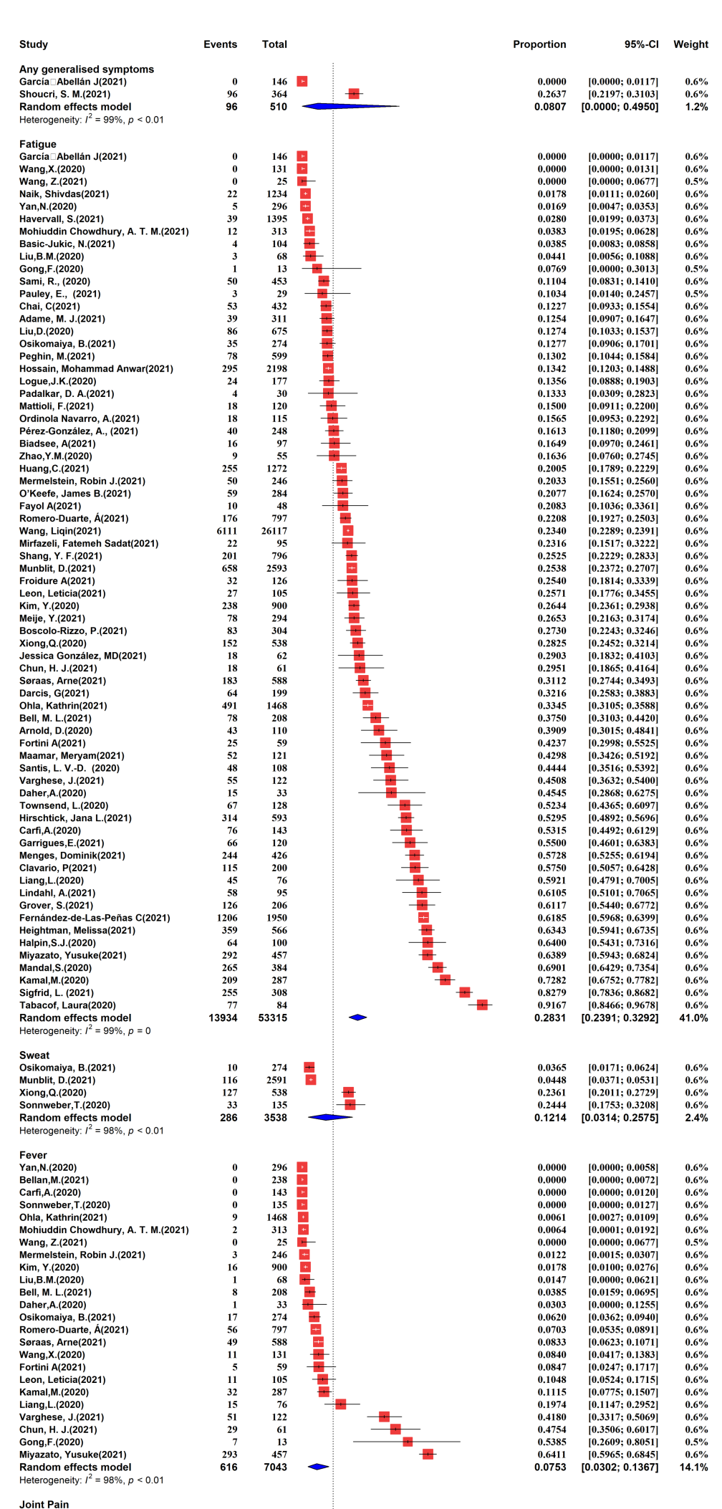
Appendix Figure S4: Forest Plot of Pooled Prevalence of Generalized Symptoms

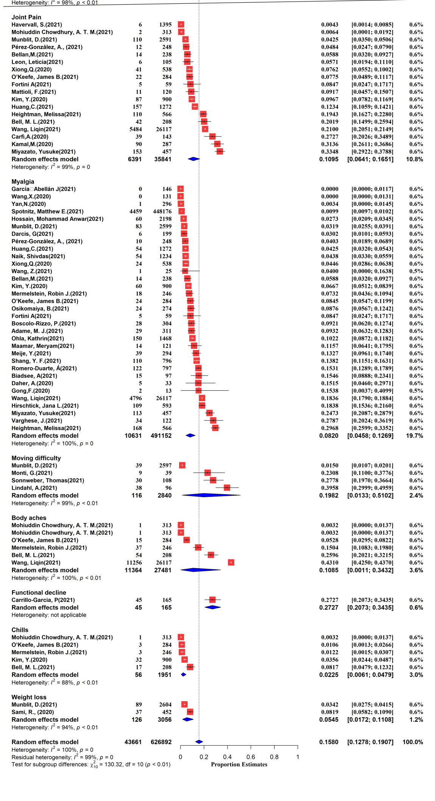

Appendix Figure S5: Forest Plot of Pooled Prevalence of Subjective Respiratory Symptoms
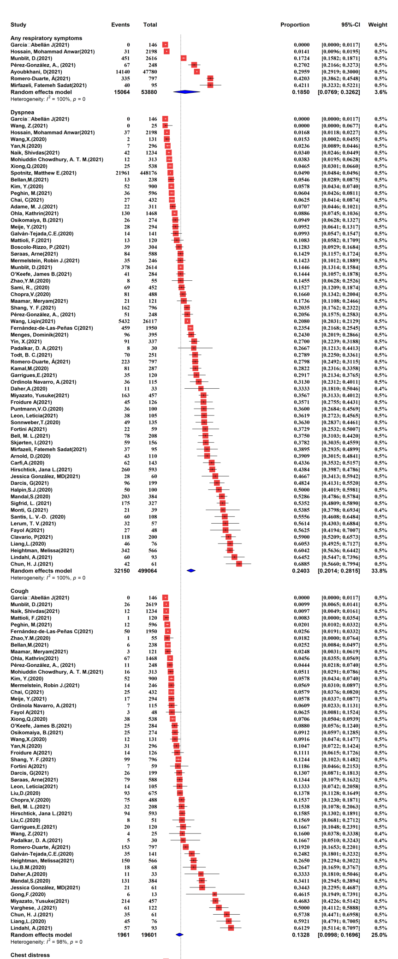
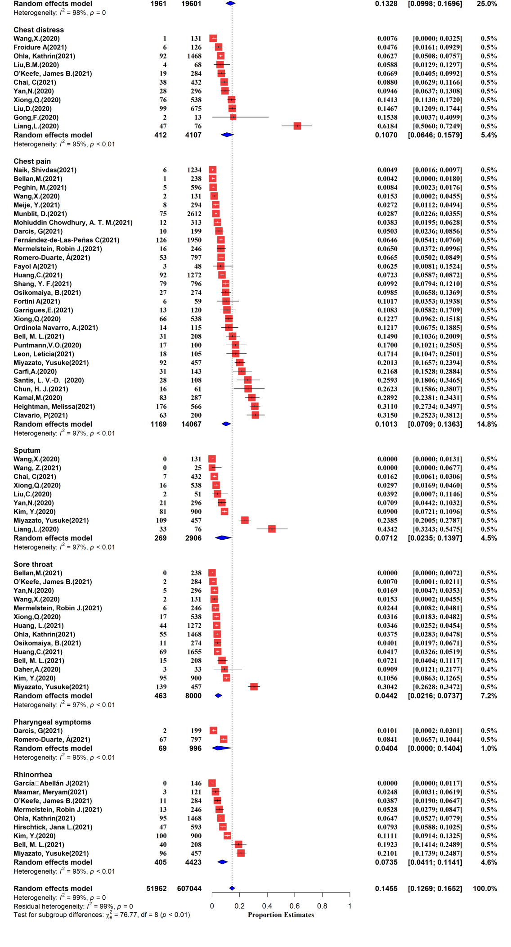

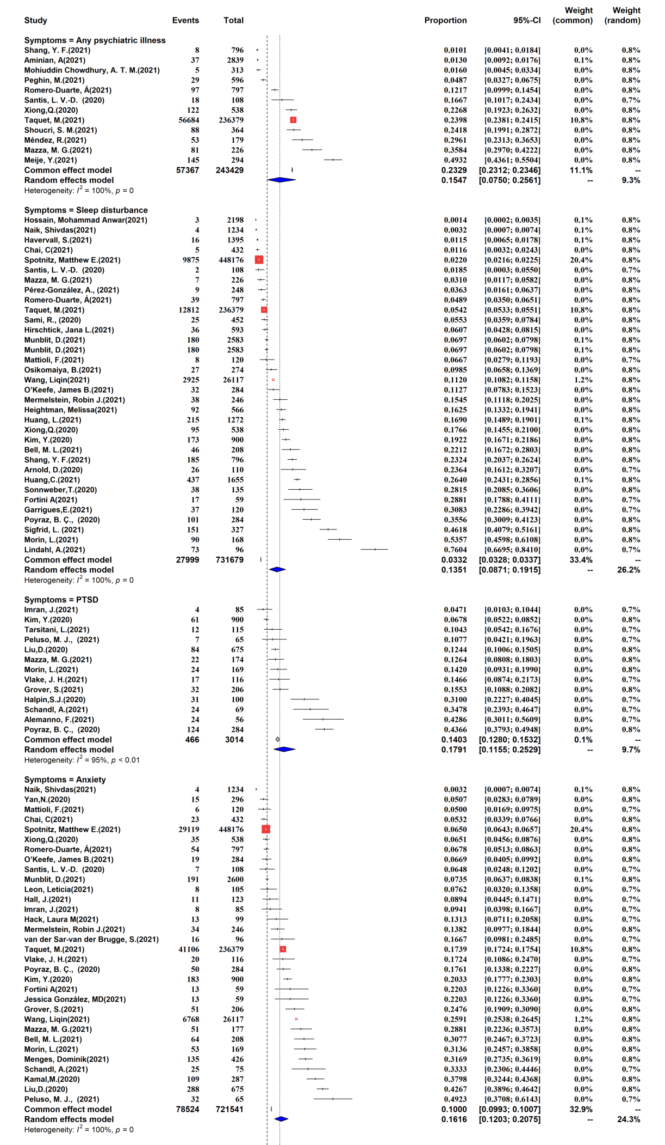
Appendix Figure S6: Forest Plot of Pooled Prevalence of Psychiatric Symptoms

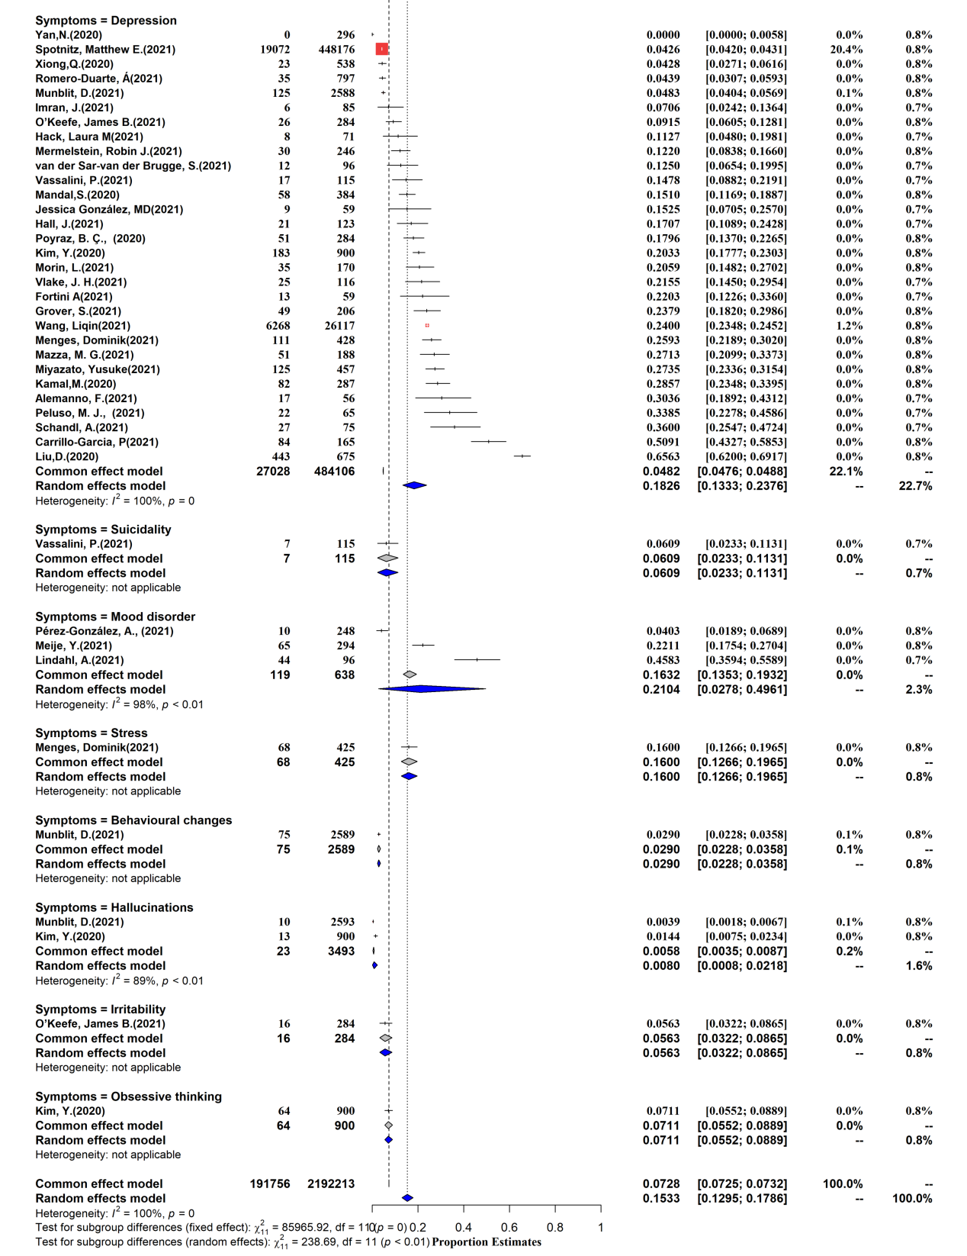

Appendix Figure S6.1: Forest Plot of Pooled Prevalence of different severity of anxiety

Appendix Figure S6.2: Forest Plot of Pooled Prevalence of different severity of depression

Appendix Figure S6.3: Forest Plot of Pooled Prevalence of different severity of PTSD

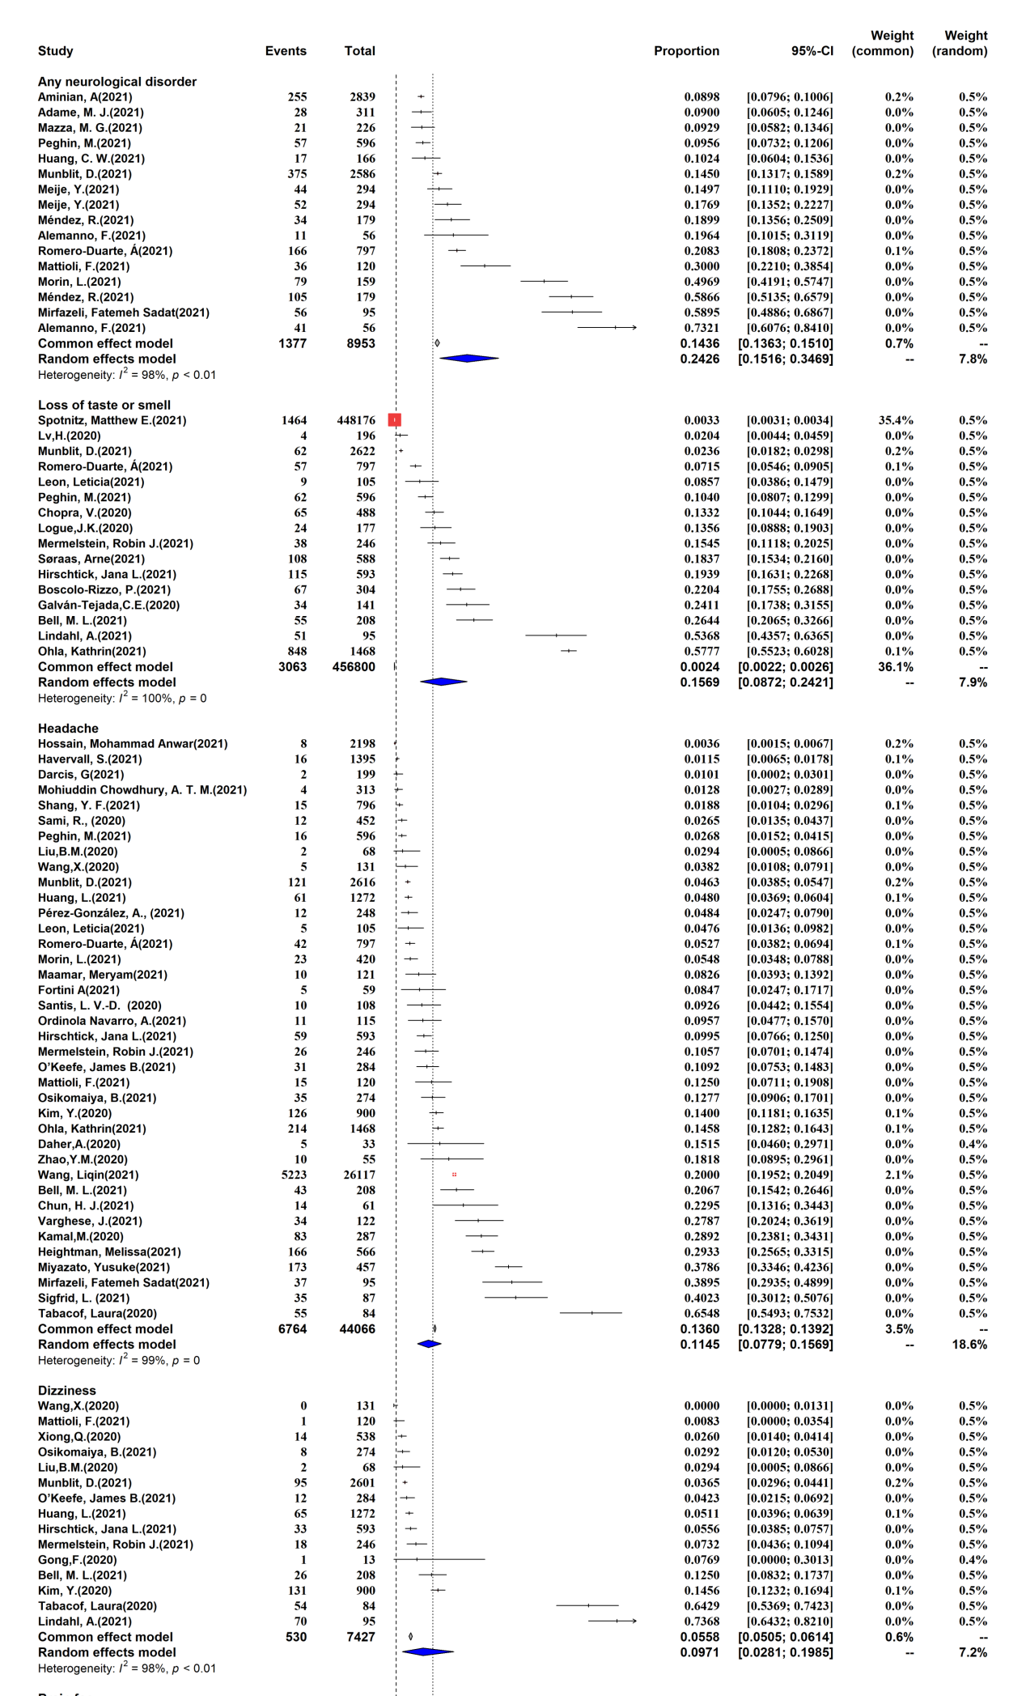
Appendix Figure S7: Forest Plot of Pooled Prevalence of Neurological Symptoms
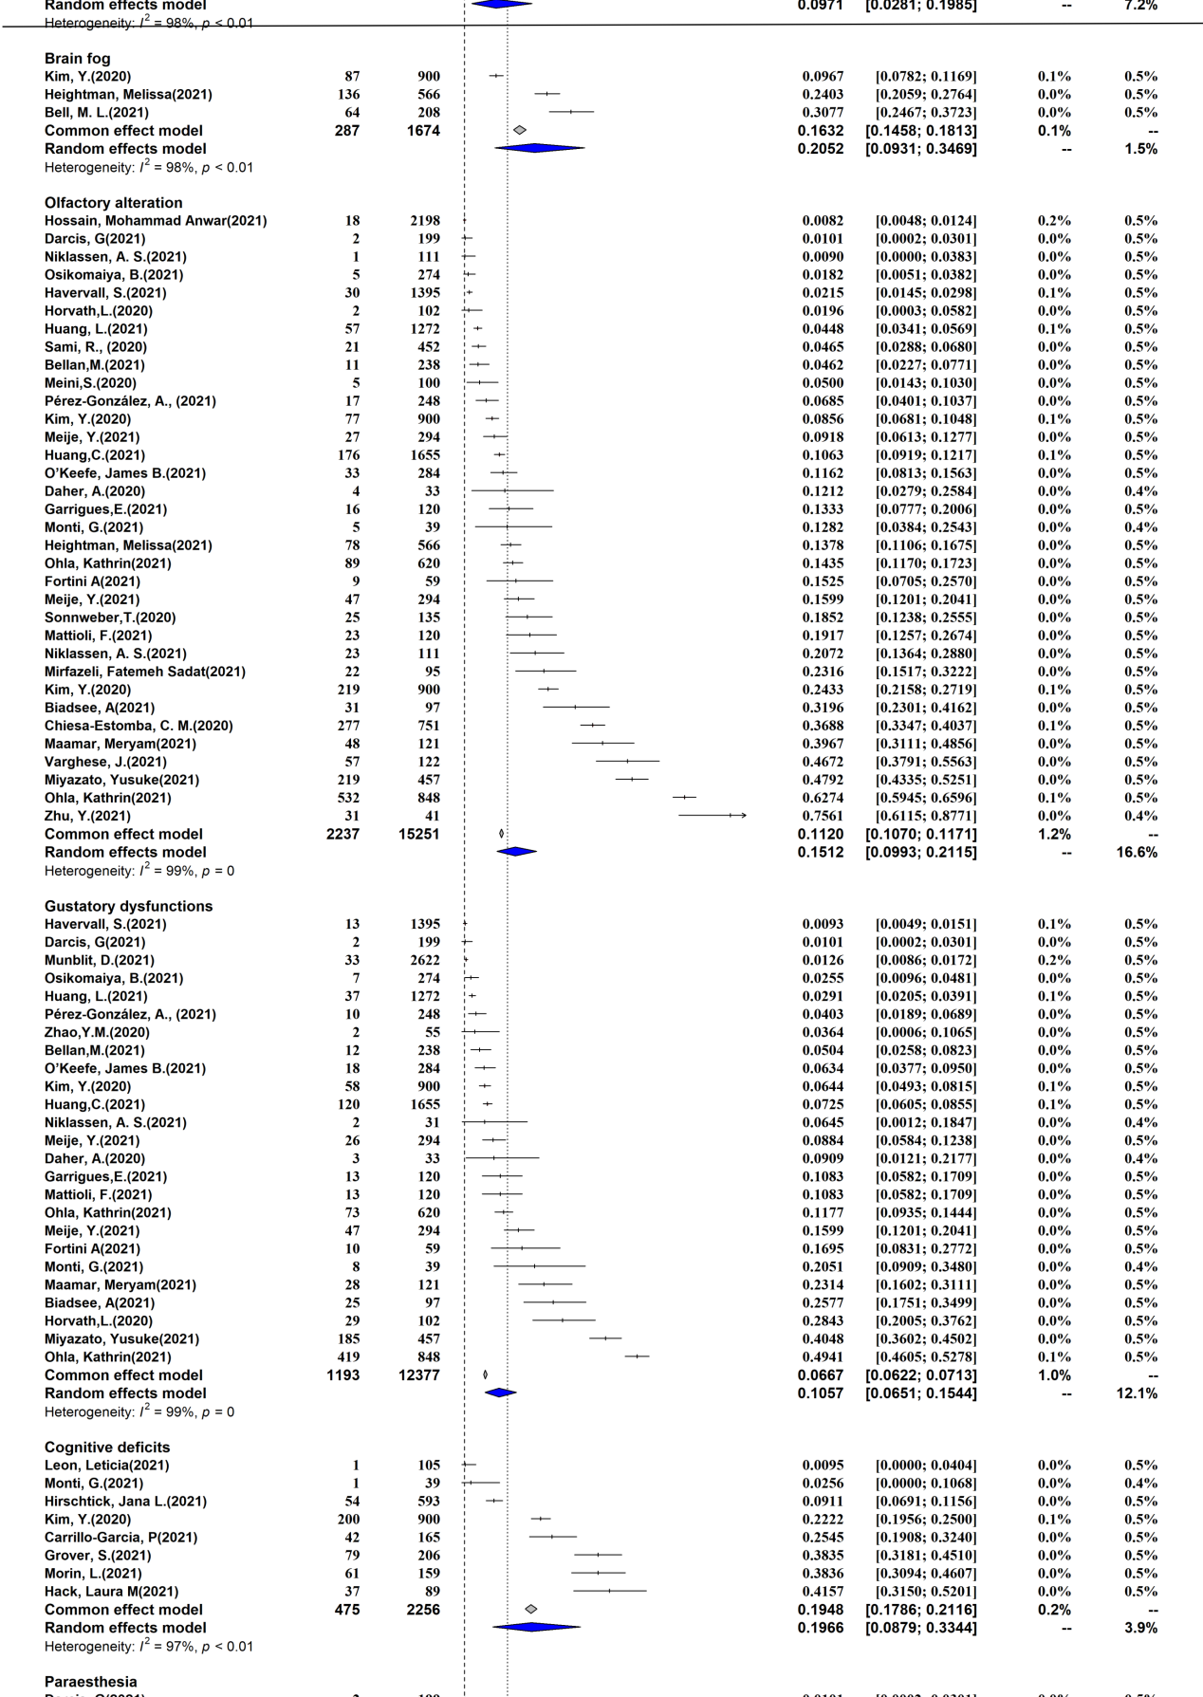

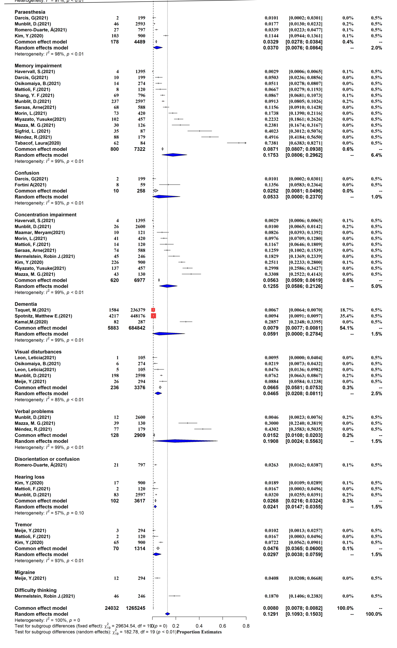

Appendix Figure S8: Forest Plot of Pooled Prevalence of Objective Cardiovascular Findings

Appendix Figure S9: Forest Plot of Pooled Prevalence of Cardiovascular Symptoms

Appendix Figure S10: Forest Plot of Pooled Prevalence of Dermatological Symptoms

Appendix Figure S11: Forest Plot of Pooled Prevalence of Digestive Symptoms

Appendix Figure S12: Forest Plot of Pooled Prevalence of COVID-19 Repositive Rate

Appendix Figure S13: Forest Plot of Pooled Prevalence of COVID-19 Readmission Rate

Appendix Figure S14: Prevalence of Clinical Sequelae with Time after COVID-19 Infection
Appendix Figure S14.1: Prevalence of CT Abnormal Manifestations with Time after COVID-19 Infection

Appendix Figure S14.2: Prevalence of Pulmonary Function Tests with Time after COVID-19 Infection
Appendix Figure S14.3: Prevalence of Generalized Symptoms with Time after COVID-19 Infection

Appendix Figure S14.4: Prevalence of Subjective Respiratory Symptoms with Time after COVID-19 Infection
Appendix Figure S14.5: Prevalence of Psychiatry Symptoms with Time after COVID-19 Infection

Appendix Figure S14.6: Prevalence of Neurologic Symptoms with Time after COVID-19 Infection

Appendix Figure S14.7: Prevalence of Cardiovascular Symptoms with Time after COVID-19 Infection

Appendix Figure S14.8: Prevalence of Digestive Symptoms with Time after COVID-19 Infection

Appendix Figure S15: Prevalence of Clinical Sequelae with Time after COVID-19 Infection (Multi Measures in One Study)

Appendix Figure S15.1: Prevalence of any Symptoms with Time after COVID-19 Infection (Multi Measures in One Study)

Appendix Figure S15.2: Prevalence of CT Abnormal Manifestations with Time after COVID-19 Infection (Multi Measures in One Study)

Appendix Figure S15.3: Prevalence of Generalized Symptoms with Time after COVID-19 Infection (Multi Measures in One Study)

Appendix Figure S15.4: Prevalence of Subjective Respiratory Symptoms with Time after COVID-19 Infection (Multi Measures in One Study)

Appendix Figure S15.5: Prevalence of Psychiatry Symptoms with Time after COVID-19 Infection (Multi Measures in One Study)

Appendix Figure S15.6: Prevalence of Neurologic Symptoms with Time after COVID-19 Infection (Multi Measures in One Study)

Appendix Figure S15.7: Prevalence of Cardiovascular Symptoms with Time after COVID-19 Infection (Multi Measures in One Study)

Appendix Figure S15.8: Prevalence of Digestive Symptoms with Time after COVID-19 Infection (Multi Measures in One Study)

Appendix Figure S16: Subgroup Comparison of Clinical Sequelae of COVID-19 across Different Follow-up Periods

Appendix Figure S16.1: Subgroup Comparison of Any Symptoms across Different Follow-up Periods

Appendix Figure S16.2: Subgroup Comparison of CT Abnormal Manifestations across Different Follow-up Periods

Appendix Figure S16.3: Subgroup Comparison of Pulmonary Function Tests across Different Follow-up Periods

Appendix Figure S16.4: Subgroup Comparison of Generalized Symptoms across Different Follow-up Periods

Appendix Figure S16.5: Subgroup Comparison of Subjective Respiratory Symptoms across Different Follow-up Periods

Appendix Figure S16.6: Subgroup Comparison of Psychiatry Symptoms across Different Follow-up Periods

Appendix Figure S16.6.1: Subgroup Comparison of Anxiety across Different Follow-up Periods

Appendix Figure S16.6.2: Subgroup Comparison of Depression across Different Follow-up Periods

Appendix Figure S16.6.3: Subgroup Comparison of Sleep Disturbance across Different Follow-up Periods

Appendix Figure S16.6.4: Subgroup Comparison of PTSD across Different Follow-up Periods

Appendix Figure S16.7: Subgroup Comparison of Neurologic Symptoms across Different Follow-up Periods

Appendix Figure S16.7.1: Subgroup Comparison of Cognitive deficits across Different Follow-up Periods

Appendix Figure S16.7.2: Subgroup Comparison of Memory impairment across Different Follow-up Periods

Appendix Figure S16.7.3: Subgroup Comparison of Loss of taste or smell across Different Follow-up Periods

Appendix Figure S16.7.4: Subgroup Comparison of Olfactory dysfunction across Different Follow-up Periods

Appendix Figure S16.7.4: Subgroup Comparison of Concentration impairment across Different Follow-up Periods

Appendix Figure S16.7.5: Subgroup Comparison of Headache across Different Follow-up Periods

Appendix Figure S16.7.5: Subgroup Comparison of Gustatory dysfunction across Different Follow-up Periods

Appendix Figure S16.7.6: Subgroup Comparison of Visual disturbance across Different Follow-up Periods
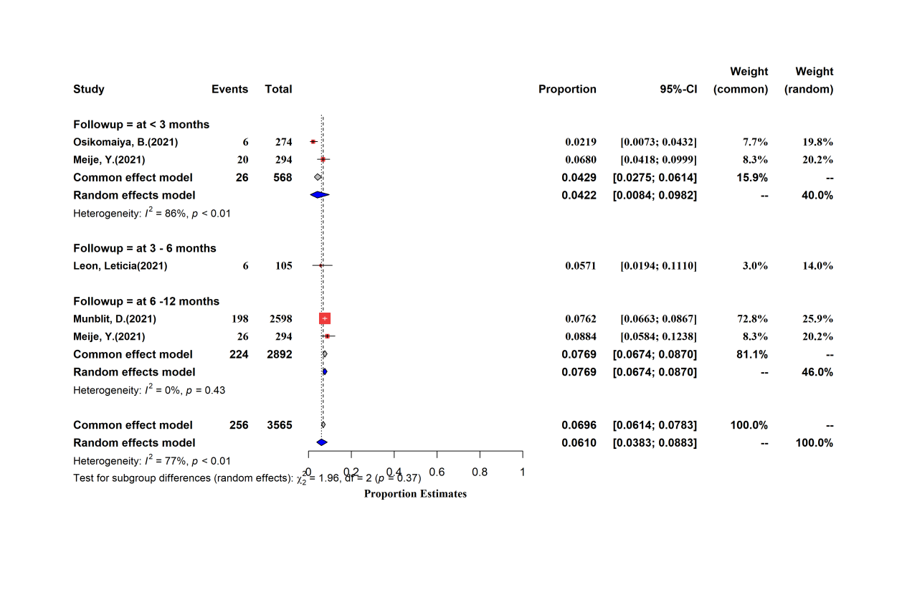

Appendix Figure S16.8: Subgroup Comparison of Cardiovascular Symptoms across Different Follow-up Periods

Appendix Figure S16.9: Subgroup Comparison of Digestive Symptoms across Different Follow-up Periods

Appendix Figure S17: Subgroup Comparison of Clinical Sequelae of COVID-19 for Different Ages

Appendix Figure S17.1: Subgroup Comparison of Any Symptoms for Different Ages

Appendix Figure S17.2: Subgroup Comparison of CT Abnormal Manifestations for Different Ages

Appendix Figure S17.3: Subgroup Comparison of Pulmonary Function Tests for Different Ages

Appendix Figure S17.4: Subgroup Comparison of Generalized Symptoms for Different Ages

Appendix Figure S17.5: Subgroup Comparison of Subjective Respiratory Symptoms for Different Ages

Appendix Figure S17.6: Subgroup Comparison of Psychiatry Symptoms for Different Ages

Appendix Figure S17.6.1: Subgroup Comparison of Anxiety for Different Ages

Appendix Figure S17.6.2: Subgroup Comparison of Depression for Different Ages

Appendix Figure S17.6.3: Subgroup Comparison of PTSD for Different Ages

Appendix Figure S17.6.4: Subgroup Comparison of Sleep disturbance for Different Ages

Appendix Figure S17.7: Subgroup Comparison of Neurologic Symptoms for Different Ages

Appendix Figure S17.7.1: Subgroup Comparison of Cognitive deficits for Different Ages

Appendix Figure S17.7.2: Subgroup Comparison of Memory impairment for Different Ages

Appendix Figure S17.7.3: Subgroup Comparison of Loss of taste or smell for Different Ages

Appendix Figure S17.7.4: Subgroup Comparison of Olfactory dysfunction for Different Ages

Appendix Figure S17.7.5: Subgroup Comparison of Concentration impairment for Different Ages

Appendix Figure S17.7.6: Subgroup Comparison of Headache for Different Ages

Appendix Figure S17.7.87: Subgroup Comparison of Gustatory dysfunction for Different Ages

Appendix Figure S17.7.8: Subgroup Comparison of Dizziness for Different Ages

Appendix Figure S17.7.9: Subgroup Comparison of Visual disturbance for Different Ages

Appendix Figure S17.8: Subgroup Comparison of Cardiovascular Symptoms for Different Ages

Appendix Figure S17.9: Subgroup Comparison of Dermatological Symptoms for Different Ages

Appendix Figure S17.10: Subgroup Comparison of Digestive Symptoms for Different Ages

Appendix Figure S18: Subgroup Comparison of Clinical Sequelae of COVID-19 across Genders

Appendix Figure S18.1: Subgroup Comparison of Any Symptoms across Genders
Appendix Figure S18.2: Subgroup Comparison of CT Abnormal Manifestations across Genders

Appendix Figure S18.3: Subgroup Comparison of Pulmonary Function Tests across Genders

Appendix Figure S18.4: Subgroup Comparison of Generalized Symptoms across Genders
Appendix Figure S18.5: Subgroup Comparison of Subjective Respiratory Symptoms across Genders
Appendix Figure S18.6: Subgroup Comparison of Psychiatry Symptoms across Genders
Appendix Figure S18.6.1: Subgroup Comparison of Anxiety across Genders

Appendix Figure S18.6.2: Subgroup Comparison of Depression across Genders

Appendix Figure S18.6.3: Subgroup Comparison of PTSD across Genders

Appendix Figure S18.6.4: Subgroup Comparison of Sleep disturbance across Genders

Appendix Figure S18.7: Subgroup Comparison of Neurologic Symptoms across Genders

Appendix Figure S18.7.1: Subgroup Comparison of Cognitive deficits across Genders

Appendix Figure S18.7.2: Subgroup Comparison of Memory impairment across Genders

Appendix Figure S18.7.3: Subgroup Comparison of Loss of taste or smell across Genders

Appendix Figure S18.7.4: Subgroup Comparison of Olfactory dysfunction across Genders

Appendix Figure S18.7.5: Subgroup Comparison of Concentration impairment across Genders

Appendix Figure S18.7.6: Subgroup Comparison of Headache across Genders

Appendix Figure S18.7.7: Subgroup Comparison of Loss of taste or Gustatory dysfunction across Genders

Appendix Figure S18.7.8: Subgroup Comparison of Dizziness across Genders

Appendix Figure S18.7. 9: Subgroup Comparison of Visual disturbance across Genders

Appendix Figure S18.8: Subgroup Comparison of Cardiovascular Symptoms across Genders

Appendix Figure S18.9: Subgroup Comparison of Dermatological Symptoms across Genders

Appendix Figure S18.10: Subgroup Comparison of Digestive Symptoms across Genders

Appendix Figure S19: Subgroup Comparison of Clinical Sequelae of COVID-19 across Regions
Appendix Figure S19.1: Subgroup Comparison of Any Symptoms across Regions

Appendix Figure S19.2: Subgroup Comparison of CT Abnormal Manifestations across Regions
Appendix Figure S19.3: Subgroup Comparison of Pulmonary Function Tests across Regions

Appendix Figure S19.4: Subgroup Comparison of Generalized Symptoms across Regions

Appendix Figure S19.5: Subgroup Comparison of Subjective Respiratory Symptoms across Regions

Appendix Figure S19.6: Subgroup Comparison of Psychiatry Symptoms across Regions

Appendix Figure S19.6.1: Subgroup Comparison of Anxiety across Regions

Appendix Figure S19.6.2: Subgroup Comparison of Depression across Regions

Appendix Figure S19.6.3: Subgroup Comparison of PTSD across Regions

Appendix Figure S19.6.4: Subgroup Comparison of Sleep disturbance across Regions

Appendix Figure S19.7: Subgroup Comparison of Neurologic Symptoms across Regions

Appendix Figure S19.7.1: Subgroup Comparison of Cognitive deficits across Regions

Appendix Figure S19.7.2: Subgroup Comparison of Memory impairment across Regions

Appendix Figure S19.7.3: Subgroup Comparison of Loss of taste or smell across Regions

Appendix Figure S19.7.4: Subgroup Comparison of Olfactory dysfunction across Regions

Appendix Figure S19.7.5: Subgroup Comparison of Concentration impairment across Regions

Appendix Figure S19.7.6: Subgroup Comparison of Headache across Regions

Appendix Figure S19.7.7: Subgroup Comparison of Gustatory dysfunction across Regions

Appendix Figure S19.7.8: Subgroup Comparison of Dizziness across Regions

Appendix Figure S19.7.9: Subgroup Comparison of Visual disturbance across Regions

Appendix Figure S19.8: Subgroup Comparison of Cardiovascular Symptoms across Regions
Appendix Figure S19.9: Subgroup Comparison of Dermatological Symptoms across Regions

Appendix Figure S19.10: Subgroup Comparison of Digestive Symptoms across Regions

Appendix Figure S20: Subgroup Comparison of Clinical Sequelae of COVID-19 for Different Severity of Acute Infection of COVID-19
Appendix Figure S20.1: Subgroup Comparison of Any Symptoms for Different Severity of Acute Infection of COVID-19

Appendix Figure S20.2: Subgroup Comparison of CT Abnormal Manifestations for Different Severity of Acute Infection of COVID-19

Appendix Figure S20.3: Subgroup Comparison of Pulmonary Function Tests for Different Severity of Acute Infection of COVID-19

Appendix Figure S20.4: Subgroup Comparison of Generalized Symptoms for Different Severity of Acute Infection of COVID-19

Appendix Figure S20.5: Subgroup Comparison of Subjective Respiratory Symptoms for Different Severity of Acute Infection of COVID-19

Appendix Figure S20.6: Subgroup Comparison of Psychiatry Symptoms for Different Severity of Acute Infection of COVID-19
Appendix Figure S20.6.1: Subgroup Comparison of Anxiety for Different Severity of Acute Infection of COVID-19

Appendix Figure S20.6.2: Subgroup Comparison of Depression for Different Severity of Acute Infection of COVID-19
Appendix Figure S20.6.3: Subgroup Comparison of PTSD for Different Severity of Acute Infection of COVID-19
Appendix Figure S20.6.4: Subgroup Comparison of Sleep Disturbance for Different Severity of Acute Infection of COVID-19

Appendix Figure S20.7: Subgroup Comparison of Any neurological symptoms for Different Severity of Acute Infection of COVID-19

Appendix Figure S20.7.1: Subgroup Comparison of Concentration impairment for Different Severity of Acute Infection of COVID-19

Appendix Figure S20.7.2: Subgroup Comparison of Gustatory dysfunction Symptoms for Different Severity of Acute Infection of COVID-19

Appendix Figure S20.7.3: Subgroup Comparison of Memory impairment Symptoms for Different Severity of Acute Infection of COVID-19

Appendix Figure S20.7.4: Subgroup Comparison of Olfactory alteration Symptoms for Different Severity of Acute Infection of COVID-19
Appendix Figure S20.8: Subgroup Comparison of Cardiovascular Symptoms for Different Severity of Acute Infection of COVID-19

Appendix Figure S20.9: Subgroup Comparison of Digestive Symptoms for Different Severity of Acute Infection of COVID-19

Appendix Figure S21: Funnel Plot

Appendix Figure S21.1: Funnel Plot of Any Symptoms

Appendix Figure S21.2: Funnel Plot of CT Abnormal Manifestations

Appendix Figure S21.3: Funnel Plot of Pulmonary Function Tests

Appendix Figure S21.4: Funnel Plot of Generalized Symptoms

Appendix Figure S21.5: Funnel Plot of Subjective Respiratory Symptoms
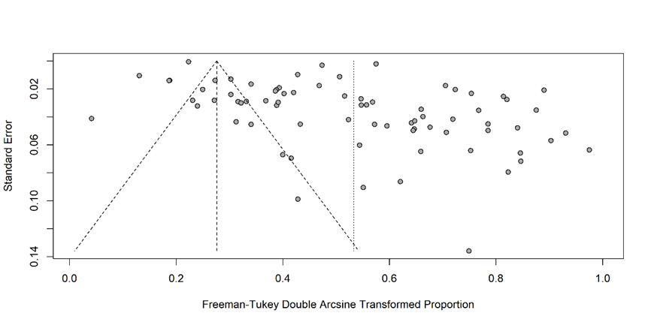

Appendix Figure S21.6: Funnel Plot of Psychiatric Symptoms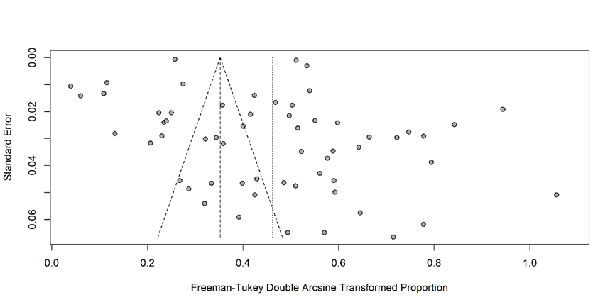

Appendix Figure S21:7 Funnel Plot of Neurologic Symptoms

Appendix Figure S21.8: Funnel Plot of Cardiovascular Symptoms

Appendix Figure S21.9: Funnel Plot of Dermatological Symptoms

Appendix Figure S21.10: Funnel Plot of Digestive Symptoms

Appendix Figure S22: Forest Plot of the Leave-One-Out-Analyses

Appendix Figure S22.1: Forest Plot of the Leave-One-Out-Analyses of Any Symptoms

Appendix Figure S22.2: Forest Plot of the Leave-One-Out-Analyses of CT Abnormal Manifestations
Appendix Figure S22.3: Forest Plot of the Leave-One-Out-Analyses of Pulmonary Function Tests

Appendix Figure S22.4: Forest Plot of the Leave-One-Out-Analyses of Generalized Symptoms

Appendix Figure S22.5: Forest Plot of the Leave-One-Out-Analyses of Subjective Respiratory Symptoms

Appendix Figure S22.6: Forest Plot of the Leave-One-Out-Analyses of Psychiatric Disorder

Appendix Figure S22:7 Forest Plot of the Leave-One-Out-Analyses of Neurologic Symptoms

Appendix Figure S22.8: Forest Plot of the Leave-One-Out-Analyses of Cardiovascular Symptoms

Appendix Figure S22.9: Forest Plot of the Leave-One-Out-Analyses of Dermatological Symptoms

Appendix Figure S22.10: Forest Plot of the Leave-One-Out-Analyses of Digestive Symptoms

Appendix Table S4. Egger’s Tests of COVID-19 Sequelae
Sequelae | Bias | Se.bias | P value
Any of symptoms | 2.135 | 3.811 | 0.6371
CT abnormal manifestation | 4.558 | 3.781 | 0.2415
Pulmonary function tests | 6.122 | 1.150 | 0.000138
Generalised symptoms | 16.307 | 2.960 | <0.001
Cardiovascular symptoms | 2.968 | 2.972 | 0.3265
Psychiatric symptoms | 4.271 | 4.075 | 0.2991
Respiratory symptoms | 9.600 | 2.397 | 0.000148
Neurologic symptoms | 12.608 | 2.121 | <0.001
Dermatosis symptoms | 0.364 | 3.882 | 0.926
Digestive symptoms | -4.756 | 1.996 | 0.0223

Appendix Table S5. Meta regression analysis of prevalence of COVID-19 sequelae by age, female proportion and follow up duration
Symptoms | Age |  | Male proportion |  | Follow up duration
Symptoms | β (95%CI) | P value | β (95%CI) | P value | β (95%CI) | P value
Any of the symptoms | 0.0073  (-0.0005,0.0150) | 0.0649 | 0.0052  (-0.015, 0.0120) | 0.1215 | -0.0014  (-0.0023, -0.0006) | <0.0001*
CT abnormal manifestations | 0.0101  (-0.0013, 0.0216) | 0.0833 | 0.0010  (-0.0090, 0.0110) | 0.8475 | -0.0023  (-0.0125, 0.0078) | 0.6516
Pulmonary function tests | 0.0073  (-0.0057,0.0203) | 0.2718 | 0.0055  (-0.0004, 0.0115) | 0.0687 | -0.0050  (-0.0144, 0.0045) | 0.3015
Generalized symptoms | 0.0008  (-0.0044,0.0061) | 0.7573 | 0.0004  (-0.0035, 0.0043) | 0.8385 | -0.0001  (-0.0032, 0.0030) | 0.9619
Psychiatric disorder | 0.0065  (0.0022,0.0108) | 0.0029* | 0.0013  (-0.0014, 0.0040) | 0.3327 | -0.0039  (-0.0059, -0.0019) | 0.0001*
Subjective respiratory symptoms | 0.0046  (0.0006,0.0086) | 0.0242* | 0.0026  (0.0002, 0.0049) | 0.0302* | -0.0006  (-0.0027,0.0016) | 0.6072
Cardiovascular symptoms | 0.0003  (-0.0082,0.0088) | 0.9493 | 0.0022  (-0.0075, 0.0030) | 0.4006 | -0.0051  (-0.0118,0.0015) | 0.1284
Neurologic symptoms | -0.0019  (-0.0082,0.0044) | 0.5536 | -0.0002  (-0.0039, 0.0035) | 0.9151 | -0.0004  (-0.0018, 0.0009) | 0.5417
Digestive symptoms | 0.0010  (-0.0053,0.0072) | 0.7621 | 0.0008  (-0.0029, 0.0045) | 0.6734 | 0.0006  (-0.0024,0.0035) | 0.7127

Appendix Table S6. Measurements and corresponding cutoff values of psychiatric symptoms
Study | Symptoms | Measure
Alemanno, F. et al (2021) | PTSD | DTS*
Alemanno, F. et al (2021) | Depression | HRSD*
Aminian, A. et al (2021) | Any psychiatric symptoms | consult order to psychology or psychiatry
Arnold, D. et al (2020) | Sleep disturbance | WEMWBS questionnaires*
Bell, M. L.et al (2021) | Anxiety | Questionnaire  Which of the following symptoms did you experience or are you currently experiencing?  Stress and/or anxiety
Bell, M. L.et al (2021) | Sleep disturbance | Questionnaire  Which of the following symptoms did you experience or are you currently experiencing?  Insomnia or trouble sleeping
Carrillo-Garcia, P. et al (2021) | Depression | DSM-V*
Chai, C. et al (2021) | Anxiety | Questionnaire  Do you feel anxiety or depression compared with the status prior to COVID-19
Chai, C. et al (2021) | Sleep disturbance | Questionnaire  What do you think about your sleeping compared with the status prior to COVID-19?
Fortini, A. et al (2021) | Sleep disturbance | Completed a 46-item self-administered questionnaire designed by the Health Service of the Tuscany Region, aiming to assess the persistence of symptoms complained of during hospitalization.
Fortini, A. et al (2021) | Depression | Completed a 46-item self-administered questionnaire designed by the Health Service of the Tuscany Region, aiming to assess the persistence of symptoms complained of during hospitalization.
Fortini, A. et al (2021) | Anxiety | Completed a 46-item self-administered questionnaire designed by the Health Service of the Tuscany Region, aiming to assess the persistence of symptoms complained of during hospitalization.
Garrigues, E. et al (2021) | Sleep disturbance | Phone questionnaire
Grover, S. et al (2021) | Anxiety | PHQ-4*
Grover, S. et al (2021) | Depression | PHQ-4*
Grover, S. et al (2021) | PTSD | IES-R*
Hack, Laura M. et al (2021) | Depression | PHQ-9 (PHQ-9 ≥ 10 corresponding to a least moderate depression and/or anxiety)
Hack, Laura M. et al (2021) | Anxiety | GAD-7 (GAD-7 ≥ 10 corresponding to a least moderate depression and/or anxiety)
Hall, J. et al (2021) | Depression | PHQ-9*
Hall, J. et al (2021) | Anxiety | PHQ-9*
Halpin, S. J. et al (2020) | PTSD | Iterative peer review
Havervall, S. et al (2021) | Sleep disturbance | The Sheehan Disability Scale 6 was used to score functional impairment from present or prior long-term symptoms (0, not at all; 1-3, mild; 4-6,moderate; and 7-10, marked)
Heightman, Melissa. et al (2021) | Sleep disturbance | Clinical assessment was developed by secondary care clinicians and therapists, consisting of a consultation and multi-professional assessment, delivered primarily face-to-face, or where necessary, virtually.
Hirschtick, Jana L. et al (2021) | Sleep disturbance | If you have not recovered from COVID-19 to your usual state of health, which symptoms are you still  experiencing?  Trouble sleeping
Hossain, Mohammad Anwar. et al (2021) | Sleep disturbance | Do you feel that you have any challenges or have any persisting symptoms after receiving a negative test result for COVID-19
Huang, L. et al (2021) | Sleep disturbance | Questionnaire  Have you experienced sleep difficulty now?  Is it newly onset post COVID-19?  Is it worse than the status prior to COVID-19?
Huang, C. et al (2021) | Sleep disturbance | Questionnaire  What do you think about your sleeping compared with the status prior to COVID-19?
Imran, J. et al (2021) | PTSD | PCL-5 (PCL-5 ≥ 31)*
Imran, J. et al (2021) | Anxiety | GAD-7 (GAD-7 ≥ 8)*
Imran, J. et al (2021) | Depression | PHQ-9 (PHQ-9 ≥4)*
González, J. et al (2021) | Depression | HADS (HADS ≥8)*
González, J. et al (2021) | Anxiety | HADS (HADS ≥8)*
Kamal, M. et al (2020) | Anxiety | Recovered Egyptian subjects from COVID-19 received a questionnaire aimed to collect data related to their post-COVID-19 manifestations.
Kamal, M. et al (2020) | Depression | Recovered Egyptian subjects from COVID-19 received a questionnaire aimed to collect data related to their post-COVID-19 manifestations.
Kim, Y. et al (2020) | Anxiety | Questionnaire survey
Kim, Y. et al (2020) | Depression | Questionnaire survey
Kim, Y. et al (2020) | Sleep disturbance | Questionnaire survey
Kim, Y. et al (2020) | Obsessive thinking | Questionnaire survey
Kim, Y. et al (2020) | PTSD | Questionnaire survey
Kim, Y. et al (2020) | Hallucinations | Questionnaire survey
Leon, Leticia. et al (2021) | Anxiety | Self-reported symptoms
Lindahl, A. et al (2021) | Sleep disturbance | Questionnaire survey
Lindahl, A. et al (2021) | Mood disorder | Questionnaire survey
Liu, D. et al (2020) | PTSD | PCL-5 (At least one re-experiencing symptom, one avoidance symptom, two negative alterations in cognition or mood symptoms, and two arousal symptoms, where a symptom was considered present with a score of 2 (moderate) or higher)
Liu, D. et al (2020) | Anxiety | GAD-7 (GAD-7≥10)*
Liu, D. et al (2020) | Depression | PHQ-9 (PHQ-9≥10)*
Mandal, S. et al (2020) | Depression | PHQ-2 (PHQ-2 ≥ 3)*
Mazza, M. G. et al (2020) | Sleep disturbance | MOS-SS*
Mazza, M. G. et al (2020) | PTSD | PCL-5 (PCL-5 ≥ 33)*
Mazza, M. G. et al (2020) | Anxiety | STAI-Y (STAI-state ≥ 40)*
Mazza, M. G. et al (2020) | Depression | BDI-13 (BDI-13 ≥ 9)*
Mattioli, F. et al (2021) | Sleep disturbance | Questionnaire survey
Mattioli, F. et al (2021) | Anxiety | DASS-21*
Meije, Y. et al (2021) | Any psychiatric illness | Questionnaire survey
Meije, Y. et al (2021) | Mood disorder | Questionnaire survey
Méndez, R. et al (2021) | Any psychiatric illness | GAD-7 & PHQ-2 & DTS (psychiatric morbidity was predefined as positive screening in any of the three questionnaires assessing psychiatric morbidity.)
Menges, Dominik. et al (2021) | Depression | DASS-21*
Menges, Dominik. et al (2021) | Anxiety | DASS-21*
Menges, Dominik. et al (2021) | Stress | DASS-21*
Mermelstein, Robin J. et al (2021) | Sleep disturbance | Questionnaire survey
Mermelstein, Robin J. et al (2021) | Anxiety | Questionnaire survey
Mermelstein, Robin J. et al (2021) | Depression | Questionnaire survey
Miyazato, Yusuke. et al (2021) | Depression | Questionnaire survey  Depression
Mohiuddin Chowdhury, A. T. M. et al (2021) | Any psychiatric illness | Questionnaire survey
Munblit, D.et al (2021) | Sleep disturbance | Questionnaire survey  Problems sleeping
Munblit, D.et al (2021) | Anxiety | Questionnaire survey  Anxiety
Munblit, D.et al (2021) | Behavioural changes | Questionnaire survey  Behavioural changes
Munblit, D.et al (2021) | Depression | Questionnaire survey  Depressed mood
Munblit, D.et al (2021) | Hallucinations | Questionnaire survey  Hallucinations (seeing or hearing things others don’t see or hear)
Naik, Shivdas. et al (2021) | Anxiety | Questionnaire survey
Naik, Shivdas. et al (2021) | Sleep disturbance | Questionnaire survey
O’Keefe, James B. et al (2021) | Sleep disturbance | Questionnaire survey
O’Keefe, James B. et al (2021) | Depression | Questionnaire survey
O’Keefe, James B. et al (2021) | Anxiety | Questionnaire survey
O’Keefe, James B. et al (2021) | Irritability | Questionnaire survey
Osikomaiya, B. et al (2021) | Sleep disturbance | Self-reported symptoms
Peghin, M. et al (2021) | Any psychiatric illness | Questionnaire survey by telephone interview
Peluso, M. J. et al (2021) | Anxiety | GAD-7*
Peluso, M. J. et al (2021) | Depression | PHQ-8*
Peluso, M. J. et al (2021) | PTSD | PCL-5*
Pérez-González, A. et al (2021) | Mood disorder | Questionnaire  Mood disorder
Pérez-González, A. et al (2021) | Sleep disturbance | Questionnaire  Insomnia
Poyraz, B. Ç. et al (2020) | PTSD | IES-R*
Poyraz, B. Ç. et al (2020) | Anxiety | HADS*
Poyraz, B. Ç. et al (2020) | Depression | HADS*
Poyraz, B. Ç. et al (2020) | Sleep disturbance | PSQI*
Romero-Duarte, Á. et al (2021) | Any psychiatric illness | Questionnaire  Any of the following mental symptoms were present at any point during the follow-up
Romero-Duarte, Á. et al (2021) | Depression | Questionnaire  Sadness, apathy, anodyne or hopelessness symptoms reported by the patient but not measured in quantitative scales
Romero-Duarte, Á. et al (2021) | Anxiety | Questionnaire  Anxiety, restlessness or extreme fear reported by the patient but not measured in quantitative scales
Romero-Duarte, Á. et al (2021) | Sleep disturbance | Questionnaire  Insomnia or lack of rest reported by the patient and not present before COVID-19 hospitalization
Sami, R. et al (2020) | Sleep disturbance | Questionnaire  Sleep disorder
Santis, Lucía Valiente-De. et al (2020) | Any psychiatric illness | Questionnaire survey
Santis, Lucía Valiente-De. et al (2020) | Anxiety | Questionnaire survey
Santis, Lucía Valiente-De. et al (2020) | Sleep disturbance | Questionnaire survey
Schandl, A. et al (2021) | PTSD | PTSS-14 (PTSS-14≥45)*
Schandl, A. et al (2021) | Anxiety | HADS (HADS≥ 8)*
Schandl, A. et al (2021) | Depression | HADS (HADS≥ 8)*
Shang, Y. F. et al (2021) | Sleep disturbance | Questionnaire survey
Shang, Y. F. et al (2021) | Any psychiatric illness | Questionnaire survey
Shoucri, S. M. et al (2021) | Any psychiatric illness | Questionnaire survey  Altered Mentation
Sigfrid, Louise. et al (2021) | Sleep disturbance | Questionnaire survey  problems sleeping
Sonnweber, T. et al (2020) | Sleep disturbance | Questionnaire survey  Do you suffer from sleeping disorders now?
Spotnitz, Matthew E. et al (2021) | Sleep disturbance | Sleep disorder diagnosed by SNOMED codes
Spotnitz, Matthew E. et al (2021) | Depression | Depression diagnosed by SNOMED codes
Spotnitz, Matthew E. et al (2021) | Anxiety | Anxiety diagnosed by SNOMED codes
Taquet, M. et al (2021) | Anxiety | ICD-10, F20–48
Taquet, M. et al (2021) | Sleep disturbance | ICD-10, F51.0 or G47 .0
Tarsitani, L. et al (2021) | PTSD | PCL-5 (Patients with 3criteria out of 4 were considered as affected by a subthreshold PTSD)
S. van der Sar - van der Brugge. et al (2021) | Anxiety | HADS*
S. van der Sar - van der Brugge. et al (2021) | Depression | HADS*
Vassalini, P. et al (2021) | Depression | PHQ-9*
Vassalini, P. et al (2021) | Suicidality | Questionnaire survey  Thoughts that you would be better off dead or of hurting yourself in some way
Vlake, J. H. et al (2021) | PTSD | IES-R*
Vlake, J. H. et al (2021) | Anxiety | HADS*
Vlake, J. H. et al (2021) | Depression | HADS*
Wang, Liqin. et al (2021) | Anxiety | Questionnaire survey
Wang, Liqin. et al (2021) | Depression | Symptoms of depression include: a sad or gloomy mood, lack of pleasure in activities you previously enjoyed, difficulties managing your weight, early morning awakening with inability to return to sleep or excessive sleeping, agitation or moving so slow that others notice, difficulty concentrating, fatigue, or mental slowness
Wang, Liqin. et al (2021) | Sleep disturbance | Questionnaire survey
Xiong, Q. et al (2020) | Sleep disturbance | Questionnaire survey  with poor sleep quality or insomnia
Xiong, Q. et al (2020) | Anxiety | Questionnaire survey
Xiong, Q. et al (2020) | Depression | Questionnaire survey
Yan, N. et al (2020) | Anxiety | Questionnaire survey
Yan, N. et al (2020) | Depression | Questionnaire survey
*Abbreviation
BDI-13, 13-item Beck’s Depression Inventory; DASS-21, Depression anxiety and stress scale-21; DSM-V, Diagnostic and Statistical Manual of Mental Disorders-V;
DTS, the Davidson Trauma Scale; GAD-7, Generalized Anxiety Disorder 7-item; HADS, Hospital Anxiety and Depression Scale; HRSD, Hamilton Rating Scale for Depression; IES-R, Impact of Events Scale-Revised; MOS-SS, Medical Outcomes Study Sleep Scale; PCL-5, PTSD checklist; PHQ-9, Patient Health Questionnaire-9;
PHQ-4, Patient Health Questionnaire-4; PSQI, Pittsburgh Sleep Quality Index; PTSS-14, Posttraumatic stress symptom scale -14; STAI-Y, State-Trait Anxiety Inventory form Y; WEMWBS, Warwick-Edinburgh Mental Wellbeing Scales.

Included Articles
1. Alemanno, F., E. Houdayer, A. Parma, A. Spina, A. Del Forno, A. Scatolini, et al. COVID-19 cognitive deficits after respiratory assistance in the subacute phase: A COVID rehabilitation unit experience. PLoS ONE. 2021; 16(2 February).
2. Aminian, A., J. Bena, K.M. Pantalone and B. Burguera. Association of obesity with postacute sequelae of COVID-19. Diabetes, Obesity and Metabolism. 2021; 23(9): 2183-2188.
3. Arnold, D., F. Hamilton, A. Milne, A. Morley, J. Viner, M. Attwood, et al. Patient outcomes after hospitalisation with COVID-19 and implications for follow-up; results from a prospective uk cohort. medRxiv. 2020.
4. Ayoubkhani, D., K. Khunti, V. Nafilyan, T. Maddox, B. Humberstone, I. Diamond and A. Banerjee. Post-COVID syndrome in individuals admitted to hospital with COVID-19: Retrospective cohort study. The BMJ. 2021; 372.
5. Banerjee, J., C.P. Canamar, C. Voyageur, S. Tangpraphaphorn, A. Lemus, C. Coffey, Jr., et al. Mortality and readmission rates among patients with COVID-19 after discharge from acute care setting with supplemental oxygen. JAMA Netw Open. 2021; 4(4): e213990.
6. Basic-Jukic, N., I. Juric, V. Furic-Cunko, L. Katalinic, J. Radic, Z. Bosnjak, et al. Follow-up of renal transplant recipients after acute COVID-19—a prospective cohort single-center study. Immunity, Inflammation and Disease. 2021.
7. Bell, M.L., C.J. Catalfamo, L.V. Farland, K.C. Ernst, E.T. Jacobs, Y.C. Klimentidis, et al. Post-acute sequelae of COVID-19 in a non-hospitalized cohort: Results from the arizona covhort. PLoS ONE. 2021; 16(8 August).
8. Bellan, M., D. Soddu, P.E. Balbo, A. Baricich, P. Zeppegno, G.C. Avanzi, et al. Respiratory and psychophysical sequelae among patients with COVID-19 four months after hospital discharge. JAMA Netw Open. 2021; 4(1): e2036142.
9. Biadsee, A., O. Dagan, Z. Ormianer, F. Kassem, S. Masarwa and A. Biadsee. Eight-month follow-up of olfactory and gustatory dysfunctions in recovered COVID-19 patients. American Journal of Otolaryngology - Head and Neck Medicine and Surgery. 2021; 42(4).
10. Blackett, J.W., J. Li, D. Jodorkovsky and D.E. Freedberg. Prevalence and risk factors for gastrointestinal symptoms after recovery from COVID-19. Neurogastroenterology and Motility. 2021.
11. Boscolo-Rizzo, P., F. Guida, J. Polesel, A.V. Marcuzzo, V. Capriotti, A. D'Alessandro, et al. Sequelae in adults at 12 months after mild-to-moderate coronavirus disease 2019 (COVID-19). International Forum of Allergy and Rhinology. 2021.
12. Budhiraja, S., M. Aggarwal, R. Wig, A. Tyagi, R. Mishra, M. Mahajan, et al. Long term health consequences of COVID-19 in hospitalized patients from north India: A follow up study of upto 12 months. medRxiv. 2021.
13. Carfì, A., R. Bernabei and F. Landi. Persistent symptoms in patients after acute COVID-19. JAMA. 2020; 324(6): 603-605.
14. Carrillo-Garcia, P., B. Garmendia-Prieto, G. Cristofori, I.L. Montoya, J.J. Hidalgo, M.Q. Feijoo, et al. Health status in survivors older than 70 years after hospitalization with COVID-19: Observational follow-up study at 3 months. European Geriatric Medicine. 2021.
15. Chai, C., X. Feng, M. Lu, S. Li, K. Chen, H. Wang, et al. One-year mortality and consequences of COVID-19 in cancer patients: A cohort study. IUBMB Life. 2021.
16. Chiesa-Estomba, C.M., J.R. Lechien, T. Radulesco, J. Michel, L.J. Sowerby, C. Hopkins and S. Saussez. Patterns of smell recovery in 751 patients affected by the COVID-19 outbreak. Eur J Neurol. 2020; 27(11): 2318-2321.
17. Chopra, V., S.A. Flanders, M. O'Malley, A.N. Malani and H.C. Prescott. Sixty-day outcomes among patients hospitalized with COVID-19. Ann Intern Med. 2020.
18. Chun, H.J., E. Coutavas, A.B. Pine, A.I. Lee, V.L. Yu, M.K. Shallow, et al. Immunofibrotic drivers of impaired lung function in postacute sequelae of SARS-CoV-2 infection. JCI Insight. 2021; 6(14).
19. Clavario, P., V. De Marzo, R. Lotti, C. Barbara, A. Porcile, C. Russo, et al. Cardiopulmonary exercise testing in COVID-19 patients at 3 months follow-up. International Journal of Cardiology. 2021.
20. Daher, A., P. Balfanz, C. Cornelissen, A. Müller, I. Bergs, N. Marx, et al. Follow up of patients with severe coronavirus disease 2019 (COVID-19): Pulmonary and extrapulmonary disease sequelae. Respir Med. 2020; 174: 106197.
21. Darcis, G., A. Bouquegneau, N. Maes, M. Thys, M. Henket, F. Labye, et al. Long-term clinical follow-up of patients suffering from moderate-to-severe COVID-19 infection: A monocentric prospective observational cohort study. International Journal of Infectious Diseases. 2021; 109: 209-216.
22. Daugherty, S.E., Y. Guo, K. Heath, M.C. Dasmariñas, K.G. Jubilo, J. Samranvedhya, et al. SARS-CoV-2 infection and risk of clinical sequelae during the post-acute phase: A retrospective cohort study. medRxiv. 2021.
23. Deng, W., T.W. Guang, M. Yang, J.R. Li, D.P. Jiang, C.Y. Li and D.X. Wang. Positive results for patients with COVID-19 discharged form hospital in chongqing,China. BMC Infect Dis. 2020; 20(1): 429.
24. Denina, M., G. Pruccoli, C. Scolfaro, F. Mignone, M. Zoppo, I. Giraudo, et al. Sequelae of COVID-19 in hospitalized children: A 4-months follow-up. Pediatr Infect Dis J. 2020; 39(12): e458-e459.
25. Eggert, L.E., Z. He, W. Collins, A.S. Lee, G. Dhondalay, S.Y. Jiang, et al. Asthma phenotypes, associated comorbidities, and long-term symptoms in COVID-19. Allergy: European Journal of Allergy and Clinical Immunology. 2021.
26. E, E., F. R, E. Öi, L. Im, L. M, R. S, et al. Impaired diffusing capacity for carbon monoxide is common in critically ill COVID-19 patients at four months post-discharge. Respiratory Medicine. 2021; 182.
27. Eksombatchai, D., T. Wongsinin, T. Phongnarudech, K. Thammavaranucupt, N. Amornputtisathaporn and S. Sungkanuparph. Pulmonary function and six-minute-walk test in patients after recovery from COVID-19: A prospective cohort study. PLoS One. 2021; 16(9): e0257040.
28. Engelen, M.M., C. Vandenbriele, T. Balthazar, E. Claeys, J. Gunst, I. Guler, et al. Venous thromboembolism in patients discharged after COVID-19 hospitalization. Seminars in Thrombosis and Hemostasis. 2021; 47(4): 362-671.
29. Faverio, P., F. Luppi, P. Rebora, S. Busnelli, A. Stainer, M. Catalano, et al. Six-month pulmonary impairment after severe COVID-19: A prospective, multicentre follow-up study. Respiration. 2021.
30. Fayol, A., M. Livrozet, P. Boutouyrie, H. Khettab, M. Betton, V. Tea, et al. Cardiac performance in patients hospitalized with COVID-19: A 6 month follow-up study. ESC Heart Fail. 2021; 8(3): 2232-2239.
31. Fernández-de-las-Peñas, C., C. Guijarro, S. Plaza-Canteli, V. Hernández-Barrera and J. Torres-Macho. Prevalence of post-COVID-19 cough one year after SARS-CoV-2 infection: A multicenter study. Lung. 2021; 199(3): 249-253.
32. Fortini, A., A. Torrigiani, S. Sbaragli, A. Lo Forte, A. Crociani, P. Cecchini, et al. COVID-19: Persistence of symptoms and lung alterations after 3–6 months from hospital discharge. Infection. 2021.
33. Frija-Masson, J., M.P. Debray, M. Gilbert, F.X. Lescure, F. Travert, R. Borie, et al. Functional characteristics of patients with SARS-CoV-2 pneumonia at 30 days post-infection. Eur Respir J. 2020; 56(2).
34. Froidure, A., A. Mahsouli, G. Liistro, J. De Greef, L. Belkhir, L. Gérard, et al. Integrative respiratory follow-up of severe COVID-19 reveals common functional and lung imaging sequelae. Respiratory Medicine. 2021; 181.
35. Galván-Tejada, C.E., C.F. Herrera-García, S. Godina-González, K.E. Villagrana-Bañuelos, J.D.L. Amaro, K. Herrera-García, et al. Persistence of COVID-19 symptoms after recovery in mexican population. Int J Environ Res Public Health. 2020; 17(24).
36. García-Abellán, J., S. Padilla, M. Fernández-González, J.A. García, V. Agulló, M. Andreo, et al. Antibody response to SARS-CoV-2 is associated with long-term clinical outcome in patients with COVID-19: A longitudinal study. Journal of Clinical Immunology. 2021.
37. Garrigues, E., P. Janvier, Y. Kherabi, A. Le Bot, A. Hamon, H. Gouze, et al. Post-discharge persistent symptoms and health-related quality of life after hospitalization for COVID-19. J Infect. 2020; 81(6): e4-e6.
38. Gebhard, C.E., C. Sütsch, S. Bengs, M. Deforth, K.P. Buehler, N. Hamouda, et al. Sex- and gender-specific risk factors of post-COVID-19 syndrome: A population-based cohort study in switzerland. medRxiv. 2021.
39. Gherlone, E.F., E. Polizzi, G. Tetè, R. De Lorenzo, C. Magnaghi, P. Rovere Querini and F. Ciceri. Frequent and persistent salivary gland ectasia and oral disease after COVID-19. J Dent Res. 2021; 100(5): 464-471.
40. Ghosn, J., L. Piroth, O. Epaulard, P. Le Turnier, F. Mentré, D. Bachelet and C. Laouénan. Persistent COVID-19 symptoms are highly prevalent 6 months after hospitalization: Results from a large prospective cohort. Clin Microbiol Infect. 2021; 27(7): 1041.e1041-1041.e1044.
41. Gong, F., Y. Dai, T. Zheng, L. Cheng, D. Zhao, H. Wang, et al. Peripheral CD4+ T cell subsets and antibody response in COVID-19 convalescent individuals. J Clin Invest. 2020; 130(12): 6588-6599.
42. Grilli, G.M., R. Giancaspro, A. Del Colle, C.M.I. Quarato, D. Lacedonia, M.P. Foschino Barbaro and M. Cassano. Dysphagia in non-intubated patients affected by COVID-19 infection. European Archives of Oto-Rhino-Laryngology. 2021.
43. Grover, S., S. Sahoo, E. Mishra, K.S. Gill, A. Mehra, R. Nehra, et al. Fatigue, perceived stigma, self-reported cognitive deficits and psychological morbidity in patients recovered from COVID-19 infection. Asian Journal of Psychiatry. 2021; 64.
44. Guler, S.A., L. Ebner, C. Aubry-Beigelman, P.O. Bridevaux, M. Brutsche, C. Clarenbach, et al. Pulmonary function and radiological features 4 months after COVID-19: First results from the national prospective observational swiss COVID-19 lung study. European Respiratory Journal. 2021; 57(4).
45. González, J., I.D. Benítez, P. Carmona, S. Santisteve, A. Monge, A. Moncusí-Moix, et al. Pulmonary function and radiologic features in survivors of critical COVID-19: A 3-month prospective cohort. Chest. 2021; 160(1): 187-198.
46. Hack, L.M., J. Brawer, M. Chesnut, X. Zhang, M. Wintermark, B. Jiang, et al. Survivors of SARS-CoV-2 infection show neuropsychiatric sequelae measured by surveys, neurocognitive testing, and magnetic resonance imaging: Preliminary results. medRxiv. 2021.
47. Hall, J., K. Myall, J.L. Lam, T. Mason, B. Mukherjee, A. West and A. Dewar. Identifying patients at risk of post-discharge complications related to COVID-19 infection. Thorax. 2021; 76(4): 408-411.
48. Halpin, S.J., C. McIvor, G. Whyatt, A. Adams, O. Harvey, L. McLean, et al. Postdischarge symptoms and rehabilitation needs in survivors of COVID-19 infection: A cross-sectional evaluation. J Med Virol. 2021; 93(2): 1013-1022.
49. Han, X., Y. Fan, O. Alwalid, N. Li, X. Jia, M. Yuan, et al. Six-month follow-up chest ct findings after severe COVID-19 pneumonia. Radiology. 2021; 299(1): E177-E186.
50. Havervall, S., A. Rosell, M. Phillipson, S.M. Mangsbo, P. Nilsson, S. Hober and C. Thålin. Symptoms and functional impairment assessed 8 months after mild COVID-19 among health care workers. JAMA. 2021; 325(19): 2015-2016.
51. Heightman, M., J. Prashar, T.E. Hillman, M. Marks, R. Livingston, H. Ridsdale, et al. Post-COVID assessment in a specialist clinical service: A 12-month, single-centre analysis of symptoms and healthcare needs in 1325 individuals. medRxiv. 2021.
52. Hirschtick, J.L., A.R. Titus, E. Slocum, L.E. Power, R.E. Hirschtick, M.R. Elliott, et al. Population-based estimates of post-acute sequelae of SARS-CoV-2 infection (pasc) prevalence and characteristics: A cross-sectional study. medRxiv. 2021.
53. Horvath, L., J.W.J. Lim, J.W. Taylor, T. Saief, R. Stuart, J. Rimmer and P. Michael. Smell and taste loss in COVID-19 patients: Assessment outcomes in a victorian population. Acta Otolaryngol. 2020: 1-5.
54. Hossain, M.A., K.M.A. Hossain, K. Saunders, Z. Uddin, L.M. Walton, V. Raigangar, et al. Prevalence of long COVID symptoms in bangladesh: A prospective inception cohort study of COVID-19 survivors. medRxiv. 2021.
55. Huang, C., L. Huang, Y. Wang, X. Li, L. Ren, X. Gu, et al. 6-month consequences of COVID-19 in patients discharged from hospital: A cohort study. Lancet. 2021; 397(10270): 220-232.
56. Huang, C.W., P.P. Desai, K.K. Wei, I.A. Liu, J.S. Lee and H.Q. Nguyen. Characteristics of patients discharged and readmitted after COVID-19 hospitalisation within a large integrated health system in the united states. Infect Dis (Lond). 2021; 53(10): 800-804.
57. Huang, L., Q. Yao, X. Gu, Q. Wang, L. Ren, Y. Wang, et al. 1-year outcomes in hospital survivors with COVID-19: A longitudinal cohort study. The Lancet. 2021; 398(10302): 747-758.
58. Huang, Y., C. Tan, J. Wu, M. Chen, Z. Wang, L. Luo, et al. Impact of coronavirus disease 2019 on pulmonary function in early convalescence phase. Respir Res. 2020; 21(1): 163.
59. Imran, J., P. Nasa, L. Alexander, S. Upadhyay and V. Alanduru. Psychological distress among survivors of moderate-to-critical COVID-19 illness: A multicentric prospective cross-sectional study. Indian Journal of Psychiatry. 2021; 63(3): 285-289.
60. Kamal, M., M. Abo Omirah, A. Hussein and H. Saeed. Assessment and characterisation of post-COVID-19 manifestations. Int J Clin Pract. 2020: e13746.
61. Kim, Y., S.W. Kim, H.H. Chang, K.T. Kwon, S. Bae and S. Hwang. Significance and associated factors of long-term sequelae in patients after acute COVID-19 infection in korea. Infection and Chemotherapy. 2020; 53.
62. Lam, G.Y., A.D. Befus, R.W. Damant, G. Ferrara, D.P. Fuhr, M.K. Stickland, et al. Exertional intolerance and dyspnea with preserved lung function: An emerging long COVID phenotype? Respiratory Research. 2021; 22(1).
63. Leon, L., I. Perez-Sancristobal, A.M. Garcia, L.L. Pedraza, J.I. Colomer, S.L. Lara, et al. Post discharge persistent symptoms after COVID-19 in rheumatic and musculoskeletal diseases. medRxiv. 2021.
64. Lerum, T.V., T.M. Aaløkken, E. Brønstad, B. Aarli, E. Ikdahl, K.M.A. Lund, et al. Dyspnoea, lung function and ct findings 3 months after hospital admission for COVID-19. Eur Respir J. 2021; 57(4).
65. Li, G., L. Du, X. Cao, X. Wei, Y. Jiang, Y. Lin, et al. Follow-up study on serum cholesterol profiles and potential sequelae in recovered COVID-19 patients. BMC Infectious Diseases. 2021; 21(1).
66. Liang, L., B. Yang, N. Jiang, W. Fu, X. He, Y. Zhou, et al. Three-month follow-up study of survivors of coronavirus disease 2019 after discharge. J Korean Med Sci. 2020; 35(47): e418.
67. Lindahl, A., M. Aro, J. Reijula, M.J. Mäkelä, J. Ollgren, M. Puolanne, et al. Women report more symptoms and impaired quality of life: A survey of finnish COVID-19 survivors. Infectious Diseases. 2021.
68. Liu, B.M., Q.Q. Yang, L.Y. Zhao, W. Xie and X.Y. Si. Epidemiological characteristics of COVID-19 patients in convalescence period. Epidemiol Infect. 2020; 148: e108.
69. Liu, C., L. Ye, R. Xia, X. Zheng, C. Yuan, Z. Wang, et al. Chest computed tomography and clinical follow-up of discharged patients with COVID-19 in wenzhou city, zhejiang, China. Ann Am Thorac Soc. 2020; 17(10): 1231-1237.
70. Liu, D., R.F. Baumeister, J.C. Veilleux, C. Chen, W. Liu, Y. Yue and S. Zhang. Risk factors associated with mental illness in hospital discharged patients infected with COVID-19 in Wuhan, China. Psychiatry Res. 2020; 292: 113297.
71. Liu, M., F. Lv, Y. Zheng and K. Xiao. A prospective cohort study on radiological and physiological outcomes of recovered COVID-19 patients 6 months after discharge. Quantitative Imaging in Medicine and Surgery. 2021; 11(9): 4181-4192.
72. Logue, J.K., N.M. Franko, D.J. McCulloch, D. McDonald, A. Magedson, C.R. Wolf and H.Y. Chu. Sequelae in adults at 6 months after COVID-19 infection. JAMA Netw Open. 2021; 4(2): e210830.
73. Lv, H., W. Zhang, Z. Zhu, Q. Xiong, R. Xiang, Y. Wang, et al. Prevalence and recovery time of olfactory and gustatory dysfunction in hospitalized patients with COVID‑19 in Wuhan, China. Int J Infect Dis. 2020; 100: 507-512.
74. Lyu, Y., D. Wang, X. Li, T. Gong, P. Xu, L. Liu and J. Sun. Continued nucleic acid tests for sarscov-2 following discharge of patients with COVID-19 inLu’an, China. PeerJ. 2021.
75. Maamar, M., A. Artime, E. Pariente, P. Fierro, Y. Ruiz, S. Gutiérrez, et al. Post-COVID-19 syndrome, inflammatory markers and sex differences. medRxiv. 2021.
76. Mandal, S., J. Barnett, S.E. Brill, J.S. Brown, E.K. Denneny, S.S. Hare, et al. 'Long-COVID': A cross-sectional study of persisting symptoms, biomarker and imaging abnormalities following hospitalisation for COVID-19. Thorax. 2020.
77. Marchese, M.R., C. Ausili Cefaro, M. Giorgia, P. Ilaria, C. Angelo, T. Matteo, et al. Oropharyngeal dysphagia after hospitalization for COVID-19 disease: Our screening results. Dysphagia. 2021.
78. Mattioli, F., C. Stampatori, F. Righetti, E. Sala, C. Tomasi and G. De Palma. Neurological and cognitive sequelae of COVID-19: A four month follow-up. Journal of Neurology. 2021.
79. Mazza, M.G., R. De Lorenzo, C. Conte, S. Poletti, B. Vai, I. Bollettini, et al. Anxiety and depression in COVID-19 survivors: Role of inflammatory and clinical predictors. Brain Behav Immun. 2020; 89: 594-600.
80. Mazza, M.G., M. Palladini, R. De Lorenzo, C. Magnaghi, S. Poletti, R. Furlan, et al. Persistent psychopathology and neurocognitive impairment in COVID-19 survivors: Effect of inflammatory biomarkers at three-month follow-up. Brain, Behavior, and Immunity. 2021; 94: 138-147.
81. Meije, Y., A. Duarte-Borges, X. Sanz, M. Clemente, A. Ribera, L. Ortega, et al. Long-term outcomes of patients following hospitalization for coronavirus disease 2019: A prospective observational study. Clin Microbiol Infect. 2021; 27(8): 1151-1157.
82. Meini, S., L.R. Suardi, M. Busoni, A.T. Roberts and A. Fortini. Olfactory and gustatory dysfunctions in 100 patients hospitalized for COVID-19: Sex differences and recovery time in real-life. Eur Arch Otorhinolaryngol. 2020; 277(12): 3519-3523.
83. Méndez, R., V. Balanzá-Martínez, S.C. Luperdi, I. Estrada, A. Latorre, P. González-Jiménez, et al. Short-term neuropsychiatric outcomes and quality of life in COVID-19 survivors. J Intern Med. 2021; 290(3): 621-631.
84. Menges, D., T. Ballouz, A. Anagnostopoulos, H.E. Aschmann, A. Domenghino, J.S. Fehr and M.A. Puhan. Burden of post-COVID-19 syndrome and implications for healthcare service planning: A population-based cohort study. medRxiv. 2021.
85. Mermelstein, R.J., M. Aiyer, C. Canfield, D. Chestek, J.A. Cook, M.D. Rios, et al. Rapid implementation of cross-sectional study: Post-acute sequelae of SARS-CoV-2 (PASC) in a racially and ethnically diverse sample in illinois. medRxiv. 2021.
86. Mirfazeli, F.S., A. Sarabi-JAMAb, A. kordi, B. Shariati, S.V. Shariat, S. Bahrami, et al. Acute phase clinical manifestation of COVID-19 is linked to long-COVID symptoms; a 9-month follow-up study. medRxiv. 2021.
87. Miyazato, Y., S. Tsuzuki, S. Morioka, M. Terda, S. Kutsuna, S. Saito, et al. Risk factors associated with development and persistence of long COVID. medRxiv. 2021.
88. Mo, X., W. Jian, Z. Su, M. Chen, H. Peng, P. Peng, et al. Abnormal pulmonary function in COVID-19 patients at time of hospital discharge. Eur Respir J. 2020; 55(6).
89. Mohiuddin Chowdhury, A.T.M., M.R. Karim, M.A. Ali, J. Islam, Y. Li and S. He. Clinical characteristics and the long-term post-recovery manifestations of the COVID-19 patients—a prospective multicenter cross-sectional study. Frontiers in Medicine. 2021; 8.
90. Monti, G., C. Leggieri, E. Fominskiy, A.M. Scandroglio, S. Colombo, M. Tozzi, et al. Two-months quality of life of COVID-19 invasively ventilated survivors; an Italian single-center study. Acta Anaesthesiol Scand. 2021; 65(7): 912-920.
91. Morin, L., L. Savale, T. Pham, R. Colle, S. Figueiredo, A. Harrois, et al. Four-month clinical status of a cohort of patients after hospitalization for COVID-19. JAMA. 2021; 325(15): 1525-1534.
92. Munblit, D., P. Bobkova, E. Spiridonova, A. Shikhaleva, A. Gamirova, O. Blyuss, et al. Incidence and risk factors for persistent symptoms in adults previously hospitalized for COVID-19. Clinical and Experimental Allergy. 2021.
93. Naik, S., M. Soneja, S. Haldar, N.G. Mundadan, P. Garg, A. Mittal, et al. Post COVID-19 sequelae: A prospective observational study from Northern India. medRxiv. 2021.
94. Nguyen, H.Q., A. Baecker, T. Ho, D.N. Huynh, H.L. Watson, J. Li and E. Shen. Association between post-hospital clinic and telephone follow-up provider visits with 30-day readmission risk in an integrated health system. BMC Health Serv Res. 2021; 21(1): 826.
95. Niklassen, A.S., J. Draf, C. Huart, C. Hintschich, S. Bocksberger, E.M.C. Trecca, et al. COVID-19: Recovery from chemosensory dysfunction. A multicentre study on smell and taste. Laryngoscope. 2021; 131(5): 1095-1100.
96. O’Keefe, J.B., H.C. Minton, C. Johnson, M.A. Moore, G.A.D. O’Keefe, K. Benameur, et al. High proportion of post-acute sequelae of SARS-CoV-2 infection in individuals 1-6 months after illness and association with disease severity in an outpatient telemedicine population. medRxiv. 2021.
97. Ohla, K., M.G. Veldhuizen, T. Green, M.E. Hannum, A.J. Bakke, S.T. Moein, et al. Increasing incidence of parosmia and phantosmia in patients recovering from COVID-19 smell loss. medRxiv. 2021.
98. Ordinola Navarro, A., J. Cervantes-Bojalil, O.D.J. Cobos Quevedo, A. Avila Martínez, C.A. Hernández-Jiménez, E. Pérez Álvarez, et al. Decreased quality of life and spirometric alterations even after mild-moderate COVID-19. Respiratory Medicine. 2021; 181.
99. Orzes, N., L. Pini, G. Levi, S. Uccelli, F. Cettolo and C. Tantucci. A prospective evaluation of lung function at three and six months in patients with previous SARS-CoV-2 pneumonia. Respiratory Medicine. 2021; 186.
100. Osikomaiya, B., O. Erinoso, K.O. Wright, A.O. Odusola, B. Thomas, O. Adeyemi, et al. ‘Long COVID’: Persistent COVID-19 symptoms in survivors managed in lagos state, Nigeria. BMC Infectious Diseases. 2021; 21(1).
101. Padalkar, D.A., M. Bargaje, P.P. Doke, S. Gilani, V. Nadkarni and S. Pala. Clinical and radiological outcomes of recovered COVID-19 patients- an observational study during the early phase of the pandemic. Journal of Clinical and Diagnostic Research. 2021; 15(7): 33-37.
102. Pauley, E., T.M. Drake, D.M. Griffith, N.I. Lone, E.M. Harrison, J.K. Baillie, et al. Recovery from COVID-19 critical illness: A secondary analysis of the isaric4c CCP-UK cohort study and the recover trial. medRxiv. 2021.
103. Peghin, M., A. Palese, M. Venturini, M. De Martino, V. Gerussi, E. Graziano, et al. Post-COVID-19 symptoms 6 months after acute infection among hospitalized and non-hospitalized patients. Clinical Microbiology and Infection. 2021.
104. Peluso, M.J., J.D. Kelly, S. Lu, S.A. Goldberg, M.C. Davidson, S. Mathur, et al. Rapid implementation of a cohort for the study of post-acute sequelae of SARS-CoV-2 infection/COVID-19. medRxiv. 2021.
105. Peng, J., Z.Y. Liu, X.J. Yu, X.Y. Chen, K. Zhang, Y. Liu, et al. Antibody response in COVID-19 patients with and without re-positive RT-PCR results during the convalescent phase. Arch Virol. 2021; 166(8): 2299-2303.
106. Pérez-González, A., A. Araújo-Ameijeiras, A. Fernández-Villar, M. Crespo, E. Poveda and o.b.o.t.C.C.-o.t.G.S.H.R. Institute. Long COVID in hospitalized and non-hospitalized patients in a large cohort in northwest Spain, a prospective cohort study. medRxiv. 2021.
107. Poyraz, B.Ç., C.A. Poyraz, Y. Olğun, Ö. Gürel, S. Alkan, Y.E. Özdemir, et al. Psychiatric morbidity and protracted symptoms in recovered COVID-19 patients. medRxiv. 2020.
108. Puntmann, V.O., M.L. Carerj, I. Wieters, M. Fahim, C. Arendt, J. Hoffmann, et al. Outcomes of cardiovascular magnetic resonance imaging in patients recently recovered from coronavirus disease 2019 (COVID-19). JAMA Cardiol. 2020; 5(11): 1265-1273.
109. Romero-Duarte, Á., M. Rivera-Izquierdo, I. Guerrero-Fernández de Alba, M. Pérez-Contreras, N.F. Fernández-Martínez, R. Ruiz-Montero, et al. Sequelae, persistent symptomatology and outcomes after COVID-19 hospitalization: The ancohvid multicentre 6-month follow-up study. BMC Medicine. 2021; 19(1).
110. van der Sar-van der Brugge, S., S. Talman, L. Boonman-de Winter, M. de Mol, E. Hoefman, R.W. van Etten and I.C. De Backer. Pulmonary function and health-related quality of life after COVID-19 pneumonia. Respir Med. 2021; 176: 106272.
111. Salonia, A., M. Pontillo, P. Capogrosso, S. Gregori, C. Carenzi, A.M. Ferrara, et al. Testosterone in males with COVID-19: A 7-month cohort study. Andrology. 2021.
112. Sami, R., F. Soltaninejad, B. Amra, Z. Naderi, S.H. Javanmard, B. Iraj, et al. A one-year hospital-based prospective COVID-19 open-cohort in the eastern mediterranean region: The khorshid COVID cohort (KCC) study. medRxiv. 2020.
113. Santis, L.V.-D., I. Pérez-Camacho, B. Sobrino, G.E. González, J.D. Ruíz-Mesa, A. Plata, et al. Clinical and immunoserological status 12 weeks after infection with COVID-19: Prospective observational study. medRxiv. 2020.
114. Schandl, A., A. Hedman, P. Lyngå, S. Fathi TaChinabad, J. Svefors, M. Roël, et al. Long-term consequences in critically ill COVID-19 patients: A prospective cohort study. Acta Anaesthesiologica Scandinavica. 2021; 65(9): 1285-1292.
115. Shang, Y.F., T. Liu, J.N. Yu, X.R. Xu, K.R. Zahid, Y.C. Wei, et al. Half-year follow-up of patients recovering from severe COVID-19: Analysis of symptoms and their risk factors. Journal of Internal Medicine. 2021; 290(2): 444-450.
116. Shoucri, S.M., L. Purpura, C. Delaurentis, M.A. Adan, D.A. Theodore, A.L. Irace, et al. Characterising the long-term clinical outcomes of 1190 hospitalised patients with COVID-19 in new york city: A retrospective case series. BMJ Open. 2021; 11(6).
117. Sigfrid, L., T.M. Drake, E. Pauley, E.C. Jesudason, P. Olliaro, W.S. Lim, et al. Long COVID in adults discharged from UK hospitals after COVID-19: A prospective, multicentre cohort study using the isaric who clinical characterisation protocol. medRxiv. 2021.
118. Silva, L.S., R.B. Joao, M.H. Nogueira, I.K. Aventurato, B.M. de Campos, M.R. de Brito, et al. Functional and microstructural brain abnormalities, fatigue, and cognitive dysfunction after mild COVID-19. medRxiv. 2021.
119. Simjanoska, M., Z. Mitrev, G. Villa, D.O. Griffin and R.A. Rosalia. Severe COVID-19 is associated with sustained biochemical disturbances and prolonged symptomatology; a retrospective single-centre cohort study. medRxiv. 2021.
120. Skjørten, I., O.A.W. Ankerstjerne, D. Trebinjac, E. Brønstad, Ø. Rasch-Halvorsen, G. Einvik, et al. Cardiopulmonary exercise capacity and limitations 3 months after COVID-19 hospitalisation. European Respiratory Journal. 2021; 58(2).
121. Sonnweber, T., S. Sahanic, A. Pizzini, A. Luger, C. Schwabl, B. Sonnweber, et al. Cardiopulmonary recovery after COVID-19: An observational prospective multicentre trial. Eur Respir J. 2021; 57(4).
122. Sonnweber, T., P. Tymoszuk, S. Sahanic, A. Boehm, A. Pizzini, A. Luger, et al. Investigating phenotypes of pulmonary COVID-19 recovery – a longitudinal observational prospective multicenter trial. medRxiv. 2021.
123. Søraas, A., R. Bø, K.T. Kalleberg, M. Ellingjord-Dale and N.I. Landrø. Self-reported memory problems eight months after non-hospitalized COVID-19 in a large cohort. medRxiv. 2021.
124. Spotnitz, M.E., G. Hripcsak, P.B. Ryan and K. Natarajan. Characterizing post-acute sequelae of SARS-CoV-2 infection across claims and electronic health record databases. medRxiv. 2021.
125. Tabacof, L., J. Tosto-Mancuso, J. Wood, M. Cortes, A. Kontorovich, D. McCarthy, et al. Post-acute COVID-19 syndrome negatively impacts health and wellbeing despite less severe acute infection. medRxiv. 2020.
126. Taquet, M., J.R. Geddes, M. Husain, S. Luciano and P.J. Harrison. 6-month neurological and psychiatric outcomes in 236 379 survivors of COVID-19: A retrospective cohort study using electronic health records. Lancet Psychiatry. 2021; 8(5): 416-427.
127. Tarsitani, L., P. Vassalini, A. Koukopoulos, C. Borrazzo, F. Alessi, C. Di Nicolantonio, et al. Post-traumatic stress disorder among COVID-19 survivors at 3-month follow-up after hospital discharge. J Gen Intern Med. 2021; 36(6): 1702-1707.
128. Todt, B.C., C. Szlejf, E. Duim, A.O.M. Linhares, D. Kogiso, G. Varela, et al. Clinical outcomes and quality of life of COVID-19 survivors: A follow-up of 3 months post hospital discharge. Respiratory Medicine. 2021; 184.
129. Townsend, L., A.H. Dyer, K. Jones, J. Dunne, A. Mooney, F. Gaffney, et al. Persistent fatigue following SARS-CoV-2 infection is common and independent of severity of initial infection. PLoS One. 2020; 15(11): e0240784.
130. van den Borst, B., J.B. Peters, M. Brink, Y. Schoon, C.P. Bleeker-Rovers, H. Schers, et al. Comprehensive health assessment 3 months after recovery from acute coronavirus disease 2019 (COVID-19). Clin Infect Dis. 2021; 73(5): e1089-e1098.
131. Varghese, J., S. Sandmann, K. Ochs, I.M. Schrempf, C. Frömmel, M. Dugas, et al. Persistent symptoms and lab abnormalities in patients who recovered from COVID-19. Sci Rep. 2021; 11(1): 12775.
132. Vassalini, P., R. Serra, L. Tarsitani, A.E. Koukopoulos, C. Borrazzo, F. Alessi, et al. Depressive symptoms among individuals hospitalized with COVID-19: Three-month follow-up. Brain Sciences. 2021; 11(9).
133. Vlake, J.H., S. Wesselius, M.E. van Genderen, J. van Bommel, B. Boxma-de Klerk and E.J. Wils. Psychological distress and health-related quality of life in patients after hospitalization during the COVID-19 pandemic: A single-center, observational study. PLoS One. 2021; 16(8): e0255774.
134. Wang, L., D. Foer, E. MacPhaul, Y.-C. Lo, D.W. Bates and L. Zhou. Development of a post-acute sequelae of COVID-19 (PASC) symptom lexicon using electronic health record clinical notes. medRxiv. 2021.
135. Wang, X., H. Xu, H. Jiang, L. Wang, C. Lu, X. Wei, et al. Clinical features and outcomes of discharged coronavirus disease 2019 patients: A prospective cohort study. QJM. 2020; 113(9): 657-665.
136. Wang, Z., L. Yang, Y. Chen, Z. Xu, H. Wang and X. Zhang. A longitudinal follow-up of COVID-19 patients in the convalescent phase showed recovery in radiological results, the dynamics of lymphocytes, and a decrease in the level of IgG antibody: A single-centre, observational study. Journal of Thoracic Disease. 2021; 13(5): 2986-3000.
137. Wei, J., H. Yang, P. Lei, B. Fan, Y. Qiu, B. Zeng, et al. Analysis of thin-section CT in patients with coronavirus disease (COVID-19) after hospital discharge. J Xray Sci Technol. 2020; 28(3): 383-389.
138. Weng, J., Y. Li, J. Li, L. Shen, L. Zhu, Y. Liang, et al. Gastrointestinal sequelae 90 days after discharge for COVID-19. Lancet Gastroenterol Hepatol. 2021; 6(5): 344-346.
139. Wu, X., X. Liu, Y. Zhou, H. Yu, R. Li, Q. Zhan, et al. 3-month, 6-month, 9-month, and 12-month respiratory outcomes in patients following COVID-19-related hospitalisation: A prospective study. Lancet Respir Med. 2021; 9(7): 747-754.
140. Xiong, Q., M. Xu, J. Li, Y. Liu, J. Zhang, Y. Xu and W. Dong. Clinical sequelae of COVID-19 survivors in Wuhan, China: A single-centre longitudinal study. Clin Microbiol Infect. 2021; 27(1): 89-95.
141. Xu, H., E. Liu, J. Xie, R.L. Smyth, Q. Zhou, R. Zhao, et al. A follow-up study of children infected with SARS-CoV-2 from western China. Ann Transl Med. 2020; 8(10): 623.
142. Yan, N., W. Wang, Y. Gao, J. Zhou, J. Ye, Z. Xu, et al. Medium term follow-up of 337 patients with coronavirus disease 2019 (COVID-19) in a fangcang shelter hospital in Wuhan, China. Front Med (Lausanne). 2020; 7: 373.
143. Yeo, I., S. Baek, J. Kim, H. Elshakh, A. Voronina, M.S. Lou, et al. Assessment of thirty-day readmission rate, timing, causes and predictors after hospitalization with COVID-19. J Intern Med. 2021; 290(1): 157-165.
144. Yin, X., X. Xi, X. Min, Z. Feng, B. Li, W. Cai, et al. Long-term chest ct follow-up in COVID-19 survivors: 102-361 days after onset. Annals of Translational Medicine. 2021; 9(15).
145. Zhang, S., L. Liu, B. Yang, R. Li, J. Luo, J. Huang, et al. Clinical characteristics of 134 convalescent patients with COVID-19 in guizhou, China. Respir Res. 2020; 21(1): 314.
146. Zhao, Y.M., Y.M. Shang, W.B. Song, Q.Q. Li, H. Xie, Q.F. Xu, et al. Follow-up study of the pulmonary function and related physiological characteristics of COVID-19 survivors three months after recovery. EClinicalMedicine. 2020; 25: 100463.
147. Zheng, J., R. Zhou, F. Chen, G. Tang, K. Wu, F. Li, et al. Incidence, clinical course and risk factor for recurrent pcr positivity in discharged COVID-19 patients in guangzhou, China: A prospective cohort study. PLoS Negl Trop Dis. 2020; 14(8): e0008648.
148. Zhou, M., J. Xu, T. Liao, Z. Yin, F. Yang, K. Wang, et al. Comparison of residual pulmonary abnormalities 3 months after discharge in patients who recovered from COVID-19 of different severity. Frontiers in Medicine. 2021; 8.
149. Zhou, H., L. Zhu, Y. Leng, D. Wang, H.X. Bai, Z. Xiong, et al. Clinical and imaging findings of discharged patients with SARS-CoV-2 positive anal swab samples: A descriptive study. BMC Infect Dis. 2020; 20(1): 644.
150. Zhou, M., C.K. Wong, Y.M. Lau, J.C.Y. Lee, F.C.C. Tam, Y.M. Lau, et al. Cardiovascular sequalae in uncomplicated COVID-19 survivors. PLoS One. 2021; 16(2 Febuary).
151. Zhu, Y., M. Cao, P. Zheng and W. Shen. Residual olfactory dysfunction in coronavirus disease 2019 patients after long term recovery. Journal of Clinical Neuroscience. 2021; 93: 31-35.

