Supplementary Appendix

Table S1. Keywords for article searches
Table S2. Screening and confirmatory criteria of primary aldosteronism of the 27 include studies
Table S3.1. Risk of bias assessed by Joanna Briggs Institute (JBI) Critical Appraisal Tools for cross-sectional study
Table S3.2. Risk of bias assessed by Joanna Briggs Institute (JBI) Critical Appraisal Tools for cohort study
Table S3.3. Risk of bias assessed by Joanna Briggs Institute (JBI) Critical Appraisal Tools for case-control study
Table S3. Egger’s regression analysis
Table S5. Grading of Recommendations Assessment, Development and Evaluation (GRADE) rating
Figure S1. Forest plots of subgroup analysis of all glycemic abnormalities comparing primary aldosteronism and essential hypertension patients
Figure S2. Funnel plots of studies with outcomes of glycemic abnormalities
Figure S3. Funnel plots of studies with outcomes of glucose metabolic profiles

Table S1. Keywords for article searches
Keywords | Number of articles
Pubmed | 341
("Hyperaldosteronism"[Mesh] OR "primary aldosteronism" OR "aldosteronism") AND ("Glucose"[Mesh] OR "Insulin"[Mesh] OR "Diabetes Mellitus"[Mesh] OR "insulin resistance" OR "glucose metabolism" OR "glucose tolerance" OR "HOMA" OR “impaired glucose”) | 341
Scopus | 1,154
(( "Hyperaldosteronism" OR "primary aldosteronism" OR "aldosteronism") AND ("Glucose" OR "Insulin" OR "Diabetes Mellitus" OR "insulin resistance" OR "glucose metabolism" OR "glucose tolerance" OR "HOMA" OR "impaired glucose")) | 1,154
Web of science | 57
(( "Hyperaldosteronism" OR "primary aldosteronism" OR "aldosteronism") AND ("Glucose" OR "Insulin" OR "Diabetes Mellitus" OR "insulin resistance" OR "glucose metabolism" OR "glucose tolerance" OR "HOMA" OR "impaired glucose")) | 57
Cochrane | 42
(("Hyperaldosteronism" OR "primary aldosteronism" OR "aldosteronism") AND ("Glucose" OR "Insulin" OR "Diabetes Mellitus" OR "insulin resistance" OR "glucose metabolism" OR "glucose tolerance" OR "HOMA" OR "impaired glucose")) | 42

Table S2. Screening and confirmatory criteria of primary aldosteronism of the 27 include studies
Author | Year | Screening criteria | Confirmatory criteria
Grewal | 2021 | ARR >20-40 (ng/dL)/(ng/mL/hr)* | SIT  - post-infusion PAC >10 ng/dL  - post-infusion PAC (seated) >6 ng/dL
Huang | 2021 | - ARR >20-40 (ng/dL)/(ng/mL/hr)*  - 2016 China’s  primary aldosteronism treatment expert consensus (data not available) | SIT  - post-infusion PAC >10 ng/dL  - post-infusion PAC (seated) >6 ng/dL  CCT  - PAC suppressed <30% after captopril
Choudhary | 2020 | -PAC (pmol/L) to PRA (ng/mL/h) ratio >750, with PAC≥ 280 pmol/L  -PAC (pmol/L) to DRC (mU/L) ratio >30, with PAC ≥280 pmol/L | Oral sodium loading test  - Urine aldosterone excretion >33 nmol/day
Manosroi | 2020 | ARR >20 (ng/dL)/(ng/mL/hr) with PAC >15 ng/dL and suppressed PRA | SIT  - post-infusion PAC >10 ng/dL
Vujacik | 2020 | ARR >20-40 (ng/dL)/(ng/mL/hr)* | SIT  - post-infusion PAC >10 ng/dL  - post-infusion PAC (seated) >6 ng/dL  CCT  - PAC suppressed <30% after captopril
Zhang | 2020 | ARR >25 (ng/dL)/(ng/mL/hr) | CCT  - PAC >10 ng/dL with suppressed PRA or ARR>  8.1 (ng/dL)/(ng/mL/hr)  SIT  - post-infusion PAC >10 ng/dL
Hundemer | 2018 | ARR >20 (ng/dL)/(ng/mL/hr) | Oral sodium loading  - 24h urine aldosterone excretion > 33 nmol with 24h urine sodium excretion > 200 mmol  SIT  - Post-infusion PAC > 280 nmol/L
Monticone | 2017 | ARR >30 (ng/dL)/(ng/mL/hr) with PAC>10 ng/dL | SIT  - post-infusion PAC >5 ng/dL  CCT  - ARR >30 (ng/dL)/(ng/mL/hr)
Murata | 2017 | ARR >20 (ng/dL)/(ng/mL/hr) | CCT  - ARR >20 (ng/dL)/(ng/mL/hr)  SIT  - post-infusion PAC >6 ng/dL  UFT  - PRA <2.0 ng/ml/h in post-loading blood sample
Yang | 2016 | ARR >24 (ng/dL)/(ng/mL/hr) with PAC>20 ng/dL | SIT  - post-infusion PAC >10 ng/dL
Watanabe | 2016 | N/A | N/A
Hanslik | 2015 | ARR >20-40 (ng/dL)/(ng/mL/hr)* | CCT  - PAC suppressed <30% after captopril  SIT  - post-infusion PAC >10 ng/dL  Fludrocortisone suppression test  - Upright PAC >6 ng/dL  Oral sodium loading  - 24h urine aldosterone excretion > 12 µg/24hr
Turchi | 2014 | (1) (a) Upright PAC above upper normal limits, and urinary aldosterone levels above upper normal limits; plus (b) a finding of low upright PRA (<1.0 ng/ml per h) plus (c) PAC after saline infusion higher or equal to 10 ng/dl; (2) (a) plus (c) plus normal upright PRA; (3) (b) plus (c) plus normal baseline upright values of serum aldosterone and urinary aldosterone; (4) (a) plus (b) plus suppressible serum aldosterone after saline infusion (i.e. < 10 ng/dl) plus evidence of an adrenal mass.
Savard | 2013 | ARR >64 pmol/mIU (3.6 ng/ng) on 2 occasions and if PAC >550 pmol/L (20 ng/dL) in the standing or sitting position or >500 pmol/L (18 ng/dL) in the supine position  or urinary aldosterone excretion was >63 nmol/d (23 μg/d)
Fischer | 2013 | ARR >50 ng/mU (sitting) | SIT  - ARR >50 ng/L
Prejbisz | 2013 | ARR >30 (ng/dL)/(ng/mL/hr) with PAC>15 ng/dL | CCT  - PAC suppressed <30% after captopril
Somloova | 2010 | ARR >30 (ng/dL)/(ng/mL/hr) with PRA <0.7 ng/mL/hr PAC>15 ng/dL | SIT  - post-infusion PAC >7 ng/dL
Reinke | 2010 | 3 of the following 6 criteria had to be present  1. Elevated ARR, or suppressed renin and elevated PAC in those patients without ARR  2. PAC >middle normal range  3. Abnormal confirmatory testing  4. Adrenal adenoma in histopathology  5. Blood pressure response to adrenalectomy  6. Blood pressure response to treatment with mineralocorticoid antagonist
Iacobellis | 2010 | ARR >40 (ng/dL)/(ng/mL/hr) with suppressed PRA and PAC>15 ng/dL | SIT  - post-infusion PAC >5 ng/dL
Ronconi | 2009 | ARR >40 (ng/dL)/(ng/mL/hr) and PAC>15 ng/dL | SIT  - post-infusion PAC >7 ng/dL
Fallo | 2010 | ARR >40 (ng/dL)/(ng/mL/hr) with suppressed PRA and PAC>15 ng/dL | SIT  - post-infusion PAC >5 ng/dL
Matrozova | 2009 | ARR >64 pmol/mU (107 pmol/ng) on 2 occasions and the PAC >500 pmol/L  (18 ng/dL) in the supine position or 550 pmol/L (20 ng/dL) in the standing or sitting position or if urinary aldosterone excretion was >63 nmol/d (23 g/d)
Mosso | 2007 | ARR >25 (ng/dL)/(ng/mL/hr) | UFT  - Upright PAC >5 ng/dL
Fallo | 2007 | ARR >40 (ng/dL)/(ng/mL/hr) with suppressed PRA and PAC>15 ng/dL | SIT  - post-infusion PAC >5 ng/dL
Catena | 2006 | ARR >20 (ng/dL)/(ng/mL/hr) with PAC>15 ng/dL | SIT  - post-infusion PAC >5 ng/dL
Fallo | 2006 | ARR >40 (ng/dL)/(ng/mL/hr) with suppressed PRA and PAC>15 ng/dL | SIT  - post-infusion PAC >5 ng/dL
Widimsky | 2001 | Decreased PRA, an increased PAC, increased ARR, postural, NaCl and dexamethasone tests and genetic screening for the exclusion of dexamethasone suppressible hyperaldosteronism (DSH)) as well as morphological methods (adrenal CT scan, adrenal venous sampling)
*Endocrine Society 2016 criteria
ARR: aldosterone-renin ratio, PAC: plasma aldosterone concentration, PRA: plasma renin activity, SIT: saline infusion test, CCT: captopril challenge test, UFT: upright furosemide loading test, N/A: data not available

Table S3.1. Risk of bias assessed by Joanna Briggs Institute (JBI) Critical Appraisal Tools for cross-sectional study
Question | Grewal 2021 | Choudhary 2020 | Manosroi 2020 | Vujacik 2020 | Zhang 2020 | Monticone  2017 | Murata  2017 | Yang 2016 | Watanabe 2016 | Hanslik 2015 | Savard 2013 | Fischer 2013 | Prejbisz 2013
Were the criteria for inclusion in the sample clearly defined? | / | / | / | / | / | / | / | / | / | / | / | / | /
Were the study subjects and the setting described in detail? | / | / | / | / | / | / | / | / | / | / | / | / | /
Was the exposure measured in a valid and reliable way? | / | / | / | / | / | / | / | / | / | / | / | / | /
Were objective, standard criteria used for measurement of the condition? | / | / | / | / | / | / | / | / | / | / | / | / | /
Were confounding factors identified? | X | / | / | / | / | / | / | / | / | / | / | / | X
Were strategies to deal with confounding factors stated? | X | / | / | X | / | / | / | / | / | / | / | / | X
Were outcomes measured in a valid and reliable way? | / | N/A | N/A | N/A | N/A | N/A | N/A | N/A | N/A | / | N/A | / | /
Was appropriate statistical analysis used? | X | / | / | X | / | / | / | / | / | / | / | / | X
Total | 5 | 7 | 7 | 5 | 7 | 7 | 7 | 7 | 7 | 8 | 7 | 8 | 5
Risk of bias | Moderate | Low | Low | Moderate | Low | Low | Low | Low | Low | Low | Low | Low | Moderate

Question | Somloova 2010 | Iacobellis 2010 | Ronconi 2009 | Fallo 2010 | Matrozova 2009 | Mosso 2007 | Fallo 2007 | Fallo 2006 | Widimsky 2001
Were the criteria for inclusion in the sample clearly defined? | / | / | / | / | / | / | / | / | /
Were the study subjects and the setting described in detail? | / | / | / | / | / | / | / | / | /
Was the exposure measured in a valid and reliable way? | / | / | / | / | / | / | / | / | /
Were objective, standard criteria used for measurement of the condition? | / | / | / | / | / | / | / | / | /
Were confounding factors identified? | / | / | / | / | / | / | / | / | /
Were strategies to deal with confounding factors stated? | / | / | / | / | / | / | / | / | /
Were the outcomes measured in a valid and reliable way? | / | / | / | N/A | / | / | / | / | /
Was appropriate statistical analysis used? | / | / | / | / | / | / | / | / | /
Total | 8 | 8 | 8 | 7 | 8 | 8 | 8 | 8 | 8
Risk of bias | Low | Low | Low | Low | Low | Low | Low | Low | Low

Low risk: scores ≥7
Moderate risk: scores 4-6
High risk: scores <4

Table S3.2. Risk of bias assessed by Joanna Briggs Institute (JBI) Critical Appraisal Tools for cohort study
Question | Catena  2006 | Turchi  2014 | Hundemer  2018
Were the two groups similar and recruited from the same population? | / | / | /
Were the exposures measured similarly to assign people to both exposed and unexposed groups? | / | / | /
Was the exposure measured in a valid and reliable way? | / | / | /
Were confounding factors identified? | / | / | /
Were strategies to deal with confounding factors stated? | / | / | /
Were the groups/participants free of the outcome at the start of the study (or at the moment of exposure)? | N/A | N/A | /
Were the outcomes measured in a valid and reliable way? | N/A | / | /
Was the follow up time reported and sufficient to be long enough for outcomes to occur? | N/A | N/A | /
Was follow up complete, and if not, were the reasons to loss to follow up described and explored? | N/A | N/A | /
Were strategies to address incomplete follow up utilized? | N/A | N/A | /
Was appropriate statistical analysis used? | / | / | /
Total | 6 | 7 | 11
Risk of bias | Moderate | Moderate | Low

High risk: ≤49% of “yes” scores
Moderate risk: 50 to 69% of “yes” scores
Low risk: more than 70% of “yes” scores
Table S3.3. Risk of bias assessed by Joanna Briggs Institute (JBI) Critical Appraisal Tools for case-control study
Question | Reincke  2012 | Huang  2021
Were the groups comparable other than the presence of disease in cases or the absence of disease in controls? | / | /
Were cases and controls matched appropriately? | / | /
Were the same criteria used for identification of cases and controls? | / | /
Was exposure measured in a standard, valid and reliable way? | / | /
Was exposure measured in the same way for cases and controls? | / | /
Were confounding factors identified? | / | /
Were strategies to deal with confounding factors stated? | / | /
Were outcomes assessed in a standard, valid and reliable way for cases and controls? | N/A | N/A
Was the exposure period of interest long enough to be meaningful? | N/A | N/A
Was appropriate statistical analysis used? | / | /
Total | 8 | 8
Risk of bias | Low | Low

High risk: ≤49% of “yes” scores
Moderate risk: 50 to 69% of “yes” scores
Low risk: more than 70% of “yes” scores

Table S4. Egger’s regression analysis

Outcomes | p-value
All glycemic abnormalities | 0.122
Diabetes mellitus | 0.496
Impaired fasting glucose | 0.360
Impaired glucose tolerance | 0.140
Fasting blood glucose | 0.078
HbA1c | 0.760
2-hr oral glucose tolerance test | 0.151
HOMA-IR | 0.126
HOMA- ß | 0.538
AUC of glucose | 0.058
AUC of insulin | 0.252
QUICKI | 0.199

Table S5. Grading of Recommendations Assessment, Development and Evaluation (GRADE) rating

Outcome | Certainty assessment |  |  |  |  |  |  | Absolute effect (95% CI) | Certainty
Outcome | No. of studies | Study design | Risk of bias | Inconsistency | Indirectness | Imprecision | Other considerations | Absolute effect (95% CI) | Certainty
All glycemic abnormalities | 18 | Observational | Not serious | Serious | Serious | Not serious | None | RR 1.54 (1.20,1.98) | Very low
DM | 15 | Observational | Not serious | Not serious | Serious | Not serious | None | RR 1.27 (1.08,1.49) | Very low
IGT | 5 | Observational | Not serious | Not serious | Serious | Not serious | None | RR 2.99 (1.74,5.16) | Very low
IFG | 4 | Observational | Not serious | Serious | Serious | Serious | None | RR 1.70 (0.55, 5.26) | Very low
FBG | 10 | Observational | Not serious | Not serious | Serious | Serious | None | SMD 0.07 (-0.05, 0.20) | Very low
HbA1c | 6 | Observational | Not serious | Serious | Serious | Serious | None | SMD 0.01 (-0.23, 0.25) | Very low
2-hr OGTT | 5 | Observational | Not serious | Not serious | Serious | Serious | None | SMD -0.05 (-0.35, 0.25) | Very low
HOMA-IR | 10 | Observational | Not serious | Serious | Serious | Serious | None | SMD 0.18 (-0.28, 0.64) | Very low
HOMA-ß | 5 | Observational | Not serious | Not serious | Serious | Serious | None | SMD -0.44 (-0.62, -0.26) | Very low
AUC glucose | 3 | Observational | Not serious | Serious | Serious | Serious | None | SMD 0.83 (-0.23, 1.90) | Very low
AUC insulin | 4 | Observational | Not serious | Serious | Serious | Serious | None | SMD 0.43 (-0.54, 1.41) | Very low
QUICKI | 3 | Observational | Not serious | Serious | Serious | Serious | None | SMD -0.90 (-2.62, 0.81) | Very low

Figure S1. Forest plots of subgroup analyses of all glycemic abnormalities comparing primary aldosteronism and essential hypertension patients: ethnicity (A) and demographic data matching (B).

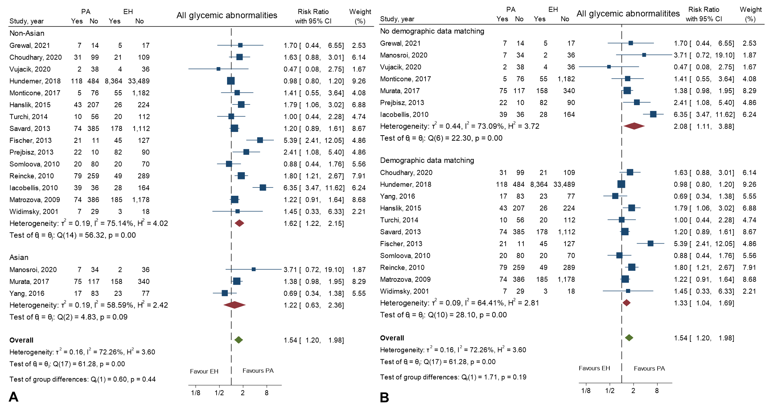
Figure S2. Funnel plots of studies with the outcomes of glycemic abnormalities: all glycemic abnormalities (A), diabetes mellitus (B), impaired glucose tolerance (C) and impaired fasting glucose (D)

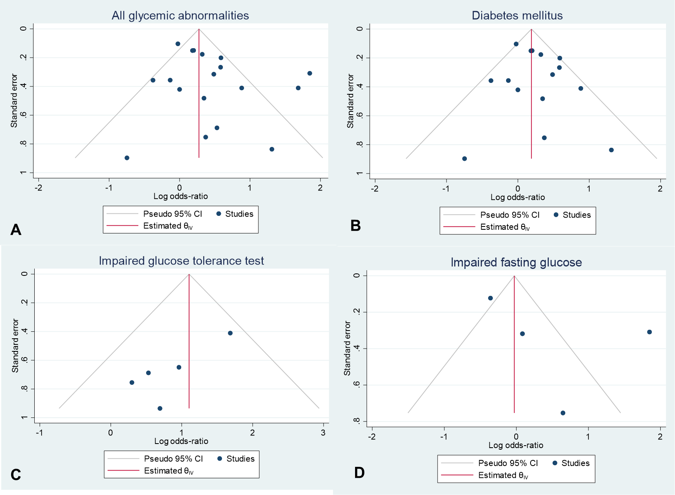

Figure S3. Funnel plots of the studies with the outcomes of glucose metabolic profiles: fasting blood glucose (A), HbA1c (B), 2-hr oral glucose tolerance test (2-hr OGTT) (C), homeostatic model assessment of insulin resistance (HOMA-IR) (D), homeostatic model assessment of ß-cell function (HOMA-ß) (E), area under the curve (AUC) of glucose (F), AUC of insulin (G) and the quantitative insulin-sensitivity check index (QUICKI) (H).

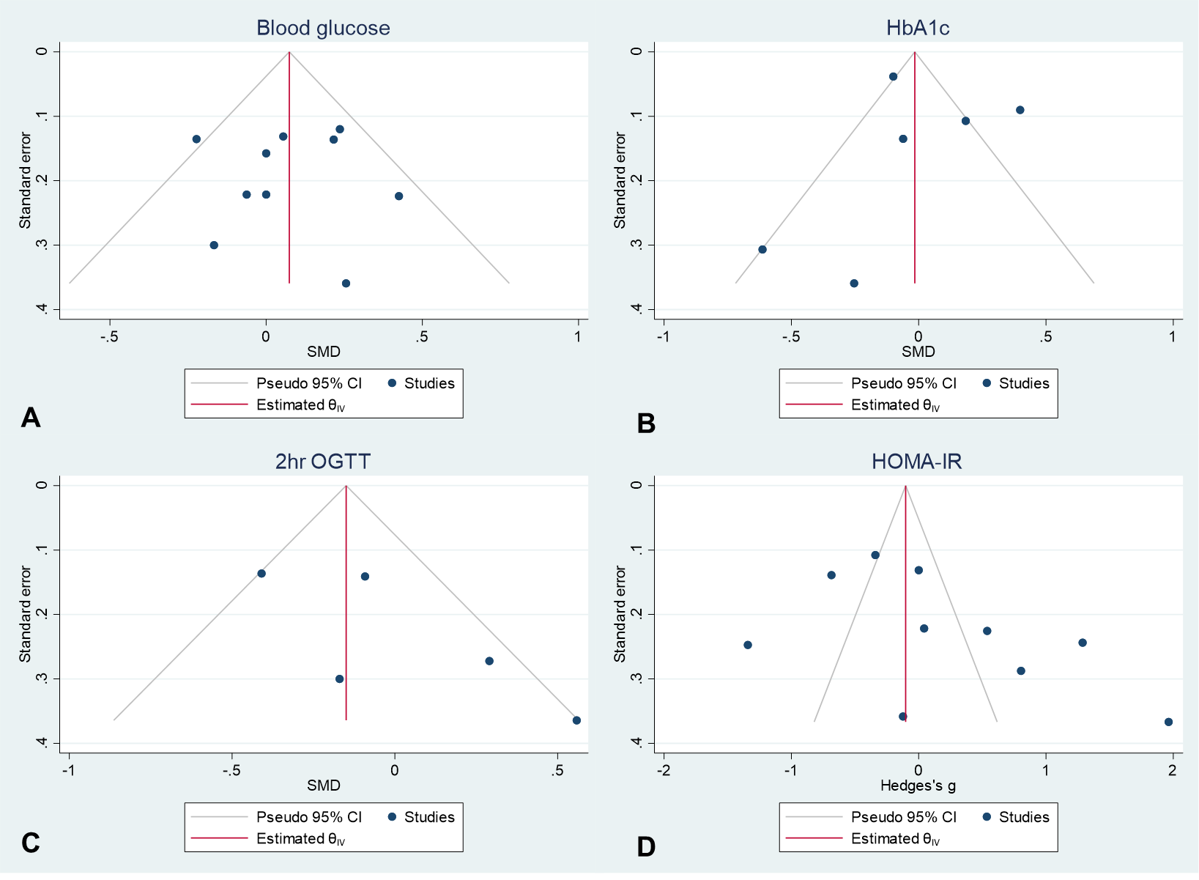

Figure S3. (continued) Funnel plots of the studies with the outcomes of glucose metabolic profiles: fasting blood glucose (A), HbA1c (B), 2-hr oral glucose tolerance test (2-hr OGTT) (C), homeostatic model assessment of insulin resistance (HOMA-IR) (D), homeostatic model assessment of ß-cell function (HOMA-ß) (E), area under the curve (AUC) of glucose (F), AUC of insulin (G) and the quantitative insulin-sensitivity check index (QUICKI) (H).



