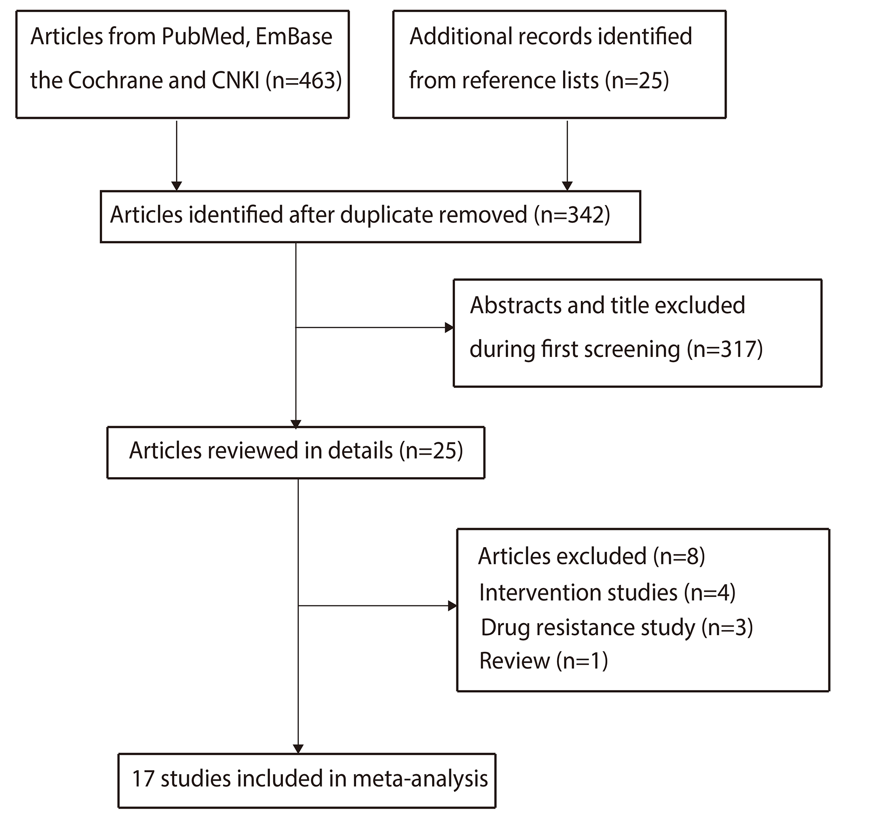
Additional Figure S1. Flow diagram of the literature search and study selection process.
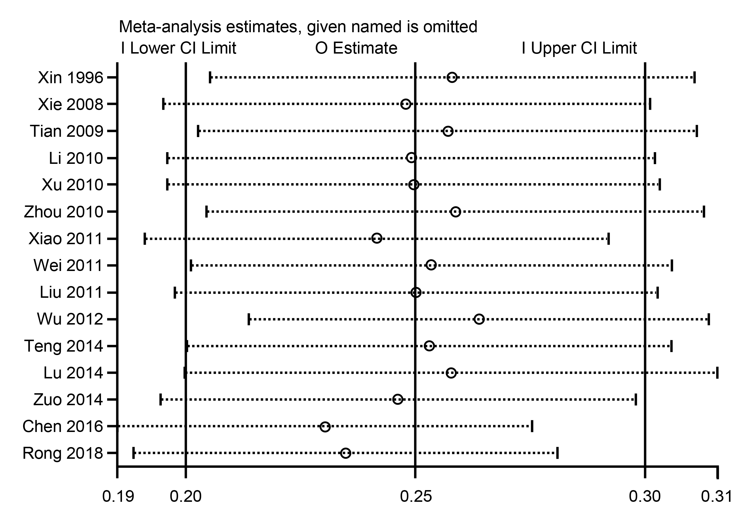
Additional Figure S2. Sensitivity analysis for gram-positive cocci.
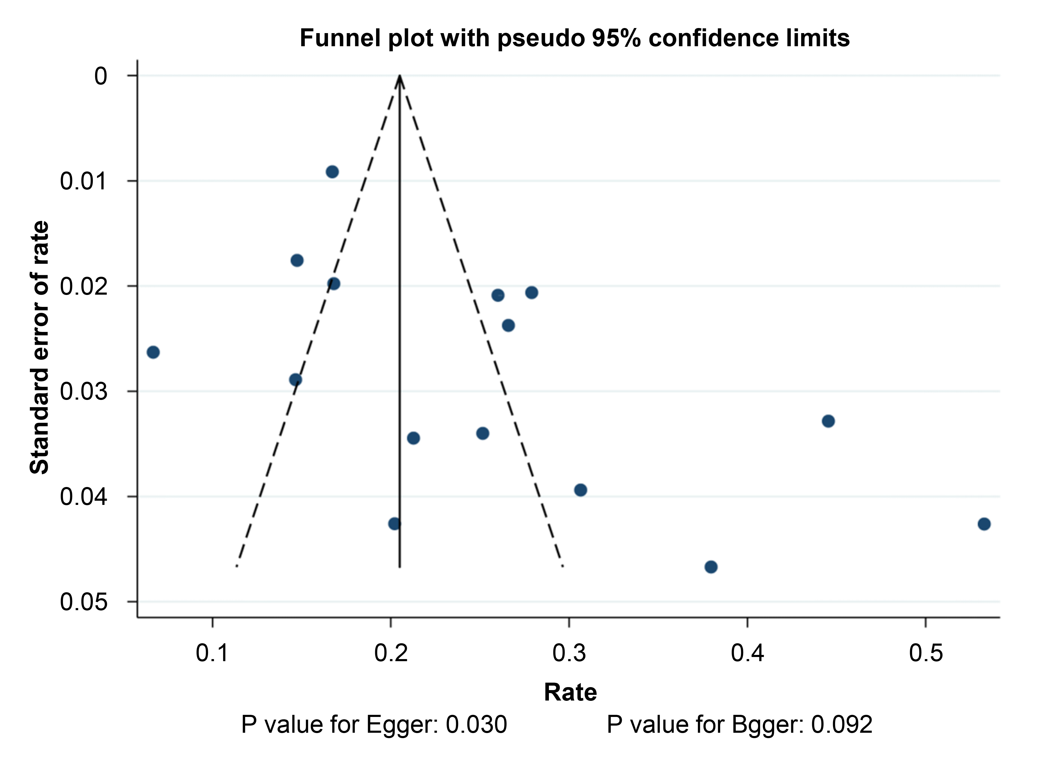
Additional Figure S3. Funnel plot for gram-positive cocci.
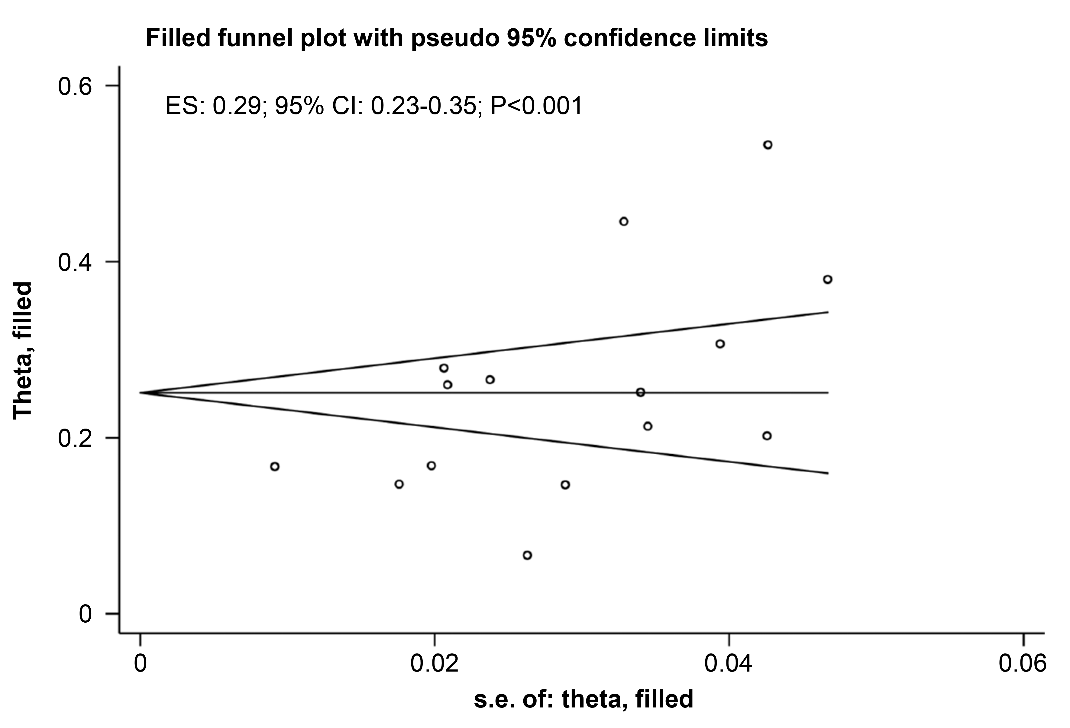
Additional Figure S4. Trim and fill for gram-positive cocci.
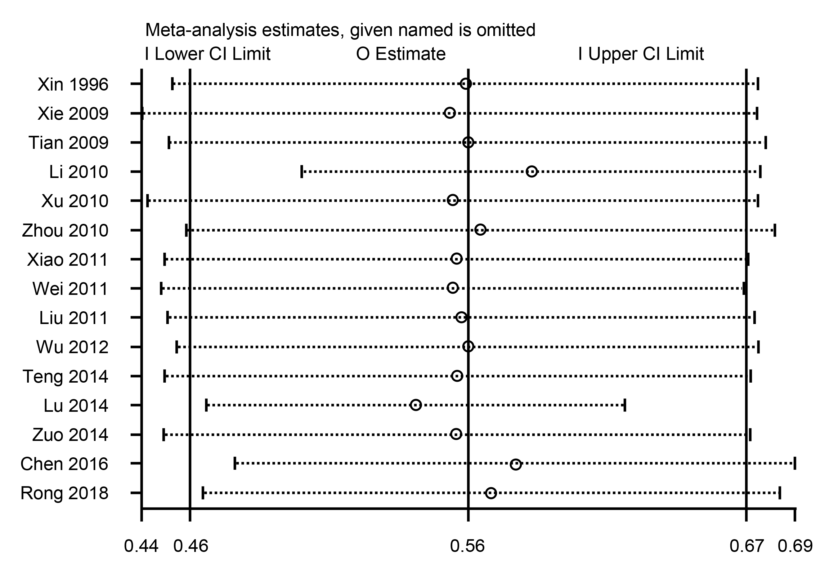
Additional Figure S5. Sensitivity analysis for gram-negative bacilli.
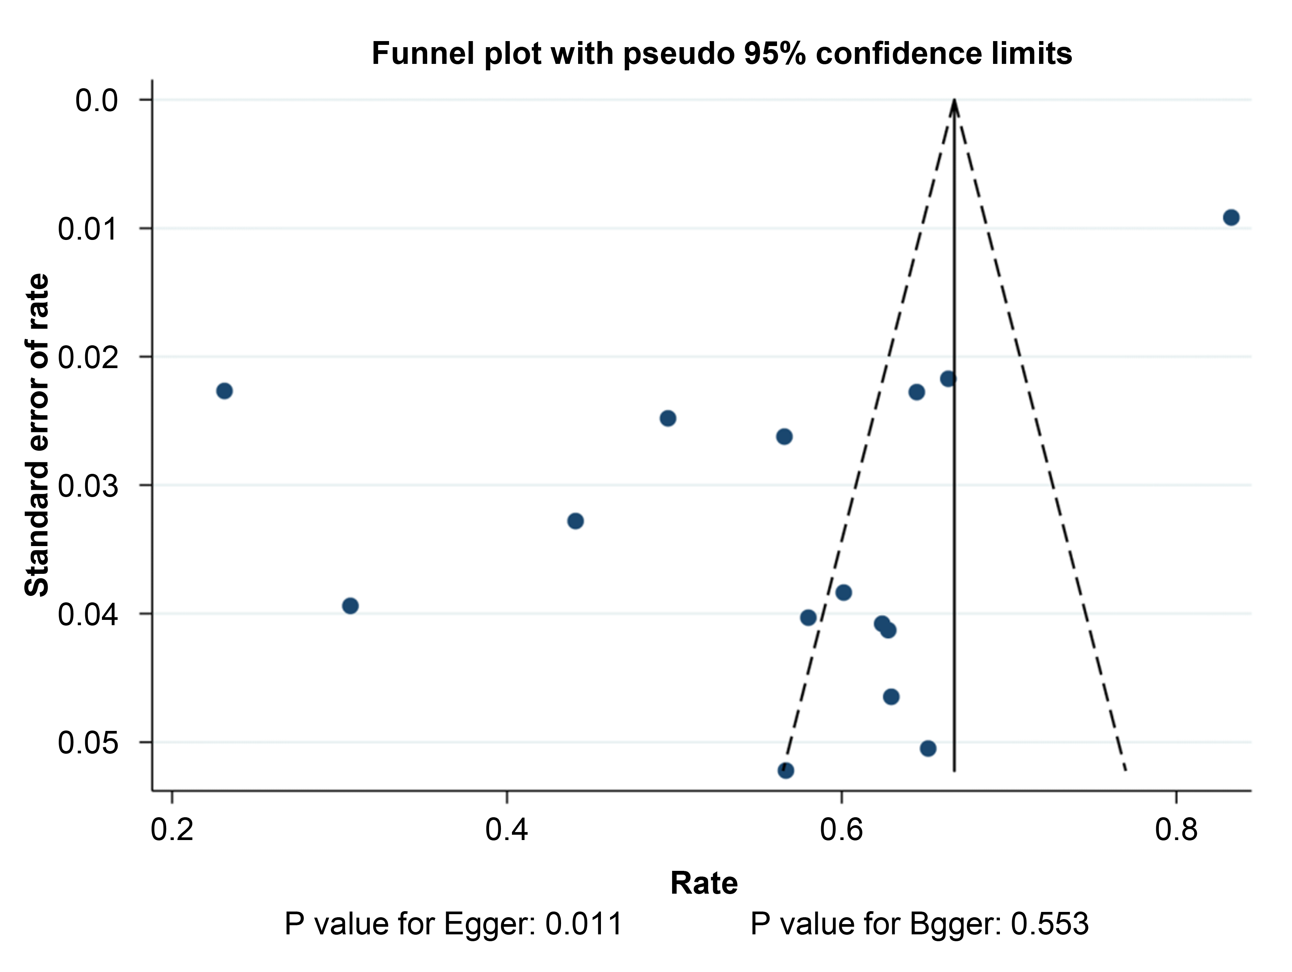
Additional Figure S6. Funnel plot for gram-negative bacilli.
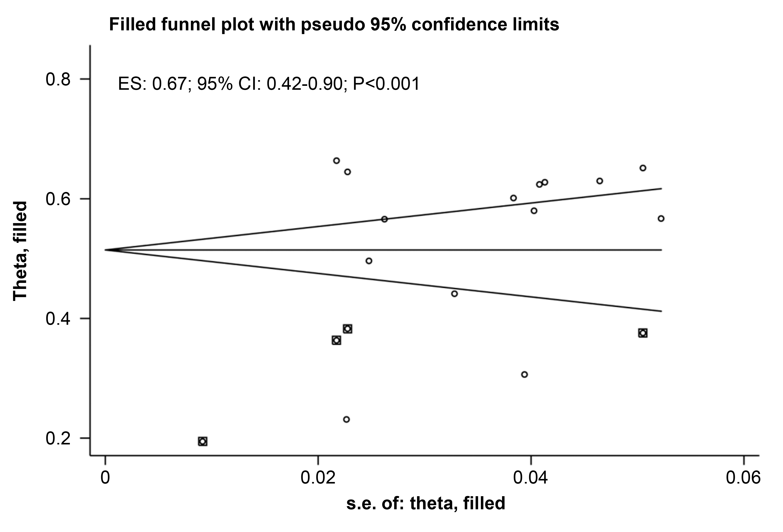
Additional Figure S7. Trim and fill for gram-negative bacilli.
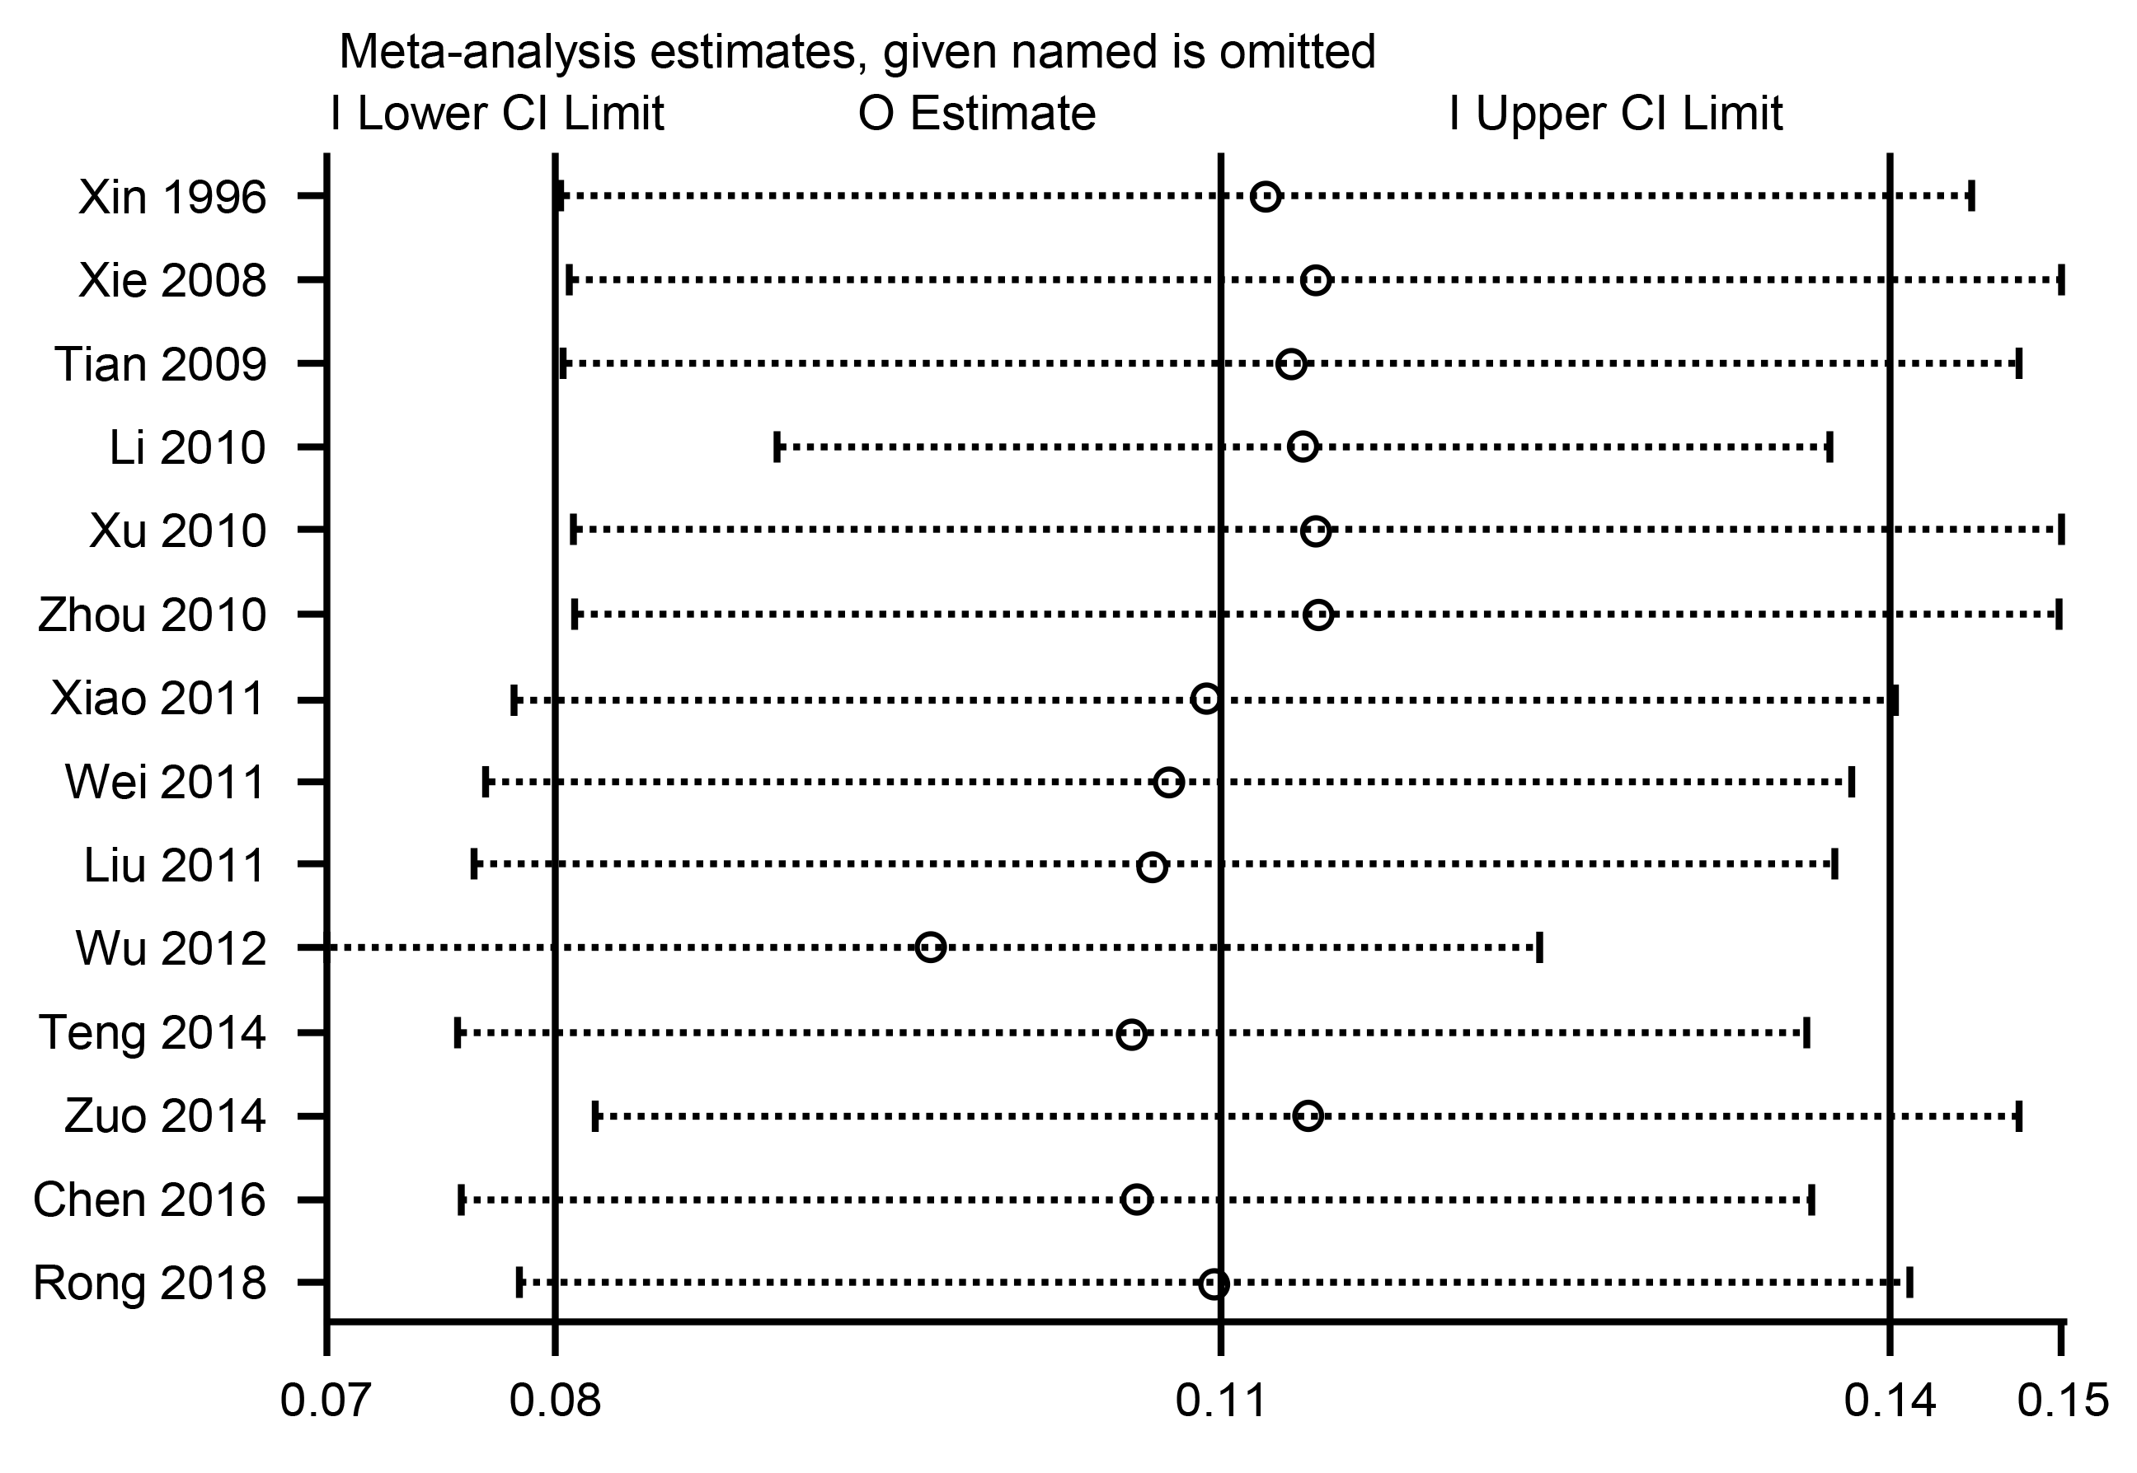
Additional Figure S8. Sensitivity analysis for fungus.
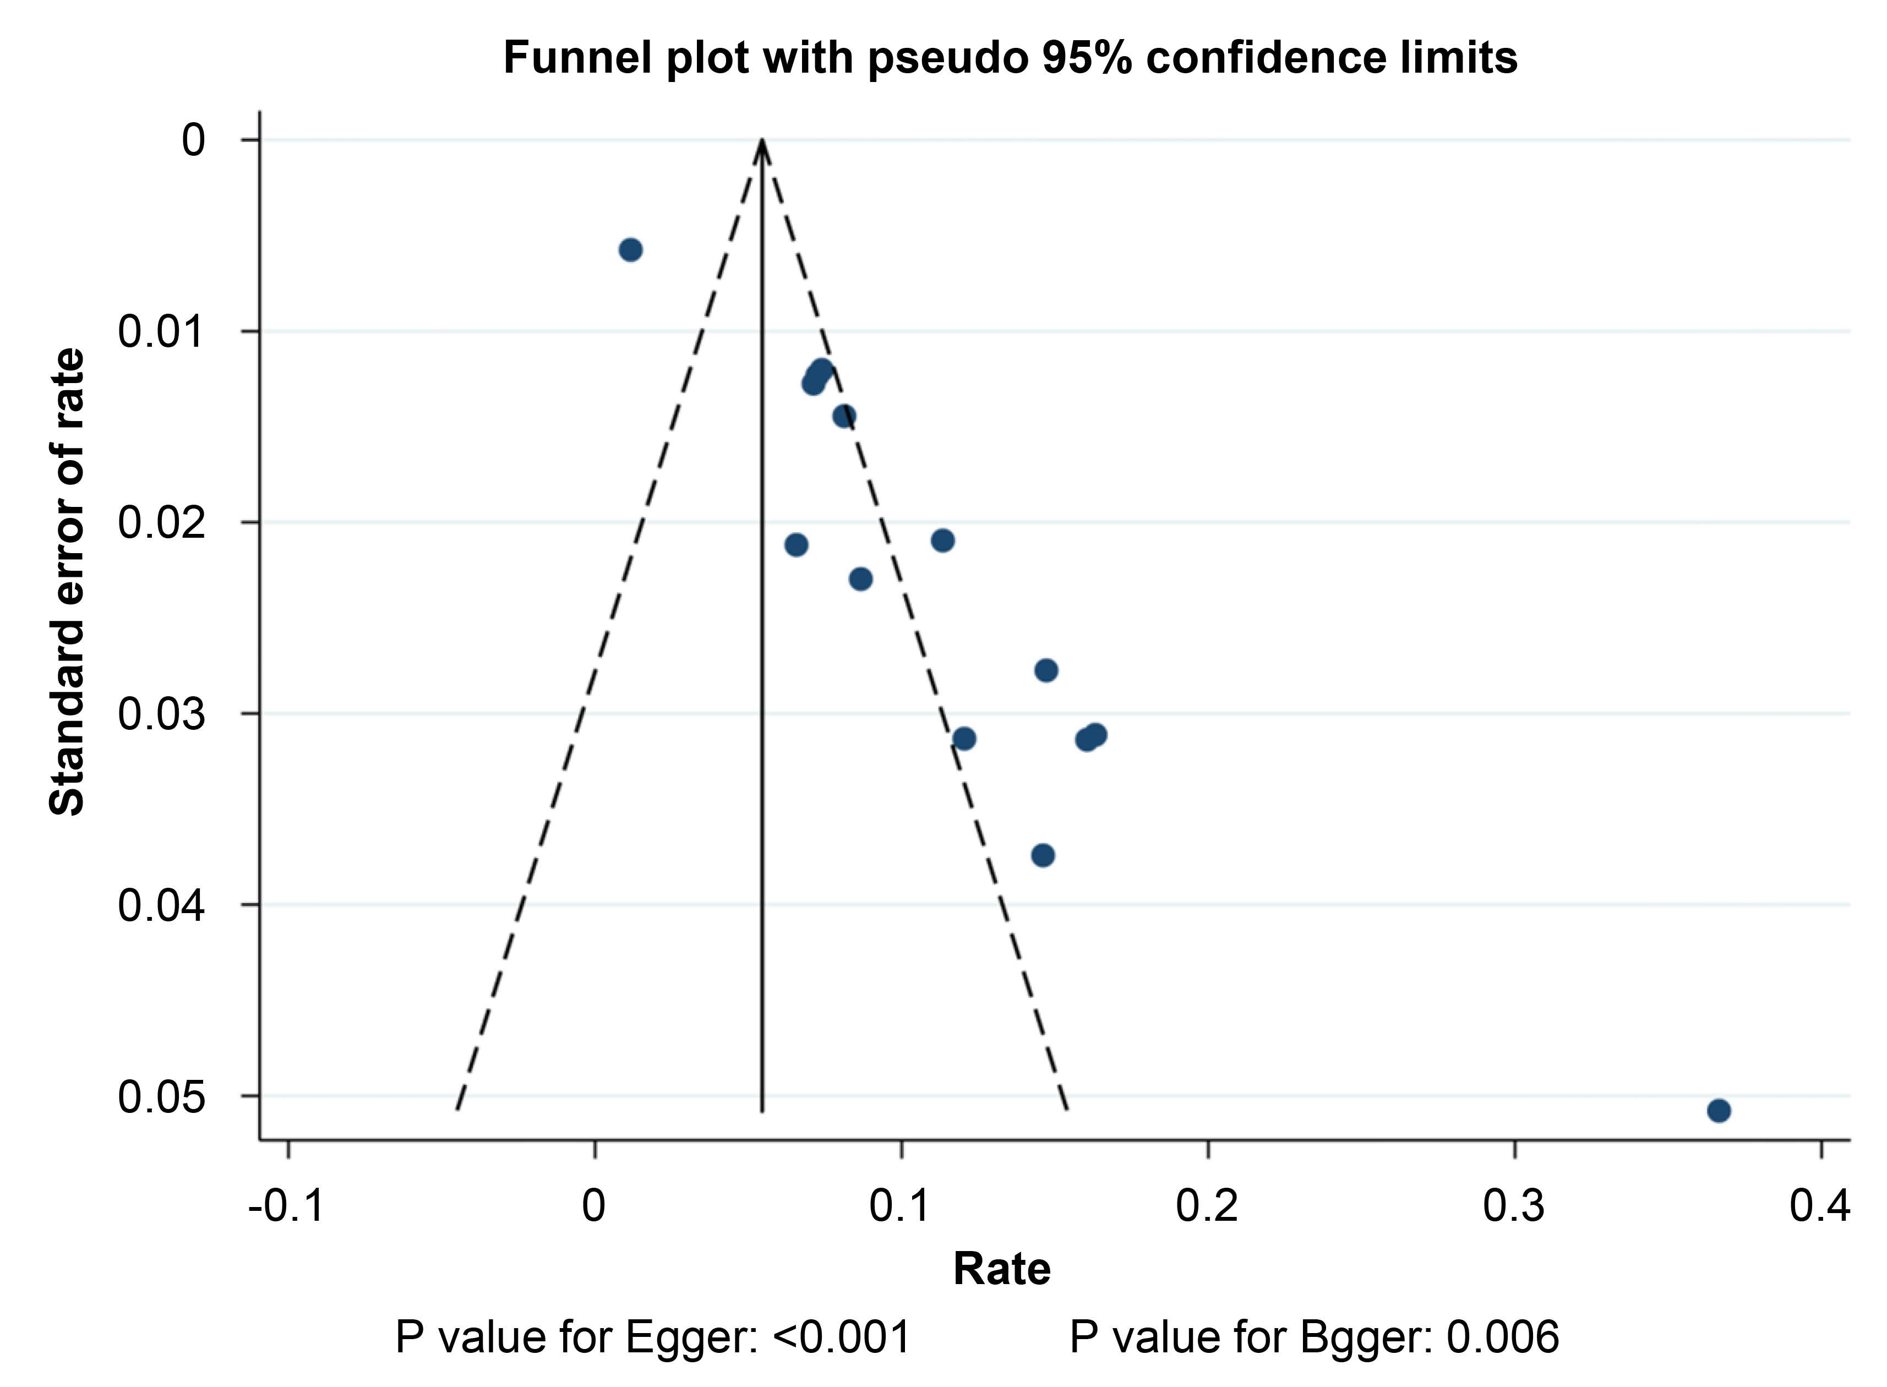
Additional Figure S9. Funnel plot for fungus.
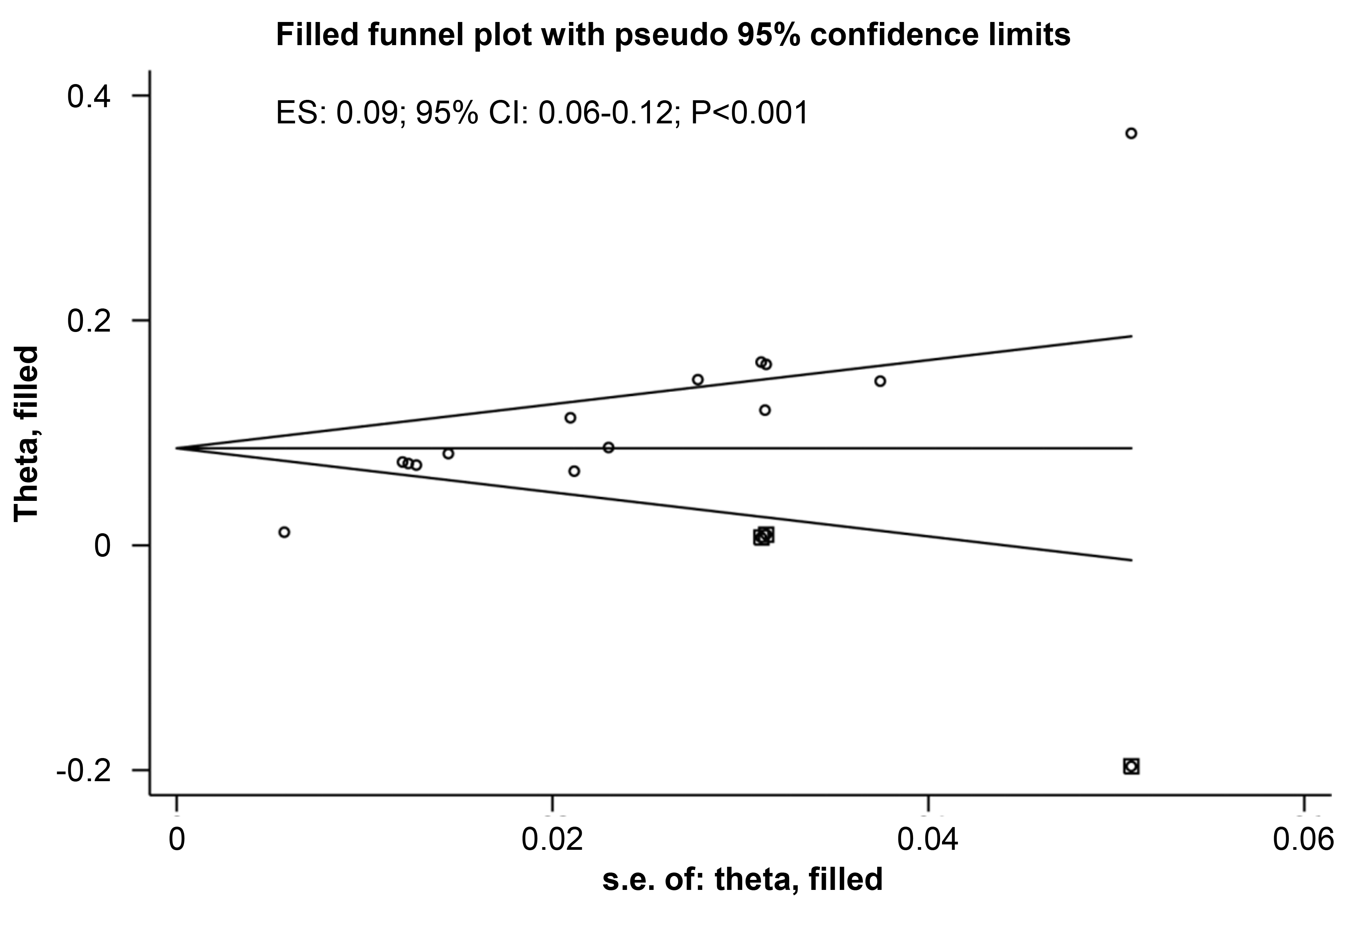
Additional Figure S10. Trim and fill for fungus.

