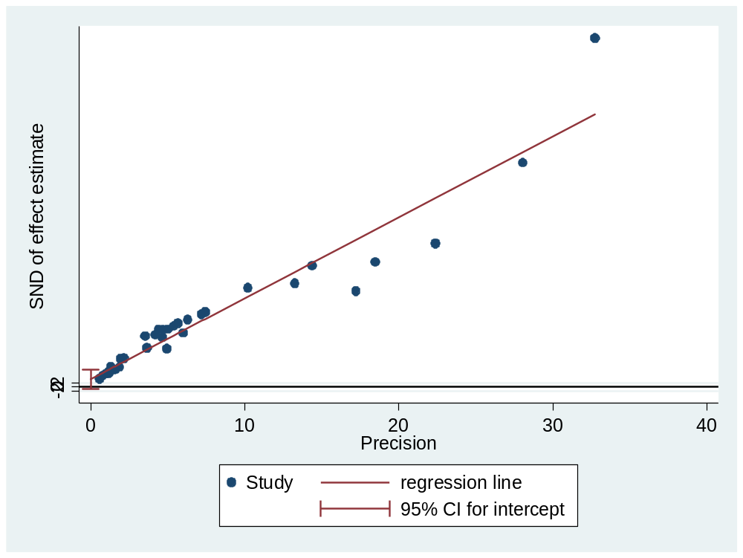
Additional file 2: figure S2. A Plot of Egger’s test of publication bias for pooled estimate of HIV among blood donors in Ethiopia

