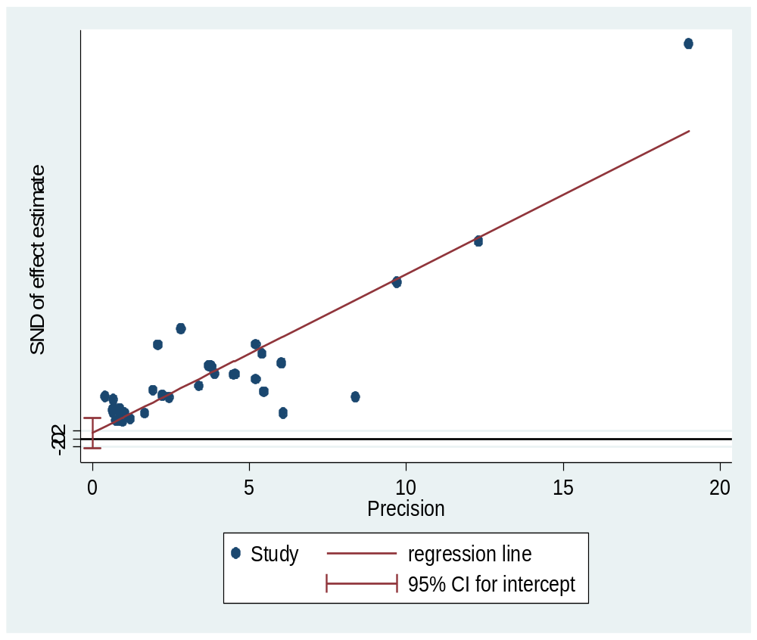
Additional file 3: figure S3. A Plot of Egger’s test of publication bias for pooled estimate of HBV among blood donors in Ethiopia

