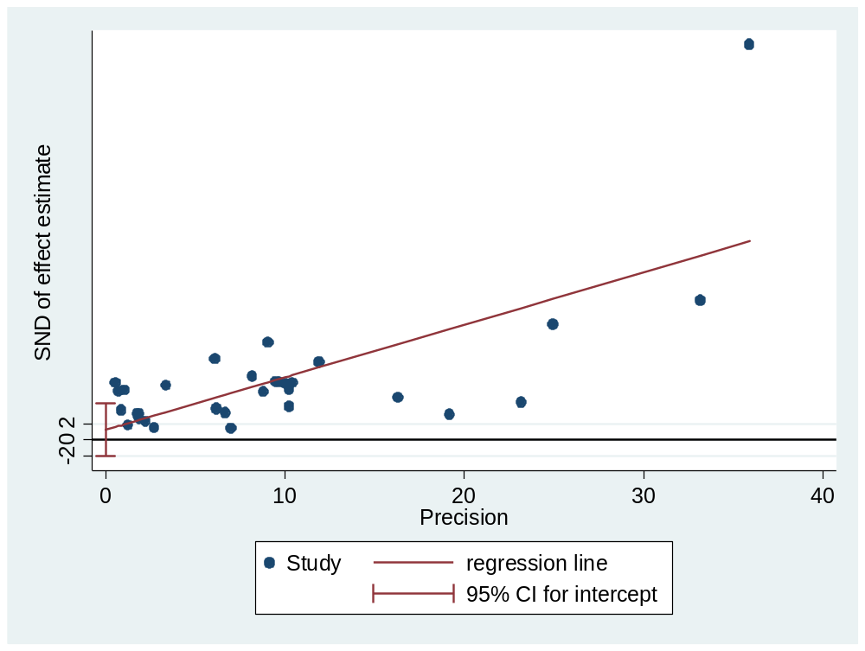
Additional file 4: figure S4. A Plot of Egger’s test of publication bias for pooled estimate of HCV among blood donors in Ethiopia

