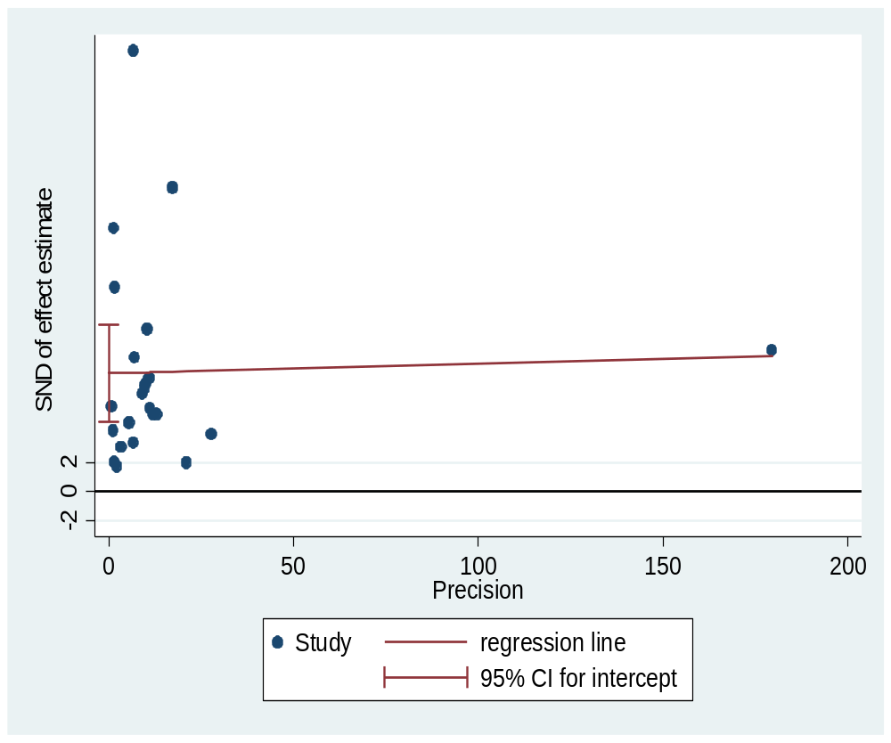
Additional file 5: figure S5. A Plot of Egger’s test of publication bias for pooled estimate of Syphilis among blood donors in Ethiopia

