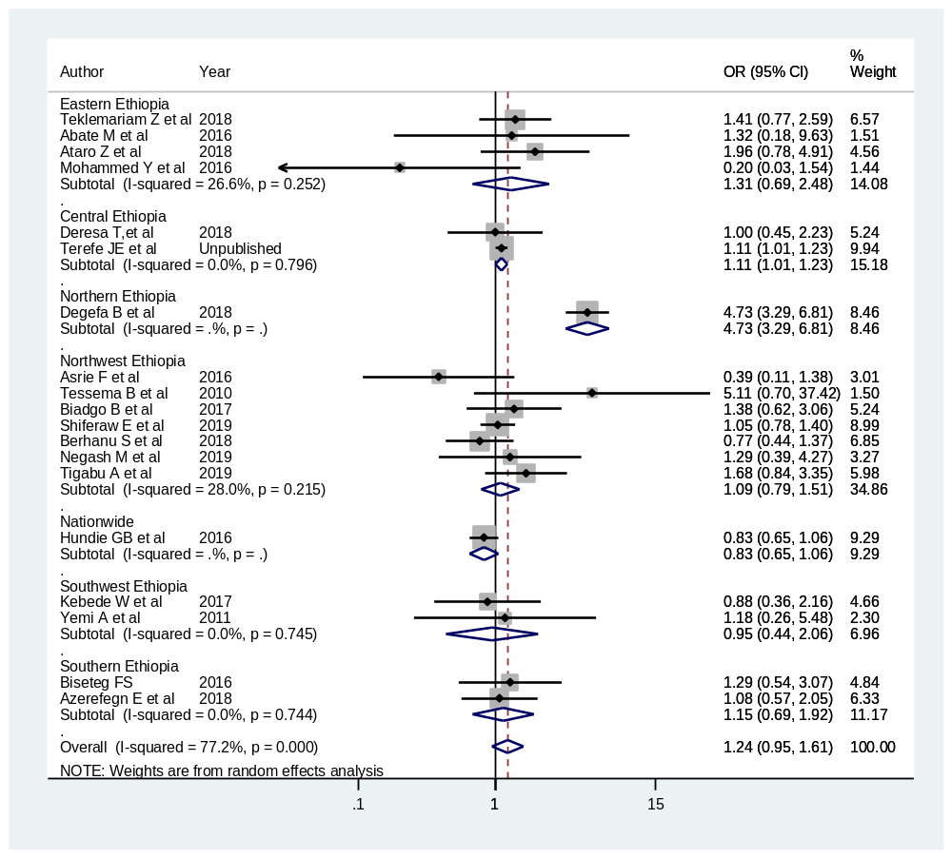
Additional file 6: Figure 56: Effect size of sex on HCV infection among blood donors in Ethiopia – a sub-group analysis by geographic region

