Additional file 1

Appendix S1

Full electronic search strategy for PubMed
Searched from March 1971 to April 2019

(((((((((((("Abortion, Habitual"[Mesh]) OR Recurrent miscarriage) OR Recurrent pregnancy loss) AND "Killer Cells, Natural"[Mesh]) OR Natural killer cells) OR NK cells) OR NK cell cytotoxicity) OR TH1/TH2 ratio) OR T-lymphocytes) AND "Immunoglobulins, Intravenous"[Mesh]) OR Intravenous immunoglobulin) OR IVIG) AND "Pregnancy Outcome"[Mesh]

240 Hits, 15.12.20

Free terms used for search.
Population | Intervention | Outcome | Design | Setting
Women with  Recurrent miscarriage  Recurrent pregancy loss  Habitual abortion  AND  Cytotoxicity  Natural killer cells  T-lymphocytes  Cytokines  TNFa | Intravenous immunoglobulin  Intravenous IG  Intravenous antibodies  IVIG | Pregnancy outcome  Live birth rate  Miscarriage rate | RCT  Case-control study  Prospective study  Retrospective study  Cohort study | Clinical setting

Figure 1S (Supplementary Information)

Figure 2S (Supplementary Information)

Figure 3S (Supplementary Information)
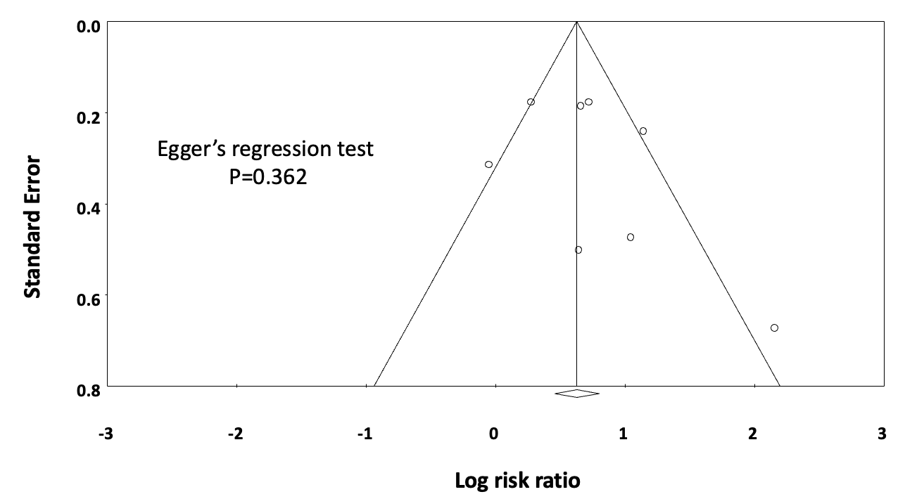

Table S1 (Supplementary Information)

Table S1. Specification of immunological abnormalities of included patients
Study | Inclusion criteria | Definition of abnormal lymphocyte markers | Screening for SLE | Screening for APS
Ahmadi et al.  2019 | Age 18-40 years  Elevated NK-cell number | NK-cell number > 12% | Not screened | Not screened
Jafarzadeh et al.  2019 | Age 18-41 years  Immune system abnormality | Not specified | Not screened | Not screened
Mahmoud et al.  2004 | Positive for APS | Not screened | Not screened | Positive for APS, not further specified
Moraru et al.  2012 | Elevated NK-cell number  Elevated NKT-like cells | NK-cell number >12%  NKT-like cells > 10% | Full fertility screening included determination of antinuclear antibodies; status not further specified for included women | Full fertility screening included determination of lupus anticoagulant and anti-beta-2-glycoprotein (IgG or IgM); status not further specified for included women
Perricone et al.  2008 | Systemic lupus erythematosus | Not screened | Screening included determination of antinuclear antibodies; disease activity was scored using lupus activity index-pregnancy scale (LAI-P; range 0-2.6); status not further specified for included women | Not screened
Ramos-Medina et al. 2014 | Elevated NK-cell number  Elevated NK-cell like number | NK-cell number > 12%  NK-cell like number >10% | Screening included determination of antinuclear antibodies; status not further specified for included women | Screening included determination of anticardiolipin, anti-beta-2-glycoprotein I (IgG and IgM) and lupus anticoagulant; status not further specified for included women
Stricker et al.  2005 | Age > 28 years  Abnormal immunologic tests including among others T-cell counts, NK-cell levels and different antibodies | NK-cell levels, CD4 and CD8 T-cell counts | Screening included determination of antinuclear antibodies; status not further specified for included women | Screening included determination of antiphospholipid antibody (IgG, IgA, IgM); status not further specified for included women
Winger et al.  2008 | Elevated NK-cell number  Elevated CD56-cell number | NK-cells > 15%  CD56-cell number > 12% | Not specified | Not specified

