Supplementary Online Content

Supplementary table 1. Search Strategies for PubMed, Embase and Cochrane Library
Supplementary table 2. Risk of Bias
Supplementary table 3. Key Inclusion and Exclusion Criteria of Each Trial for Patients with CNS Metastasis
Supplementary figure 1. Sensitivity Analysis by Excluding the KEYNOTE-024 Trial. (A) Hazard Ratios comparing overall survival in patients with brain metastases who received immunotherapy vs chemotherapy, excluding the KEYNOTE-024 Trial, (B) The interaction between immunotherapy efficacy and brain metastases, excluding the KEYNOTE-024 Trial
Supplementary figure 2. Sensitivity Analysis by Excluding the CheckMate-057 Trial. (A) Hazard Ratios comparing overall survival in patients with brain metastases who received immunotherapy vs chemotherapy, excluding the CheckMate-057 Trial, (B) The interaction between immunotherapy efficacy and brain metastases, excluding the CheckMate-057 Trial
Supplementary figure 3. A Funnel Plot of the Interaction between Immunotherapy Effect and Brain Metastases

Supplementary table 1. Search strategies for PubMed, Embase and Cochrane Library
Database | Keywords
PubMed
#1 | "Lung Neoplasms"[Mesh]
#2 | Neoplasms,Lung[Title/Abstract] OR Lung Neoplasm[Title/Abstract] OR Neoplasm,Lung[Title/Abstract] OR Neoplasms,Pulmonary[Title/Abstract] OR Neoplasm,Pulmonary[Title/Abstract] OR Pulmonary Neoplasm[Title/Abstract] OR Lung Cancer[Title/Abstract] OR Cancer,Lung[Title/Abstract] OR Cancers,Lung[Title/Abstract] OR Lung Cancers[Title/Abstract] OR Pulmonary Cancer[Title/Abstract] OR Cancer,Pulmonary[Title/Abstract] OR Cancers,Pulmonary[Title/Abstract] OR Pulmonary Cancers[Title/Abstract] OR Cancer of the Lung[Title/Abstract] OR Cancer of Lung[Title/Abstract]
#3 | #1 OR #12
#4 | immune checkpoint inhibitor[Title/Abstract] OR Programmed Cell Death 1 Receptor[Title/Abstract] OR PD-1 Receptor[Title/Abstract] OR PD 1 Receptor[Title/Abstract] OR Receptor, PD-1[Title/Abstract] OR CD279 Antigen[Title/Abstract] OR Antigen, CD279[Title/Abstract] OR PD1 Receptor[Title/Abstract] OR Receptor, PD1[Title/Abstract] OR Programmed Cell Death 1 Protein[Title/Abstract] OR Antigens, CD279[Title/Abstract] OR CD279 Antigens[Title/Abstract] OR CTLA-4 Antigen[Title/Abstract] OR Antigen, CTLA-4[Title/Abstract] OR CTLA 4 Antigen[Title/Abstract] OR Antigens, CD152[Title/Abstract] OR CD152 Antigens[Title/Abstract] OR Cytotoxic T-Lymphocyte-Associated Antigen 4[Title/Abstract] OR Cytotoxic T Lymphocyte Associated Antigen 4[Title/Abstract] OR Cytotoxic T-Lymphocyte Antigen 4[Title/Abstract] OR Cytotoxic T Lymphocyte Antigen 4[Title/Abstract] OR CD152 Antigen[Title/Abstract] OR Antigen, CD152[Title/Abstract] OR Programmed cell death ligand 1[Title/Abstract] OR PD-L1[Title/Abstract] OR Ipilimumab[Title/Abstract] OR tremelimumab[Title/Abstract] OR pembrolizumab[Title/Abstract] OR nivolumab[Title/Abstract] OR atezolizumab[Title/Abstract] OR durvalumab[Title/Abstract] OR avelumab[Title/Abstract] OR Cemiplimab[Title/Abstract] OR Camrelizumab[Title/Abstract] OR Sintilimab[Title/Abstract] OR Tislelizumab[Title/Abstract] OR Toripalimab[Title/Abstract]
#5 | randomized controlled trial[Publication Type] OR controlled clinical trial[Publication Type] OR randomized[Title/Abstract] OR placebo[Title/Abstract] OR drug therapy[MeSH Subheading] OR randomly[Title/Abstract] OR trial[Title/Abstract] OR groups[Title/Abstract]
#6 | animals[MeSH Terms] NOT humans[MeSH Terms]
#7 | #5 NOT #6
#8 | #3 AND #4 AND #7
Embase
#1 | 'lung cancer'/exp
#2 | 'Pulmonary Neoplasms':ab,ti OR 'Neoplasms, Lung':ab,ti OR 'Lung Neoplasm':ab,ti OR 'Neoplasms, Pulmonary':ab,ti OR 'Neoplasm, Pulmonary':ab,ti OR 'Pulmonary Neoplasm':ab,ti OR 'Lung Cancer':ab,ti OR 'Cancer, Lung':ab,ti OR 'Cancers, Lung':ab,ti OR 'Lung Cancers':ab,ti OR 'Pulmonary Cancers':ab,ti OR 'Cancer, Pulmonary':ab,ti OR 'Cancers, Pulmonary':ab,ti OR 'Pulmonary Cancers':ab,ti OR 'Cancer of the Lung':ab,ti OR 'Cancer of Lung':ab,ti
#3 | #1 OR #2
#4 | 'immune checkpoint inhibitOR':ab,ti OR 'Programmed Cell Death 1 ReceptOR':ab,ti OR 'PD-1 ReceptOR':ab,ti OR 'PD 1 ReceptOR':ab,ti OR 'ReceptOR, PD-1':ab,ti OR 'CD279 Antigen':ab,ti OR 'Antigen, CD279':ab,ti OR 'PD1 ReceptOR':ab,ti OR 'ReceptOR, PD1':ab,ti OR 'Programmed Cell Death 1 Protein':ab,ti OR 'Antigens, CD279':ab,ti OR 'CD279 Antigens':ab,ti OR 'CTLA-4 Antigen':ab,ti OR 'Antigen, CTLA-4':ab,ti OR 'CTLA 4 Antigen':ab,ti OR 'Antigens, CD152':ab,ti OR 'CD152 Antigens':ab,ti OR 'Cytotoxic T-Lymphocyte-Associated Antigen 4':ab,ti OR 'Cytotoxic T Lymphocyte Associated Antigen 4':ab,ti OR 'Cytotoxic T-Lymphocyte Antigen 4':ab,ti OR 'Cytotoxic T Lymphocyte Antigen 4':ab,ti OR 'CD152 Antigen':ab,ti OR 'Antigen, CD152':ab,ti OR 'Programmed cell death ligand 1':ab,ti OR 'PD-L1':ab,ti OR 'Ipilimumab':ab,ti OR 'tremelimumab':ab,ti OR 'pembrolizumab':ab,ti OR 'nivolumab':ab,ti OR 'atezolizumab':ab,ti OR 'durvalumab':ab,ti OR 'avelumab':ab,ti OR 'Cemiplimab':ab,ti OR 'Camrelizumab':ab,ti OR 'Sintilimab':ab,ti OR 'Tislelizumab':ab,ti OR 'TORipalimab':ab,ti
#5 | 'crossover procedure':de OR 'double-blind procedure':de OR 'randomized controlled trial':de OR 'single-blind procedure':de OR random*:de,ab,ti OR factorial*:de,ab,ti OR crossover*:de,ab,ti OR ((cross NEXT/1 over*):de,ab,ti) OR placebo*:de,ab,ti OR ((doubl* NEAR/1 blind*):de,ab,ti) OR ((singl* NEAR/1 blind*):de,ab,ti) OR assign*:de,ab,ti OR allocat*:de,ab,ti OR volunteer*:de,ab,ti
#6 | #3 AND #4 AND #5
Cochrane Library
#1 | MeSH: Lung Neoplasms
#2 | (Pulmonary Neoplasms):ti,ab,kw OR (Neoplasms, Lung):ti,ab,kw OR (Lung Neoplasm):ti,ab,kw OR (Neoplasms, Pulmonary):ti,ab,kw OR (Neoplasm, Pulmonary):ti,ab,kw OR (Pulmonary Neoplasm):ti,ab,kw OR (Lung Cancer):ti,ab,kw OR (Cancer, Lung):ti,ab,kw OR (Cancers, Lung):ti,ab,kw OR (Lung Cancers):ti,ab,kw OR (Pulmonary Cancer):ti,ab,kw OR (Cancer, Pulmonary):ti,ab,kw OR (Cancers, Pulmonary):ti,ab,kw OR (Pulmonary Cancers):ti,ab,kw OR (Cancer of the Lung):ti,ab,kw OR (Cancer of Lung):ti,ab,kw
#3 | #1 OR #2
#4 | (immune checkpoint inhibitor):ti,ab,kw OR (Programmed Cell Death 1 Receptor):ti,ab,kw OR (PD-1 Receptor):ti,ab,kw OR (PD 1 Receptor):ti,ab,kw OR (Receptor, PD-1):ti,ab,kw OR (CD279 Antigen):ti,ab,kw OR (Antigen, CD279):ti,ab,kw OR (PD1 Receptor):ti,ab,kw OR (Receptor, PD1):ti,ab,kw OR (Programmed Cell Death 1 Protein):ti,ab,kw OR (Antigens, CD279):ti,ab,kw OR (CD279 Antigens):ti,ab,kw OR (CTLA-4 Antigen):ti,ab,kw OR (Antigen, CTLA-4):ti,ab,kw OR (CTLA 4 Antigen):ti,ab,kw OR (Antigens, CD152):ti,ab,kw OR (CD152 Antigens):ti,ab,kw OR (Cytotoxic T-Lymphocyte-Associated Antigen 4):ti,ab,kw OR (Cytotoxic T Lymphocyte Associated Antigen 4):ti,ab,kw OR (Cytotoxic T-Lymphocyte Antigen 4):ti,ab,kw OR (Cytotoxic T Lymphocyte Antigen 4):ti,ab,kw OR (CD152 Antigen):ti,ab,kw OR (Antigen, CD152):ti,ab,kw OR (Programmed cell death ligand 1):ti,ab,kw OR (PD-L1):ti,ab,kw OR (Ipilimumab):ti,ab,kw OR (tremelimumab):ti,ab,kw OR (pembrolizumab):ti,ab,kw OR (nivolumab):ti,ab,kw OR (atezolizumab):ti,ab,kw OR (durvalumab):ti,ab,kw OR (avelumab):ti,ab,kw OR (Cemiplimab):ti,ab,kw OR (Camrelizumab):ti,ab,kw OR (Sintilimab):ti,ab,kw OR (Tislelizumab):ti,ab,kw OR (Toripalimab):ti,ab,kw
#5 | #3 AND #4
Supplementary table 2. Risk of Bias
 | Random Sequence Generation(selection bias) | Allocation concelment(selection bias) | Blinding of participants and personnel(performence bias) | Blinding of outcome assessment(detection bias) | Incomplete outcome data(attrition bias) | Selective reporting(reporting bias)
Gandhi et al | Low Risk | Low Risk | Low Risk | Low Risk | Low Risk | Low Risk
Hellmann et al | Low Risk | Low Risk | At Risk | Low Risk | Low Risk | Low Risk
Horn et al | Low Risk | Low Risk | Low Risk | Low Risk | Low Risk | Low Risk
Reck et al | Low Risk | Low Risk | At Risk | Low Risk | Low Risk | Low Risk
Fehrenbacher et al | Low Risk | At Risk | At Risk | Unclear | Low Risk | Low Risk
Reck et al | Low Risk | Low Risk | Low Risk | Low Risk | Low Risk | Low Risk
Borghaei et al | Low Risk | Low Risk | At Risk | Low Risk | Low Risk | Low Risk
Rudin et al | Low Risk | Low Risk | Low Risk | Low Risk | Low Risk | Low Risk
Paz-Ares et al | Low Risk | Low Risk | At Risk | Low Risk | Low Risk | Low Risk
Supplementary table 3. Key Inclusion and Exclusion Criteria of Each Trial for Patients with CNS Metastasis
Trial | Asymptomatic metastases | Active symptomatic metastases/  eptomeningeal disease | CNS metastasis  identification | Location of  CNS metastasis | Steroid/anticonvulsant | CNS directed therapy
KEYNOTE-189 | Eligible | Excluded | CT or MRI | No restriction | off steroids 3 days prior to dosing with study medication | NR
CheckMate 227 | Eligible if treated | Excluded | NR | No restriction | NR | NR
IMpower133 | Eligible if treated | Excluded | CT or MRI | Only supratentorial and cerebellar metastases allowed | No ongoing requirement for corticosteroids as therapy for CNS disease | Patients with new asymptomatic CNS metastases detected at the screening scan must receive radiation therapy and/or surgery for CNS metastases.
KEYNOTE-024 | Eligible if treated | Excluded | NR | No restriction | NR | NR
OAK | Eligible if treated | Excluded | CT or MRI | Only supratentorial metastases with no intracranial hemorrhage  were eligible | Anticonvulsants at a stable dose allowed but no ongoing steroids as therapy for CNS disease | No stereotactic radiation within 7 days or whole brain radiation within 14 days prior to study
CA184-156 study | Eligible | Excluded | CT or MRI | No restriction | Not requiring treatment with steroids or anticonvulsant medications | If treated with radiation therapy, CNS metastases must be stable with no evidence of progression on scans for at least 30 days from initial radiologic diagnosis of CNS metastases
Trial | Asymptomatic metastases | Active symptomatic metastases/  eptomeningeal disease | CNS metastasis  identification | Location of  CNS metastasis | Steroid/anticonvulsant | CNS directed therapy
CheckMate 057 | Eligible if treated | Excluded | CT or MRI | No restriction | stable for at least 2 weeks without the use of steroids or  on stable or decreasing dose of ≤ 10mg daily prednisone (or equivalent) | At least 2 weeks prior to study enrolment
KEYNOTE-604 | Eligible if treated | Excluded | CT or MRI | No restriction | Neurologically stable without corticosteroids for ≥ 7 days before starting study treatment | Whole-brain radiation and stereotactic radiosurgery≥14 days before starting study treatment
CASPIAN | Eligible if treated | Excluded | CT or MRI | No restriction | Stable off steroids and anticonvulsants for at least 1 month before study entry | Radiation therapy outside of the chest for palliative care is allowed but must be completed before first dose of the study medication
Abbreviations: CNS, central nervous system; CT, computed tomography; MRI, magnetic resonance imaging; NR, not reported.

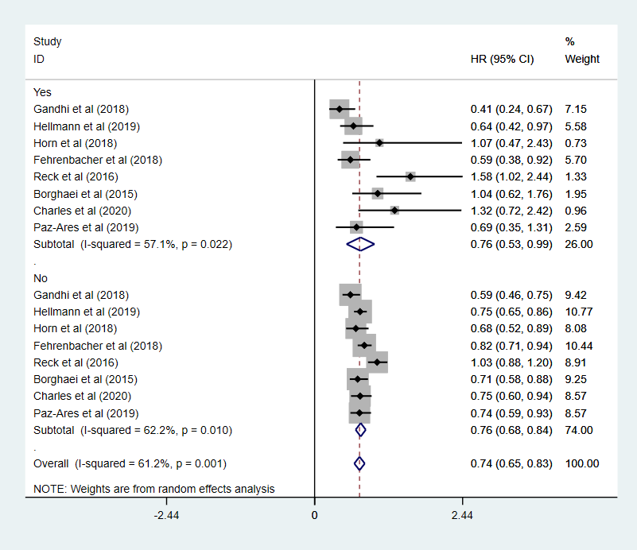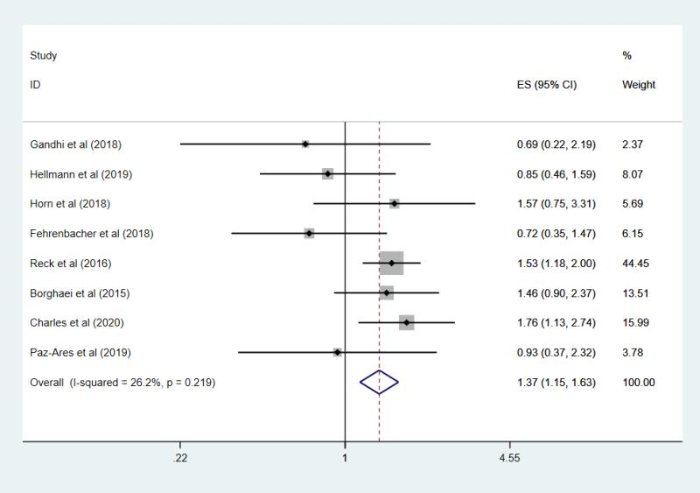
A
B
Supplementary figure 1. Sensitivity Analysis by Excluding the KEYNOTE-024 Trial.
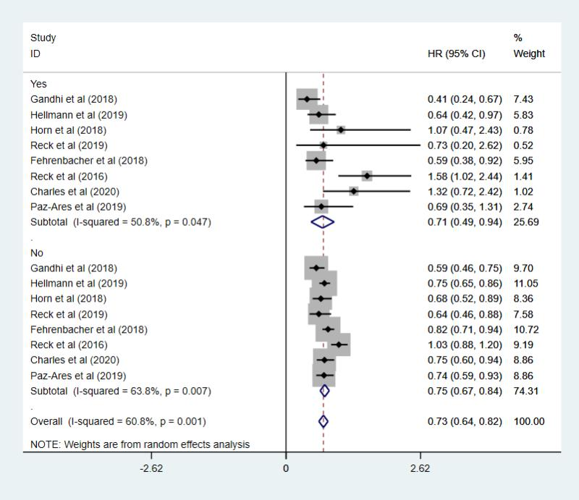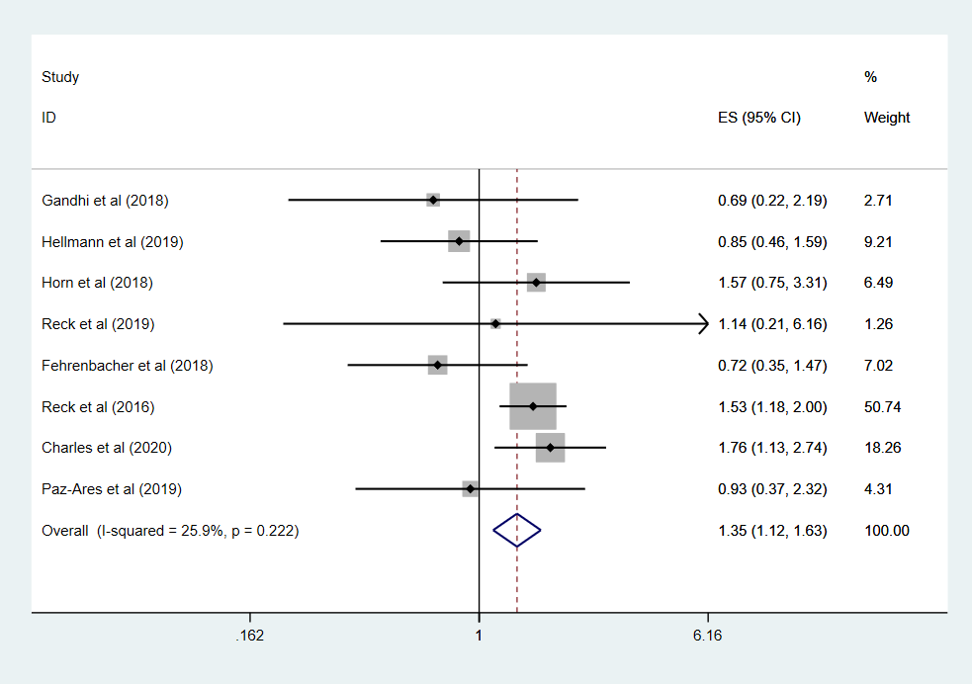
A
B
Supplementary figure 2. Sensitivity Analysis by Excluding the CheckMate-057 Trial.
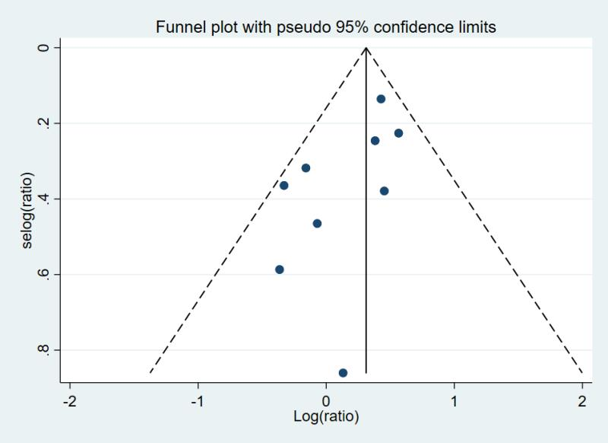
Supplementary figure 3. A Funnel Plot of the Interaction between Immunotherapy Effect and Brain Metastases

