Supplementary Material

Appendix 1: Search strategy
Appendix 1: Search strategy
Database: PubMed 10-07-21
#1. Diabetes mellitus, type 2/
#2.(diabetes mellitus, noninsulin-dependent or diabetes mellitus, ketosis resistant or diabetes mellitus, stable or diabetes mellitus, type II or diabetes mellitus, maturity-onset or diabetes mellitus, maturity-onset or type 2 diabetes mellitus or type 2 diabetes).ti,ab
#3.#1 or #2
#4. Non-alcoholic Fatty Liver Disease/
#5. (nonalcoholic fatty liver disease or NAFLD or fatty liver, nonalcoholic or liver, nonalcoholic fatty or nonalcoholic steatohepatitis).ti,ab
#6 #4 or #5
#7. Glucagon-Like Peptide-1 Receptor/
#8.(Glucagon like peptide 1 receptor or GLP-1R receptor or GLP1R Protein or GLP receptor).ti,ab
#9.(liraglutide or lixisenatide or exenatide or dulaglutide or albiglutide or semaglutide).ti,ab
#10.#7 or #8 or #9
#11. #3 and #6 and #10
Database: Web of Science 10-07-21
11.3 and 6 and 10
10. 7 or 8 or 9
9.TS=Glucagon-Like Peptide-1 Receptor
8.TS=Glucagon like peptide 1 receptor or GLP-1R receptor or GLP1R Protein or GLP receptor
7.TS= liraglutide or lixisenatide or exenatide or dulaglutide or albiglutide or semaglutide
6.4 or 5
5.TS=nonalcoholic fatty liver disease or NAFLD or fatty liver, nonalcoholic or liver, nonalcoholic fatty or nonalcoholic steatohepatitis
4.TS=Non-alcoholic Fatty Liver Disease
3. 1 or 2
2.TS= diabetes mellitus, noninsulin-dependent or diabetes mellitus, ketosis resistant or diabetes mellitus, stable or diabetes mellitus, type II or diabetes mellitus, maturity-onset or diabetes mellitus, maturity-onset or type 2 diabetes mellitus or type 2 diabetes
1.TS= Diabetes mellitus, type 2
Database: Embase 10-07-21
1. Diabetes mellitus, type 2/
2.(diabetes mellitus, noninsulin-dependent or diabetes mellitus, ketosis resistant or diabetes mellitus, stable or diabetes mellitus, type II or diabetes mellitus, maturity-onset or diabetes mellitus, maturity-onset or type 2 diabetes mellitus or type 2 diabetes).ti,ab
3.1 or 2
4. Non-alcoholic Fatty Liver Disease/
5. (nonalcoholic fatty liver disease or NAFLD or fatty liver, nonalcoholic or liver, nonalcoholic fatty or nonalcoholic steatohepatitis).ti,ab
6 4 or 5
7. Glucagon-Like Peptide-1 Receptor/
8.(Glucagon like peptide 1 receptor or GLP-1R receptor or GLP1R Protein or GLP receptor).ti,ab
9.(liraglutide or lixisenatide or exenatide or dulaglutide or albiglutide or semaglutide).ti,ab
10.7 or 8 or 9
11. 3 and 6 and 10
Database: Scopus 10-07-21
#1.(“Diabetes mellitus, type 2 “or “diabetes mellitus, noninsulin-dependent” or (diabetes mellitus*) or(type 2 diabetes*)).ti,ab.
#2.(“Non-alcoholic Fatty Liver Disease “or NAFLD or” nonalcoholic fatty liver disease “or “fatty liver, nonalcoholic” or” liver, nonalcoholic fatty “or” nonalcoholic steatohepatitis”).ti,ab.
#3.(Glucagon-Like Peptide-1 Receptor or (GLP-1R*) or (liraglutide* or lixisenatide* or exenatide* or dulaglutide* or albiglutide* or semaglutide*)).ti,ab.
4.#1 and #2 and #3
Database: Cochrane Central Register of Controlled Trials (CENTRAL) 10-07-21
(“Diabetes mellitus, type 2”or “diabetes mellitus, noninsulin-dependent” or (diabetes mellitus*)or (type 2 diabetes*) in Title Abstract Keywords) AND(“Non-alcoholic Fatty Liver Disease “or NAFLD or” nonalcoholic fatty liver disease “or “fatty liver, nonalcoholic” or” liver, nonalcoholic fatty “or” nonalcoholic steatohepatitis” in Title Abstract Keywords) AND(Glucagon-Like Peptide-1 Receptor or (GLP-1R*) or (liraglutide* or lixisenatide* or exenatide* or dulaglutide* or albiglutide* or semaglutide*) in Title Abstract Keywords) AND("randomized controlled trial" OR "controlled clinical trial" OR randomized OR placebo OR "clinical trials" OR randomly OR trial NOT (animals NOT humans)) in Title Abstract Keyword.

2.Appendix 2: Supplementary Figures
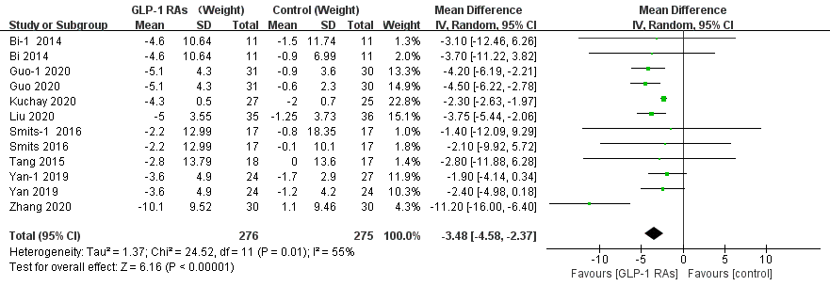
Supplementary Figure 1 The forest graph of comparison of the mean change from baseline of weight between glucagon-like peptide-1 receptor agonists (GLP-1RAs) vs. control in patients with T2DM and NAFLD. SD, Standard deviation; CI, confidence interval; IV, inverse variance; Bi-1, concluded exenatide vs pioglitazone; Guo-1, concluded liraglutide vs insulin; Smits-1, concluded liraglutide vs placebo; Yan-1, concluded liraglutide vs sitagliptin.
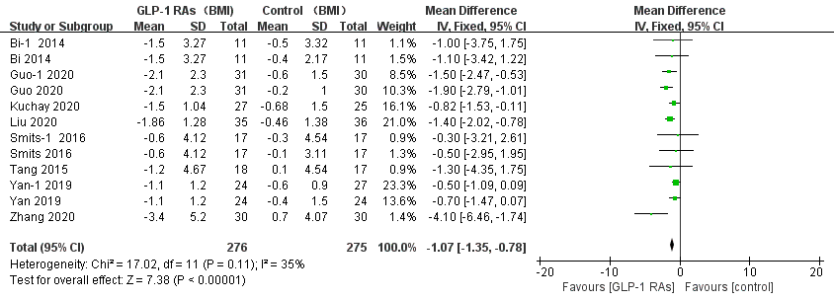
Supplementary Figure 2 The forest graph of comparison of the mean change from baseline of body mass index between glucagon-like peptide-1 receptor agonists (GLP-1RAs) vs. control in patients with T2DM and NAFLD. SD, Standard deviation; CI, confidence interval; IV, inverse variance; body mass index (BMI); Bi-1, concluded exenatide vs pioglitazone; Guo-1, concluded liraglutide vs insulin; Smits-1, concluded liraglutide vs placebo; Yan-1, concluded liraglutide vs sitagliptin.
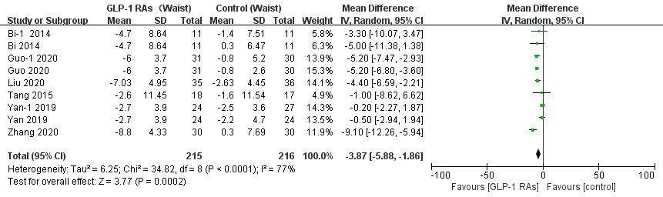
Supplementary Figure 3 The forest graph of comparison of the mean change from baseline of waist circumference between glucagon-like peptide-1 receptor agonists (GLP-1RAs) vs. control in patients with T2DM and NAFLD. SD, Standard deviation; CI, confidence interval; IV, inverse variance; Bi-1, concluded exenatide vs pioglitazone; Guo-1, concluded liraglutide vs insulin; Yan-1, concluded liraglutide vs sitagliptin.
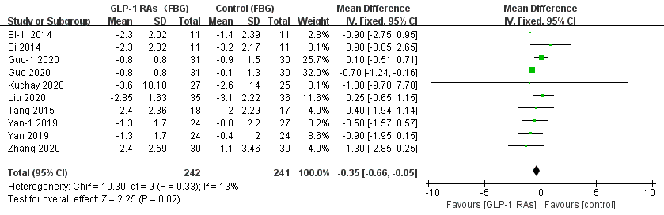
Supplementary Figure 4 The forest graph of comparison of the mean change from baseline of fasting blood glucose between glucagon-like peptide-1 receptor agonists (GLP-1RAs) vs. control in patients with T2DM and NAFLD. SD, Standard deviation; CI, confidence interval; IV, inverse variance; fasting blood glucose (FBG); Bi-1, concluded exenatide vs pioglitazone; Guo-1, concluded liraglutide vs insulin; Yan-1, concluded liraglutide vs sitagliptin.

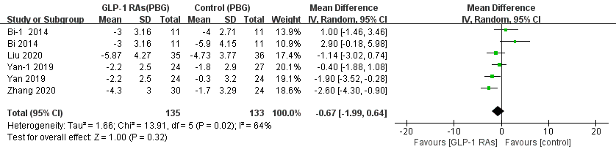
Supplementary Figure 5 The forest graph of comparison of the mean change from baseline of postprandial blood glucose between glucagon-like peptide-1 receptor agonists (GLP-1RAs) vs. control in patients with T2DM and NAFLD. SD, Standard deviation; CI, confidence interval; IV, inverse variance; postprandial blood glucose (PBG); Bi-1, concluded exenatide vs pioglitazone ;Yan-1, concluded liraglutide vs sitagliptin.
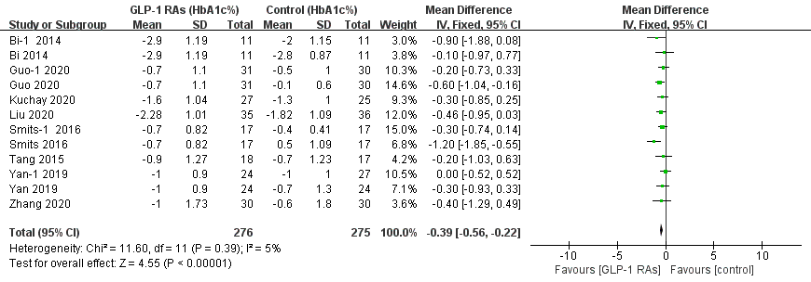
Supplementary Figure 6 The forest graph of comparison of the mean change from baseline of the percent HbA1c between glucagon-like peptide-1 receptor agonists (GLP-1RAs) vs. control in patients with T2DM and NAFLD. SD, Standard deviation; CI, confidence interval; IV, inverse variance; Bi-1, concluded exenatide vs pioglitazone; Guo-1, concluded liraglutide vs insulin; Smits-1, concluded liraglutide vs placebo; Yan-1, concluded liraglutide vs sitagliptin.
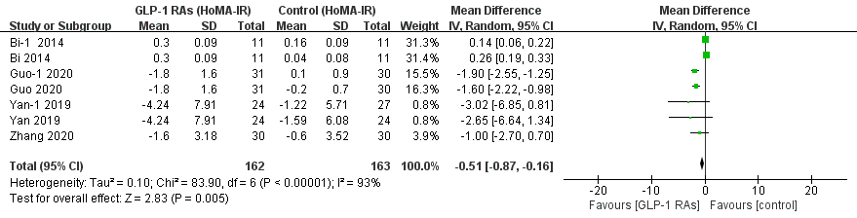
Supplementary Figure 7 The forest graph of comparison of the mean change from baseline of HoMA-IR between glucagon-like peptide-1 receptor agonists (GLP-1RAs) vs. control in patients with T2DM and NAFLD. SD, Standard deviation; CI, confidence interval; IV, inverse variance; Bi-1, concluded exenatide vs pioglitazone; Guo-1, concluded liraglutide vs insulin; Smits-1, concluded liraglutide vs placebo; Yan-1, concluded liraglutide vs sitagliptin.

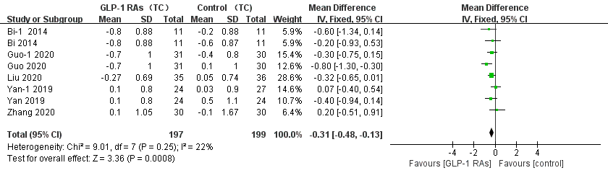
Supplementary Figure 8 The forest graph of comparison of the mean change from baseline of total cholesterol between glucagon-like peptide-1 receptor agonists (GLP-1RAs) vs. control in patients with T2DM and NAFLD. SD, Standard deviation; CI, confidence interval; IV, inverse variance; total cholesterol (TC); Bi-1, concluded exenatide vs pioglitazone; Guo-1, concluded liraglutide vs insulin;Yan-1, concluded liraglutide vs sitagliptin.

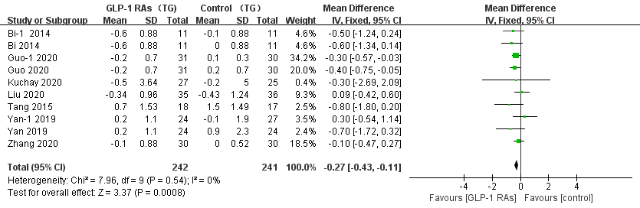
Supplementary Figure 9 The forest graph of comparison of the mean change from baseline of triglycerides between glucagon-like peptide-1 receptor agonists (GLP-1RAs) vs. control in patients with T2DM and NAFLD. SD, Standard deviation; CI, confidence interval; IV, inverse variance; triglyceride (TG); Bi-1, concluded exenatide vs pioglitazone; Guo-1, concluded liraglutide vs insulin; Yan-1, concluded liraglutide vs sitagliptin.

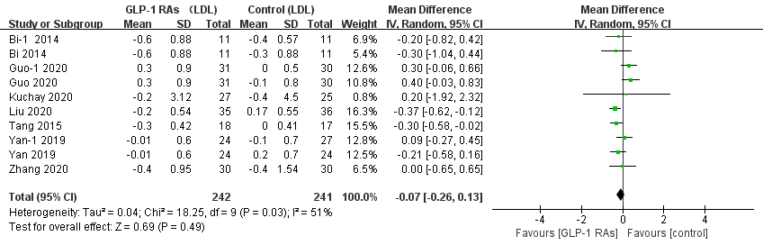
Supplementary Figure 10 The forest graph of comparison of the mean change from baseline of low-density lipoprotein between glucagon-like peptide-1 receptor agonists (GLP-1RAs) vs. control in patients with T2DM and NAFLD. SD, Standard deviation; CI, confidence interval; IV, inverse variance; low-density lipoprotein (LDL); Bi-1, concluded exenatide vs pioglitazone; Guo-1, concluded liraglutide vs insulin; Yan-1, concluded liraglutide vs sitagliptin.

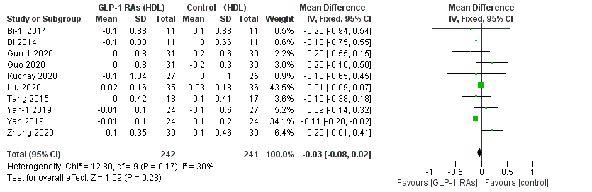
Supplementary Figure 11 The forest graph of comparison of the mean change from baseline of high-density lipoprotein between glucagon-like peptide-1 receptor agonists (GLP-1RAs) vs. control in patients with T2DM and NAFLD. SD, Standard deviation; CI, confidence interval; IV, inverse variance; high-density lipoprotein (HDL); Bi-1, concluded exenatide vs pioglitazone; Guo-1, concluded liraglutide vs insulin; Yan-1, concluded liraglutide vs sitagliptin.
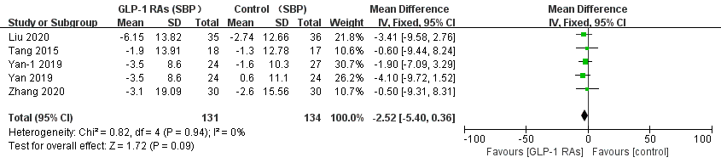
Supplementary Figure 12 The forest graph of comparison of the mean change from baseline of systolic blood pressure between glucagon-like peptide-1 receptor agonists (GLP-1RAs) vs. control in patients with T2DM and NAFLD. SD, Standard deviation; CI, confidence interval; IV, inverse variance; systolic blood pressure (SBP); Yan-1, concluded liraglutide vs sitagliptin.
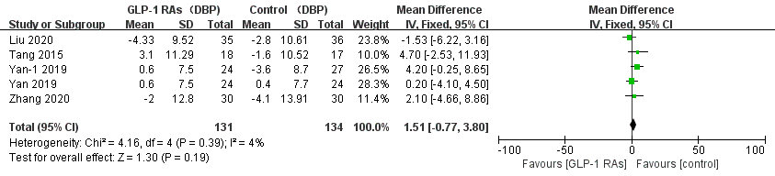
Supplementary Figure 13 The forest graph of comparison of the mean change from baseline of diastolic blood pressure between glucagon-like peptide-1 receptor agonists (GLP-1RAs) vs. control in patients with T2DM and NAFLD. SD, Standard deviation; CI, confidence interval; IV, inverse variance; diastolic blood pressure (DBP); Yan-1, concluded liraglutide vs sitagliptin.

