Appendix D.1: Sensitivity analysis for the association between serum 25(OH)D level < 30 ng/ml and mortality

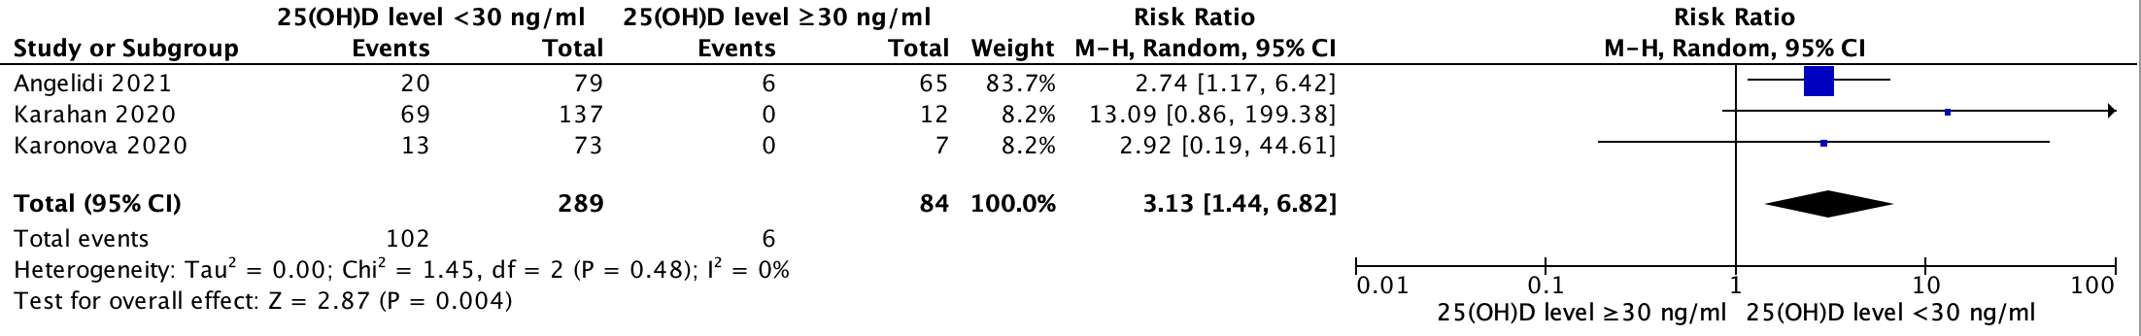
2
3
1
Appendix D.2: Sensitivity analysis for the association between serum 25(OH)D level < 30 ng/ml and length of hospital stay in days

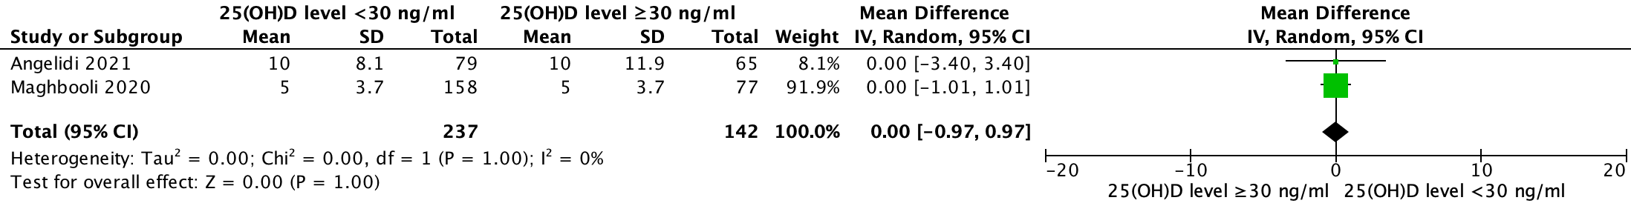
4
1

Appendix D.3: Sensitivity analysis for the association between serum 25(OH)D level < 30 ng/ml and disease severity (defined as SaO2 <93% or respiratory distress or lung infiltrates more than 50% within 24 to 48 hours or respiratory failure or organ failure)

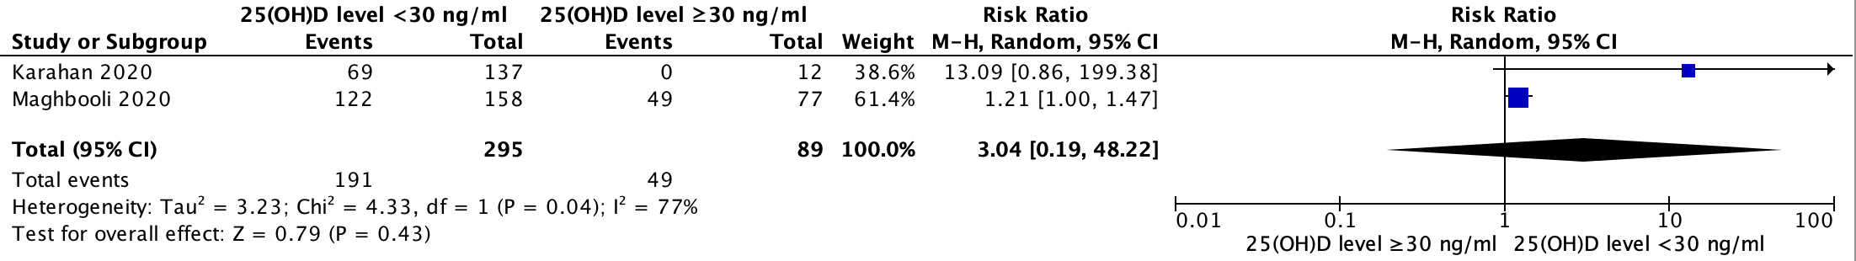
4
2

Appendix D.4: Sensitivity analysis for the association between serum 25(OH)D level < 30 ng/ml and ARDS

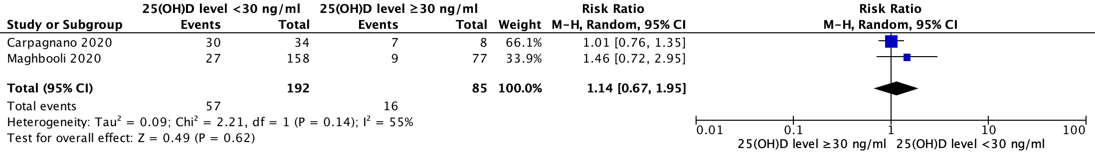
4
5

Appendix D.5: Sensitivity analysis for the association between serum 25(OH)D level < 30 ng/ml and SARS-CoV-2 positivity

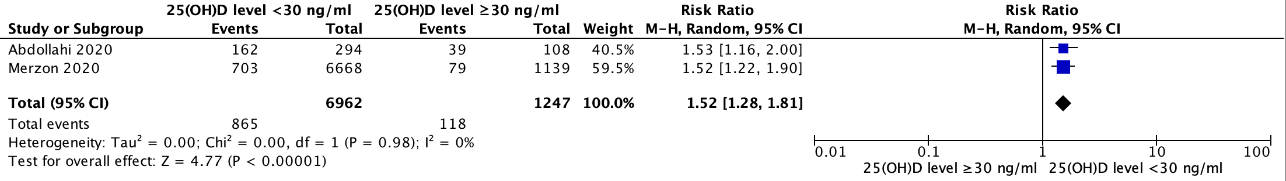
6
7
(1-7)
References
1. Angelidi AM, Belanger MJ, Lorinsky MK, Karamanis D, Chamorro-Pareja N, Ognibene J, et al., editors. Vitamin D Status is Associated With In-hospital Mortality and Mechanical Ventilation: A Cohort of COVID-19 Hospitalized Patients. Mayo Clinic Proceedings; 2021: Elsevier.
2. Karahan S, Katkat F. Impact of Serum 25(OH) Vitamin D Level on Mortality in Patients with COVID-19 in Turkey. Journal of Nutrition, Health and Aging. 2020.
3. Каронова Т, Андреева А, Вашукова М. Уровень 25 (ОН) D в сыворотке крови у больных COVID-19. Журнал инфектологии. 2020;12(3):21-7.
4. Maghbooli Z, Sahraian MA, Ebrahimi M, Pazoki M, Kafan S, Tabriz HM, et al. Vitamin D sufficiency, a serum 25-hydroxyvitamin D at least 30 ng/mL reduced risk for adverse clinical outcomes in patients with COVID-19 infection. PLoS One. 2020;15(9):e0239799.
5. Carpagnano GE, Di Lecce V, Quaranta VN, Zito A, Buonamico E, Capozza E, et al. Vitamin D deficiency as a predictor of poor prognosis in patients with acute respiratory failure due to COVID-19. Journal of endocrinological investigation. 2020:1-7.
6. Abdollahi A, Sarvestani HK, Rafat Z, Ghaderkhani S, Mahmoudi-Aliabadi M, Jafarzadeh B, et al. The Association Between the Level of Serum 25(OH) Vitamin D, Obesity, and underlying Diseases with the risk of Developing COVID-19 Infection: A case-control study of hospitalized patients in Tehran, Iran. Journal of Medical Virology. 2020;12:12.
7. Merzon E, Tworowski D, Gorohovski A, Vinker S, Golan Cohen A, Green I, et al. Low plasma 25 (OH) vitamin D level is associated with increased risk of COVID‐19 infection: an Israeli population‐based study. The FEBS journal. 2020.

