Supplementary Appendix:

Differences of blood pressure measured at clinic versus at home in the morning and in the evening in Europe and Asia: A systematic review and meta-analysis

Search strategies:
Pubmed:
(("clinic blood pressure"[Title/Abstract] OR "office blood pressure"[Title/Abstract] OR "office bp"[Title/Abstract] OR "clinic bp"[Title/Abstract] OR "clinic blood pressure measurement"[Title/Abstract] OR "CBPM"[Title/Abstract] OR "office blood pressure monitoring"[Title/Abstract] OR "office blood pressure measurement"[Title/Abstract] OR "clinic blood pressure monitoring"[Title/Abstract] OR "OBP"[Title/Abstract]) AND ("home blood pressure"[Title/Abstract] OR "home blood pressure monitoring"[Title/Abstract] OR "home blood pressure measurement"[Title/Abstract] OR "HBPM"[Title/Abstract] OR "home bp"[Title/Abstract])) AND (english[Filter])
Embase:
#1 'home blood pressure':ab,ti OR 'home blood pressure measurement':ab,ti OR hbpm:ab,ti OR 'home blood pressure monitoring':ab,ti OR 'home bp':ab,ti
#2 'clinic blood pressure':ab,ti OR 'office blood pressure':ab,ti OR 'clinic blood pressure measurement':ab,ti OR cbpm:ab,ti OR 'office blood pressure monitoring':ab,ti OR 'office blood pressure measurement':ab,ti OR 'clinic blood pressure monitoring':ab,ti OR 'office bp':ab,ti OR 'clinic bp':ab,ti OR 'obp':ab,ti
#3 #1 AND #2 AND [english]/lim
Scopus:
( TITLE-ABS-KEY ( clinic AND blood AND pressure ) OR TITLE-ABS-KEY ( office AND blood AND pressure ) OR TITLE-ABS-KEY ( office AND blood AND pressure AND measurement ) OR TITLE-ABS-KEY ( office AND blood AND pressure AND monitoring ) OR TITLE-ABS-KEY ( clinic AND blood AND pressure AND monitoring ) OR TITLE-ABS-KEY ( clinic AND blood AND pressure AND measurement ) OR TITLE-ABS-KEY ( clinic AND bp ) OR TITLE-ABS-KEY ( office AND bp ) OR TITLE-ABS-KEY ( cbpm ) OR TITLE-ABS-KEY ( obp ) ) AND ( TITLE-ABS-KEY ( home AND blood AND pressure ) OR TITLE-ABS-KEY ( home AND blood AND pressure AND measurement ) OR TITLE-ABS-KEY ( home AND blood AND pressure AND monitoring ) OR TITLE-ABS-KEY ( home AND bp ) OR TITLE-ABS-KEY ( hbpm ) ) AND ( LIMIT-TO ( LANGUAGE , "english" ) )

Table S1: Descriptions of BP measurement methods at clinic and home.
Table S2: Quality assessment of the included studies. (QUADAS-2).
Table S3: Summaries of meta-regression analyses for differences between clinic BP and home morning BP.
Table S4: Summaries of meta-regression analyses for differences between clinic BP and home evening BP.

Figure S1: Forest plot of the subgroup analysis by clinic SBP levels for the SBP difference between clinic BP and home morning BP in Europe.
Figure S2: Forest plot of the subgroup analysis by clinic SBP levels for the SBP difference between clinic BP and home morning BP in Asia.
Figure S3: Forest plot of the subgroup analysis by clinic DBP levels for the DBP difference between clinic BP and home morning BP in Europe.
Figure S4: Forest plot of the subgroup analysis by clinic DBP levels for the DBP difference between clinic BP and home morning BP in Asia.
Figure S5: Forest plot of the subgroup analysis by clinic SBP levels for the SBP difference between clinic BP and home evening BP in Europe.
Figure S6: Forest plot of the subgroup analysis by clinic SBP levels for the SBP difference between clinic BP and home evening BP in Asia.
Figure S7: Forest plot of the subgroup analysis by clinic DBP levels for the DBP difference between clinic BP and home evening BP in Europe.
Figure S8: Forest plot of the subgroup analysis by clinic DBP levels for the DBP difference between clinic BP and home evening BP in Asia.
Figure S9: Forest plot of SBP difference between clinic BP and home morning BP in studies that measured home BP at least twice each time for at least 3 consecutive days
Figure S10: Forest plot of SBP difference between clinic BP and home evening BP in studies that measured home BP at least twice each time for at least 3 consecutive days
Figure S11: Forest plot of SBP difference between clinic BP and home morning BP in studies with hypertensive populations.
Figure S12: Forest plot of SBP difference between clinic BP and home evening BP in studies with hypertensive populations.

Table S1: Descriptions of BP measurement methods at clinic and home.
Study | Clinic BP device | Clinic BP measurement description | Home BP device | Home BP measurement description
Al-Karkhi, I. et.al. 2015 | Omron i-C10 | Measurements were taken on arm with higher BP after 5 min of rest. Three recordings with1-min interval were  taken and the mean values of the last two measurements were recorded. | Omron i-C10 | Both morning and evening BP were recorded for 7 consecutive days. Three recordings with1-min interval were taken and the mean values of the last two measurements were recorded.
Asayama, K. et.al.  2019 | Omron HEM-907 | Measurements were taken twice or once in different clinic after a few minutes of rest. | n.a. | Both morning and evening BP were recorded for 5 days. Two recordings with 2-min interval were taken.
Campo, C. et.al.  2000 | mercury column sphygmomanometer | Measurements were taken on arm with higher BP. Three recordings with1-min interval were taken. | OMRON HEM 705 CP | Both morning and evening BP were recorded for 2 consecutive days. Three measurements with1-min interval were taken.
Chantrel, F. et.al.  2020 | Microlife BPA100 Plus MAM | Three BP measurements were made after 5 minutes  of rest. | Microlife BPA100 Plus MAM | Both morning and evening BP were recorded for 3 consecutive days. Three measurements with1-min interval were taken.
de Heus, R. A. A. et.al.  2019 | manual sphygmomanometer | According to standard clinical practice. | Microlife WatchBP Home | Duplicate measurements in the morning and evening for 7 consecutive days were recorded. Measurements for day 1 were discarded and a minimum threshold of 12 measurements were required.
Divisón, J. A. et.al.  2004 | OMRON 705CP | Three measurements with 2/3-min interval. | n.a. | 12 self-measurements were recorded for one day, which contain three measurements in each of the following four time-periods: before lunch, before dinner, at bedtime and in the morning on arising from bed.
Jula, A. et.al.  1999 | mercury sphygmomanometer | BP was recorded twice, with 2-min interval. | Omron HEM 705C | Both morning and evening BP were recorded for 7 consecutive days. Two measurements with 2-min interval were taken.
Kario, K.et.al.  2013 | n.a. | n.a. | n.a. | n.a.
Kjeldsen, S. E. et.al.  2002 | n.a. | n.a. | Yamasu Model No. 501 | Both morning and evening BP were recorded for 7 consecutive days. Three measurements were taken.
Kondo, K. et.al.  2016 | mercury  sphygmomanometer | Made by the physician with the patient in a sitting position after 5-min of rest. | Omron Healthcare | Twice both in the morning and evening BP were recorded. Average values were calculated for two different days.
Mancia, G. et.al.  2002 | mercury  sphygmomanometer | Three BP measurements were made in a sitting position after 10-min of rest. | Omron HEM-705 | Both morning and evening BP were recorded for 7 consecutive days. Three measurements were taken each time. Values recorded on the first day were excluded.
Mori, H. et.al.  2017 | n.a. | n.a. | n.a. | 3 consecutive days of morning and night BP measurements.
Nakano, M. et.al.  2016 | n.a. | n.a. | Omron HEM-5001 | Both morning and evening BP were recorded for 14 days. Three measurements were taken each time.
Niiranen, T. J. et.al.  2006 | mercury  sphygmomanometer | BP measurements were made two times with a 2-min interval after 10 min of rest. | Omron model HEM-722 C | Both morning and evening BP were recorded for 7 consecutive days. Duplicate measurements with 2-min interval were taken.
Ohta, Y. et.al.  2014 | sphygmomanometer | n.a. | n.a. | Based on the first morning record. HBP values on the preceding 3 days of clinical visit were averaged.
Okada, T. et.al.  2008 | mercury  sphygmomanometer | Single measurement was recorded. | semiautomatic arm device | Both morning and evening BP were recorded for 7 consecutive days. The value of a single measurement was recorded each time.
Saito, I. et.al.  2013 | n.a. | n.a. | electronic arm-cuff devices | Morning BP were recorded on 2 different days within 28 days before treatment.
Stenehjem, A. E. et.al.  2006 | mercury  sphygmomanometer | Three BP measurements were made after 5 minutes of rest. | Omron M4 | Both morning and evening BP were recorded after 5 min of rest. Duplicate measurements each time were taken.
Udani, J. et.al.  2015 | n.a. | n.a. | n.a. | Two times every day include morning and evening
Uno, H. et.al.  2008 | n.a. | n.a. | Omron HEM-705IT | Duplicate morning and evening BP were measured for 3 days.
Kadowaki, S. et.al.  2021 | Omron BP-8800SF | Two BP measurements were made with an interval of 30s after 5-min of rest. | Omron HEM-705 IT Fuzzy Cuff | Once every morning for 7 consecutive days.
Kakio, Y. et.al.  2017 | n.a. | BP measurements were made in a sitting position after 5 min of rest. | n.a. | Morning BP were measured for 5 days.
Kamoi, K. et.al.  2010 | n.a. | Measured once in clinic visit. | n.a. | Measured once in the same morning at clinic visit
Kuriyama, S. et.al.  2014 | n.a. | Measured in a sitting position. | n.a. | Morning BP were measured within 30 minutes after awakening for several times
Miyagawa, S. et.al.  2012 | n.a. | Measured three times at 1-min interval after 5-min of rest. | OMRON HEM 7041 | Measured 3 times every morning for 3 consecutive days.
Mori, H. et.al.  2013 | automatic oscillometric device or mercury BP manometer | Measured in a seated position after 5-min of rest. | OMRON HEM 7000 | Morning BP were measured after 2-min of rest.
Ohkubo, T. et.al.  2004 | mercury or aneroid  sphygmomanometer | Measured two times after 2-min of rest. | n.a. | Once every morning after 2-min of rest over 2 weeks.
Ohta, Y. et.al.  2011 | n.a. | Measured two times | n.a. | Once in the morning for 3 days.
Satoh, A. et.al.  2019 | Omron BP-8800SF | Measured twice in a sitting position after 5-min of rest. | OMRON HEM 705 IT | Measured once in the morning during the 7 consecutive days.
Suzuki, K. et.al.  2011 | mercury  sphygmomanometer | n.a. | OMRON HEM 762 FUZZY | Once in the morning for 7 days.
Yasui,D. et.al.  2012 | USM700F | Measured twice in a sitting position after 2 min of rest. | OMRON HEM401C | Measured both in the morning and evening during the 4 weeks.
Asayama K. et al.  2012 | OMRONHEM-907IT | Measured twice. | OMRONHEM-747IC-N | Measured in the morning after 2-min rest.
Huang, H. C. et.al. 2005 | Microfile BP 3BTO-A | Measured at 10:00AM after 5-min of rest. | Microfile BP 3BTO-A | Measured at 10:00AM for 4 consecutive days.
Xu, J. et.al. 2016 | n.a. | According to standard measurement method | Omron HEM-4030 | Measured once both in the morning and evening
Zhang, D. Y. et.al. 2020 | Omron HEM-7011-C1 | Measured 3 times in a sitting position after 5-min of rest. | Omron HEM-7011-C1 | Measured three times both in the morning and evening during 7 consecutive days.

Table S2: Quality assessment of the included studies. (QUADAS-2)
Study | Risk of Bias |  |  |  | Applicability Concerns
Study | Patient selection | Index test | Reference standard | Flow and timing | Patient selection | Index test | Reference standard
Al-Karkhi, I. et.al. 2015 | Unclear | Unclear | Unclear | Low | Low | Low | Low
Asayama,K.et.al.  2019 | Unclear | Low | high | Low | Low | Low | unclear
Campo,C. et.al.  2000 | Unclear | Unclear | Unclear | Low | Low | high | Low
Chantrel,F. et.al.  2020 | Unclear | high | Low | Low | Low | Low | Low
de Heus, R. A. A. et.al.  2019 | Low | Unclear | Unclear | unclear | unclear | Low | Low
Divisón,J.A. et.al.  2004 | Low | high | low | Low | Low | high | Low
Jula, A. et.al.  1999 | Unclear | Unclear | Unclear | Low | Low | Low | Low
Kario, K.et.al.  2013 | Unclear | Unclear | Unclear | Low | Low | Unclear | unclear
Kjeldsen, S. E. et.al.  2002 | Unclear | Unclear | Unclear | unclear | low | low | unclear
Kondo, K. et.al.  2016 | Unclear | Unclear | Unclear | Low | Low | high | Low
Mancia, G. et.al.  2002 | Unclear | Unclear | Unclear | Low | Low | Low | Low
Mori, H. et.al.  2017 | Unclear | Low | high | Low | Low | Unclear | unclear
Nakano, M. et.al.  2016 | Unclear | Unclear | Unclear | Low | Low | Low | unclear
Niiranen, T. J. et.al.  2006 | low | Unclear | Unclear | Low | Low | Low | Low
Ohta, Y. et.al.  2014 | low | low | high | low | Low | High | unclear
Okada, T. et.al.  2008 | Unclear | Unclear | Unclear | Low | Low | high | high
Saito, I. et.al.  2013 | Unclear | Unclear | Unclear | Low | Low | high | unclear
Stenehjem, A. E. et.al.  2006 | Unclear | unclear | Unclear | Low | Low | unclear | Low
Udani, J. et.al.  2015 | Unclear | low | high | Low | Low | unclear | unclear
Uno, H. et.al.  2008 | Unclear | low | high | low | Low | Low | Low
Kadowaki, S. et.al.  2021 | low | high | low | Low | Low | high | Low
Kakio, Y. et.al.  2017 | Unclear | low | high | Low | Low | unclear | Low
Kamoi, K. et.al.  2010 | Unclear | Unclear | Unclear | Low | Low | high | high
Kuriyama, S. et.al.  2014 | Unclear | unclear | unclear | Low | Unclear | unclear | unclear
Miyagawa, S. et.al.  2012 | Unclear | unclear | Unclear | Low | Low | Low | Low
Mori, H. et.al.  2013 | Unclear | unclear | Unclear | Low | Low | unclear | unclear
Ohkubo, T. et.al.  2004 | Low | Unclear | unclear | low | Low | high | Low
Ohta, Y. et.al.  2011 | Unclear | Low | High | Low | Low | high | Low
Satoh, A. et.al.  2019 | low | high | low | Low | Low | high | Low
Suzuki, K. et.al.  2011 | Unclear | Unclear | Unclear | Low | Low | high | Low
Yasui,D. et.al.  2012 | Unclear | unclear | unclear | low | low | unclear | low
Asayama K. et al.  2012 | Unclear | low | high | low | low | unclear | low
Huang, H. C. et.al. 2005 | Unclear | high | high | low | low | unclear | unclear
Xu, J. et.al. 2016 | low | high | low | unclear | low | high | low
Zhang, D. Y. et.al. 2020 | Unclear | high | low | low | low | low | low

Table S3: Summaries of meta-regression analyses for differences between clinic BP and home morning BP.
Clinic SBP-home morning SBP difference |  | Clinic DBP-home morning DBP difference
Variables | P value | Variables | P value
Region | 0.041 | Region | 0.011
Mean age | 0.959 | Mean age | 0.160
Gender | 0.439 | Gender | 0.457
Mean clinic SBP | 0.246 | Mean clinic DBP | 0.012
Mean home morning SBP | 0.223 | Mean home morning DBP | 0.676
Hypertension (%) | 0.991 | Hypertension (%) | 0.776
Antihypertensive treatment (%) | 0.846 | Antihypertensive treatment (%) | 0.179
Diabetes (%) | 0.400 | Diabetes (%) | 0.070

Table S4: Summaries of meta-regression analyses for differences between clinic BP and home evening BP.
Clinic SBP-home evening SBP difference |  | Clinic DBP-home evening DBP difference
Variables | P value | Variables | P value
Region | 0.544 | Region | 0.712
Mean age | 0.023 | Mean age | 0.482
Gender | 0.796 | Gender | 0.796
Mean clinic SBP | 0.019 | Mean clinic DBP | 0.585
Mean home morning SBP | 0.928 | Mean home morning DBP | 0.352
Hypertension (%) | 0.404 | Hypertension (%) | 0.404
Antihypertensive treatment (%) | 0.125 | Antihypertensive treatment (%) | 0.125
Diabetes (%) | 0.416 | Diabetes (%) | 0.889

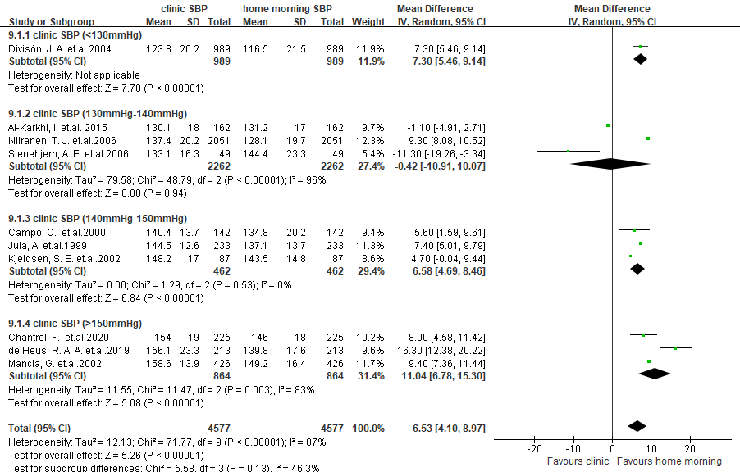
Figure S1: Forest plot of the subgroup analysis by clinic SBP levels for the SBP difference between clinic BP and home morning BP in Europe.
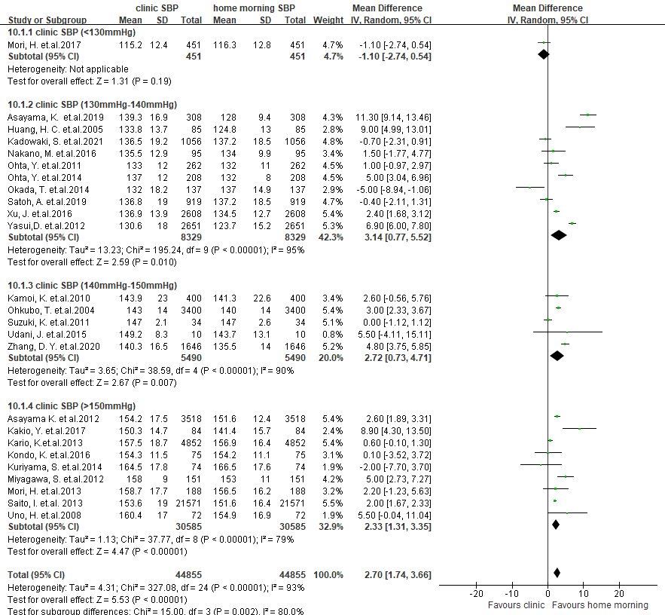
Figure S2: Forest plot of the subgroup analysis by clinic SBP levels for the SBP difference between clinic BP and home morning BP in Asia.
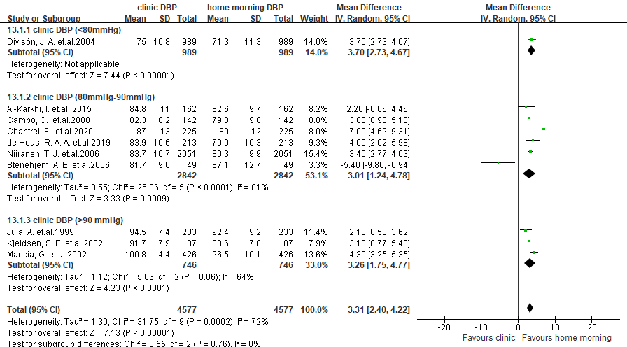
Figure S3: Forest plot of the subgroup analysis by clinic DBP levels for the DBP difference between clinic BP and home morning BP in Europe.
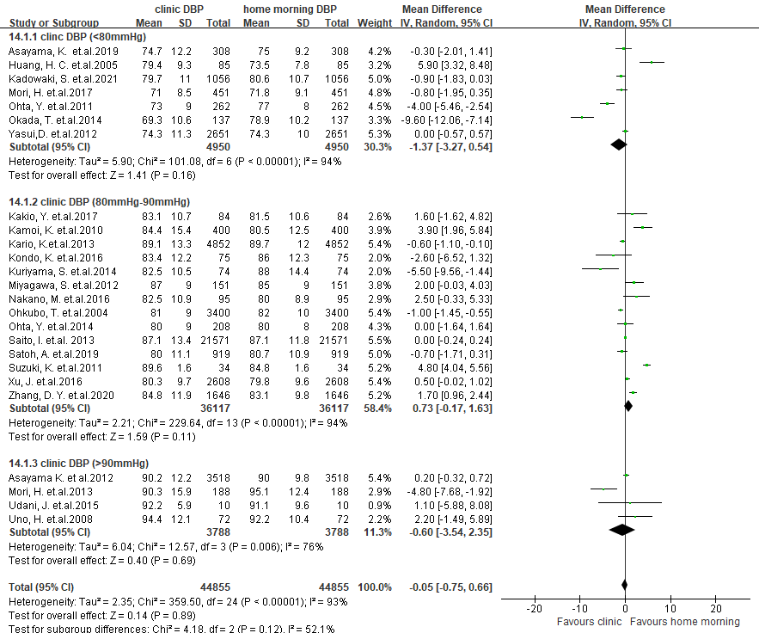
Figure S4: Forest plot of the subgroup analysis by clinic DBP levels for the DBP difference between clinic BP and home morning BP in Asia.
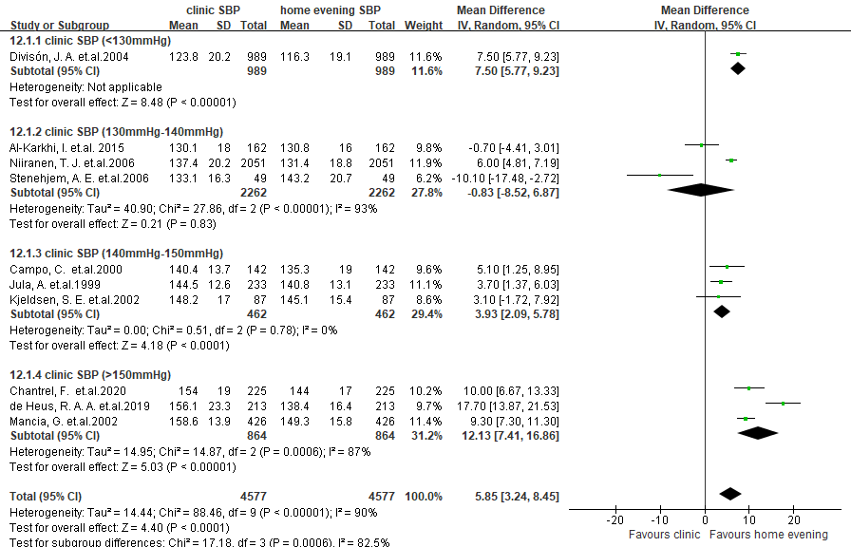
Figure S5: Forest plot of the subgroup analysis by clinic SBP levels for the SBP difference between clinic BP and home evening BP in Europe.
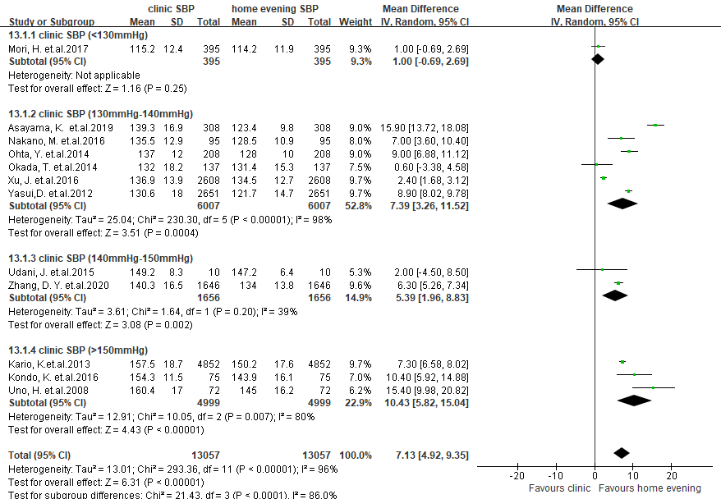
Figure S6: Forest plot of the subgroup analysis by clinic SBP levels for the SBP difference between clinic BP and home evening BP in Asia.
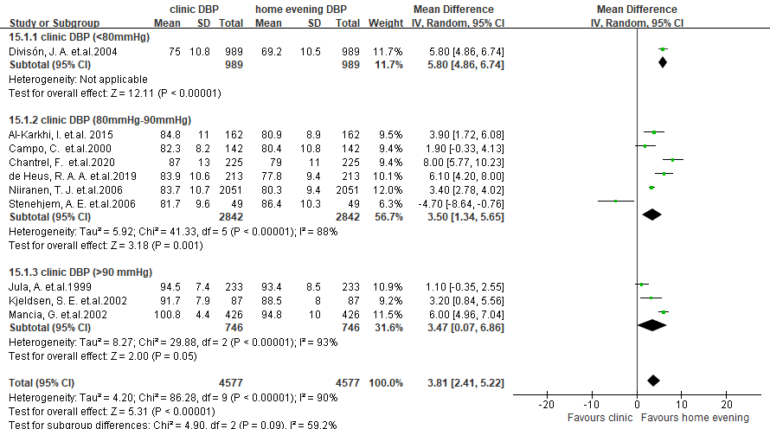
Figure S7: Forest plot of the subgroup analysis by clinic DBP levels for the DBP difference between clinic BP and home evening BP in Europe.
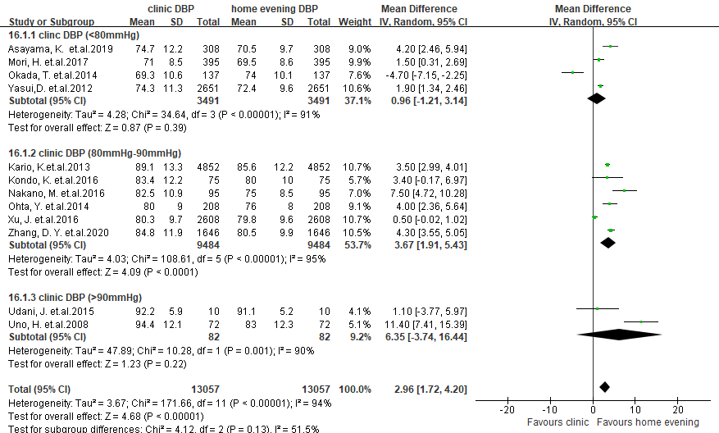
Figure S8: Forest plot of the subgroup analysis by clinic DBP levels for the DBP difference between clinic BP and home evening BP in Asia.

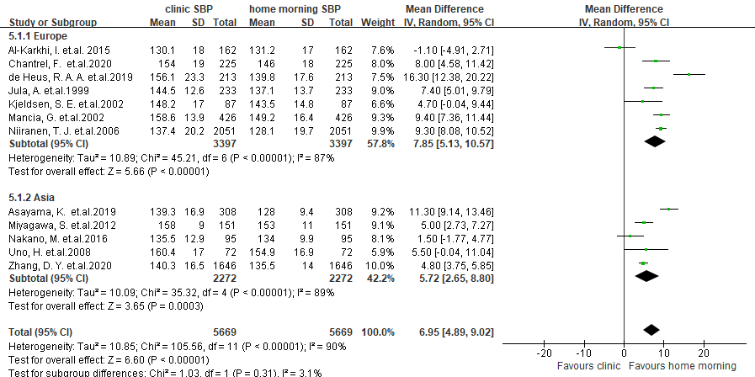
Figure S9: Forest plot of SBP difference between clinic BP and home morning BP in studies that measured home BP at least twice each time for at least 3 consecutive days.
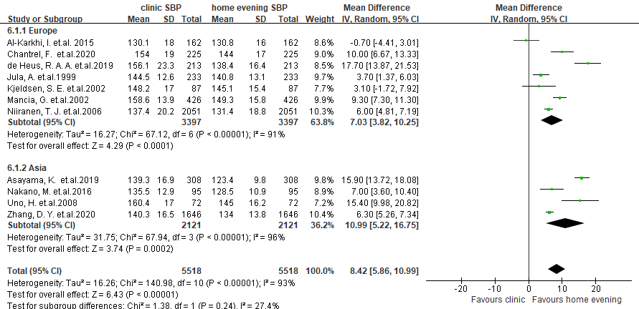
Figure S10: Forest plot of SBP difference between clinic BP and home evening BP in studies that measured home BP at least twice each time for at least 3 consecutive days.

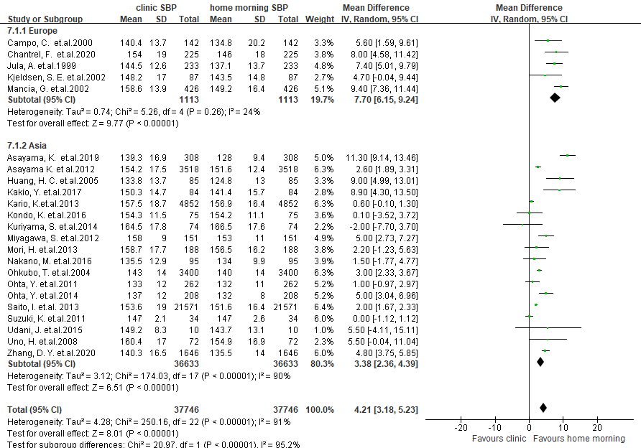
Figure S11: Forest plot of SBP difference between clinic BP and home morning BP in studies with hypertensive populations.
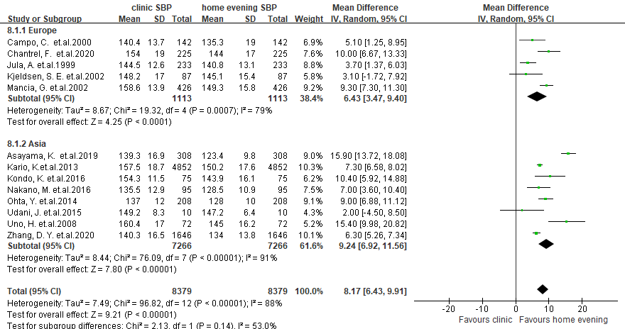
Figure S12: Forest plot of SBP difference between clinic BP and home evening BP in studies with hypertensive populations.

