S1 Characteristics of studies included in the present meta-analysis
author（year） | ethnicity | disease | detection | tissues | sample size
Abdelaty2020 | Caucasian | DKD | qRT-PCR | plasma | 75
Abdelsalam2020 | Caucasian | DKD | qRT-PCR | plasma | 120
Abdelsalam2020 | Caucasian | DKD | qRT-PCR | urine | 120
Abdul-Maksoud2021 | Caucasian | LN | Real-time PCR | urine | 116
Abdul-Maksoud2021 | Caucasian | LN | Real-time PCR | urine | 116
Abdul-Maksoud2021 | Caucasian | LN | Real-time PCR | urine | 116
Beltrami2018 | Caucasian | DKD | qRT-PCR | urine | 130
Conserva2019 | Caucasian | DKD | Real-time PCR | urine | 29
Duan2016 | Asian | IgAN | Real-time PCR | urine | 215
Duan2016 | Asian | IgAN | Real-time PCR | urine | 215
Duan2016 | Asian | IgAN | Real-time PCR | urine | 215
Eissa2016 | Caucasian | DKD | qRT-PCR | plasma | 220
Eissa2016 | Caucasian | DKD | qRT-PCR | plasma | 220
Eissa2016 | Caucasian | DKD | qRT-PCR | plasma | 220
eissa2016 | Caucasian | DKD | Real-time PCR | urine | 180
eissa2016 | Caucasian | DKD | Real-time PCR | urine | 180
eissa2016 | Caucasian | DKD | Real-time PCR | urine | 180
Fouad2019 | Caucasian | DKD | qRT-PCR | plasma | 340
Kocyigit2017 | Caucasian | ADPKD | qRT-PCR | Serum | 130
Lv2013 | Asian | CKD | qRT-PCR | urine | 39
Lv2013 | Asian | CKD | qRT-PCR | urine | 39
Magayr2020 | Caucasian | ADPKD | Real-time PCR | urine | 60
Magayr2020 | Caucasian | ADPKD | Real-time PCR | urine | 60
Magayr2020 | Caucasian | ADPKD | Real-time PCR | urine | 60
Magayr2020 | Caucasian | ADPKD | Real-time PCR | urine | 60
Magayr2020 | Caucasian | ADPKD | Real-time PCR | urine | 60
Nakhjavani2019 | Caucasian | LN | Real-time PCR | Plasma | 52
Nakhjavani2019 | Caucasian | LN | Real-time PCR | Plasma | 52
Nakhjavani2019 | Caucasian | LN | Real-time PCR | Plasma | 52
Nakhjavani2019 | Caucasian | LN | Real-time PCR | Plasma | 52
Navarro-Quiroz2016 | Caucasian | LN | qRT-PCR | serum | 180
Nossier2020 | Caucasian | DKD | qRT-PCR | urine | 70
Nossier2020 | Caucasian | DKD | qRT-PCR | urine | 70
Serino2015 | Caucasian/Asian | IgAN | Real-time PCR | serum | 209
Serino2015 | Caucasian/Asian | IgAN | Real-time PCR | serum | 209
Serino2015 | Caucasian/Asian | IgAN | Real-time PCR | serum | 209
Solé2015 | Caucasian | LN | qRT-PCR | urine | 67
Solé2019 | Asian | LN | qRT-PCR | urine | 65
Solé2019 | Asian | LN | qRT-PCR | urine | 65
Solé2019 | Asian | LN | qRT-PCR | urine | 65
Szeto2019 | Asian | IgAN | qRT-PCR | urine | 42
Tayel2019 | Caucasian | DKD | RT-PCR | plasma | 229
Tayel2019 | Caucasian | DKD | qRT-PCR | plasma | 229
Vahed2018 | Caucasian | LN | Real-time PCR | plasma | 53
Vahed2018 | Caucasian | LN | Real-time PCR | plasma | 53
Vahed2018 | Caucasian | LN | Real-time PCR | plasma | 53
Vahed2018 | Caucasian | LN | Real-time PCR | plasma | 53
Vahed2018 | Caucasian | LN | Real-time PCR | plasma | 53
Wang2020 | Asian | MsPGN | RT-PCR | plasma | 100
Wang2020 | Asian | MsPGN | RT-PCR | plasma | 100
Wang2020 | Asian | MsPGN | RT-PCR | plasma | 100
Wang2020 | Asian | MsPGN | RT-PCR | plasma | 100
wang2020 | Asian | DKD | qRT-PCR | serum | 132
Wu2018 | Asian | IgAN | qRT-PCR | plasma | 102
Xiao2018 | Asian | FSGS | qRT-PCR | plasma | 44
Zhang2020 | Asian | LN | qRT-PCR | serum | 167

S2 Basic information about the literature on diagnostic efficacy
author（year） | miRNA | TP | FP | FN | TN | sensitivity | specificity
Abdelaty2020 | miR-192 | 32 | 3 | 18 | 23 | 0.63 | 0.90
Abdelsalam2020 | miR-451 | 82 | 10 | 8 | 20 | 0.91 | 0.67
Abdelsalam2020 | miR-451 | 86 | 1 | 4 | 29 | 0.96 | 0.96
Abdul-Maksoud2021 | miR-181a | 45 | 13 | 4 | 54 | 0.92 | 0.81
Abdul-Maksoud2021 | miR-223 | 39 | 12 | 10 | 55 | 0.79 | 0.83
Abdul-Maksoud2021 | panel：miR-181a,miR-223 | 46 | 5 | 3 | 62 | 0.94 | 0.92
Beltrami2018 | panel：miR-29b,miR-126-3p,miR-155-5p | 71 | 15 | 18 | 26 | 0.80 | 0.63
Conserva2019 | panel：miR-27b-3p,miR-1228-3p | 19 | 1 | 0 | 9 | 1.00 | 0.90
Duan2016 | miR-25-3p | 81 | 25 | 12 | 97 | 0.87 | 0.79
Duan2016 | miR-144-3p | 77 | 27 | 16 | 95 | 0.82 | 0.78
Duan2016 | miR-486-5p | 87 | 18 | 6 | 104 | 0.94 | 0.85
Eissa2016 | miR-133b | 143 | 15 | 23 | 39 | 0.86 | 0.72
Eissa2016 | miR-342 | 136 | 10 | 30 | 44 | 0.82 | 0.81
Eissa2016 | miR-30a | 127 | 5 | 39 | 49 | 0.76 | 0.91
eissa2016 | miR-15b | 133 | 8 | 3 | 36 | 0.98 | 0.82
eissa2016 | miR-34a | 127 | 6 | 9 | 38 | 0.93 | 0.86
eissa2016 | miR-636 | 133 | 3 | 3 | 41 | 0.98 | 0.93
Fouad2019 | miR-21 | 226 | 0 | 14 | 100 | 0.94 | 1.00
Kocyigit2017 | miR-3907 | 66 | 11 | 14 | 39 | 0.83 | 0.78
Lv2013 | miR-29c | 22 | 1 | 10 | 6 | 0.69 | 0.81
Lv2013 | miR-29a | 30 | 1 | 2 | 6 | 0.94 | 0.81
Magayr2020 | miR-192-5p | 33 | 6 | 7 | 14 | 0.82 | 0.70
Magayr2020 | miR-194-5p | 29 | 12 | 11 | 8 | 0.72 | 0.41
Magayr2020 | miR-30a-5p | 31 | 6 | 9 | 14 | 0.77 | 0.70
Magayr2020 | miR-30d-5p | 29 | 7 | 11 | 13 | 0.73 | 0.65
Magayr2020 | miR-30e-5p | 29 | 4 | 11 | 16 | 0.73 | 0.82
Nakhjavani2019 | miR-21 | 22 | 10 | 4 | 16 | 0.86 | 0.63
Nakhjavani2019 | miR-150 | 18 | 7 | 8 | 19 | 0.69 | 0.72
Nakhjavani2019 | miR-423 | 25 | 9 | 1 | 17 | 0.96 | 0.66
Nakhjavani2019 | panel：miR-21,miR-150,miR-423 | 21 | 4 | 5 | 22 | 0.79 | 0.83
Navarro-Quiroz2016 | panel：miR-221-5p,miR-380-3p,miR-556-5p,miR-758-3p,miR-3074-3p | 136 | 12 | 4 | 28 | 0.97 | 0.70
Nossier2020 | miR-210 | 47 | 1 | 11 | 11 | 0.81 | 0.88
Nossier2020 | miR-34a | 49 | 1 | 9 | 11 | 0.84 | 0.94
Serino2015 | let7b | 102 | 22 | 44 | 42 | 0.70 | 0.66
Serino2015 | miR-148b | 83 | 24 | 62 | 40 | 0.57 | 0.63
Serino2015 | panel：miR-148b,let7b | 93 | 17 | 52 | 47 | 0.64 | 0.74
Solé2015 | miR-29c | 44 | 4 | 3 | 16 | 0.94 | 0.82
Solé2019 | panel：miR-21,miR-150,miR-29c | 42 | 0 | 3 | 20 | 0.94 | 0.99
Solé2019 | miR-150 | 43 | 3 | 2 | 17 | 0.96 | 0.83
Solé2019 | miR-21 | 36 | 6 | 9 | 14 | 0.81 | 0.72
Szeto2019 | miR-204 | 33 | 4 | 0 | 5 | 1.00 | 0.56
Tayel2019 | miR-126 | 121 | 30 | 12 | 65 | 0.91 | 0.68
Tayel2019 | miR-192 | 122 | 6 | 12 | 89 | 0.91 | 0.94
Vahed2018 | miR-125a | 24 | 18 | 2 | 9 | 0.92 | 0.33
Vahed2018 | miR-142-3p | 21 | 12 | 5 | 15 | 0.81 | 0.56
Vahed2018 | miR-146 | 15 | 1 | 11 | 26 | 0.56 | 0.96
Vahed2018 | miR-156 | 23 | 9 | 3 | 18 | 0.88 | 0.67
Vahed2018 | panel：miR-125a,miR-142-3p,miR-146,miR-156 | 23 | 6 | 3 | 21 | 0.89 | 0.79
Wang2020 | miR-106a-5p | 42 | 15 | 8 | 36 | 0.84 | 0.71
Wang2020 | miR-17-5p | 36 | 18 | 14 | 33 | 0.72 | 0.65
Wang2020 | miR-30a-5p | 39 | 14 | 11 | 37 | 0.78 | 0.73
Wang2020 | panel：miR-106a-5p,miR-30a-5p | 43 | 10 | 8 | 40 | 0.85 | 0.80
wang2020 | miR-16-5p | 57 | 6 | 10 | 59 | 0.85 | 0.91
Wu2018 | panel：miR-148a-3p, miR-150-5p, miR-20a-5p,miR-425-3p | 39 | 20 | 12 | 31 | 0.77 | 0.61
Xiao2018 | panel：miR-17,miR-451,miR-106a,miR-19b | 19 | 3 | 4 | 18 | 0.83 | 0.85
Zhang2020 | miR-203 | 71 | 14 | 22 | 60 | 0.76 | 0.81
TP:true positive,FP:false positive,FN:false negative,TN:true negative

Subgroup |  | sensitivity | specificity | PLR | NLR | DOR | AUC
miRNA | single | 0.86 | 0.79 | 4.1 | 0.18 | 22 | 0.89
 | panel | 0.88 | 0.81 | 4.6 | 0.15 | 31 | 0.91
ethnicity | Caucasians | 0.88 | 0.81 | 4.5 | 0.15 | 29 | 0.91
 | Asians | 0.85 | 0.79 | 4.1 | 0.19 | 22 | 0.89
tissue | urine | 0.89 | 0.82 | 4.8 | 0.13 | 37 | 0.92
 | plasma | 0.87 | 0.78 | 3.8 | 0.21 | 19 | 0.88
 | serum | 0.79 | 0.76 | 3.3 | 0.27 | 12 | 0.83
disease | DKD | 0.9 | 0.88 | 7.5 | 0.12 | 64 | 0.95
 | LN | 0.88 | 0.78 | 4.0 | 0.15 | 26 | 0.90
 | IgAN | 0.81 | 0.74 | 3.2 | 0.25 | 13 | 0.82
 | ADPKD | 0.77 | 0.68 | 2.4 | 0.33 | 7 | 0.80
miRNA30 |  | 0.76 | 0.78 | 3.4 | 3.10 | 11 | 0.77

S3 Results of partial subgroup analysis（PLR:positive likelihood ratio,NLR:negative likelihood ratio , DOR:diagnostic odds ratio）

S4 Search strategy
Pubmed:("kidney diseases"[MeSH Terms] OR "kidney failure"[Title/Abstract] OR "kidney insufficiency"[Title/Abstract] OR "kidney function"[Title/Abstract] OR "kidney dysfunction"[Title/Abstract] OR "renal disease"[Title/Abstract] OR "renal failure"[Title/Abstract] OR "renal insufficiency"[Title/Abstract] OR "renal function"[Title/Abstract] OR "renal dysfunction"[Title/Abstract] OR "nephritis"[Title/Abstract] OR "chronic renal failure"[Title/Abstract] OR "CKD"[Title/Abstract]) AND ("micrornas"[MeSH Terms] OR "MicroRNA"[Title/Abstract] OR "miRNAs"[Title/Abstract] OR "micro rna"[Title/Abstract] OR "rna micro"[Title/Abstract] OR "miRNA"[Title/Abstract] OR "primary microrna"[Title/Abstract] OR "microrna primary"[Title/Abstract] OR "primary mirna"[Title/Abstract] OR "mirna primary"[Title/Abstract] OR "pri-miRNA"[Title/Abstract] OR "pri-miRNA"[Title/Abstract] OR (("RNA"[MeSH Terms] OR "RNA"[All Fields]) AND "small temporal"[Title/Abstract]) OR (("Temporal"[All Fields] OR "temporally"[All Fields] OR "temporals"[All Fields]) AND "rna small"[Title/Abstract]) OR "stRNA"[Title/Abstract] OR "small temporal rna"[Title/Abstract] OR "pre-miRNA"[Title/Abstract] OR "pre-miRNA"[Title/Abstract]) AND ("diagnosis"[Title/Abstract] OR "predict"[Title/Abstract] OR "sensitivity"[Title/Abstract] OR "specificity"[Title/Abstract] OR "ROC"[Title/Abstract] OR "AUC"[Title/Abstract])
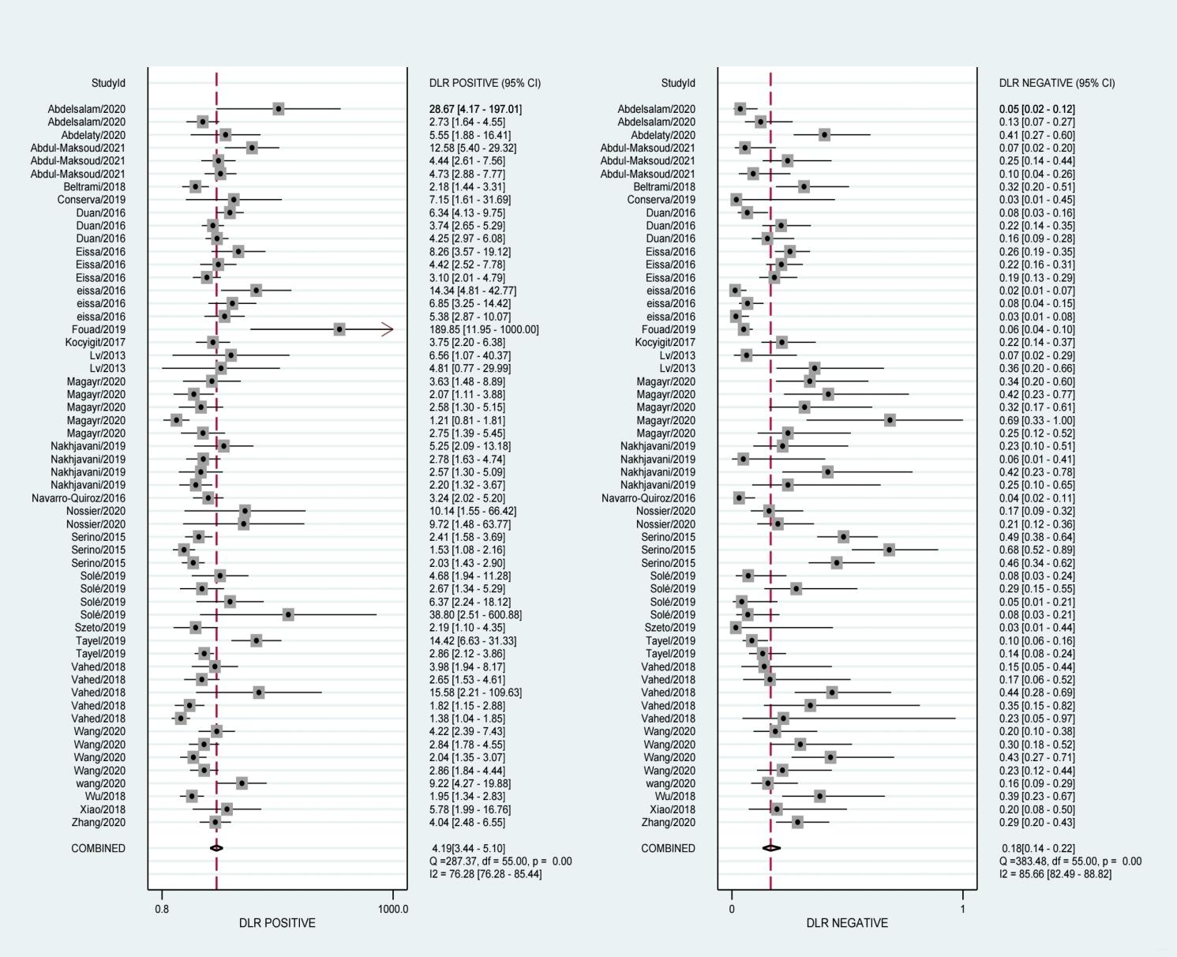
S5 Forest plots of positive and negative likelihood ratios
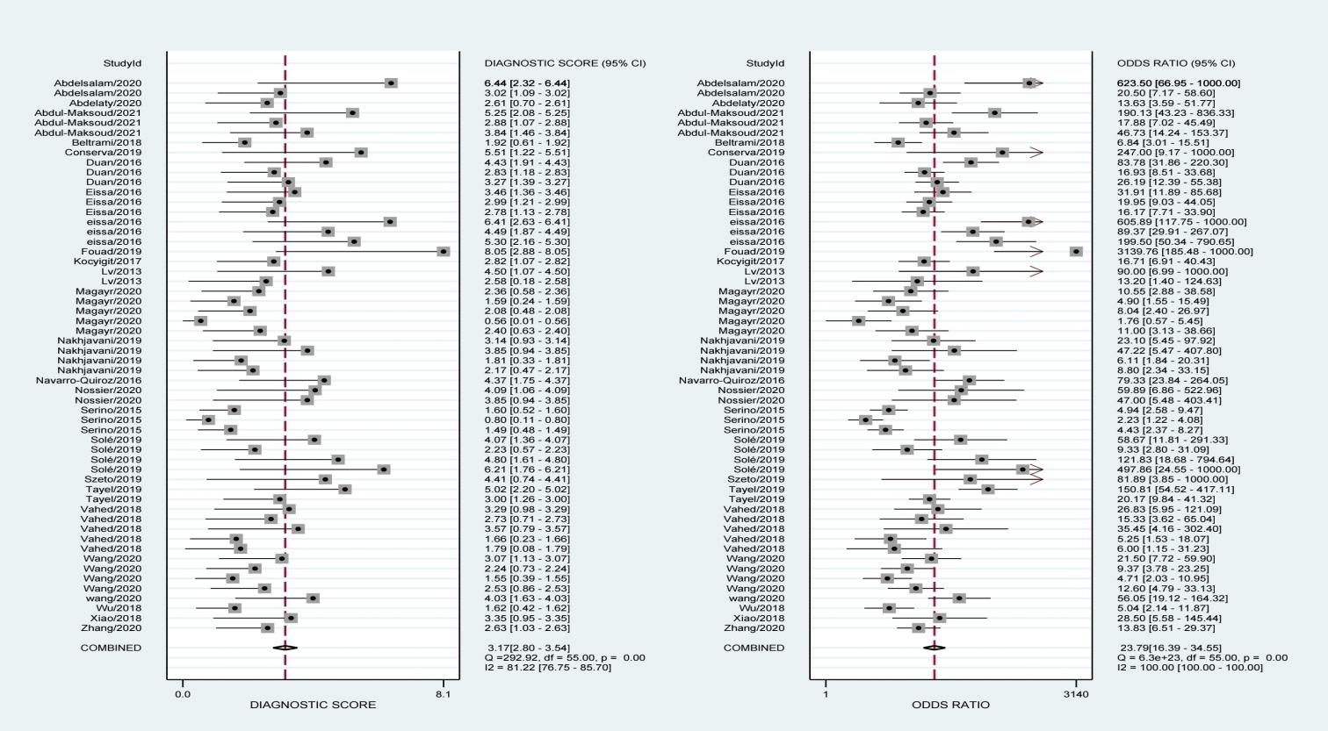

S6 Forest plots of diagnostic odds ratios
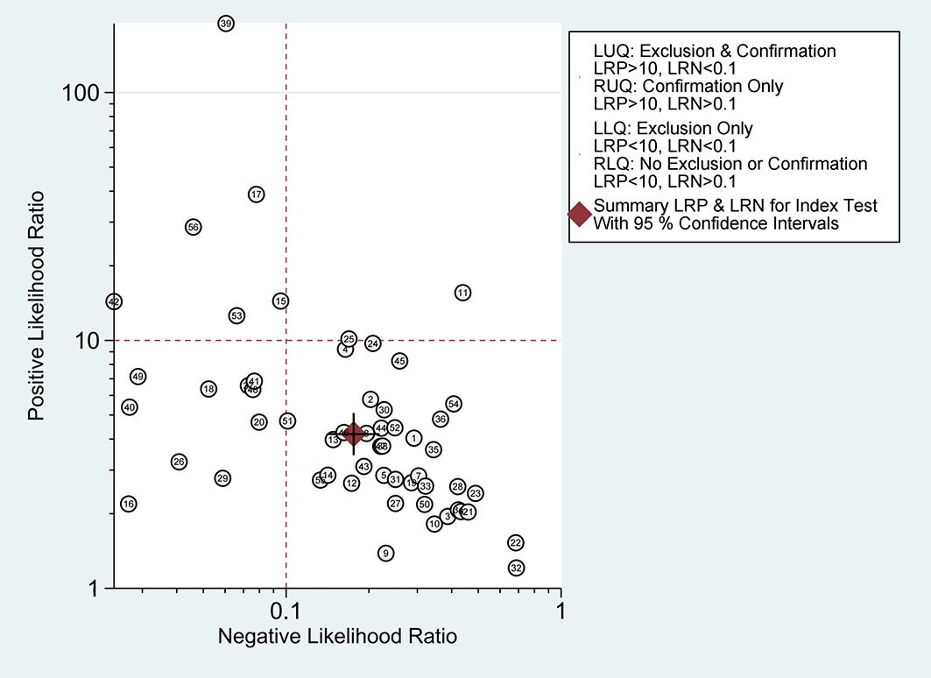
S7 Summary of positive likelihood ratio and
negative likelihood ratio for diagnosis of CKD

