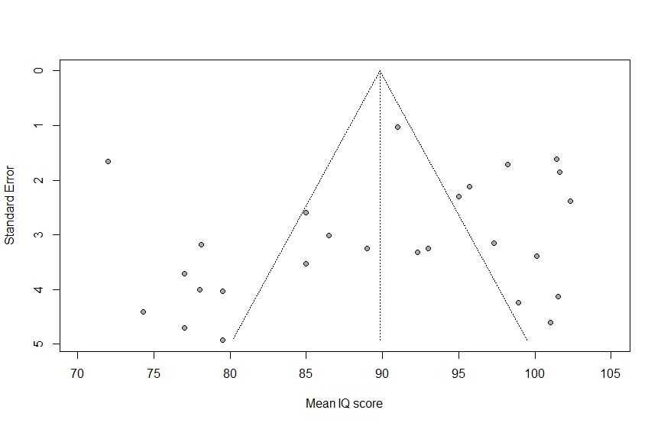
Figure S1. Funnel plot of the meta-analysis of studies reporting on DQ/IQ. Each plotted dot represents the mean DQ/IQ and standard error of a single study. The triangle represents the region in which 95% of the data points would lie in the absence of publication bias. The vertical dashed line represents the pooled overall mean DQ/IQ found in the meta-analysis. The funnel plot shows asymmetry indicating publication bias.
DQ: developmental quotient, IQ: intelligence quotient.

Mean DQ/IQ

