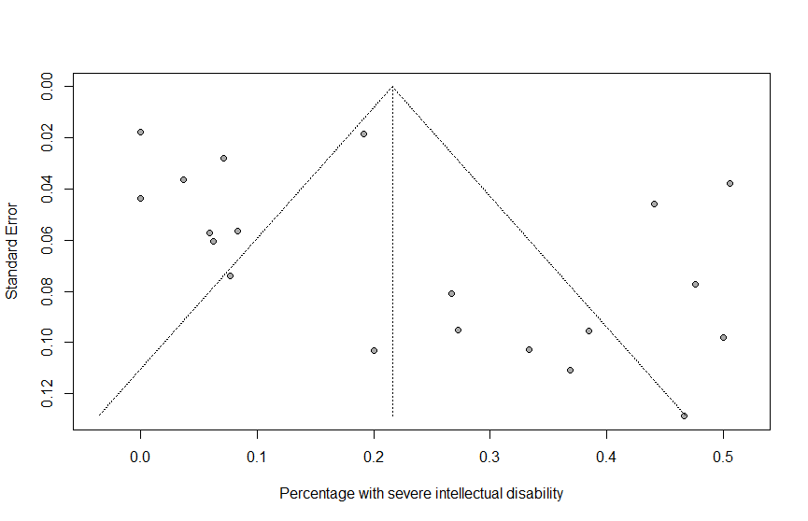
Figure S2. Funnel plot of the meta-analysis of studies reporting on percentage of patients with severe developmental delay/disability (developmental/intelligence quotient <70). Each plotted dot represents the percentage of patients with severe developmental delay/disability and standard error of a single study. The triangle represents the region in which 95% of the data points would lie in the absence of publication bias. The vertical dashed line represents the pooled overall percentage with severe developmental delay/disability found in the meta-analysis. The funnel plot shows asymmetry indicating publication bias.

0 10 20 30 40 50
Percentage with severe developmental delay/disability

