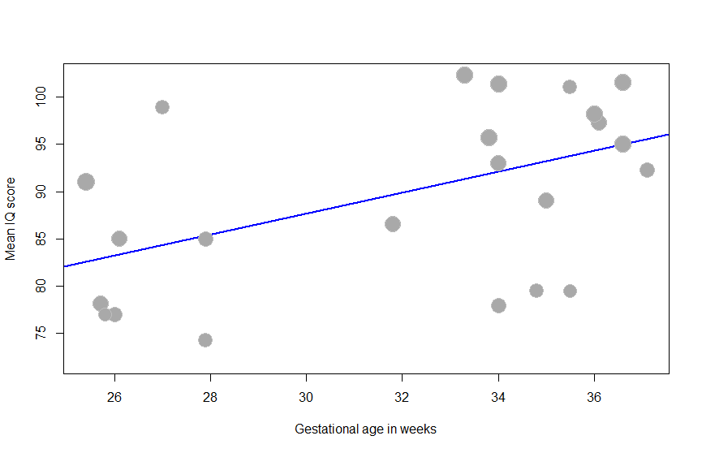
Figure S3. Scatterplot of the meta-regression analyzing the association between gestational age in weeks and mean DQ/IQ. Each plotted dot represents the mean gestational age in weeks and corresponding mean DQ/IQ of a single study. The increasing regression line with positive slope indicates that higher gestational age in weeks is associated with higher mean DQ/IQ (p = 0.041).
DQ: developmental quotient, IQ: intelligence quotient.

Mean DQ/IQ
Gestational age in weeks

