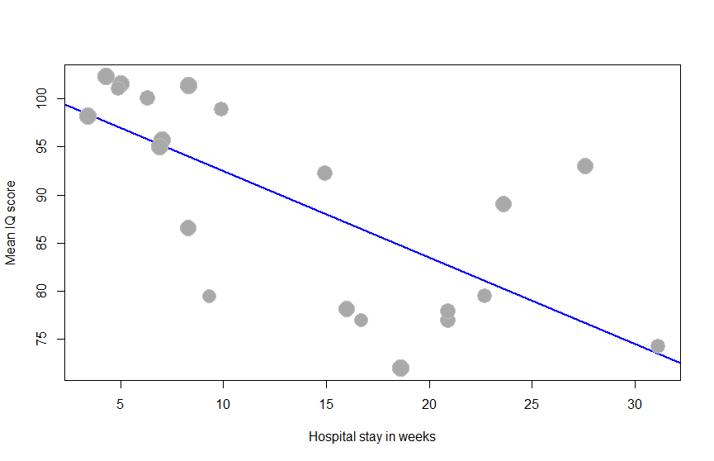
Figure S4. Scatterplot of the meta-regression analyzing the association between hospital stay in weeks and mean DQ/IQ. Each plotted dot represents the mean hospital stay in weeks and corresponding mean DQ/IQ of a single study. The decreasing regression line with negative slope indicates that a longer hospital stay in weeks is associated with lower mean DQ/IQ (p = 0.014).
DQ: developmental quotient, IQ: intelligence quotient.

Hospital stay in weeks
Mean DQ/IQ

