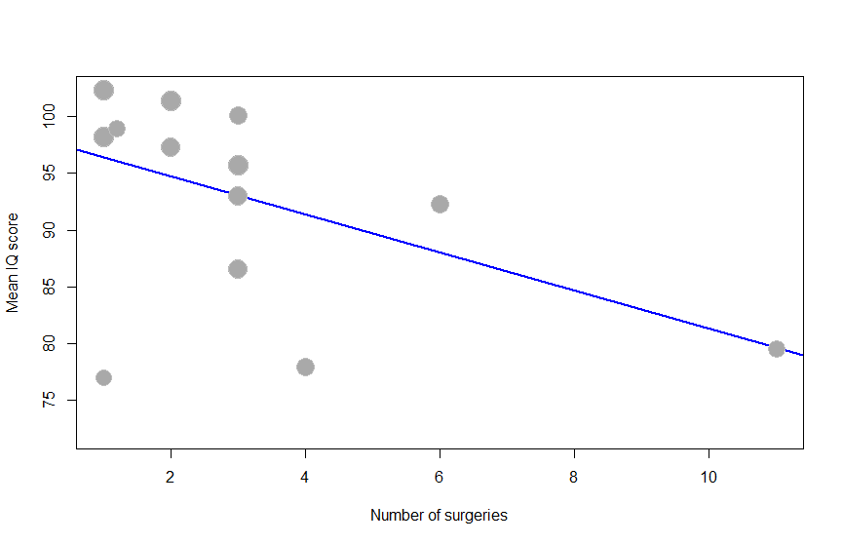
Figure S5. Scatterplot of the meta-regression analyzing the association between number of surgeries and mean DQ/IQ. Each plotted dot represents the number of surgeries and corresponding mean DQ/IQ of a single study. The decreasing regression line with negative slope indicates that a higher number of surgeries is associated with lower mean DQ/IQ (p = 0.033).
DQ: developmental quotient, IQ: intelligence quotient.

Number of surgeries
Mean DQ/IQ

