Supplementary Material

Table of Contents

1 Sample characteristics and references for studies included in analyses
2 Suicide outcome measures and grouping by categories included in analyses
3 Measures of impulsivity reported across articles, number of articles employing each measure, and grouping used in analyses
4 Measures of aggression reported across studies, number of studies employing each measure, and grouping employed in meta-analyses
- Funnel plots
- Figures showing significant moderation

Supplementary Material 1. Sample characteristics and references for studies included in analyses (all studies scored 100% on relevant items on the Joanna Briggs Quality Assessment Tool)

 | n | Region | Design | Sample | Covariates | Suicidality measure* | Impulsivity measure* | Aggression measure*
1 | 120 | Egypt | Cross-sectional | Psychiatric patients hospitalized for suicide attempts |  | Suicide risk (SPS) | BIS-11 total and subscales | SPS hostility subscale
2 | 72 | USA | Comparison of suicide attempters with non-attempters | Military personnel with affective disorders |  | Presence of absence of a suicide attempt (CHSF) | BIS-11 total | BDHI
3 | 2295 | USA | Comparison of suicide attempters with non-attempters | Students |  | Presence of absence of a suicide attempt (SBQR) | UPPS urgency subscales | STAXI- 2 trait anger
4 | 60 | USA | Cross-sectional and comparison of suicide attempters with non-attempters | Psychiatric patients |  | Presence of absence of a suicide attempt (interview/admission report)  Suicide risk (SRS) | ICS | MAI  PFAV
5 | 28 | USA | Cross-sectional | Forensic psychiatric patients |  | Suicide risk (SRS) | ICS | MAI  PFAV
6 | 359 | Spain | Comparison of suicide attempters with non-attempters | Psychiatric and community |  | Presence of absence of a suicide attempt (interview/admission report) | BIS-11 total | BGAI
7 | 1000 | Korea | Cross-sectional | Community | Age and sex | BSIS total | BIS-11 total | STAXI-2 total
8 | 99 | Italy | Cross-sectional | Major affective disorder inpatients |  | CSSR | BIS-11 total | MOAS
9 | 87 | Australia | Comparison of suicide attempters and/or deliberate self harm with non-attempters/without deliberate self harm | Forensic |  | Local risk assessment protocol | BIS-11 total and subscales | STAXI-2 total and subscales
10 | 133 | USA | Comparison of suicide attempters with non-attempters | Veterans with and without traumatic brain injury | Sex, medication, diagnosis, age, education | Presence or absence of suicide attempt (LSASII) | IMT/DMT commission errors  IGT total net score | STAXI-2 state, trait, and expression index
11 | 488 | USA | Comparison of suicide attempters with non-attempters | Affective disorders |  | Presence or absence of suicide attempt (CHSF) | BIS-11 total | LHA
12 | 136 | USA | Comparison of suicide attempters with non-attempters | Psychiatric patients |  | Presence or absence of suicide attempt (CHSF) | BIS-11 total | BGAI
13 | 115 | UK | Comparison of those with and without suicidal ideation | Community sample and patients hospitalized for suicide attempt |  | Presence or absence of suicidal ideation (BDI and EPQ)  Presence or absence of suicide attempt (hospital admission report) | BIS-11 total | BPAQ
14 | 240 | Canada | Comparison of deaths by suicide with living controls | Deaths by suicide and community sample | Marital status, occupational status, psychiatric diagnosis, substance misuse, victim of abuse | Coroner’s report registered death as by suicide, or living control | BIS-11 total (by proxy) | LHA (by proxy)
15 | 78 | USA | Comparison of those with a history of suicidal ideation but not of suicide attempts, suicidal ideation and attempts, and neither | Psychiatric inpatients and community |  | CSSR | BIS-11 total | BPAQ
16 | 40 | USA | Cross-sectional | Suicide attempters with Borderline Personality Disorder |  | Number of suicide attempts (CHSF)  Intent at most recent attempt (BSIS Objective Planning Factor)  Lethality of most recent attempt (LRS) | SIB-Impulsivity Subscale | LHA
17 | 539 | France | Cross-sectional | Patients with a history of suicide attempts amd Attention Deficit Hyperactivity Disorder diagnosis |  | Age at first suicide attempt; lethality of suicide attempts; number of suicide attempts (CHSF) | BDHI
18 | 878 | USA | Comparison of those with and without a history of suicide attempts, and with and without a history of suicidal ideation | Patients with substance misuse disorder |  | Presence or absence of suicide attempt (NCS)  Presence or absence of suicidal ideation (NCS) | IPAS IA | IPAS PA
19 | 202 | USA | Comparison of suicide attempters (multiple attempts) with non-attempters | Patients with Bipolar or Major Depressive Disorder |  | Presence or absence of suicide attempt(s) (CSSR) | BIS (total + 3 subscales) | MAOS (total + 4 subscales)
20 | 40 | Canada | Comparison of suicide attempters with non-attempters | Forensic |  | Presence or absence of suicide attempt (LSARS) | ICS | HDHQ (in, out, and total)
21 | 328 | Canada | Comparison of deaths by suicide with living controls | Patients with Major Depressive Disorder |  | Deaths by suicide or living controls | BIS-11 total | BDHI & LHA
22 | 116 | USA | Comparison of suicide attempters with non-attempters | Psychiatric patients with affective/mood disorders |  | Presence or absence of suicide attempt (CSHF) | BIS-11 total | BGAI
23 | 162 | Canada | Comparison of deaths by suicide with living controls | Deaths by suicide and living controls (both with and without Axis 1 disorders) |  | Deaths by suicide (Coroner’s reports) and living controls | BIS-11 total | BDHI and BGLHA
24 | 76 | Spain | Comparison of suicide attempters with non-attempters | Outpatients with Borderline Personality Disorder |  | Presence or absence of suicide attempt (clinical interview) | BIS (total + 3 subscales) | BDHI (total + 8 subscales)
25 | 67 | USA | Comparison of suicide attempters with non-attempters | Outpatients and inpatients with Bipolar Depression |  | Presence or absence of suicide attempt, and lethality of most serious attempt (CHSF) | BIS-11 total  IGT total | BPAQ
26 | 97 | Israel | Cross-sectional | Patients admitted to psychiatric hospital 2-5 years ago |  | Number and medical severity of follow up suicide attempt (medical records) | ICS | STAXI (5 subscales)  PFAV
27 | 196 | Israel | Cross-sectional | Suicide attempters |  | LRS  BSIS (Objective Planning subscale) | ICS | STAXI-2 anger expression in and out  PFAV
28 | 36309 | USA | Cross-sectional | Community |  | Number of suicide attempts (interview) | DSM-V BPD impulse control criteria | DSM-V BPD intense anger criteria
29 | 47 | USA | Comparison of suicide attempters with non-attempters | Veterans with traumatic brain injury |  | Presence or absence of suicide attempt (CHSF) | IGT total net score  IMT/DMT commission errors | LHA
30 | 92 | Israel | Cross-sectional | Psychiatric patients with and without suicidal ideation, and healthy controls |  | Suicide risk (SRS) | ICS | MAI
31 | 69790 | China | Cross-sectional | Students |  | Suicidal ideation (SSI) | BIS-11 total | BPAQ
32 | 594 | China | Comparison of suicide attempters with non-attempters | Medically serious suicide attempters and matched healthy controls |  | Presence or absence of suicide attempt (medical records and clinical interview) | BIS-11 total | BPAQ
33 | 127 | USA | Cross-sectional | Students |  | Suicidality index based on local interview (from ideation, to medically serious suicide attempts) | Factor analysis of various measures of impulsivity | BPAQ (4 subscales)
34 | 188 | USA | Comparison of suicide attempters with non-attempters | Patients with affective/mood disorders |  | Presence or absence of suicide attempt | BIS-11 total | BDHI  BGLHA
35 | 140 | USA | Cross-sectional | Patients with Borderline Personality Disorder |  | Suicidal behaviour (DSM-3 Borderline Personality Disorder) diagnostic criteria) | Impulsive aggression factor
36 | 94 | Israel | Cross-sectional | Military |  | Suicide risk (PVFB) | ICS | MAI
37 | 88 | USA | Cross-sectional | Psychiatric patients |  | Suicide risk (SRS) | ICS | MAI
38 | 50 | Israel | Cross-sectional | Patients with affective/mood disorders or Post Traumatic Stress Disorder, and healthy controls |  | Suicide risk (SRS) | ICS | MAI
39 | 67 | USA | Comparison of suicide attempters with non-attempters | Patients with Bipolar Depression |  | Presence or absence of suicide attempt (CSHF) | BIS-11 total | BDHI
40 | 259 | Canada | Comparison of deaths by suicide with living controls | Patients with affective/mood disorders |  | Death by suicide or living control | BIS-11 total | BDHI  BGLHA
41 | 693 | France | Cross-sectional | Suicide attempers admitted to hospital |  | Number of suicide attempts and age at first attempt (CSHF) | BIS-11 total | BDHI
42 | 208 | Italy | Cross-sectional | Patients with and without chronic pain |  | Suicidal ideation (HDRS) | BIS-11 total | OAS (total + 4 subscales)
43 | 441 and 69 | USA | Cross-sectional | Military (Study 1) and community (Study 2) |  | Suicidal ideation (BSIS) | UPPS-negative urgency | BDHI
44 | 81 | Canada | Comparison of deaths by suicide with living controls | Patients with Schizophrenia |  | Deaths by suicide or living controls | BIS-11 total | BDHI and BGLHA
45 | 120 | Canada | Comparison of deaths by suicide with living controls | Patients with Borderline Personality Disorder |  | Deaths by suicide or living controls | BIS-11 total | BDHI and BGLHA
46 | 52 | USA | Comparison of suicide attempters with non-attempters, and of those with single with multiple suicide attempts | Patients with affective/mood disorders |  | Presence or absence of suicide attempt; single or multiple suicide attempts (SAD) | BIS-11 (total and all sub-scales) | BDHI (total and all subscales)
47 | 81 | Africa | Cross-sectional | Patients with Obsessive Compulsive Disorder |  | Suicidal ideation (SSI) | BIS-11 | SPS
48 | 314 | USA | Comparison of suicide attempters with non-attempters | Patients with affective/mood disorders |  | Presence or absence of suicide attempt (CSHF) | BIS-11 total | BDHI  BGLHA
49 | 44 | USA | Comparison of suicide attempters with non-attempters | Patients with affective/mood disorders |  | Presence or absence of suicide attempt (CSHF) | BIS-11 total | BDHI  BGLHA  (
50 | 46 | Sweden | Comparison of suicide attempters with non-attempters | Patients with Seasonal Affective Disorder and non-seasonal Major Depressive Disorder |  | Presence or absence of suicide attempt (admission report) | KSP impulsivity | KSP aggression and subscales
51 | 1922 | France and Switzerland | Comparison of suicide attempters with non-attempters | Psychiatric patients and community non-suicide attempters |  | Number of suicide attempts, age at first suicide attempt, severity, and violence of most serious suicide attempt (self report) | BIS-11 total | STAXI-2 (5 subscales)  LHA
52 | 28 | USA | Comparison of suicide attempters with non-attempters | Patients with Bipolar Depression and community sample of healthy controls |  | Presence or absence of suicide attempt (CSHF) | UPPS-P (total + 5 subscales) | IPAS (2 subscales)
53 | 1000 | Canada | Cross-sectional | Community |  | Suicidal ideation in past month (self report) | MDRS – risk taking subscale | MDRS – anger and aggression subscale
54 | 1000 | Canada | Cross-sectional | Community |  | Presence or absence of suicide attempt in past month (self report) | MDRS – risk taking subscale | MDRS – anger and aggression subscale
55 | 59 | UK | Comparison of suicide attempters with non-attempters | Forensic |  | Presence or absence of near lethal suicide attempt (medical records and self report) | ICS | LHA  BDHI
56 | 320 | USA | Cross-sectional | Psychiatric patients |  | Suicidal ideation (SSI), number of suicide attempts and lethality of most recent and most serious attempt (CHSF) | BIS-11 | BDHI  BGLHA
57 | 229 | USA | Cross-sectional | Psychology outpatients |  | Suicidal intent (BSIS total)  Number of suicide attempts | PID-5 impulsivity | PID-5 hostility
58 | 194 | Australia | Comparison of deaths by suicide with case controls (sudden death by other causes) | Sudden deaths |  | Cause of death (suicide or sudden death by other cause, from Coroner’s reports) | BIS-11 total (by proxy) | OAS (by proxy)
59 | 246 | USA | Comparison of suicide attempters with non-attempters | Patients with substance misuse disorders |  | Presence or absence of suicide attempt (clinical interview) | BIS-7B subscales | HDHQ
60 | 1537 | Italy | Comparison of suicide attempters with non-attempters | Forensic |  | Presence or absence of suicide attempt  Lifetime number of suicide attempts (clinical interview) | BIS-10 | LHA  BDHI (total + 8 subscales)  STAXI-2 (5 subscales)
61 | 435 | USA | Comparison of suicide attempters with non-attempters | Patients with Borderline Personality Disorder and healthy controls |  | Presence or absence of suicide attempt (self report) | BIS-11 total | LHA
62 | 683 | USA | Comparison of suicide attempters (with a history of single versus multiple attempts) with non-attempters | Patients with Depression |  | Presence or absence of suicide attempt (CSHF) | BIS-11 total | BDHI  BGLAI
63 | 177 | India | Comparison of suicide attempters with non-attempters | Community |  | Presence or absence of suicide attempt (CSSR) | BIS-11 total | MOAS
64 | 84 | USA | Comparison of suicide attempters with non-attempters | Patients with Borderline Personality Disorder |  | Presence or absence of suicide attempt (SAD) | BIS-10 | BDHI
65 | 113 | USA | Comparison of participants with and high or low lethality suicide attempts | Patients with Borderline Personality Disorder |  | High or low lethality suicide attempt (MLS) | BIS-11 total | BDHI  BGLHA
66 | 123 | USA | Comparison of suicide attempters with non-attempters in last 8 years | Patients with Borderline Personality Disorder |  | Presence or absence of suicide attempt (MHCRCSB) | BIS-11 total | LHA  BDHI
67 | 84 | USA | Comparison of suicide attempters with non-attempters | Patients with Borderline Personality Disorder |  | Presence or absence of suicide attempt (SADS) | BIS-10 total | BDHI
68 | 72 | USA | Comparison of suicide attempters with non-attempters | Patients with mood/affective disorders |  | Presence or absence of suicide attempt (CSHF) | BIS-11 total | LHA
69 | 96 | USA | Comparison of suicide attempters with non-attempters | Forensic |  | Presence or absence of suicide attempt (NCS SA item) | IPAS-IA | IPAS-PA
70 | 108 | Japan | Comparison of suicide attempters with non-attempters | Patients with Major Depressive Disorder and healthy controls |  | Presence or absence of suicide attempt (self report and medical records) | BIS-11 total | BPAQ
71 | 130 | India | Cross-sectional | Patients with Bipolar Depression | Groups matched for:  age, gender, socioecon-omic status, and duration of  illness | Suicidal ideation (BDI item 9) | BIS-11 total | BDHI (total + 8 subscales)
72 | 159 | USA | Comparison of healthy controls, and depressed patients who were non-suicidal, had suicidal ideation, a history of suicide attempts, and a history of high lethality suicide attempts lethality | Patients with Depression and healthy controls |  | Participants with and without suicidal ideation (BSIS) and healthy controls; | BIS-11 total | ARS
73 | 5233 | China | Comparison of suicide attempters/ideators with non-attempters/ideators | Students |  | Presence or absence of suicide attempt/ideation (PHQ-9) | BIS-11 (3 subscales) | BPAQ (5 subscales)
74 | 58 | Germany | Comparison of suicide ideators with non-ideators | Psychiatric patients and healthy controls |  | Presence or absence of suicidal ideation (BSIS) | BIS-11 (total and subscales)  GNG commission errors  IGT commission errors | FAF and subscales
75 | 1061 | USA | Comparison of suicide attempters with non-attempters | Military |  | Presence or absence of suicide attempt (interview) | MMPI | CMHS
76 | 179 | USA | Cross-sectional | Patients with Borderline Personality Disorder |  | Number of suicide attempts (LSASII) | ZAN-BPD | STAXI-2 anger out subscale
77 | 243 | Taiwan | Comparison of suicide attempters with non-attempters, and single with multiple attempts | Suicide attempters admitted to hospital and case control non-attempters from psychiatric clinics |  | Presence or absence of suicide attempt (single and multiple) assessed as part of development of an assessment for risk of repeated suicide attempts (the Assessment for Repeated Suicide) | IRS | BPAQ
Degrees of freedom used to calculate individual effect sizes may differ from that of the total sample;
*For abbreviations, please see Supplementary 2-4

References

- Abdeen MS, Shaker NM, Elrassas HH, Hashim MA, Abo Zeid MY. Characteristics of the schizophrenia suicide attempts in comparison with the suicide attempts with other diagnosed psychiatric disorders: An Egyptian study. International Journal of Social Psychiatry. 2019 Aug;65(5):368–77.
- Alter S, Wilson C, Sun S, Harris RE, Wang Z, Vitale A, Hazlett EA, Goodman M, Ge Y, Yehuda R, Galfalvy H. The association of childhood trauma with sleep disturbances and risk of suicide in US veterans. Journal of Psychiatric Research. 2021 Apr 1;136:54–62.
- Ammerman BA, Kleiman EM, Uyeji LL, Knorr AC, McCloskey MS. Suicidal and violent behavior: The role of anger, emotion dysregulation, and impulsivity. Personality and Individual Differences. 2015 Jun 1;79:57–62.
- Apter A, Van Praag HM, Plutchik R, Sevy S, Korn M, Brown SL. Interrelationships among anxiety, aggression, impulsivity, and mood: a serotonergically linked cluster?. Psychiatry Research. 1990 May 1;32(2):191–9.
- Apter A, Kotler M, Sevy S, Plutchik R, Brown SL, Foster H, Hillbrand M, Korn ML, Van Praag HM. Correlates of risk of suicide in violent and nonviolent psychiatric patients. The American Journal of Psychiatry. 1991 Jul.
- Baca-Garcia E, Vaquero C, Diaz-Sastre C, Garcı́a-Resa E, Saiz-Ruiz J, Fernández-Piqueras J, De Leon J. Lack of association between the serotonin transporter promoter gene polymorphism and impulsivity or aggressive behavior among suicide attempters and healthy volunteers. Psychiatry Research. 2004 Apr 30;126(2):99–106.
- Bae SM, Lee YJ, Cho IH, Kim SJ, Im JS, Cho SJ. Risk factors for suicidal ideation of the general population. Journal of Korean medical science. 2013 Apr 1;28(4):602–7.
- Bartoli F, Crocamo C, Bava M, Castagna G, Di Brita C, Riboldi I, Trotta G, Verrengia E, Clerici M, Carrà G. Testing the association of serum uric acid levels with behavioral and clinical characteristics in subjects with major affective disorders: a cross-sectional study. Psychiatry research. 2018 Nov 1;269:118–23.
- Barton JJ. Characteristics of inmates with a history of suicide attempts and/or deliberate self harm (Doctoral dissertation, University of Western Sydney (Australia)).
- Brenner LA, Bahraini N, Homaifar BY, Monteith LL, Nagamoto H, Dorsey-Holliman B, Forster JE. Executive functioning and suicidal behavior among veterans with and without a history of traumatic brain injury. Archives of physical medicine and rehabilitation. 2015 Aug 1;96(8):1411–8.
- Brent DA, Melhem NM, Oquendo M, Burke A, Birmaher B, Stanley B, Biernesser C, Keilp J, Kolko D, Ellis S, Porta G. Familial pathways to early-onset suicide attempt: a 5.6-year prospective study. JAMA psychiatry. 2015 Feb 1;72(2):160–8.
- Brodsky BS, Oquendo M, Ellis SP, Haas GL, Malone KM, Mann JJ. The relationship of childhood abuse to impulsivity and suicidal behavior in adults with major depression. American Journal of Psychiatry. 2001 Nov 1;158(11):1871–7.
- Cameron S, Brown VJ, Dritschel B, Power K, Cook M. Understanding the relationship between suicidality, current depressed mood, personality, and cognitive factors. Psychology and Psychotherapy: Theory, Research and Practice. 2017 Dec;90(4):530–49.
- Chachamovich E, Kirmayer LJ, Haggarty JM, Cargo M, McCormick R, Turecki G. Suicide among Inuit: results from a large, epidemiologically representative follow-back study in Nunavut. The Canadian Journal of Psychiatry. 2015 Jun;60(6):268–75.
- Chang HB, Munroe S, Gray K, Porta G, Douaihy A, Marsland A, Brent D, Melhem NM. The role of substance use, smoking, and inflammation in risk for suicidal behavior. Journal of affective disorders. 2019 Jan 15;243:33–41.
- Chesin MS, Jeglic EL, Stanley B. Pathways to high-lethality suicide attempts in individuals with borderline personality disorder. Archives of Suicide Research. 2010 Nov 9;14(4):342–62.
- Conejero I, Jaussent I, Lopez R, Guillaume S, Olié E, Hebbache C, Cohen RF, Kahn JP, Leboyer M, Courtet P, Lopez-Castroman J. Association of symptoms of attention deficit-hyperactivity disorder and impulsive-aggression with severity of suicidal behavior in adult attempters. Scientific reports. 2019 Mar 14;9(1):1–8.
- Conner KR, Swogger MT, Houston RJ. A test of the reactive aggression-suicidal behavior hypothesis: is there a case for proactive aggression?. Journal of abnormal psychology. 2009 Feb;118(1):235.
- Coryell W, Wilcox H, Evans SJ, Pandey GN, Jones-Brando L, Dickerson F, Yolken R. Aggression, impulsivity and inflammatory markers as risk factors for suicidal behavior. Journal of psychiatric research. 2018 Nov 1;106:38–42.
- Daigle MS, Côté G. Nonfatal suicide-related behavior among inmates: Testing for gender and type differences. Suicide and Life-Threatening Behavior. 2006 Dec;36(6):670–81.
- Dalca IM, McGirr A, Renaud J, Turecki G. Gender-specific suicide risk factors: a case-control study of individuals with major depressive disorder. The Journal of clinical psychiatry. 2013 Dec 15;74(12):0–1
- Dervic K, Grunebaum MF, Burke AK, Mann JJ, Oquendo MA. Protective factors against suicidal behavior in depressed adults reporting childhood abuse. The Journal of nervous and mental disease. 2006 Dec 1;194(12):971–4.
- Ernst C, Lalovic A, Lesage A, Seguin M, Tousignant M, Turecki G. Suicide and no axis I pathology. Revista de Psiquiatria do Rio Grande do Sul. 2004;26:268–73.
- Ferraz L, Portella MJ, Vállez M, Gutiérrez F, Martín-Blanco A, Martín-Santos R, Subirà S. Hostility and childhood sexual abuse as predictors of suicidal behaviour in Borderline Personality Disorder. Psychiatry research. 2013 Dec 30;210(3):980–5.
- Gilbert AM, Garno JL, Braga RJ, Shaya Y, Goldberg TE, Malhotra AK, Burdick KE. Clinical and cognitive correlates of suicide attempts in bipolar disorder: is suicide predictable?. The Journal of clinical psychiatry. 2011 Jul 12;72(8):0–1.
- Gvion Y. Aggression, impulsivity, and their predictive value on medical lethality of suicide attempts: a follow-up study on hospitalized patients. Journal of affective disorders. 2018 Feb 1;227:840–6.
- Gvion Y, Horresh N, Levi-Belz Y, Fischel T, Treves I, Weiser M, David HS, Stein-Reizer O, Apter A. Aggression–impulsivity, mental pain, and communication difficulties in medically serious and medically non-serious suicide attempters. Comprehensive psychiatry. 2014 Jan 1;55(1):40–50.
- Harford TC, Chen CM, Kerridge BT, Grant BF. Borderline personality disorder and violence toward self and others: A national study. Journal of personality disorders. 2019 Oct;33(5):653–70.
- Homaifar BY, Brenner LA, Forster JE, Nagamoto H. Traumatic brain injury, executive functioning, and suicidal behavior: A brief report. Rehabilitation Psychology. 2012 Nov;57(4):337.
- Horesh N, Rolnick T, Iancu I, Dannon P, Lepkifker E, Apter A, Kotler M. Anger, impulsivity and suicide risk. Psychotherapy and psychosomatics. 1997;66(2):92–6.
- Huang Y, Kuang L, Wang W, Cao J, Xu L. Association between personality traits and risk of suicidal ideation in Chinese university students: Analysis of the correlation among five personalities. Psychiatry research. 2019 Feb 1;272:93–9.
- Jiang C, Li X, Phillips MR, Xu Y. Matched case-control study of medically serious attempted suicides in rural China. Shanghai archives of psychiatry. 2013 Feb;25(1):22.
- Johnson SL, Carver CS, Joormann J. Impulsive responses to emotion as a transdiagnostic vulnerability to internalizing and externalizing symptoms. Journal of Affective Disorders. 2013 Sep 25;150(3):872–8.
- Keilp JG, Gorlyn M, Oquendo MA, Brodsky B, Ellis SP, Stanley B, Mann JJ. Aggressiveness, not impulsiveness or hostility, distinguishes suicide attempters with major depression. Psychological medicine. 2006 Dec;36(12):1779–-88.
- Koenigsberg HW, Harvey PD, Mitropoulou V, New AS, Goodman M, Silverman J, Serby M, Schopick F, Siever LJ. Are the interpersonal and identity disturbances in the borderline personality disorder criteria linked to the traits of affective instability and impulsivity?. Journal of personality disorders. 2001 Aug 1;15(4):358–70.
- Koslowsky M, Bleich A, Apter A, Solomon Z, Wagner B, Greenspoon A. Structural equation modelling of some of the determinants of suicide risk. British journal of medical psychology. 1992 Jun;65(2):157–65.
- Kotler M, Finkelstein G, Molcho A, Botsis AJ, Plutchik R, Brown SL, van Praag HM. Correlates of suicide and violence risk in an inpatient population: coping styles and social support. Psychiatry research. 1993 Jun 1;47(3):281–90.
- Kotler M, Iancu I, Efroni R, Amir M. Anger, impulsivity, social support, and suicide risk in patients with posttraumatic stress disorder. The Journal of nervous and mental disease. 2001 Mar 1;189(3):162–7.
- Lijffijt M, Rourke ED, Swann AC, Zunta‐Soares GB, Soares JC. Illness‐course modulates suicidality‐related prefrontal gray matter reduction in women with bipolar disorder. Acta psychiatrica scandinavica. 2014 Nov;130(5):374–87.
- de Lara CL, Brezo J, Rouleau G, Lesage A, Dumont M, Alda M, Benkelfat C, Turecki G. Effect of tryptophan hydroxylase-2 gene variants on suicide risk in major depression. Biological psychiatry. 2007 Jul 1;62(1):72–80.
- Lopez-Castroman J, Jaussent I, Beziat S, Guillaume S, Baca-Garcia E, Genty C, Olié E, Courtet P. Increased severity of suicidal behavior in impulsive aggressive patients exposed to familial adversities. Psychological medicine. 2014 Oct;44(14):3059–68.
- Margari F, Lorusso M, Matera E, Pastore A, Zagaria G, Bruno F, Puntillo F, Margari L. Aggression, impulsivity, and suicide risk in benign chronic pain patients–a cross-sectional study. Neuropsychiatric disease and treatment. 2014;10:1613.
- Martin RL, Bauer BW, Smith NS, Daruwala SE, Green BA, Anestis MD, Capron DW. Internal battles: examining how anger/hostility moderate the association between negative urgency and suicidal desire variables in military and civilian samples. Suicide and Life‐Threatening Behavior. 2020 Aug;50(4):805–22.
- McGirr A, Tousignant M, Routhier D, Pouliot L, Chawky N, Margolese HC, Turecki G. Risk factors for completed suicide in schizophrenia and other chronic psychotic disorders: A case–control study. Schizophrenia Research. 2006 May 1;84(1):132–43
- McGirr A, Paris J, Lesage A, Renaud J, Turecki G. Risk factors for suicide completion in borderline personality disorder: a case-control study of cluster B comorbidity and impulsive aggression. Journal of Clinical Psychiatry. 2007 May 15;68(5):721.
- Michaelis BH, Goldberg JF, Davis GP, Singer TM, Garno JL, Wenze SJ. Dimensions of impulsivity and aggression associated with suicide attempts among bipolar patients: a preliminary study. Suicide and Life-Threatening Behavior. 2004 Jun 1;34(2):172–6.
- Nagy NE, El-Serafi DM, Elrassas HH, Abdeen MS, Mohamed DA. Impulsivity, hostility and suicidality in patients diagnosed with obsessive compulsive disorder. International journal of psychiatry in clinical practice. 2020 Sep 1;24(3):284–92.
- Oquendo MA, Bongiovi-Garcia ME, Galfalvy H, Goldberg PH, Grunebaum MF, Burke AK, Mann JJ. Sex differences in clinical predictors of suicidal acts after major depression: a prospective study. American Journal of Psychiatry. 2007 Jan;164(1):134–41.
- Oquendo MA, Waternaux C, Brodsky B, Parsons B, Haas GL, Malone KM, Mann JJ. Suicidal behavior in bipolar mood disorder: clinical characteristics of attempters and nonattempters. Journal of affective disorders. 2000 Aug 1;59(2):107–17.
- Pendse B, Westrin Å, Engström G. Temperament traits in seasonal affective disorder, suicide attempters with non-seasonal major depression and healthy controls. Journal of affective disorders. 1999 Jul 1;54(1-2):55–65.
- Perroud N, Baud P, Ardu S, Krejci I, Mouthon D, Vessaz M, Guillaume S, Jaussent I, Olié E, Malafosse A, Courtet P. Temperament personality profiles in suicidal behaviour: an investigation of associated demographic, clinical and genetic factors. Journal of affective disorders. 2013 Apr 5;146(2):246–53.
- Popovic D, Vieta E, Azorin JM, Angst J, Bowden CL, Mosolov S, Young AH, Perugi G, BRIDGE‐II‐Mix Study Group. Suicide attempts in major depressive episode: evidence from the BRIDGE‐II‐Mix study. Bipolar disorders. 2015 Nov;17(7):795–803.
- Reich R, Gilbert A, Clari R, Burdick KE, Szeszko PR. A preliminary investigation of impulsivity, aggression and white matter in patients with bipolar disorder and a suicide attempt history. Journal of affective disorders. 2019 Mar 15;247:88–96.
- Rice SM, Kealy D, Oliffe JL, Ogrodniczuk JS. Externalizing depression symptoms among Canadian males with recent suicidal ideation: A focus on young men. Early intervention in psychiatry. 2019 Apr;13(2):308–13.
- Rice SM, Oliffe JL, Kealy D, Ogrodniczuk JS. Male depression subtypes and suicidality: Latent profile analysis of internalizing and externalizing symptoms in a representative Canadian sample. The Journal of nervous and mental disease. 2018 Mar 1;206(3):169–72.
- Rivlin A, Hawton K, Marzano L, Fazel S. Psychosocial characteristics and social networks of suicidal prisoners: towards a model of suicidal behaviour in detention. PloS one. 2013 Jul 29;8(7):e68944.
- Rizk MM, Galfalvy H, Miller JM, Milak M, Parsey R, Grunebaum M, Burke A, Sublette ME, Oquendo MA, Stanley B, Mann JJ. Characteristics of depressed suicide attempters with remitted substance use disorders. Journal of psychiatric research. 2021 May 1;137:572–8.
- Rogers ML, Joiner Jr TE. Borderline personality disorder diagnostic criteria as risk factors for suicidal behavior through the lens of the interpersonal theory of suicide. Archives of Suicide Research. 2016 Oct 1;20(4):591–604.
- Ross V, Kõlves K, De Leo D. Beyond psychopathology: A case–control psychological autopsy study of young adult males. International journal of social psychiatry. 2017 Mar;63(2):151–60.
- Roy A. Characteristics of opiate dependent patients who attempt suicide. Journal of Clinical Psychiatry. 2002 May 12;63(5):403–7.
- Roy A, Carli V, Sarchiapone M, Branchey M. Comparisons of prisoners who make or do not make suicide attempts and further who make one or multiple attempts. Archives of suicide research. 2014 Jan 1;18(1):28–38.
- Sher L, Fisher AM, Kelliher CH, Penner JD, Goodman M, Koenigsberg HW, New AS, Siever LJ, Hazlett EA. Clinical features and psychiatric comorbidities of borderline personality disorder patients with versus without a history of suicide attempt. Psychiatry research. 2016 Dec 30;246:261–6.
- Sher L, Grunebaum MF, Burke AK, Chaudhury S, Mann JJ, Oquendo MA. Depressed multiple-suicide attempters–a high-risk phenotype. Crisis. 2017 Sep 15.
- Singh PK, Rao VR. Explaining suicide attempt with personality traits of aggression and impulsivity in a high risk tribal population of India. PloS one. 2018 Feb 15;13(2):e0192969.
- Soloff PH, Chiappetta L. Suicidal behavior and psychosocial outcome in borderline personality disorder at 8-year follow-up. Journal of personality disorders. 2017 Dec;31(6):774–89.
- Soloff PH, Fabio A, Kelly TM, Malone KM, Mann JJ. High-lethality status in patients with borderline personality disorder. Journal of personality disorders. 2005 Aug 1;19(4):386–99.
- Soloff PH, Lis JA, Kelly T, Cornelius JR, Ulrich R. Risk factors for suicidal behavior in borderline personality disorder. The American Journal of Psychiatry. 1994 Sep.
- Stanley B, Michel CA, Galfalvy HC, Keilp JG, Rizk MM, Richardson-Vejlgaard R, Oquendo MA, Mann JJ. Suicidal subtypes, stress responsivity and impulsive aggression. Psychiatry research. 2019 Oct 1;280:112486.
- Swogger MT, Walsh Z, Maisto SA, Conner KR. Reactive and proactive aggression and suicide attempts among criminal offenders. Criminal justice and behavior. 2014 Mar;41(3):337–44.
- Tsujii N, Mikawa W, Tsujimoto E, Adachi T, Niwa A, Ono H, Shirakawa O. Reduced left precentral regional responses in patients with major depressive disorder and history of suicide attempts. PloS one. 2017 Apr 5;12(4):e0175249.
- Umamaheswari V, Avasthi A, Grover S. Risk factors for suicidal ideations in patients with bipolar disorder. Bipolar disorders. 2014 Sep;16(6):642–51.
- Vanyukov PM, Szanto K, Hallquist M, Moitra M, Dombrovski AY. Perceived burdensomeness is associated with low‐lethality suicide attempts, dysfunctional interpersonal style, and younger rather than older age. International journal of geriatric psychiatry. 2017 Jul;32(7):788–97.
- Wang L, He CZ, Yu YM, Qiu XH, Yang XX, Qiao ZX, Sui H, Zhu XZ, Yang YJ. Associations between impulsivity, aggression, and suicide in Chinese college students. BMC public health. 2014 Dec;14(1):1–8.
- Westheide J, Quednow BB, Kuhn KU, Hoppe C, Cooper-Mahkorn D, Hawellek B, Eichler P, Maier W, Wagner M. Executive performance of depressed suicide attempters: the role of suicidal ideation. European archives of psychiatry and clinical neuroscience. 2008 Oct;258(7):414–21.
- Windle M. Characteristics of alcoholics who attempted suicide: co-occurring disorders and personality differences with a sample of male Vietnam era veterans. Journal of studies on alcohol. 1994 Sep;55(5):571–7.
- Wnuk S, McMain S, Links PS, Habinski L, Murray J, Guimond T. Factors related to dropout from treatment in two outpatient treatments for borderline personality disorder. Journal of personality disorders. 2013 Dec;27(6):716–26.
- Yeh AW, Hung CF, Lee Y, Lin PY, Chiu NM, Huang TY, Hsu ST, Lee CY, Chen CC, Lin HC, Chong MY. Development and validation of the Assessment for Repeated Suicide. Asia‐Pacific Psychiatry. 2012 Mar;4(1):20–9.

Supplementary Material 2. Suicide outcome measures and grouping by categories included in analyses

Suicide outcome measure | Measures | N
History of suicide attempt | Hospital admission records, local file review, or self-report  Assessment for Repeated Suicide¹  Columbia History of Suicide Form²  Columbia Suicide Severity Rating Scale³  Lethality of Suicide Attempt Rating Scale⁴  Lifetime Suicide Attempt Self-Injury Interview⁵  The National Comorbidity Survey⁶  Paykel Suicide Items⁷  Schedule for Affective Disorders⁸ | 41
Suicidal ideation | Beck Depression Inventory⁹  Beck Suicide Intent Scale¹⁰  Columbia Suicide Severity Rating Scale³  The Eysenck Personality Questionnaire¹¹  The Hamilton Depression Rating Scale¹²  The National Comorbidity Survey⁵  Local risk assessment, file review, or self-report  Patient Health Questionnaire-9¹³  Scale of Suicidal Ideation¹⁴ | 9
Number of suicide attempts | Beck Suicide Intent Scale¹⁰  Columbia History of Suicide Form²  Lifetime Suicide Attempt Self-Injury Interview⁵  Local risk assessment, file review, or self-report  Paykel Suicide Items⁷  Suicide Behavior Questionnaire-Revised¹⁵ | 14
Cause of death | Cause of death (suicide compared to living controls or sudden deaths by other cause) from Coroner’s reports | 7
Lethality of suicide attempt | Columbia History of Suicide Form²  The Lethality Scale¹⁰  Lethality of Suicide Attempt Rating Scale⁴  Local risk assessment, file review, or (clinical) interview/questionnaire | 8
Suicidal intent | Beck Suicide Intent Scale¹⁰ | 1
Age at first suicide attempt | Columbia History of Suicide Form²  Local risk assessment, file review, or self-report | 3
Suicide risk | Suicide Probability Scale¹⁶  Suicide Risk Scale¹⁷ | 6

- Yeh AW, Hung CF, Lee Y, Lin PY, Chiu NM, Huang TY, Hsu ST, Lee CY, Chen CC, Lin HC, Chong MY. Development and validation of the Assessment for Repeated Suicide. Asia‐Pacific Psychiatry. 2012 Mar;4(1):20–9.
- Mann JJ, McBride PA, Brown RP, Linnoilam M, Leon AC, DeMeo M, Mieczkowski T, Myers JE, Stanley M. Relationship between central and peripheral serotonin indexes in depressed and suicidal psychiatric inpatients. Archives of general psychiatry. 1992 Jun 1;49(6):442–6.
- Posner K, Brown GK, Stanley B, Brent DA, Yershova KV, Oquendo MA, Currier GW, Melvin GA, Greenhill L, Shen S, Mann JJ. The Columbia–Suicide Severity Rating Scale: initial validity and internal consistency findings from three multisite studies with adolescents and adults. American journal of psychiatry. 2011 Dec;168(12):1266–77.
- Smith K, Conroy RW, Ehler BD. Lethality of suicide attempt rating scale. Suicide and Life‐Threatening Behavior. 1984 Dec;14(4):215–42.
- Linehan MM, Comtois KA, Brown MZ, Heard HL, Wagner A. Suicide Attempt Self-Injury Interview (SASII): development, reliability, and validity of a scale to assess suicide attempts and intentional self-injury. Psychological assessment. 2006 Sep;18(3):303.
- Kessler RC, Borges G, Walters EE. Prevalence of and risk factors for lifetime suicide attempts in the National Comorbidity Survey. Archives of general psychiatry. 1999 Jul 1;56(7):617–6.
- Paykel ES, Klerman GL, Prusoff BA. Prognosis of depression and the endogenous-neurotic distinction. Psychological Medicine. 1974 Feb;4(1):57–64.
- Endicott, J., & Spitzer, R. L. (1978). A diagnostic interview: the schedule for affective disorders and schizophrenia. Archives of General Psychiatry, 35(7), 837–844.
- Beck AT, Steer RA, Ball R, Ranieri WF. Comparison of Beck Depression Inventories-IA and-II in psychiatric outpatients. Journal of personality assessment. 1996 Dec 1;67(3):588–97.
- Beck AT, Beck R, Kovacs M. Classification of suicidal behaviors: I. Quantifying intent and medical lethality. The American journal of psychiatry. 1975 Mar.
- Eysenck, H. J., & Eysenck, S. B. G. (1984). Eysenck personality questionnaire-revised.
- Hamilton MA. Development of a rating scale for primary depressive illness. British journal of social and clinical psychology. 1967 Dec;6(4):278–96.
- Kroenke K, Spitzer RL. The PHQ-9: a new depression diagnostic and severity measure.
- Gosling SD, Augustine AA, Vazire S, Holtzman N, Gaddis S. Manifestations of personality in online social networks: Self-reported Facebook-related behaviors and observable profile information. Cyberpsychology, Behavior, and Social Networking. 2011 Sep 1;14(9):483–8.
- Osman A, Bagge CL, Gutierrez PM, Konick LC, Kopper BA, Barrios FX. The Suicidal Behaviors Questionnaire-Revised (SBQ-R): validation with clinical and nonclinical samples. Assessment. 2001 Dec;8(4):443–54.
- Cull JG, Gill WS. Suicide Probability Scale:(SPS). California: Western Psychological Services; 2000.
- Plutchik R, Van Praag HM, Conte HR, Picard S. Correlates of suicide and violence risk 1: the suicide risk measure. Comprehensive Psychiatry. 1989 Jul 1;30(4):296–302

Supplementary Material 3. Measures of impulsivity reported across articles, number of articles employing each measure, and grouping used in analyses

Measure | Description | State or trait | Cognitive, behavioral or both | n
The Barratt Impulsiveness Scale 11 (BIS -11)¹  The Barratt Impulsiveness Scale 7B (BIS-7B)²  The Barratt Impulsiveness Scale 10 (BIS-10)³ | BIS 11: Assessment of trait impulsivity with 3 subscales:  - Attentional (BIS-11)/cognitive (BIS-7B,10) impulsivity (lack of focus on a task)  - Motor impulsivity (acting without thinking)  - Nonplanning impulsivity (orientation to present rather than future)  In addition, 7B assesses:  - Sensory stimulation  - Interpersonal impulsivity  - Risk taking | Trait | Total score/sensory/interpersonal: both  Attentional/cognitive subscales: cognitive  Motor subscale: behavioral  Nonplanning subscale: cognitive  Risk taking subscale: behavioral | 49
The DSM-V diagnostic criteria for Borderline Personality Disorder⁴ | Impulsivity must be reported in at least two areas from spending, sex, substance abuse, reckless driving, binge eating (not including self harm) | Trait | Both | 1
Go/No Go task⁵ | Participants are required to respond to some stimuli not others. Number of commission errors (making a response on trials that do not require a response), is treated as a proxy of prepotent response inhibition | State | Behavioral | 1
The Impulse Control Scale^{6,7} | Measures engagement in behaviours which indicate a loss of control | Trait | Behavioral | 9
The Iowa Gambling Task⁸ | A task in which participants are asked to pick a series of 100 cards from 4 decks  Participants start with a nominal ‘loan’ of $2000, with each card either adding or subtracting from the loan  Decks A and B are disadvantageous (provide small immediate rewards, but larger losses over time) in comparison to decks C and D which produce smaller immediate gains, and smaller losses and, ultimately, greater profit over time  Total net $ at the end of the task provides a measure of planning, with lower amounts corresponding to riskier decision making | State | Cognitive | 4
The immediate and delayed memory test⁹ | Performance based assessment of impulsive behavior in which participants are presented with a sequence of numbers and asked to respond when the current number matches the immediately preceding number (IMT) or with matching numbers separated by a filler sequence (DMT)  Included in both are ‘catch sequences’ which are nearly identical to the target sequence  Non-target responding to catch sequences, or ‘commission errors’, is interpreted as evidence of more impulsive responses | State | Behavioral | 2
Impulsivity Rating Scale¹⁰ | Evaluates day to day impulsivity, based on the behavior during the last week | State | Both | 1
Male  Depression Risk Scale¹¹ | Includes a risk-taking subscale | Trait | Both | 2
Minnesota Multiphasic Personality Inventory¹² | Includes a ‘Behavioral Inhibition’ subscale | Trait | Behavioral | 1
Johnston et al., (2013)¹³ | Factor analysis of various measures of impulsivity | Trait | Both | 1
Research-based diagnostic criteria for a  mixed state depression¹⁴ | Contains an item concerning impulsivity | Trait | Both | 1
The Schedule for Interviewing Borderlines¹⁵ | A clinician-administered instrument used to  diagnose schizotypal and borderline personality  disorders which contains an impulsivity subscale | Trait | Both | 1
The Impulsive Behavior Scale¹⁶ | Assessment of 5 dimensions of impulsivity:  - Negative and positive  urgency (the tendency to act impulsively when experiencing intense negative or positive emotions)  - Lack of premeditation (the tendency to act without thinking)  - Lack of perseverance (the tendency to lose focus)  - Sensation seeking (the tendency to seek out thrilling experiences) | Trait | Total score: both  Urgency subscales: behavioral  Lack of premeditation subscale: cognitive  Lack of perseverance: cognitive  Sensation seeking: behavioral | 3
The Zanarini Rating Scale for Borderline Personality Disorder¹⁷ | A semi-structured interview to assess severity of severity of BPD domains based on DSM-4 diagnostic criteria  Includes an impulsivity score comprised of self-damaging impulsive behaviors | Trait | Behavioral | 1

- Patton JH, Stanford MS, Barratt ES. Factor structure of the Barratt impulsiveness scale. Journal of clinical psychology. 1995 Nov;51(6):768–74.
- Barratt ES. Impulsivity: Integrating cognitive, behavioral, biological, and environmental data.
- Barratt ES. Factor analysis of some psychometric measures of impulsiveness and anxiety. Psychological reports. 1965 Apr;16(2):547–54.
- American Psychiatric Association, American Psychiatric Association. Diagnostic and statistical manual of mental disorders: DSM-5. Arlington, VA. 2013.
- Donders FC. On the speed of mental processes. Acta psychologica. 1969 Jan 1;30:412–31.
- Plutchik R, Vanpraag H. THE MEASUREMENT OF SUICIDALITY, AGGRESSIVENESS AND IMPULSIVITY. Clinical neuropharmacology. 1986 Jan 1;9:380–2.
- Plutchik R, Van Praag HM. A self-report measure of violence risk, II. Comprehensive Psychiatry. 1990 Sep 1;31(5):450–6.
- Bechara A, Damasio H, Tranel D, Damasio AR. The Iowa Gambling Task and the somatic marker hypothesis: some questions and answers. Trends in cognitive sciences. 2005 Apr 1;9(4):159–62.
- Dougherty DM, Marsh DM, Mathias CW. Immediate and delayed memory tasks: a computerized behavioral measure of memory, attention, and impulsivity. Behavior research methods, instruments, & computers. 2002 Aug;34(3):391–8.
- Lecrubier Y, Braconnier A, Said S, Payan C. The impulsivity rating scale (IRS): preliminary results. European Psychiatry. 1995;10(7):331–8.
- Rice SM, Fallon BJ, Aucote HM, Möller-Leimkühler AM. Development and preliminary validation of the male depression risk scale: Furthering the assessment of depression in men. Journal of affective disorders. 2013 Dec 1;151(3):950–8.
- Hathaway SR, McKinley JC. Minnesota Multiphasic Personality Inventory; Manual, revised.
- Johnson SL, Carver CS, Joormann J. Impulsive responses to emotion as a transdiagnostic vulnerability to internalizing and externalizing symptoms. Journal of Affective Disorders. 2013 Sep 25;150(3):872–8.
- Perugi G, Angst J, Azorin JM, Bowden CL, Mosolov S, Reis J, Vieta E, Young AH, BRIDGE-II-Mix Study Group. Mixed features in patients with a major depressive episode: the BRIDGE-II-MIX study. The Journal of clinical psychiatry. 2015 Mar 25;76(3):0–1.
- Baron M, Gruen R. Schedule for interviewing borderlines. New York: New York State Psychiatric Institute. 1980.
- Whiteside SP, Lynam DR. The five factor model and impulsivity: Using a structural model of personality to understand impulsivity. Personality and individual differences. 2001 Mar 1;30(4):669–89.
- Zanarini MC, Vujanovic AA, Parachini EA, Boulanger JL, Frankenburg FR, Hennen J. A screening measure for BPD: The McLean screening instrument for borderline personality disorder (MSI-BPD). Journal of personality disorders. 2003 Dec 1;17(6):568–73.
Supplementary Material 4. Measures of aggression reported across studies, number of studies employing each measure, and grouping employed in meta-analyses

Measure | Description | State or trait | Outcome | N of studies
Buss-Durkee Hostility Inventory¹ | Assesses hostility and guilt | Trait | Hostility  Has been treated as a proxy of impulsive aggression across the literature | 25
Brown-Goodwin Aggression Inventory² | Assessment of aggression across the lifetime | Trait | General aggression | 4
The Brown-Goodwin Lifetime History of Aggression² | Assesses expression of aggression (verbal and physical) across lifetime | Trait | General aggression | 21
The Buss-Perry Aggression Questionnaire³ | Assesses trait aggression, as well sub-scales:  - Physical aggression  - Verbal aggression  - Anger  - Hostility | Trait | Total = general aggression  Physical aggression  Verbal aggression  Anger  Hostility | 10
The DSM-V diagnostic criteria for Borderline Personality Disorder⁴ | Includes a scale assessing intense anger | Trait | Anger | 1
Hostility and direction of hostility questionnaire⁵ | Assesses inwardly and outwardly directed hostility | Trait | Hostility | 3
Impulsive aggression⁶ | A factor assessing impulsive aggression | Trait | Impulsive aggression | 1
Impulsive Premeditated Aggression Scale⁷ | Assesses impulsive and premeditated aggression | Trait | Impulsive aggression  Premeditated aggression | 3
Karolinska Scales of Personality⁸ | Assesses vulnerability to different pathologies, with subscales: Indirect aggression, verbal aggression, irritability, suspiciousness, guilt, and inhibition of aggression | Trait | Indirect aggression = other  Verbal aggression = verbal aggression  Irritability = irritability  Suspiciousness = other  Guilt = other  Inhibition of aggression = general aggression | 1
Multidimensional Anger Inventory⁹ | Assess dimensions of anger | Trait | Anger | 6
The Male Depression Risk Scale¹⁰ | Assessment of broad externalizing domains, including aggression | Trait | General aggression | 2
The Overt Aggression Scale¹¹ and the modified version¹² | Monitors frequency and severity of verbal and physical, autoaggression and aggression against property (designed for use in inpatient settings over the last week)  Subscales:  - verbal aggression  - aggression against property  - autoaggression  - physical aggression | State | Total score = general aggression  Verbal aggression sub-scale = verbal aggression  Physical and aggression against property = physical aggression  Autoagression = other | 5
Past Feelings and Acts of Violence¹³ | Assesses risk of engaging in violence based on past violence | Trait | Physical aggression | 4
Past Violent Feelings and Behavior Scale¹⁴ | Includes items to assess history of violence | Trait | Physical aggression | 1
Research-based diagnostic criteria for a  mixed state depression¹⁵ | Items about physical and verbal aggression | Trait | General aggression | 1
Suicide Probability Scale¹⁶ | Screening measure of suicide risk in outpatient settings; includes items concerning hostility | Trait | Hostility | 2
State and Trait Anger Expression Inventory¹⁷ | Assesses anger with 11 subscales:  - State anger  - Trait anger  - Experience of anger  - Verbal expression of anger  - Physical expression of anger  - Angry temperament  - Angry reaction  - Outward expression of anger  - Inward expression of anger  - Control of outward anger  - Control of inward anger  - Anger expression index | Both | Anger | 9

- Buss AH, Durkee A. An inventory for assessing different kinds of hostility. Journal of consulting psychology. 1957 Aug;21(4):343.
- Brown GL, Goodwin FK, Ballenger JC, Goyer PF, Major LF. Aggression in humans correlates with cerebrospinal fluid amine metabolites. Psychiatry research. 1979 Oct 1;1(2):131–9.
- Buss AH, Perry M. The aggression questionnaire. Journal of personality and social psychology. 1992 Sep;63(3):452.
- American Psychiatric Association, American Psychiatric Association. Diagnostic and statistical manual of mental disorders: DSM-5. Arlington, VA. 2013.
- Caine TM, Foulds GA, Hope K. Manual of the hostility and direction of hostility questionnaire. University of London Press; 1967.
- Koenigsberg HW, Harvey PD, Mitropoulou V, New AS, Goodman M, Silverman J, Serby M, Schopick F, Siever LJ. Are the interpersonal and identity disturbances in the borderline personality disorder criteria linked to the traits of affective instability and impulsivity?. Journal of personality disorders. 2001 Aug 1;15(4):358–70.
- Stanford MS, Houston RJ, Mathias CW, Villemarette-Pittman NR, Helfritz LE, Conklin SM. Characterizing aggressive behavior. Assessment. 2003 Jun;10(2):183–90.
- Schalling D, Åsberg M, Edman G, Oreland L. Markers for vulnerability to psychopathology: temperament traits associated with platelet MAO activity. Acta Psychiatrica Scandinavica. 1987 Aug;76(2):172–82.
- Siegel JM. The multidimensional anger inventory. Journal of personality and social psychology. 1986 Jul;51(1):191.
- Rice SM, Fallon BJ, Aucote HM, Möller-Leimkühler AM. Development and preliminary validation of the male depression risk scale: Furthering the assessment of depression in men. Journal of affective disorders. 2013 Dec 1;151(3):950–8.
- Yudofsky SC, Silver JM, Yudofsky B. Organic personality disorder, explosive type. Treatments of Psychiatric Disorders: A Task Force Report of the American Psychiatric Association. Washington, DC: American Psychiatric Association. 1989:839–52.
- Margari F, Matarazzo R, Casacchia M, Roncone R, Dieci M, Safran S, Fiori G, Simoni L. Italian validation of MOAS and NOSIE: a useful package for psychiatric assessment and monitoring of aggressive behaviours. International Journal of Methods in Psychiatric Research. 2005 Jun;14(2):109–18.
- Plutchik R, Van Praag HM. A self-report measure of violence risk, II. Comprehensive Psychiatry. 1990 Sep 1;31(5):450–6.
- Plutchik R, Vanpraag H. THE MEASUREMENT OF SUICIDALITY, AGGRESSIVENESS AND IMPULSIVITY. Clinical neuropharmacology. 1986 Jan 1;9:380–2.
- Perugi G, Angst J, Azorin JM, Bowden CL, Mosolov S, Reis J, Vieta E, Young AH, BRIDGE-II-Mix Study Group. Mixed features in patients with a major depressive episode: the BRIDGE-II-MIX study. The Journal of clinical psychiatry. 2015 Mar 25;76(3):0–1.
- Cull JG, Gill WS. Suicide Probability Scale:(SPS). California: Western Psychological Services; 2000.
- Spielberger CD, Sydeman SJ, Owen AE, Marsh BJ. Measuring anxiety and anger with the State-Trait Anxiety Inventory (STAI) and the State-Trait Anger Expression Inventory (STAXI). Lawrence Erlbaum Associates Publishers; 1999.

Supplementary Material 5. Funnel plots

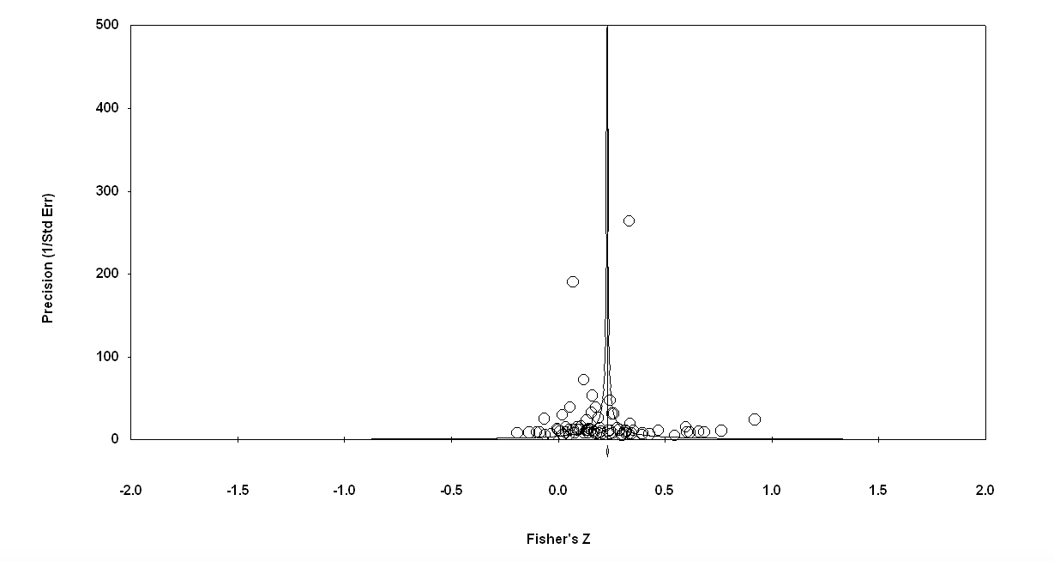

Funnel plot to assess publication bias following a random effects model of overall effect sizes for relationships between impulsivity, aggression, and suicidality

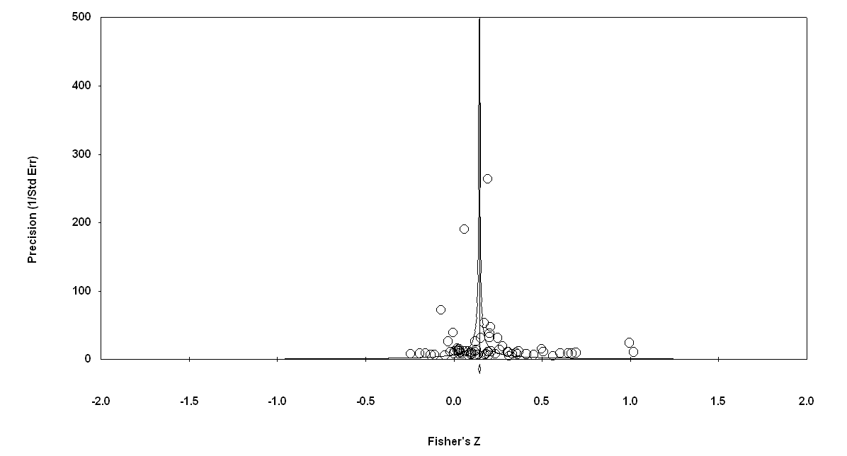
Funnel plot inspected to assess publication bias following a random effects model of overall effect sizes for relationships between impulsivity and suicidality

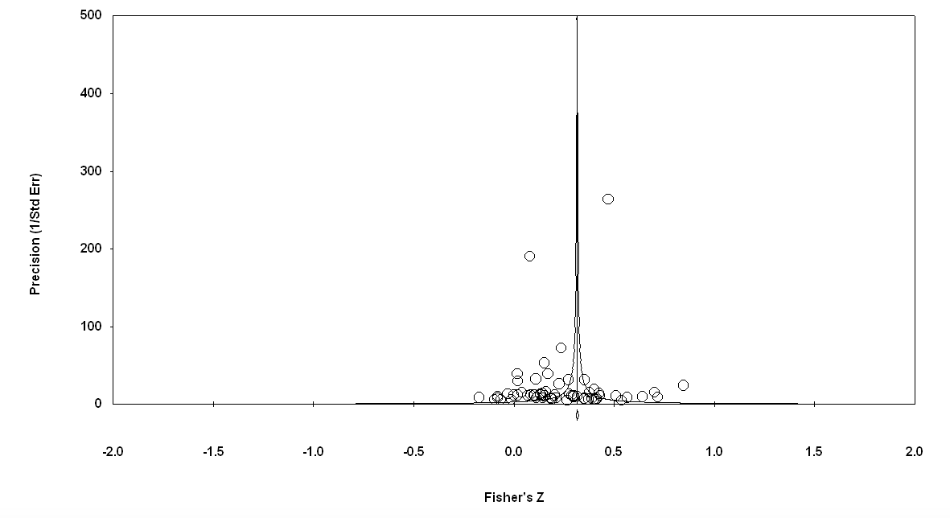
Funnel plot inspected to assess publication bias following a random effects model of overall effect sizes for relationships between aggression and suicidality

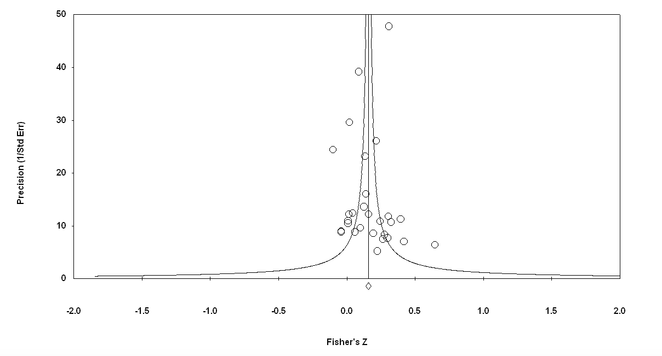

Funnel plot inspected to assess publication bias following a random effects model of overall effect sizes for relationships between impulsive aggression and suicidality

Supplementary Material 6. Figures showing significant moderation

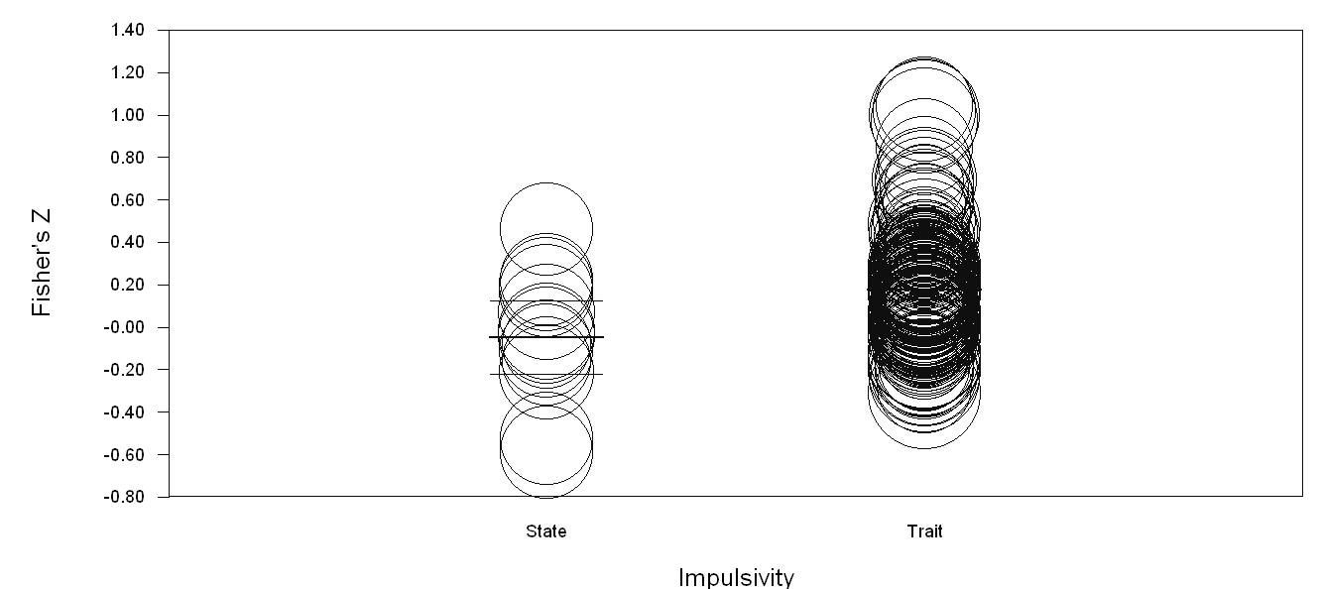
State and trait impulsivity as a moderator of the relationship with suicidality

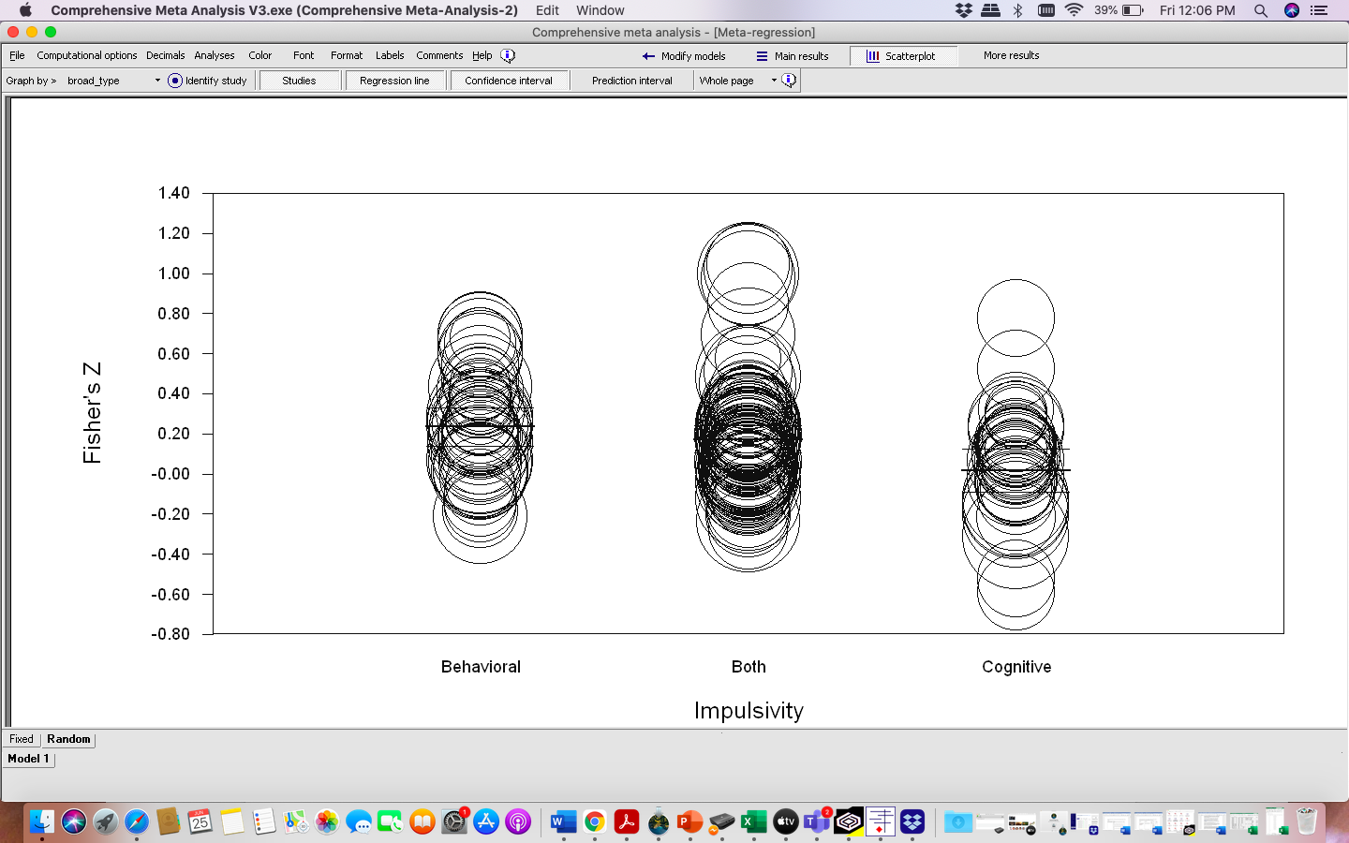
Type of impulsivity (cognitive, behavioral, or both) as a moderator of the relationship with suicidality
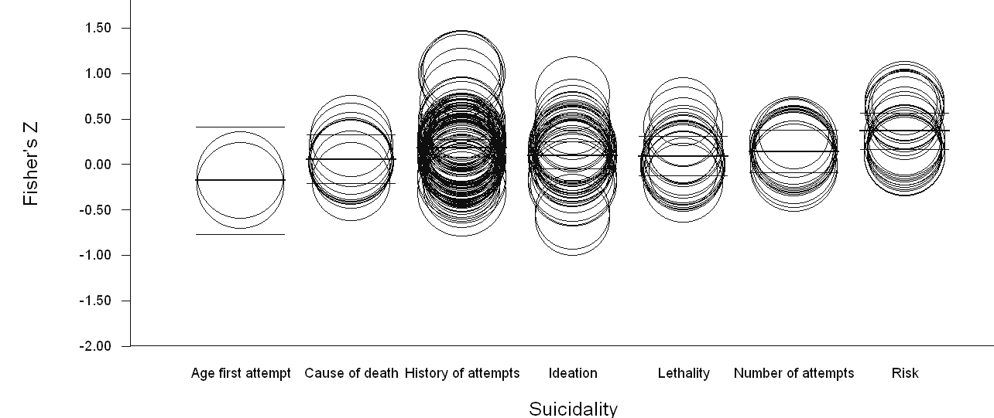
Measure of suicidality as a moderator of the relationship with impulsivity
Age at first suicide attempt
Suicidal ideation
Lethality
Number of suicide attempts
Suicide risk
Cause of death
History of suicide attempt
Age at first suicide attempt
Suicidal ideation
Lethality
Number of suicide attempts
Suicide risk
Cause of death
History of suicide attempt

Measure of suicidality as a moderator of the relationship between aggression and suicidality

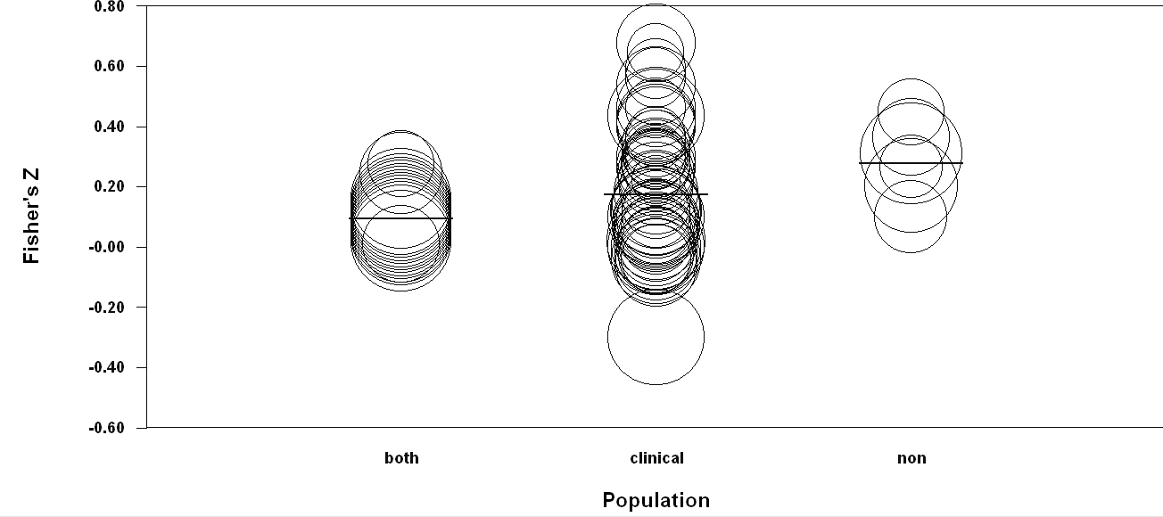
Non-clinical
Clinical
Both
Population as a moderator of the relationship between impulsive aggression and suicidality

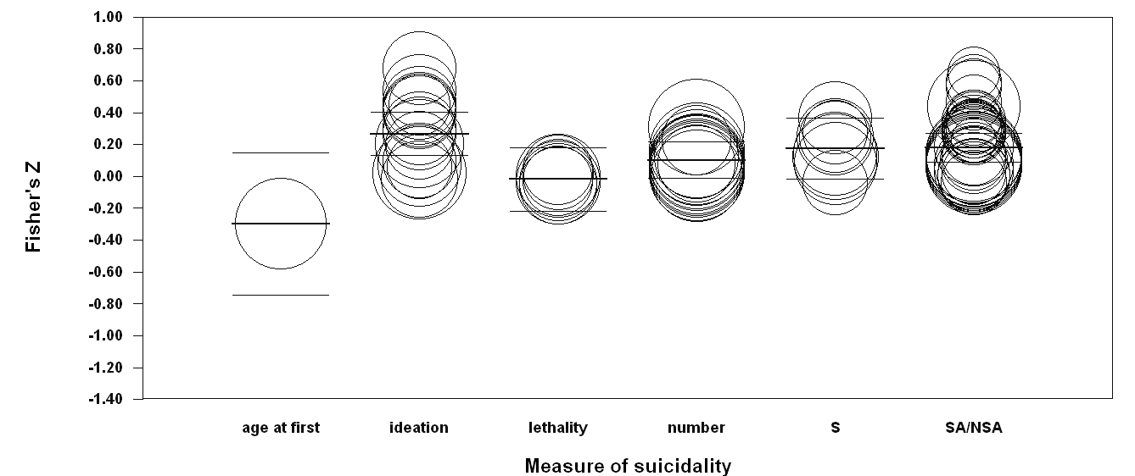
Age at first attempt
Lethality
Ideation
Number attempts
Cause of death
History of attempts

Measure of suicidality as a moderator of the relationship between aggression and suicidality

