Supplementary information
Supplementary Data File S1 | Search strategy | p. 2
Supplementary Data File S2 | Crude numbers | p. 3
Supplementary Data File S3 | Risk of bias assessment per study | p. 5
Supplementary Figure S1 | Meta-analyses of OCP and breast cancer risk for BRCA1 and BRCA2 | p. 7
Supplementary Figure S2 | Meta-analysis of OCP and breast cancer risk, , studies published >10 years ago versus studies published <10 years ago | p. 8
Supplementary Figure S3 | Meta-analyses of OCP and ovarian cancer risk for BRCA1 and BRCA2 | p. 9
Supplementary Figure S4 | Meta-analysis of OCP and ovarian cancer risk, studies published >10 years ago versus studies published <10 years ago | p. 10
Supplementary Figure S5 | Meta-analyses of tubal ligation and ovarian cancer risk for BRCA1 and BRCA2 | p. 11
Supplementary Figure S6 | Meta-analysis of time since last OCP use and breast cancer risk | p. 12

Supplementary Data File S1. Search strategy

(“Genes, BRCA1”[Mesh] OR “Genes, BRCA2”[Mesh] OR “Hereditary Breast and Ovarian Cancer Syndrome”[Mesh] OR BRCA[Title/Abstract] OR BRCA1[Title/Abstract] OR BRCA2[Title/Abstract] OR HBOC[Title/Abstract] OR “Hereditary breast and ovarian cancer*”[Title/Abstract] OR Familial ovarian cancer*[Title/Abstract] OR familial breast cancer*[Title/Abstract] OR Hereditary ovarian cancer*[Title/Abstract] OR Hereditary breast cancer*[Title/Abstract] OR “Familial breast and ovarian cancer*”[Title/Abstract] OR Breast Cancer Gene*[Title/Abstract])
AND
(“Contraceptive Agents, Female”[Mesh] OR “Contraceptive Devices, Female”[Mesh] OR “Contraceptive Agents, Hormonal”[Mesh] OR “Contraceptive Agents, Hormonal” [Pharmacological Action] OR “Contraceptives, Oral, Hormonal” [Pharmacological Action] OR “Contraceptive Agents, Female” [Pharmacological Action] OR “Contraceptives, Oral, Combined”[Mesh] OR “ethinyl estradiol, levonorgestrel drug combination” [Supplementary Concept] OR “Ethinyl Estradiol-Norgestrel Combination”[Mesh] OR “Sterilization, Tubal”[Mesh] OR “Salpingectomy”[Mesh:NoExp] OR Oral contraceptive*[Title/Abstract] OR IUD[Title/Abstract] OR intra uterine device[Title/Abstract] OR intrauterine device[Title/Abstract] OR COCP[Title/Abstract] OR Salpingectom*[Title/Abstract] OR Tubal sterilization[Title/Abstract] OR Tubal uet ozation[Title/Abstract] OR Tubectom*[Title/Abstract] OR Tubal Excision*[Title/Abstract]OR NuvaRing [Title/Abstract] OR etonogestrel [Title/Abstract] OR Contraception*[ Title/Abstract] OR Contraceptive*[ Title/Abstract])

Supplementary Data File S2. Crude numbers
Breast cancer data
First author, year | Study design | Risk ratio | Contra-ceptive | BRCA | N total | N with cancer | N without cancer | N users | N non-users | N users with cancer | N non-users with cancer | N users without cancer | N non-users without cancer | Crude OR
Bernholtz, 2011 | case-only | HR | OCP | BRCA1 | 638 | 280 | 358 | 309 | 182
Bernholtz, 2011 | case-only | HR | OCP | BRCA2 | 250 | 123 | 127 | 136 | 72
Brohet, 2007 | retrospective cohort | HR | OCP | BRCA1 | 1181 | 597 | 584 |  |  | 436 | 161
Brohet, 2007 | retrospective cohort | HR | OCP | BRCA2 | 412 | 249 | 163 |  |  | 171 | 78
Gronwald, 2006 | matched case-control | OR | OCP | BRCA1 | 696 | 348 | 348 |  |  | 56 | 292 | 285 | 63 | 0.04
Haile, 2006 | case-control | OR | OCP | BRCA1 | 497 | 195 | 302 |  |  | 146 | 49 | 214 | 86 | 1.20
Haile, 2006 | case-control | OR | OCP | BRCA2 | 307 | 128 | 179 |  |  | 109 | 19 | 132 | 45 | 1.96
Heimdal, 2002 | matched case-control | HR | OCP | BRCA1 | 98 | 33 | 65
Kotsopoulos, 2014 | matched case-control | OR | OCP | BRCA1 | 4984 | 2492 | 2492 |  |  | 1474 | 1018 | 1408 | 1084 | 1.11
Narod, 2002 | matched case-control | OR | OCP | BRCA1 | 1962 | 981 | 981
Narod, 2002 | matched case-control | OR | OCP | BRCA2 | 660 | 330 | 330
Park, 2017 | retrospective cohort | HR | OCP | BRCA1 | 222 | 222 | 0 | 33 | 189
Park, 2017 | retrospective cohort | HR | OCP | BRCA2 | 359 | 359 | 0 | 45 | 314
Rieder, 2016 | retrospective cohort | HR | OCP | BRCA1/2 | 366 | 366 | 0 | 306 | 133
Schrijver, 2018 | prospective cohort | HR | OCP | BRCA1 | 2276 | 269 | 2007 |  |  | 236 | 39 | 1734 | 290
Schrijver, 2018 | prospective cohort | HR | OCP | BRCA2 | 1610 | 157 | 1453 |  |  | 140 | 17 | 1248 | 214
Toss, 2017 | retrospective cohort | HR | OCP | BRCA1/2 | 113 | 45 | 68 | 41 | 30
Ovarian cancer data
Antoniou, 2009 | retrospective cohort | HR | OCP | BRCA1 | 2281 | 201 | 2080 |  |  | 98 | 92 | 1557 | 429
Antoniou, 2009 | retrospective cohort | HR | TL | BRCA1 | 2281 | 201 | 2080 |  |  | 18 | 166 | 237 | 1654
Antoniou, 2009 | retrospective cohort | HR | OCP | BRCA2 | 1038 | 52 | 986 |  |  | 22 | 28 | 738 | 216
Antoniou, 2009 | retrospective cohort | HR | TL | BRCA2 | 1038 | 52 | 986 |  |  | 5 | 45 | 163 | 784
Ferris, 2014 | case-control | OR | OCP | BRCA1/2 | 639 | 75 | 564 |  |  | 46 | 30 | 404 | 162 | 0.61
Gronwald, 2006 | matched case-control | OR | OCP | BRCA1 | 300 | 150 | 150 |  |  | 12 | 138 | 22 | 128 | 0.51
Kotsopoulos, 2015 | matched case-control | OR | OCP | BRCA1 | 5386 | 1095 | 4291 |  |  | 459 | 636 | 2361 | 1975 | 0.60
Kotsopoulos, 2015 | matched case-control | OR | TL | BRCA1 | 5386 | 1095 | 4291 |  |  | 143 | 856 | 456 | 3478 | 1.27
Kotsopoulos, 2015 | matched case-control | OR | OCP | BRCA2 | 1180 | 233 | 947 |  |  | 137 | 96 | 749 | 225 | 0.43
Kotsopoulos, 2015 | matched case-control | OR | TL | BRCA2 | 1180 | 233 | 947 |  |  | 47 | 166 | 206 | 703 | 0.97
Narod, 1998 | matched case-control | OR | OCP | BRCA1 | 229 | 179 | 50 |  |  | 0 | 89 | 38 | 0
Narod, 1998 | matched case-control | OR | OCP | BRCA2 | 31 | 28 | 3 |  |  | 14 | 14 | 2 | 1 | 0.50
Narod, 2001 | matched case-control | OR | OCP | BRCA1 | 346 | 173 | 173
Narod, 2001 | matched case-control | OR | TL | BRCA1 | 346 | 173 | 173 |  |  | 30 | 143 | 60 | 113 | 0.40
Narod, 2001 | matched case-control | OR | OCP | BRCA2 | 118 | 59 | 59
Narod, 2001 | matched case-control | OR | TL | BRCA2 | 118 | 59 | 59
Perri, 2015 | historical prospective cohort | OR | OCP | BRCA1 | 718 | 139 | 579
Perri, 2015 | historical prospective cohort | OR | OCP | BRCA2 | 331 | 33 | 298
Schrijver, 2021 | retrospective cohort | HR | OCP | BRCA1 | 4818 | 555 | 4263 |  |  | 291 | 235 | 3388 | 793
Schrijver, 2021 | retrospective cohort | HR | OCP | BRCA2 | 2844 | 174 | 2670 |  |  | 83 | 85 | 2101 | 513
Vicus, 2010 | matched case-control | OR | OCP | BRCA1 | 661 | 48 | 613 |  |  | 24 | 24 | 408 | 198 | 0.49
Vicus, 2010 | matched case-control | OR | TL | BRCA1 | 661 | 48 | 613 |  |  | 7 | 33 | 111 | 414 | 0.79
Whittemore, 2004 | matched case-control | OR | OCP | BRCA1/2 | 451 | 147 | 304 |  |  | 78 | 69 | 188 | 116 | 0.70

HR, Hazard ratio; OR, Odds ratio; N, number of participants; OCP, oral contraceptive pill; TL, tubal ligation.

Supplementary Data File S3. Risk of bias assessment per study
 |  |  | Narod, 1998 | Narod, 2001 | Heimdal, 2002 | Narod, 2002 | Whittemore, 2004 | Gronwald, 2006 | Haile, 2006 | Brohet, 2007 | Antoniou, 2009 | Vicus, 2010 | Bernholtz, 2011 | Ferris, 2014 | Kotsopoulos, 2014 | Kotsopoulos, 2015 | Perri, 2015 | Rieder, 2016 | Park, 2017 | Toss, 2017 | Schrijver, 2018 | Schrijver, 2021
Bias uet o confounding
Bias due to selection of participants
Bias due to classification of intervention
Bias due to deviations from intended interventions
Bias due to missing data
Bias in measurement of outcomes
Bias in selection of the reported result
Overall risk of bias
 | low risk of bias
 | moderate risk of bias
 | serious risk of bias
 | unclear risk of bias

General remarks:
Baseline confounding is almost always present in non-randomized trials
Bias due to classification of the intervention is often present in retrospective studies

Supplementary Figure S1. Meta-analyses of OCP and breast cancer risk for BRCA1 and BRCA2
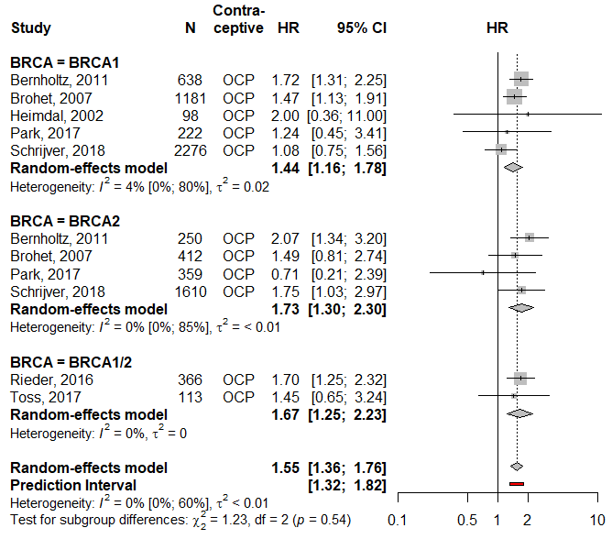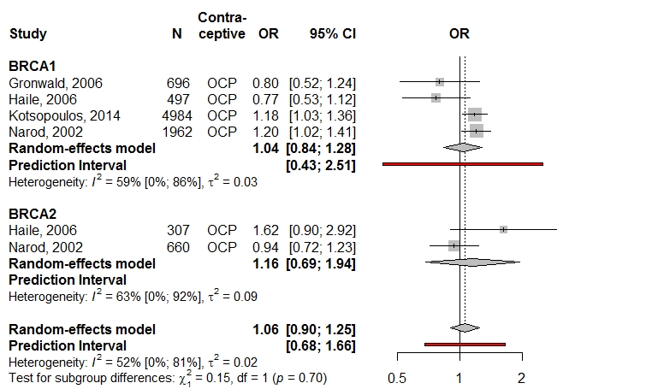
The first forest plot represents analysis of all studies representing a hazard ratio, the second forest plot represents analysis of al studies representing an odds ratio.
HR, Hazard ratio; N, number of participants; CI, confidence interval; OCP, oral contraceptive pill; BRCA1/2, studies that did not differentiate between BRCA1 and BRCA2 pathogenic variant carriers; OR, Odds ratio
Supplementary Figure S2. Meta-analysis of OCP and breast cancer risk, studies published >10 years ago versus studies published <10 years ago
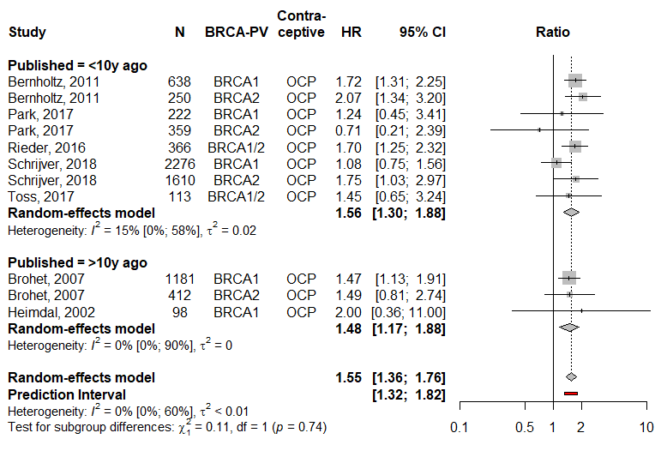
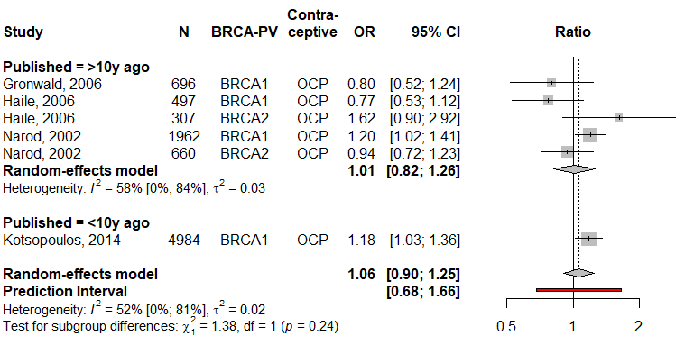
The first forest plot represents analysis of al studies representing a hazard ratio, the second forest plot represents analysis of al studies representing an odds ratio.
HR, Hazard ratio; N, number of participants; CI, confidence interval; OCP, oral contraceptive pill; OR, Odds ratio

Supplementary Figure S3. Meta-analyses of OCP and ovarian cancer risk for BRCA1 and BRCA2
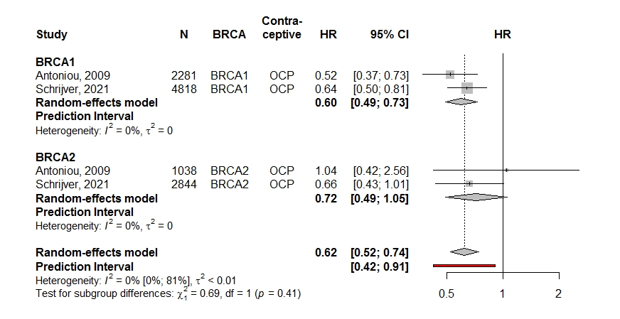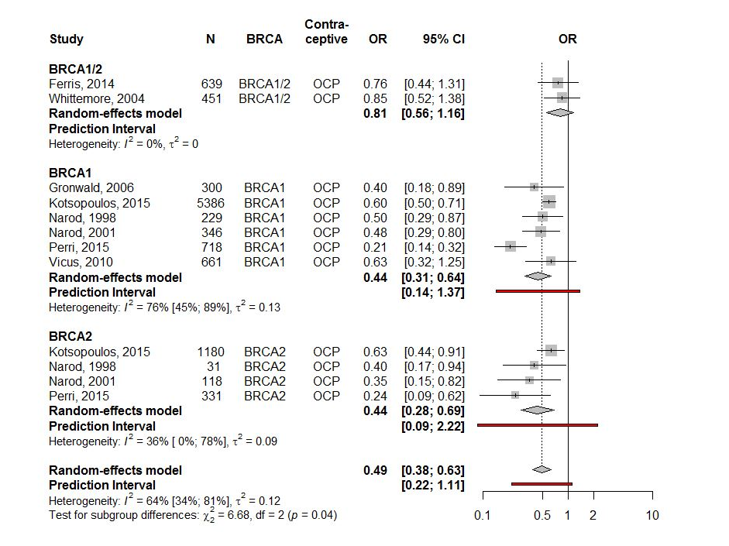
The first forest plot represents analysis of al studies representing a hazard ratio, the second forest plot represents analysis of al studies representing an odds ratio.
HR, Hazard ratio; N, number of participants; CI, confidence interval; OCP, oral contraceptive pill; BRCA1/2, studies that did not differentiate between BRCA1 and BRCA2 pathogenic variant carriers; OR, Odds ratio
Supplementary Figure S4. Meta-analysis of OCP and ovarian cancer risk, studies published >10 years ago versus studies published <10 years ago
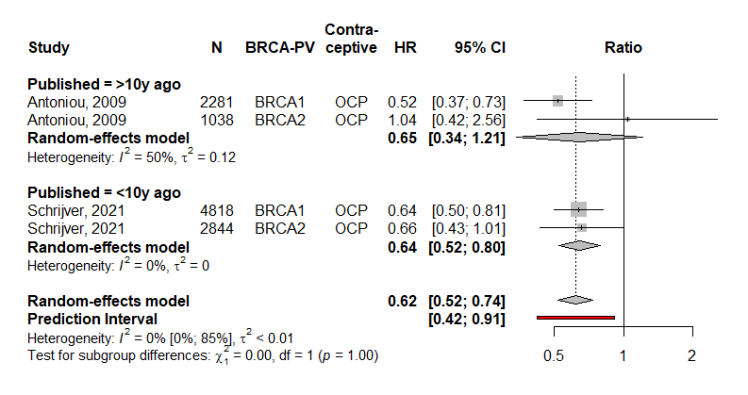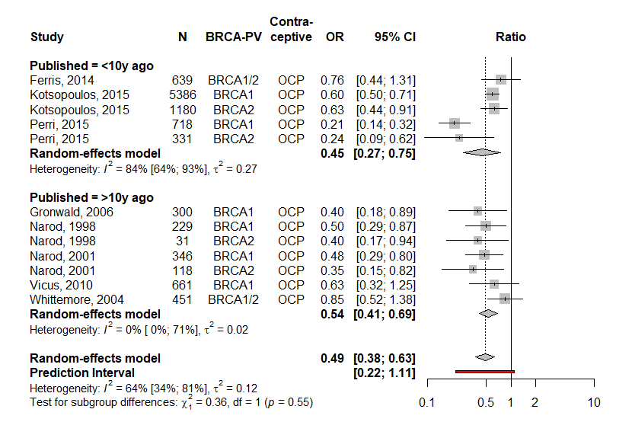
The first forest plot represents analysis of al studies representing a hazard ratio, the second forest plot represents analysis of al studies representing an odds ratio.
HR, Hazard ratio; N, number of participants; CI, confidence interval; OCP, oral contraceptive pill; OR, Odds ratio

Supplementary Figure S5. Meta-analyses of tubal ligation and ovarian cancer risk for BRCA1 and BRCA2
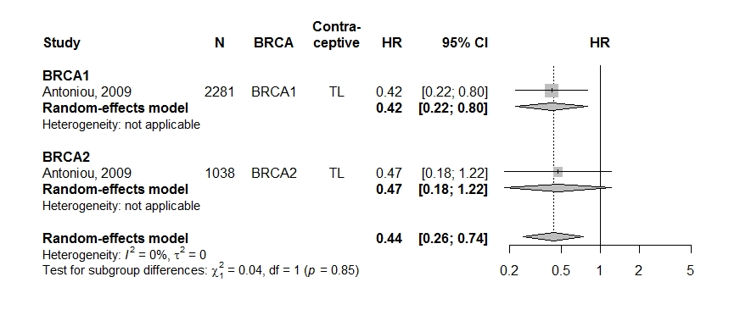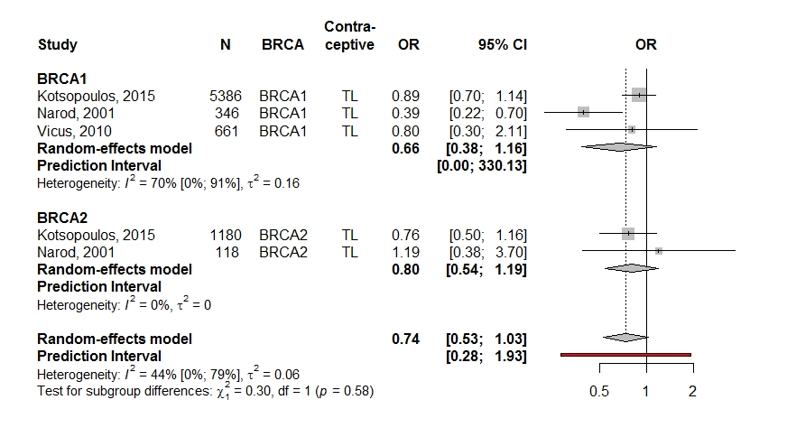
The first forest plot represents analysis of al studies representing a hazard ratio, the second forest plot represents analysis of al studies representing an odds ratio.
HR, Hazard ratio; N, number of participants; CI, confidence interval; OCP, oral contraceptive pill; OR, Odds ratio

Supplementary Figure S6. Meta-analysis of time since last OCP use and breast cancer risk
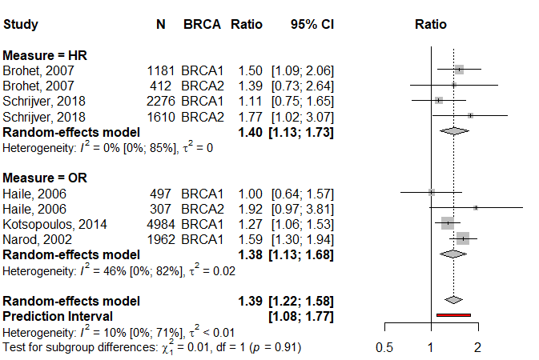
Analysis split on effect size, i.e. studies reporting a HR versus studies reporting an OR. The ratio represents the risk of breast cancer at least 10 years after last use of OCP compared to never use.
HR, Hazard ratio; N, number of participants; CI, confidence interval; OCP, oral contraceptive pill; OR, Odds ratio

