Additional File 2

Risk of Bias Assessment
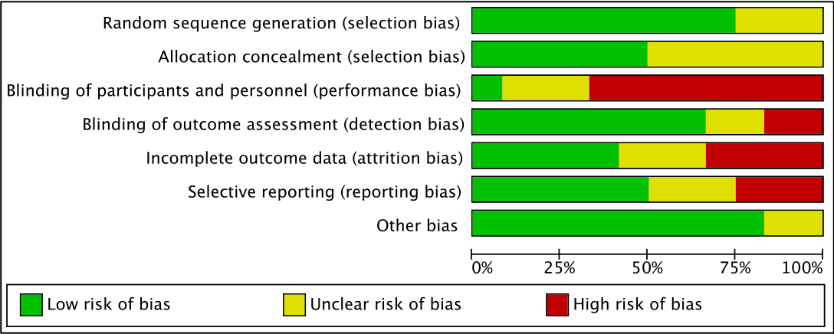
Summary

Assessment details
Study | Sequence Generation | Allocation Concealment | Blinding of Patients and Personnel | Blinding of Outcome Assessors | Incomplete Outcome Data | Selective Reporting | Other Risk of Bias | Overall Assessment*
Schweickert et al. 2009 | Low | Low | High | Low | Low | Low | - | good
Comment |  |  | "the nature of the intervention prevented any blinding from patient and health-care providers"
Dantas et al. 2012 | Unclear | Unclear | Unclear | Unclear | Low | Unclear | Present | poor
Comment | Randomization strategy not stated. | Allocation concealment strategy not stated. | No information on blinding of participants available. | No information on blinding of outcome assessors available. |  | No protocol available. | Extreme baseline imbalance (age and gender).
Denehy et al. 2013 | Low | Low | High | Low | Unclear | High | - | poor
Comment |  |  | "maintained (single) blinding" |  | Different n for each outcome measure reported (Table 3). | No information provided for some prespecified outcomes and time points.
Brummel et al. 2014 | Low | Low | High | Low | High | High | - | poor
Comment |  |  | "inability to blind patients or those performing the interventions" |  | Follow-up occurred less frequently in the cognitive plus physical therapy group because of withdrawals. | No information provided for some prespecified outcomes and time point.
Dong et al. 2014 | Unclear | Unclear | High | Unclear | Unclear | Unclear | - | poor
Comment | Randomization strategy not stated. | Allocation concealment not mentioned. | "this study [...] is not double blinded" | No information on blinding of outcome assessors available. | No information on attrition available. | No protocol available.
Kayambu et al. 2015 | Low | Unclear | Low | Low | High | High | - | poor
Comment |  | Allocation concealment strategy not stated. |  |  | Differentially more losses in intervention group. | No information provided for some prespecified outcomes and time points.
Dong et al. 2016 | Low | Unclear | High | High | Low | Unclear | - | poor
Comment |  | Allocation concealment not mentioned. | "Blinding could not be performed in this randomized study" | "Blinding could not be performed in this randomized study" |  | Outcomes not clearly prespecified. No muscle strength or functional mobility outcome reported.
Fischer et al. 2016 | Low | Unclear | Unclear | High | Unclear | Low | - | poor
Comment |  | Allocation concealment not mentioned. | Blinding attempted but potentially broken, depends on communication with patients. | "Nonblinded assessors performed the ultrasound scans, [...]"; Results are at high risk of bias due to unblinded performance of ultrasound scans. | Significant attrition (>30%), but no missing outcome data for outcomes of interest. Intention-to-treat analysis, no imputation used.
Hodgson et al. 2016 | Unclear | Low | High | Low | Low | Low | Present | poor
Comment | Randomization not mentioned. |  | "all clinicians involved in their care were aware of study-group assignments";  Specifically mentioned as assessor-blinded, no mentioning of blinding of patients. |  |  |  | Potential issues related to study design: imbalance in group size (21 vs. 29 under randomized allocation).
Morris et al. 2016 | Low | Unclear | High | Low | High | Low | - | poor
Comment |  | Allocation concealment not mentioned. | Specifically mentioned as assessor-blinded, no mentioning of blinding of patients. |  | High amount of missing data at several timepoints.
Schaller et al. 2016 | Low | Low | Unclear | Low | High | Low | - | fair
Comment |  |  | "Patients were not made aware of their assignment." |  | Significant loss to follow-up (38% of patients). Multiple imputation for SF-36 at 3 months performed as sensitivity analysis.
Eggmann et al. 2018 | Low | Low | High | Low | Low | Low | - | good
Comment |  |  | "Blinding the responsible ICU staff was impossible";  "blinding of participants and physiotherapists was impossible."
*blinding of personnel not considered for the overall assessment, as judged almost impossible to perform.

