Appendices

Appendix 1 Search Analysis
No | Search | Pubmed | Cinahl | Medline | Cochrane
1 | exp QIGONG/ | 689 | 135 | 211 | 363
2 | exp QI GONG/ | 100 | 2 | 28 | 25
3 | Exp HYPERTENSION/ | 381985 | 6474 | 60081 | 40838
4 | exp BLOOD PRESSURE/ | 298634 | 3484 | 59229 | 73830
5 | exp Randomized Controlled Trial as Topic/ | 68555 | 13498 | 46013 | 126425
6 | Exp Clinical Trial/ | 1172245 | 6841 | 107180 | 88493
7 | random$.ab. | 265789 | 633 | 60843 | 1441
8 | 3 or 4 | 581732 | 9616 | 101970 | 34837
9 | 1 or 2 | 784 | 137 | 239 | 368
10 | 5 or 6 or 7 | 1424332 | 1930 | 176514 | 331898
11 | 8 and 9 and 10 | 34 | 14 | 12 | 15
12 | limit 11 to (humans and yr="2014 - 2019") | 4 | 2 | 6 | 3

Appendix 2 Assessment of Systolic Blood Pressure Weighted Mean Difference (The Funnel Plot Asymmetry Test)

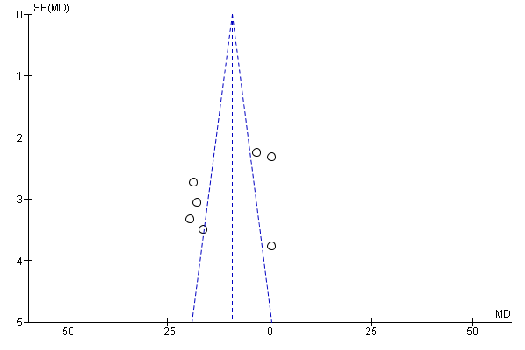

Appendix 3 Assessment of Diastolic Blood Pressure Weighted Mean Difference (The Funnel Plot Asymmetry Test)

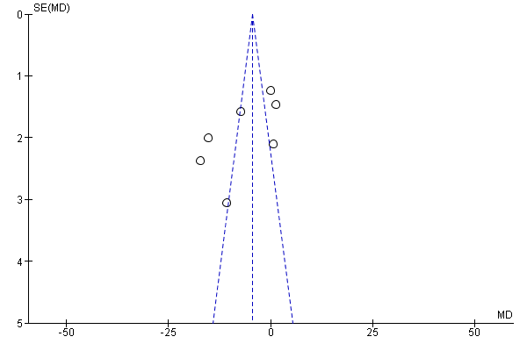
Inference: Presence of publication bias due to evidence of asymmetry in the funnel plot. Due to the limited number of studies (<10 studies) included, these results should be interpreted with caution.

Appendix 4: Assessment of small-study effects by using Egger’s regression test for the effect of Qigong on reduction of systolic blood pressure.

Appendix 5: Assessment of small-study effects by using Egger’s regression test for the effect of Qigong on reduction of diastolic blood pressure

Appendix 6: Results of GRADE

Results of GRADE
Certainty assessment |  |  |  |  |  |  | № of patients |  | Effect |  | Certainty | Importance
№ of studies | Study design | Risk of bias | Inconsistency | Indirectness | Imprecision | Other considerations | Qigong | Control | Relative  (95% CI) | Absolute  (95% CI) | Certainty | Importance
Systolic (assessed with: mmHg)
7 | randomised trials | not serious | serious | not serious | not serious | publication bias strongly suspected | 181 | 189 | - | MD 10.66 mmHg lower  (17.69 lower to 3.62 lower) | ⨁⨁◯◯  LOW | IMPORTANT
Diastolic (assessed with: mmHg)
7 | randomised trials | not serious | serious | not serious | not serious | publication bias strongly suspected | 181 | 189 | - | MD 6.76 mmHg lower  (12.22 lower to 1.3 lower) | ⨁⨁◯◯  LOW | IMPORTANT
CI: Confidence interval; MD: Mean difference

