Appendix

Table of contents | Page
I. Tables………………………………………………………………………... | 2-7
II. Figures………………………………………………………………………. | 8-9

Supplementary Table 1: Search Strategy
No. | Search terms
1 | COVID-19 | (((((COVID-19) OR (SARS-CoV-2)) OR (COVID-19[MeSH Terms])) OR (Coronavirus[MeSH])) OR (Coronavirus) OR (SARS-CoV-2)[MeSH Terms]
2 | Remdesivir | Remdesivir[title/abstract] or Remdesivir [MeSH Terms]
3 | COVID-19 AND Remdesivir | #1 AND #2

Supplementary Table 2. GRADE (Certainty of Evidence) for efficacy and safety Outcomes
Outcomes | Risk Difference  (95% CI) | № of Trials | Certainty of the evidence  (GRADE)
Improvement time  (follow up: range 28 days to 29 days) | SMD -0.80  (-1.90 to 0.53) | (3 RCTs) | ⨁◯◯◯^{a,b}  VERY LOW
Recovered patients (follow up: range 28 days to 29 days) | RD 0.07  (0.05 to 0.08) | (3 RCTs) | ⨁⨁⨁◯^{c,d}  MODERATE
Discharged patients (follow up: range 28 days to 29 days) | RD 0.07  (0.03 to 0.11) | (3 RCTs) | ⨁⨁⨁◯^{c,e}  MODERATE
Death (follow up: range 28 days to 29 days) | RD -0.01  (-0.03 to 0.01) | (4 RCTs) | ⨁⨁⨁◯^{c,e}  MODERATE
Any serious events (follow up: range 28 days to 29 days) | RD -0.05  (-0.10 to -0.01) | (3 RCTs) | ⨁⨁⨁◯^{c,d}  MODERATE
Any adverse events (follow up: range 28 days to 29 days) | RD 0.01  (-0.15 to 0.19) | (3 RCTs) | ⨁◯◯◯^{c,f,g}  VERY LOW

a. Very high heterogeneity (I²=98%)
b. Means were calculated from medians ands and ranges
c. Combining 5-day and 10-day treatment together (indirectness)
d. The optimal information size criterion is met (performed by trial sequential analysis) and the 95% confidence interval excludes no effect
e. The optimal criterion size is not met
f. Very high heterogeneity I²=66% (very serious inconsistency was considered if heterogeneity was >50%)
g. The optimal information size criterion is met, but the 95% CI overlaps no effect
Supplementary Table 3. GRADE (Certainty of Evidence) for efficacy and safety Outcomes for patients with moderate disease (sensitivity analysis)
Outcomes | Risk Difference  (95% CI) | № of Trials | Certainty of the evidence  (GRADE)
Improvement time  (follow up: range 28 days to 29 days) | SMD -0.36  (-2.12 to 1.18) | (2 RCTs) | ⨁◯◯◯^{a,b,c,d}  VERY LOW
Recovered patients (follow up: range 28 days to 29 days) | RD 0.07  (0.02 to 0.11) | (2 RCTs) | ⨁◯◯◯ ^{c,d,e}  VERY LOW
Death (follow up: range 28 days to 29 days) | RD 0.00  (-0.01 to 0.01) | (3 RCTs) | ⨁⨁⨁◯^{c,d}  MODERATE

a. High heterogeneity (I²=36%)
b. Means were calculated from medians ands and ranges
c. Combining 5-day and 10-day treatment together indirectness)
d. Including subgroup of one of the trials (indirectness)
e. The optimal criterion size is not met

Supplementary Table 4: Demographics of the included patients
 |  |  |  |  |  | Wang |  |  |  | Beigel |  | Spinner |  |  | Pan (Solidarity)
 |  |  |  |  |  | Remdesivir  (n=158) |  | Placebo  (n=78) |  | Remdesivir  (N=541) | Placebo  (N=522) | Remdesivir (10-Day)  (n = 193) | Remdesivir  (5-Day)  (n = 191) | Standard care  (n = 200) | Remdesivir  (n=2743) | Placebo  (n=2708)
 |  |  | Age, years (median with IQR, mean±SD, or number of patiemts per age range) |  |  | 66·0 (57·0–73·0) |  | 64·0 (53·0–70·0) |  | 58.6±14.6 | 59.2±15.4 | 56 (45-66) | 58 (48-66) | 57 (45-66) | <50 (961)  50-69 (1282)  70+ (500) | <50 (952)  50-69 (1287)  70+ (469)
 |  |  | Men |  |  | 89 (56%) |  | 51 (65%) |  | 352 (65.1%) | 332 (63.6%) | 118 (61%) | 114 (60%) | 125 (63%) | 1706 (62%) | 1725 (64%)
 |  |  | Asian |  |  | - |  | - |  | 79 (14.6%) | 56 (10.7%) | 31/188 (16%) | 34/186 (18%) | 37/193 (19%) | - | -
 |  |  | Black or African American |  |  | - |  | - |  | 109 (20.1%) | 117 (22.5%) | 37/188 (20%) | 35/186 (19%) | 27/193 (14%) | - | -
 |  |  | White |  |  | - |  | - |  | 279 (51.6%) | 287 (55.1%) | 107/188 (57%) | 109/186 (59%) | 112/193 (58%) | - | -
 |  |  | Hispanic or Latino — no. (%) |  |  | - |  | - |  | 134 (24.8%) | 116 (22.3%) | 42/186 (23%) | 25/187 (13%) | 34/186 (18%) | - | -
 |  |  | Other |  |  | - |  | - |  | - | - | 13/188 (7%) | 8/186 (4%) | 17/193 (9%) | - | -
 |  |  | Median time (IQR) from symptom onset to randomization — days‡ |  |  | - |  | - |  | 9 (6–12) | 9 (7–13) | - | - | - | - | -
 |  |  | Body mass index, median (IQR)c |  |  | - |  | - |  | 30.7 (7.4) | 30.5 (7.3) | 28 (25-32) | 27 (24-30) | 27 (24-31) | - | -
 |  |  | Hypertension |  |  | 72 (46%) |  | 30 (38%) |  | 269/532 (50.6%) | 264/519 (50.9%) | 85 (44%) | 82 (43%) | 81 (41%) | - | -
 |  |  | Diabetes |  |  | 40 (25%) |  | 16 (21%) |  | 164/532 (30.8%) | 158/519 (30.4%) | 85 (44%) | 71 (37%) | 76 (38%) | 707 (26%) | 666 (25%)
 |  |  | Heart disease |  |  | 15 (9%) |  | 2 (3%) |  | - | - | 111 (58) | 111 (58) | 107 (54) | 571 (21%) | 567 (21%)
 |  |  | Asthma |  |  | - |  | - |  | 59(12.6) | 47 (10.3) | 31 (16) | 22 (12) | 28 (14) | 139 (5%) | 139 (5%)
 |  |  | Estimated glomerular filtration rate, median (IQR), mL/minf |  |  | - |  | - |  | - | - | 110 (86-143) | 99 (75-130) | 103 (78-130) | - | -
 |  |  | Serum creatinine, μmol/L |  |  |  |  | 71·3 (56·0–88·7) |  | - | - | - | - | - | - | -
  68·0
  (56·0–82·0)
 |  |  | Aspartate aminotransferase, U/L |  |  | 31·0 (22·0–44·0) |  | 33·0 (24·0–48·0) |  | - | - | 34  (23-48) | 32  (25-48) | 34  (24-49) | - | -
 |  |  | Alanine aminotransferase, U/L |  |  | 26·0 (18·0–42·0) |  | 26·0 (20·0–43·0) |  | - | - | 28 (21-47) | 30 (19-51) | 30 (19-49) | - | -
 |  |  | Median duration of symptoms before first dose of remdesivir (IQR) — days |  |  | 11 (9–12) |  | 10 (9–12) |  | 9 (6,12) | 9(7,13) | 8 (5-11) | 8 (5-11) | 9(6-11) | - | -
 |  |  | Hospital admission, not requiring supplemental oxygen |  |  | 0(0%) |  | 3 (4%) |  | 75 (13.9%) | 63 (12.1%) | 163 (84%) | 160 (84%) | 160 (80%) | 661 (24%) | 664 (25%)
 |  |  | Hospital admission, requiring supplemental oxygen |  |  | 129 (82%) |  | 65 (83%) |  | 232 (42.9%) | 203 (39.0%) | 23 (12%) | 29 (15%) | 36 (18%) | 1828 (67%) | 1811 (67%)
 |  |  | Hospital admission, requiring high-flow nasal cannula or non-invasive mechanical ventilation |  |  | 28(18%) |  | 9 (12%) |  | 95 (17.6%) | 98 (18.8%) | 1 (1%) | 2 (1%) | 2 (1%) | 1828 (67%) | 1811 (67%)
 |  |  | Hospital admission, requiring extracorporeal membrane oxygenation or invasive mechanical ventilation |  |  | 0 (0%) |  | 1 (1%) |  | 131 (24.2%) | 154 (29.6%) | - | - | - | 254 (9%) | 233 (8%)
 |  |  | Received lopinavir–ritonavir |  |  | 27 (17%) |  | 15 (19%) |  | - | - | 11 (6%) | 10 (5%) | 43 (22%) | 0 (0%) | 0 (0%)
 |  |  | Received antibiotic |  |  | 121 (77%) |  | 63 (81%) |  | 420 (78.9%) | 443 (85.9%) | 41 (21%) | 35 (18%) | 62 (31%) | - | -
 |  |  | Received corticosteroids |  |  | 60 (38%) |  | 31 (40%) |  | 115 (21.6%) | 126 (24.4%) | 29 (15%) | 33 (17%) | 38(19%) | 1310 (48%) | 1288 (48%)
 |  |  | Received hydroxychloroquine/chloroquine |  |  | - |  | - |  | 184 (34.6%) | 189 (36.6%) | 22 (11%) | 16 (8%) | 89(45%) | 0 (0%) | 0 (0%)
 |  |  | Received tocilizumab |  |  | - |  | - |  | - | - | 1 (1%) | 1 (1%) | 10 (5%) | 133 (5%) | 143 (5%)

Supplementary Table 5: Leave-one-out analysis (sorted by I²)
Outcome | Effect | Lower limit of confidence interval | Upper limit of confidence interval | I²
Improvement time:  Omitting Beigel, 2020  Omitting Spinner, 2020  Omitting Wang, 2020 | -0.466  -0.978  -0.922 | -1.027  -6.476  -7.044 | 0.095  4.520  5.201 | 0.000  0.967  0.987
Recoveries:  Omitting Beigel, 2020  Omitting Spinner, 2020  Omitting Wang, 2020 | -0.466  -0.978  -0.922 | -1.027  -6.476  -7.044 | 0.095  4.520  5.201 | 0.000  0.967  0.987
Discharges:  Omitting Wang, 2020  Omitting Beigel, 2020  Omitting Spinner, 2020 | 0.073  0.060  0.072 | -0.016  -0.115  -0.163 | 0.163  0.235  0.307 | 0.000  0.000  0.000
Deaths:  Omitting Beigel, 2020  Omitting Pan (Solidarity), 2020  Omitting Wang, 2020  Omitting Spinner, 2020 | -0.003  -0.014  -0.009  -0.011 | -0.015  -0.062  -0.047  -0.064 | 0.008  0.034  0.029  0.043 | 0.000  0.104  0.262  0.324
Any serious adverse events:  Omitting Wang, 2020  Omitting Beigel, 2020  Omitting Spinner, 2020 | -0.052  -0.045  0.071 | -0.234  -0.198  -0.101 | 0.130  0.108  -0.041 | 0.000  0.000  0.000
Any adverse events:  Omitting Beigel, 2020  Omitting Spinner, 2020  Omitting Wang, 2020 | 0.064  -0.041  0.012 | -0.329  -0.375  -0.858 | 0.457  0.293  0.882 | 0.000  0.000  0.851

Supplementary Figure 1: Risk of bias
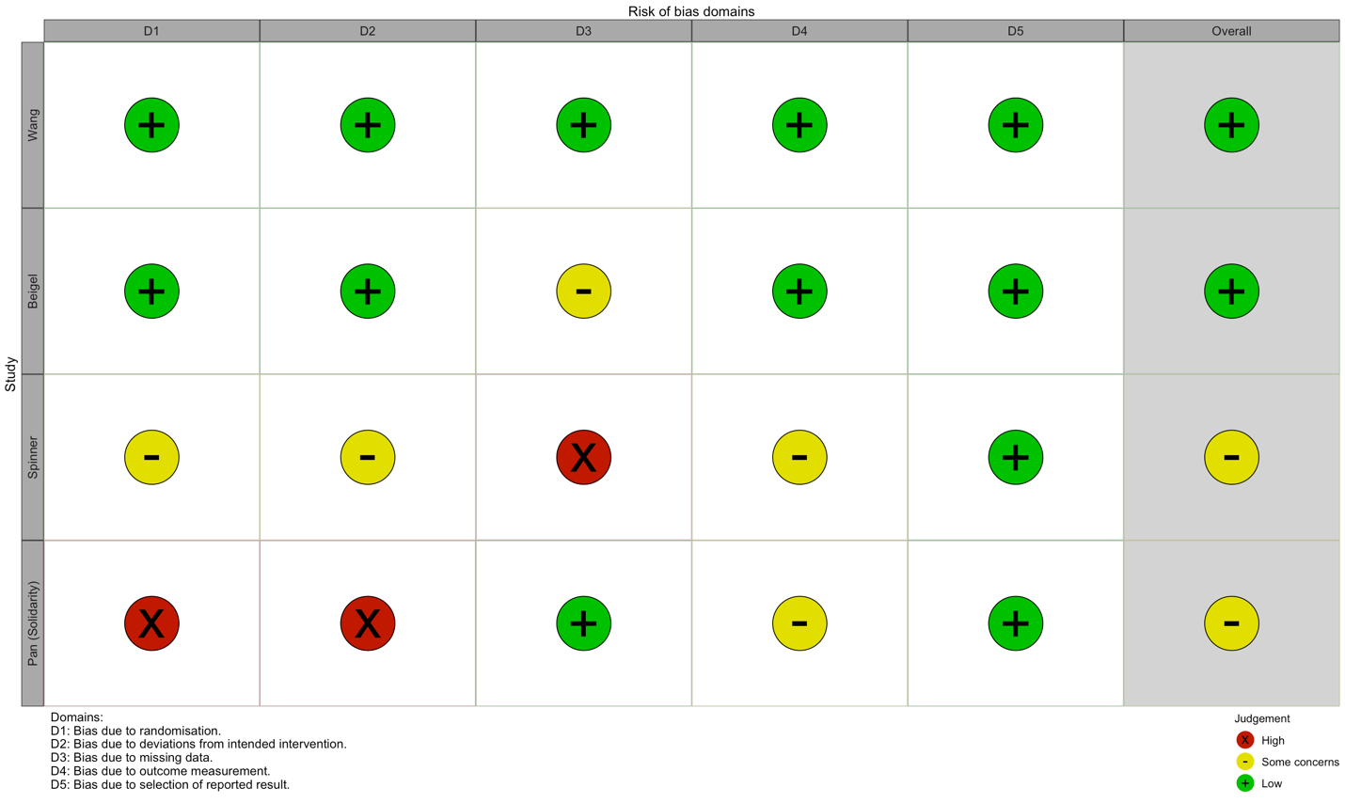

Supplementary Figure 2-A: Forest plot of mean time to clinical improvement (moderate disease)
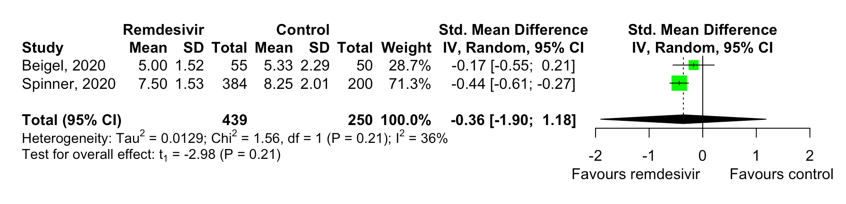

Supplementary Figure 2-B: Forest plot of recoveries (moderate disease)

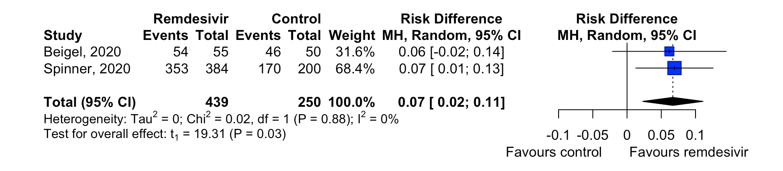

Supplementary Figure 2-C: Forest plot of deaths (moderate disease)



