Supplemental Appendix

Studies included in the main meta-analysis:

Shin et al conducted a retrospective cohort study on 948 South Korean patients with known alcoholic cirrhosis and used propensity score matching to compare aspirin users to non-users to determine their incidence of both HCC and gastrointestinal bleeding ¹. Shen et al performed a case-control study among 673 patients treated at three tristate area U.S. Liver Transplant Center and compared their outcomes to 1,166 controls to determine risk factors associated with HCC development ². Simon et al conducted a population-based retrospective cohort study of 49,925 Swedish adults with chronic HBV or HCV infection, and used inverse probability of treatment weighting to compare new users of low-dose aspirin (<163mg/day) to non-users, between 2006-2015³. Tsoi et al performed a retrospective cohort study of HCC incidence from 2000-2013 in older Chinese adults ⁴. Hwang et al performed a cohort study of Korean adults with chronic viral hepatitis, between 2007 and 2013 ⁵. Kim et al undertook a case-control study of Korean patients with type 2 diabetes and incident HCC diagnosed between 2002 and 2013 ⁶. Lee M et al conducted a retrospective cohort study of patients with chronic HBV infection and suppressed viral loads with 14,392 patients between 2002-2015 ⁷. A total of 6 retrospective cohort studies were performed using different populations identified from the Taiwan National Health Insurance Research Database (NHIRD), including patients with type 2 diabetes⁸, patients with established NAFLD⁹, patients with HCV infection ¹⁰, and patients with pre-existing head and neck cancer¹¹. Additionally, Lee et al performed a retrospective, propensity score-matched cohort study of 10,615 Taiwanese adults with chronic HBV infection, between 1997-2012 ¹². Additionally, Chiu et al used the Taiwanese NHIRD to conduct a retrospective case-control study focused on older adults aged ≥50 years with a new diagnosis of HCC from 2005 to 2008¹³. Coogan et al performed a case-control study in 4 US centers of patients with a new diagnosis of HCC, between 1977-1998 ¹⁴. Friis et al conducted a population-based retrospective cohort study in Denmark between 1989 and 1997 ¹⁵. Du et al evaluated post-operative aspirin administration in cirrhotic patients undergoing splenectomy¹⁶. Yang et al performed a case-control study in the United Kingdom’s Clinical Practice Research Datalink of patients with a new diagnosis of HCC from 1988 to 2011 ¹⁷. Sahasrabuddhe et al conducted a prospective cohort study in the National Institutes of Health–AARP (NIH-AARP) Diet and Health Study cohort, between 1995 and 2006 ¹⁸. Petrick et al conducted a pooled, prospective cohort study of aspirin use, from 10 U.S. cohorts; as one of those cohorts included the NIH-AARP cohort, we included the published estimates that were calculated by Petrick et al after they excluded the NIH-AARP study¹⁹.

Studies excluded for overlapping populations:
In the event that two or more studies included overlapping study populations, we included the study with the largest number of subjects. Based on this criterion, a total of 4 studies were excluded²⁰⁻²³: (1) a retrospective study from 2020 by Yip et al²¹ that utilized the same Hong Kong Hospital Authority database that was included in the publication by Tsoi et al ⁴; (2) a 2019 study by Cho et al²² that relied on the same South Korean National Health insurance database as Hwang et al⁵ and Kim et al⁶ (which themselves had distinct populations, as outlined above); (3) a 2020 study by Liao et al²³ that utilized a general study population from the Taiwanese NHIRD database, and overlapped with the other included studies from that database (listed above). Finally, (4) we also excluded a 2018 prospective cohort study by Simon et al²⁰, because that study population overlapped with participants included in the larger, 2015 pooled analysis by Petrick et al¹⁹. However, for the exploratory dose- and duration-response analysis, we chose to include the 2018 study by Simon et al, because its study population (i.e. the Nurses’ Health Study and Health Professionals Follow-up Study cohorts) was distinct from those used by Petrick and colleagues for their analyses of aspirin duration of use.

Supplementary Table S1. Complete list of PubMed Search Strategy using MeSH terms.

Pubmed/MEDLINE | ((aspirin[mesh] or "Cyclooxygenase 2 Inhibitors"[Mesh] or "Anti-Inflammatory Agents, Non-Steroidal"[Mesh:NoExp] or aspirin[Title/Abstract] OR "acetylsalicylic acid"[Title/Abstract] OR "non steroidal anti inflammatory drugs"[Title/Abstract] OR "nonsteroidal anti inflammatory drugs"[Title/Abstract] OR "nonsteroidal antiinflammatory drugs"[Title/Abstract] OR "non steroidal antiinflammatory drugs"[Title/Abstract] OR NSAIDs[Title/Abstract] OR "Anti-Inflammatory Agents, Non-Steroidal" [Pharmacological Action] OR aceclofenac[Title/Abstract] OR acemetacin[Title/Abstract] OR acetosyringone[Title/Abstract] OR acetovanillone[Title/Abstract] OR Adapalene [Title/Abstract] OR alclofenac[Title/Abstract] OR alminoprofen[Title/Abstract] OR amiprilose[Title/Abstract] OR Ampyrone[Title/Abstract] OR andrographolide[Title/Abstract] OR anisodamine[Title/Abstract] OR anisodine[Title/Abstract] OR Antipyrine[Title/Abstract] OR Apazone[Title/Abstract] OR apremilast[Title/Abstract] OR Arteparon[Title/Abstract] OR Arthrotec[Title/Abstract] OR azulene[Title/Abstract] OR baicalin[Title/Abstract] OR balsalazide[Title/Abstract] OR bendazac[Title/Abstract] OR "bendazac lysine"[Title/Abstract] OR benorilate[Title/Abstract] OR benoxaprofen[Title/Abstract] OR benzobarbital[Title/Abstract] OR berbamine[Title/Abstract] OR "betulinic acid"[Title/Abstract] OR bevonium[Title/Abstract] OR biphenylylacetic acid[Title/Abstract] OR boldine[Title/Abstract] OR "boswellic acid"[Title/Abstract] OR "bromfenac orbucillamine"[Title/Abstract] OR Bufexamac[Title/Abstract] OR bumadizone[Title/Abstract] OR butibufen[Title/Abstract] OR "carbaspirin calcium"or carprofen[Title/Abstract] OR caryophyllene[Title/Abstract] OR castanospermine[Title/Abstract] OR Celebrex[Title/Abstract] OR Celecoxib[Title/Abstract] OR cepharanthine[Title/Abstract] OR "chloroquine diphosphate"[Title/Abstract] OR "choline magnesium trisalicylate"[Title/Abstract] OR "chrysarobin"[Title/Abstract] OR Clonixin[Title/Abstract] OR Curcumin[Title/Abstract] OR dauricine[Title/Abstract] OR "dexketoprofen trometamol"[Title/Abstract] OR Diclofenac[Title/Abstract] OR "diclofenac hydroxyethylpyrrolidine"or difenpiramide[Title/Abstract] OR Diflunisal[Title/Abstract] OR dimephosphon[Title/Abstract] OR Dipyrone[Title/Abstract] OR diucifon[Title/Abstract] OR droxicam[Title/Abstract] OR ebselen[Title/Abstract] OR ecallantide[Title/Abstract] OR eltenac[Title/Abstract] OR "enfenamic acid"[Title/Abstract] OR Epirizole[Title/Abstract] OR Etanercept[Title/Abstract] OR ethenzamide[Title/Abstract] OR Ethonium[Title/Abstract] OR Etodolac[Title/Abstract] OR etofenamate[Title/Abstract] OR Etoricoxib[Title/Abstract] OR "evening primrose oil"[Title/Abstract] OR "fenamic acid"or fenbufen[Title/Abstract] OR fenclofenac[Title/Abstract] OR fenflumizole[Title/Abstract] OR Fenoprofen[Title/Abstract] OR fentiazac[Title/Abstract] OR fepradinol[Title/Abstract] OR Feprazone[Title/Abstract] OR "ferulic acid"[Title/Abstract] OR floctafenine[Title/Abstract] OR flosulide[Title/Abstract] OR flunixin[Title/Abstract] OR flunoxaprofen[Title/Abstract] OR fluproquazone[Title/Abstract] OR Flurbiprofen[Title/Abstract] OR glucametacin[Title/Abstract] OR guacetisal[Title/Abstract] OR helenalin[Title/Abstract] OR hemodes[Title/Abstract] OR higenamine[Title/Abstract] OR Ibuprofen[Title/Abstract] OR ibuproxam[Title/Abstract] OR icatibant[Title/Abstract] OR "imidazole 2 hydroxybenzoate"[Title/Abstract] OR indobufen[Title/Abstract] OR Indomethacin[Title/Abstract] OR Indoprofen[Title/Abstract] OR iodoantipyrine[Title/Abstract] OR isoxicam[Title/Abstract] OR kebuzone[Title/Abstract] OR Ketoprofen[Title/Abstract] OR Ketorolac[Title/Abstract] OR licofelone[Title/Abstract] OR "lipoxin A4"or "lipoxin B4"[Title/Abstract] OR lisofylline[Title/Abstract] OR lobenzarit[Title/Abstract] OR lonazolac[Title/Abstract] OR lornoxicam[Title/Abstract] OR loxoprofen[Title/Abstract] OR lumiracoxib[Title/Abstract] OR "Magnesium Salicylate"[Title/Abstract] OR magnolol[Title/Abstract] OR manoalide[Title/Abstract] OR Masoprocol[Title/Abstract] OR "Meclofenamic Acid"[Title/Abstract] OR "Mefenamic Acid"[Title/Abstract] OR Meloxicam[Title/Abstract] OR Mesalamine[Title/Abstract] OR mizoribine[Title/Abstract] OR mofebutazone[Title/Abstract] OR mofezolac[Title/Abstract] OR Nabumetone[Title/Abstract] OR nafamostat[Title/Abstract] OR Naproxen[Title/Abstract] OR Nebacetin[Title/Abstract] OR nepafenac[Title/Abstract] OR nifenazone[Title/Abstract] OR "Niflumic Acid"[Title/Abstract] OR nimesulide[Title/Abstract] OR nitroaspirin[Title/Abstract] OR "Olopatadine Hydrochloride"[Title/Abstract] OR olsalazine[Title/Abstract] OR olvanil[Title/Abstract] OR "oren gedoku to"[Title/Abstract] OR orgotein[Title/Abstract] OR Oxaprozin[Title/Abstract] OR Oxyphenbutazone[Title/Abstract] OR palmidrol[Title/Abstract] OR parecoxib[Title/Abstract] OR parthenolide[Title/Abstract] OR peoniflorin[Title/Abstract] OR phenidone[Title/Abstract] OR Phenylbutazone[Title/Abstract] OR pimecrolimus[Title/Abstract] OR pirfenidone[Title/Abstract] OR Piroxicam[Title/Abstract] OR pirprofen[Title/Abstract] OR proglumetacin[Title/Abstract] OR propacetamol[Title/Abstract] OR propionylcarnitine[Title/Abstract] OR propyphenazone[Title/Abstract] OR proquazone[Title/Abstract] OR pyranoprofen[Title/Abstract] OR pyrazolone[Title/Abstract] OR pyrogenal[Title/Abstract] OR Resveratrol[Title/Abstract] OR rofecoxib[Title/Abstract] OR "rosmarinic acid"[Title/Abstract] OR Rumalon[Title/Abstract] OR "saiko keishi to"[Title/Abstract] OR saikosaponin[Title/Abstract] OR salicin[Title/Abstract] OR salicylamide[Title/Abstract] OR Salicylates[Title/Abstract] OR "salicylsalicylic acid"[Title/Abstract] OR semapimod[Title/Abstract] OR seratrodast[Title/Abstract] OR serratiopeptidase[Title/Abstract] OR shikonin[Title/Abstract] OR sinapaldehyde[Title/Abstract] OR "Sodium Salicylate"[Title/Abstract] OR Sulfasalazine [Title/Abstract] OR Sulindac[Title/Abstract] OR "sulindac sulfide"or "sulindac sulfone"[Title/Abstract] OR Suprofen[Title/Abstract] OR suxibuzone[Title/Abstract] OR tanshinone[Title/Abstract] OR taxifolin[Title/Abstract] OR tenidap[Title/Abstract] OR tenoxicam[Title/Abstract] OR tepoxalin[Title/Abstract] OR "tiaprofenic acid"or tiaramide[Title/Abstract] OR tinoridine[Title/Abstract] OR "tolfenamic acid"[Title/Abstract] OR Tolmetin[Title/Abstract] OR tranilast[Title/Abstract] OR tribenoside[Title/Abstract] OR "ursolic acid"[Title/Abstract] OR valdecoxib[Title/Abstract] OR zileuton[Title/Abstract] OR zomepirac[Title/Abstract]OR (("cox 2"[Title/Abstract] OR "cox two"[Title/Abstract] OR "cyclooxygenase 2"[Title/Abstract] OR "cyclooxygenase two"[Title/Abstract]) AND (inhibitor*[Title/Abstract]))) AND ("Liver Neoplasms"[Mesh:NoExp] OR "Carcinoma, Hepatocellular"[Mesh] OR "hepatocellular carcinoma"[Title/Abstract] OR HCC[Title/Abstract] OR hepatoma*[Title/Abstract] OR (liver[Title/Abstract] AND (cancer*[Title/Abstract] OR neoplasm*[Title/Abstract] OR malignan*[Title/Abstract] OR carcinoma*[Title/Abstract] OR tumor[Title/Abstract] OR tumors[title/abstract] OR tumour[Title/Abstract] or tumours[title/abstract]))

Supplemental Table 2: Newcastle Ottawa Scores

a- Study had to include adequate time after index date without a diagnosis of hepatocellular carcinoma (defined as at least 1 year) to rule out underlying hepatocellular carcinoma, and to obtain full selection score
b- Study had to control for cirrhosis or comparable scoring system to adjust for liver disease in patients to obtain full comparability score
c- Study had to include statement regarding follow-up of subjects to obtain full score (if it was a prospective cohort study)

Study  (Author, Year) | Newcastle  Ottawa  Score | Selection ª | Comparability ^{b} |  | Outcome/Exposure ^{c}
Lee, T, 2020 | 8 | 3/4 | 2/2 | 3/3
Shen, 2020 | 9 | 4/4 | 2/2 | 3/3
Shin, 2020 | 8 | 4/4 | 2/2 | 2/3
Simon, 2020 | 9 | 4/4 | 2/2 | 3/3
Du, 2019 | 9 | 4/4 | 2/2 | 3/3
Lee, T, 2019 | 8 | 3/4 | 2/2 | 3/3
Tsoi, 2019 | 7 | 3/4 | 1/2 | 3/3
Hwang, 2018 | 9 | 4/4 | 2/2 | 3/3
Lin, 2018 | 6 | 3/4 | 1/2 | 2/3
Tseng, 2018 | 8 | 3/4 | 2/2 | 3/3
Lee, M, 2017 | 7 | 3/4 | 1/2 | 3/3
Lee, T, 2017 | 7 | 3/4 | 1/2 | 3/3
Kim, 2017 | 7 | 3/4 | 2/2 | 2/3
Yang, 2016 | 7 | 3/4 | 2/2 | 2/3
Petrick, 2015 | 7 | 3/4 | 1/2 | 2/3
SahasrabuddhE, 2012 | 7 | 3/4 | 1/2 | 3/3
Chiu, 2011 | 6 | 2/4 | 2/2 | 2/3
FriIs, 2003 | 6 | 3/4 | 0/2 | 3/3
Coogan, 2000 | 6 | 3/4 | 0/2 | 3/3

Studies included in meta-Analysis (n =19)
Full-text articles assessed for eligibility
(n = 62)
Records screened
(n = 12,543)

Identification

Eligibility

Included

Screening
Records identified through initial database search
(n =12,544)

Additional records identified through other sources
(n = 7) ª

Records after duplicated studies (n=8) removed
(n = 12,536)

Records excluded after screening of the title/abstract
(n =12,481)

Full-text articles excluded due to following reasons (n=43):
- Incorrect Study Design (n=24; i.e. preclinical study, review without original research, letter to editor)
- Abstract only (n=12)
- Wrong Patient Population (n=3; i.e. aspirin or NSAIDs in patients with established liver cancer or hepatocellular carcinoma)
- Overlapping Study Population (n=4)

ª Studies identified from other sources included: Lin 2018, Tseng 2018, Lee, T, 2017, Kim 2017, Yang 2016, Friis 2003, Chiu 2011

Supplemental Figure 1. PRISMA (Preferred Reporting Items for Systematic Reviews and Meta-Analyses) Flow Diagram for study selection including identification, removal of duplicate studies, screening, eligibility based on inclusion and exclusion criteria and final included sample for analysis.

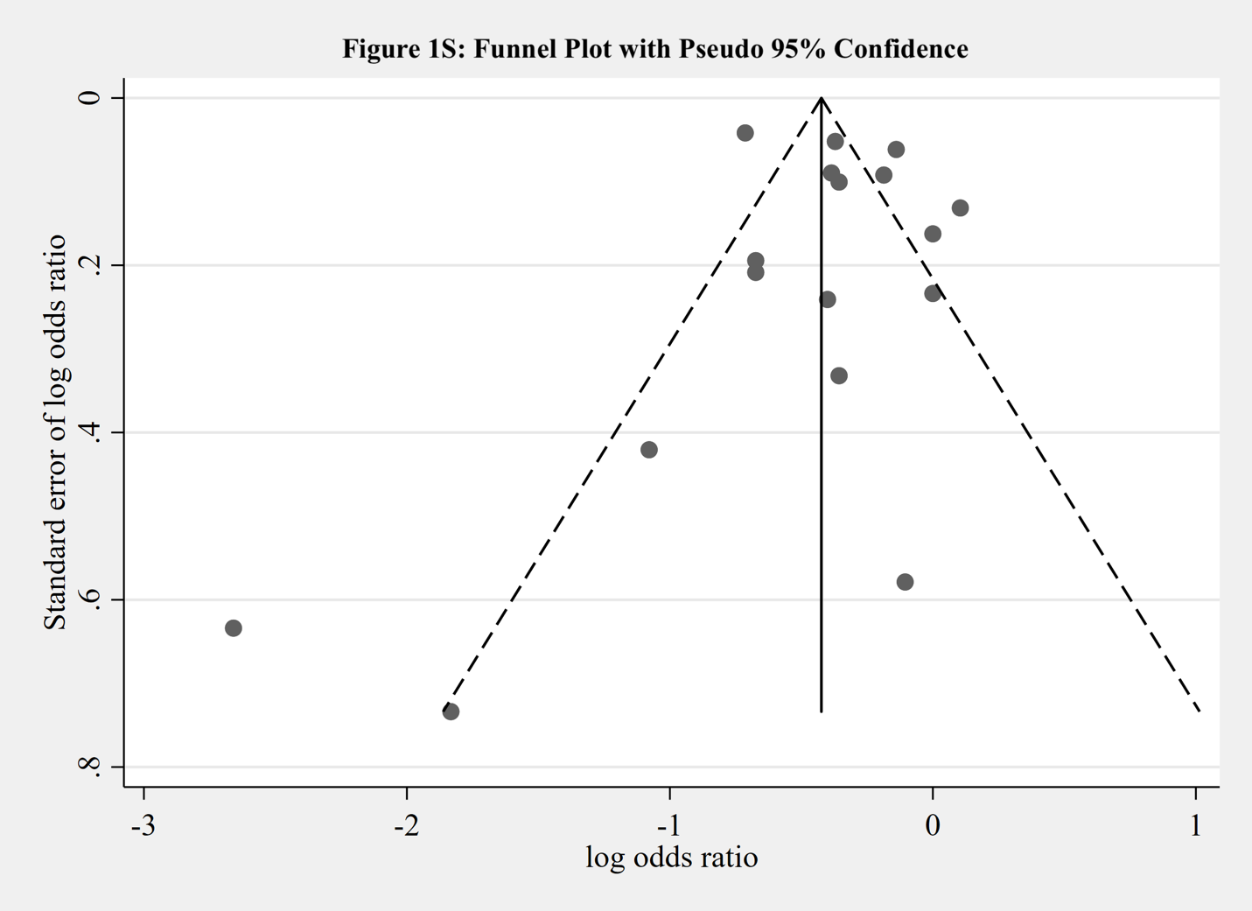

Supplemental Figure 2. Funnel Plot with Pseudo 95% Confidence Intervals, to Ascertain Publication Bias among 19 Studies Evaluating the Association between Aspirin Usage and Incident Hepatocellular Carcinoma. This funnel plot demonstrates no evidence of significant publication bias.

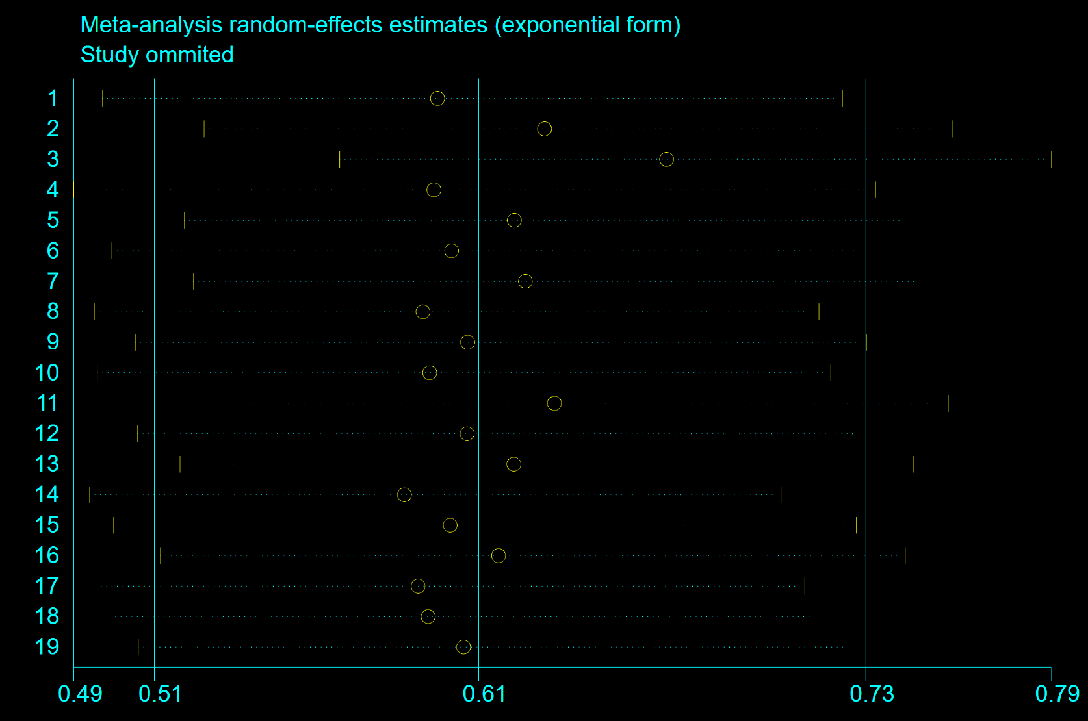

Supplemental Figure 3. Influence of Individual studies on the Pooled Risk Estimate. The vertical axis in the center indicates the overall risk estimate and the two corresponding vertical axes on the sides indicate its 95% CI. The hollow circles illustrate the pooled risk estimate when the left study is omitted in this meta-analysis. The two ends of every broken line represent the respective 95% CI. Study name was omitted and replaced by number corresponding to the order in Table 1.

Supplementary References:
1. Shin S, Lee SH, Lee M, et al. Aspirin and the risk of hepatocellular carcinoma development in patients with alcoholic cirrhosis. Medicine (Baltimore). 2020;99(9):e19008.
2. Shen Y, Risch H, Lu L, et al. Risk factors for hepatocellular carcinoma (HCC) in the northeast of the United States: results of a case-control study. Cancer Causes Control. 2020;31(4):321-332.
3. Simon TG, Duberg AS, Aleman S, Chung RT, Chan AT, Ludvigsson JF. Association of Aspirin with Hepatocellular Carcinoma and Liver-Related Mortality. The New England journal of medicine. 2020;382(11):1018-1028.
4. Tsoi KKF, Ho JMW, Chan FCH, Sung JJY. Long-term use of low-dose aspirin for cancer prevention: A 10-year population cohort study in Hong Kong. Int J Cancer. 2019;145(1):267-273.
5. Hwang IC, Chang J, Kim K, Park SM. Aspirin Use and Risk of Hepatocellular Carcinoma in a National Cohort Study of Korean Adults. Sci Rep. 2018;8(1):4968.
6. Kim G, Jang SY, Han E, et al. Effect of statin on hepatocellular carcinoma in patients with type 2 diabetes: A nationwide nested case-control study. Int J Cancer. 2017;140(4):798-806.
7. Lee M, Chung GE, Lee JH, et al. Antiplatelet therapy and the risk of hepatocellular carcinoma in chronic hepatitis B patients on antiviral treatment. Hepatology. 2017;66(5):1556-1569.
8. Tseng CH. Metformin and risk of hepatocellular carcinoma in patients with type 2 diabetes. Liver Int. 2018;38(11):2018-2027.
9. Lee TY, Wu JC, Yu SH, Lin JT, Wu MS, Wu CY. The occurrence of hepatocellular carcinoma in different risk stratifications of clinically noncirrhotic nonalcoholic fatty liver disease. Int J Cancer. 2017;141(7):1307-1314.
10. Lee TY, Hsu YC, Tseng HC, Lin JT, Wu MS, Wu CY. Association of Daily Aspirin Therapy With Hepatocellular Carcinoma Risk in Patients With Chronic Hepatitis C Virus Infection. Clin Gastroenterol Hepatol. 2020.
11. Lin YS, Yeh CC, Huang SF, et al. Aspirin associated with risk reduction of secondary primary cancer for patients with head and neck cancer: A population-based analysis. PLoS One. 2018;13(8):e0199014.
12. Lee TY, Hsu YC, Tseng HC, et al. Association of Daily Aspirin Therapy With Risk of Hepatocellular Carcinoma in Patients With Chronic Hepatitis B. JAMA Intern Med. 2019;179(5):633-640.
13. Chiu HF, Ho SC, Chen CC, Yang CY. Statin use and the risk of liver cancer: a population-based case–control study. Am J Gastroenterol. 2011;106(5):894-898.
14. Coogan PF, Rosenberg L, Palmer JR, et al. Nonsteroidal anti-inflammatory drugs and risk of digestive cancers at sites other than the large bowel. Cancer Epidemiol Biomarkers Prev. 2000;9(1):119-123.
15. Friis S, Sørensen HT, McLaughlin JK, Johnsen SP, Blot WJ, Olsen JH. A population-based cohort study of the risk of colorectal and other cancers among users of low-dose aspirin. Br J Cancer. 2003;88(5):684-688.
16. Du ZQ, Zhao JZ, Dong J, et al. Effect of low-dose aspirin administration on long-term survival of cirrhotic patients after splenectomy: A retrospective single-center study. World J Gastroenterol. 2019;25(28):3798-3807.
17. Yang B, Petrick JL, Chen J, et al. Associations of NSAID and paracetamol use with risk of primary liver cancer in the Clinical Practice Research Datalink. Cancer Epidemiol. 2016;43:105-111.
18. Sahasrabuddhe VV, Gunja MZ, Graubard BI, et al. Nonsteroidal anti-inflammatory drug use, chronic liver disease, and hepatocellular carcinoma. J Natl Cancer Inst. 2012;104(23):1808-1814.
19. Petrick JL, Sahasrabuddhe VV, Chan AT, et al. NSAID Use and Risk of Hepatocellular Carcinoma and Intrahepatic Cholangiocarcinoma: The Liver Cancer Pooling Project. Cancer Prev Res (Phila). 2015;8(12):1156-1162.
20. Simon TG, Ma Y, Ludvigsson JF, et al. Association Between Aspirin Use and Risk of Hepatocellular Carcinoma. JAMA Oncol. 2018;4(12):1683-1690.
21. Yip TC, Wong VW, Chan HL, et al. Thiazolidinediones reduce the risk of hepatocellular carcinoma and hepatic events in diabetic patients with chronic hepatitis B. J Viral Hepat. 2020;27(9):904-914.
22. Cho KS, Sohn W, Lee YC, et al. Use of cyclooxygenase inhibitor and the risk of hepatocellular carcinoma in patients with chronic hepatitis B: A nested case-control study using a nationwide population-based data. J Viral Hepat. 2020;27(1):68-73.
23. Liao YH, Hsu RJ, Wang TH, et al. Aspirin decreases hepatocellular carcinoma risk in hepatitis C virus carriers: a nationwide cohort study. BMC Gastroenterol. 2020;20(1):6.

