Jie Yang et al: COVID-19 Pandemic and Population-level Pregnancy and Neonatal Outcomes: A Systematic Review and Meta-analysis
Supporting Information Tables and Figures
Appendix Element | Page
Appendix S1. Search Strategies | 3
Appendix S2. Excluded Studies and Reasons for Exclusion | 6
Appendix S3. Forest Plot for Odds of Preterm Birth in Single Centre/Single Health Authority Studies by Income Level of Country | 10
Appendix S4. Forest Plot for Odds of Preterm Birth in Regional/National Studies by Income Level of Country | 11
Appendix S5. Forest Plot for Odds of Preterm Birth <34 Weeks’ Gestation by Single Center/Single Health Authority vs. Regional/National Studies | 12
Appendix S6. Forest Plot for Odds of Preterm Birth <32 Weeks’ Gestation by Single Center/Single Health Authority vs. Regional/National Studies | 13
Appendix S7. Forest Plot for Odds of Preterm Birth <28 Weeks’ Gestation by Single Center/Single Health Authority vs. Regional/National Studies | 14
Appendix S8. Forest Plot for Odds of Spontaneous Preterm Birth | 15
Appendix S9. Forest Plot for Odds of Induced Preterm Birth | 16
Appendix S10. Forest Plot for Odds of Stillbirth in Single Centre/Single Health Authority by Income Level of Country | 17
Appendix S11. Forest Plot for Odds of Stillbirth in Regional/National Studies by Income Level of Country | 18
Appendix S12. Forest Plot of Adjusted Odds of Stillbirth | 19
Appendix S13. Forest Plot for Mean Difference in Birth weight | 20
Appendix S14. Forest Plot for Odds of Low Birth Weight by Single Center/Single Health Authority vs. Regional/National Studies | 21
Appendix S15. Forest Plot for Odds of Very Low Birth Weight | 22
Appendix S16. Forest Plot for Odds of Extremely Low Birth Weight | 23
Appendix S17. Forest Plot for Odds of Neonatal Mortality | 24
Appendix S18. Funnel Plot for Preterm Birth <37 Weeks’ Gestation | 25
Appendix S19. Funnel Plot for Stillbirth | 26

Appendix S1. Search Strategies
MEDLINE search strategy (until November 20, 2021)
1 | exp Coronavirus/
2 | exp Coronavirus Infections/
3 | (coronavirus* or corona virus* or corona virinae* or coronavirinae* or OC43 or NL63 or 229E or HKU1 or HCoV* or covid* or ncov* or coV or sars-cov* or sarscov* or Sars-coronavirus* or Severe Acute Respiratory Syndrome Coronavirus* or 2019-ncov or 2019-novel CoV or SARS-like coronavirus*).mp.
4 | ((novel or new or nouveau) adj2 pandemi*).mp.
5 | ((pneumonia or sars*).mp. or exp pneumonia/) and Wuhan.mp.
6 | (COVID-19 or severe acute respiratory syndrome coronavirus 2).os,ps,rs,ox,px,rx,nm.
7 | or/1-6
8 | exp Pregnancy/
9 | exp Pregnancy Complications/
10 | exp Pregnancy Outcome/
11 | exp Obstetrics/
12 | exp Maternal Health Services/
13 | exp Fetus/
14 | exp Infant, Newborn/
15 | Pregnant Women/
16 | (pregnan* or gestation* or parturition or neonatal* or neo natal* or neonate* or ante natal* or antenatal* or pre natal* or prenatal* or puerper* or postnatal* or postpartum or post partum or post natal* or peripartum or peri partum or intrapartum or intra partum or prepregnancy or pre pregnancy or preconception* or pre conception* or periconception* or peri conception* or preterm or premature or labo?r or newborn* or new born* or fetal or foetal or fetus or foetus or miscarriage* or obstetric*).tw,kf,kw.
17 | Infant, Premature/
18 | Infant, Extremely Premature/
19 | Infant, Low Birth Weight/
20 | Infant, Small for Gestational Age/
21 | Infant, Very Low Birth Weight/
22 | Infant, Extremely Low Birth Weight/
23 | ((Prematur* or Pre-matur* or Preterm* or Pre-term*) adj1 (Infan* or Newborn* or Neonat* or baby* or babies)).tw,kf,kw.
24 | (Low adj1 (Birth Weight or Birth Size)).tw,kf,kw.
25 | (Low-Birth-Weight or LBW).tw,kf,kw.
26 | or/8-25
27 | 7 and 26
28 | 27
29 | limit 28 to english language and human

Embase and Embase Plus search strategy (until November 20, 2021)
1 | exp Coronavirus/
2 | exp Coronavirus Infections/
3 | (coronavirus* or corona virus* or corona virinae* or coronavirinae* or OC43 or NL63 or 229E or HKU1 or HCoV* or covid* or ncov* or coV or sars-cov* or sarscov* or Sars-coronavirus* or Severe Acute Respiratory Syndrome Coronavirus* or 2019-ncov or 2019-novel CoV or SARS-like coronavirus*).mp.
4 | ((novel or new or nouveau) adj2 pandemi*).mp.
5 | ((pneumonia or sars*).mp. or exp pneumonia/) and Wuhan.mp.
6 | (COVID-19 or severe acute respiratory syndrome coronavirus 2).os,ps,rs,ox,px,rx,nm.
7 | or/1-6
8 | exp Pregnancy/
9 | exp Pregnancy Complications/
10 | exp Pregnancy Outcome/
11 | exp Obstetrics/
12 | exp Maternal Health Services/
13 | exp Fetus/
14 | exp Infant, Newborn/
15 | Pregnant Women/
16 | (pregnan* or gestation* or parturition or neonatal* or neo natal* or neonate* or ante natal* or antenatal* or pre natal* or prenatal* or puerper* or postnatal* or postpartum or post partum or post natal* or peripartum or peri partum or intrapartum or intra partum or prepregnancy or pre pregnancy or preconception* or pre conception* or periconception* or peri conception* or preterm or premature or labo?r or newborn* or new born* or fetal or foetal or fetus or foetus or miscarriage* or obstetric*).tw,kf,kw.
17 | Infant, Premature/
18 | Infant, Extremely Premature/
19 | Infant, Low Birth Weight/
20 | Infant, Small for Gestational Age/
21 | Infant, Very Low Birth Weight/
22 | Infant, Extremely Low Birth Weight/
23 | ((Prematur* or Pre-matur* or Preterm* or Pre-term*) adj1 (Infan* or Newborn* or Neonat* or baby* or babies)).tw,kf,kw.
24 | (Low adj1 (Birth Weight or Birth Size)).tw,kf,kw.
25 | (Low-Birth-Weight or LBW).tw,kf,kw.
26 | or/8-25
27 | 7 and 26
28 | 27
29 | limit 28 to english language
30 | limit 29 to humans

Appendix S2. Excluded Studies and Reasons for Exclusion
Author | Reasons for Exclusion
Alshaikh¹ | Data from broader study from same region available
Arun² | Letter to editor – no data
Donath³ | Different outcome reported
Duncanson⁴ | Different outcome reported
Feldman⁵ | Awaiting assessment (Full report not published)
Ghesquiere⁶ | Different outcome reported
Goldenberg⁷ | Different outcome reported
Hederman⁸ | Included in previous version of review but excluded now because of new study with broader population/ longer time period became available
Homer⁹ | Different to study objective
Kaempf¹⁰ | No comparison between pandemic and pre-pandemic periods; irrelevant outcome
Khalil¹¹ | Included in previous version of review but excluded now because of new study with broader population/ longer time period became available
Kniffka¹² | Details of outcome requested from authors (awaiting)
Kugelman¹³ | Different outcome reported
Liao¹⁴ | Outcomes of maternal infections with COVID-19
Maeda¹⁵ | Details of outcome not available
Maji¹⁶ | Different to study objective
Malhotra¹⁷ | Outcomes of maternal infections with COVID-19; no comparison
Mascio¹⁸ | No comparison between pandemic and pre-pandemic periods; different outcome
Mulji¹⁹ | Awaiting assessment (Full report not published)
Mullins²⁰ | Outcomes of maternal infections with COVID-19
Muhaidat²¹ | No comparison between pandemic and pre-pandemic periods; irrelevant outcome
Nafees²² | Different to study objective
Naurin²³ | Different outcome reported
Newnham²⁴ | Awaiting assessment (Full report not published)
Osanan²⁵ | Editorial
Overbeck²⁶ | Different study objective, no comparison between pandemic and pre-pandemic periods
Ozimek²⁷ | Awaiting assessment (Full report not published)
Pasternak²⁸ | Included in previous version of review but excluded now because of new study with broader population/ longer time period became available
Shikuku²⁹ | Awaiting assessment – Preprint only
Simpson³⁰ | Included in previous version of review but excluded now because of new study with broader population/ longer time period became available
Spurlin³¹ | Different to study objective
Sun³² | Another study from the US with broader population included so this study was not included to avoid duplicate data
Tadesse³³ | No comparison between pandemic and pre-pandemic periods; different outcome
Taseen³⁴ | Letter to the editor
Ucyigit³⁵ | Awaiting assessment (Full report not published)
Vaccaro³⁶ | Systematic review
Vazquez-Vazquez³⁷ | Different to study objective
Vimalesvaran³⁸ | Letter to the editor
Viswanatha³⁹ | Awaiting assessment (Full report not published)
Watson⁴⁰ | Awaiting assessment (Full report not published)
Ostacoli⁴¹ | No comparison between pandemic and pre-pandemic periods; different outcome

References
1. Alshaikh B, Cheung PY, Soliman N, Brundler MA, Yusuf K. Impact of Lockdown Measures during COVID-19 Pandemic on Pregnancy and Preterm Birth. Am J Perinatol. 2021. doi: 10.1055/s-0041-1739357.
2. Arun Babu T, Sharmila V, Vishnu Bhat B. Curious scenario of changes in incidence of preterm births during COVID-19 pandemic. Pointers for future research? Eur J Obstet Gynecol Reprod Biol. 2020;253:333-334.
3. Donath H, Zielen S, Wittekindt B, et al. Effects of the SARS-CoV2-Lockdown on Pediatric Care in the Rhine-Main Area. Klin Padiatr. 2021;233:31-36.
4. Duncanson M, Wheeler BJ, Jelleyman T, Dalziel SR, McIntyre P. Delayed access to care and late presentations in children during the COVID-19 pandemic New Zealand-wide lockdown: A New Zealand Paediatric Surveillance Unit study. J Paediatr Child Health. 2021;57:1600-1604.
5. Feldman KM, Jagannatham S, Hussain FN, et al. 12 Observations from an inner city hospital during COVID-19: preterm birth rate and mode of delivery. American Journal of Obstetrics and Gynecology. 2021;224 (2 Supplement):S8.
6. Ghesquière L, Garabedian C, Drumez E, et al. Effects of COVID-19 pandemic lockdown on gestational diabetes mellitus: A retrospective study. Diabetes Metab. 2020;101201.
7. Goldenberg RL, McClure EM. Have Coronavirus Disease 2019 (COVID-19) Community Lockdowns Reduced Preterm Birth Rates? Obstet Gynecol. 2021;137:399-402.
8. Hedermann G, Hedley PL, Bækvad-Hansen M, et al. Danish premature birth rates during the COVID-19 lockdown. Arch Dis Child Fetal Neonatal Ed. 2021;106:93-95.
9. Homer CSE, Leisher SH, Aggarwal N, et al. Counting stillbirths and COVID 19-there has never been a more urgent time. Lancet Glob Health. 2021;9:e10-e11.
10. Kaempf JW, Dirksen KM, Kockler NJ. Extremely premature infants, scarcity and the COVID-19 pandemic. Acta Paediatr. 2020. doi: 10.1111/apa.15651.
11. Khalil A, von Dadelszen P, Draycott T, Ugwumadu A, O'Brien P, Magee L. Change in the Incidence of Stillbirth and Preterm Delivery During the COVID-19 Pandemic. Jama. 2020;324:705-706.
12. Kniffka MS, Nitsche N, Rau R, Kühn M. Stillbirths in Germany: On the rise, but no additional increases during the first COVID-19 lockdown. Int J Gynaecol Obstet. 2021;155:483-489.
13. Kugelman N, Lavie O, Assaf W, et al. Changes in the obstetrical emergency department profile during the COVID-19 pandemic. J Matern Fetal Neonatal Med. 2020;1-7.
14. Liao J, He X, Gong Q, Yang L, Zhou C, Li J. Analysis of vaginal delivery outcomes among pregnant women in Wuhan, China during the COVID-19 pandemic. Int J Gynaecol Obstet. 2020;150:53-57.
15. Maeda Y, Nakamura M, Ninomiya H, Ogawa K, Sago H, Miyawaki A. Trends in intensive neonatal care during the COVID-19 outbreak in Japan. Arch Dis Child Fetal Neonatal Ed. 2020. doi: 10.1136/archdischild-2020-320521.
16. Maji KJ, Namdeo A, Bell M, et al. Unprecedented reduction in air pollution and corresponding short-term premature mortality associated with COVID-19 lockdown in Delhi, India. J Air Waste Manag Assoc. 2021;71:1085-1101.
17. Malhotra Y, Miller R, Bajaj K, Sloma A, Wieland D, Wilcox W. No change in cesarean section rate during COVID-19 pandemic in New York City. Eur J Obstet Gynecol Reprod Biol. 2020;253:328-329.
18. Di Mascio D, Khalil A, Saccone G, et al. Outcome of coronavirus spectrum infections (SARS, MERS, COVID-19) during pregnancy: a systematic review and meta-analysis. Am J Obstet Gynecol MFM. 2020;2:100107.
19. Mulji Y, Bishop C, Letchworth P. A review comparing in-utero death and placental abruption in 2020 to 2019. BJOG: An International Journal of Obstetrics and Gynaecology. 2021;128 (SUPPL 2):193.
20. Mullins E, Hudak ML, Banerjee J, et al. Pregnancy and neonatal outcomes of COVID-19: coreporting of common outcomes from PAN-COVID and AAP-SONPM registries. Ultrasound Obstet Gynecol. 2021;57:573-581.
21. Muhaidat N, Fram K, Thekrallah F, Qatawneh A, Al-Btoush A. Pregnancy During COVID-19 Outbreak: The Impact of Lockdown in a Middle-Income Country on Antenatal Healthcare and Wellbeing. Int J Womens Health. 2020;12:1065-1073.
22. M. Nafees FK. Pakistan's response to COVID-19 pandemic and efficacy of quarantine and partial lockdown: a review. Electron J Gen Med. 2020;17:
23. Naurin E, Markstedt E, Stolle D, et al. Pregnant under the pressure of a pandemic: a large-scale longitudinal survey before and during the COVID-19 outbreak. Eur J Public Health. 2021;31:7-13.
24. Newnham J. COVID-19: Preterm and stillbirth rates. Australian and New Zealand Journal of Obstetrics and Gynaecology. 2021;61 (SUPPL 1):140.
25. Osanan GC, Vidarte MFE, Ludmir J. Do not forget our pregnant women during the COVID-19 pandemic. Women Health. 2020;60:959-962.
26. Overbeck G, Graungaard AH, Rasmussen IS, et al. Pregnant women's concerns and antenatal care during COVID-19 lock-down of the Danish society. Dan Med J. 2020;67: A06200449.
27. Ozimek JA, Greene N, Kilpatrick S, Naqvi M. 1114 Fetal demise during the COVID-19 pandemic: are rates increasing? American Journal of Obstetrics and Gynecology. 2021;224 (2 Supplement):S686-S687.
28. Pasternak B, Neovius M, Söderling J, et al. Preterm Birth and Stillbirth During the COVID-19 Pandemic in Sweden: A Nationwide Cohort Study. Ann Intern Med. 2021;174:873-875.
29. Shikuku D, Nyaoke I, Gichuru S, et al. Early indirect impact of COVID-19 pandemic on utilization and outcomes of reproductive, maternal, newborn, child and adolescent health services in Kenya. medRxiv. 2020;2020.2009.2009.20191247.
30. Simpson AN, Snelgrove JW, Sutradhar R, Everett K, Liu N, Baxter NN. Perinatal Outcomes During the COVID-19 Pandemic in Ontario, Canada. JAMA Netw Open. 2021;4:e2110104.
31. Spurlin EE, Han ES, Silver ER, et al. Where Have All the Emergencies Gone? The Impact of the COVID-19 Pandemic on Obstetric and Gynecologic Procedures and Consults at a New York City Hospital. J Minim Invasive Gynecol. 2020; doi: 10.1016/j.jmig.2020.11.012.
32. Sun S, Savitz DA, Wellenius GA. Changes in Adverse Pregnancy Outcomes Associated With the COVID-19 Pandemic in the United States. JAMA Netw Open. 2021;4:e2129560.
33. Tadesse E. Antenatal Care Service Utilization of Pregnant Women Attending Antenatal Care in Public Hospitals During the COVID-19 Pandemic Period. Int J Womens Health. 2020;12:1181-1188.
34. Taseen S, Abbas M. Incidence of preterm birth in low- and middle-income countries during COVID-19 pandemic: Recommendations. J Obstet Gynaecol Res. 2021;47:3418.
35. Ucyigit A, Burnie R, Martin H, Hassan M. Maternity outcomes during the Covid-19 pandemic: A single-site controlled retrospective observational study. BJOG: An International Journal of Obstetrics and Gynaecology. 2021;128 (SUPPL 2):195-196.
36. Vaccaro C, Mahmoud F, Aboulatta L, Aloud B, Eltonsy S. The impact of COVID-19 first wave national lockdowns on perinatal outcomes: a rapid review and meta-analysis. BMC Pregnancy Childbirth. 2021;21:676.
37. Vazquez-Vazquez A, Dib S, Rougeaux E, Wells JC, Fewtrell MS. The impact of the Covid-19 lockdown on the experiences and feeding practices of new mothers in the UK: Preliminary data from the COVID-19 New Mum Study. Appetite. 2021;156:104985.
38. Vimalesvaran S, Shetty M, Khashu M. Letter to the Editor on the original article "Lack of changes in preterm delivery and stillbirths during COVID-19 lockdown in a European region" by Juan Arnaez. Eur J Pediatr. 2021;180:2003-2004.
39. Viswanatha DT, Viswanatha R, Shehata H, Ganapathy R. Covid-19 pandemic is not associated with an increased risk of perinatal mortality. BJOG: An International Journal of Obstetrics and Gynaecology. 2021;128:90.
40. Watson H, Adeluwoye T, Mehta M. A cross-sectional study of the impact of the COVID-19 pandemic on preterm birth rates on an innercity population. BJOG: An International Journal of Obstetrics and Gynaecology. 2021;128 (SUPPL 1):129.
41. Ostacoli L, Cosma S, Bevilacqua F, et al. Psychosocial factors associated with postpartum psychological distress during the Covid-19 pandemic: a cross-sectional study. BMC Pregnancy Childbirth. 2020;20:703.

Appendix S3. Forest Plot for Odds of Preterm Birth in Single Centre/Single Health Authority Studies by Income Level of Country
Abbreviations: CI, confidence interval; IV, inverse variance.
Appendix S4. Forest Plot for Odds of Preterm Birth in Regional/National Studies by Income Level of Country
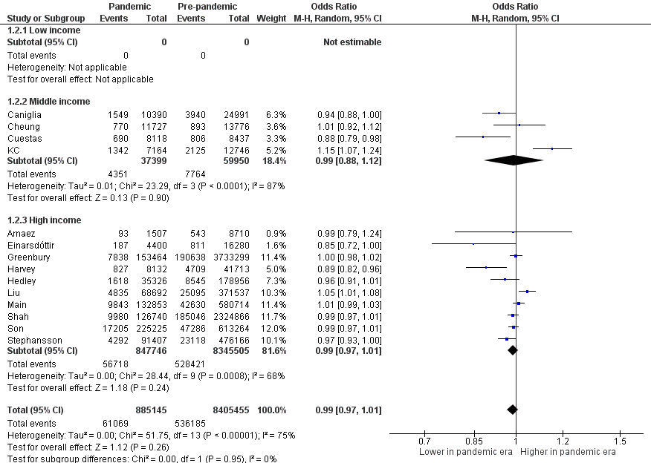
Abbreviations: CI, confidence interval; IV, inverse variance.
Appendix S5. Forest Plot for Odds of Preterm Birth <34 Weeks’ Gestation in Pandemic vs Pre-pandemic Periods by Single Center/Single Health Authority vs. Regional/National Studies
Abbreviations: CI, confidence interval; IV, inverse variance.
Appendix S6. Forest Plot for Odds of Preterm Birth <32 Weeks’ Gestation in Pandemic vs Pre-pandemic Periods by Single Center/Single Health Authority vs. Regional/National Studies
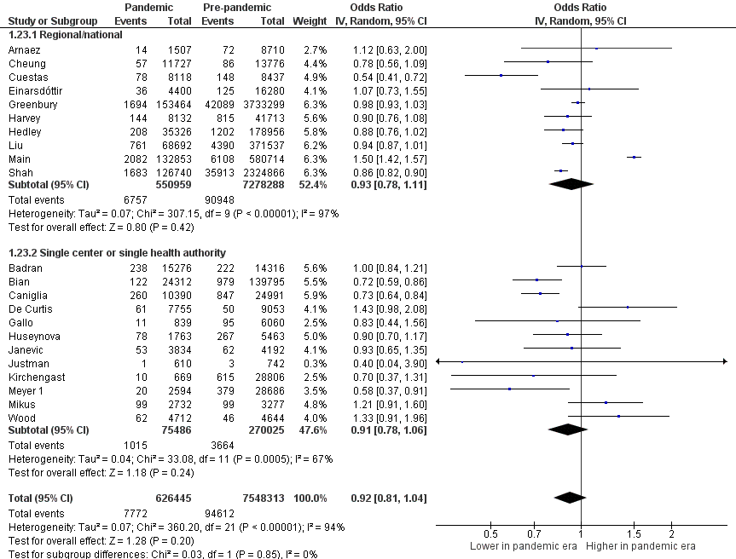
Abbreviations: CI, confidence interval; IV, inverse variance.
Appendix S7. Forest Plot for Odds of Preterm Birth <28 Weeks’ Gestation in Pandemic vs Pre-pandemic Periods by Single Center/Single Health Authority vs. Regional/National Studies
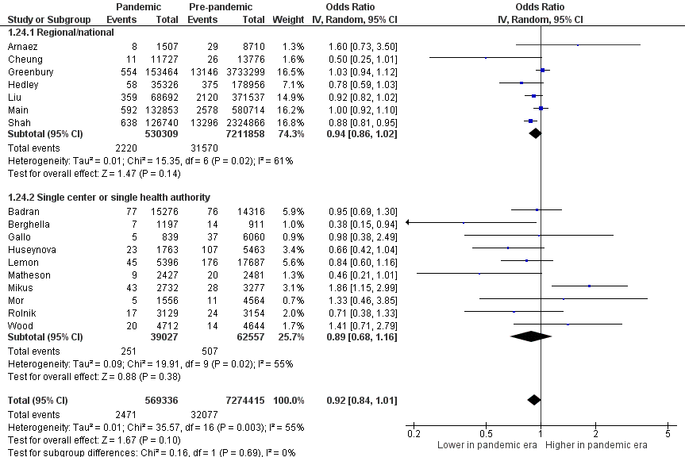
Abbreviations: CI, confidence interval; IV, inverse variance.
Appendix S8. Forest Plot for Odds of Spontaneous Preterm Birth in Pandemic vs Pre-pandemic Periods
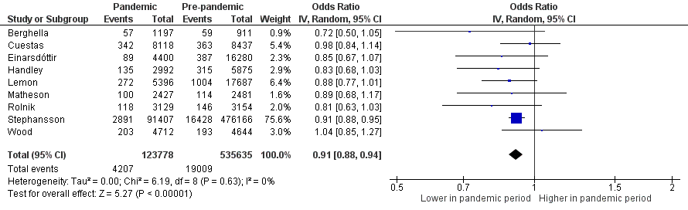

Abbreviations: CI, confidence interval; IV, inverse variance.
Appendix S9. Forest Plot for Odds of Induced Preterm Birth in Pandemic vs Pre-pandemic Periods
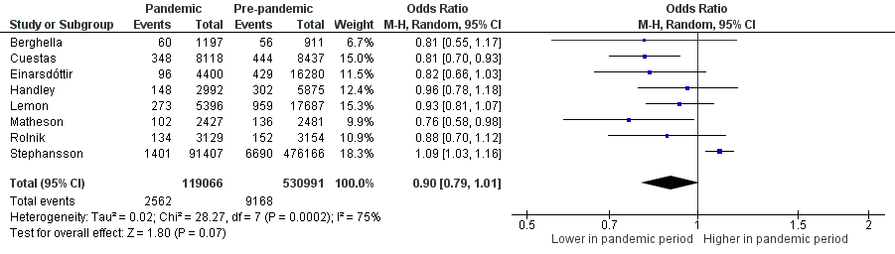
Abbreviations: CI, confidence interval; IV, inverse variance.
Appendix S10. Forest Plot for Odds of Stillbirth in Single Centre/Single Health Authority by Income Level of Country
Abbreviations: CI, confidence interval; IV, inverse variance.
Appendix S11. Forest Plot for Odds of Stillbirth in Regional/National Studies by Income Level of Country
Abbreviations: CI, confidence interval; IV, inverse variance.

Appendix S12. Forest Plot for Adjusted Odds of Stillbirth
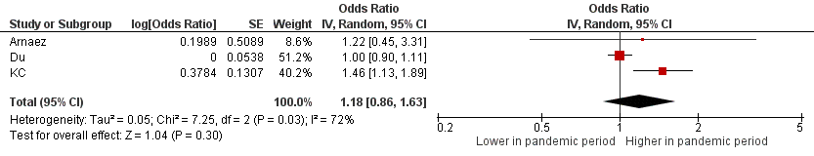
Abbreviations: CI, confidence interval; IV, inverse variance.
Appendix S13. Forest Plot for Mean Difference in Birth Weight in Pandemic vs Pre-pandemic Periods
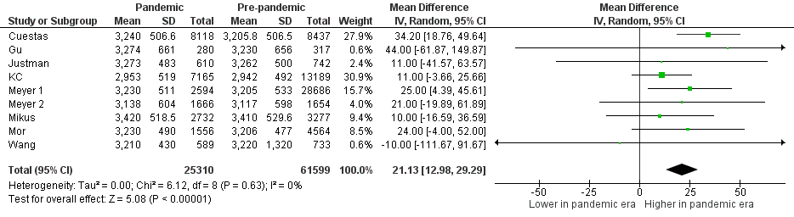
Abbreviations: CI, confidence interval; IV, inverse variance; SD, standard deviation.

Appendix S14. Forest Plot for Odds of Low Birth Weight by Single Center/Single Health Authority vs. Regional/National Studies
Abbreviations: CI, confidence interval; IV, inverse variance.
Appendix S15. Forest Plot for Odds of Very Low Birth Weight in Pandemic vs Pre-pandemic Periods
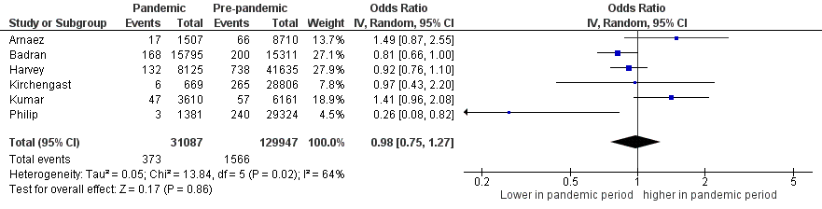
Abbreviations: CI, confidence interval; IV, inverse variance.
Appendix S16. Forest Plot for Odds of Extremely Low Birth Weight in Pandemic vs Pre-pandemic Periods
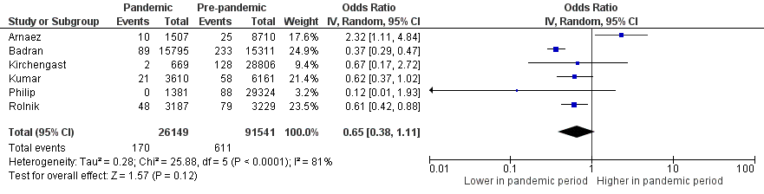
Abbreviations: CI, confidence interval; IV, inverse variance.

Appendix S17. Forest Plot for Odds of Neonatal Mortality in Pandemic vs Pre-pandemic Periods
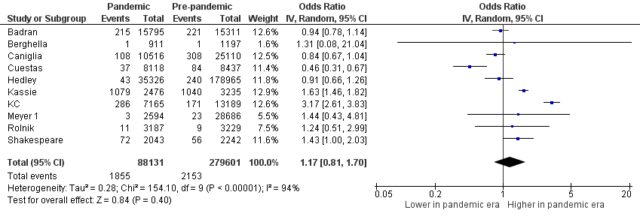
Abbreviations: CI, confidence interval; IV, inverse variance.

Appendix S18. Funnel Plot for Preterm Birth <37 Weeks’ Gestation

Appendix S19. Funnel Plot for Stillbirth

