Appendix 1 Search strategy
MEDLINE
1. exp Cholestasis, Intrahepatic/
2. ((cholestas* and (hepat* or liver*)) or jaundice or icterus graviardum).mp. [mp=title, abstract, original title, name of substance word, subject heading word, keyword heading word, protocol supplementary concept word, rare disease supplementary concept word, unique identifier]
3. 1 or 2
4. exp Pregnancy/
5. (pregnan* or obstetric* or gestation*).mp. [mp=title, abstract, original title, name of substance word, subject heading word, keyword heading word, protocol supplementary concept word, rare disease supplementary concept word, unique identifier]
6. 3 or 4
7. hyperlipidemia OR dyslipidemia OR hyperlipidemic OR hypolipidemic OR hypercholesterolemic OR hypercholesterolemia OR dyslipidemic OR hypocholesterolemic OR hypertriglyceridemia OR hypotriglyceridemic OR high-density lipoprotein OR low-density lipoprotein OR dyslipoproteinemia OR lipoprotein disorder OR hyperlipoproteinemia OR hypolipoproteinemia OR triglycerides OR total cholesterol
8. 3 and 5 and 6

EMBASE
1. exp intrahepatic cholestasis/
2. ((cholestas* and (hepat* or liver*)) or jaundice or icterus graviardum).mp. [mp=title, abstract, heading word, drug trade name, original title, device manufacturer, drug manufacturer, device trade name, keyword]
3. 1 or 2
4. exp pregnancy/
5. (pregnan* or obstetric* or gestation*).mp. [mp=title, abstract, heading word, drug trade name, original title, device manufacturer, drug manufacturer, device trade name, keyword]
6. 4 or 5
7. hyperlipidemia OR dyslipidemia OR hyperlipidemic OR hypolipidemic OR hypercholesterolemic OR hypercholesterolemia OR dyslipidemic OR hypocholesterolemic OR hypertriglyceridemia OR hypotriglyceridemic OR high-density lipoprotein OR low-density lipoprotein OR dyslipoproteinemia OR lipoprotein disorder OR hyperlipoproteinemia OR hypolipoproteinemia OR triglycerides OR total cholesterol
8. 3 and 6 and 7

COCHRANE LIBRARY
#1 MeSH descriptor: [Cholestasis, Intrahepatic] explode all trees
#2 (cholestas* and (hepat* or liver*)) or jaundice or icterus graviardum
#3 #1 or #2
#4 MeSH descriptor: [Pregnancy] explode all trees
#5 pregnan* or obstetric* or gestation*
#6 #4 or #5
#7 (hyperlipidemia OR dyslipidemia OR hyperlipidemic OR hypolipidemic OR hypercholesterolemic OR hypercholesterolemia OR dyslipidemic OR hypocholesterolemic OR hypertriglyceridemia OR hypotriglyceridemic OR high-density lipoprotein OR low-density lipoprotein OR dyslipoproteinemia OR lipoprotein disorder OR hyperlipoproteinemia OR hypolipoproteinemia OR triglycerides OR total cholesterol)
#8 #3 and #6 and #7

Appendix 2 Sensitivity analysis
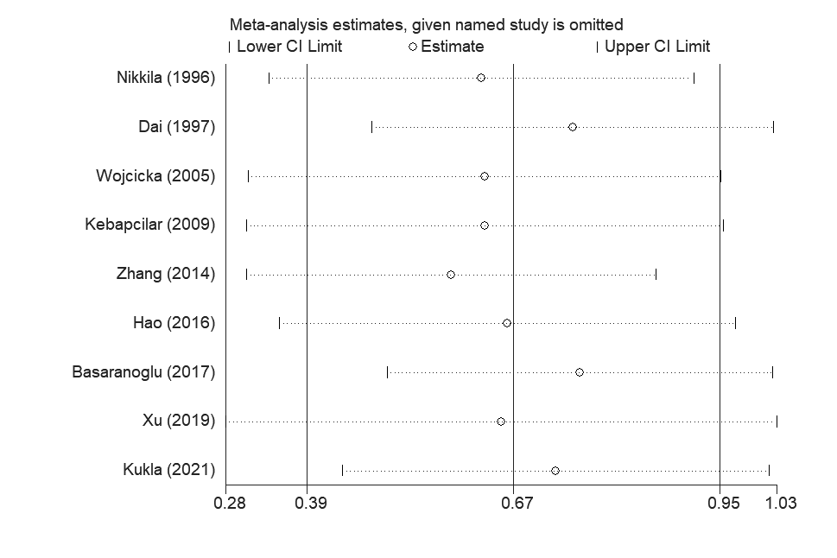
- Sensitivity analysis for individual studies on the summary effect. (ICP and TG)
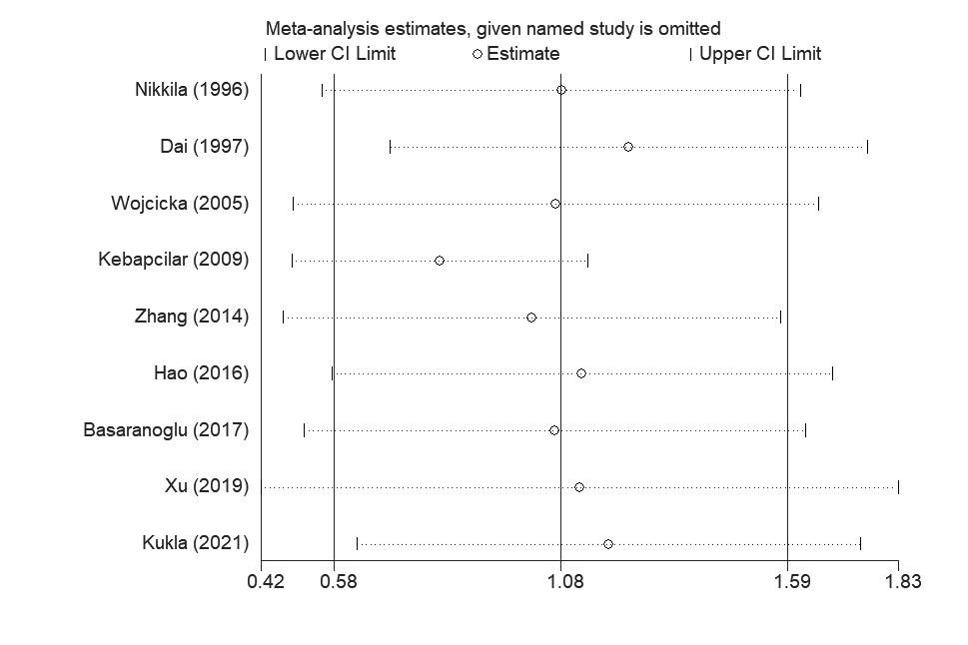
- Sensitivity analysis for individual studies on the summary effect. (ICP and TC)
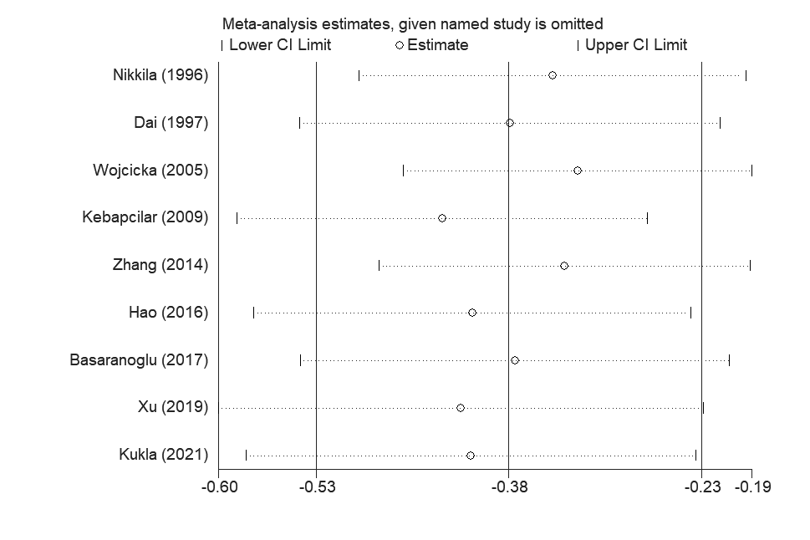
- Sensitivity analysis for individual studies on the summary effect. (ICP and HDL-cholesterol)
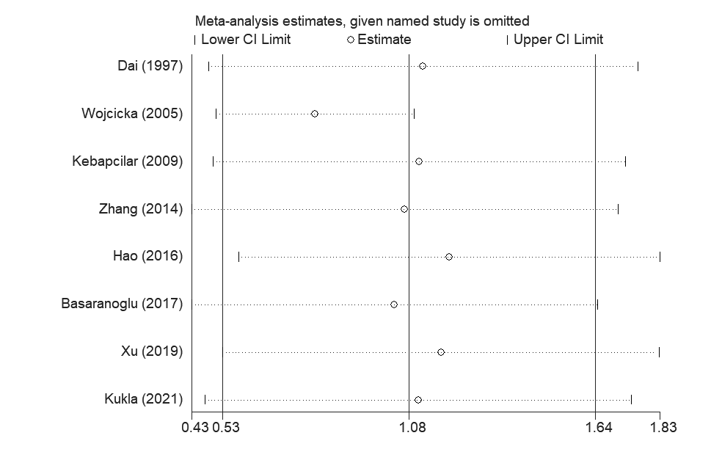
- Sensitivity analysis for individual studies on the summary effect. (ICP and LDL-cholesterol)

Appendix 3 Funnel plot
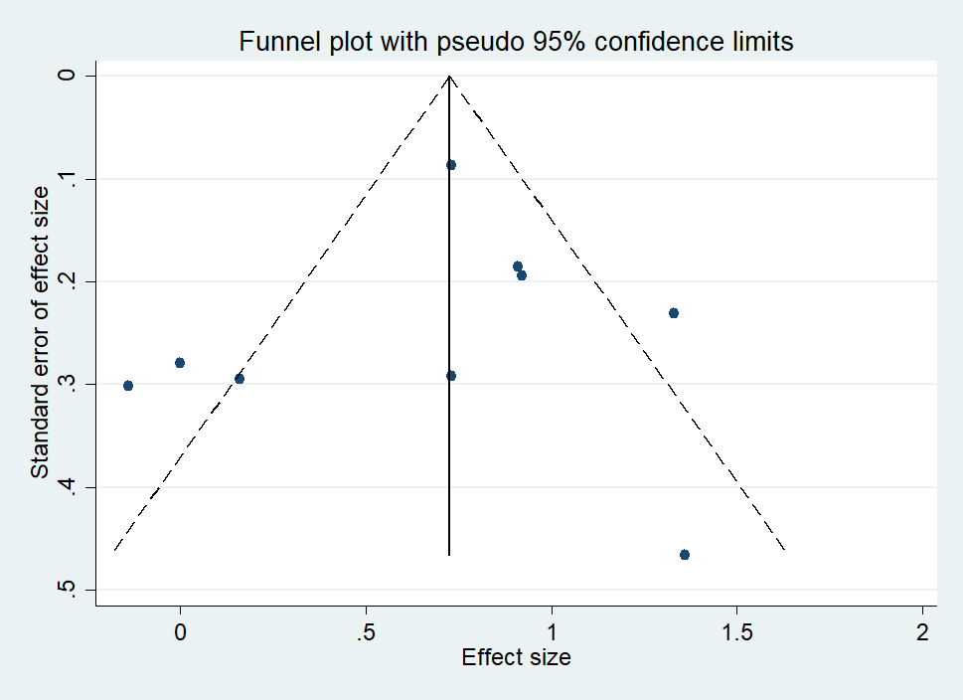
- Funnel plot of the included studies in the meta-analysis. (ICP and TG)

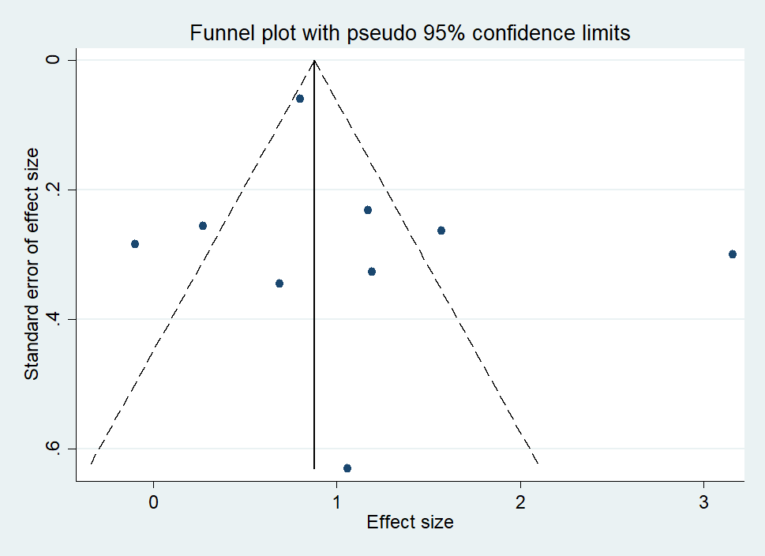
- Funnel plot of the included studies in the meta-analysis. (ICP and TC)
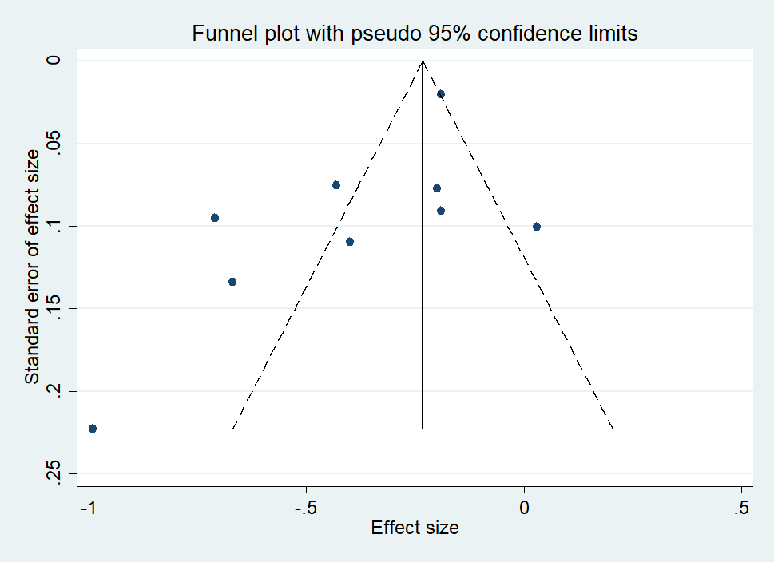
- Funnel plot of the included studies in the meta-analysis. (ICP and HDL-cholesterol)

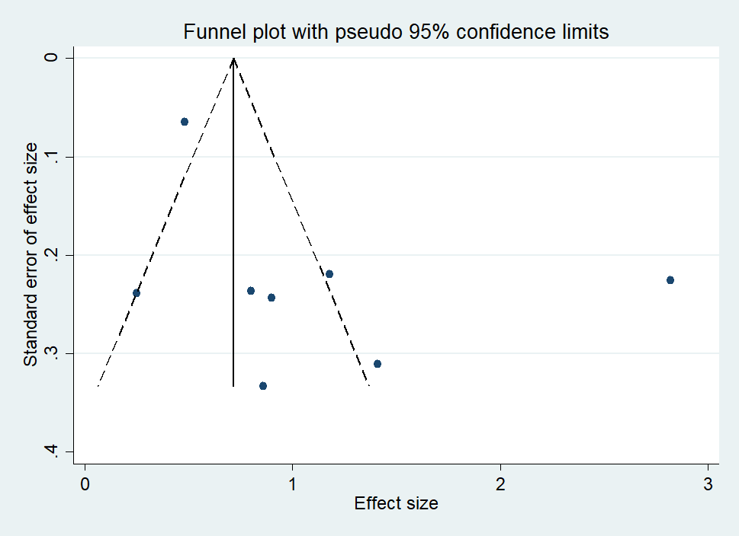
- Funnel plot of the included studies in the meta-analysis. (ICP and LDL-cholesterol)

