Supplementary Material
Table of Contents
1. PRISMA Guidelines 2
1.1. Supplementary Figure 1. Checklist Summarizing Compliance with PRISMA Guidelines 2
2. MOOSE Guidelines 3
2.1. Supplementary Figure 2. Checklist Summarizing Compliance with Meta-analyses of Observational Studies (MOOSE) Guidelines 3
3. Search strings used in the selected electronic databases 4
4. PRISMA Flow Diagram 5
4.1. Figure 1. PRISMA flow diagram showing the search, article selection, and extraction process for the search regarding the psychotropic drug repurposing for COVID-19 5
5. Studies included narrative synthesis only 6
5.1. Supplementary Table 1. Characteristics of the included computational studies and narrative synthesis of results 6
5.2. Supplementary Table 2. Characteristics of the included preclinical studies and narrative synthesis of results 7
6. Quality assessment of the included studies 8
6.1. Supplementary Table 3. Quality assessment of the included computational studies, following the previous description of Mohamed et al. (2021) 8
6.2. OHAT Risk of Bias assessment tool 8
6.3. Supplementary Table 4. Risk of bias analysis of the preclinical studies according to criteria based on OHAT tool 9
6.4. Supplementary Table 5. Quality assessment of the included clinical cohort or case-control studies 10
6.5. Supplementary Table 3. Quality assessment of the included clinical cohort or case-control studies 10
7. Additional Analyses 11
7.1. Supplementary Figure 3. Meta-analysis of the association between serotonin selective reuptake inhibitors (SSRI) or other antidepressants and severe COVID-19. 11

PRISMA Guidelines

Supplementary Figure 1. Checklist Summarizing Compliance with PRISMA Guidelines

Section and Topic | Item # | Checklist item | Location where item is reported
TITLE
Title | 1 | Identify the report as a systematic review. | 1
ABSTRACT
Abstract | 2 | See the PRISMA 2020 for Abstracts checklist. | 2
INTRODUCTION
Rationale | 3 | Describe the rationale for the review in the context of existing knowledge. | 5
Objectives | 4 | Provide an explicit statement of the objective(s) or question(s) the review addresses. | 5
METHODS
Eligibility criteria | 5 | Specify the inclusion and exclusion criteria for the review and how studies were grouped for the syntheses. | 6
Information sources | 6 | Specify all databases, registers, websites, organisations, reference lists and other sources searched or consulted to identify studies. Specify the date when each source was last searched or consulted. | 6
Search strategy | 7 | Present the full search strategies for all databases, registers and websites, including any filters and limits used. | 6-supplementary
Selection process | 8 | Specify the methods used to decide whether a study met the inclusion criteria of the review, including how many reviewers screened each record and each report retrieved, whether they worked independently, and if applicable, details of automation tools used in the process. | 6
Data collection process | 9 | Specify the methods used to collect data from reports, including how many reviewers collected data from each report, whether they worked independently, any processes for obtaining or confirming data from study investigators, and if applicable, details of automation tools used in the process. | 6
Data items | 10a | List and define all outcomes for which data were sought. Specify whether all results that were compatible with each outcome domain in each study were sought (e.g. for all measures, time points, analyses), and if not, the methods used to decide which results to collect. | 6
Data items | 10b | List and define all other variables for which data were sought (e.g. participant and intervention characteristics, funding sources). Describe any assumptions made about any missing or unclear information. | 6
Study risk of bias assessment | 11 | Specify the methods used to assess risk of bias in the included studies, including details of the tool(s) used, how many reviewers assessed each study and whether they worked independently, and if applicable, details of automation tools used in the process. | 6
Effect measures | 12 | Specify for each outcome the effect measure(s) (e.g. risk ratio, mean difference) used in the synthesis or presentation of results. | 6
Synthesis methods | 13a | Describe the processes used to decide which studies were eligible for each synthesis (e.g. tabulating the study intervention characteristics and comparing against the planned groups for each synthesis (item #5)). | 7
Synthesis methods | 13b | Describe any methods required to prepare the data for presentation or synthesis, such as handling of missing summary statistics, or data conversions. | 7
Synthesis methods | 13c | Describe any methods used to tabulate or visually display results of individual studies and syntheses. | 7
Synthesis methods | 13d | Describe any methods used to synthesize results and provide a rationale for the choice(s). If meta-analysis was performed, describe the model(s), method(s) to identify the presence and extent of statistical heterogeneity, and software package(s) used. | 7
Synthesis methods | 13e | Describe any methods used to explore possible causes of heterogeneity among study results (e.g. subgroup analysis, meta-regression). | 7
Synthesis methods | 13f | Describe any sensitivity analyses conducted to assess robustness of the synthesized results. | 7
Reporting bias assessment | 14 | Describe any methods used to assess risk of bias due to missing results in a synthesis (arising from reporting biases). | 7
Certainty assessment | 15 | Describe any methods used to assess certainty (or confidence) in the body of evidence for an outcome. | 7
RESULTS
Study selection | 16a | Describe the results of the search and selection process, from the number of records identified in the search to the number of studies included in the review, ideally using a flow diagram. | 7
Study selection | 16b | Cite studies that might appear to meet the inclusion criteria, but which were excluded, and explain why they were excluded. | 7
Study characteristics | 17 | Cite each included study and present its characteristics. | 8
Risk of bias in studies | 18 | Present assessments of risk of bias for each included study. | 17
Results of individual studies | 19 | For all outcomes, present, for each study: (a) summary statistics for each group (where appropriate) and (b) an effect estimate and its precision (e.g. confidence/credible interval), ideally using structured tables or plots. | 8
Results of syntheses | 20a | For each synthesis, briefly summarise the characteristics and risk of bias among contributing studies. | 8
Results of syntheses | 20b | Present results of all statistical syntheses conducted. If meta-analysis was done, present for each the summary estimate and its precision (e.g. confidence/credible interval) and measures of statistical heterogeneity. If comparing groups, describe the direction of the effect. | 8
Results of syntheses | 20c | Present results of all investigations of possible causes of heterogeneity among study results. | 8
Results of syntheses | 20d | Present results of all sensitivity analyses conducted to assess the robustness of the synthesized results. | 8
Reporting biases | 21 | Present assessments of risk of bias due to missing results (arising from reporting biases) for each synthesis assessed. | 17
Certainty of evidence | 22 | Present assessments of certainty (or confidence) in the body of evidence for each outcome assessed. | 17
DISCUSSION
Discussion | 23a | Provide a general interpretation of the results in the context of other evidence. | 17
Discussion | 23b | Discuss any limitations of the evidence included in the review. | 18
Discussion | 23c | Discuss any limitations of the review processes used. | 18
Discussion | 23d | Discuss implications of the results for practice, policy, and future research. | 19
OTHER INFORMATION
Registration and protocol | 24a | Provide registration information for the review, including register name and registration number, or state that the review was not registered. | 6
Registration and protocol | 24b | Indicate where the review protocol can be accessed, or state that a protocol was not prepared. | 6
Registration and protocol | 24c | Describe and explain any amendments to information provided at registration or in the protocol. | 6
Support | 25 | Describe sources of financial or non-financial support for the review, and the role of the funders or sponsors in the review. | 6
Competing interests | 26 | Declare any competing interests of review authors. | 2
Availability of data, code and other materials | 27 | Report which of the following are publicly available and where they can be found: template data collection forms; data extracted from included studies; data used for all analyses; analytic code; any other materials used in the review. | 2

MOOSE Guidelines

Supplementary Figure 2. Checklist Summarizing Compliance with Meta-analyses of Observational Studies (MOOSE) Guidelines
Item No | Recommendation | Reported on Page Nº
Reporting of background should include
1 | Problem definition | 1
2 | Hypothesis statement | 2
3 | Description of study outcome(s) | 2
4 | Type of exposure or intervention used | 2
5 | Type of study designs used | 2
6 | Study population | 2
Reporting of search strategy should include
7 | Qualifications of searchers (eg, librarians and investigators) | 3
8 | Search strategy, including time period included in the synthesis and key words | 3, supplementary
9 | Effort to include all available studies, including contact with authors | 3
10 | Databases and registries searched | 3
11 | Search software used, name and version, including special features used (eg, explosion) | 3
12 | Use of hand searching (eg, reference lists of obtained articles) | 4
13 | List of citations located and those excluded, including justification | 4
14 | Method of addressing articles published in languages other than English | 5
15 | Method of handling abstracts and unpublished studies | 6
16 | Description of any contact with authors | 6
Reporting of methods should include
17 | Description of relevance or appropriateness of studies assembled for assessing the hypothesis to be tested | 6
18 | Rationale for the selection and coding of data (eg, sound clinical principles or convenience) | 6
19 | Documentation of how data were classified and coded (eg, multiple raters, blinding and interrater reliability) | 7
20 | Assessment of confounding (eg, comparability of cases and controls in studies where appropriate) | 7
21 | Assessment of study quality, including blinding of quality assessors, stratification or regression on possible predictors of study results | 6
22 | Assessment of heterogeneity | 7
23 | Description of statistical methods (eg, complete description of fixed or random effects models, justification of whether the chosen models account for predictors of study results, dose-response models, or cumulative meta-analysis) in sufficient detail to be replicated | 7
24 | Provision of appropriate tables and graphics | 8-10
Reporting of results should include
25 | Graphic summarizing individual study estimates and overall estimate | 10
26 | Table giving descriptive information for each study included | 11
27 | Results of sensitivity testing (eg, subgroup analysis) | 11
28 | Indication of statistical uncertainty of findings | 11

Search strings used in the selected electronic databases

- MEDLINE/Pubmed/Index Medicus: ((COVID[MeSH Terms] OR covid-19[Title/Abstract] OR SARS-CoV-2[Title/Abstract])) AND (lithium[Title/Abstract] OR mood stabiliz*[Title/Abstract] OR mood stabil*[Title/Abstract] OR antipsychot*[Title/Abstract] OR antidepress*[Title/Abstract] OR antiepilep* [Title/Abstract])) OR psychotrop* [Title/Abstract] OR anxioly* [Title/Abstract]
- Embase-Scopus: ALL ( ( covid-19 OR sars-cov-2 ) AND ( lithium OR mood stabiliz* OR antipsychot* OR antidepress*or AND antiepilep* ) )
- PsycINFO: (Any Field: covid-19 OR sars-cov-2) AND (Any Field: lithium OR mood stabiliz* OR antipsychot* OR antidepress*or AND antiepilep*)
- Clinicaltrials.gov: psychotropic | Covid19

PRISMA Flow Diagram

Figure 1. PRISMA flow diagram showing the search, article selection, and extraction process for the search regarding the psychotropic drug repurposing for COVID-19

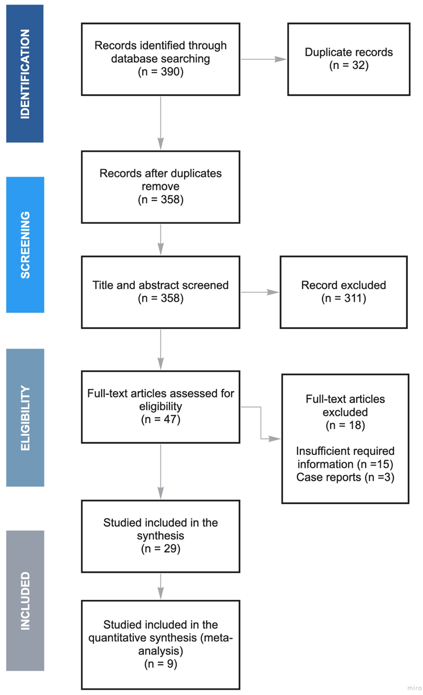

Studies included narrative synthesis only

Supplementary Table 1. Characteristics of the included computational studies and narrative synthesis of results
Study and Location | Method/  Protocol/  Pipeline | Drug | Selected Software | Starting Dataset | Result highlights
Naasani, 2020, Europe | In vitro testing/COMPARE analysis | Several antiarrhythmics, nucleosides, antipsychotics, alkaloids, antibiotics, and vitamins | NCI Database Browser 2.2 | NCI’s DTP repository : includes the growth inhibitory patterns of more than 55,000 molecules. | Several clinically approved drugs showed potential anti-COVID-19 activity.  1) Psychotropic drugs: Valproic acid, thiothixene  2) Other drugs: lucanthone, amiodarone, ethacizine, methotrexate, azabirine, Brequinar, retinol, flucloxacillin, didanosine, uridine, several corticosteroids, scopolamine, nicotinamide, succimer, 2’-Deoxyuridine
Pandey et al., 2020, USA | Molecular docking–based molecular dynamics simulation study | Haloperidol and Dextromethorphan | GROMACS v5.1.4 | ZINC Database | Dextromethorphan binding leads to structural destabilization and increase in conformational dynamics and energetic frustrations.  The strong binding of haloperidol leads to minimal structural and dynamical perturbations to NSP6.
Udrea et al., 2020, Europe | Molecular docking | Drugs from the class of phenothiazines including Thioridazine  (TZ) and Clorpromazine (CPZ) | Autodock 4.2.6 | RCSB Protein Data Bank | Thioridazine and its identified photoproducts (mesoridazine and sulforidazine) have high biological activity on the SARS-CoV-2 main protease
Loschwitz et al., 2021, Europe | Molecular dynamics stimulation/In vitro | 147 compounds including 61 FDA-approved drugs, 38 Non-FDA drugs, 39 natural products, and nine steroids | GROMACS 2018 | General AMBER force field (GAFF) parameters of the 160 organic molecules (data from previous research) | Eight compounds found to inhibit 3CL^{pro} enzyme of SARS-CoV-2:  - Lurasidone  - Corilagin, rhoifolin, ZINC000011865175, apixaban, dasatinib, cilostazol, and telcagepant
Khater et al., 2021, Egypt | Molecular docking–based molecular dynamics simulation study | Fluoxetine hydrochloride (FH) loaded in lipid polymer hybrid (LPH) | Autodock 1.5.6 | Pubchem | FH effectively bind with SARS-COV-2 main protease via hydrogen bond formation (-6.7 kcal/mol). The optimization of FH-LPH formulation achieved 65.1 ± 2.7% encapsulation efficiency, 10.3 ± 0.4% loading efficiency, 98.5 ± 3.5 nm particle size, and − 10.5 ± 0.45 mV zeta potential.

Supplementary Table 2. Characteristics of the included preclinical studies and narrative synthesis of results
Study and Location | Drugs | Targets | Animal model characteristics | Cell lines studied | Result highlights
Schloer et al., 2021, Europe | Itraconazole, Fluoxetine, Remdesivir | Host-cells | Not applicable | Bronchial epithelial cell lines Calu-3 and the Vero E6 cells | Itraconazole–remdesivir and fluoxetine–remdesivir combinations inhibited the production of infectious SARS-CoV-2 particles > 90%.
Creeden et al., 2021, USA | Fluoxetine,  Paroxetine, Buproprion,  Dexamethasone | NF-kB and its downstream target IL6 pathway | Not applicable | 45 different cells lines treated with fluoxetine,  paroxetine, buproprion,  or dexamethasone | Fluoxetine show a non-serotonergic, anti-inflammatory by  decreasing NF-kappaB signaling and the IL6 cascade linked to the destructive cytokine  storm in COVID-19
Plaze et al., 2021, Europe | Clorpromazine | Clathrin and AP2 of cell surface, implicated in clathrin-mediated endocitosis | Not applicable | Monkey VeroE6 cells and human alveolar basal epithelial A549-ACE2 cells infected with SARS-CoV-2 in the presence of various concentrations of CPZ. | CPZ was found to have antiviral activity against SARS-CoV-2 in monkey VeroE6 cells, with a half maximal inhibitory concentration (IC₅₀) of 8.2 µM, half maximal cytotoxic concentration (CC₅₀) of 13.5 µM, and selectivity index (SI) of 1.65. In human A549-ACE2 cells, CPZ was also found to have anti-SARS-CoV-2 activity, with IC₅₀ of 11.3 µM, CC₅₀ of 23.1 µM and SI of 2.04.
Lu et al., 2021, China | 19 different antipsychotics (APS) | ACE2 protein | Not applicable | ACE2 high-expressing HEK293T cells (ACE2^{hi} cells) | 5 APS showed significant antiviral activities in vitro.  Three quarters of them belong to phenothiazine and could significantly inhibit the entrance of coronavirus into ACE2-HEK293T cells. Aripiprazole and tiapride exhibited weaker inhibition.
Carpinteiro et al., 2020, Europe | Amitriptyline, imipramine, fluoxetine, sertraline, escitalopram, or maprotiline | Acid sphingomyelinase | Not applicable | Vero cells infected with SARS-CoV-2  Cultured cells or freshy isolated human nasal epithelial cells with severe SARS-CoV-2 | All tested drugs at concentrations between 5 μM and 35 μM inhibited acid sphingomyelinase activity, prevented the entry of pp-VSV-SARS-CoV-2 spike, and prevented the upregulation of surface ACE2 as marker for the infection, but had no effect on the infection of cells with pp-VSV-G.  Low dose of amitriptyline prevents infection of freshly isolated nasal epithelial cells with pp-VSV-SARS-CoV-2 spike.
Schloer et al., 2020, Europe | Fluoxetine, amiodarone and imipramine | Acid sphingomyelinase | Not applicable | Calu-3 and Vero E6 cells infected with SARS-CoV-2 and IAV (influenza A) | Fluoxetine inhibited the entry and propagation of SARS-CoV-2 in the cell culture model without cytotoxic effects
Viet et al., 2020, USA | Lithium | Senescence-associated secreted phenotypes (SASP) | Not applicable | Human iPSC-derived astrocytes | Low-dose lithium can reduce the SASP of human iPSCs-derived astrocytes following acute treatment
Gordon et al., 2020, USA | 69 compounds (29 FDA-approved drugs, 12 drugs in clinical trials, and 28 preclinical compounds) | 26 SARS-CoV-2 proteins | Not applicable | Human cells | Inhibitors of mRNA translation and predicted regulators of the Sigma1 and Sigma2 receptors displayed antiviral activity
Brunotte et al., 2021, Europe | Remdesivir metabolite GS-441524, fluoxetine | Three SARS-CoV-2 variants | Not applicable | Polarized Calu-3 cell culture | GS-441524 and fluoxetine were well-tolerated and displayed synergistic antiviral effects against SARS-CoV-2

Quality assessment of the included studies

Supplementary Table 3. Quality assessment of the included computational studies, following the previous description of Mohamed et al. (2021)

Author | Target |  | The target template modeling |  |  | Docking tools |  | Molecular dynamics simulation |  | Approved Drug Database
 | Mono | Multi | Crystal stucture | Homology modeling | Co-crystal ligand | Auto-Dock | Others | Yes | No | Mono | Multi
Naasani, 2020, Europe |  |  |  |  |  |  | Enhance NCI Database Browser 2.2 |  |  | NCI’s DTP repository
Pandey et al., 2020, USA |  |  |  |  |  |  |  |  |  | ZINC Database
Udrea et al., 2020, Europe |  |  |  |  |  |  |  |  |  | RCSB Protein Data Bank
Loschwitz et al., 2021, Europe |  |  |  |  |  |  |  |  |  |  | ZINC database, In-house database with 3200 natural compounds isolated from African plants
Khater et al., 2021, Egypt |  |  |  |  |  |  |  |  |  | Pubchem`

OHAT Risk of Bias assessment tool

Selection Bias
1. Was administered dose or exposure level adequately randomised?
2. Was allocation to study groups adequately concealed?
Confounding Bias
3. Did the study design or analyses account for important confounding and modifying variables?
Performance Bias
4. Were experimental conditions identical across study groups?
5. Were the research personnel and human subjects blinded to the study group in
the study?
Attrition/Exclusion Bias
6. Were outcome data complete without attrition or exclusion from analysis?
Detection Bias
7. Can we be confident in the exposure characterization?
8. Can we be confident in the outcome assessment?
Selective Reporting Bias
9. Were all measured outcomes reported?
Other Sources of Bias
10. Were there any other potential threats to internal validity (e.g., statistical methods
were appropriate and researchers adhered to study protocol?)

Answer Format: ‘definitely low risk of bias’ (++), ‘probably low risk of bias’ (+), ‘probably high risk of bias’ (-) or (NR), or ‘definitely high risk of bias’ (--)
https://ntp.niehs.nih.gov/ntp/ohat/pubs/riskofbiastool_508.pdf

Supplementary Table 4. Risk of bias analysis of the preclinical studies according to criteria based on OHAT tool

 | Selection Bias |  | Confounding Bias | Performance Bias |  | Attrition / Exclusion Bias | Detection Bias |  | Selective Reporting Bias | Other Sources of Bias
 | 1 | 2 | 3 | 4 | 5 | 6 | 7 | 8 | 9 | 10
Schloer et al., 2021 | (+) | (++) | NR | (++) | (+) | NR | (+) | (+) | (++) | (++)
Creeden et al., 2021 | (++) | (+) | NR | (++) | (+) | NR | (+) | (++) | (++) | (++)
Plaze et al., 2021 | (+) | (+) | NR | (++) | (+) | NR | (+) | (++) | (+) | (+)
Lu et al., 2021, | (+) | (+) | NR | (++) | (+) | NR | (+) | (+) | (++) | (+)
Carpinteiro et al., 2020 | (++) | (+) | NR | (++) | (++) | NR | (++) | (++) | (++) | (++)
Schloer et al., 2020 | (+) | (+) | NR | (++) | (+) | NR | (++) | (++) | (++) | (++)
Viet et al., 2020 | (+) | (+) | NR | (+) | (-) | NR | (+) | (+) | (+) | (+)
Gordon et al., 2020 | (++) | (+) | NR | (++) | (++) | NR | (++) | (++) | (++) | (++)
Brunotte et al., 2021 | (+) | (++) | NR | (++) | (+) | NR | (++) | (++) | (++) | (+)

Study can be categorized into three tiers, T1, T2 and T3, as proposed by the National Toxicology Program/Office for Health Assessment and Translation (NTP/OHAT). The tiers depend on ‘Key Questions’, which are randomization bias, outcome detection bias, and performance bias. Tier 1: Study must be rated as “definitely low” or “probably low” risk of bias for key elements AND have most other applicable items answered “definitely low” or “probably low” risk of bias. Tier 2: Study meets neither the criteria for tiers or is rated “Not Reported.” Tier 3: A study must be rated as “definitely high” or “probably high” risk of bias for key elements AND have most other applicable items answered “definitely high” or “probably high” risk of bias.

Supplementary Table 5. Quality assessment of the included clinical cohort or case-control studies

 |  | NEWCASTLE-OTTAWA SCALE CASE-CONTROL STUDIES (http://www.ohri.ca/programs/clinical_epidemiology/oxford.asp)
Author | Year | Selection—Case definition | Selection - Representativeness of the cases | Selection - Selection of  controls | Selection - Definition of controls | Compara bility of  cases and controls | Exposure - Ascertainment of exposure | Exposure- Nonresponse  rate |  | Quality rating
McKeigue | 2021 | * | * | * |  | * | * |  |  | Poor
Harrison | 2021 | * | * | * | * | * |  | * |  | Good
 |  | NEWCASTLE-OTTAWA SCALE COHORT STUDIES (http://www.ohri.ca/programs/clinical_epidemiology/oxford.asp)
Author | Year | Selection - Representativeness of exposed cohort | Selection - Representativeness of the unexposed cohort | Selection - Ascertainment of exposure | Selection - Demonstration, outcome of the study, was not present at the beginning of the study | Comparbility of  cohorts | Outcome- Assessment of  outcome | Outcome -Follow-up  long enough | Outcome - Adequacy of follow-up  cohorts | Quality rating
Diez-Quevedo | 2021 |  |  | * |  | * | * | * | * | Poor
Govind | 2020 | * | * | * |  | * | * | * |  | Good
Hoertel | 2021a | * | * | * |  | * | * | * |  | Good
McKeigue | 2021 | * |  |  |  | * | * | * | * | Poor
Hoertel | 2021b | * | * | * |  | * | * | * |  | Good
Harrison | 2021 | * | * | * |  | * | * | * | * | Good
Pun | 2021 | * | * | * |  | * | * | * | * | Good
Poblador-Plou | 2021 | * |  | * | * |  | * | * | * | Good
Crespo-Facorro | 2021 | * | * |  |  | * | * |  |  | Fair
Fei | 2021 |  |  |  | * | * | * |  |  | Poor
Clelland | 2021 | * | * | * |  | * | * | * |  | Good
Nemani | 2021 | * | * | * | * | * | * | * | * | Good
Oskotsky | 2021 | * | * | * |  | * | * | * |  | Good
Ohlis | 2021 | * | * | * |  | * | * | * |  | Good

Supplementary Table 3. Quality assessment of the included clinical cohort or case-control studies

COCHRANE RISK OF BIAS TOOL FOR RANDOMIZED CONTROLLED TRIALS
(http://methods.cochrane.org/bias/sites/methods.cochrane.org.bias/files/public/uploads/6.%20Assessing%20risk%20of%20bias%20in%20included%20studies%20v1.0%20Stan dard%20author%20slides.pdf)
Author | Year | Random sequence generation | Allocation concealment | Blinding of participants | Blinding of evaluator (self-reported) | Blinding of evaluator (objective  measures) | Incomplete outcome data | Selective reporting | Other bias | Overall
Lenze | 2021 | Low risk | Low risk | Low risk | Unclear | Low risk | Low risk | Low risk | - | Low risk
Reis | 2021 | Low risk | Unclear | Low risk | Unclear | Low risk | Low risk | Low risk | - | Low risk

Additional Analyses

Supplementary Figure 3. Meta-analysis of the association between serotonin selective reuptake inhibitors (SSRI) or other antidepressants and severe COVID-19.
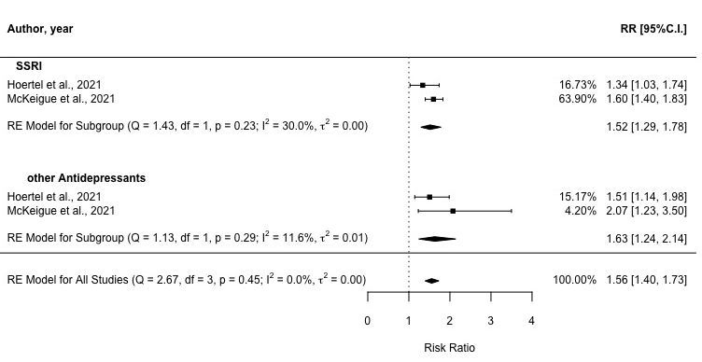

Risk of severe COVID-19 is expressed as risk ratio (RR), unadjusted. The three diamonds represents respectively the pooled RR for the association of SSRI, other ADs than SSRI, and all ADs and severe COVID-19 and corresponding 95 % CI.

