Figure 1: PRISMA flow diagram showing search strategy for meta-analysis comparing COVID-19 patients with and without venous thromboembolism
Additional records identified through other sources
(n = 201)
Records identified through database searching
(n = 1222)
Records screened
(n = 56)
Records after duplicates removed
(n = 56)

Screening

Eligibility
Records excluded
(n = 18 due to no data on outcomes of interest)

Identification

Included

Full-text articles excluded, with reasons
(n = 8)
5 – no direct comparison
3- editorials/reviews

Full-text articles assessed for eligibility
(n = 36)

Studies included in qualitative synthesis
(n = 28)

Studies included in quantitative synthesis (meta-analysis)
(n = 28)

Figure 2: Forest plot showing results of meta-analysis comparing COVID-19 patients with
and without venous thromboembolism and association with the male sex.
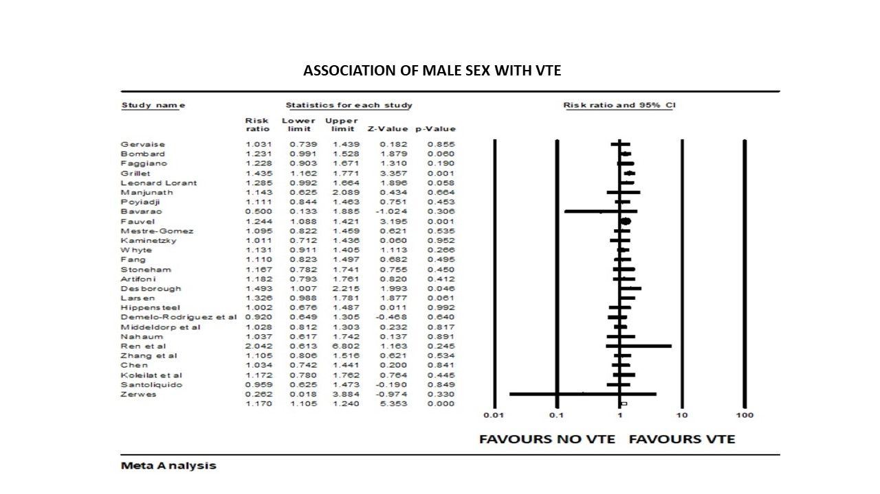

Figure 3: Forest plot showing results of meta-analysis comparing COVID-19 patients with
and without venous thromboembolism and association with smoking.
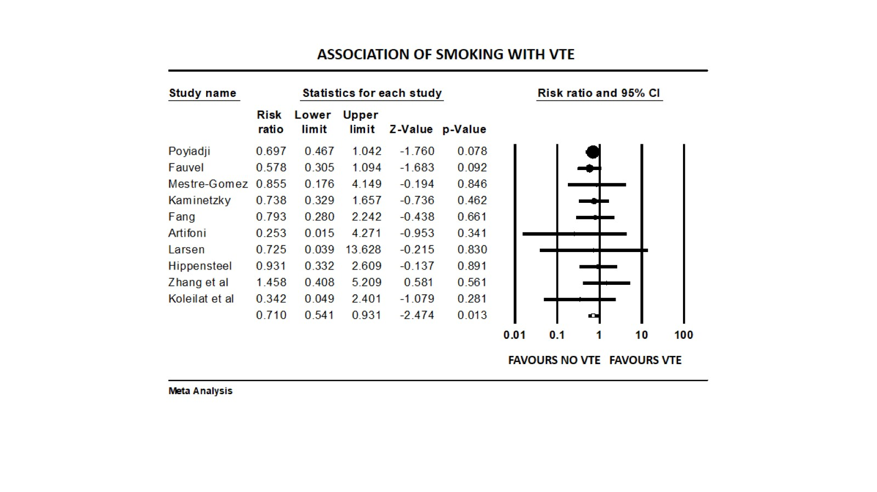

Figure 4: Forest plot showing meta-analysis results comparing COVID-19 patients with
and without venous thromboembolism and association with severe and critical illness.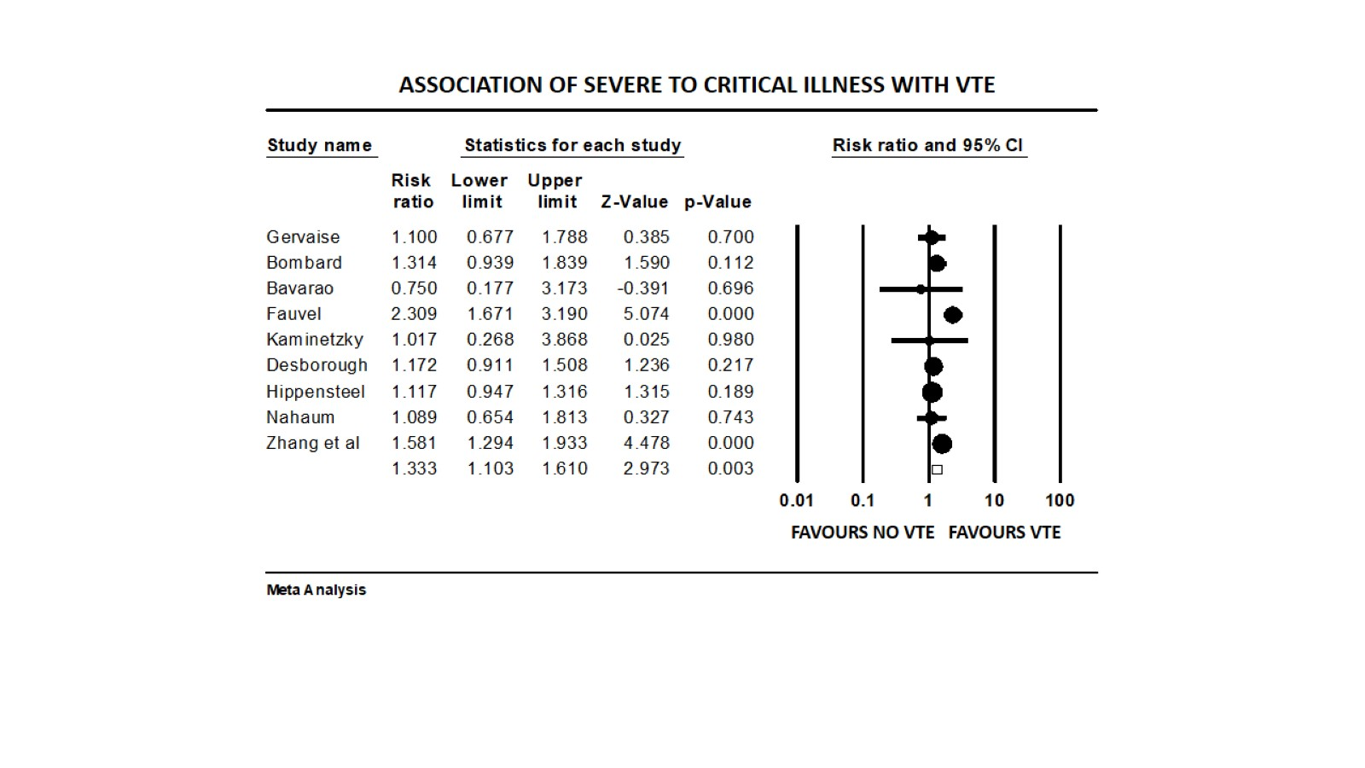

Figure 5: Forest plot showing results of meta-analysis comparing COVID-19 patients with
and without venous thromboembolism and association with length of stay.
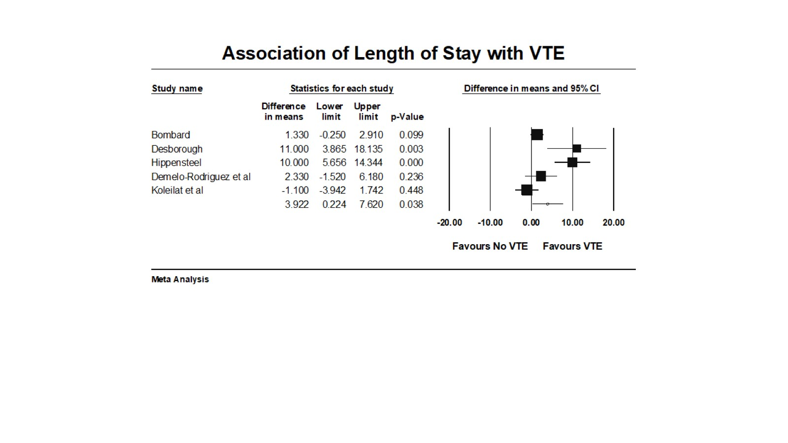

Figure 6: Forest plot showing results of meta-analysis comparing COVID-19 patients with
and without venous thromboembolism and association with ICU admission

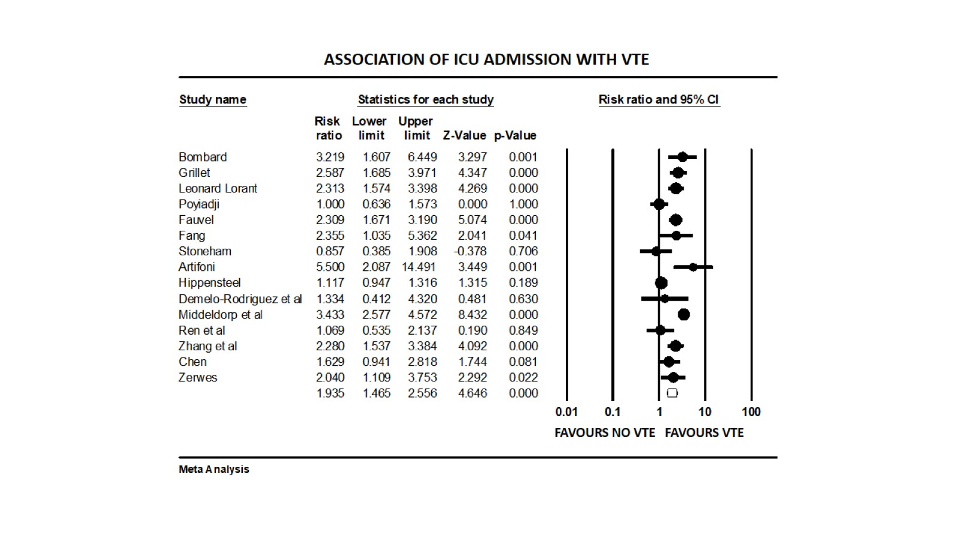

Figure 7: Forest plot showing results of meta-analysis comparing COVID-19 patients with
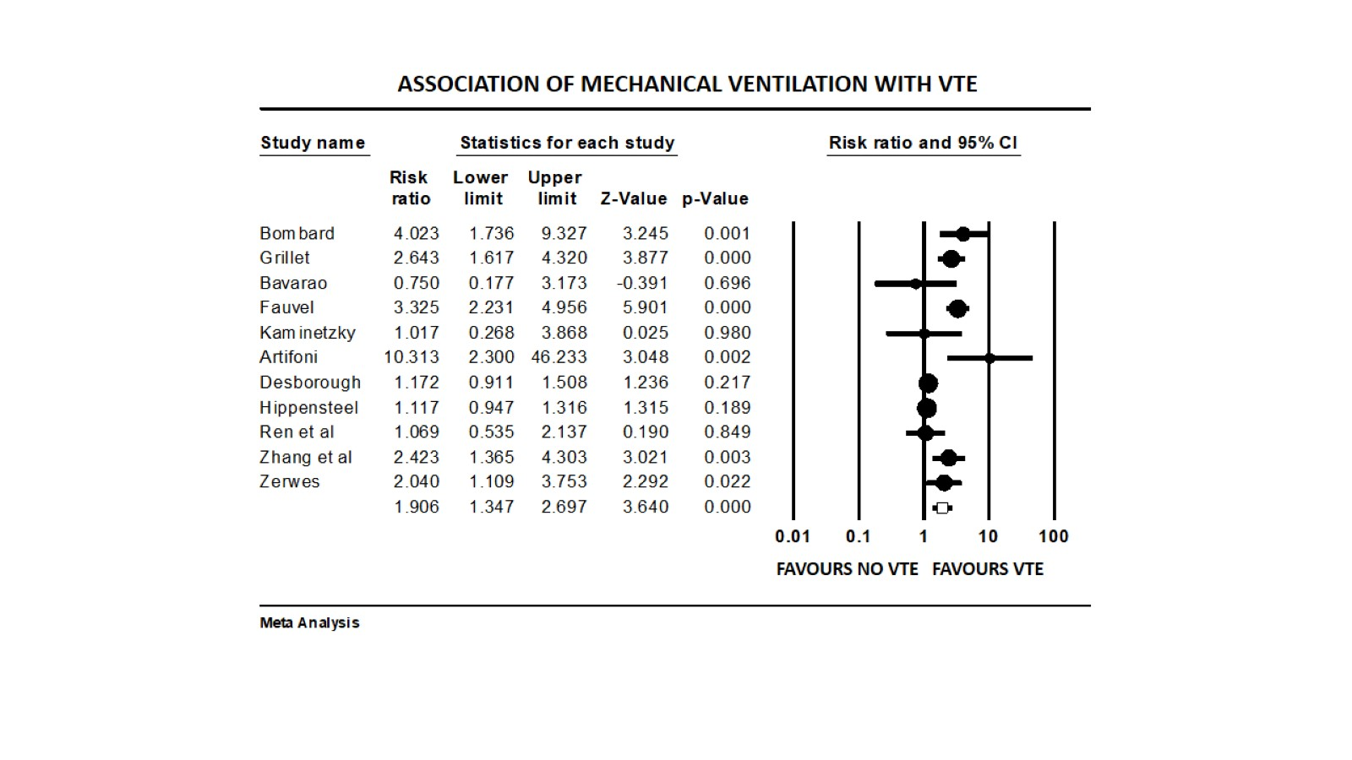
And without venous thromboembolism and association with mechanical ventilation

Figure 8: Forest plot showing results of meta-analysis comparing COVID-19 patients with
And without venous thromboembolism and association with P/F Ratio.
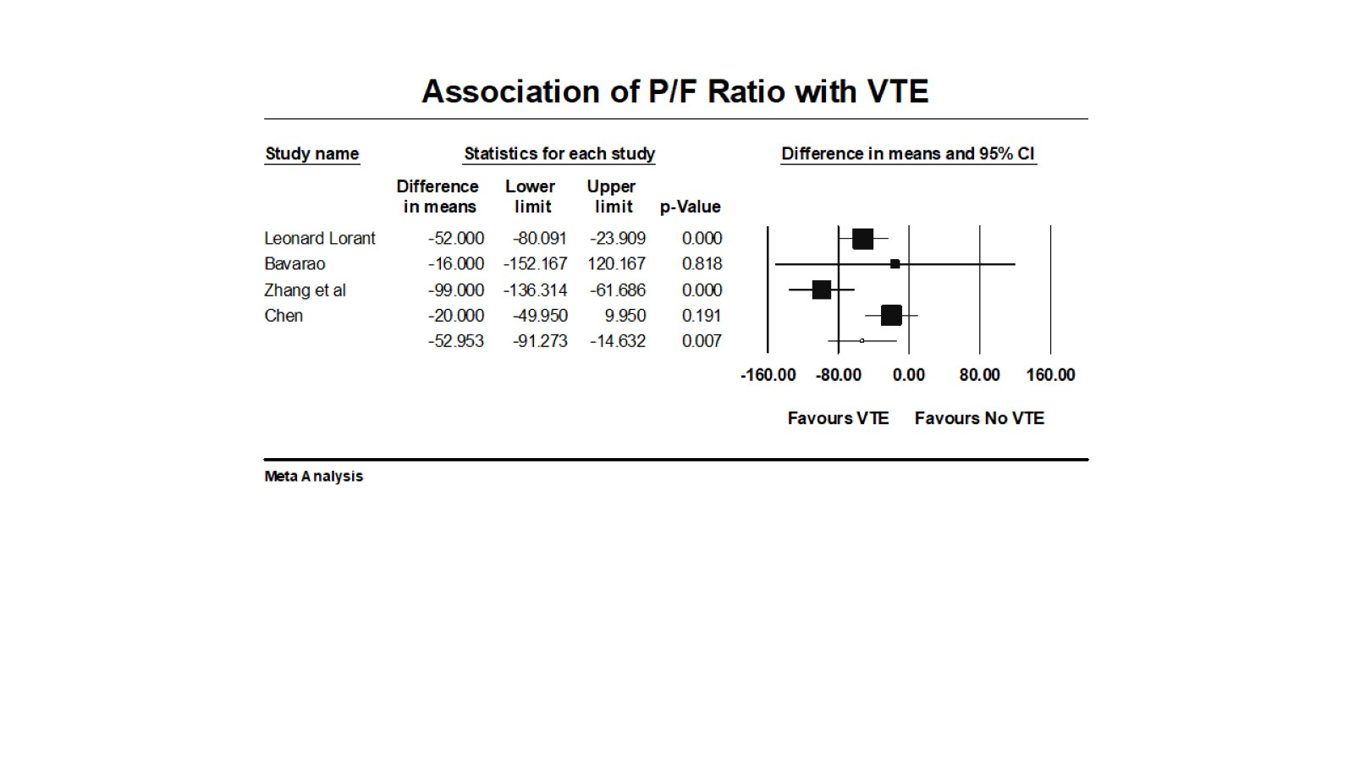

Figure 9: Forest plot showing results of meta-analysis comparing COVID-19 patients with
and without venous thromboembolism and association with leukocyte count
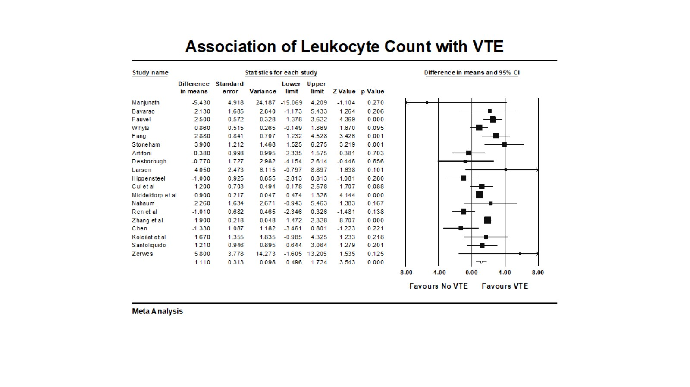

Figure 10: Forest plot showing results of meta-analysis comparing COVID-19 patients with
and without venous thromboembolism and association with D-Dimer levels.

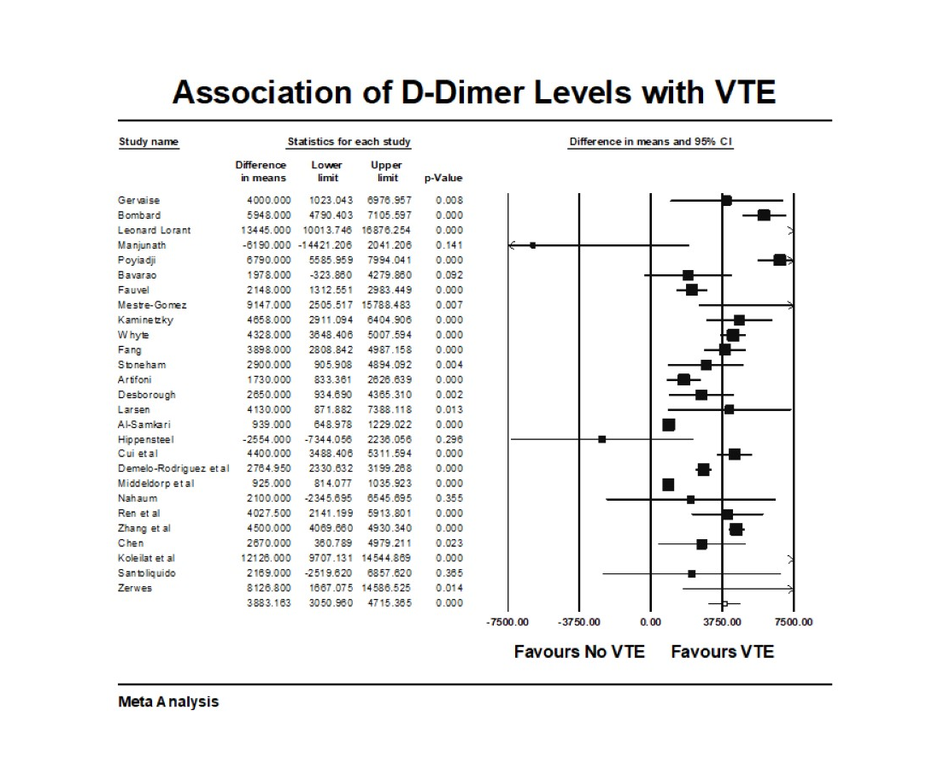

Figure 11: Forest plot showing results of meta-analysis comparing COVID-19 patients with and without venous thromboembolism and association with C-reactive protein levels.
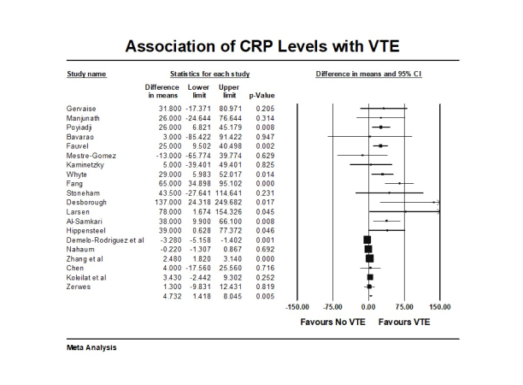

Figure 12: Forest plot showing results of meta-analysis comparing COVID-19 patients with
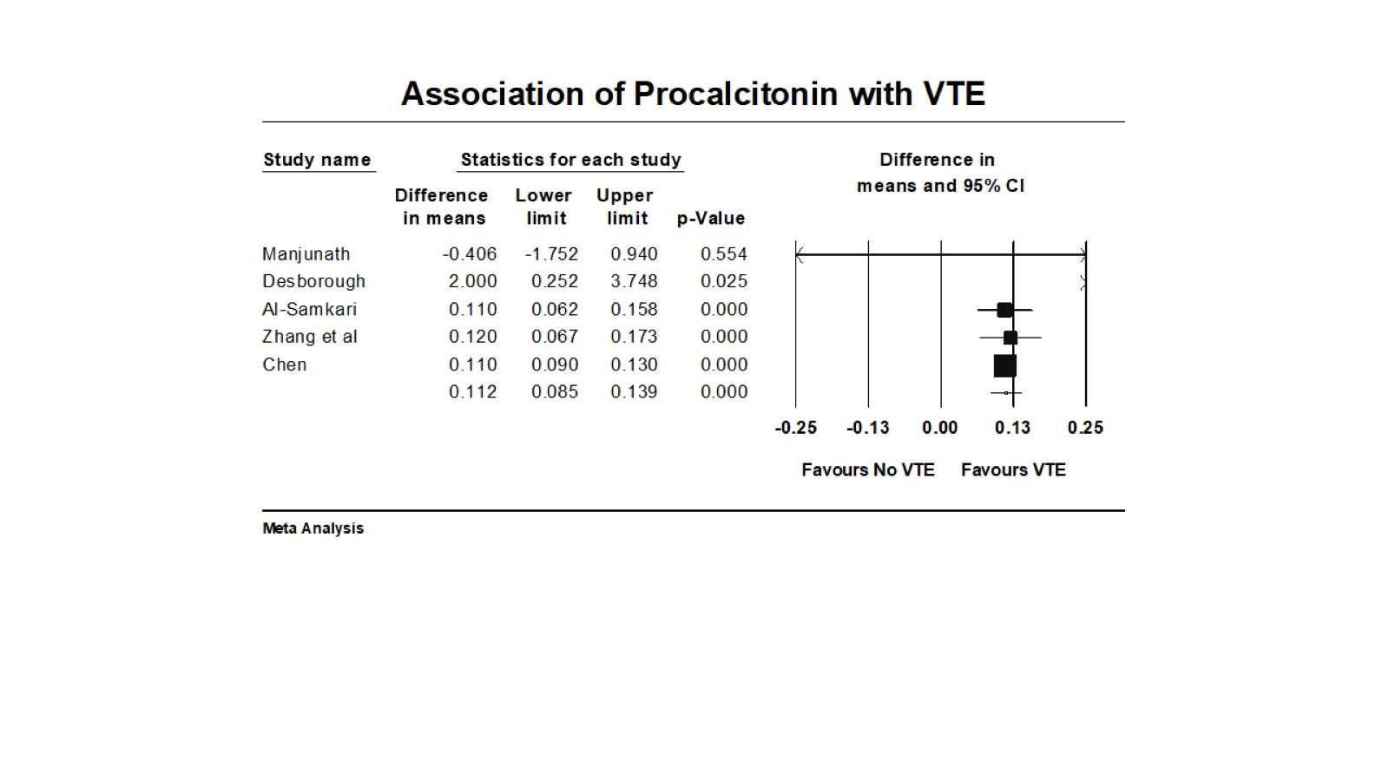
and without venous thromboembolism and association with Pro-calcitonin levels.

Fig 13. Forest plot showing results of meta-analysis comparing COVID-19 patients with
and without venous thromboembolism and association with VTE history.
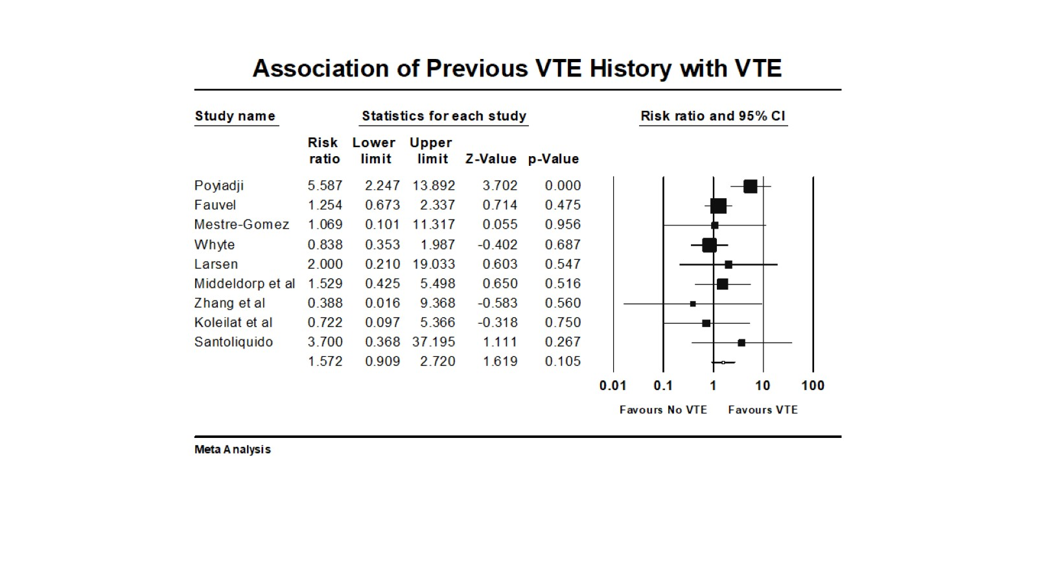

Fig 14. Forest plot showing results of meta-analysis comparing COVID-19 patients with
and without venous thromboembolism and association with cancer.
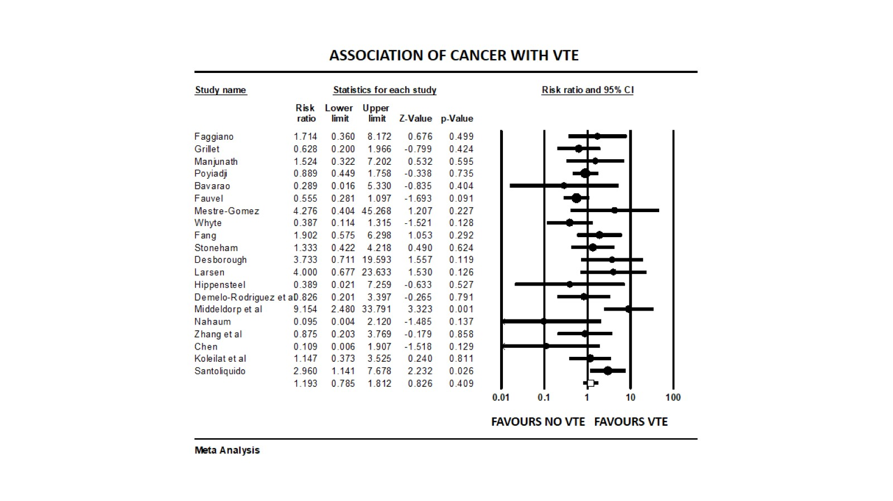
Fig 15. Forest plot showing results of meta-analysis comparing COVID-19 patients with
and without venous thromboembolism and association with mortality.
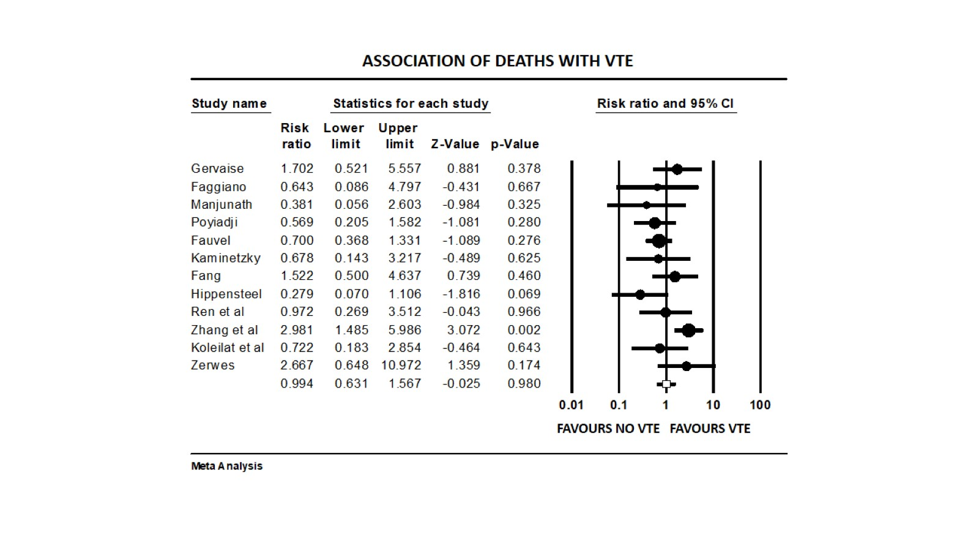

Fig 16. Forest plot showing results of meta-analysis comparing COVID-19 patients with
and without venous thromboembolism and association with prophylactic anticoagulation.



