Additional file 9; Figure 2A. Funnel plots of meta-analysis of age before trim-and-fill

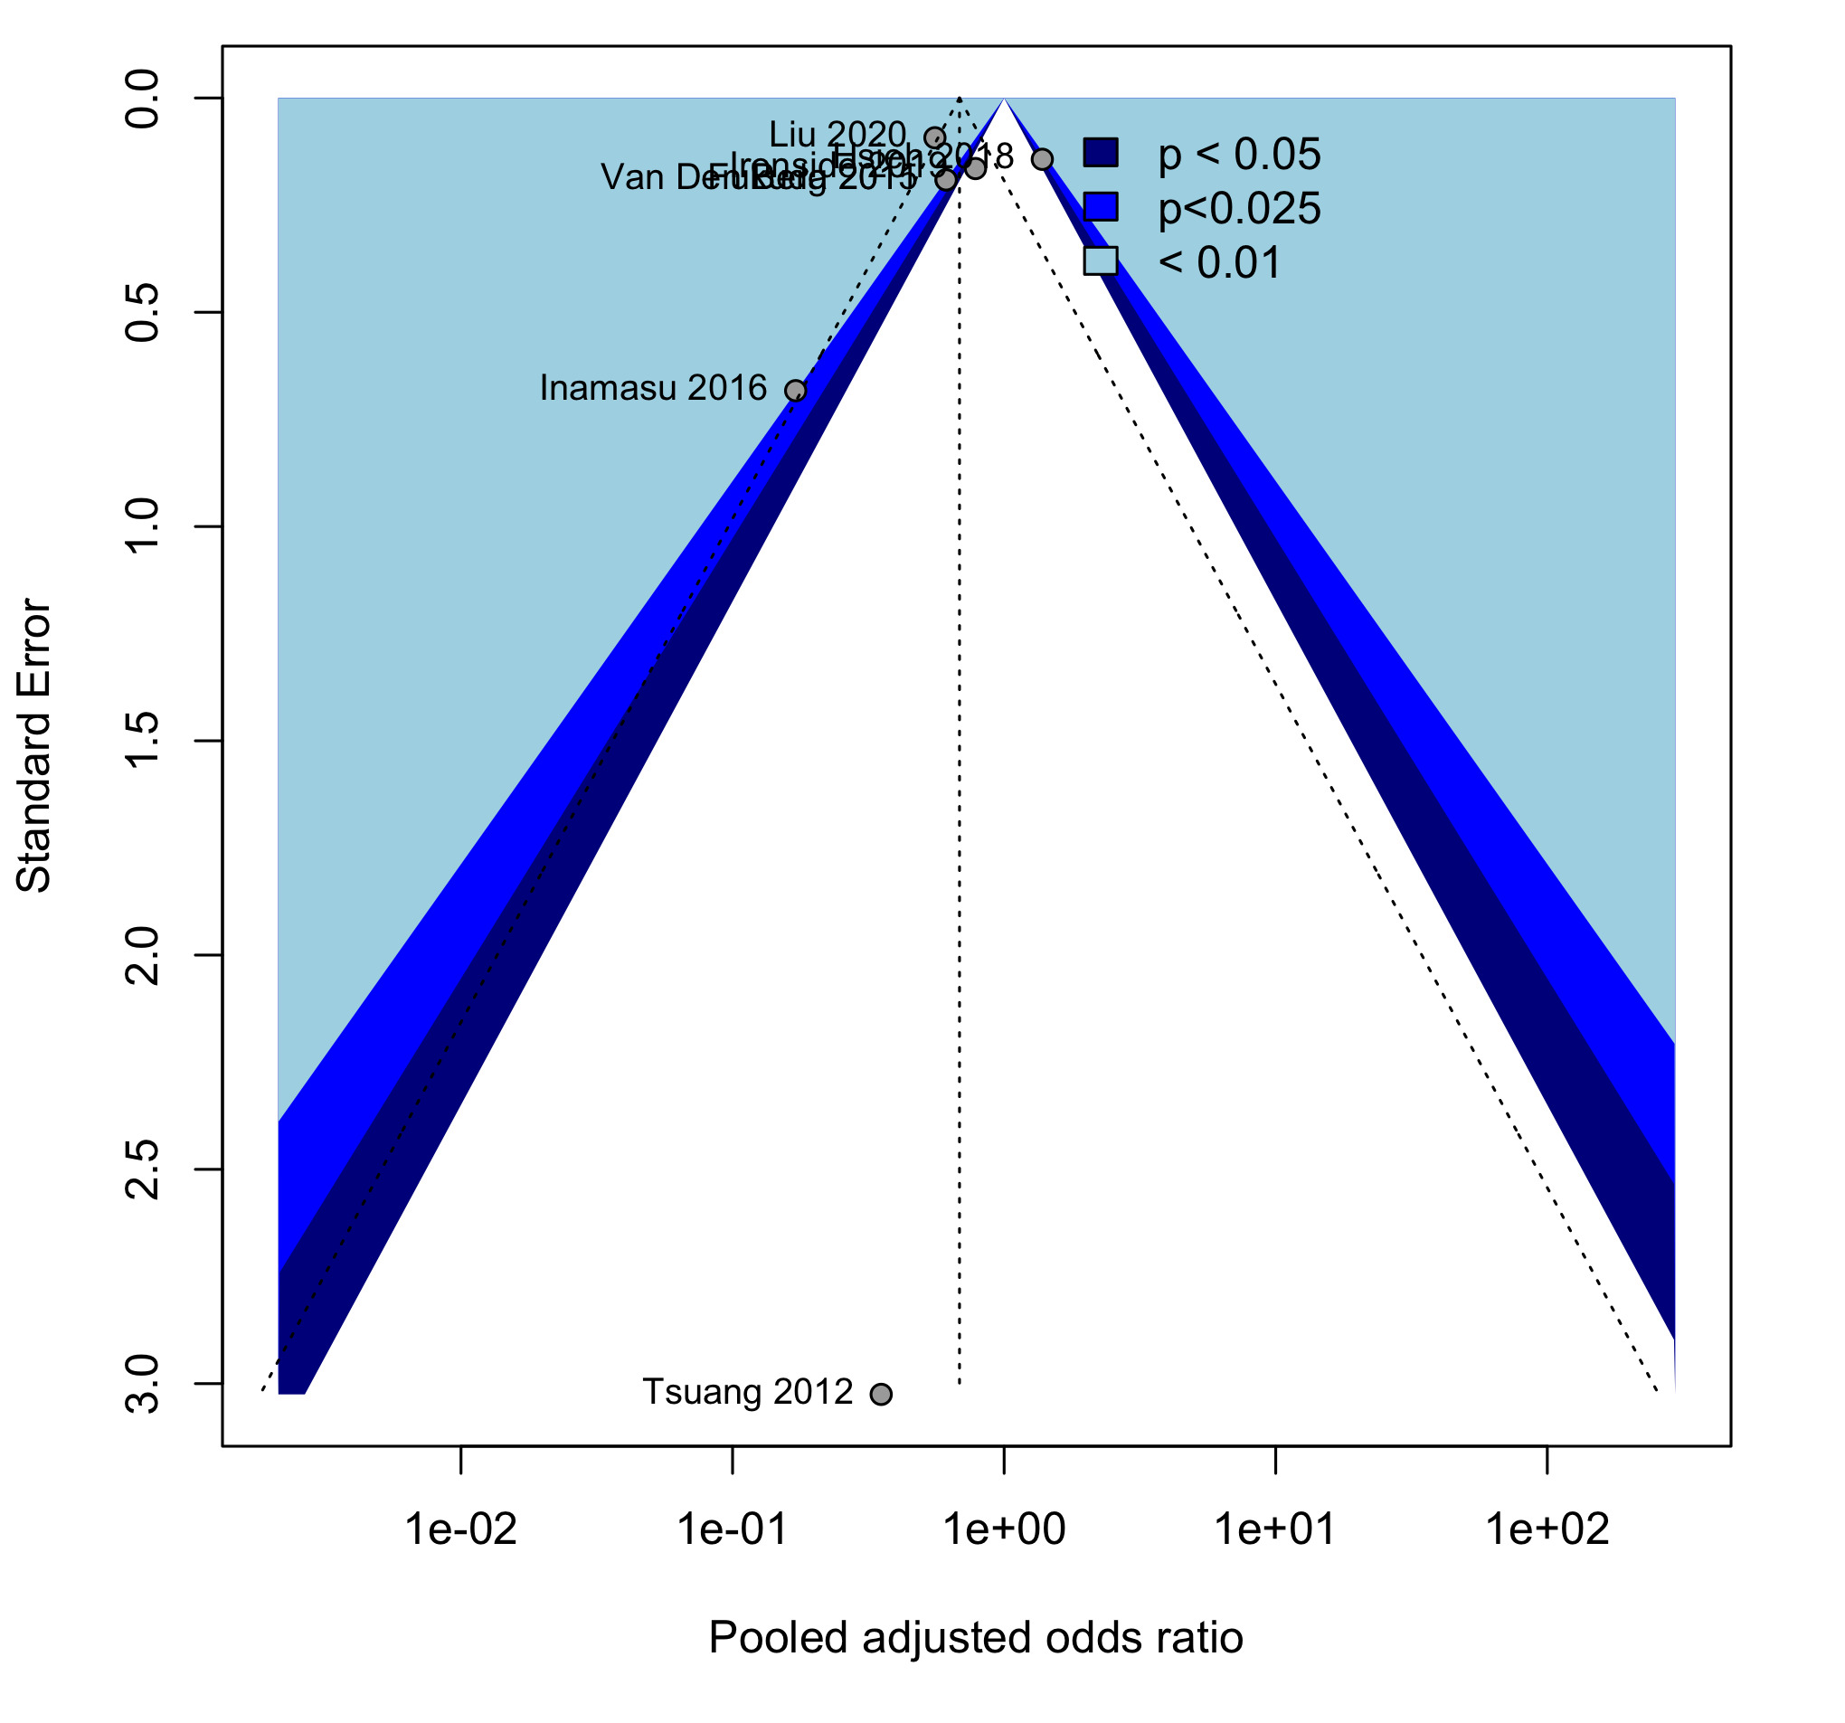

Additional file 9; Figure 2B. Funnel plots of meta-analysis of age after trim-and-fill



