Supplementary material

Supplementary material 1. Search strategy
Filter: 2010-2021
Search strategy | Date of Search | Results
Pubmed
prevalence[mesh] OR incidence[mesh] OR Observational Study[Publication Type] OR Observational studies as topic[mesh] OR Cross-Sectional Studies[mesh] OR Cohort Studies[mesh] OR Longitudinal Studies[mesh] OR prevalenc*[tiab] OR incidenc*[tiab] OR “cross-sectional”[tiab] OR “cross sectional”[tiab] OR “cohort”[tiab] OR longitudinal*[tiab] OR transvers*[tiab] OR prospective*[tiab] OR retrospective*[tiab] OR “follow-up*”[tiab] | 23/03 | 928
Latin America[Mh] OR "Latin America"[tiab] OR Caribbean Region[Mh] OR "Caribbean Region"[tiab] OR South America [Mh] OR "South America”[tiab] OR Indians, South American [Mh] OR Hispanoamerica*[tiab] OR Iberoamerica*[tiab] OR Panamerican*[tiab] OR Argentina[Mh] OR Argentina[tiab] OR Argentin*[ad] OR Bolivia[Mh] OR Bolivia[tiab] OR Bolivia[ad] OR Brazil[Mh] OR Brazil[tiab] OR Brazil*[ad] OR Brasil*[ad] OR Chile[Mh] OR Chile[tiab] OR Colombia[Mh] OR Colombia[tiab] OR Colombia[ad] OR Costa rica[Mh] OR Costa rica[tiab] OR Costa Ric*[ad] OR Cuba[Mh] OR Cuba[tiab] OR Ecuador[Mh] OR Ecuador[tiab] OR Ecuador*[ad] OR El salvador[Mh] OR "El salvador"[tiab] OR "El salvador"[ad] OR Guatemala[Mh] OR Guatemala[tiab] OR Guatemala[ad] OR Haiti[Mh] OR Haiti[tiab] OR Honduras[Mh] OR Honduras[tiab] OR Mexico[Mh] OR Mexico[tiab] or Mexico[ad] or Mejico[ad] OR Nicaragua[Mh] OR Nicaragua[tiab] OR Panama[Mh] OR Panama[tiab] OR Paraguay[Mh] OR Paraguay[tiab] OR Paraguay[ad] OR Peru[Mh] OR Peru[tiab] OR Peru*[ad] OR Puerto Rico[Mh] OR "Puerto Rico"[tiab] OR "Puerto Rico"[ad] OR Dominican Republic[Mh] OR "Dominican Republic"[tiab] OR "Dominican Republic"[ad] OR Uruguay[Mh] OR Uruguay[tiab] OR Uruguay[ad] OR Venezuela [Mh] OR Venezuela [tiab] OR Venezuela [ad] OR Suriname[Mh] OR Suriname[tiab] OR Surinam*[ad] OR Guiana*[tiab] OR Guiana*[ad] OR Guyan*[tiab] OR Guyan*[ad] | 23/03 | 928
“Pulmonary Disease, Chronic Obstructive”[MH] OR “chronic obstructive pulmonary dis*” [TIAB] OR “chronic obstructive pulmonary dis*” [OT] OR “Chronic Obstructive Lung Dis*” [TIAB] OR “Chronic Obstructive Lung Dis*” [OT] OR “Chronic Obstructive Airway Dis*” [TIAB] OR “Chronic Obstructive Airway Dis*” [OT] OR “chronic obstructive respiratory dis*” [TIAB] OR “chronic obstructive respiratory dis*” [OT] OR “lung chronic obstructive dis*” [TIAB] OR “lung chronic obstructive dis*” [OT] OR “obstructive respiratory tract dis*” [TIAB] OR “obstructive respiratory tract dis*” [OT] OR COPD[ TIAB] OR COPD[OT] OR “chronic obstructive bronchitis” [TIAB] OR “chronic obstructive bronchitis” [OT] OR “chronic obstructive bronchopulmonary dis* ” [TIAB] OR “chronic obstructive bronchopulmonary dis* ” [OT] OR “Chronic Airflow Obstruction*” [TIAB] OR “Chronic Airflow Obstruction*” [OT] OR “chronic airway obstruction*” [TIAB] OR “chronic airway obstruction*” [OT] OR Pulmonary Emphysem [MH] OR emphysem* [TIAB] OR emphysem* [OT] OR “Bronchitis, Chronic” [MH] OR “Chronic bronch*” [TIAB] OR “Chronic bronch*” [OT] OR “Bronchitis chronic*” [TIAB] OR “Bronchitis chronic*” [OT]  #1 AND #2 AND #3 | 23/03 | 928
Scopus
TITLE-ABS-KEY(Prevalen* OR incidenc* OR “cross$sectional” OR cohort OR longitudinal* OR frequenc* OR transvers* OR prospective* OR retrospective* OR “follow-up*” OR “follow up*”) OR TITLE-ABS-KEY (observational W/2 stud*) |  | 1613
AFFILCOUNTRY ( argentina OR bolivia OR brazil OR brasil OR colombia OR chile OR ecuador OR guyana OR "french Guiana" OR paraguay OR peru OR suriname OR uruguay OR venezuela OR belize OR "costa rica" OR "el Salvador" OR guatemala OR honduras OR nicaragua OR panama OR mexico OR mejico OR cuba OR "dominican republic" OR haiti OR jamaica OR "Puerto rico" OR "trinidad and tobago" OR barbados OR guadeloupe OR grenada OR martinique OR bermuda OR bahamas )

TITLE-ABS-KEY(“lung chronic obstructive dis*” OR COPD OR “chronic airway obstruction*” OR emphysem*) OR TITLE-ABS-KEY(“chronic obstructive” W/2 (“pulmonary dis*” OR “lung dis*” OR airway OR “respiratory dis*” OR “bronch*” OR “bronchopulmonary dis*”)) OR TITLE-ABS-KEY(Chronic W/1 bronchitis)
Embase
(Incidence OR prevalence OR ‘cross-sectional study’ OR ‘cohort analysis’ OR ‘frequency analysis’ OR ‘prospective study’ OR ‘retrospective study’ OR ‘follow up’ OR ‘observational study’)/exp OR (Prevalen* OR incidenc* OR “cross-sectional” OR “cross sectional” OR cohort OR longitudinal* OR frequenc* OR transvers* OR prospective* OR retrospective* OR “follow-up*” OR “follow up*”):ti,ab,kw OR (observational NEAR/2 stud*):ti,ab,kw |  | 1326
'argentina':ca OR 'bolivia':ca OR 'brazil':ca OR brasil:ca OR 'colombia':ca OR 'chile':ca OR 'ecuador':ca OR 'guyana':ca OR 'french guiana':ca OR 'paraguay':ca OR 'peru':ca OR 'suriname':ca OR 'uruguay':ca OR 'venezuela':ca OR 'belize':ca OR 'costa rica':ca OR 'el salvador':ca OR 'guatemala':ca OR 'honduras':ca OR 'nicaragua':ca OR 'panama':ca OR 'mexico':ca OR mejico:ca OR 'cuba':ca OR 'dominican republic':ca OR 'haiti':ca OR 'jamaica':ca OR 'puerto rico':ca OR 'trinidad and tobago':ca OR 'barbados':ca OR 'guadeloupe':ca OR 'grenada':ca OR 'martinique':ca OR 'bermuda':ca OR 'bahamas':ca |  | 1326
'chronic obstructive lung disease':de OR 'chronic airflow obstruction':tn,ti,ab OR 'chronic airway obstruction':tn,ti,ab OR 'chronic obstructive bronchitis':tn,ti,ab OR 'chronic obstructive bronchopulmonary disease':tn,ti,ab OR 'chronic obstructive lung disease':tn,ti,ab OR 'chronic obstructive lung disorder':tn,ti,ab OR 'chronic obstructive pulmonary disease':tn,ti,ab OR 'chronic obstructive pulmonary disorder':tn,ti,ab OR 'chronic obstructive respiratory disease':tn,ti,ab OR 'copd':tn,ti,ab OR 'lung chronic obstructive disease':tn,ti,ab OR 'lung disease, chronic obstructive':tn,ti,ab OR 'lung diseases, obstructive':tn,ti,ab OR 'obstructive lung disease':tn,ti,ab OR 'obstructive lung disease, chronic':tn,ti,ab OR 'obstructive lung diseases':tn,ti,ab OR 'obstructive pulmonary disease':tn,ti,ab OR 'obstructive respiratory disease':tn,ti,ab OR 'obstructive respiratory tract disease':tn,ti,ab OR 'pulmonary disease, chronic obstructive':tn,ti,ab OR 'pulmonary disorder, chronic obstructive':tn,ti,ab |  | 1326
WoS
TS=(Prevalen* OR incidenc* OR “cross$sectional” OR cohort OR longitudinal* OR frequenc* OR transvers* OR prospective* OR retrospective* OR “follow$up*”) OR TS=(observational NEAR/2 stud*) |  | 846
CU= (argentina OR bolivia OR brazil OR BRASIL OR colombia OR chile OR ecuador OR guyana OR "french Guiana" OR paraguay OR peru OR suriname OR uruguay OR venezuela OR belize OR "costa rica" OR "el Salvador" OR guatemala OR honduras OR nicaragua OR panama OR mexico OR mejico OR cuba OR "dominican republic" OR haiti OR jamaica OR "Puerto rico" OR "trinidad and tobago" OR barbados OR guadeloupe OR grenada OR martinique OR bermuda OR bahamas) |  | 846
TS=(“lung chronic obstructive dis*” OR COPD OR “chronic airway obstruction*” OR emphysem*) OR TS=(“chronic obstructive” NEAR/2 (“pulmonary dis*” OR “lung dis*” OR airway OR “respiratory dis*” OR “bronchitis” OR “bronchopulmonary dis*”)) OR TS=(Chronic NEAR/1 bronchitis) |  | 846
Scielo (WoS)
TS=(Prevalen* OR incidenc* OR “cross$sectional” OR cohort OR longitudinal* OR frequenc* OR transvers* OR prospective* OR retrospective* OR “follow$up*”) OR TS=(observational NEAR/2 stud*) |  | 383
CU= (argentina OR bolivia OR brazil OR BRASIL OR colombia OR chile OR ecuador OR guyana OR "french Guiana" OR paraguay OR peru OR suriname OR uruguay OR venezuela OR belize OR "costa rica" OR "el Salvador" OR guatemala OR honduras OR nicaragua OR panama OR mexico OR mejico OR cuba OR "dominican republic" OR haiti OR jamaica OR "Puerto rico" OR "trinidad and tobago" OR barbados OR guadeloupe OR grenada OR martinique OR bermuda OR bahamas) OR AD= (argentina OR bolivia OR brazil OR BRASIL OR colombia OR chile OR ecuador OR guyana OR "french Guiana" OR paraguay OR peru OR suriname OR uruguay OR venezuela OR belize OR "costa rica" OR "el Salvador" OR guatemala OR honduras OR nicaragua OR panama OR mexico OR mejico OR cuba OR "dominican republic" OR haiti OR jamaica OR "Puerto rico" OR "trinidad and tobago" OR barbados OR guadeloupe OR grenada OR martinique OR bermuda OR bahamas) |  | 383
TS=(“lung chronic obstructive dis*” OR COPD OR “chronic airway obstruction*” OR emphysem*) OR TS=(“chronic obstructive” NEAR/2 (“pulmonary dis*” OR “lung dis*” OR airway OR “respiratory dis*” OR “bronchitis” OR “bronchopulmonary dis*”)) OR TS=(Chronic NEAR/1 bronchitis) |  | 383
Medline
TS=(Prevalen* OR incidenc* OR “cross$sectional” OR cohort OR longitudinal* OR frequenc* OR transvers* OR prospective* OR retrospective* OR “follow$up*”) OR TS=(observational NEAR/2 stud*) |  | 778
AD= (argentina OR bolivia OR brazil OR BRASIL OR colombia OR chile OR ecuador OR guyana OR "french Guiana" OR paraguay OR peru OR suriname OR uruguay OR venezuela OR belize OR "costa rica" OR "el Salvador" OR guatemala OR honduras OR nicaragua OR panama OR mexico OR mejico OR cuba OR "dominican republic" OR haiti OR jamaica OR "Puerto rico" OR "trinidad and tobago" OR barbados OR guadeloupe OR grenada OR martinique OR bermuda OR bahamas) |  | 778
TS=(“lung chronic obstructive dis*” OR COPD OR “chronic airway obstruction*” OR emphysem*) OR TS=(“chronic obstructive” NEAR/2 (“pulmonary dis*” OR “lung dis*” OR airway OR “respiratory dis*” OR “bronchitis” OR “bronchopulmonary dis*”)) OR TS=(Chronic NEAR/1 bronchitis) |  | 778
ENCABEZADO MeSH: (Pulmonary Disease Chronic Obstructive)  MH=(Pulmonary Disease Chronic Obstructive) |  | 778

Supplementary material 2. Excluded studies reviewed in full text

Author - Year | Title | Reason for exclusion
Lange - 2015 | Lung-Function Trajectories Leading to Chronic Obstructive Pulmonary Disease. | Different country
Sood - 2014 | Spirometry and health status worsen with weight gain in obese smokers but improve in normal-weight smokers. | Different country
Marin-Sanchez - 2020 | [Basic clinical characteristics in the first 100 fatal cases of COVID-19 in Colombia]. | Different diagnostic criteria
Souza - 2020 | Prevalence and factors associated with respiratory diseases and diarrhea in recyclable material cooperative workers in the city of Sao Paulo, Brazil: a cross-sectional study, 2013. | Different diagnostic criteria
Ahumada - 2013 | Prevalence of abnormal lung volumes, DLCO and chest HRCT in smokers with normal spirometry | Different publication type
Lamprecht - 2013 | Heterogeneity in prevalence and underdiagnosis of COPD: Results from BOLD, EPI-SCAN, PLATINO, and PREPOCOL | Different diagnostic criteria
Thorington - 2011 | Prevalence of chronic obstructive pulmonary disease among stable chronic disease subjects in primary care in Trinidad, West Indies. | Different diagnostic criteria
Sood - 2010 | Wood smoke exposure and gene promoter methylation are associated with increased risk for COPD in smokers. | Different country
Leal - 2020 | Epidemiology and burden of chronic respiratory diseases in Brazil from 1990 to 2017: analysis for the Global Burden of Disease 2017 Study. | Different diagnostic criteria
Rosa - 2013 | Clinical, epidemiological and radiological of pneumonia in the elderly. Service Geriatric Hospital Almanzor Aguinaga Asenjo, July 2010-July 2011 | Different diagnostic criteria
Bensenor - 2012 | Household income, sex and respiratory mortality in Sao Paulo, Brazil, 1996-2010 | Different diagnostic criteria
Gimenes - 2012 | Respiratory pressures and expiratory peak flow rate of patients undergoing coronary artery bypass graft surgery | Different diagnostic criteria
Antunes - 2012 | Trends in hospitalizations for respiratory diseases in Salvador, Bahia State, Brazil, 1998-2009 | Different diagnostic criteria
Varela - 2012 | Variability in COPD: The PLATINO Study Viewpoint | Different publication type
Crawford - 2012 | Tobacco-Related Chronic Illnesses: A Public Health Concern for Jamaica | Different diagnostic criteria
Montes de Oca - 2011 | Paid employment in subjects with and without chronic obstructive pulmonary disease in five Latin American cities: the PLATINO study | Duplicated population
Washko - 2011 | Lung Volumes and Emphysema in Smokers with Interstitial Lung Abnormalities | Different country
Bensenor - 2011 | Chronic obstructive pulmonary disease in Brazil: mortality and hospitalization trends and rates, 1996-2008 | Different diagnostic criteria
Martin-Loeches - 2011 | Use of early corticosteroid therapy on ICU admission in patients affected by severe pandemic (H1N1)v influenza A infection | Different country
Volpe - 2011 | Association of chronic pulmonary obstructive disease (COPD) and complications in head and neck surgery | Different population
Silva - 2010 | Update on chronic obstructive pulmonary disease | Different publication type
Montes de Oca - 2010 | Acute bronchodilator responsiveness in subjects with and without airflow obstruction in five Latin American cities: The PLATINO study | Duplicated population
Arcanjo - 2018 | Clinical and laboratory characteristics associated with referral of hospitalized elderly to palliative care. | Different outcome
Souza - 2020 | Prevalence and factors associated with respiratory diseases and diarrhea in recyclable material cooperative workers in the city of SÃ£o Paulo, Brazil: a cross-sectional study, 2013 | Different diagnostic criteria
Fabra-Arrieta - 2019 | Respiratory disease associated with environmental and health factors in three villages from Guarne, Colombia, 2015 | Different diagnostic criteria
Kovelis - 2019 | Characteristics of long-term home oxygen therapy users in the municipality of Curitiba, Brazil | Different diagnostic criteria
Arancibia - 2017 | Chronic obstructive pulmonary disease and smoking | Different publication type
Signes-Costa - 2021 | Prevalence and 30-Day Mortality in Hospitalized Patients With Covid-19 and Prior Lung Diseases | Different diagnostic criteria
Evaristo-Mendez - 2016 | [Risk factors for nosocomial pneumonia in patients with abdominal surgery]. | Different diagnostic criteria
Fialkow - 2016 | Mechanical ventilation in patients in the intensive care unit of a general university hospital in southern Brazil: an epidemiological study | Different diagnostic criteria
CaÃ±ibano - 2020 | Prevalence of abdominal aortic aneurysms in a risk population seen in a vascular surgery department | Different diagnostic criteria
GarcÃa-Ortiz - 2020 | Evaluation with copd-ps questionnaire and vitalograph copd-6 portable device as a strategy for early diagnosis of copd in primary care | Different diagnostic criteria
Torre-Bouscoulet - 2015 | Comorbidities, sleep quality and quality of life in patients with lung cancer | Different diagnostic criteria
Llanqui - 2015 | Chemical irritants and prevalence of asthma and chronic bronchitis among cleaner workers of health institutions at the Puno region, Peru. | Different diagnostic criteria
Lizarbe - 2015 | Risk factors associated with Hospital complications in elderly patients to Hospital Nacional Edgardo Rebagliati Martins Lima, 2010 | Different diagnostic criteria
Sales - 2014 | Aortic Center: specialized care improves outcomes and decreases mortality | Different diagnostic criteria
Prudencio - 2014 | Epidemiology of COPD in Military Hospital | Different diagnostic criteria
Athanazio - 2012 | Airway disease: similarities and differences between asthma, COPD and bronchiectasis | Different study design
Teixeira - 2012 | Impact of a mechanical ventilation weaning protocol on the extubation failure rate in difficult-to-wean patients | Different diagnostic criteria
Lisanti - 2011 | Programa de oxigenoterapia domiciliaria de la Obra Social de Empleados públicos (OSEP), Mendoza (Argentina), experiencia de 7 años | Different diagnostic criteria
Sousa - 2011 | Prevalence of chronic obstructive pulmonary disease and risk factors in SÃ£o Paulo, Brazil, 2008-2009 | Different diagnostic criteria
Volpe - 2011 | Association of chronic pulmonary obstructive disease (COPD) and complications in head and neck surgery | Duplicate record
Souza - 2010 | Respiratory symptoms in charcoal production workers in the cities of Lindolfo Collor, Ivoti and Presidente Lucena, Brazil | Different diagnostic criteria
Mohammed - 2018 | A descriptive study of chronic obstructive pulmonary disease in tertiary care clinics of a Caribbean island | Different population
Horner - 2017 | Altitude and COPD prevalence: Analysis of the PREPOCOL-PLATINO-BOLD-EPI-SCAN study | Duplicated population
Jardim - 2017 | Respiratory medication use in primary careamongCOPDsubjects in four Latin American countries | Duplicated population
Vega - 2015 | Respiratory diseases in workers exposed to lateritic dust | Different diagnostic criteria
Watanabe - 2015 | Long term home oxygen therapy: Usersâ€™ profile and costs | Different outcome
Chen - 2014 | Native American ancestry, lung function, and COPD in Costa Ricans | Different study design
Dougados - 2014 | Prevalence of comorbidities in rheumatoid arthritis and evaluation of their monitoring: Results of an international, cross-sectional study (COMORA) | Different diagnostic criteria
Mendoza-Gonzalez - 2020 | EPIDEMIOLOGICAL ANALYSIS OF THE PANDEMIC BY SARS-COV2 IN MEXICAN POPULATION: EVALUATION OF MIDDLEWAY, CHARACTERISTICS, COMORBIDITY AND RISK | Different diagnostic criteria
Hernandez-Galdamez - 2020 | Increased Risk of Hospitalization and Death in Patients with COVID-19 and Pre-existing Noncommunicable Diseases and Modifiable Risk Factors in Mexico | Different diagnostic criteria
Tomaniak - 2020 | Impact of chronic obstructive pulmonary disease and dyspnoea on clinical outcomes in ticagrelor treated patients undergoing percutaneous coronary intervention in the randomized GLOBAL LEADERS trial | Different diagnostic criteria
Maas - 2020 | Prevalence of Chronic Bronchitis and Respiratory Health Profile of a Population Exposed to Wood Smoke in Nicaragua | Different diagnostic criteria
Goncalves-Macedo - 2019 | Trends in morbidity and mortality from COPD in Brazil, 2000 to 2016 | Different diagnostic criteria
Babanov - 2011 | Epidemiological characteristics of chronic obstructive pulmonary disease in the middle volga region | Different country
Krishnan - 2019 | Prevalence and Characteristics of Asthma-Chronic Obstructive Pulmonary Disease Overlap in Routine Primary Care Practices | Different country
Morgan - 2019 | Epidemiology and risk factors of asthma-chronic obstructive pulmonary disease overlap in low- and middle-income countries | Different study design
Valle - 2010 | Morbidity and mortality in patients aged over 75 years undergoing surgery for aortic valve replacement | Different diagnostic criteria
Carlos - 2010 | Association between indoor pollution, respiratory symptoms and COPD in Santiago, Chile: PLATINO Study | Duplicate record
De Vries - 2020 | Current state of respiratory disease in Suriname, a retrospective analysis of 4987 hospital files | Different diagnostic criteria
Trompeter - 2018 | Patterns of Body Composition Relating to Chronic Respiratory Diseases Among Adults in Four Resource-Poor Settings in Peru | Duplicated population
Freitas - 2017 | COPD Diagnosis Prevalence in Patients with Ischemic Heart Disease hospitalized in a university hospital in the interior of Rio Grande do Sul State | Different diagnostic criteria
Horner - 2016 | Altitude and COPD prevalence and other determinants: analysis of the PREPOCOL-PLATINO-BOLD-EPISCAN study | Duplicate record
Paschoalini - 2019 | Copd due to home biomass smoke exposure in rural non-smokers Brazilian women | Different publication type
Ruiz - 2018 | Assessing the burden of disease-associated malnutrition among hospitalized malnourished Colombian patients with heart and lung disease | Different population
Goebel - 2018 | Chronic obstructive pulmonary disorder in chronically exposed to silica: Experience of hospital Das clinicas da UFMG | Different diagnostic criteria
Oliveira - 2017 | Predictors of mediastinitis risk after coronary artery bypass surgery: Applicability of score in 1.322 cases | Different diagnostic criteria
Rodriguez - 2017 | Validation of the PUMA score for detecting COPD in a primary care population at the Hospital Maciel, Montevideo | Different publication type
Angarita - 2017 | COPD incidence in subjects with risk factors, chronic respiratory symptoms and normal spirometry: The PLATINO study> | Different publication type
Leslie - 2017 | Body composition as a risk of prolonged hospitalisations in patients with heart failure and / or respiratory distress | Different diagnostic criteria
Montes de Oca - 2017 | Asthma-COPD overlap syndrome (ACOS) in primary care of four Latin America countries: The PUMA study | Duplicated population
Montes de Oca - 2017 | Classification of patients with chronic obstructive pulmonary disease according to the Latin American Thoracic Association (ALAT) staging systems and the global initiative for chronic obstructive pulmonary disease (GOLD) | Duplicated population
Montes de Oca - 2017 | Classification of COPD Patients According to ALAT and GOLD Staging Systems Using PUMA Study Data | Duplicate record
Fernandez - 2017 | Tuberculosis in octogenarian patients between 2011-2016 in fundacion valle Del Lili, a reference Hospital In Latin America | Different diagnostic criteria
Guzman-Bouilloud - 2017 | Determining the prevalence Of COPD in primary care setting by using a telemedicine spirometry program. A screening study | Different publication type
de São José - 2016 | Primary care physicians' ability to diagnose the most prevalent respiratory diseases | Different diagnostic criteria
Torres-Duque - 2016 | Is Chronic Obstructive Pulmonary Disease Caused by Wood Smoke a Different Phenotype or a Different Entity? | Different study design
De Freitas - 2016 | Prevalence of asthma-chronic obstructive pulmonary disease (COPD) overlap syndrome in brazilian elderly patients | Different publication type
Bastidas - 2015 | Use of artificial intelligence in the diagnosis of chronic obstructive pulmonary disease (COPD) | Different study design
Torre-Bouscoulet - 2015 | Comorbidities, sleep quality and quality of life in patients with locally advanced lung cancer | Different diagnostic criteria
Antonio - 2015 | 48-hour fluid balance does not predict a successful spontaneous breathing trial | Different diagnostic criteria
Lopez - 2014 | Primary care COPD case finding in four latin america countries: The puma study | Different publication type
Casas - 2014 | Copd under-diagnosis and misdiagnosis in primary care population at high risk in four latin america countries: The puma study | Different publication type
Vianna - 2014 | Detection of COPD in a senior community center: High occurrence of undiagnosed COPD and reduced quality of life | Different publication type
Barbosa - 2014 | Chronic obstructive pulmonary disease (COPD)-searching the prevalence | Different publication type
Manzano - 2014 | Incidence of chronic obstructive pulmonary disease (COPD) based on three criteria for diagnosis: Follow-up Platino study-Sao Paulo, Brasil | Different publication type
Manzano - 2014 | Prospective analysis of smoking aspects over eight years in a population-based study-follow-up Platino study | Different publication type
Laniado - 2014 | Prevalence of chronic obstructive pulmonary disease in successfully treated pulmonary tuberculosis patients | Different population
Perez-Padilla - 2019 | Chronic Obstructive Pulmonary Disease in Latin America. | Duplicate record
Cherbuin - 2019 | Chronic Obstructive Pulmonary Disease and Risk of Dementia and Mortality in Lower to Middle Income Countries. | Different diagnostic criteria
Menezes - 2014 | CPOD and lung function parameters as predictors of mortality: Results from the Latin American PLATINO cohort study | Different publication type
Stelzer - 2014 | Chronic headache (CH) and obstructive sleep apnoea (OSA): Preliminary findings | Different diagnostic criteria
Menezes - 2014 | Increased risk of exacerbation and hospitalization in subjects with an overlap phenotype : COPD-Asthma | Duplicated population
Schiavi - 2014 | COPD screening in primary care in four latin American countries: Methodology of the PUMA study | Duplicated population
Hernández-Díaz - 2013 | Impact of coexisting COPD / smoking in the evolution of a cohort of patients lung carcinoma | Different diagnostic criteria
Martín - 2013 | Using the lower limit of normal (LLN) for the FEV1/fvc ratio changes the prevalence of airway obstruction in a hospital based-population | Different country
Angeli - 2019 | Detrimental Impact of Chronic Obstructive Pulmonary Disease in Atrial Fibrillation: New Insights from Umbria Atrial Fibrillation Registry. | Different country
Blanco - 2018 | Geographical Distribution of COPD Prevalence in the Americas. | Different study design
Grigsby - 2016 | Socioeconomic status and COPD among low- and middle-income countries. | Duplicated population
Kawassaki - 2013 | Differences in chest HRCT between smoking and non-smoking rheumatoid arthritis patients with abnormal spirometry | Different publication type
José - 2013 | The lack of awareness by general practitioners in diagnosing acute and chronic respiratory conditions in a low-income setting | Different diagnostic criteria
Morais - 2013 | Smoking status, prevalence of smoking-related diseases and their impact on costs in patients hospitalized in the thoracic units of a tertiary hospital in Brazil | Different diagnostic criteria
Nonato - 2013 | The frequency of number of respiratory symptoms in restrictive ventilatory impairment and chronic pulmonary obstructive disease related to disease severity: The Platino study | Different population
Torres-Duque - 2013 | Chronic obstructive pulmonary disease in people exposed to wood smoke. Prepocol: A population based study | Different publication type
de Carvalho - 2012 | Infrarenal abdominal aortic aneurysm: Significance of screening in patients of public hospitals in the metropolitan region of salvador - bahia, Brazil | Different diagnostic criteria
Roldan - 2012 | Lung cancer, chronic obstructive pulmonary disease (COPD) and tuberculosis in mexican women nonsmokers exposed to smoke from biomass | Different population
Loera - 2012 | Results of spirometry campaign hold between october 14 (world day spirometry) and november 17 (world COPD day) 2010 in Durango city, Mexico | Different publication type
Arbex - 2012 | Under-diagnosis of COPD in suspected lung cancer patients | Different publication type
Aaron - 2016 | Influence of country-level differences on COPD prevalence. | Different study design
Torres - 2018 | Trends in mortality from chronic obstructive pulmonary disease in Rio de Janeiro and Porto Alegre, Brazil, 1980-2014. | Different outcome
da Silva - 2012 | Impaired lung function in individuals chronically exposed to biomass combustion | Different outcome
Suzuki - 2011 | Estimating the budget impact of introducing indacaterol in the treatment of chronic obstructive pulmonary disease (COPD) from the public payer perspective in sÃ£o paulo | Different study design
Lutz - 2011 | Cost-utility analysis of varenicline vs existing smoking cessation strategies in EL Salvador | Different diagnostic criteria
Alvis - 2011 | Effect of biomass smoke on chronic obstructive pulmonary diseasein rural localities of Colombia | Different diagnostic criteria
Martins - 2011 | The prevalence of comorbidities in a cohort of chronic heart failure outpatients | Different diagnostic criteria
Machado - 2011 | Hospitalization rates due to chronic obstructive pulmonary disease and related costs before and after institution of outclinics for advanced lung diseases treatment in Sao Paulo City, Brazil (2004-2009) | Different study design
De Oliveira - 2011 | Alpha 1 antitrypsin deficiency in Brazil | Different population
Hernandez-Zenteno - 2011 | Dyspnea is a good predictor for early diagnosis of COPD. A comparison of a symptoms-based versus a non-symptoms based strategies to detect smokers with COPD | Different publication type
Cabrera-Serrano - 2019 | Tobacco Use and Associated Health Conditions and Risk Factors in the Lesbian, Gay, Bisexual, Transgender, and Transsexual Populations of Puerto Rico, 2013-2015. | Different diagnostic criteria
Santos - 2014 | Characteristics of undiagnosed COPD in a senior community center. | Different diagnostic criteria
Perez-Padilla - 2012 | Airflow obstruction in never smokers in five Latin American cities: the PLATINO study. | Duplicated population
Laniado-Laborin - 2010 | The prevalence of airway obstruction in subjects with a history of pulmonary tuberculosis in Mexico | Different outcome
Estenssoro - 2010 | Epidemiology, risk factors, clinical characteristics and oseltamivir use in adult patients admitted to the ICU with acute respiratory failure requiring mechanical ventilation during 2009 Influenza A H1N1 Pandemia | Different diagnostic criteria
Estenssoro - 2010 | Mechanical ventilation in adult patients admitted to the ICU with acute respiratory failure during 2009 influenza A H1N1 pandemia: Are There differences between confirmed vs. probable and suspected cases? the registry of the argentinean society of intensive care medicine (SATI) | Different diagnostic criteria
Silva - 2010 | Prevalence of patients with respiratory symptoms as a primary reason for seeking an outpatient unit and an emergence service in rio de janeiro, Brazil-preliminary results | Different publication type
Ugarte - 2010 | Influenza A pandemics: Clinical and organizational aspects: The experience in Chile | Different diagnostic criteria
de Souza - 2010 | Respiratory symptoms in charcoal production workers in the cities of lindolfo collor, ivoti and presidente lucena, Brazil | Duplicate record
Sousa - 2011 | Prevalence of chronic obstructive pulmonary disease and risk factors in SÃ£o Paulo, Brazil, 2008-2009. | Different diagnostic criteria
Landis - 2014 | Continuing to Confront COPD International Patient Survey: methods, COPD prevalence, and disease burden in 2012-2013. | Different diagnostic criteria
Moreira - 2014 | PLATINO, a nine-year follow-up study of COPD in the city of SÃ£o Paulo, Brazil: the problem of underdiagnosis. | Duplicated population
Lopez - 2010 | Sex-related differences in COPD in five Latin American cities: the PLATINO study. | Duplicated population
Menezes - 2014 | A population-based cohort study on chronic obstructive pulmonary disease in Latin America: methods and preliminary results. The PLATINO Study Phase II. | Different diagnostic criteria
Rubinstein - 2011 | Detection and follow-up of chronic obstructive pulmonary disease (COPD) and risk factors in the Southern Cone of Latin America: the pulmonary risk in South America (PRISA) study. | Different publication type
Olmos - 2015 | [Primary care consultations due to respiratory diseases in the period 2003-2008]. | Different diagnostic criteria
Guarnieri - 2015 | Lung Function in Rural Guatemalan Women Before and After a Chimney Stove Intervention to Reduce Wood Smoke Exposure: Results From the Randomized Exposure Study of Pollution Indoors and Respiratory Effects and Chronic Respiratory Effects of Early Childhood Exposure to Respirable Particulate Matter Study. | Different outcome
Lasa - 2012 | [Bacteremia in patients hospitalized with cellulitis]. | Different diagnostic criteria
Pérez - 2011 | Preoperative clinical and demographic characteristis in Puerto Rico patients referred to inpatient cardiac rehabiliation after cardiac surgery. | Different diagnostic criteria
Denktaş - 2010 | Underutilization of prescribed drugs use among first generation elderly immigrants in the Netherlands. | Different country
Queiroz - 2012 | Underdiagnosis of COPD at primary health care clinics in the city of Aparecida de GoiÃ¢nia, Brazil. | Duplicate record
Zaitune - 2012 | [Factors associated with smoking in the elderly: a health survey in SÃ£o Paulo (ISA-SP)]. | Different diagnostic criteria
Teixeira - 2012 | Impact of a mechanical ventilation weaning protocol on the extubation failure rate in difficult-to-wean patients. | Duplicate record
Moreira - 2015 | Prevalence of Pulmonary Hypertension in the General Population: The Rotterdam Study. | Different country
Macedo-Viñas - 2018 | Estimating the Burden of Serious Fungal Infections in Uruguay. | Different diagnostic criteria
Camacho - 2020 | Self-Reported Prevalence of Chronic Non-Communicable Diseases in Relation to Socioeconomic and Educational Factors in Colombia: A Community-Based Study in 11 Departments. | Different diagnostic criteria
Fabra-Arrieta - 2019 | [Respiratory disease associated with environmental and health factors in three villages from Guarne, Colombia, 2015]. | Duplicate record
Comim - 2017 | Higher prevalence of clinical cardiovascular comorbidities in postmenopausal women with self-reported premenopausal hirsutism and/or oligo-amenorrhea. | Different diagnostic criteria
Flores - 2010 | Association between indoor pollution, respiratory symptoms and COPD in Santiago, Chile: PLATINO Study | Duplicated population
Sansores - 2013 | Prevalence and diagnosis of chronic obstructive pulmonary disease among smokers at risk. A comparative study of case-finding vs. screening strategies | Duplicated population
Laniado-Laborin - 2012 | High altitude and chronic obstructive pulmonary disease prevalence: a casual or causal correlation? | Duplicated population
Lamprecht - 2015 | Determinants of underdiagnosis of COPD in national and international surveys | Different diagnostic criteria
Pilla – 2018 | Rhinosinusitis symptoms, smoking and COPD: Prevalence and associations | Duplicate population

Supplementary material 3. Characteristics of the included study assessing the incidence of chronic obstructive pulmonary disease in Latin America and the Caribbean (n=1).
Study id | Country | Setting | Follow-up | Smoking status | n | Age (years) Mean ± SD | Male sex (%) | COPD cumulative incidence (%) | Quality score (Max. 9)
Laender - 2015 | Brazil | General population | 9 years | Non-smokers, ex-smokers or smokers | 594 | 62.4 ± 9.9 | 45.5 | 3.4 | 8
COPD: Chronic obstructive pulmonary disease.

Supplementary material 4. Prevalence of chronic obstructive pulmonary disease by sex in the general population of Latin America and the Caribbean.
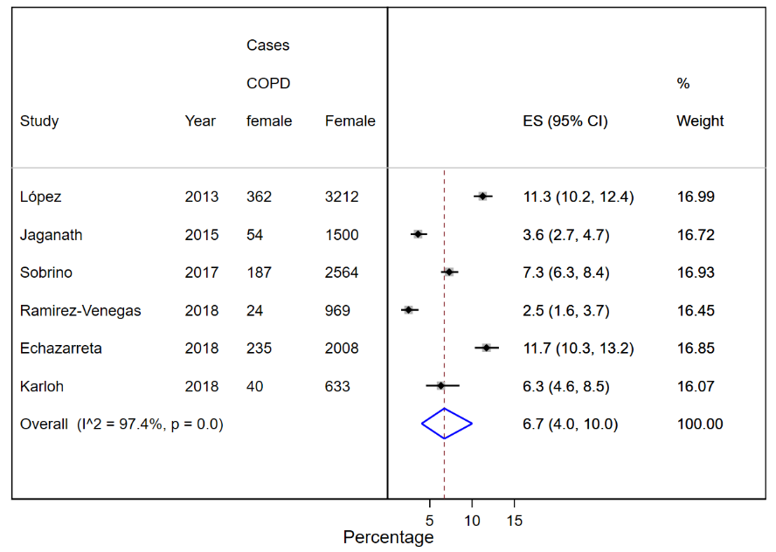
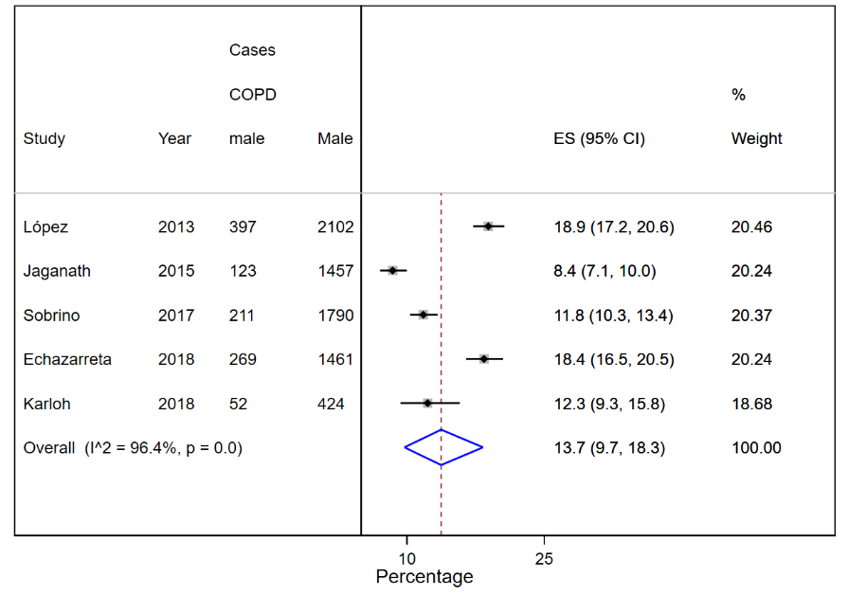
Male Female

Supplementary material 5. Prevalence of chronic obstructive pulmonary disease in the general population of Latin America and the Caribbean by countries.
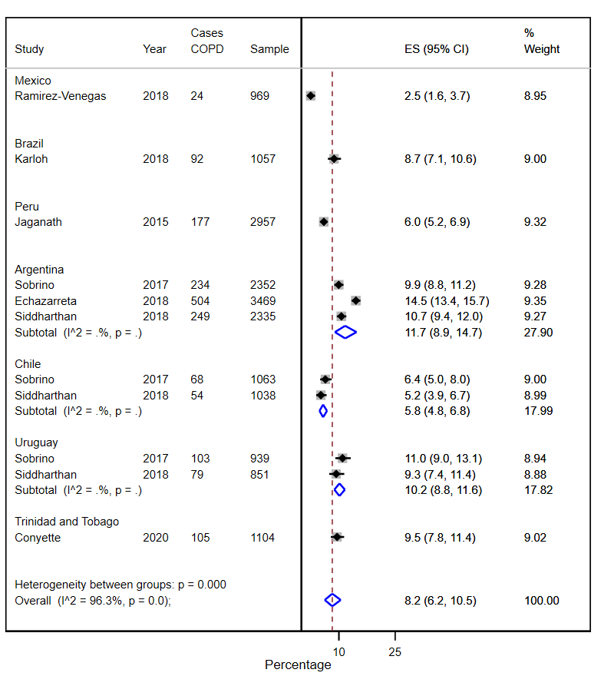

Supplementary material 6. Prevalence of chronic obstructive pulmonary disease by risk of bias score (higher score, higher methodological quality) in Latin America and the Caribbean.
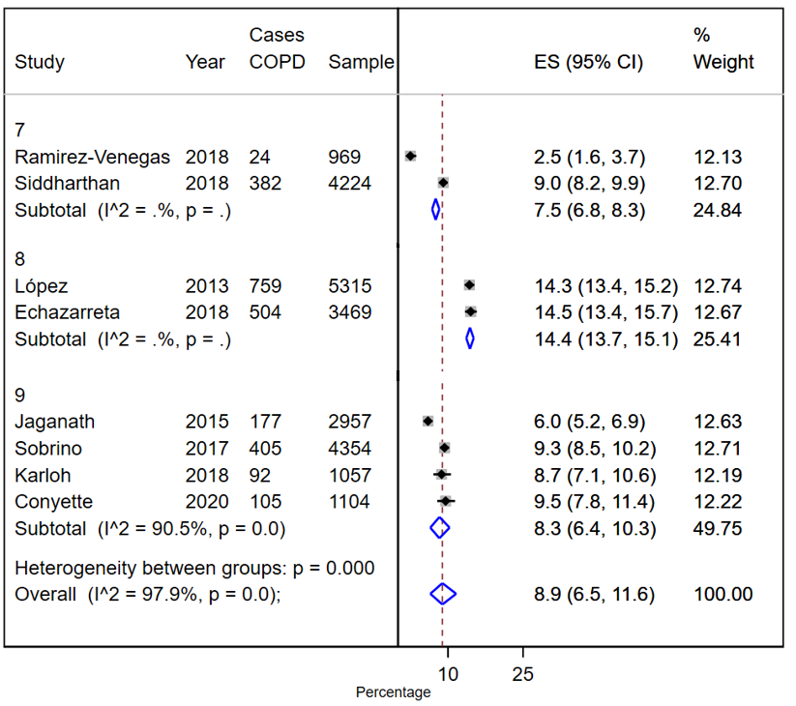

Supplementary material 7. Prevalence of chronic obstructive pulmonary disease in smokers and ex-smokers of Latin America and the Caribbean.
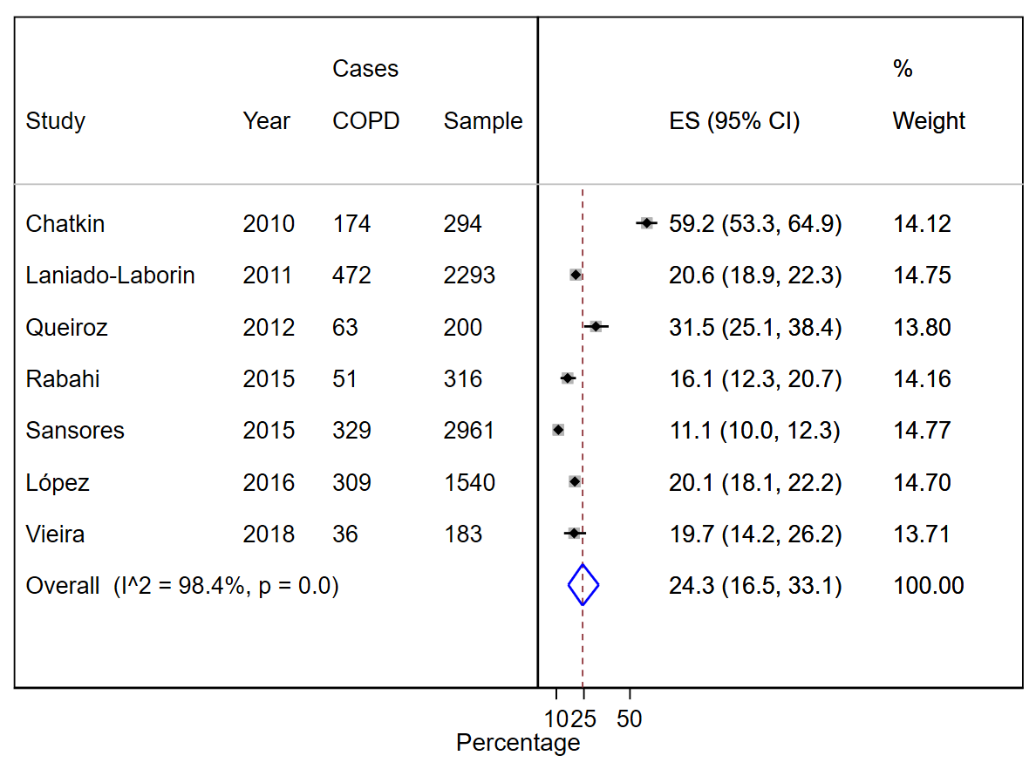

Supplementary material 8. Prevalence of chronic obstructive pulmonary disease by setting in Latin America and the Caribbean. Sensitivity analysis of the variation in prevalence if each included study is removed.
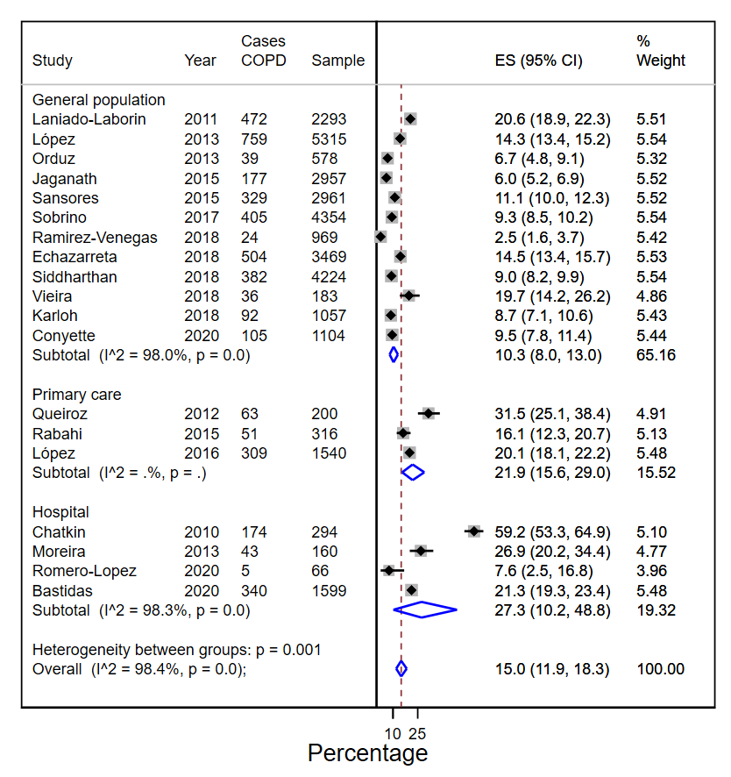

Supplementary material 9. Risk of bias of included studies using the Joanna Briggs Institute Critical Apraissal Tool for prevalence studies.
Study id | Was the sample frame appropriate to address the target population? | Were study participants sampled in an appropriate way? | Was the sample size adequate? | Were the study subjects and the setting described in detail? | Was the data analysis conducted with sufficient coverage of the identified sample? | Were valid methods used for the identification of the condition? | Was the condition measured in a standard, reliable way for all participants? | Was there appropriate statistical analysis? | Was the response rate adequate, and if not, was the low response rate managed appropriately?
Romero-Lopez - 2020 | No | Unclear | No | Yes | No | Yes | Yes | Yes | Yes
Bastidas - 2020 | No | No | Yes | Yes | Yes | Yes | Yes | No | Yes
Conyette - 2020 | Yes | Yes | Yes | Yes | Yes | Yes | Yes | Yes | Yes
Ramirez-Venegas - 2018 | Yes | Yes | Yes | Yes | No | Yes | Yes | No | Yes
Pilla - 2018 | Yes | Yes | Yes | Yes | Yes | Yes | Yes | No | Yes
Echazarreta - 2018 | Yes | Yes | Yes | Yes | Yes | Yes | Yes | Yes | No
Yesddharthan - 2018 | Yes | Yes | Yes | Yes | Yes | Yes | Yes | No | Unclear
Vieira - 2018 | No | Yes | Yes | Yes | Yes | Yes | Yes | No | No
Karloh - 2018 | Yes | Yes | Yes | Yes | Yes | Yes | Yes | Yes | Yes
SobriNo - 2017 | Yes | Yes | Yes | Yes | Yes | Yes | Yes | Yes | Yes
López - 2016 | No | No | Yes | Yes | Yes | Yes | Yes | No | Yes
Jaganath - 2015 | Yes | Yes | Yes | Yes | Yes | Yes | Yes | Yes | Yes
Laender - 2015 | Yes | Yes | Yes | Yes | Yes | Yes | Yes | Yes | No
Rabahi - 2015 | No | No | Yes | No | Unclear | Yes | Yes | No | Unclear
Sansores - 2015 | No | No | Yes | Yes | Yes | Yes | Yes | No | Yes
López - 2013 | Yes | Yes | Yes | Yes | Yes | Yes | Yes | No | Yes
Moreira - 2013 | No | Unclear | No | Yes | No | Yes | Yes | No | Unclear
Orduz - 2013 | Yes | Yes | Yes | No | Unclear | Yes | Yes | No | Unclear
Queiroz - 2012 | No | No | Yes | Yes | Yes | Yes | Yes | No | Yes
Laniado-Laborin - 2011 | Yes | No | Yes | Yes | Yes | Yes | Yes | Yes | Yes
Chatkin - 2010 | No | No | Yes | Yes | Yes | Yes | Yes | No | Unclear

