Aggressive Angiomayxoma in Men: Case Report and Systematic Review
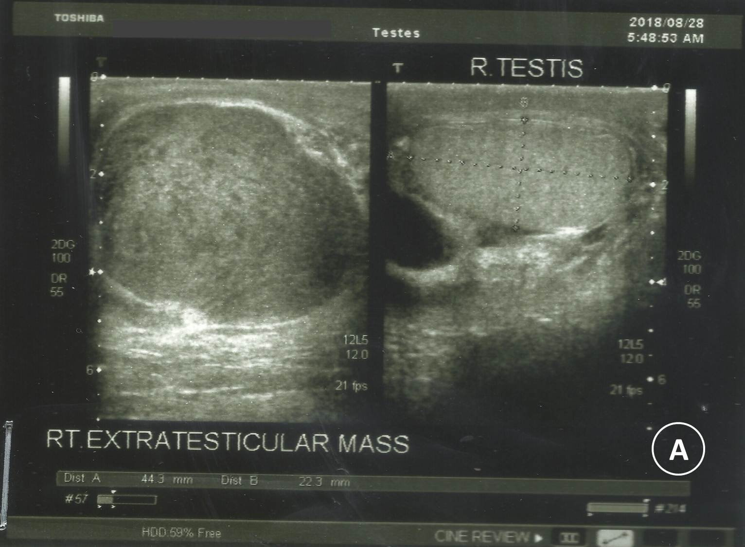
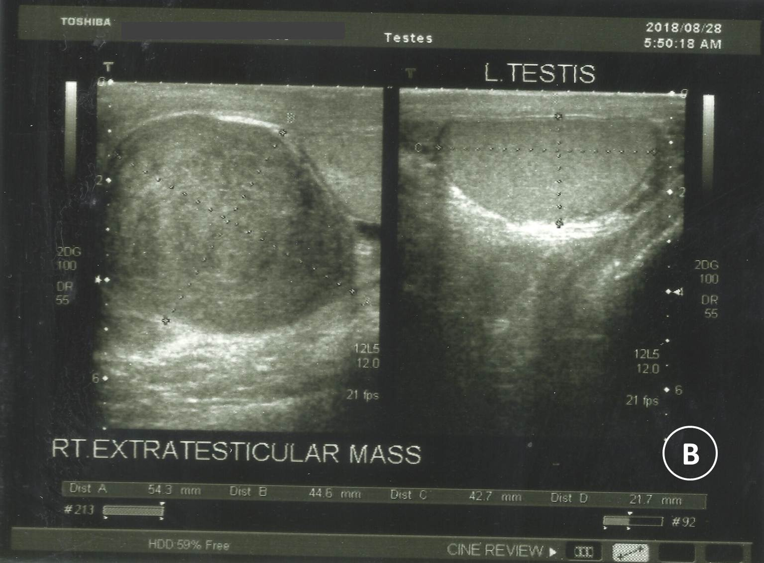
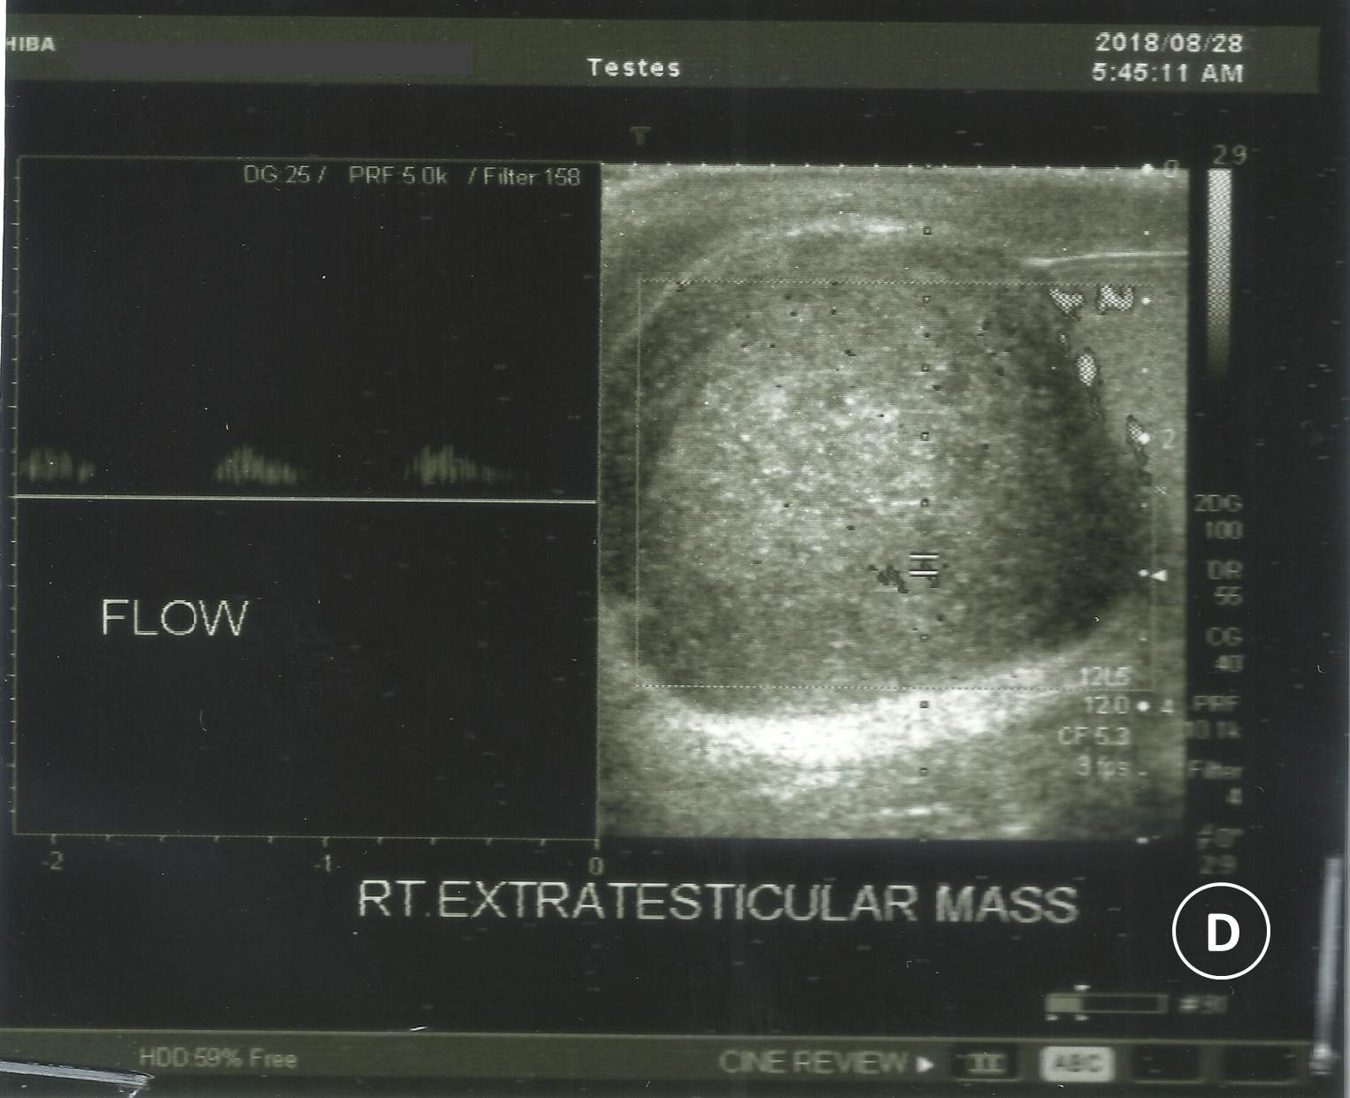
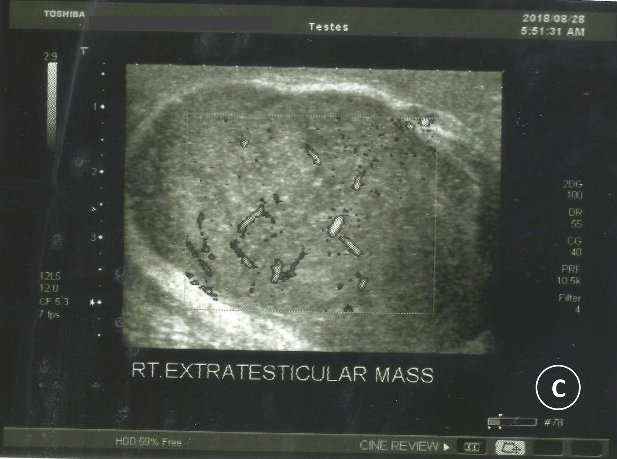
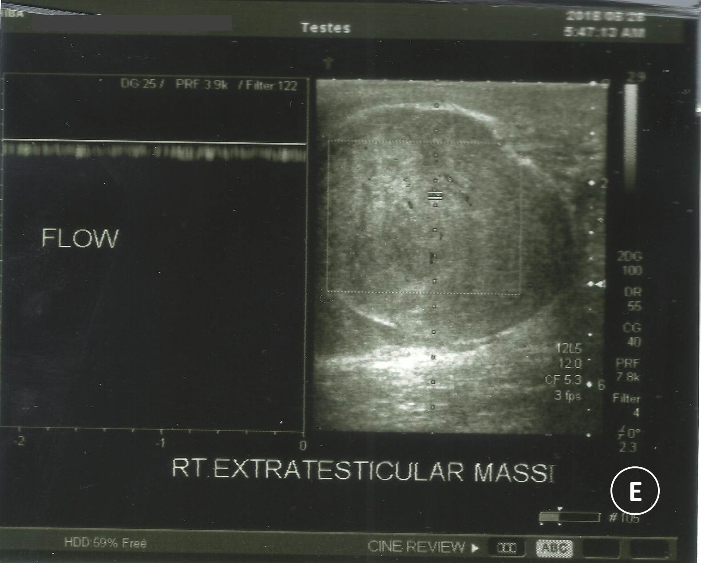

Supplementary Figure 1: Ultrasound showing (A) right testis (4.4*2.2 cm), (B) left testis (4.3*2.2 cm), and (C, D, E) right extra-testicular, well-defined, oval, and hypoechoic mass (6.1*4.5 cm) and homogeneous with internal vascularity.

