Aggressive Angiomayxoma in Men: Case Report and Systematic Review
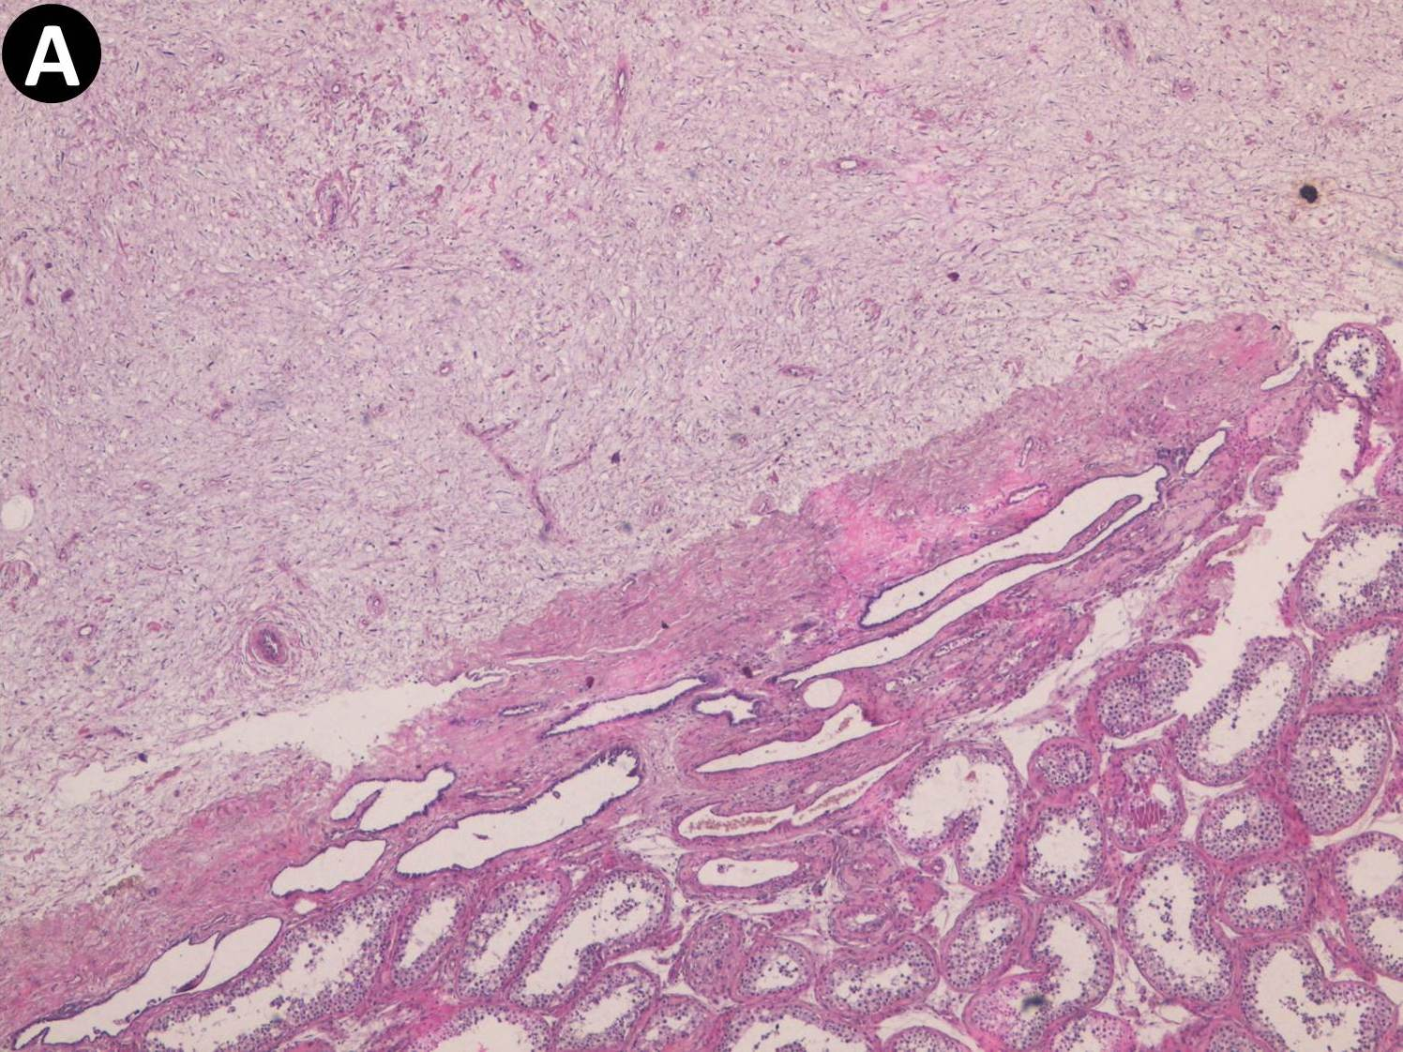
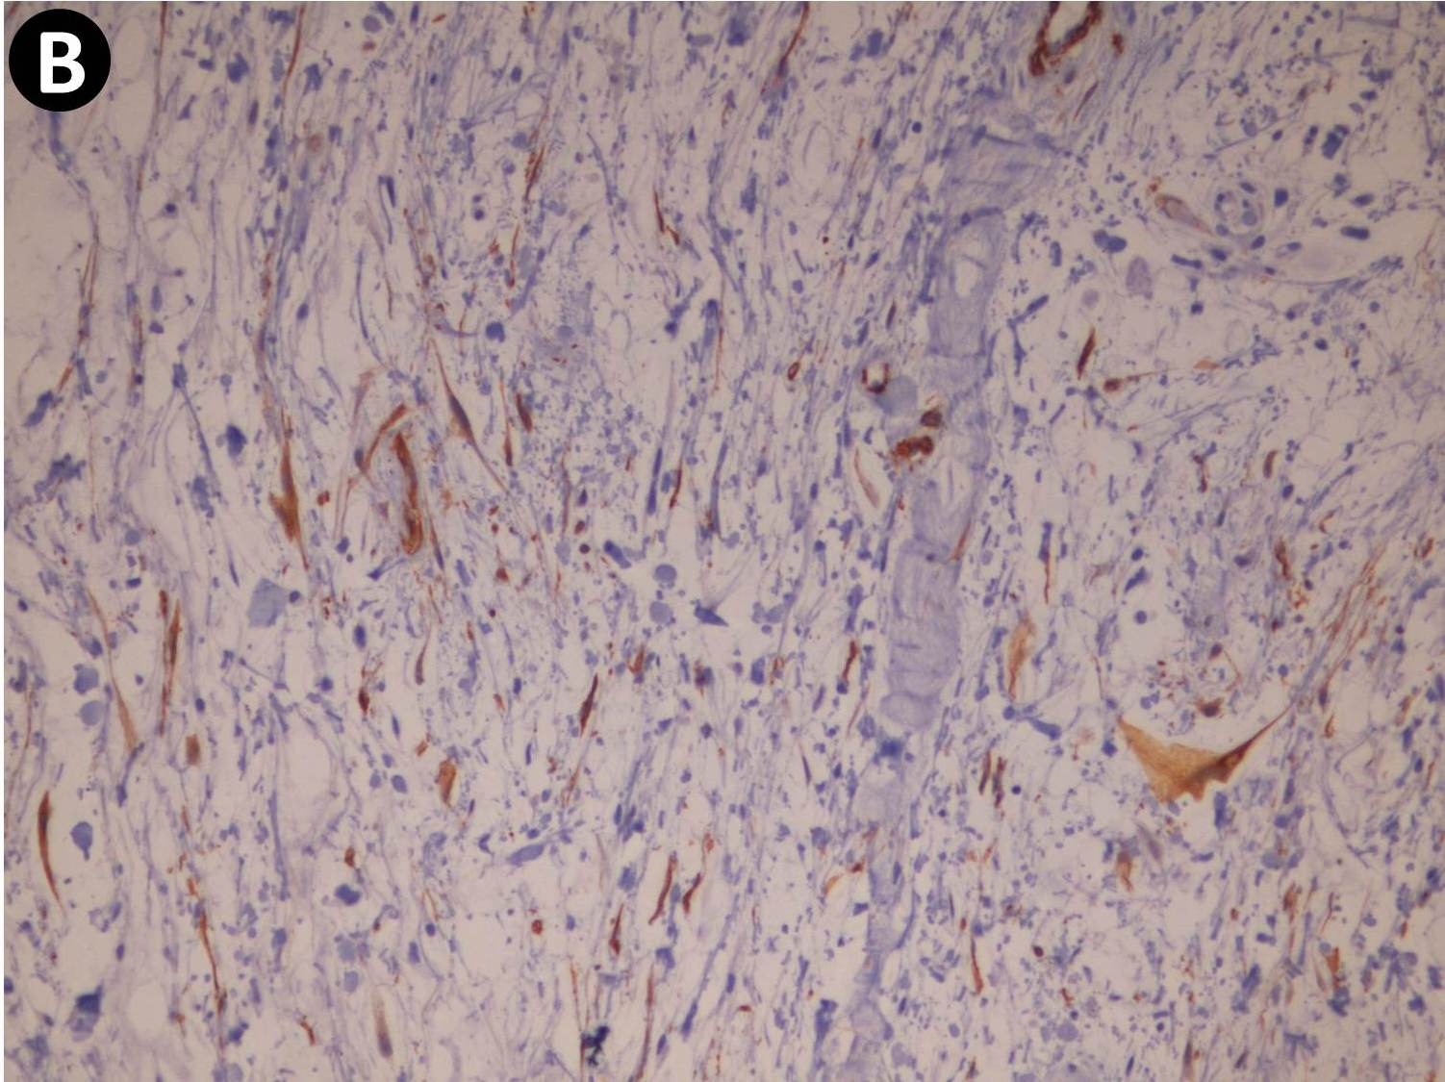

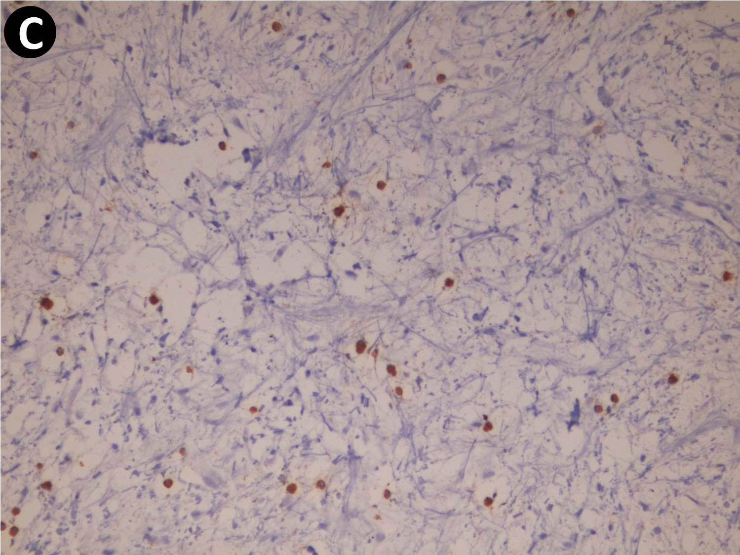
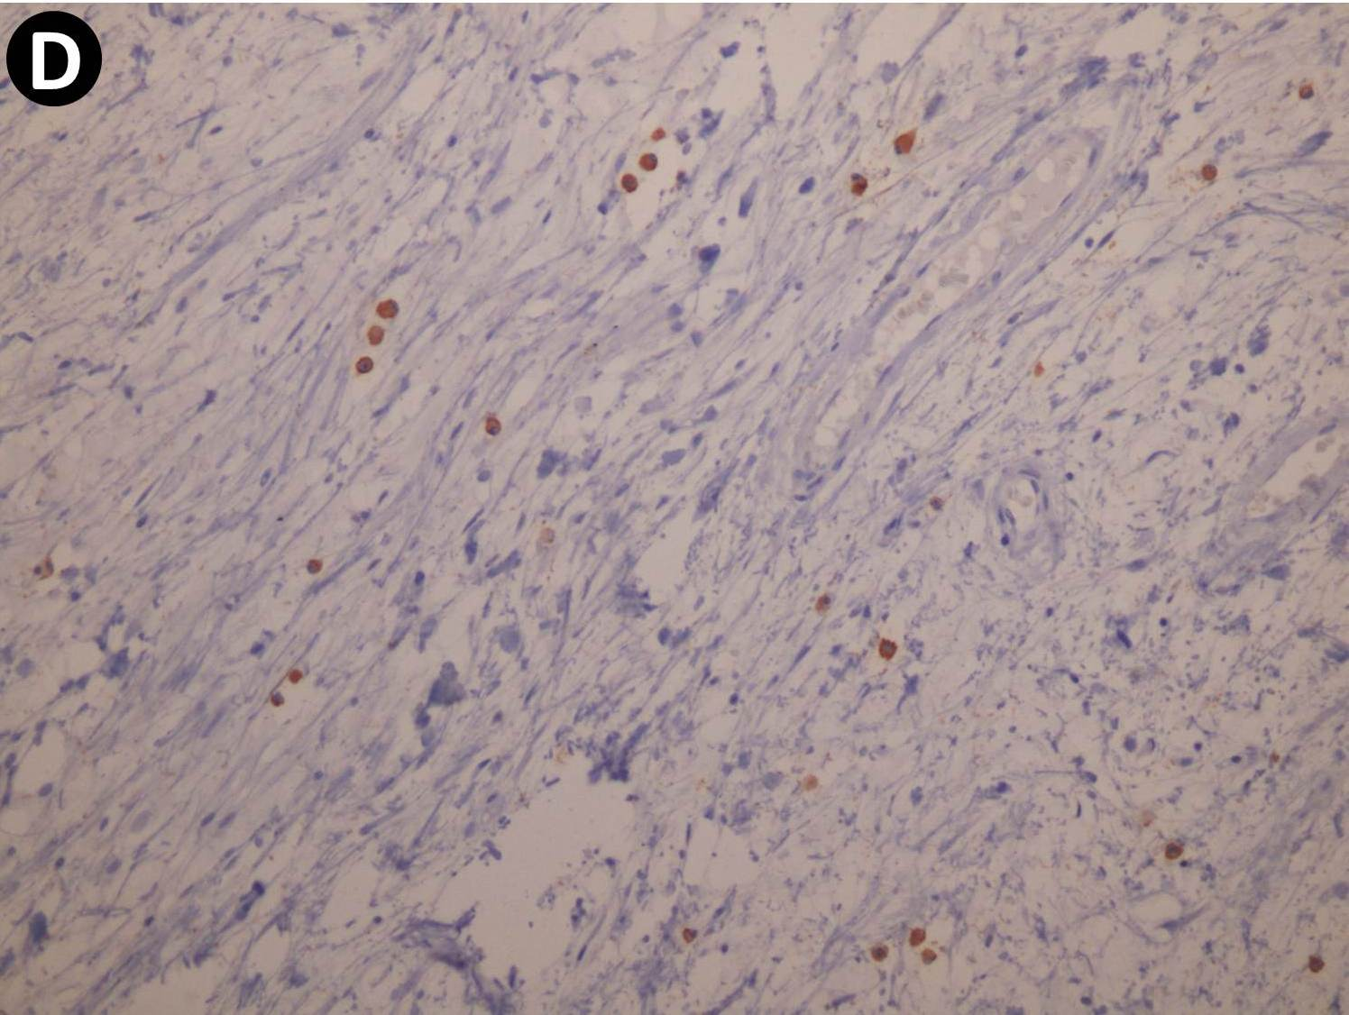

Supplementary Figure 2: (A) Microscopic section of the tumor showing bland, spindled, and stellate cells with delicate cytoplasmic processes that surrounded blood vessels, on the myxoid stroma (H&E).
(B) Focally positive staining with anti-SMA.
(C) Positive staining with anti-ER.
(D) Positive staining with anti-PR.

